

|  |  |
| --- | --- |
| S | 19 |

**De La Salle University • College of Computer Studies**

**Analysis of Average Number of Hours Spent on Facebook Per Day**

Name (last name first) : Fernandez, Ryan Austin

Hosoya, Ken

San Pedro, Marc Dominic

Wang, Kenneth

Section : S19

Date of Submission : January 22, 2015

Time of Submission : 9:15 AM

**Population Data (for S19)**

Figure 1 is the graph for the average hours spent on Facebook per day in the class S19, with a population of thirty-seven (37) students.

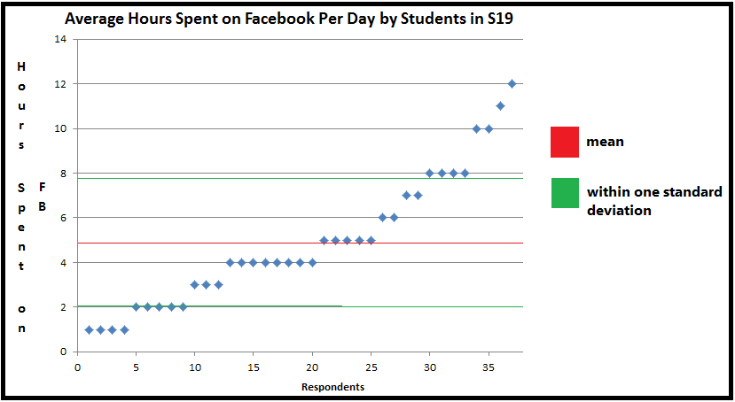

**Figure 1. – Data Set of Average Hours Spend on Facebook Per Day from Population of S19**

By further analysis of this dataset, we have gathered the following information: The mean of the dataset is 4.89; the median is 4; the mode is 4; the variance is 8.37; and the standard deviation is 2.89.

**Sample Data (for students in Gokongwei)**

**Sampling Methodology**

There were two data gathering methods used. These are namely face-to-face interview and online survey.

The face-to-face interview was done by approaching random people in the Br. Rafael Donato Study Hall in the ground floor of the Gokongwei Building and asking for their answers.

The online survey involved posting the question on CCS Facebook groups or direct messaging and getting their responses. These students, however, were biased based on the group member’s friend lists, which mostly consisted of ID 113 students, although there were about 10-12% of students with ID 112 and above included.

After using the aforementioned data gathering techniques, the data was compiled and resulted in the following.

**Dataset for a Sample of Fifty Students from the Gokongwei Building Students Population**

Figure 2 shows the data gathered from the sample of fifty students.

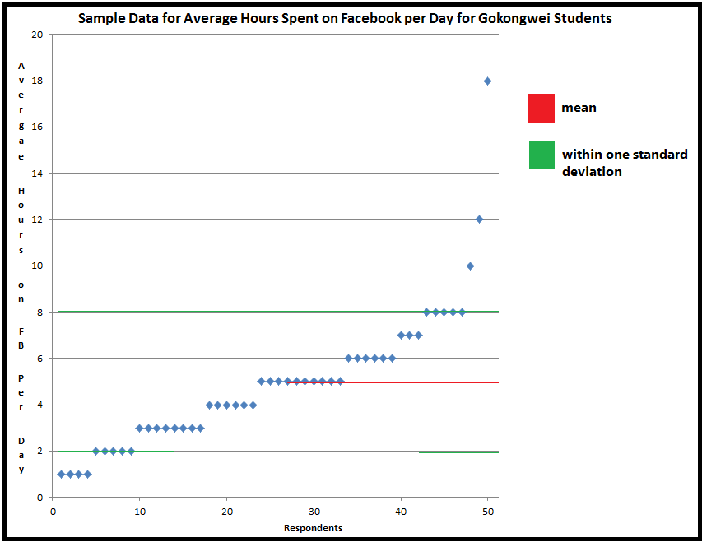

**Figure 2. – Data Set of Average Hours Spend on Facebook Per Day from a Sample Space of Fifty Gokongwei Students**

By further analysis of this dataset, we have gathered the following information: The mean of the dataset is 4.98; the median is 5; the mode is 5; the variance is 9.24; and the standard deviation is 3.04.