

**De La Salle University • College of Computer Studies**

**SystemScape**

**Quality Control Strategy, Revised ER Diagram, and MVC Class Diagram**

Name (last name first) : Angeles, Antonio Mariano

Coquilla, Philip Bryan

Cote, Christian Gabriel

Fernandez, Ryan Austin

Poblete, Clarisse Felicia

Quindoza, Rissa Marie Grace

Salceda, Juan Francesco

Tan, Shayane

Uy, Mervin Stewart

Velez, Gio Anton

Section : S19A

Date of Submission : February 23, 2015

**A Quality Control Strategy**

**1. Conducting of Code Reviews**

Code review for a user story will be conducted once that user story has been completely coded by the development team. During a code review, the quality assurance team will check the following:

* Compliance of code with the coding standards
* Consistency of the current program with the user stories and specifications
* Competency of current program given all possible test cases
* Compatibility of code with other modules

**2. Reporting and Monitoring of Code Defects**

Code defects will be recorded in a spreadsheet file. This report will include the following:

* Issue Number
* Location of Issue (file and line number or function, whichever is applicable)
* Date Reported
* Reported By
* Description
* Recommendation
* Date Resolved
* Resolved By

**3. Conducting of UI Reviews**

UI review for a user story will be conducted once that user story has been completely coded by the analyst team. During a UI review, the quality assurance team will check the following:

* Compliance of code with the UI standards
* Consistency of the current UI with the user stories and specifications
* Competency of current UI given all possible test cases
* Integration of current UI with model and controller

**4. Reporting and Monitoring of UI Issues**

UI Issues will be recorded in a spreadsheet file. This report will include the following:

* Issue Number
* Location of Issue (section of the UI)
* Date Reported
* Reported By
* Description
* Recommendation
* Date Resolved
* Resolved By

**B Revised ER Diagram**

**Figure 2-1 – Revised Entity-Relationship Diagram**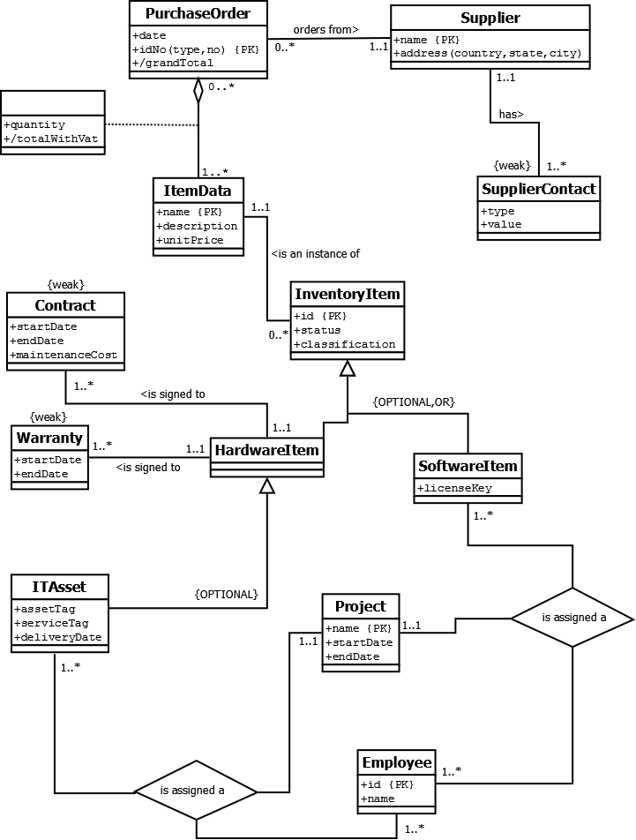

**C Model-View-Controller Class Diagram**

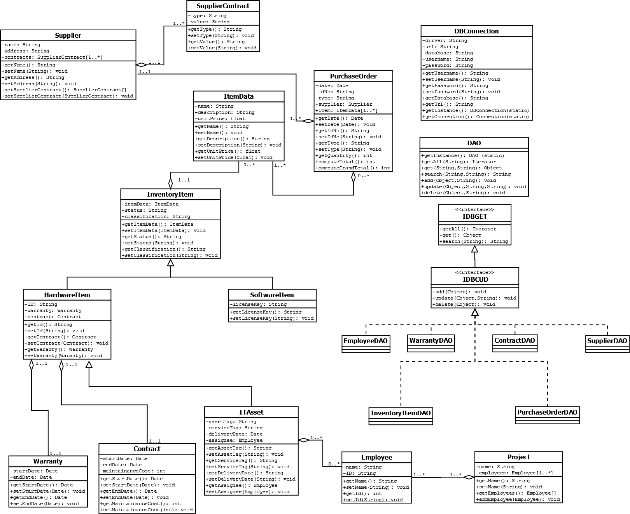 **Figure C-1. Model Class Diagram**

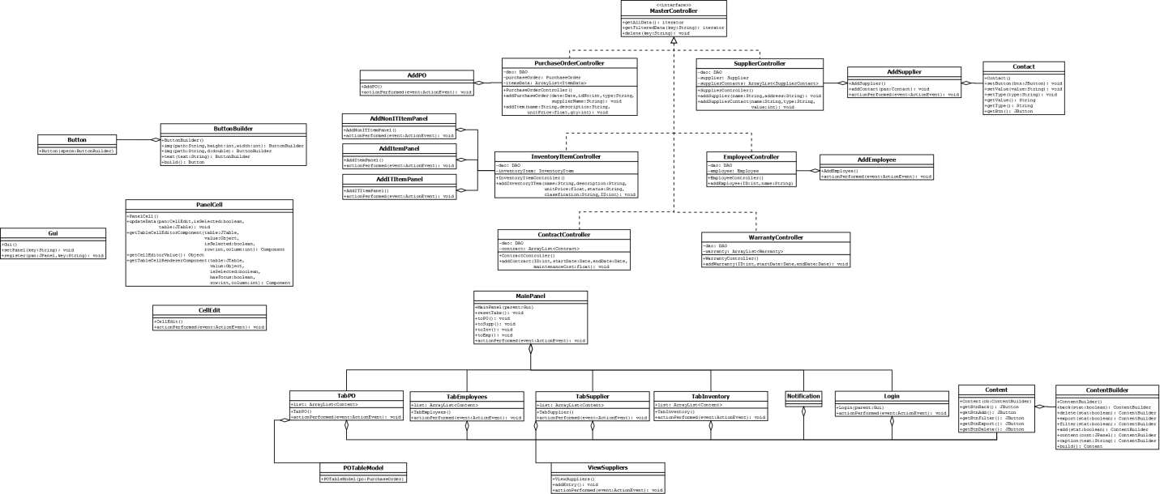 **Figure C-2. View-Controller Class Diagram**