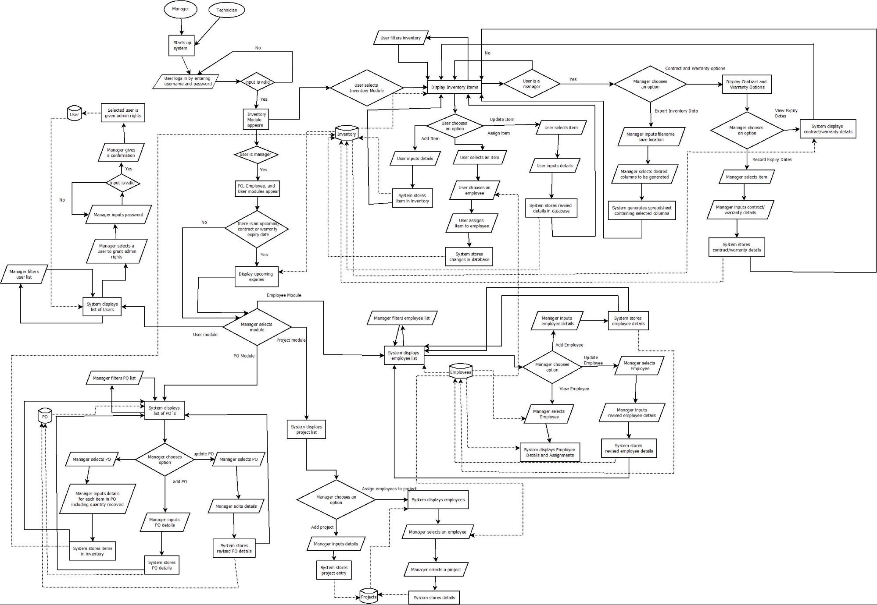

Starts up system

Selected user is given admin rights

System displays list of Users

**No**

Display upcoming

User module

Manager filters Polist

expiries

Employee Module

Project module

PO Module

Manager inputs details for item in PO including quantity received

Manager edits details

System stores items in inventory

System stores revised PO details

System stores PO details

Add project

User filters inventory

No.

User selects Inventory Module

User chooses an

System stores item in inventory

employee

User assigns item to employee

Update Item

Assign item

User inputs details

User selects tem

Export Inventory

selects desired columns to be generated

System generates spreadsheet containing selected olumns

System displays employee list

Add Employee

View Employee

System stores employee details

System displays Employee Details and Assignments

System stores revised employee details

Assign employeestop

option

System stores project entry

System displays employees

System stores details

Contract and Warranty options

Display Contract and Warranty Options

**----**