

**CAI-STA**

SOFTWARE REQUIREMENTS SPECIFICATION

|  |  |
| --- | --- |
| **Team Name** | **SystemScape** |
| **Section** | S19A |
| **Team Members** | Angeles, Antonio Mariano  Coquilla, Phillip Bryan  Cote, Christian Gabriel  Fernandez, Ryan Austin  Poblete, Clarisse Felicia  Quindoza, Rissa Marie Grace  Salceda, Francesco Juan  Tan, Shayane  Uy, Mervin Stewart  Velez, Gio Anton |
| **Date Submitted** | February 23, 2015 |

**Table of Contents**

|  |  |
| --- | --- |
| 1. Executive Summary | 1-1 |
| 1. Overview | 2-1 |
| * 1. Existing Business Process | 2-1 |
| * 1. Data Requirements | 2-2 |
| * 1. Roles in the Business Process | 2-3 |
| 1. Problem Analysis | 3-1 |
| 1. Software Solution | 4-1 |
| * 1. Objectives | 4-1 |
| * 1. Characteristics | 4-1 |
| 1. User Stories | 5-1 |

|  |  |
| --- | --- |
| * 1. User Story #1 | 5-1 |
| * 1. User Story #2 | 5-1 |
| * 1. User Story #3 | 5-2 |
| * 1. User Story #4 | 5-2 |
| * 1. User Story #5 | 5-2 |
| * 1. User Story #6 | 5-3 |
| * 1. User Story #7 | 5-3 |
| * 1. User Story #8 | 5-3 |

|  |  |
| --- | --- |
| * 1. User Story #9 | 5-4 |
| * 1. User Story #10 | 5-4 |
| * 1. User Story #11 | 5-5 |
| * 1. User Story #12 | 5-5 |
| * 1. User Story #13 | 5-6 |
| * 1. User Story #14 | 5-6 |
| * 1. User Story #15 | 5-7 |
| * 1. User Story #16 | 5-7 |
| * 1. User Story #17 | 5-8 |
| Appendix A - Improved Business Process | A-1 |
| Appendix B - Interview Transcript | B-1 |
| Appendix C - Sample Forms and Reports | C-1 |
| 1. Purchase Order Form | C-1 |
| 1. Inventory Form | C-2 |
| 1. Contract Form | C-3 |
| 1. Additional Details Provided by the Company | C-3 |
| Appendix D - References and Acknowledgements | D-1 |

1. **Executive Summary**

CAI-STA is a joint venture partner of Computer Aid Inc., Headquartered in Metro Manila, Philippines. They are CAI’s global presence in the Asia Pacific Region.

The company is a marketing and sales platform for CAI-built intellectual property tools which are owned and developed by CAI and marketed in Asia by CAI-STA Philippines. It also offers CAI tools, application services and consulting to improve the Information Communication Technology management of its clients, both in the private and public sector, through its Class A facilities and team of knowledgeable professionals. CAI-STA’s delivery strategy identifies, trains, and leverages local human resources to deliver these services under the management of CAI senior consultants. (“CAI-STA Philippines”, n.d.)

1. **Overview of the Business Process**

This chapter presents CAI-STA’s business process and goals as an organization. Included in this chapter are the following items:

* Description of CAI-STA’s existing process and business requirements
* Data requirements as part of the business process for managing inventory, purchase orders, and asset and product assignment, including items, inventory entries, purchase orders, suppliers, employees, projects, contracts, warranties, and inventory reports.
* Different roles in the business process

**2.1 Existing Business Process**

CAI-STA provides tools and application services for its customers in both the private and the public sectors to improve the Information and Communication Technology management of its clients.

The business process for managing inventory, purchase orders, and asset and product assignment begins with the manager creating a purchase order using a spreadsheet upon request from the clients (see Appendix C-1). Once the purchase order has been created and has been sent to the supplier, the supplier will then deliver the ordered items to the company. When the items have been received, the manager signs the contract/warranty form and the manager or technicians record the item details in a spreadsheet that is used to track down the items in the inventory (See Appendix C-2). The manager then double-checks the added item, assigns an asset tag to the item, and keeps the item’s warranty form.

Although all hardware items have a warranty form, not all items include a contract form. Items are classified as I.T. Assets, Non-I.T. Assets (i.e. Furniture, Office Supplies), I.T. Components, or Software, but only items that are classified as I.T. assets include a contract form that the manager will keep. On the other hand, when an item’s contract expires, the manager monitors the maintenance cost and then renews the contract to replace or to repair the equipment. The manager also monitors each item’s warranty end date.

The manager could also assign an item, which would set the item status to “in use”, to a project and an employee. Otherwise, the item status is set to “in store”. While doing so, the manager keeps track of the project name, the employee’s name, and the asset tags given to the items assigned to the current project. Items that are classified as IT Assets or as Software are the only ones involved in this process.The project manager gives the manager a list of employees and assets needed for the project. If there are missing assets, they are ordered via purchase order. Once all assets are present, the manager then assigns them based on the project manager’s list.

The business process for managing inventory, purchase orders, and asset and product assignment can be visualized in the diagram shown in Figure 2-1.

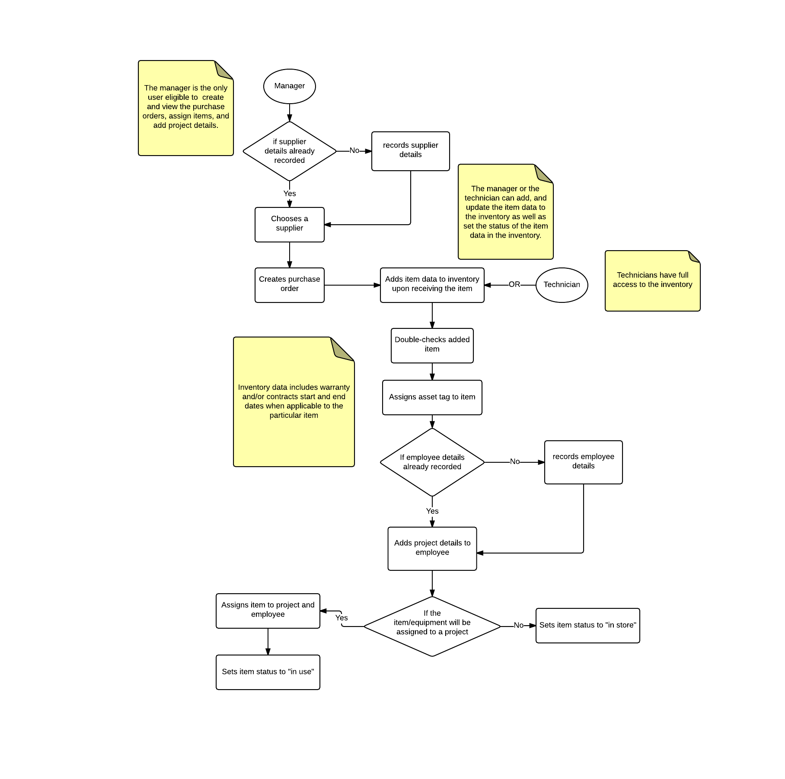

**Figure 2-1. Existing Business Process**

The manager generates an inventory report on a regular basis by creating a separate MS Excel spreadsheet file and sorting out each item based on the desired category from the other spreadsheets where the items are recorded.

**2.2 Data Requirements**

A supplier contains the following information: supplier name, supplier’s complete address (street, city, zip code), supplier’s contact numbers (cell phone number, telephone number, fax number).

A purchase order (see Appendix C-1) that is created by the manager contains the following information: purchase date, supplier details as mentioned above, and P.O. number. The P.O. number is acomposite attribute that is composed of the item’s type and the item’s id number. An item in the Purchase Order can be categorized as a “Hard” for hardware, “Soft” for software, or “Gen” for general items. On the other hand, the id number of an item is auto incremental. The purchase order also contains the item name, description, quantity, unit price, total with VAT, and grand total.

An item that is stored into the inventory has an item name, item description, can be classified into an IT Asset, a non-IT Asset, an IT component, a software, or other, and can be either available, on stock, in use, disposed, or junk. IT Assets contain the following attributes: date of delivery, asset tag, service tag, warranty, and assignee. IT components also have the warranty attribute. In the case that the item is software, it is assigned a license key instead. Furthermore, an item may also optionally be assigned to multiple projects.

The contract form (see Appendix C-3) that the manager must accomplish if an item is classified as an IT asset includes the start and end date of the contract and the maintenance cost of the item.

The warranty form that the manager must accomplish for each item in the inventory includes the start and end date of the warranty.

An Employee has an ID number and a name. The project assignment of an item includes the project name, the employee name,the item’s asset tag number, project start date, and project end date.

The generated reports only involves all items that are in the inventory. The reports for the inventory (see Appendix C-2) includes the item name, service tag, asset tag, date of delivery, end of warranty, amount, and P.O. number.

**2.3 Roles in the Business Process**

There are two main types of users in the proposed system. These users and their tasks are summarized in Table 2-1.

|  |  |
| --- | --- |
| **Role** | **Description of Tasks** |
| Technician | * Manages inventory system * Views inventory system |
| Manager | * Manages inventory system * Views inventory system * Manages purchase orders * Views purchase orders * Manages contracts and warranties * Receives notifications regarding contracts and warranties * Manages supplier information * Manages employee information * Manages employee project assignment |

**Table 2-1. User Roles and Tasks in CAI-STA**

**3 Problem Analysis**

This chapter presents the findings of the investigation on CAI-STA’s needs and problems to be addressed by the software.

|  |  |  |  |  |
| --- | --- | --- | --- | --- |
| **ID** | **Description** | **Cause** | **Symptoms** | **Impact** |
| # | What’s the problem? | What causes the problem? | How do we know the problem exists? | Why is this important? What are the consequences? |
| 1 | The ends of warranties and contracts are difficult to keep track of. | * Even though the relevant dates are present in the MS Excel files being used, MS Excel itself does not have a notification feature; * The manager needs to manually set the dates in a calendar application to be notified of approaching warranty and contract expirations. | * There are instances wherein the client overlooked contracts and end of warranties of some items and pieces of equipment. | * If a piece of equipment were to get damaged, and its warranty or contract were not renewed, then there will be complications in the repair or replacement of that piece of equipment. |
| 2 | The current approach in managing the inventory and purchase orders is open to inconsistencies between the different files used to store data. | * There is no centralized database for easy data management; * Instead multiple MS Excel files are used, often for the same data. | * The need to maintain multiple files that are not directly connected and contain copies of the same data sometimes leads to discrepancies in this data. * The manager needs to update and check multiple files whenever the data is edited. | * If there are discrepancies between these files, they would be difficult to resolve and may lead to complications in handling inventory items through this data later on. |
| 3 | The items listed in the inventory are difficult to filter and sort. | * The manager is unable to automatically sort the items and data contained in MS Excel. | * The manager currently has to create a separate MS Excel file that the manager manually arranged in order to view the sorted list of items. * If the manager were to make a mistake in transferring, copying and rearranging data between these files (e.g. forgetting to transfer an item or accidentally overwriting an item), then this could invalidate some of that data and lead to complications later in processes involving that data. | * It will be difficult to view the inventory because of manual sorting or filtering. * Maintaining an accurate inventory is difficult due to there being many files, necessary for different kinds of items, pertaining to the same data. This leads to inconsistency from human error. |
| 4 | The assignments of items to employees and projects are difficult to keep track of. | * The manager is unable to easily view and organize assignments through MS Excel because of the format’s inflexibility. | * Staff is often hired in bulk; around 50 employees are assigned to a project at once. * There is shortage of admin support * Rampant resignation can complicate the assignment process. * Incompetent technical support can cause problems. * Manual input using Excel is required for these 50+ employees. | * If employee and project assignment were poorly managed, then it would be difficult for the manager to determine which employee is responsible for which items, and for what projects these employees require these items for. * Time is wasted manually inputting 50+ employee data and assigning them to assets. |
| 5 | The lists of suppliers and their corresponding contact persons are difficult to keep track of. | * There is no centralized database for the organization of this information. | * Supplier information is not readily available when creating a purchase order, necessitating access to a separate file. | * If the supplier information were poorly managed, then information could potentially end up being misplaced, causing complications in the purchase order process later on. |

Inconsistencies arise due to the separation of the purchase manager’s system and the technician’s system. Additionally, it is currently easy to forget the ends of warranties and contracts manually. Project and asset assignment is also difficult since this is usually done by the manager in bulk as there are many projects ongoing with many employees involved, each with a possible software and asset assignment. Finally, filtering and sorting of inventory is done across multiple files, and is thus prone to human error, not to mention inefficient. Automation would make sorting and filtering more efficient through use of a database.

**4 Software Solution**

* 1. **Objectives**

The software aims to provide CAI-STA with a system to manage the data involved in purchases and inventory.

“The specific objectives of the software are as follows:

* To provide a facility for managing inventory;
* To provide a facility for managing suppliers;
* To provide a facility for managing purchase orders;
* To provide a facility for keeping track of contracts and warranties;
* To provide a facility for keeping track of item and project assignments to employees;
* To notify the manager about any upcoming expiries of contracts and warranties;
* To generate inventory reports”

* 1. **Characteristics**

The software is intended to run on the Java Runtime Environment (JRE). The software should present consistency in records and ease in creating purchase orders, supplier management, project/employee assignment, adding items to inventory, and generating the necessary reports as needed (defined by the President, usually when there is a new project). It should have the correct information at all times, to be implemented by using a single database, and it should be easily usable and maintainable, in case future development teams wish to add features.

**5 User Stories**

This chapter presents the user stories included in the product backlog.

Note that for the estimates, 1 day = 16 hours.

|  |  |
| --- | --- |
| **User Story #1:** A user (manager, technician) can login to view and manage the purchase order module, the inventory module, and the project assignment module. | |
| **Estimate:** 2 days | **Priority:** 20 |
| **Pre-condition:** The user must be registered to the database. | |
| **Scenario:**   1. The system prompts the user for his/her password and username. 2. The user inputs his/her password and username. 3. The system validates both the username and the password. 4. The system displays the inventory module    1. The system also displays the purchase order module and the project assignment module for the manager. 5. The system notifies the manager of any upcoming contract or warranty expiry dates. | |
| **Post-condition**: The manager can now create the purchase order and view the purchase orders created. The manager can now also manage the information in the inventory and assign the projects to the employees. The technician can now manage the inventory. | |
| **Acceptance Criteria:**   1. Test if the system displays the screens for the inventory module if both the username and the password are correct. 2. Test if the purchase order module and the project assignment module’s screens are displayed if the user is a manager. 3. Test if the system does not display the screens for the inventory module if the username or the password is incorrect. 4. Test if the purchase order module and the project assignment module do not appear if the user is not a manager. 5. Test if the system prompts the user for the correct password and username if the password or the username is incorrect. | |

|  |  |
| --- | --- |
| **User Story #2:** A manager can export the inventory data into spreadsheets to generate the reports. | |
| **Estimate:** 1 day | **Priority:** 30 |
| **Pre-condition:** The inventory must be populated with data. The manager must also be logged in. | |
| **Scenario:**   1. The manager chooses to generate inventory report (see Appendix C-2). 2. The manager inputs the location in their drive as well as the filename. 3. The system generates the spreadsheet containing the inventory items’ status or assignee, model,service tag, asset tag, date of purchase, end of warranty, and cost. | |
| **Post-condition:** The generated spreadsheet can now be printed and be viewed. | |
| **Acceptance Criteria:**   1. Test if correct data were extracted from the database to generate the reports. 2. Test if the generated file is a spreadsheet. 3. Test if the spreadsheet is located in the specified directory 4. Test if the spreadsheet has the given filename. 5. Test if the content of the generated file follows the required format specified by the client. | |

|  |  |
| --- | --- |
| **User Story #3:** A manager can view the list of suppliers, which may be filtered, to monitor the supplier details. | |
| **Estimate:** 24 hours | **Priority:** 10 |
| **Pre-condition:** The manager must be logged in. | |
| **Scenario:**   1. The manager chooses to view the list of suppliers. 2. The system displays the list of suppliers, showing their name and address (country, state, and city). 3. The manager may choose to filter the suppliers by name or address.    1. The list is now filtered to reflect the chosen criteria | |
| **Post-condition:** The manager can now view the list of suppliers in the database. | |
| **Acceptance Criteria:**   1. Test if the system displays the data equivalent to the ones in the database. 2. Test if the system displays a list of suppliers that fits the given criteria. 3. Test if the system displays a notification message if there are no matches to the criteria. | |

|  |  |
| --- | --- |
| **User Story #4:** A manager can record supplier details to have a directory of suppliers where the company could get their purchases as well as contact for any inquiries | |
| **Estimate:** 8 hours | **Priority:** 10 |
| **Pre-condition:** The manager must be logged in. The manager must currently be viewing the list of suppliers. | |
| **Scenario:**   1. The manager chooses to add a supplier. 2. The manager inputs the supplier name and address(country, state. and city). 3. The manager chooses to add the supplier. 4. The system stores the details to the database. 5. The system updates the viewable list of suppliers | |
| **Post-condition:** The manager can now see the new supplier in the updated list of suppliers. | |
| **Acceptance Criteria:**   1. Test if the system displays a confirmation message to check if all entered information is correct before saving it. 2. Test if the system displays a warning message if there is any significant information that was left blank upon submission. 3. Test if the system displays a warning message if the supplier has already been added previously based on name. 4. Test if the system displays an updated supplier list once the details are added to the database. | |

|  |  |
| --- | --- |
| **User Story #5:** A manager can view the list of purchase orders, which may be filtered, to monitor the purchase order details. | |
| **Estimate:** 2 days | **Priority:** 10 |
| **Pre-condition:** The manager must be logged in. | |
| **Scenario:**   1. The manager chooses to view the list of purchase orders. 2. The system displays the list of purchase orders, each includes ID, supplier, date, and each item with its quantity and total with VAT, and a grand total of all items. 3. The purchase orders may be filtered based on ID type (**HARD**ware, **SOFT**ware, or **GEN**eral items), supplier, date range, or whether it contains a certain item.    1. System displays filtered list | |
| **Post-condition:** The manager can now view the list of purchase orders in the database. | |
| **Acceptance Criteria:**   1. Test if the system displays the data equivalent to the ones in the database. 2. Test if the system displays a list of purchase orders that fits the chosen criteria. 3. Test if the system displays a notification message if there are no matches to the criteria. 4. Test if computation of total with VAT and grand total is accurate. | |

|  |  |
| --- | --- |
| **User Story #6:** A manager can create purchase orders to monitor purchase transactions between the company and its suppliers. | |
| **Estimate:** 8 hours | **Priority:** 10 |
| **Pre-condition:** The manager must be logged in. The manager must currently be viewing the list of purchase orders. | |
| **Scenario:**   1. The manager chooses to create a purchase order. 2. The manager inputs the purchase order type, supplier, date, and ordered items. 3. The manager chooses to add the purchase order details. 4. The system stores details in the database. 5. The system updates the viewable list of purchase orders | |
| **Post-condition:** The manager can now see the new purchase order in the updated list of purchase orders. | |
| **Acceptance Criteria:**   1. Test if the system displays a confirmation message to check if all entered information is correct before saving it. 2. Test if the system displays a warning message if there is any significant information that was left blank upon submission. 3. Test if the system displays a message once the submitted purchase order has been successfully added in the database. 4. Test if the system displays an updated list of purchase orders once the details are added to the database. | |

|  |  |
| --- | --- |
| **User Story #7:** A manager can update purchase orders to modify incorrect values and inconsistencies**.** | |
| **Estimate:** 8 hours | **Priority:** 30 |
| **Pre-condition:** The manager must be logged in. The manager must currently be viewing the list of purchase orders. There must also be previous information stored regarding the specified purchase order. | |
| **Scenario:**   1. The manager selects a purchase order to edit. 2. The system displays the current purchase order details, each includes ID, supplier, date, and items, with quantity and total with VAT, and a grand total of all items. 3. The manager modifies the aforementioned purchase order details. 4. The manager confirms the edited purchase order details. 5. The system updates the details of the chosen purchase order in the database. | |
| **Post-condition:** The manager can now see the edited purchase order details when the manager chooses to view it again. | |
| **Acceptance Criteria:**   1. Test if the system displays a confirmation message to check if all entered information is correct before saving it. 2. Test if the system displays a warning message if there is any significant information that was left blank upon submission. 3. Test if the system displays a message once the edited information has been successfully updated in the database. 4. Test if the system displays an updated list of purchase orders once the updates in the database are done. | |

|  |  |
| --- | --- |
| **User Story #8:** A manager can record contract expiry dates to monitor the expiry dates of equipment. | |
| **Estimate:** 4 hours | **Priority:** 10 |
| **Pre-condition:** The manager must be logged in. The manager must currently be adding an item classified as I.T. asset to the inventory. | |
| **Scenario:**   1. The manager inputs the contract details. 2. The manager chooses to save the details. 3. The system adds the details to the database. | |
| **Post-condition:** The manager can now view the contract details of an item that is classified as an I.T.asset. | |
| **Acceptance Criteria:**   1. Test if the system prompts the manager to fill up the contract details form once an item is classified as an I.T. asset. 2. Test if the system displays a confirmation message to check if all entered information is correct before saving it. 3. Test if the system displays a warning message if there is any significant information that was left blank upon submission. 4. Test if system notifies manager of an error if start date inputted is after end date. 5. Test if system notifies manager is end date inputted is too close to current date. 6. Test if the system displays a message once the information has been successfully added in the database. | |

|  |  |
| --- | --- |
| **User Story #9:** A manager can view notifications on items with incoming contract expiry dates to renew the contract in order to repair or to replace an equipment when complications arise. | |
| **Estimate:** 1 day | **Priority:** 20 |
| **Pre-condition:** The manager must be logged in. The manager must have finished entering the contract details of an item that is classified as an I.T. asset. | |
| **Scenario:**   1. The system notifies the manager about items expiring within the user’s set date range. 2. The manager chooses to view the notifications. 3. The system displays the notifications on items with near contract expiry dates | |
| **Post-condition:** The manager can now be notified and view the contracts with near expiry dates. | |
| **Acceptance Criteria:**   1. Test if the system displays a notification message for items with contract expiring within the next two weeks. 2. Test if the system only displays items with contracts expiring within the next two weeks. | |

|  |  |
| --- | --- |
| **User Story #10:** A manager can record item warranty expiry dates to monitor the warranty expiry dates of an item. | |
| **Estimate:** 4 hours | **Priority:** 10 |
| **Pre-condition:** The manager must be logged in. The manager must currently be adding an item to the inventory. | |
| **Scenario:**   1. The manager inputs the warranty details. 2. The manager chooses to save the details. 3. The system adds the details to the database. | |
| **Post-condition:** The manager can now view the warranty details of an item. | |
| **Acceptance Criteria:**   1. Test if the system prompts the manager to fill up the warranty details form once an item has been added in the database. 2. Test if the system displays a confirmation message to check if all entered information is correct before saving it. 3. Test if the system displays a warning message if there is any significant information that was left blank upon submission. 4. Test if system notifies manager of an error if start date inputted is after end date. 5. Test if system notifies manager is end date inputted is too close to current date. 6. Test if the system displays a message once the information has been successfully added in the database. | |

|  |  |
| --- | --- |
| **User Story #11:** A manager can view notifications on items with incoming warranty expiry dates to monitor the fee of maintaining the item which increases without the warranty. | |
| **Estimate:** 8 hours | **Priority:** 20 |
| **Pre-condition:** The manager must be logged in. The manager must have finished entering the warranty details of an item. | |
| **Scenario:**   1. The system prompts a notification message for the manager. 2. The manager chooses to view the notifications. 3. The system displays the notifications on items with incoming warranty expiry dates within user-specified value | |
| **Post-condition:** The manager can now be notified and view the warranties with near expiry dates. | |
| **Acceptance Criteria:**   1. Test if the system displays a notification message for items with warranties expiring within the next two weeks. 2. Test if the system only displays items with warranties expiring within the next two weeks. | |

|  |  |
| --- | --- |
| **User Story #12:** A manager can view the list of employees, which may be filtered, to monitor the company staff. | |
| **Estimate:** 24 hours | **Priority:** 30 |
| **Pre-condition:** The manager must be logged in. | |
| **Scenario:**   1. The manager chooses to view the list of employees. 2. The system displays the list of employees, each with ID and name. 3. Manager may choose to filter list based on ID or name    1. The system filters list and displays appropriate results 4. Manager may select a single employee to view projects and assets assigned    1. The system displays this information separately. | |
| **Post-condition:** The manager can now view the list of employees in the database. | |
| **Acceptance Criteria:**   1. Test if the system displays the data equivalent to the ones in the database. 2. Test if the system displays a notification message if there are no employees yet. 3. Test if the system displays a list of employees that fits the chosen criteria. 4. Test if the system displays a notification message if there are no matches to the criteria. | |

|  |  |
| --- | --- |
| **User Story #13:** A manager can add employees to assign the items and the projects. | |
| **Estimate:** 8 hours | **Priority:** 10 |
| **Pre-condition:** The manager must be logged in. The manager must currently be viewing the list of employees. | |
| **Scenario:**   1. The manager chooses to add an employee. 2. The manager inputs the employee’s ID and name. 3. The manager chooses to add the employee details. 4. The system adds the details to the database**.** 5. The system updates the viewable list of employees. | |
| **Post-condition:** The manager can now see the new employee in the updated list of employees. | |
| **Acceptance Criteria:**   1. Test if the system displays a confirmation message to check if all entered information is correct before saving it. 2. Test if the system displays a warning message if there is any significant information that was left blank upon submission. 3. Test if the system displays an updated list of employees once the details are added to the database. | |

|  |  |
| --- | --- |
| **User Story #14:** A manager can assign the items to an employee for a specific project to monitor the item’s availability and the projects and the employees handling the item. | |
| **Estimate:** 1 day | **Priority:** 30 |
| **Pre-condition:** The manager must be logged in. The manager must currently be viewing the inventory. | |
| **Scenario:**   1. The manager chooses an item from the inventory. 2. The manager chooses to assign this item. 3. The system shows a list of employees 4. The manager selects an employee. 5. The system displays a list of projects.    1. If the project is not in the list, the manager can choose to input the project name, start and end date. 6. The manager selects a project. 7. The manager chooses to save the changes made. 8. The system stores the data in the database, which includes changing the status of the item to “in use”. | |
| **Post-condition:** The system saves the data into the database. The item is now assigned to an employee for a project. | |
| **Acceptance Criteria:**   1. Test if the system sets the item status to “in store” if no project and employee are assigned to it. 2. Test if item status is “in use”. 3. Test if the system displays a warning message if an item was already assigned to an employee and to a project. 4. Test if the system displays a message once the information has been successfully saved in the database. | |

|  |  |
| --- | --- |
| **User Story #15:** A user (manager, technician) can view the inventory, which may be filtered, to monitor purchases and its corresponding details. | |
| **Estimate:** 24 hours | **Priority:** 10 |
| **Pre-condition:** The user must be logged in. | |
| **Scenario:**   1. The user chooses to view the inventory. 2. The system displays the inventory, each item having a name, description, status, classification,    1. asset tag, delivery date, and service tag for IT assets    2. license key for software    3. assignee for Hardware (IT components and IT assets) 3. The user can filter based on Classification, Service Tag, Asset Tag No., Contract or Warranty Expiry Date, Assignee, Project Assigned to, Unassigned Assets (by Product Type), Assets in Contract (by Product Type), Assets not in Contract (by Product Type)    1. List is filtered and displayed | |
| **Post-condition:** The user can now view the list of inventory items | |
| **Acceptance Criteria:**   1. Test if the system displays a notification message if there are no items in the inventory. 2. Test if the system displays the inventory details equivalent to the ones in the database. 3. Test if the system displays only the list of items that fits the chosen criteria. 4. Test if the system displays a notification message if there are no matches to the criteria. | |

|  |  |
| --- | --- |
| **User Story #16:** A user (manager, technician) can add items to the inventory to record the receipt of ordered supplies from the suppliers. | |
| **Estimate:** 8 hours | **Priority:** 10 |
| **Pre-condition:** The user must be logged in. The user must currently be viewing the inventory. | |
| **Scenario:**   1. The user chooses to add an item 2. The user chooses to add an item’s data (name and description based off of purchase order item originated from), status, classification,    1. asset tag, delivery date, and service tag for IT assets    2. license key for software    3. assignee for Hardware (IT components and IT assets) 3. The user chooses to add the item details. 4. The system adds the details to the database. | |
| **Post-condition:** The user can now see the new item in the updated list of items in the inventory. | |
| **Acceptance Criteria:**   1. Test if the added details in the database reflect what was entered in the form. 2. Test if the system displays a confirmation message to check if all entered information is correct before saving it. 3. Test if the system displays a warning message if there is any significant information that was left blank upon submission. 4. Test if the system displays a warning message if the item has already been added previously. 5. Test if the system displays an updated inventory once the details are added to the database. | |

|  |  |
| --- | --- |
| **User Story #17:** A user (manager, technician) can update the details of an item in the inventory to modify wrong details or to specify the status of an item. | |
| **Estimate:** 8 hours | **Priority:** 30 |
| **Pre-condition:** The user must be logged in. The user must currently be viewing the inventory. | |
| **Scenario:**   1. The user chooses a specific item to edit. 2. The system displays the current item data (name and description based off of purchase order item originated from), status, classification,    1. asset tag, delivery date, and service tag for IT assets    2. license key for software    3. assignee for Hardware (IT components and IT assets) 3. The user modifies the item details. 4. The user confirms the edited item details. 5. The system updates the details of the chosen item in the database. | |
| **Post-condition:** The user can now see the edited item details when the user chooses to view it again. | |
| **Acceptance Criteria:**   1. Test if the system displays a confirmation message for the user to check if the edited information is correct. 2. Test if the system displays a warning message if there is any significant information that was left blank upon submission. 3. Test if the system displays a message once the edited information has been successfully updated in the database. 4. Test if the system displays an updated list of items once the updates in the database are done. | |

**Appendix A – Improved Business Process**

This chapter presents the improved business process when the proposed software solution is implemented. This visualizes how the software solution benefits or affects the current business process.

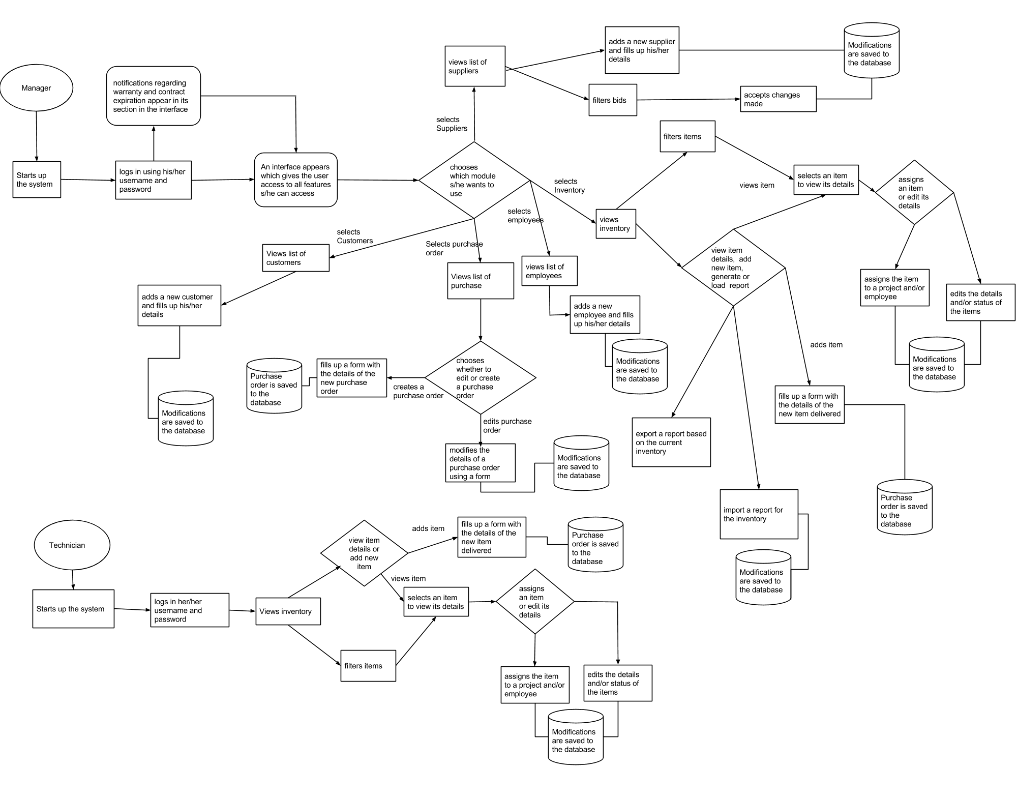

**Figure A-1. – Revised Business Process of CAI-STA**

**Notes:**

* **After the login process above, the notifications regarding warranty and contracts nearing expiration dates are displayed. These should also be the case in your User Stories.**
* **All databases (cylinders) should be named with nouns (Employees, Purchase Orders, …)**
* **Why are there no arrows going to/from the DB?**
* **Why is there an “Import a report for inventory” process?**
* **Where are the processes for managing contract and warranty details?**

**Provide report formats / contents for the reports listed in p. C-4 of Appendix C.**

**Appendix B – Interview Transcript**

The following are the interviews that took place between the four members of SystemScape: Austin Fernandez, Clarisse Poblete, Shayane Tan, and Bryan Coquilla, with Ms. Rosalie Fernandez of CAI-STA on January 23, 2015.

Shayane - S

Austin - A

Clarisse - C

Bryan - B

Ms. Fernandez - F

**B.1. Interview on January 23, 2015**

S: How the process of—

F: Purchase? Okay. We have, okay. Brief explanation lang? We have a partner in US. So they get us our clients. Marketing **** So we also have list of purchases, so the requirements from the clients are parang data gathering, stuff like that, so they discuss things like software, hardware, internet connection and once it's final, they send it through me then I'll be the one to source it out, so I make a P.O., pero simple lang, pero I use Excel only. We're the ones pala who developed ATM, the Bancnet, also the LTO registration. We're part of a team kaya lang we don't have enough time to our own inventory, kasi it's not earning money, so upon request, sinosort out yan and I make the P.O. using Excel only and then before the inventory system is online from U.S., but it's too slow and so many data that we don't need kasi sa kanila kasi online, the DELL laptops online so we even we say, so we want to make it simpler. What we need lang is the model for the or we'll start na lang from the purchase order? So we did this a.. you want to see? Gusto nyo macheck na? Uh sige. Kita niyo naman eh, so this one is the P.O. number, hard for hardware, soft for software, gen for general items, so gusto ko sana the numbering is automatic what do you call that?

S: Auto-increment

F: So yeah para di nagdodouble ung bill, so nagdrop down sya para kapag kung hardware yung ipupurchase ko yeah then ah there's name so ayun and then check to wherever if there's some modification then ito palang kasi so item description, 123, unit price, the total with vat and the grand total with the signature, this is me, purchase manager and then the president. Eto pala yan, parang yung condition, these are the things that I need lang.

S: So ano..

F: So we can give you a copy sa excel para automatic nagcocompute yung ano

S: So aside from you who else, other types of users who can have..

F: I'm the only one

S: So what, aside from editing or putting the necessary information in the purchase order are you also the one parang nagaadd ng customer?

F: Yeah

S: Yung parang other products?

F: Yeah, I canvass it, different suppliers. I pick up the lowest bidder not exactly the low quality then I make the P.O. out of the (quotation?) So hindi na computerized yan kasi it's manual. So parang final na, nasa akin na yung chosen supplier and I'll be the one to input or to input their address and contact but if we can regular suppliers if can just pick it up. I don't have to worry. Pwede ba yun?

S: So kelangan po namin ng parang I think ng list ng suppliers ng data?

F: Yung regular, or later on I can edit it or add. So clear tayo sa purchase order it's very simple so and then when the time na it was delivered already, that's the time na I want it computerized to the inventory system. Asset, We call it Asset Management. So for example, dineliver laptop, a laptop has specs, and then service tag number para kapag sira sya you just give the service tag number to the supplier and they know kung anong warranty nyan. And then we have an asset tag, this is for our own use. Alam namin through asset tag kung kanino sya nakaassign. So ang lalabas dun yung item description, asset tags, service tag number and data of delivery.

S: Gano po kafrequent yung ***** sa purchase nyo

F: Purchase? It depends kung anong dating ng project. May time na ang dami dami. May time na ilang months wala

S: Are there any business rules po na may influence po or may effect po sa data? Descriptions parang ganun. Parang ano, let's say, let's say kunwari sa faculty. Kunwari 15 units yung load nila, sa pagka purchase order po, parang may business rules po kayo?

F: Wala naman, wala naman kaming business rules. Although for the equipment I want something that kasi 1 equipment kapag dineliver yan may 5 yrs warranty I want it parang may tracking kung yung warranty when magstart at matatapos. Parang kasi after 5 yrs kapag nasira siya hindi mo na ipapagawa it's more expensive Pero when it's under warranty pwede mo pa syang ipagawa sa supplier but you have to know, kasi yung mga desktop hindi mo na babaligtadin para malaman mo kung anong service tag number nya so kapag sinabi yung asset number eto na yung ano dapat may record. Right now kasi a simple

S: Ms, Tanong lang po. Diba kayo po nageedit ng, basta main editor ng purchase order?

F: Ako lang yung purchase order, ako lang nageedit then sinasubmit ko sya. Anong nagvoview ng P.O.? AKo lang. And then yung president. Pero yung inventory

S: Sino sino po sila?

F: Yung inventory, yung technical namin kasi when nadeliver kapag dumating yung delivery go straight to them they'll be the one to input yung mga details ng … I double check their work kung tama yung inventory namin diba. Although kasi the boss will go to me, although we have these hardware the boss will not go to them, that's why I review their work para alam kung. Pero now if you have the system, if we have the system, pwede ko ng iview itype ko yung dell 620, ayan parang date of purchase, may end of warranty, hardware specs..

S: yun po yung format ng inventory?

F: since we don't have inventory system I'm using lang Excel para nasosort out ko sya kaya ganyan lang. I don't know papano nyo ba to gagawin pero yung report na kelangan sometimes ganyan. Eto yung username, eto yung model, service tag, asset tag, date of warranty so eto yung mga information na kelangan. May nakita akong sample. What else do you need?

S: So if ever gagawin po namin yung system. Ano po yung platform? Ano po yung OS na gagamit para compatible po yung system na gagawin po namin sa mga computers nyo? windows or?

F: Windows, nakawindows kami although we have linux pero kami lahat nakawindows. Nasabi mo java?

A: Yeah

F: Para walang license involved

A: But you have to install java runtime environment though

F: But we don't have to buy?

A: No, free

S: Sa paggawa ng mga nito, may mga ano po ba kayo, problems encountered?

F: Problems? Ano bang favorite mong problems anong klaseng problems?

S: Para po di po namin maulit yung

F: Ah sa inventory system before? Like I said wala pa kaming inventory system

S: Like pag manual po may problems po ba?

F: Wala kasi excel lang sya tas parang ano .. so syempre sa inventory system gusto ko ng security. Hindi matatamper. SO may user's may, administrator syempre. Una tayo papasok sya sa PO and as I've said kapag nadeliver pupunta sya sa inventory system. Lahat yan manual mo yan iinput sa system Important dun is the item description like what is stated in the PO and addition lang dun is the asset tag, the service tag, the price hindi naman important sa inventory, the quantity, the warranty period. Meron syang ano. We need to know if it's available or not available or in store or yung items in store, available, in use, and junked, disposed parang disposed sira na sya so remove na sya sa inventory. Pero may history pa rin na naremove na sya sa inventory kasi junked na sya para alam mo na hindi ninakaw yung ano. Tapos the reports has the ability to export the reports in excel. Track the life cycle of assets. So pwede mo syang itrack. Track information assets with notification if the warranty is about to expire. Like for the servers which cost mga 1 million we renew it after 5 years nererenew pa rin namin yung contract nya. So if halimbawa mga 30 days, mga dec 30 mageexpired na sya pwede ba may notification sya sakin na mageexpired na yung contract. Kaya ba yun?

B: Yes, we can do it.

F: Hm?

B: Yeah

F: So parang dun sa program parang lalabas lang parang mayroon kang puti sa taas inventory tapos contract parang nandun yung MA. We call it maintainance contract parang nakaspecify dun kasi pwede mo ipasok dun manually ah. If pwede kong ipasok dun yung items with contract. So yun yung mga kakaroon ng contract...

S: Yung items with contract po if ever ano po yung information na kelangan?

F: Start and entry sometimes pwede rin siguro yung amount pero lahat naman yan parang remarks yan. So ang drop down nyo is IT assets, non IT assets sa inventory? IT assets, non IT assets tapos asset component, software, and others, mga office supplies mga consumables, non IT na yun eh. Kuha?

C: Can you repeat?

F: ang items nyo for the inventory is IT assets pag IT assets yan yung mga equipment, non IT mga tables, chairs, office supplies, consumables, asset component uh IT component sya yung parts nung mga binili mo, software lahat na ng software. Yan lang yung drop down ng mga items nyo sa inventory.

S: Okay lang po ba clarification? So purchase reports, mga inventory tapos yung contracts

F: The contracts is information lang. Hindi mo naman ipprint yung buong contract. So kasi the contract is paper. Paper license we have a share of share holder for that. Ang kelangan lang syempre sa dami ng items, sometimes kapag namiss ko yung patay ako so gusto kong maremind. Sa US kasi meron silang ganun pero they don't want to share with us kasi may license. Dapat simple lang yung gagawin nyo. Meron akong nakita eh.. So eto parang ganito yung nakito ko dun sa ano contract.. Parang ganyan ganyan lang. Parang contract rules. parang may date from..Parang ganito..so tanggalin na natin yung mga changes para madali sa inyo so parang eto yung purchase code ng P.O., eto yung purchase order tsaka eto yung mga assets tapos pwede kayo maglagay jan ng mga computer, IT, non IT para may idea na kayo so yun na yung demo although natin kelangan yun diba... para may idea ka sa design. So this is our software..

S: Mayroon po bang mga ano?

F: Pero it's not working ha. Para meron kayong idea.

A: Do you have a centralized server for the database or ..?

F: pero this one ,standalone sya ako lang.

A: 'Cause we can either install the database here or kung nakaconnect ka sa net may local area network pwedeng ilagay yung database sa server mismo and then ethernet cable nalang

F: Pwede. Nakawifi ako. Isend ko na lang sayo. Simplehan nyo lang para hindi kayo mahirapan. Ang kelangan nyo lang na information is ganun kasimple. Tingnan mo yung warranty, iisa isahin mo pa.. Are there any?

A: Ano pa yung mga may asset tag, service tag, description dito? Laptops only.

F: Hindi lahat may asset tag. Yung mga simple items..

A: So IT assets?

F: IT assets.

A: yung components?

F: wala rin. yung mga equipments lang.

A: so sila rin yung mga may warranty?

F: lahat may warranty

A: all equipments pati yung components?

F: Yung components may warranty pero hindi ganun kaimportante… so lahat ng sample ibibigay ko nalang sayo, kung ilang digits din yung service tag...

S: yung ano lang po..

F: summary?

S: purchase order po, tapos po, for you only use excel for the PO for the purchase of order the information that you need... so yung ...tapos ano pa po yung iba?

F: Gen is for general other than software and hardware so it's general.

S: So tapos po yung number po na... So yung sa PO po yung kelangan po product description, quantity, unit price, asset, total.. tapos sa inventory?

F: once completed delivered. the items in that PO magtatally sya directly pupunta sya dun sa inventory. Although not necessarily pero para madali niyo makuha yung info.

A: after the PO what happens to get the item to the inventory?

F: because when you make the PO, the information hindi pa complete so if you receive the items, that items in the PO may icclick ka para mag go sya sa inventory. So you have to retype so andun na sya.

A: Separate yung list of items sa inventory kasi you have to transfer?

F: the inventory naman will have the info for the quantity kasi and the warranty, date of purchase pa.

S: sa inventory po yung mga information pong kelangan yung asset tag?

F: hindi una description pa nya, parang yung IT asset, non IT, classification you call that classification.

C: sorry.

A: so this is for all items? the description-the classification. Are there any special attributes for id components aside from the warranty?

F: warranty, asset tag, service tag.

A: for the components?

F: ganun din.

A: available in use, disposed?

F: sya yung san nga ba sya papasok. what do you call that. parang kapag hinanap mo yung items, for example, laptop, e620 pag you click that one lalabas sya in use,

B: status

F: status nya, assignee kanino nakaassign. kapag in use sya kanino nakaassign.

A: so that goes for all items, yung in use .. where do you get the information for assignees?

F: we assign it. manual ano din sya pero yung report lahat na sya manual entry kapag dumating items, ikikey in mo, halimbawa idesign ko sa inyo each one of you. the description, your name the description everything is included there. Pero kapag after a week I'll key in the description of this computer. Makikita ko na lahat nakaassign sakin. So assignee, Austin Fernandez then the description.

A: so imemaintain yung list of your assignees? is there any other previous source for the list? do you retrieve it from the database or manual sya?

F: We have an IT tracking system. Once you log-in to your computer, it shows all the description in your computer, all the software. Because we're not allowed to install pirated so all the software nag-aUP yan. Although I lost my access when I changed my laptop and it's from the US so I can't access it anymore. So once you log-in to your computer makikita lahat to tapos da S. Fernandez that ganyan and all the software in my laptop. But we don't need that kasi meron na kami ngayon. Now dinadrive ko yung inventory kasi out of that IT tracking system, pwedeng may excel file yun eh so they just give me the excel file and from that parang manual kong ginagawa para pagnanghingi ng reports yung presidente I'll just give it to her. So sinend ko lahat ng info. Itong ginagawa natin is for tracking of asset lang hindi naman *** talaga. Kasi natatrack yung nakaconnect. Natatrack yung in use eh, yung nakaconnect sa network but you cannot track yung mga on-stock dun sa system namin kasi yung once you log-in pero nasa stock room hindi nakikita sa inventory. That's what I want to kasi wala kaming control kung may nakapasok dun although we have cctvs so but if we have the inventory.

A: Are there any special information you need for your software?

F: we have also, the inventory is. when we use it the ** license. For example in one **** license meron syang 5 users so sumexerox kasi namin yung 5 copies na yun and we put in the individual folder with your asset tag number so it means to say na yung isang license, meron syang license key everything lahat. may inventory kami nun eh. License key, tas quantity nakaassign yun sa asset tag. Microsoftt Office 2010 to parang ganun yung license sa software namin para we're sure na walang pirated na nakakalusot.

A: So yung software may asset tag din?

F: wala. ano sya quantity lang, license key.

A: yung software may assignee din?

F: pero masyadong mahirap para sa inyo yung. quantity na lang itag natin and user kasi masyadong for the software madaming information kasi yung ano eh

A: You can maintain a list of your customers?

F: yes

A: and suppliers?

F: yes. and oh it's good you mentioned. I need a project name. Project name kasi yung assignee.. Nakaencode yung project na yun.

A: how many projects can an assignee have?

F: even you have two projects you only have 1 the other *** lang. this asset tag number is assigned to you on what project.

C: so if the person had two projects will the asset be assigned to both projects or just one of them?

F: both projects.

C: ok.

A: Can equipment be assigned to someone pero wala syang project?

F: yes. may training sya. so pero kung training lang yun. we have the training. pag may training lang ** computers. pag di mo sya owner, wala kang ownership dun sa training pc. so it means to say that computer sa training room is on stock. so ang inventory nun is on stock sya. actually sa training can be assigned to, used *** anybody.

A: so during the training, who is it assigned to?

F: uh no, training pc. you call it pc, if we don't say any need for that. we assign it then we buy new ones. kasi we always get yung top of the line. Pag bumili ka you dont buy the same model kasi madaling magobsolete sya. kaya napakadaming ng models kasi we don't stick to one. pag bumili ka this week, next week iba na yung specs nya so magiiba na naman yung inventory. so yung pag project assigned..

S: so sabihin ko ulit. sorry sorry.. yung users po ikaw na po, pati yung nakakaedit.

F: ako yung user sa purchase order. ako lang yung user sa purchase order. sa inventory we can be three.

S: sino sino po ung three?

F: technical level. so sila yung mga nagaassign. sila yung mga nageexam parang technician ng computers. technical support.

A: so the technical team has access to the system?

F: sila yung nagkikeep.

A: so bigyan nalang namin sila nung software pero may password para sa kanila lang. The president can only view?

F: only receives the reports. she doesnt need to view.

A: so yung excel file lang.

F: oo

A: there are only three kinds of users: you, technical level 1 and level 2. anong difference ng level 1 and level 2?

F: mas magaling yung level 2.

A: that's it?

C: is there a difference in how much they can access in the system?

F: actually they can access it kasi if not I'll be the one to do it. so dapat may access sya anyway they're the ones maintaining the security of everything so secret naman sya.

A: they can't edit the purchase order though?

F: they have more access than I have kasi sila talaga ang may alam ng lahat ng security. so full access. except for the PO.

A: they can't edit the PO.

F: they can't

A: but they can view the PO?

F: no, ako lang.

S: so yung contract po start and end date tapos ano pa po yung ibang?

F: yun lang report.

A: contract bills with an item any of the four types?

F: only equipment

A: so IT assets

F: yes.

A: so you need the PO, the INVENTORY, the CONTRACTS, the PROJECT ASSIGNENT is there anything else?

F: The project assignments included in the inventory, part of the inventory and the contract also is part of the inventory. everything naman ** purchase order

A: Pero kasi we can add a separate module para you can add projects tapos sa inventory drop down na lang.

F: normally naman ganun eh so there's a facility where you can add everything kasi equipment naman can be air condition, hindi naman lahat IT so may air condition pa rin yun pwedeng vehicles. so pwede kayo magsample ng ganun I'll just change it.

A: prototype?

F: yeah

A: anything else?

S: so thank you for everything thank you for the interview. if there are any more issues *** and we'll give you preview***

ALL: thank you

F: thank you

**B-2. Electronic Interview on February 17,2015**

A:

Good day,

Can we please have samples of the following forms for the software: contract form, warranty form, it asset assignment form, project assignment form?

Thanks,

Austin Fernandez

F:

We didn’t have request forms, Assignment of software and hardware are based on project basis and dictated by clients. The client and management upon inspection identify the team members, sw and hw to be used on the project. They will email me the requirements for the processing of P.O.. Upon delivery of the items, it would then be assigned to the team members for inventory.

I will send you the sample contract tomorrow.

**B-3. Electronic Interview on February 18,2015**

A:

Good day,

Can you please details some instances wherein you have had a problem with recording project assignments or asset assignments in the past for our documentation? Than you in advance.

Sincerely,

Austin Fernandez

F:

Here are some instances wherein i have problems with inventory:

1. Mass hiring - 50 staff
2. Shortage of admin support
3. Rampant resignation
4. Incompetent technical support
5. Manual input using excel

Sally F.

**Appendix C – Sample Forms and Reports**

This chapter contains the different forms and reports used by the company as part of its business process.

**C-1. Purchase Order Form**

The Purchase Order Form is filled up by the manager for each item bought from the supplier.

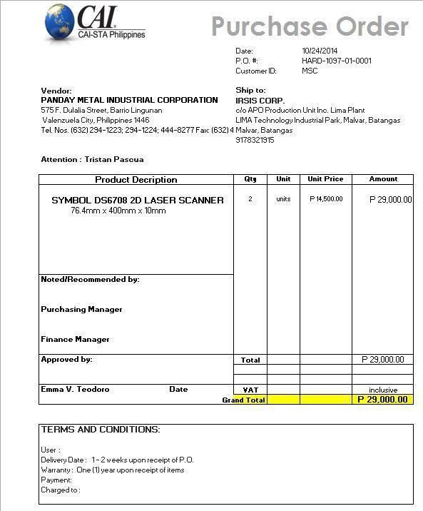

**C-2. Inventory Form**

The inventory form is accomplished by either the manager or the technician upon receiving the items.

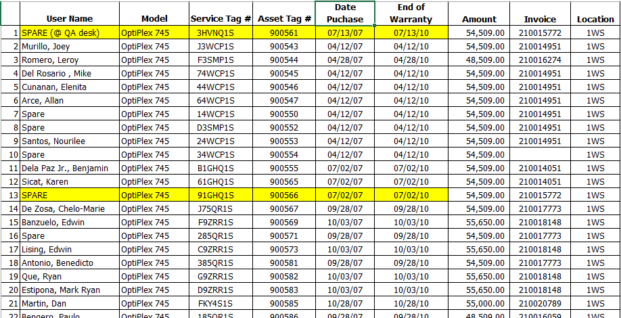

**C-3. Contract Form**

The contract form is accomplished by the manager if an item is classified as an IT asset.

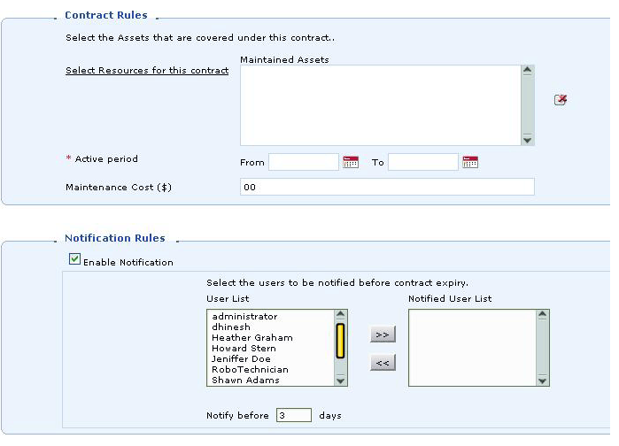

**C-4. Additional Details Provided by the Company**

The following includes additional details provided by the company through an e-mail correspondence involving Purchase Order details, Asset Management, and tracking of Inventory Reports.

**1. Purchase Order – includes**

* P.O. No. – (pre-numbered)
* Ø HARD-1097-15-0001 – Hardware
* Ø SOFT-1097-15-0001- Software
* Ø GEN-1097-15-0001 – General Items
* Supplier’s Name and Address
* Tracking of all Purchase Order
* Receives items from Purchase Orders and move them to asset inventory upon delivery of items
* Keep track of outstanding POs and completed purchases.

## 2. Asset Management

* Tracking the complete life cycle of the assets – including location
* Get the complete ownership and history for all assets
* Tracks contract information of all assets and notify on lease expiry - Set up e-mail notifications to renew contracts before expiry.
* Get **one view** of all your IT assets, Non-IT assets, components and consumables
* Import any type of asset from **CSV** files

**3.** **Inventory Reports – Tracking**

* Assets by Product Types
* Assets by Service Tag No.
* Assets by Asset Tag No.
* Assets by Expiry Date
* Assets by User Name
* Assets by Project Name
* Unassigned Assets (by Product Type)
* Assets in Contract (by Product Type)
* Assets not in Contract (by Product Type)

**Appendix D – References and Acknowledgement**

CAI-STA Philippines. (n.d.). from CAI: http://www.compaid.com/WhoWeAre/locations/philippines.aspx

We would like to acknowledge Ms. Rosalie Fernandez; Office, Administration, and Purchasing Manager of CAI-STA, for accommodating the team for the interviews.