

**CAI-STA**

SOFTWARE REQUIREMENTS SPECIFICATION

|  |  |
| --- | --- |
| **Team Name** | **SystemScape** |
| **Section** | S19A |
| **Team Members** | Angeles, Antonio Mariano  Coquilla, Phillip Bryan  Cote, Christian Gabriel  Fernandez, Ryan Austin  Poblete, Clarisse Felicia  Quindoza, Rissa Marie Grace  Salceda, Francesco Juan  Tan, Shayane  Uy, Mervin Stewart  Velez, Gio Anton |
| **Date Submitted** | March 23 2015 |

**Table of Contents**

|  |  |
| --- | --- |
| 1. Executive Summary | 1-1 |
| 1. Overview | 2-1 |
| * 1. Existing Business Process | 2-1 |
| * 1. Data Requirements | 2-2 |
| * 1. Roles in the Business Process | 2-3 |
| 1. Problem Analysis | 3-1 |
| 1. Software Solution | 4-1 |
| * 1. Objectives | 4-1 |
| * 1. Characteristics | 4-1 |
| 1. User Stories | 5-1 |
| * 1. Log In | 5-1 |
| * 1. Modify Login Details | 5-1 |
| * 1. Export Inventory Data | 5-2 |
| * 1. View Suppliers | 5-3 |
| * 1. Record Supplier Details | 5-3 |
| * 1. Update Supplier Details   2. View Purchase Orders | 5-4  5-4 |
| * 1. Create Purchase Order | 5-5 |
| * 1. Update Purchase Order | 5-6 |
| * 1. Export Specific Purchase Order | 5-7 |
| * 1. Record Contract Expiry Dates | 5-7 |
| * 1. View Incoming Contract Expiry Dates | 5-8 |
| * 1. Record Warranty Expiry Dates | 5-9 |
| * 1. View Incoming Warranty Expiry Dates | 5-9 |
| * 1. View Employees | 5-10 |
| * 1. Add Employees | 5-10 |
| * 1. Update Employee Details | 5-11 |
| * 1. Grant Admin Rights | 5-12 |
| * 1. View Projects | 5-12 |
| * 1. Add Project | 5-13 |
| * 1. Assign Items to Employees | 5-14 |
| * 1. Assign Employees to Projects | 5-14 |
| * 1. View Inventory | 5-15 |
| * 1. Add Item | 5-15 |
| * 1. Add Item Through Purchase Order | 5-16 |
| * 1. Update Item | 5-17 |
| Appendix A - Improved Business Process | A-1 |
| Appendix B - Interview Transcript | B-1 |
| 1. Interview on January 23, 2015 | B-1 |
| 1. Electronic Interview Dated February 17, 2015 | B-10 |
| 1. Electronic Interview Dated February 18, 2015 | B-10 |
| 1. Client User Interface Feedback Report Dated February 27, 2015 | B-11 |
| Appendix C - Sample Forms and Reports | C-1 |
| 1. Purchase Order Form | C-1 |
| 1. Inventory Form | C-2 |
| 1. Contract Form | C-3 |
| 1. Additional Details Provided by the Company | C-3 |
| Appendix D - References and Acknowledgements | D-1 |

1. **Executive Summary**

CAI-STA is a joint venture partner of Computer Aid Inc., Headquartered in Metro Manila, Philippines. They are CAI’s global presence in the Asia Pacific Region.

The company is a marketing and sales platform for CAI-built intellectual property tools which are owned and developed by CAI and marketed in Asia by CAI-STA Philippines. It also offers CAI tools, application services and consulting to improve the Information Communication Technology management of its clients, both in the private and public sector, through its Class A facilities and team of knowledgeable professionals. CAI-STA’s delivery strategy identifies, trains, and leverages local human resources to deliver these services under the management of CAI senior consultants. (“CAI-STA Philippines”, n.d.)

1. **Overview of the Business Process**

This chapter presents CAI-STA’s business process and goals as an organization. Included in this chapter are the following items:

* Description of CAI-STA’s existing process and business requirements
* Data requirements as part of the business process for managing inventory, purchase orders, and asset and product assignment, including items, inventory entries, purchase orders, suppliers, employees, projects, contracts, warranties, and inventory reports.
* Different roles in the business process

**2.1 Existing Business Process**

CAI-STA provides tools and application services for its customers in both the private and the public sectors to improve the Information and Communication Technology management of its clients.

The business process for managing inventory, purchase orders, and asset and product assignment begins with the manager creating a purchase order using a spreadsheet when clients request for items (see Appendix C-1). Once the purchase order has been created and has been sent to the supplier, the supplier will then deliver the ordered items to the company. When the items have been received, the manager signs the contract/warranty form and the manager or technicians record the item details in a spreadsheet that is used to track down the items in the inventory (see Appendix C-2). The manager then double-checks the added item, assigns an asset tag to the item, and keeps the item’s warranty form.

Although all hardware items have a warranty form, not all items include a contract form. Items are classified as General, Software, or Hardware which is further classified into I.T. Assets and Non-I.T. Assets (i.e. Furniture, Office Supplies). Only items that are classified as Hardware include a contract form that the manager will keep. On the other hand, when an item’s contract expires, the manager monitors the maintenance cost and then renews the contract to replace or to repair the equipment. The manager also monitors each item’s warranty end date.

The manager could also assign an item to an employee, and an employee to a project. This would set the item status to “in use”. Otherwise, the item status is set to “in store”. While doing so, the manager keeps track of the project name, the employee’s name, and the asset tags given to the items assigned to the current project. The project manager gives the manager a list of employees and assets needed for the project. If there are missing assets, they are ordered via purchase order. Once all assets are present, the manager then assigns them based on the project manager’s list.

The business process for managing inventory, purchase orders, and asset and product assignment can be visualized in the diagram shown in Figure 2-1.

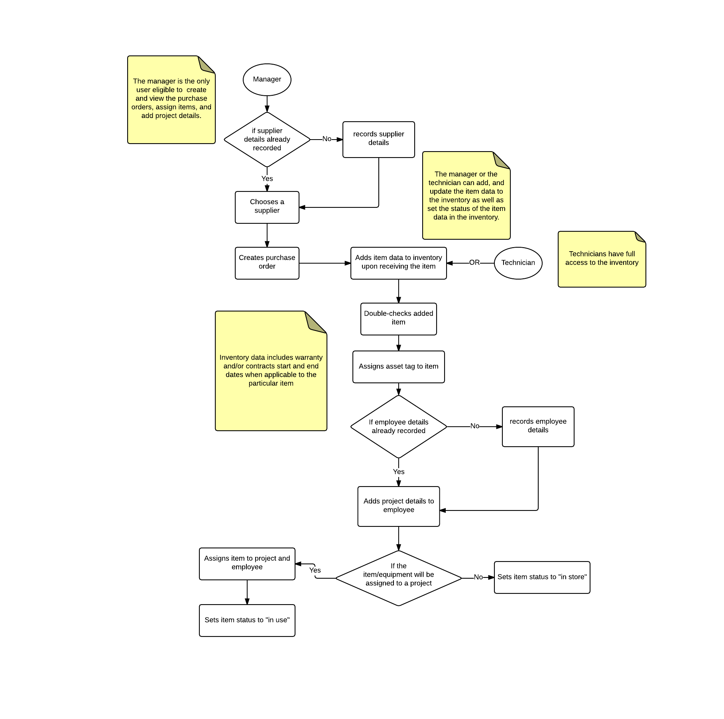

**Figure 2-1. Existing Business Process**

The manager generates an inventory report containing the item assignee (or status, if unassigned), model, asset tag, service tag, date of purchase, warranty end date, and price (see Appendix C-2) when the President requests it (which is usually when a new project is announced) by creating a separate MS Excel spreadsheet file and sorting out each item based on the desired category from the other spreadsheets where the items are recorded.

**2.2 Data Requirements**

A supplier profile contains the following information: supplier name, supplier’s complete address (country, state, city), supplier’s contact numbers (cell phone number, telephone number, fax number).

A purchase order (see Appendix C-1) that is created by the manager contains the following information: purchase date, supplier details as mentioned above, P.O. number, invoice number, and P.O. currency. The P.O. number is acomposite attribute that is composed of the item’s type and the item’s id number. An item in the Purchase Order can be categorized as a “Hard” for hardware, “Soft” for software, “Gen” for general items, or a custom tag to be defined by the manager. The purchase order also contains a currency to denote the currency of the purchase order and the exchange rate that will be use to pay the supplier. On the other hand, the id number of an item is auto incremental. The purchase order also contains the item name, description, quantity, unit price, total with VAT, and grand total. As items are received from the PO, the quantity received of each item is also stored.

An item that is stored into the inventory has an item name, item description, and a location, which is either one of the company’s two sites: One World Square in McKinley Hill or the DAO Building in Makati City, and can be classified into an IT Asset, a non-IT Asset, a software, or other, and can be either available, on stock, in use, disposed, or junk. IT Assets contain the following attributes: date of delivery, asset tag, service tag, warranty, and assignee. In the case that the item is software, it is assigned a license key instead. Furthermore, an item may also optionally be assigned to multiple projects.

The contract form (see Appendix C-3) that the manager must accomplish if an item is classified as Hardware includes the start and end date of the contract and the maintenance cost of the item.

The warranty form that the manager must accomplish for each item classified as Hardware in the inventory includes the start and end date of the warranty.

An employee has an ID number, a status (which could be “on leave”, “active”, or a custom status to be determined by the manager), and a name. A project has a project name, project start date, and project end date. The project assignment of an item includes the employee name, the item’s asset tag number, and the project name.

The generated reports only involve all items that are in the inventory. However, the information included in the reports will be dependent on the manager’s selections. The manager can select from the following columns, which are to be generated by the system: P.O. number, supplier, purchase date, grand total, supplier address, supplier contact numbers, item name, item description, item type, quantity, service tag, asset tag, date of delivery, invoice number, end of warranty, end of contract, item office location, employee name, employee status, project name, project assignment date.

**2.3 Roles in the Business Process**

There are two main types of users in the proposed system. These users and their tasks are summarized in Table 2-1.

|  |  |
| --- | --- |
| **Role** | **Description of Tasks** |
| Technician | * Manages inventory system * Views inventory system |
| Manager | * Manages inventory system * Views inventory system * Manages purchase orders * Views purchase orders * Manages contracts and warranties * Receives notifications regarding contracts and warranties * Manages supplier information * Manages employee information * Manages employee project assignment * Grants manager privileges to other users |

**Table 2-1. User Roles and Tasks in CAI-STA**

1. **Problem Analysis**

This chapter presents the findings of the investigation on CAI-STA’s needs and problems to be addressed by the software.

|  |  |  |  |  |
| --- | --- | --- | --- | --- |
| **ID**  # | **Description**  What’s the problem? | **Cause**  What causes the problem? | **Symptoms**  How do we know the problem exists? | **Impact**  Why is this important? What are the consequences? |
|
| 1 | The ends of warranties and contracts are difficult to keep track of. | ● Even though the relevant dates are present in the MS Excel files being used, MS Excel itself does not have a notification feature;  ● The manager needs to manually set the dates in a calendar application to be notified of approaching warranty and contract expirations. | ● There are instances wherein the client overlooked contracts and end of warranties of some items and pieces of equipment. | ● If piece of equipment gets damaged, and its warranty or contract were not renewed, then there will be complications in the repair or replacement of that piece of equipment. |
| 2 | The current approach in managing the inventory and purchase orders is open to inconsistencies between the different files used to store data. | ● There is no centralized database for easy data management;  ● Instead multiple MS Excel files are used, often for the same data. | ● The need to maintain multiple files that are not directly connected and contain copies of the same data sometimes leads to discrepancies in this data.  ● The manager needs to update and check multiple files whenever the data is edited. | ● If there are discrepancies between these files, they would be difficult to resolve and may lead to complications in handling inventory items through this data later on. |
| 3 | The items listed in the inventory are difficult to filter and sort. | ● The manager is unable to automatically sort the items and data contained in MS Excel. | ● The manager currently has to create a separate MS Excel file that he manually arranged in order to view the sorted list of items.  ● If the manager were to make a mistake in transferring, copying and rearranging data between these files (e.g. forgetting to transfer an item or accidentally overwriting an item), then this could invalidate some of that data and lead to complications later in processes involving that data. | ● It will be difficult to view the inventory because of manual sorting or filtering.  ● Maintaining an accurate inventory is difficult due to the presence of multiple files, necessary for different kinds of items, pertaining to the same data. This leads to inconsistency from human error. |
| 4 | The assignments of items to employees and projects are difficult to keep track of. | ● The manager is unable to easily view and organize assignments through MS Excel because of the format’s inflexibility. | ● The addition of these 50 employees are done manually by using MS Excel.  ● Assigning each employee is also done manually by using MS Excel.  ● Rampant resignation can complicate the assignment process. | ● If employee and project assignment were poorly managed, then it would be difficult for the manager to determine which employee is responsible for which items, and for what projects these employees require these items for.  ● Time is wasted manually inputting these 50+ employee data and assigning them to assets. |
| 5 | The lists of suppliers and their corresponding contact persons are difficult to keep track of. | ● There is no centralized database for the organization of this information. | ● Supplier information is not readily available when creating a purchase order, necessitating access to a separate file. | ● If the supplier information were poorly managed, then information could potentially end up being misplaced, causing complications in the purchase order process later on. |
| 6 | The license key for software is sensitive and vulnerable to theft. | ● One license key can register software on multiple devices.  ● These license keys are stored openly on a spreadsheet.  ● This results in a lack of security. | ● Technicians view the inventory records and see the license key; they then use it to register their software at the expense of the company. | ● The company has effectively been a victim of software theft. |

Inconsistencies arise due to the separation of the purchase manager’s system and the technician’s system. Additionally, it is currently easy to forget the ends of warranties and contracts manually. Project and asset assignment is also difficult since this is usually done by the manager in bulk as there are many projects ongoing with many employees involved, each with a possible software and asset assignment. Filtering and sorting of inventory is done across multiple files, and is thus prone to human error, not to mention inefficient. Automation would make sorting and filtering more efficient through use of a database, since the way a query is written can easily sort or filter rows in the database, as opposed to manual sorting through spreadsheets. Finally, license keys are stored in a manner that is not secure. This could potentially lead to software theft.

1. **Software Solution**

**4.1 Objectives**

The software aims to provide CAI-STA with a system to manage the data and transactions involved in purchases and inventory, and asset and product assignment.

The specific objectives of the software are as follows:

* To provide a facility for managing inventory;
* To provide a facility for managing suppliers;
* To provide a facility for managing purchase orders;
* To provide a facility for keeping track of contracts and warranties;
* To provide a facility for keeping track of item and project assignments to employees;
* To notify the manager about any upcoming expiries of contracts and warranties;
* To generate inventory reports

**4.2 Characteristics**

The software is intended to run on the Java Runtime Environment (JRE). The software should present consistency in records and ease in creating purchase orders, supplier management, project/employee assignment, adding items to inventory, and generating the necessary inventory reports as needed (as determined by the President, usually when there is a new project). It should have the correct information at all times, to be implemented by using a single database, and it should be easily usable and maintainable, in case future development teams wish to add features.

**4.3 Assumptions, Scope and Limitations**

The software assumes that a project can be assigned to many employees and the employees can be appointed to many projects. On the other hand, an item can be assigned to a project employee pair.

The software will provide a separate view module of the inventory for both the manager and the technician. Accordingly, only the view module of the inventory for the manager includes a feature where he/she can select the columns of a table to be included in the report. Furthermore, the license key of a software item will only be visible and editable for the view module of the manager. Otherwise, if the user is a technician, the feature and the information mentioned previously will not be accessible and available for him/her.

The software will also provide a module for the generation of reports. The reports that will be generated will only be for the inventory module and will only be exported into a .csv file format as discussed with the client. The printing of the report will not be covered by the software.

Furthermore, the creation of the purchase order will only be for the purpose of storing its information, and thus will not involve the printing of the purchase order form.

Meanwhile, the software will not cover the canvassing of the suppliers and the printing of reports as reiterated earlier.

1. **User Stories**

This chapter presents the user stories included in the product backlog.

Note that for the estimates, 1 day = 16 hours.

**5.1. Log In**

|  |  |
| --- | --- |
| **User Story #1:** A user (manager, technician) can login to view and manage the purchase order module, the inventory module, and the project assignment module. | |
| **Estimate:** 2 days | **Priority:** 20 |
| **Pre-condition:** The user must be registered to the database. | |
| **Scenario:**   1. The system prompts the user for his/her password and username. 2. The user inputs his/her password and username. 3. The system validates both the username and the password. 4. The system displays the inventory module    1. The system also displays the purchase order module and the project assignment module for the manager. 5. The system notifies the manager of any upcoming contract or warranty expiry dates. | |
| **Post-condition**: The manager can now create the purchase order and view the purchase orders created. The manager can now also manage the information in the inventory and assign the projects to the employees. The technician can now manage the inventory. | |
| **Acceptance Criteria:**   1. Test if the system displays the screens for the inventory module if both the username and the password are correct. 2. Test if the purchase order module and the project assignment module’s screens are displayed if the user is a manager. 3. Test if the system does not display the screens for the inventory module if the username or the password is incorrect. 4. Test if the purchase order module and the project assignment module do not appear if the user is not a manager. 5. Test if the system displays the notifications for nearing warranty or contract expiry dates if the user is a manager. 6. Test if the system prompts the user for the correct password and username if the password or the username is incorrect. | |

**5.2. Modify Login Details**

|  |  |
| --- | --- |
| **User Story #2:** A user (manager, technician) can modify his/her login settings which include changing his/her password and setting the date range for displaying warranty and contract notifications. | |
| **Estimate:** 1 day | **Priority:** 40 |
| **Pre-condition:** The user must be logged in . | |
| **Scenario:**   1. The user chooses to change his/her login settings. 2. The system displays a general account settings form to change his/her password. 3. if the user is a manager, the general account settings form also includes the settings to change the date range for displaying warranties and contracts expiry dates notifications. 4. The manager chooses to save the changes. 5. The system validates the user input. 6. The system saves the changes to the database. | |
| **Post-condition:** The user can now login using the new password. The manager can now be notified of the nearing warranties or contracts expiry dates base from the user’s newly set date range. | |
| **Acceptance Criteria:**   1. Test if the system displays an error message if the new password and the confirmation password are not the same. 2. Test if the system displays a general account settings form that includes the setting of date range for displaying warranties and contracts expiry dates notification if the user is a manager. 3. Test if the system displays only a general account settings form to change the password if the user is a technician. 4. Test if the system does display notifications of nearing warranty and contract expiry dates base from the user’s newly set date range. 5. Test if the user can login using the new password. | |

**5.3. Export Inventory Data**

|  |  |
| --- | --- |
| **User Story #3:** A manager can export the inventory data into spreadsheets to generate the reports. | |
| **Estimate:** 1 day | **Priority:** 30 |
| **Pre-condition:** The inventory must be populated with data. The manager must also be logged in. | |
| **Scenario:**   1. The manager chooses to generate inventory report (see Appendix C-2). 2. The manager inputs the location in their drive as well as the filename. 3. The manager selects the desired columns to be generated in the report from the following: P.O. number, supplier, purchase date, grand total, supplier address, supplier contact numbers, item name, item description, item type, quantity ,service tag, asset tag, date of delivery,invoice number, end of warranty, end of contract, item office location, employee name, employee status, project name, project assignment date. 4. The system generates the spreadsheet containing the selected columns. | |
| **Post-condition:** The generated spreadsheet can now be printed and be viewed. | |
| **Acceptance Criteria:**   1. Test if correct data were extracted from the database to generate the reports. 2. Test if the generated file is a spreadsheet. 3. Test if the spreadsheet is located in the specified directory 4. Test if the spreadsheet has the given filename. 5. Test if the content of the generated file follows the required format specified by the company. | |

**5.4. View Suppliers**

|  |  |
| --- | --- |
| **User Story #4:** A manager can view the list of suppliers, which may be filtered, to monitor the supplier details. | |
| **Estimate:** 24 hours | **Priority:** 10 |
| **Pre-condition:** The manager must be logged in. | |
| **Scenario:**   1. The manager chooses to view the list of suppliers. 2. The system displays the list of suppliers, showing their name and address (country, state, and city). 3. The manager may choose to filter the suppliers by name, address, or contact details.    1. The list is now filtered to reflect the chosen criteria. | |
| **Post-condition:** The manager can now view the list of suppliers in the database. | |
| **Acceptance Criteria:**   1. Test if the system displays the data equivalent to the ones in the database. 2. Test if the system displays a list of suppliers that fits the given criteria. 3. Test if the system displays a notification message if there are no matches to the criteria. | |

**5.5. Record Supplier Details**

|  |  |
| --- | --- |
| **User Story #5:** A manager can record supplier details to have a directory of suppliers where the company could get their purchases as well as contact for any inquiries. | |
| **Estimate:** 8 hours | **Priority:** 10 |
| **Pre-condition:** The manager must be logged in. The manager must currently be viewing the list of suppliers. | |
| **Scenario:**   1. The manager chooses to add a supplier. 2. The manager inputs the supplier name and address(country, state, and city). 3. The manager chooses to add the supplier. 4. The system validates the input values. 5. The system stores the details to the database. 6. The system updates the viewable list of suppliers. | |
| **Post-condition:** The manager can now see the new supplier in the updated list of suppliers. | |
| **Acceptance Criteria:**   1. Test if the system displays a confirmation message to check if all entered information is correct before saving it. 2. Test if the system displays an error message if there is any significant information that was left blank upon submission. 3. Test if the system displays an error message if the supplier has already been added previously based on name. 4. Test if the system displays an updated supplier list once the details are added to the database. | |

**5.6. Update Supplier Details**

|  |  |
| --- | --- |
| **User Story #6:** A manager can update the supplier details to modify incorrect values and inconsistencies. | |
| **Estimate:** 8 hours | **Priority:** 30 |
| **Pre-condition:** The manager must be logged in. The manager must currently be viewing the list of suppliers.There must also be previous information stored regarding the specified supplier. | |
| **Scenario:**   1. The manager selects a supplier to edit. 2. The system displays the current supplier details, each includes supplier name, supplier address(country, state, city), and supplier contacts. 3. The manager modifies the supplier details mentioned previously. 4. The manager confirms the edited supplier details. 5. The system validates the user inputs. 6. The system updates the details of the chosen purchase order in the database. | |
| **Post-condition:** The manager can now see the edited supplier details when the manager chooses to view it again. | |
| **Acceptance Criteria:**   1. Test if the system displays a confirmation message to check if all entered information is correct before saving it. 2. Test if the system displays an error message if there is any significant information that was left blank upon submission. 3. Test if the system displays a message once the edited information has been successfully updated in the database. 4. Test if the system displays an updated list of purchase orders once the updates have been stored in the database. | |

**5.7. View Purchase Orders**

|  |  |
| --- | --- |
| **User Story #7:** A manager can view the list of purchase orders, which may be filtered, to monitor the purchase order details. | |
| **Estimate:** 2 days | **Priority:** 10 |
| **Pre-condition:** The manager must be logged in. | |
| **Scenario:**   1. The manager chooses to view the list of purchase orders. 2. The system displays the list of purchase orders, each includes ID, supplier, date, and each item with its quantity and total with VAT. 3. The system calculates the grand total of all items. 4. The system displays the grand total of all items. 5. The purchase orders may be filtered based on ID type (**HARD**ware, **SOFT**ware, **GEN**eral items, or a custom tag entered by the manager), supplier, date range, or whether it contains a certain item.    1. System displays filtered list | |
| **Post-condition:** The manager can now view the list of purchase orders in the database. | |
| **Acceptance Criteria:**   1. Test if the system displays the data equivalent to the ones in the database. 2. Test if the system displays a list of purchase orders that fits the chosen criteria. 3. Test if the system displays a notification message if there are no matches to the criteria. 4. Test if computation of total with VAT and grand total is accurate. | |

**5.8. Create Purchase Order**

|  |  |
| --- | --- |
| **User Story #8:** A manager can create purchase orders to monitor purchase transactions between the company and its suppliers. | |
| **Estimate:** 8 hours | **Priority:** 10 |
| **Pre-condition:** The manager must be logged in. The manager must currently be viewing the list of purchase orders. | |
| **Scenario:**   1. The manager chooses to create a purchase order. 2. The system displays the purchase order form. 3. The manager selects the purchase order type, the purchase order currency, the supplier, the date, and selects the items to be ordered and corresponding quantity. 4. The manager chooses to add the purchase order details. 5. The system validates the inputs. 6. The system stores details in the database. 7. The system updates the viewable list of purchase orders | |
| **Post-condition:** The manager can now see the new purchase order in the updated list of purchase orders. | |
| **Acceptance Criteria:**   1. Test if the system displays a confirmation message to check if all entered information is correct before saving it. 2. Test if the system displays an error message if there is any significant information that was left blank upon submission. 3. Test if the system displays a message once the submitted purchase order has been successfully added in the database. 4. Test if the system displays an updated list of purchase orders once the details are added to the database. | |

**5.9. Update Purchase Order**

|  |  |
| --- | --- |
| **User Story #9:** A manager can update purchase orders to modify incorrect values and inconsistencies**.** | |
| **Estimate:** 8 hours | **Priority:** 30 |
| **Pre-condition:** The manager must be logged in. The manager must currently be viewing the list of purchase orders. There must also be previous information stored regarding the specified purchase order. | |
| **Scenario:**   1. The manager selects a purchase order to edit. 2. The system displays the current purchase order details, each includes P.O. number, supplier, date, currency, and items, with quantity and total with VAT, and a grand total of all items. 3. The manager modifies the purchase order type, purchase order currency, supplier, date, and the details of the items (see User Story #26). 4. The manager chooses to change the delivery status of an item. 5. The system displays an inventory form that contains the following details depending on the classification of an item: 6. quantity for general items 7. invoice number, delivery date, asset tag, service tag, assignee, warranty start and end date, contract start and end date, and maintenance cost for hardware items 8. invoice number, delivery date, license key, and assignee for software items 9. The manager confirms the additional information of an item. 10. The system validates the user inputs. 11. The manager confirms the edited purchase order details. 12. The system validates the inputs. 13. The system updates the details of the chosen purchase order in the database. 14. The manager chooses to delete the selected purchase order. 15. The system displays a confirmation message to delete the selected purchase order. 16. The manager confirms the deletion of the selected purchase order. 17. The system updates the list of purchase orders and the list of items in the inventory in the database. | |
| **Post-condition:** The manager can now see the edited purchase order details when the manager chooses to view it again. | |
| **Acceptance Criteria:**   1. Test if the system displays a confirmation message to check if all entered information is correct before saving it. 2. Test if the system displays an error message if there is any significant information that was left blank upon submission. 3. Test if the system displays a message once the edited information has been successfully updated in the database. 4. Test if the system displays an updated list of purchase orders once the updates have been stored in the database. 5. Test if the system displays a warning message upon the deletion of the purchase order, stating that items contained in the purchase order will also be deleted. | |

**5.10. Export Specific Purchase Order**

|  |  |
| --- | --- |
| **User Story #10:** A manager can export the purchase order data into spreadsheets to generate the purchase order forms (see Appendix C-1). | |
| **Estimate:** 1 day | **Priority:** 30 |
| **Pre-condition:** The manager must be logged in. The purchase order form must also be populated with data. | |
| **Scenario:**   1. The manager selects a specific purchase order to export. 2. The system displays a purchase order export form. 3. The manager inputs the location in their drive as well as the filename. 4. The system generates the spreadsheet containing a purchase order form that includes the purchase order details (see User Story #8) to export. | |
| **Post-condition:** The generated spreadsheet can now be printed and be viewed. | |
| **Acceptance Criteria:**   1. Test if correct data were extracted from the database to generate the purchase order form. 2. Test if the generated file is a spreadsheet. 3. Test if the spreadsheet is located in the specified directory 4. Test if the spreadsheet has the given filename. 5. Test if the content of the generated file follows the required format specified by the company. | |

**5.11. Record Contract Expiry Dates**

|  |  |
| --- | --- |
| **User Story #11:** A manager can record contract expiry dates to monitor the expiry dates of equipment. | |
| **Estimate:** 4 hours | **Priority:** 10 |
| **Pre-condition:** The manager must be logged in. The manager must currently be adding an item classified as I.T. asset to the inventory. | |
| **Scenario:**   1. The system displays the inventory form to add an item (see User Story #25). 2. The manager inputs the contract details which includes that start date, the end date, and the maintenance cost. 3. The manager chooses to save the details. 4. The system validates the inputs. 5. The system adds the details to the database. | |
| **Post-condition:** The manager can now view the contract details of an item that is classified as an I.T.asset. | |
| **Acceptance Criteria:**   1. Test if system notifies manager of an error if the selected start date is after the end date. 2. Test if system notifies manager if the selected end date is before or equivalent to the current date. 3. Test if the system displays a message once the information has been successfully added in the database. | |

**5.12. View Incoming Contract Expiry Dates**

|  |  |
| --- | --- |
| **User Story #12:** A manager can view notifications on items with incoming contract expiry dates to renew the contract in order to repair or to replace an equipment when complications arise. | |
| **Estimate:** 1 day | **Priority:** 20 |
| **Pre-condition:** The manager must be logged in. The manager must have finished entering the contract details of an item that is classified as an I.T. asset. | |
| **Scenario:**   1. The system notifies the manager about items expiring within the user’s set date range (see User Story #2). 2. The manager chooses to view the item details. 3. The system displays the item details along with its contract expiry date. | |
| **Post-condition:** The manager can now be notified and view the contracts with near expiry dates. | |
| **Acceptance Criteria:**   1. Test if the system displays a notification message for items with contracts expiring within the user’s set date range. 2. Test if the system only displays items with contracts expiring within the user’s set date range. 3. Test if the system displays the days or weeks remaining before contract expiry. 4. Test if the system displays the correct item when viewing the notification. | |

**5.13. Record Warranty Expiry Dates**

|  |  |
| --- | --- |
| **User Story #13:** A manager can record item warranty expiry dates to monitor the warranty expiry dates of an item. | |
| **Estimate:** 4 hours | **Priority:** 10 |
| **Pre-condition:** The manager must be logged in. The manager must currently be adding an item to the inventory. | |
| **Scenario:**   1. The manager inputs the warranty details which includes the start and end date of the warranty. 2. The system validates the user inputs. 3. The manager chooses to save the details. 4. The system adds the details to the database. | |
| **Post-condition:** The manager can now view the warranty details of an item. | |
| **Acceptance Criteria:**   1. Test if system notifies manager of an error if start date inputted is after end date. 2. Test if system notifies manager if the selected end date is before or equivalent to the current date. 3. Test if the system displays a message once the information has been successfully added in the database. | |

**5.14. View Incoming Warranty Expiry Dates**

|  |  |
| --- | --- |
| **User Story #14:** A manager can view notifications on items with incoming warranty expiry dates to monitor the fee of maintaining the item which increases without the warranty. | |
| **Estimate:** 8 hours | **Priority:** 20 |
| **Pre-condition:** The manager must be logged in. The manager must have finished entering the contract details of an item that is classified as an I.T. asset. | |
| **Scenario:**   1. The system notifies the manager about items expiring within the user’s set date range (see User Story #2). 2. The manager chooses to view the notifications. 3. The system displays the notifications on items with near warranty expiry dates | |
| **Post-condition:** The manager can now be notified and view the contracts with near expiry dates. | |
| **Acceptance Criteria:**   1. Test if the system displays a notification message for items with contracts expiring within the user’s set date range. 2. Test if the system only displays items with contracts expiring within the user’s set date range. 3. Test if the system displays the days or weeks remaining before contract expiry. 4. Test if the system displays the correct item when viewing the notification. | |

**5.15. View Employees**

|  |  |
| --- | --- |
| **User Story #15:** A manager can view the list of employees, which may be filtered, to monitor the company staff. | |
| **Estimate:** 24 hours | **Priority:** 30 |
| **Pre-condition:** The manager must be logged in. | |
| **Scenario:**   1. The manager chooses to view the list of employees. 2. The system displays the list of employees, each with ID, status, and name. 3. Manager may choose to filter list based on ID, name, or project    1. The system filters list and displays appropriate results 4. Manager may select a single employee to view projects and assets assigned    1. The system displays this information separately | |
| **Post-condition:** The manager can now view the list of employees in the database. | |
| **Acceptance Criteria:**   1. Test if the system displays the data equivalent to the ones in the database. 2. Test if the system displays a notification message if there are no employees yet. 3. Test if the system displays an error message if the displayed assigned projects and assets do not correspond to the ones in the database. 4. Test if the system displays a list of employees that fits the chosen criteria. 5. Test if the system displays a notification message if there are no matches to the criteria. | |

**5.16. Add Employees**

|  |  |
| --- | --- |
| **User Story #16:** A manager can add employees to assign the items and the projects. | |
| **Estimate:** 8 hours | **Priority:** 10 |
| **Pre-condition:** The manager must be logged in. The manager must currently be viewing the list of employees. | |
| **Scenario:**   1. The manager chooses to add an employee. 2. The system displays an employee form. 3. The manager inputs the employee’s ID, status, name, username, and password. 4. The manager chooses to add the employee details. 5. The system validates the user inputs. 6. The system adds the details to the database**.** 7. The system updates the viewable list of employees. | |
| **Post-condition:** The manager can now see the new employee in the updated list of employees. | |
| **Acceptance Criteria:**   1. Test if the system displays a confirmation message to check if all entered information is correct before saving it. 2. Test if the system displays an error message if there is any significant information that was left blank upon submission. 3. Test if the system displays an updated list of employees once the details are added to the database. 4. Test if the system displays an error message if the username already exists. 5. Test if the system displays an error message if the password is less than eight digits. | |

**5.17. Update Employee Details**

|  |  |
| --- | --- |
| **User Story #17:** A manager can update the employee details to modify incorrect values and inconsistencies. | |
| **Estimate:** 8 hours | **Priority:** 30 |
| **Pre-condition:** The manager must be logged in. The manager must currently be viewing the list of employees.There must also be previous information stored regarding the specified employee. | |
| **Scenario:**   1. The manager selects a an employee to edit. 2. The system displays the current employee details, each includes employee name, supplier address(country, state, city), and supplier contacts. 3. The manager modifies the supplier details mentioned previously. 4. The manager confirms the edited supplier details. 5. The system validates the user inputs. 6. The system updates the details of the chosen employee in the database. | |
| **Post-condition:** The manager can now see the edited supplier details when the manager chooses to view it again. | |
| **Acceptance Criteria:**   1. Test if the system displays a confirmation message to check if all entered information is correct before saving it. 2. Test if the system displays an error message if there is any significant information that was left blank upon submission. 3. Test if the system displays a message once the edited information has been successfully updated in the database. 4. Test if the system displays an updated list of purchase orders once the updates have been stored in the database. | |

**5.18. Grant Admin Rights**

|  |  |
| --- | --- |
| **User Story #18:** A manager can grant or remove admin privileges to a user to allow management in case of emergency and to maintain security respectively. | |
| **Estimate:** 8 hours | **Priority:** 30 |
| **Pre-condition:** The manager must be logged in. | |
| **Scenario:**   1. The manager chooses the user management module. 2. The system displays the list of users.    1. The manager may filter the list by name. 3. The manager selects a user. 4. The manager chooses to grant/remove admin rights to the chosen user. 5. The system asks the manager for their password. 6. The manager inputs their password. 7. The system checks the password    1. The system displays an error message if the password is incorrect and prompt the user to enter their password again. 8. If the password is correct, the manager is asked for confirmation. 9. If the manager confirms, the user is added/removed from the list of admins. | |
| **Post-condition:** The user can now see the new item in the updated list of items in the inventory. The purchase order chosen now has an updated “quantity received” for its items. | |
| **Acceptance Criteria:**   1. Test if the system displays all users at first opening of the module. 2. Test if the system filters users correctly. 3. Test if the system displays appropriate option (“grant admin rights” if selected user is not an admin, “remove admin rights” if selected user is an admin). 4. Test if the system correctly verifies the password. 5. Test if the system displays an error message for an incorrect password input. 6. Test if the selected user is added/removed from the admin list after a correct password is entered and the manager confirms. | |

**5.19. View Projects**

|  |  |
| --- | --- |
| **User Story #19:** A manager can view the list of projects, which may be filtered, to monitor the project details. | |
| **Estimate:** 8 hours | **Priority:** 30 |
| **Pre-condition:** The manager must be logged in. | |
| **Scenario:**   1. The manager chooses to view the list of projects. 2. The system displays the list of projects, each includes the project name, project assignment start and end date, employee name, and asset tag. 3. The projects may be filtered based on project name, and project assignment start and end date.    1. System displays filtered list | |
| **Post-condition:** The manager can now view the list of purchase orders in the database. | |
| **Acceptance Criteria:**   1. Test if the system displays the data equivalent to the ones in the database. 2. Test if the system displays a list of projects that fits the chosen criteria. 3. Test if the system displays a notification message if there are no matches to the criteria. | |

**5.20. Add Projects**

|  |  |
| --- | --- |
| **User Story #5:** A manager can add project details to assign the items and the employees. | |
| **Estimate:** 8 hours | **Priority:** 30 |
| **Pre-condition:** The manager must be logged in. The manager must currently be viewing the list of projects. | |
| **Scenario:**   1. The manager chooses to add a project. 2. The system displays a project form. 3. The manager inputs the project name, and the project assignment start and end date. 4. the manager chooses to add the project details. 5. The system validates the input values. 6. The system stores the details to the database. 7. The system updates the list of projects. | |
| **Post-condition:** The manager can now see the new project in the updated list of projects. | |
| **Acceptance Criteria:**   1. Test if the system displays a confirmation message to check if all entered information is correct before saving it. 2. Test if the system displays an error message if there is any significant information that was left blank upon submission. 3. Test if the system displays an error message if the project has already been added previously based on name. 4. Test if the system displays an updated project list once the details are added to the database. 5. Test if the system displays an error message if the end date occurs before the start date. | |

**5.21. Assign Items to Employees**

|  |  |
| --- | --- |
| **User Story #21:** A manager can assign the items to an employee for a specific project to monitor the item’s availability. | |
| **Estimate:** 1 day | **Priority:** 30 |
| **Pre-condition:** The manager must be logged in. The manager must currently be viewing the inventory. | |
| **Scenario:**   1. The manager chooses an item from the inventory. 2. The manager chooses to assign this item. 3. The system shows a list of employees. 4. The manager selects an employee. 5. The manager chooses to save the changes made. 6. The system stores the data in the database, which includes changing the status of the item to “in use”. | |
| **Post-condition:** The system saves the data into the database. The item is now assigned to an employee for a project. | |
| **Acceptance Criteria:**   1. Test if the system sets the item status to “in store” after saving the changes made, if no project and employee are assigned to it. 2. Test if item status is “in use” if an employee is assigned to it. 3. Test if the system displays a message once the information has been successfully saved in the database. | |

**5.22. Assign Employees to Projects**

|  |  |
| --- | --- |
| **User Story #22:** A manager can assign the employees to a specific project to monitor the projects and the employees handling the item. | |
| **Estimate:** 1 day | **Priority:** 30 |
| **Pre-condition:** The manager must be logged in. The manager must currently be viewing the inventory. | |
| **Scenario:**   1. The manager chooses an employee from the list of employee. 2. The manager chooses to assign this employee to a project. 3. The system shows a list of projects. 4. The manager selects a project. 5. Steps 3 to 4 are repeated for multiple assignments. 6. The manager chooses to save the changes made. | |
| **Post-condition:** The system saves the data into the database. The project is now assigned to an employee and to an item. | |
| **Acceptance Criteria:**   1. Test if the system displays an information message stating the employee is already currently assigned to the project. 2. Test if the system displays a message once the information has been successfully saved in the database. | |

**5.23. View Inventory**

|  |  |
| --- | --- |
| **User Story #23:** A user (manager, technician) can view the inventory, which may be filtered, to monitor purchases and its corresponding details. | |
| **Estimate:** 24 hours | **Priority:** 10 |
| **Pre-condition:** The user must be logged in. | |
| **Scenario:**   1. The user chooses to view the inventory. 2. The system displays the inventory, each item having a name, description, status, classification, location, assignee,    1. asset tag, delivery date, and service tag for Hardware (IT and Non-IT assets)    2. If the user is a manager, the system decrypts the stores license key       1. The license key for software is displayed 3. The user can filter based on Classification, Service Tag, Asset Tag No., Contract or Warranty Expiry Date, Assignee, Project Assigned to, Employee Assigned to, Unassigned Assets (by Product Type), Assets in Contract (by Product Type), Assets not in Contract (by Product Type)    1. The system displays the filtered list of items in the inventory. | |
| **Post-condition:** The user can now view the list of inventory items, based on specified criteria (if any). | |
| **Acceptance Criteria:**   1. Test if the system displays a notification message if there are no items in the inventory. 2. Test if the system displays the inventory details equivalent to the ones in the database. 3. Test if the system displays only the list of items that fits the specified criteria. 4. Test if the system displays a notification message if there are no matches to the criteria. | |

**5.24. Add Item**

|  |  |
| --- | --- |
| **User Story #24:** A user (manager, technician) can add items to the inventory to record the receipt of ordered supplies from the suppliers. | |
| **Estimate:** 8 hours | **Priority:** 10 |
| **Pre-condition:** The user must be logged in. The user must currently be viewing the inventory. | |
| **Scenario:**   1. The user chooses to add an item. 2. The system displays an inventory item form. 3. The user chooses to add an item’s data (name and description based off of purchase order item originated from), status, classification, assignee,    1. asset tag, delivery date, and service tag for Hardware (IT and Non-IT assets)    2. license key for software (only for manager) 4. The user chooses to add the item details. 5. The system validates the user inputs. 6. The system adds the details to the database. 7. For Software, the system encrypts the license key before storing in the database 8. The system updates the list of items in the inventory. | |
| **Post-condition:** The user can now see the new item in the updated list of items in the inventory. | |
| **Acceptance Criteria:**   1. Test if the added details in the database reflect user inputs. 2. Test if the system displays a confirmation message to check if all entered information is correct before saving it. 3. Test if the system displays an error message if there is any required information that was left blank upon submission. 4. Test if the system displays an updated inventory list once the details are added to the database. 5. Test if license key was properly encrypted. | |

**5.25. Add Item Through Purchase Order**

|  |  |
| --- | --- |
| **User Story #25:** A manager can add items to the inventory through a purchase order to reflect arrival of ordered items. | |
| **Estimate:** 1 day | **Priority:** 20 |
| **Pre-condition:** The manager must be logged in. The manager must currently be viewing the purchase orders. | |
| **Scenario:**   1. The manager chooses an existing purchase order. 2. The system displays the purchase order in detail. 3. The manager chooses to add items to inventory. 4. The manager selects an item ordered. 5. The manager updates the quantity of items of that type received. 6. For each item, the manager inputs its status, classification, assignee,    1. asset tag, delivery date, and service tag for Hardware (IT and Non-IT assets)    2. license key for software 7. The manager repeats 4-6 for all received items. 8. The manager chooses to update inventory. 9. The system stores received items in database.    1. For Software, the license key is encrypted. 10. The system displays a success message saying the items have been successfully added. 11. The system updates the list of items in the inventory. | |
| **Post-condition:** The user can now see the new item in the updated list of items in the inventory. The purchase order chosen now has an updated “quantity received” for its items. | |
| **Acceptance Criteria:**   1. Test if the added details in the database reflect what was entered in the form. 2. Test if the system displays a confirmation message to check if all entered information is correct before saving it. 3. Test if the system displays an error message if there is any significant information that was left blank upon submission. 4. Test if the system displays an updated inventory once the details are added to the database. 5. Test if license key was properly encrypted. | |

**5.26. Update Item**

|  |  |
| --- | --- |
| **User Story #26:** A user (manager, technician) can update the details of an item in the inventory to modify wrong details or to specify the status(in use, in store) of an item. | |
| **Estimate:** 8 hours | **Priority:** 30 |
| **Pre-condition:** The user must be logged in. The user must currently be viewing the inventory. | |
| **Scenario:**   1. The user chooses a specific item to edit. 2. The system displays the current item data (name and description based off of purchase order item originated from), status, classification, assignee,    1. asset tag, delivery date, and service tag for hardware (IT and Non-IT assets)    2. license key for software (only for manager) 3. The user modifies the item details. 4. The user confirms the edited item details. 5. The system updates the details of the chosen item in the database. | |
| **Post-condition:** The user can now see the edited item details when the user chooses to view it again. | |
| **Acceptance Criteria:**   1. Test if the system displays a confirmation message for the user to check if the edited information is correct. 2. Test if the system displays an error message if there is any required information that was left blank upon submission. 3. Test if the system displays a message once the edited information has been successfully updated in the database. 4. Test if the system displays an updated list of items once the updates are stored in the database. | |

**Appendix A – Improved Business Process**

This chapter presents the improved business process when the proposed software solution is implemented. This visualizes how the software solution benefits or affects the current business process.

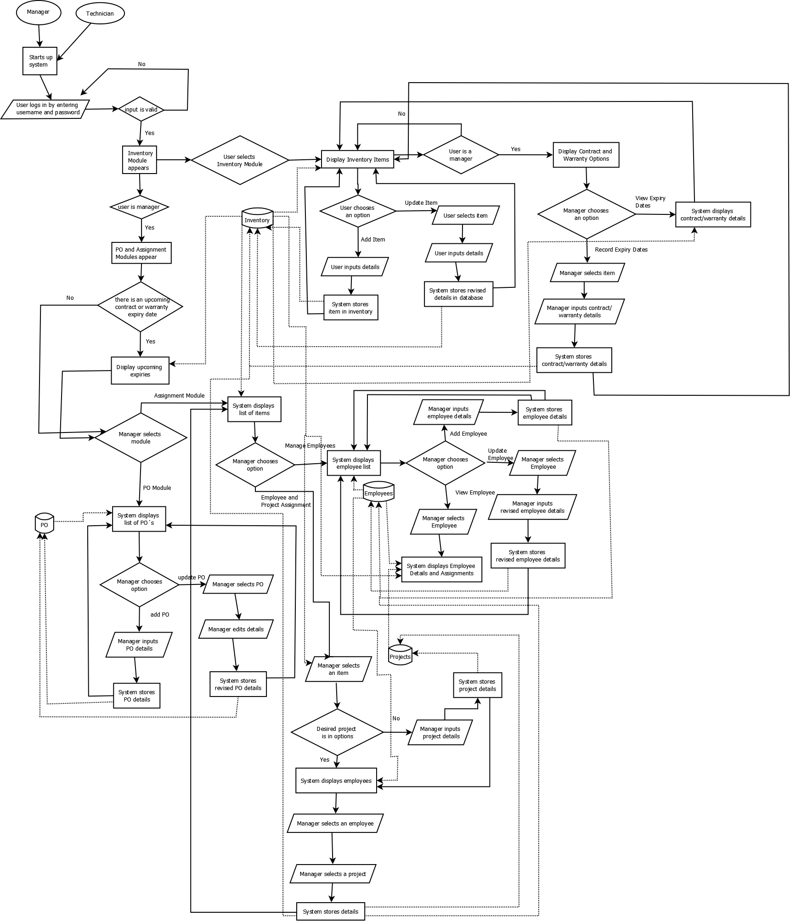

**Figure A-1. – Revised Business Process of CAI-STA**

**Appendix B – Interview Transcript**

The following are the interviews that took place between the members of SystemScape and Ms. Rosalie Fernandez of CAI-STA.

**B-1. Interview on January 23, 2015**

Shayane - S

Austin - A

Clarisse - C

Bryan - B

Ms. Fernandez - F

S: How the process of—

F: Purchase? Okay. We have, okay. Brief explanation lang? We have a partner in US. So they get us our clients. Marketing **** So we also have list of purchases, so the requirements from the clients are parang data gathering, stuff like that, so they discuss things like software, hardware, internet connection and once it's final, they send it through me then I'll be the one to source it out, so I make a P.O., pero simple lang, pero I use Excel only. We're the ones pala who developed ATM, the Bancnet, also the LTO registration. We're part of a team kaya lang we don't have enough time to our own inventory, kasi it's not earning money, so upon request, sinosort out yan and I make the P.O. using Excel only and then before the inventory system is online from U.S., but it's too slow and so many data that we don't need kasi sa kanila kasi online, the DELL laptops online so we even we say, so we want to make it simpler. What we need lang is the model for the or we'll start na lang from the purchase order? So we did this a.. you want to see? Gusto nyo macheck na? Uh sige. Kita niyo naman eh, so this one is the P.O. number, hard for hardware, soft for software, gen for general items, so gusto ko sana the numbering is automatic what do you call that?

S: Auto-increment

F: So yeah para di nagdodouble ung bill, so nagdrop down sya para kapag kung hardware yung ipupurchase ko yeah then ah there's name so ayun and then check to wherever if there's some modification then ito palang kasi so item description, 123, unit price, the total with vat and the grand total with the signature, this is me, purchase manager and then the president. Eto pala yan, parang yung condition, these are the things that I need lang.

S: So ano..

F: So we can give you a copy sa excel para automatic nagcocompute yung ano

S: So aside from you who else, other types of users who can have..

F: I'm the only one

S: So what, aside from editing or putting the necessary information in the purchase order are you also the one parang nagaadd ng customer?

F: Yeah

S: Yung parang other products?

F: Yeah, I canvass it, different suppliers. I pick up the lowest bidder not exactly the low quality then I make the P.O. out of the (quotation?) So hindi na computerized yan kasi it's manual. So parang final na, nasa akin na yung chosen supplier and I'll be the one to input or to input their address and contact but if we can regular suppliers if can just pick it up. I don't have to worry. Pwede ba yun?

S: So kelangan po namin ng parang I think ng list ng suppliers ng data?

F: Yung regular, or later on I can edit it or add. So clear tayo sa purchase order it's very simple so and then when the time na it was delivered already, that's the time na I want it computerized to the inventory system. Asset, We call it Asset Management. So for example, dineliver laptop, a laptop has specs, and then service tag number para kapag sira sya you just give the service tag number to the supplier and they know kung anong warranty nyan. And then we have an asset tag, this is for our own use. Alam namin through asset tag kung kanino sya nakaassign. So ang lalabas dun yung item description, asset tags, service tag number and data of delivery.

S: Gano po kafrequent yung ***** sa purchase nyo

F: Purchase? It depends kung anong dating ng project. May time na ang dami dami. May time na ilang months wala

S: Are there any business rules po na may influence po or may effect po sa data? Descriptions parang ganun. Parang ano, let's say, let's say kunwari sa faculty. Kunwari 15 units yung load nila, sa pagka purchase order po, parang may business rules po kayo?

F: Wala naman, wala naman kaming business rules. Although for the equipment I want something that kasi 1 equipment kapag dineliver yan may 5 yrs warranty I want it parang may tracking kung yung warranty when magstart at matatapos. Parang kasi after 5 yrs kapag nasira siya hindi mo na ipapagawa it's more expensive Pero when it's under warranty pwede mo pa syang ipagawa sa supplier but you have to know, kasi yung mga desktop hindi mo na babaligtadin para malaman mo kung anong service tag number nya so kapag sinabi yung asset number eto na yung ano dapat may record. Right now kasi a simple

S: Ms, Tanong lang po. Diba kayo po nageedit ng, basta main editor ng purchase order?

F: Ako lang yung purchase order, ako lang nageedit then sinasubmit ko sya. Anong nagvoview ng P.O.? AKo lang. And then yung president. Pero yung inventory

S: Sino sino po sila?

F: Yung inventory, yung technical namin kasi when nadeliver kapag dumating yung delivery go straight to them they'll be the one to input yung mga details ng … I double check their work kung tama yung inventory namin diba. Although kasi the boss will go to me, although we have these hardware the boss will not go to them, that's why I review their work para alam kung. Pero now if you have the system, if we have the system, pwede ko ng iview itype ko yung dell 620, ayan parang date of purchase, may end of warranty, hardware specs..

S: yun po yung format ng inventory?

F: since we don't have inventory system I'm using lang Excel para nasosort out ko sya kaya ganyan lang. I don't know papano nyo ba to gagawin pero yung report na kelangan sometimes ganyan. Eto yung username, eto yung model, service tag, asset tag, date of warranty so eto yung mga information na kelangan. May nakita akong sample. What else do you need?

S: So if ever gagawin po namin yung system. Ano po yung platform? Ano po yung OS na gagamit para compatible po yung system na gagawin po namin sa mga computers nyo? windows or?

F: Windows, nakawindows kami although we have linux pero kami lahat nakawindows. Nasabi mo java?

A: Yeah

F: Para walang license involved

A: But you have to install java runtime environment though

F: But we don't have to buy?

A: No, free

S: Sa paggawa ng mga nito, may mga ano po ba kayo, problems encountered?

F: Problems? Ano bang favorite mong problems anong klaseng problems?

S: Para po di po namin maulit yung

F: Ah sa inventory system before? Like I said wala pa kaming inventory system

S: Like pag manual po may problems po ba?

F: Wala kasi excel lang sya tas parang ano .. so syempre sa inventory system gusto ko ng security. Hindi matatamper. SO may user's may, administrator syempre. Una tayo papasok sya sa PO and as I've said kapag nadeliver pupunta sya sa inventory system. Lahat yan manual mo yan iinput sa system Important dun is the item description like what is stated in the PO and addition lang dun is the asset tag, the service tag, the price hindi naman important sa inventory, the quantity, the warranty period. Meron syang ano. We need to know if it's available or not available or in store or yung items in store, available, in use, and junked, disposed parang disposed sira na sya so remove na sya sa inventory. Pero may history pa rin na naremove na sya sa inventory kasi junked na sya para alam mo na hindi ninakaw yung ano. Tapos the reports has the ability to export the reports in excel. Track the life cycle of assets. So pwede mo syang itrack. Track information assets with notification if the warranty is about to expire. Like for the servers which cost mga 1 million we renew it after 5 years nererenew pa rin namin yung contract nya. So if halimbawa mga 30 days, mga dec 30 mageexpired na sya pwede ba may notification sya sakin na mageexpired na yung contract. Kaya ba yun?

B: Yes, we can do it.

F: Hm?

B: Yeah

F: So parang dun sa program parang lalabas lang parang mayroon kang puti sa taas inventory tapos contract parang nandun yung MA. We call it maintainance contract parang nakaspecify dun kasi pwede mo ipasok dun manually ah. If pwede kong ipasok dun yung items with contract. So yun yung mga kakaroon ng contract...

S: Yung items with contract po if ever ano po yung information na kelangan?

F: Start and entry sometimes pwede rin siguro yung amount pero lahat naman yan parang remarks yan. So ang drop down nyo is IT assets, non IT assets sa inventory? IT assets, non IT assets tapos asset component, software, and others, mga office supplies mga consumables, non IT na yun eh. Kuha?

C: Can you repeat?

F: ang items nyo for the inventory is IT assets pag IT assets yan yung mga equipment, non IT mga tables, chairs, office supplies, consumables, asset component uh IT component sya yung parts nung mga binili mo, software lahat na ng software. Yan lang yung drop down ng mga items nyo sa inventory.

S: Okay lang po ba clarification? So purchase reports, mga inventory tapos yung contracts

F: The contracts is information lang. Hindi mo naman ipprint yung buong contract. So kasi the contract is paper. Paper license we have a share of share holder for that. Ang kelangan lang syempre sa dami ng items, sometimes kapag namiss ko yung patay ako so gusto kong maremind. Sa US kasi meron silang ganun pero they don't want to share with us kasi may license. Dapat simple lang yung gagawin nyo. Meron akong nakita eh.. So eto parang ganito yung nakito ko dun sa ano contract.. Parang ganyan ganyan lang. Parang contract rules. parang may date from..Parang ganito..so tanggalin na natin yung mga changes para madali sa inyo so parang eto yung purchase code ng P.O., eto yung purchase order tsaka eto yung mga assets tapos pwede kayo maglagay jan ng mga computer, IT, non IT para may idea na kayo so yun na yung demo although natin kelangan yun diba... para may idea ka sa design. So this is our software..

S: Mayroon po bang mga ano?

F: Pero it's not working ha. Para meron kayong idea.

A: Do you have a centralized server for the database or ..?

F: pero this one ,standalone sya ako lang.

A: 'Cause we can either install the database here or kung nakaconnect ka sa net may local area network pwedeng ilagay yung database sa server mismo and then ethernet cable nalang

F: Pwede. Nakawifi ako. Isend ko na lang sayo. Simplehan nyo lang para hindi kayo mahirapan. Ang kelangan nyo lang na information is ganun kasimple. Tingnan mo yung warranty, iisa isahin mo pa.. Are there any?

A: Ano pa yung mga may asset tag, service tag, description dito? Laptops only.

F: Hindi lahat may asset tag. Yung mga simple items..

A: So IT assets?

F: IT assets.

A: yung components?

F: wala rin. yung mga equipments lang.

A: so sila rin yung mga may warranty?

F: lahat may warranty

A: all equipments pati yung components?

F: Yung components may warranty pero hindi ganun kaimportante… so lahat ng sample ibibigay ko nalang sayo, kung ilang digits din yung service tag...

S: yung ano lang po..

F: summary?

S: purchase order po, tapos po, for you only use excel for the PO for the purchase of order the information that you need... so yung ...tapos ano pa po yung iba?

F: Gen is for general other than software and hardware so it's general.

S: So tapos po yung number po na... So yung sa PO po yung kelangan po product description, quantity, unit price, asset, total.. tapos sa inventory?

F: once completed delivered. the items in that PO magtatally sya directly pupunta sya dun sa inventory. Although not necessarily pero para madali niyo makuha yung info.

A: after the PO what happens to get the item to the inventory?

F: because when you make the PO, the information hindi pa complete so if you receive the items, that items in the PO may icclick ka para mag go sya sa inventory. So you have to retype so andun na sya.

A: Separate yung list of items sa inventory kasi you have to transfer?

F: the inventory naman will have the info for the quantity kasi and the warranty, date of purchase pa.

S: sa inventory po yung mga information pong kelangan yung asset tag?

F: hindi una description pa nya, parang yung IT asset, non IT, classification you call that classification.

C: sorry.

A: so this is for all items? the description-the classification. Are there any special attributes for id components aside from the warranty?

F: warranty, asset tag, service tag.

A: for the components?

F: ganun din.

A: available in use, disposed?

F: sya yung san nga ba sya papasok. what do you call that. parang kapag hinanap mo yung items, for example, laptop, e620 pag you click that one lalabas sya in use,

B: status

F: status nya, assignee kanino nakaassign. kapag in use sya kanino nakaassign.

A: so that goes for all items, yung in use .. where do you get the information for assignees?

F: we assign it. manual ano din sya pero yung report lahat na sya manual entry kapag dumating items, ikikey in mo, halimbawa idesign ko sa inyo each one of you. the description, your name the description everything is included there. Pero kapag after a week I'll key in the description of this computer. Makikita ko na lahat nakaassign sakin. So assignee, Austin Fernandez then the description.

A: so imemaintain yung list of your assignees? is there any other previous source for the list? do you retrieve it from the database or manual sya?

F: We have an IT tracking system. Once you log-in to your computer, it shows all the description in your computer, all the software. Because we're not allowed to install pirated so all the software nag-aUP yan. Although I lost my access when I changed my laptop and it's from the US so I can't access it anymore. So once you log-in to your computer makikita lahat to tapos da S. Fernandez that ganyan and all the software in my laptop. But we don't need that kasi meron na kami ngayon. Now dinadrive ko yung inventory kasi out of that IT tracking system, pwedeng may excel file yun eh so they just give me the excel file and from that parang manual kong ginagawa para pagnanghingi ng reports yung presidente I'll just give it to her. So sinend ko lahat ng info. Itong ginagawa natin is for tracking of asset lang hindi naman *** talaga. Kasi natatrack yung nakaconnect. Natatrack yung in use eh, yung nakaconnect sa network but you cannot track yung mga on-stock dun sa system namin kasi yung once you log-in pero nasa stock room hindi nakikita sa inventory. That's what I want to kasi wala kaming control kung may nakapasok dun although we have cctvs so but if we have the inventory.

A: Are there any special information you need for your software?

F: we have also, the inventory is. when we use it the ** license. For example in one **** license meron syang 5 users so sumexerox kasi namin yung 5 copies na yun and we put in the individual folder with your asset tag number so it means to say na yung isang license, meron syang license key everything lahat. may inventory kami nun eh. License key, tas quantity nakaassign yun sa asset tag. Microsoftt Office 2010 to parang ganun yung license sa software namin para we're sure na walang pirated na nakakalusot.

A: So yung software may asset tag din?

F: wala. ano sya quantity lang, license key.

A: yung software may assignee din?

F: pero masyadong mahirap para sa inyo yung. quantity na lang itag natin and user kasi masyadong for the software madaming information kasi yung ano eh

A: You can maintain a list of your customers?

F: yes

A: and suppliers?

F: yes. and oh it's good you mentioned. I need a project name. Project name kasi yung assignee.. Nakaencode yung project na yun.

A: how many projects can an assignee have?

F: even you have two projects you only have 1 the other *** lang. this asset tag number is assigned to you on what project.

C: so if the person had two projects will the asset be assigned to both projects or just one of them?

F: both projects.

C: ok.

A: Can equipment be assigned to someone pero wala syang project?

F: yes. may training sya. so pero kung training lang yun. we have the training. pag may training lang ** computers. pag di mo sya owner, wala kang ownership dun sa training pc. so it means to say that computer sa training room is on stock. so ang inventory nun is on stock sya. actually sa training can be assigned to, used *** anybody.

A: so during the training, who is it assigned to?

F: uh no, training pc. you call it pc, if we don't say any need for that. we assign it then we buy new ones. kasi we always get yung top of the line. Pag bumili ka you dont buy the same model kasi madaling magobsolete sya. kaya napakadaming ng models kasi we don't stick to one. pag bumili ka this week, next week iba na yung specs nya so magiiba na naman yung inventory. so yung pag project assigned..

S: so sabihin ko ulit. sorry sorry.. yung users po ikaw na po, pati yung nakakaedit.

F: ako yung user sa purchase order. ako lang yung user sa purchase order. sa inventory we can be three.

S: sino sino po ung three?

F: technical level. so sila yung mga nagaassign. sila yung mga nageexam parang technician ng computers. technical support.

A: so the technical team has access to the system?

F: sila yung nagkikeep.

A: so bigyan nalang namin sila nung software pero may password para sa kanila lang. The president can only view?

F: only receives the reports. she doesnt need to view.

A: so yung excel file lang.

F: oo

A: there are only three kinds of users: you, technical level 1 and level 2. anong difference ng level 1 and level 2?

F: mas magaling yung level 2.

A: that's it?

C: is there a difference in how much they can access in the system?

F: actually they can access it kasi if not I'll be the one to do it. so dapat may access sya anyway they're the ones maintaining the security of everything so secret naman sya.

A: they can't edit the purchase order though?

F: they have more access than I have kasi sila talaga ang may alam ng lahat ng security. so full access. except for the PO.

A: they can't edit the PO.

F: they can't

A: but they can view the PO?

F: no, ako lang.

S: so yung contract po start and end date tapos ano pa po yung ibang?

F: yun lang report.

A: contract bills with an item any of the four types?

F: only equipment

A: so IT assets

F: yes.

A: so you need the PO, the INVENTORY, the CONTRACTS, the PROJECT ASSIGNENT is there anything else?

F: The project assignments included in the inventory, part of the inventory and the contract also is part of the inventory. everything naman ** purchase order

A: Pero kasi we can add a separate module para you can add projects tapos sa inventory drop down na lang.

F: normally naman ganun eh so there's a facility where you can add everything kasi equipment naman can be air condition, hindi naman lahat IT so may air condition pa rin yun pwedeng vehicles. so pwede kayo magsample ng ganun I'll just change it.

A: prototype?

F: yeah

A: anything else?

S: so thank you for everything thank you for the interview. if there are any more issues *** and we'll give you preview***

ALL: thank you

F: thank you

**B-2. Electronic Interview on February 17,2015**

A:

Good day,

Can we please have samples of the following forms for the software: contract form, warranty form, it asset assignment form, project assignment form?

Thanks,

Austin Fernandez

F:

We didn’t have request forms, Assignment of software and hardware are based on project basis and dictated by clients. The client and management upon inspection identify the team members, sw and hw to be used on the project. They will email me the requirements for the processing of P.O.. Upon delivery of the items, it would then be assigned to the team members for inventory.

I will send you the sample contract tomorrow.

**B-3. Electronic Interview on February 18,2015**

A:

Good day,

Can you please details some instances wherein you have had a problem with recording project assignments or asset assignments in the past for our documentation? Than you in advance.

Sincerely,

Austin Fernandez

F:

Here are some instances wherein i have problems with inventory:

1. Mass hiring - 50 staff
2. Shortage of admin support
3. Rampant resignation
4. Incompetent technical support
5. Manual input using excel

Sally F.

**B-4. Client User Interface Feedback Report Dated February 27, 2015**

Legend:

F: Ms. Sally Fernandez (Client)

G: Gio Anton Velez

R: Rissa Marie Grace Quindoza

S: Shayane Tan

Interview:

G: Ganito po yung color scheme ng software. So basically, light blue yung

F: Light gray? kaya lang blue diyan.

G: Hindi po...eto po light gray siya. So basically ganito po yung look nung interface

F: Ok

G: Pagpress nyo po ng...so dito po mag lo-login. So may two panels,so meron technician and meron manager view.

F: Pero pwede ka magadd ng user?

G: Opo.

F: May facility siya to add a user?

G: Opo. So admin…

R: Admin yung magaassign....

F: Ah so yung admin. Yung admin yung magaassign.

G: Opo, para controlled yung…

F: Yeah, yeah

G: So next...eto po yung...So for the purchase orders

S: Yan po yung template ng screens

F: So yung username lalabas yung name doon

G: Opo

F: Tapos yung list of purchase orders

G: So parang may tab po diyan...So nandun po yung tab. So automatically by default lalabas yung

F: So yan yung ano...screen. Pag naglogin ka yan yung first na makikita mo.

R: Opo

S: So template muna yung papakita namin sa inyo bago yung actual screens.So yung mga icons po na yan...ito yung filter, yung add, then yung export. Then ito yung icons for view then edit.

G: Ay oki po, pinepresent po namin ito kasi...I mean we want to get your feedback as well

F: Yes

G: And so just feel free to tell us

S: Any concerns…

F: So far...so yung purchase order...ano ko lang ah. So pag...yung purchase order once you click it, lalabas yung screen ng purchase order, pero yung view reports...if i want yung reports ng lahat ng purchase order, ano i cli-click ko? Yung summary nung mga purchase order? For example, para masearch yung...halimbawa may PO akong kailangan makita?

R: So yung fi-filter po

F: Nasaan yung filter niyo?

R: Ito po...icli-click niyo po yung

F: so idrodrop down lang yung

G: Opo, makikita niyo po yung flow mamaya. Basically, template lang toh then later on papakita namin yung slides yung flow ng screens.

F: Ah sige ok

S: So ito po yung para sa pag generate ng reports.So... so far, base sa .. yung tanung ni Austin noon. Yung reports na kailangan ninyo po is inventory?

F: Yes, Inventory chaka assignment. So yung employees na yun...yun yung list of employees.

S: Yung actual screens na po. So pagkaclick mo po ng purchase order, ito po yung lalabas na makikita ninyo.

R: yung list of purchase orders.

F: Oh, list of purchase orders. But if you want to create

R: ah, mamaya po

S: Ito yung sinasabi na pang filter po. So pagclick nyo po ng filter, may lalabas po na pop-up screen. Tapos you can filter it by item, classification, supplier, then yung date, or its grand total. Meron po siyang greater than or less than the amount.

F: But the, yun yung creating PO?

S: Ah, hindi po

G: Yung filter…

F: Ah, bsta nasa filter pa lang tayo? So Hindi tayo nagstart sa creating PO?

R: Hindi po

S: So view lang po ito.

R: Or gusto niyo po sa pagadd na ng PO?

F: Ah dun na lang para hindi tayo maguluhan. Dun sa start ng system, if i want to create a PO patingin o malayo pa ba?

R: Pagganun po, i cli-click lang po ninyo yung add, yung plus tapos eto po

S: Eto po for add or creating PO

F: So yan na yan

G: So basically po, pagka press niyo po ng plus sign dun sa previous screen ito po yung lalabas.

S: So pipili ka lang po ng supplier na nakasave na dun sa DB.

F: Pero yung PO Number?

R: Kami na po yung bahala maggenerate

F: Ah..wala pa diyan?

R: Automatic po siya

F: Pero saan diyan?

S: Pipili ka lang po kung anung klaseng type po yung PO

F: Kung hard, soft, general ganun? Tapos pakakilick mo yun...hindi pa kasi tapos...so lalabas dun yung automatic numbering ng PO?

R: Ay hindi po, i gegenerate na po. So pagstore namin may number na siya agad.

F: So walang duplicate?

R: Wala po

F: Walang duplicate numbers?

R: Opo

F: So hindi from the start makikita niyo na yung number ng PO?

R: Hindi po

F: Ok

F: Basta yung result nung template, yung PO na binigay so sainyong sample. When i print it, ganun yung format ng PO. Ok, tama ba? So clear tayo dun? kasi importante yun e.

R: O sige po

S: Yung date kung kailan create yung PO . Tapos pwede po magadd ng item ng PO. Tapos pagka click mo niyan. Ito po yung lalabas.

F: Pagnaassign na

S: Hindi po, diba po sa PO nandun po yung item na i-oorder nyo

F: So yung “Rissa”? yung “Rissa” na yun item yun Kungyari ikaw yung item?

R: Haha opo.

F: Kasi pag name, parang assignment yun eh. So ito pwede ninyong isample na ilagay nyo dun computer...kaya nalito ako. So ayan na yung item description? Ok ok. So yung item desciption anu yan...walang any lines? madaming lines?

S: Pwedeng madaming lines po

G: Kapag sumobra po sa box na yan

R: May scroll po

F: So good! ok naman so far, simple.

S: So yung amount automatically computed na siya ng system.

F: So yung sa unit price kinocompute na nya?

R: Opo

F: Ok

S: So pagclick nyo po ng submit, dito na po lalabas sa table.

S: So kung gusto naman niyo pong i-edit…

F: So may choice karin kung pwedeng Australian dollars siya o US Dollars siya?

R: Wala po

F: So paki anu. Kasi tayu peso diba? Eh sometimes yung PO ko US Dollars minsan Australian dollars. So pwede ako na lang magtype o may option ba na itype ko kung dollar o US?

R: Kami na lang po…

F: Oh sige kayu na lang. Lagyan niyo rin ng ibang currency. pero normally naman ano eh US Dollar, Peso, and Australian... AUS.

R: Pero pagtotal po?

F: Kasi di naman yung computation. Kaya lang minsan yung PO na igingenerate ah pagnagpaprma ka kailngan alam ng finance na ang babayaran nila is in Dollar. Kailangan nakikita nila yung sign. Kasi yung PO kapagkacreate kapag for payment napupunta sa finance eh. So yung amount na makikita nila dapat kung hindi 100 yung nakalagay 100 pesos pero 100 dollars malaki difference nun.

R: Sige po

F: Pero yung reporting nakalagay yung peso sign if ever diyaan? Sa final PO?

R: Dadagan na lng po namin

F: Ah dagdagan na lang ninyo baka makalimutan

G: Kasi inassume po namin na

F: Puro peso? hindi. So sometimes may mga order abroad so may dollars.

R: Ah sige po

F: Chaka yung bayad saamin puro dollars

S: So sa edit po, pwede niyo po i-edit yung definiton/details ng Purchae Order. Pwede niyo rin po i-edit yung item

F: And pwede rin ako magadd?

S: Yes, pwede ka rin po magadd ng item

F: Ng Classification? Bigay nyo ng option for me to add sa classification. diba binigay ko sainyon hard, general, chaka software. May services ba akong binigay?

S: Wala po

F: Sometimes may bagong kami project nagkakaroon ng bagong classification. Bigyan niyo lang ako ng option to add. Sometimes may services…

G: So parang custom settings

F: Oo. pero ok na yung tatlong choices bigyan nyo lang ako ng option. mas madali kasi yung dropdown. Kaya lang if i want to add...pag ako na nagadd parang nandun na siya sa program. Once nadd ko kasama na siya dun sa choices.

R: Oh cge po

S: So kung gusto niyo po iedit yung item. iclick niyo lang po ito tapos may magpop-up na screen. Once you clicked submit po, mag-uupdate na yung details automatically.

S: So ito po sa Supplier. Parang purchase order po, merong filter, may add, may edit, may view.

R: Baliktad, view then edit.

S: So ito yung para sa filter. So may supplier, may country, state, street, contact number. So kung gusto niyo po specifically iview yung isang supplier, i-click niyo po yung button tapos ito po lalabas tapos may previous and next button. pwede niyo rin po siyang i edit and delete.

R: Edit and close

F: If ever binlock list ko na yung supplier, delete lang. Pwede kong idelete?

R: Sa edit po pwede siyang i-delete

F: Oh ok

R: Ito yung add suppliers

S: Sa contact number po, kungyari marami mo yung contact ng supplier pwede kayo mag add ng value and then yung type ng contact number-fax,email, telephone, cellphone number. Tapos kung meron pa pong iba, add niyo na lang po tapos may lalabas na bago.

F: Editable sya

R: Opo

S: pwede niyo rin pong i-delete yung supplier

F: Pagkasave saan siya

R: Yung submit lang po

F: Basta lahat ng submit save.

R: Opo

S: Sa inventory po ito. Pero ang kaibahan ng inventory module sa purchase order and suppliers is that may export button siya since nasabi niyo po na ang kailangan na reports lang is for the inventory. So you can filter it by item, type- non IT, IT,.. Tapos kung gusto niyo i view yung item, ito lalabas. Kung non-It asset siya ito yung information na lalabas. Yung item, yung description, type, and warranty expiry date.

S: So pagka yung Item software naman po, may type, may license key, may warranty expiry date.

F: Yan license key na yan milliones yan. Na kapagka nauha ng ibang user they can use it anywhere so may security naman tayo diba? Sa admin user? Kasi lahat ng security dito ako lang may alam.

S: Ah so, yung inventory po diba sa technician sabi niyo po

F: Ah oo, pero sa technician saakin parin nila kinukuha yung ano. kasi they can share it to their friends. So sa technician may option siya kung binigay ko sakanya. pero kung binili ko wala sila unless... Ganito kasi yun, bibilhin ko siya, ako lang makakareceive ng license key. Sa microsoft name ko lang yung tinatanggap nila or sa ibang ano pati … but if nakareceive sila ng ticket...Sa ibang software na toh ah...but if nakareceive na sila ng ticket nagrerequest ng software, ini-email nila ako to ask. And then chaka ko pa lang binibigay sa kanila yung cd key/ yung license key namin.

S: So kung ganun po

F: Pero kanina may admin user ka naman eh. So sa admin user pati sa isang user pwede magkaroon ng security may ibang ano na hindi niya pwedeng maccess like yung license key lang.

G: So pwede naman naming i ano...so for the admin

F: All access. So yung isa diyan lang naman nililimit ko sakanya eh

S: So yung sakanya mawala...hindi niya makikita yung

F: Yung license key lang block sa ibang user

G: Pero makikita niya po yung iba like yung description

F: Makikita niya di na niya magagamit. Kahit nakakalat lahat ng software ko o cd installer unless na wala yan hindi magagamit yung

R: So tatago na lang po namin yung license key

F: Oo, dapat admin lang yung

G: So basically po yung license key lang po yung tatangalin namin

F: Oo, or kahit nandyan yung license key basta blank siya sa ibang user

R: O sige po

F: Pero so admin, kung ako yung admin makikita ko siya tapos magadd siya dun sa inventory ko. kasi merong technical na senior na pwede kong ishare sakaniya. So ako na lang magshshare sakaniya. Pwede ba yun?

G: So parang meron kang ability to share it to someone

F: Pwede ba? Paanu yun?

R: Employee na po siya?

F: Oo

G: So anung difference niya po sa technician.

F: ah so technician na siya, pero meron kaming level 1, level 2, and level 3. So yung level 3 alam niya kung ano yung alam ko kasi kung wala ako nasa hospital or what wala na makakapag-install. Pero sometimes if you don’t trust him that much hindi mo dpat ishare yung key. Kapagka hinihingi lang chaka ko binibigay.Kasi kahit wala ako dito i can sell them, kasi i have access on them. Kasi mahal ang mga software, pagnagamit mo malalaman ng Microsoft na may duplicate copy ka then they can sue us parang ganun.

S: Miss, clarification lang po sa pagadd po ng inventory...yung technician pwede rin po ba siyang magadd ng license key or ikaw na po yun.

F: Ahh, ako. Kasi mahihirapan siya kasi minsan ayaw ko kasi kapagka inaccess mo siya sa web paminsan sabay sabay yung question paminsan technical yung question. Sometimes yung email fino-forward ko sakanya kasi trusted ko siya, pero kapagka nagresign siya ang papalit sakaniya kahit level 3 you don;t trust him agad. Hindi ko binibigay. Pero katulad niya matagal na siya sa akin so fino-forward ko sakanya yung email ng Microsoft. Yung account ko ginawan na rin ng...syempre technical sila...yung account ko kya na niyang i-access. Yung computer ko kasi they can access it eh so kinukuha na lang niya...may time na ganun. Pero ako ang pwede maglagay.

G: So gusto niyo Ms. lalagyan namin ng capability na you can share the information

F: Oo, yun lang naman yung ano

R: So bibigyan namin ng admin rights

G: So ganito po, baka we can give you a list of technicians and then kayo po pipili ng technician and then share it to them

F: Oo, sige ganun na lang para simple

G: Pero how would you want to share it? Would you want to share it na I’ll give you this license key one at a time or…

F: Ah ganito kasi...sometimes they don’t need the license key. Ah ganito kasi ginagawa nila, pag may bago kaming software dinadownload nila sa server. So yung website nungg Microsoft so katulad nung ganyan bagong bili. For example half million yan, so pagdeliver nun sa akin...nakalagay na dun yung username ko . Kasi ang binibigay lang ay email eh. So you pay half a million, tapos yung email lang ang marereceive mo. Yung email na yun wala dun yung cd key/ license key. Yung email na yun fino-forward ko sa level 3. Sabi ko please install to ...nakalagay yung mga associates na yun...yun yung ilalagay ko sa inventory diba? So nakalagay yung name ng associates na yun. So ang ginagawa niya, dinodownload na niya yung software tapos stinostore na niya sa server. Ngayon yun na yung installer niya. Yung cd key na binigay ko sakaniya ininstall lang niya ganun paulit-ulit. Hindi na niya minememorize yung cd key. Kasi ewan ko kung paanu na niya gingawa yun. Kasi nga para hindi na niya maistrobo yung pagtanung-tanung saaakin. Pero kung ikaw level 2 at nakareceive ka ng ticket hindi pwede na alam mo yung alam namin dalawa.Kung absent siya absent ako tapos kaya mo lang kunin lahat. Tapos meron kang friend sa labas tapos tatanong “Uy! meron ka bang activate diyan?”. Diba ganun naman tayo tapos sasabihn eto cd key bibigay mo sa kaniya. So hindi pwede.

G: So kung tama pagkakaintindi ko level 3 lang ang pwede?

F: Oo, kahit yung name lang. kasi yung level 2 ka tapos na promote ka susunod level 3 ka na. Kung wala kami mahire sa level 3 sa level 2 ko ibibigay.

G: So name na lang

F: Oo, name na lang. Anyway tatlo lang naman eh. 1,2,3.

R: Tapos license lang ibibigay?

F: Oo yung cd key...yan license key parehas lang naman. Sorry sanay kami sa cd key... license key.

G: So for that specific item lang

F: Oo. Lahat naman yung software lang naman ang may license key

G: No, what i mean is…

F: May access sila sa lahat ng inventory kasi sila yung gagawa noon.

G: How would you want to share it? Like for example...kasi diba as a manager gusto mo secure yung mga license keys mo?

F: Oo

G: Pero kasi diba marami kang software so maraming license key yun. Do you want to share it as a whole? For example, ibigay ko lahat ng ability o isa- isa lang?

F: Ah, no. Meron naman tayong report diba? Kasama siya sa inventory...na kapag ka bumili ka ng software...kapagka sinearch ko yung MS Software lalabas yung license key?

G: Opo

F: Tapos kapagka nagginerate ako ng report nandun lahat siya. Naka-excel file siya diba I can also share that so kung ako lang may capability mag share but they cannot access it by their own parang ganun

G: So I sha-share mo yung file? Ok.. kasi yung naiisip ko po was diba magshshare ka yung hindi mo na ishsare through the software… you’ll share it by file nalang… sa kaniya? Or gusto mo mapapakita na lang sa screen na niya yung license key noon …

F: Pwede kung ano maaccess ko yung maaccess ng Level 3..

G:So all the privileges.

F: Makikita ko ba yung mga nag edit?

G,S,R: Hindi po..

F: Well actually makikita ko naman pala yung mga date

F: Standalone ba to orrr… pwede malagay sa server yung software nyo?

G,S,R: Standalone.

F: So yung file iinstall sa laptop ko then I share ko sa kanya . hindi pwede siyang nakainstall sa server iiaaccess namin dalawa?

G: naka database siya

F: Ah naka database siya. Ano ba ginamit nyo SQL? Meron naman kayong license na ganun

R: Ah yung server po yung kung saan isesave sa server po… yung program nasalaptop

F: Yung system iinstall sa akin, yung data nasaserver kasi dapat safe pa. Ano SQL nyo? Ah yung free

S: So… ito po yung sa IT Asset so.. may item description type asset tag service tag delivery date then yung assignee.

F: Diyan lang yung input ng mga information. Anong information to?

All : View po..

F: Medyo.. ok .. medyo magulo.. so kalian ko siya iviview kapag naenter ko mga information nay an? Yun yung view?

S: Nakasave na po sa db…

F: Diyan ako mag iinput.. yun yung view?

R: Eto yung list tapos kapag gusto mag view ng specific

F: Patiningin nga ulit ng view?

F: Hindi pa pwede naka? Ah sabagay view lang siya no?

F: Tingnan nga natin yung view

F: Hindi ba pwede bang ….. sa bagay view  
siya ah no

G: Ano po yung gusto niyong sabihin

F: Parang naguguluhan ako diyan sa layout.  
Gusto nyo bang i box na may konting color yan? Para sa view, para ano pwede  
natin ma benta yan ah. kapag ano pwede nyo yun pagkakitaan so yung view item  
parang naka box na siya tapos eto yung item lagyan nyo ng color para… wag nyo  
gawing ano ha multi-colored ah ano lang wag yung red pink blue lang box nyo  
yung description para uniform kayo sa view nyo.. so pag interview nyo pwede nyo  
pakita sa HR yan.. so ano gandahan nyo ung … parang ginaganyan nyo…

S: So eto po parang yung sa add item.

F: Yan o parang ginaganyan …. ginanyan nyo na siya eh so sa view gawan nyo nalang ng simple …. para sa view uniform siya

S: So.. Item may description, then yung warrant start and end date then kung non It Asset… so kung non IT Asset may?

F: Yung lang naman yung information

S: Yung software po ba may assignee?

F: Ayun o may assignee na?

F: Paan yung sa inventory kapag available siya.. pwede mo lagyan yung assignee e di available? Dba option siya?

R: O sige po.. pero all types po pwede I assign?

F: Merong quantity dba? Walang quantity eh di lagyan nyo ng quantity

R: O sige po

F: View ba to.. kanina yung software.. view to ng item? So.. importante yung quantity?

G: So doon po sa software….

F: Kasi Lahat ng Item kasi inventory to eh..Teka view format ba to? Sa list of items na what?

G: Opo list of items

F: list of items na what ba to sa input mo lang?

G: View po ng list po to ng list of specific items

F: List of Items na kasama sa inventory. Kelan ko makikita yung quantity?

S: for example sa dell laptop sa dell laptop may ganitong makikita mo yung quantity… ah..

F: gusto ko lang Makita ngayon.. halimbawa may lumapit sa akin na project may tatlong laptop saan ko makikita yun?

R: sa purchase order ata?

F: Sa inventory dapat?

G: sa purchase order po nakalagay yung quantity.

F: hinde siyempre kapag may purchase ka may quantity… pero for example nag search ako sa inventory… kunwari dell laptop siyempre may quantity, model and quantity.

S: Kasi I think.. ano po ba yung gusto niyo sa view?

F: Kaya tinatanong ko kung anong view yun kasi.. anong reason kung bakit ko vineview yan.. pero yung main reason ko is to view PO and view quantity. So siyempre view ko is to create PO and create inventory so inventory and PO lang .. hindi ko siya iviview kasi memorize ko siya para lang I viview ko siya para malaman ko kung may stock ako sa item so from the Purchase order palang may quantity na…. iintegrate nyo nalang dun sa list. Teka maguguluhan ba?

S: Clarification lang po.. so yung list of of items naka group na siya like kunwari eto yung dell laptops….

G: Ganito po… Like for example yung list of items nasa purchase order na siya tapos I add nalang siya doon sa inventory…

F: pero ibaba yung dates kasi yung history doon different dates.. nakikita naman yung history ng purchase… so ang view na sinasabi nyo di ko gets view ba yun paggawa ko ng PO?

G: paggawa mo ng PO , once you add it dba may list of items ka sa PO

F:Wait wait may mali...

F: So.. ulet.. Pag gumawa ka ng PO, chochoose ako dun sa items, correct? Kasi.. gagawa ako ng PO, magdrodrop down ako kung hardware siya, software.. ako magiinput ng mga description niya diba? Pwede ko nang gawan ng template. Ako na magiinput ng lahat ng mga items ko, diba? Diba meron kayo nyan? Kasi hindi niyo alam kung ano ung mga bnibili ko. From the start, bibigay nyo ung system, lahat ng information iinput ko.. suppliers ko.. numbers.. everything. Siyempre, un ba ung view na sinasabi niyo na pag clinick ko yun, yun ang makikita ko? Yun ba ung view na pinapakita niyo sa akin? Kanina?

S: Oo

F: Kung yun, then you don’t need the quantity. Yun ba ung pinapakita mo? Yung sinabi kong gandahan niyo? Para sa PO ko ba yun?

R: Para sa inventory. Sa item specifically.

F: Specific item.. baka malito kayo. Yung view na yun ulit, anong klaseng view pag gumagawa ako ng PO?

G: Para siya sa item.. Kasi.. Diba.. Ok.. Before mo vineview, diba before the inventory, ito ung view natin. So.. umm.. Ung items dito, like for example lalabas ung item name, description type, pero kung gustong makita ung detailed view nya, iprepress yun.

F: Ah so yun ung view na yun. So I dont need the quantity. Ayusin nyo lng. So, I dont need the quantity. So para hindi magulo, wla pa tayo sa inventory. Nasa PO pa tayo.

G: Nasa inventory na tayo.

F: Nasa inventory na tayo?

G: Opo

R: So lalagay lng kami ng quantity.

F: Baka kasi mali ito. So erase lahat. So ganito, kiniclear ko lang yung view kasi ito yung PO, magcrecreate ako ng PO, ah yung dropdown na sinabi niyo, ako rin ang naglagay ng information lahat diba? So yung bang view na pinakita niyo sa akin. Yun ba un makikita ko pag naghahanap ako ng PO na gagawin ko? Ung kanina? Yun ba yun?

G: Opo kasi diba, eto.. Sa add purchase order, supplier, pagkapress mo ng add item, ilalagay po yung item tapos yung item description.

F: OO, yun na nga. Item description tinype ko jan diba? The end. Tapos na yun? Submit

R: Opo

F: So Ok tapos na tayo jan. Ung view kanina pinakita nyo. Kelan ko makikita yun?

G: After ng PO.

F: After ng PO?

G: Kasi diba after ng PO, nasumbit mo na, so papasok yun sa inventory niyo. Once pumasok sa inventory, lalabas na siya sa list of items, so dun sa list of items mo na pwede mmaview.

F: So ganun, ung view na yun, after na ng PO, I need the quantity. So yun yung hindi masyadong malinaw. I need the quantity. Pero parang ano rin.. Parang mali. Kasi parang viniew ko lang ung PO ko. Bakit kailangan mo pang pumunta dun. Edi view mo nalang ung PO. Diba? Tama? Dun na, kumpleto na yung PO eh.

G: So uhm clarify. So yung sa PO niyo, diba uhm gagawa kayo ng PO and then kasi pwede mo rin maview ung purchase order. And then once maview mo yung purchase order.

F: Indi, kung nacreate ko na yung PO. Ung dropdown, quantity, everything, the end. So kapag dumating na yung.. ah after thirty days, dineliver na yung mga equipment, nareceive mo na ito, limang ganita, pupunta ako sa inventory, receive items nasa inventory din xa. Dell laptop, 5 pieces, ilalagay ko yun. Date warranties, saka ko ilalagay ung mga information dun. Ako mismo maglalagay, hindi system. Pwede rin na kasi yung dun sa PO, hindi lalabas kung kailan dinilever yun eh. Nakalagay thirty days pero nagkaron ng fort congestion, everything, nadelay siya, hindi pwede magautomatic pumunta yun. Nareceive ko yung invoice, tinype ko five items, warranty five years, nilagay ko date. Lalabas na sa report. Ganun ba ginawa niyo? Diba ganun pagexplain ko before?

G: Ok. Kasi po tama po. We’re in the same page. Kasi naisip pala namin. SSo yung purchase order, wala pa siya sa inventory.

F: Yun ung sinabi ko na pwedeng macancel or maging obsolete yung item. So I have to change it, edit it.

G: So lalagyan lang natin ng option.

F: Wag mo siyang automatic ilagay sa inventory. Kelangan ako maglalagay sa inventory.

S: So kunwari yung sa add item ka, nireceive mo yung PO diba, so ikaw mismo magaadd item.

F: Ako mismo maglalagay. Hindi ung PO ang magaautomatic sa inventory. Magiging mali yun. Kailangan human intervention dun. Kasi maaring something happened inbetween 30 days, hind dumating on time, magiging mali ung inventory. Yung warranty kelangan ako magiinput based sa invoice and everything

G: So basically yung item mo and PO is not directly linked to your inventory.

F: Supposedly naglink but there are cases beyond my control na hindi siya dumadating on time. So ang ginagawa ko, pag dumating.. Pero nice to have na PO mismo pumupunta sa inventory. Pwede nalng edit siguro. Yung data lang yung ichachange ko. Mas maganda nga kasi hindi ko na kelangan.. Yung warranty yung pwede kong paglaruan.

G: Actually yung pwede nating gawin jan, like for example may PO ka..

F: Ah alam ko na, ito na yung PO, direct dun sa inventory. Pede ba kayong magkaron ng box na delivered yes or no? So pagclick ko yes, pupunta na sa inventory.

R: Tapos. pag may license key siya, iaadd nalng, ieedit nalng

F: Oo. Eedit ko nalng. Blank siya pag dumating. Malalaman mo siya after delivery.

G: After delivery nalang

F: Oo

G: So what we can do there is meron tayong isang tab.. delivery PO? Kasi magaaccept

ka pa eh. Ah may.. ano nalng.. kung ok na ung PO o hindi.

R: Tapos ung inventory, dadagdag nalng ng inventory

F: Oo kasi yun ung importante sa inventory

G: Nakalimutan natin

R: Sige po

G: So pagkaview ng list of items

F: Pwede nyo ba dagdagan pa ng invoice number?

G: PO?

F: Sa PO.. ah hindi, sa inventory.. sa report.

G: Kung anong galing invoice xa? Ung item na yan.. invoice number is from the PO right? So parang kita mo pag filter mo ng item, makikita mo.. like for example from this invoice number lang?

S: So sa IT Asset, same lng dito or dito since IT Asset, may asset tag, service tag, then assignee. So yung assignee, dito na namin inimplement ung project assignee

.

F: Nasan yung project? May assignee ka na maglagay ka na ng project

S: Hindi po. sa employee po siya.

G: Kasi we’re assuming na ung employee nandun sa project na yun.

F: So yung employee, sa tabi niya may project siya. Pag clinick mo yung empoloyee name, lalabas yung project.

G: Opo

F: Pag si James clinick ko, ito lalabas

G: So pano niyo po gusto yung item. Per project/ employee siya?

F: Indi, ok lang to. Sometimes ganito eh, bigyan mo ako ng report kung ilan nakaassign sa project Pwede ko ba itype yung project, lalabas ung project, lalabas yung employees

R: Dadagdag nalng po kami

F: Yung search niya, pwede name/project.

R: Sige

F: Tulad ng sinabi ko rin, yung equipment, pag tinype ko yung monitor, lalabas din yung *something* ng monitor. So kasama din yung monitor. So lalabas din ilan. Tulad ng project, pag cliclick ko name mo, lalabas yung nakaassign na items. Pagclick ko ung project, lalabas ung project names saka yung nakaassign sa kanila. May report na jan diba?

S: Wala. Inventory lang daw. Pero pwede namin dagdagan.

F: May mga sample ako binigay.

S: Yung project? Wala po.

F: Di binigay? Sa report lang naman yun. Di ko alam pano ginegenerate yung report. Parang excel, diba parang sinort mo lang namansiya. Kasi manual ko lang ginagawa. So sinosort ko by projects so lalabas lang naman yun. Baka madali lang naman yun.

G: So dadagdag tayo ng tab?

R: Hindi, filter nalang yun.

G: Ah ok.

S: Ah so yung reports. dalawa na? Inventory pati project?

F: Hindi. Inventory by project. Lahat to inventory lang eh. Hinahanap mo kung ano yung nakaassign sa project na items. Kasi pag nagassign ka nung PO mo, kasama yung project.

G: So eto po yung add employee

S: Sa add employee, wala pa po yung add project. Sa edit employee pa po yun. SSa add po, add mo lang yung name ng employee tapos yung status niya. Tapos kunwari naadd mo na siya, sa edit, pwede mo na maadd yung project.

F: Status is.. active and resigned? Indi, yung iba.. yung status niya pwedeng onsite, offsite.. So edit din tong status?

R: Opo. Ano pong mga status gusto niyo?

G: Custom nalang.

F: Sige. Minsan kasi nasa US, offsite. Minsan locally, nakaassign sa Unilab. Pag nakaassign siya eh, wlang nakaassign na laptop. Pag outside siya, di ko kailangan ng inventory. Kasi wala siya dito.

R: So hindi nalang siya dropdown?

F: Ok lang.

R: Pati yung pagadd ng project?

F: May dropdown. Pero ako nalang maglalagay ng Project. Kasi hindi nyo alam yung mga project?

R: Pwede namin istore, pag naadd niyo na. So in case may another employee na same project, pwede niyo idropdown nalng, di niyo na iadd ulit. Yung nasa side po, yung contract pati warranty notifications. So 6 days to..

F: Ako din magchochoose?

R: Ay hindi po, kami po magkeekeep track sa inventory.

G: Pero pwede mo siya maview, dito. Kasi nakasabi dito 2 weeks tapos pwede niyo iview.

F: Ano yung view niya? Meron kayong sample?

G: Yun po yung kanina. Yung pagkaress niyo ng item. Pag mageexpire na yung contract ng item. Pagkapress niyo ng view, babalik sa view item.

F: Ah ito. Yung ibobox niyo. Ito pala yung pinakaimportanteng view. Kasi pagnakalimutan ko yan, patay ako. Kaya yan yung gusto ko na may notification. Pinabasa niya ba sa inyo yung contract? Kasi nagbigay ako ng sample.

S: Yung para pong printscreen ng sample contract sa isang software?

F: Oo. Kasi.. nakakalimutan ko lagi although yun yung ginagawa ko lagi.

S: Yung contract po. sa maintenance cost. In peso din ba yun or may in USD?

F: Ah iba iba, merong pero, merong USD. Reports yung importante.

S: Generate reports. Pagclick mo ng export.

F: Pagclick ko ng name. Parang may search?

G: File name po yan.

F: Pano po yung search ko?

R: Ah gusto niyo po specific item?

F: Parang google. Pero nagcoconcentrate lang tayo sa IT. Sa mga employees, hardware, software.

G: So parang.. kasi yung nandito, yung naisip namin, yung viniview mo ngayon, yun yung igegenerate. Para makapili ka ng items na masasali sa report.

F: So ganito yung reporting eh. Halimbawa hardware lahat. Yung gusto ko.. pag tinype mo yung isang.. telephone.. lalabas lahat ng inventory ng telephone. parang excel file. kung kanino siya nakaassgin. Ganun ba reporting niyo? So kung wlanag nakaassign, vacant lang?

G: Oo. Depende sa filter.

R: So ganito yung list. Ififilter mo lang po.

F: Basta pwedeng individual? Basta may view sa employees, may view sa hardware, software, and general. Lahat ng items.

F: Anong sample report ba dapat?

S: Yung sample report po namin binase po namin doon sa ano.. sa excel file na binigay nyo po. Item description quantity,unit price, delivery date, asset tag, service tag tapos dinagdagan nalang po namin yung sinabi niyo po na quantity…

F: So pwede rin siya ma export umm import sa excel.. so from the excel i can hide some cells column ganun… pwede bang ganun.. ah mahirap bang gawin iyon? because sometimes my boss doesn’t need yung.. gusto niya yung quantity or what. pwede kong tanggalin yung ibang… pwede ba siyang copy sa excel or what… kasi kapag pumasok kami sa door namin may mga access nakukuha nya yung time so ikaw kapag nagloloko ka sa attendance , pwede ko kukunin lahat ng attendance nyo idedelete nalang namin yung in and out mo para yung first in first out mo nalang parang sample nalang yung ng reporting sa summarize… parang ilang hours ba siya nag specify titingnan mo lang yung attendance monitoring tinitingnan mo lang 40 hours niya within the week. yan sa inventory ayaw ng boss ko yung invoice .. gusto niya lang makita yung quantity.

S: If ever, papapili namin sa iyo yung mga columns sa excel..

F: Bigyan nyo nalang ako ng ano.. yung pwede kong mapaglaruan parang sa excel, makapili lang ako kung ano columns. parang excel lang talaga na pwede ko mapili and alis alisin mahirap ba yun

G: Lagyan nalang ng check box…

S: Yung form type excel tapos yung destination po saan nyo po gusto i save

F: Dba meron ao sinabing iba yung location… kung kasi dalawa office namin eh…

G: Ah location for?

F: Item para malaman namin kung aling office galing yung item..

F:Namention ko na dalawa office namin eh..

sometimes yung mga computer may mga servers nandoon sa kabilang office… andali llang naman yun eh.. dalawang location naman eh…

**Appendix C – Sample Forms and Reports**

This chapter contains the different forms and reports used by the company as part of its business process.

**C-1. Purchase Order Form**

The Purchase Order Form is filled up by the manager for each item bought from the supplier.

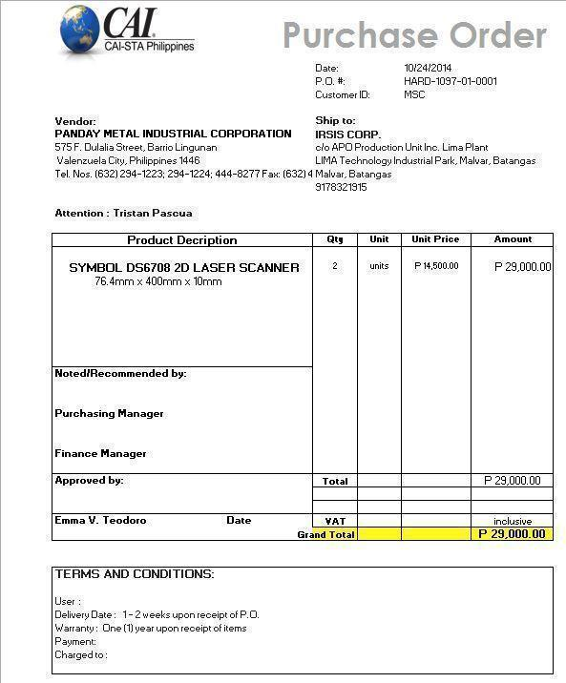

**C-2. Inventory Forms**

The inventory form is accomplished by either the manager or the technician upon receiving the items.

**C-2.1. Desktop Inventory Form**

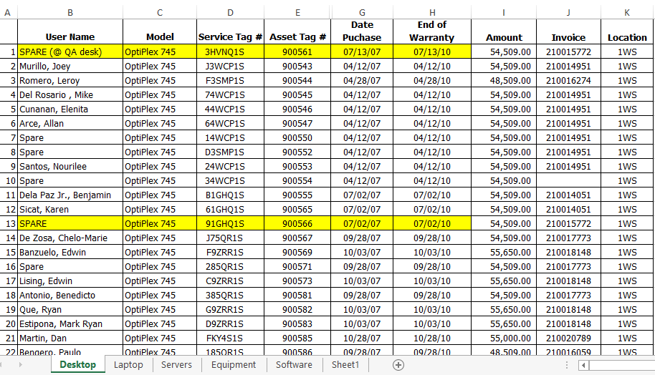

**C-2.2. Laptop Inventory Form**

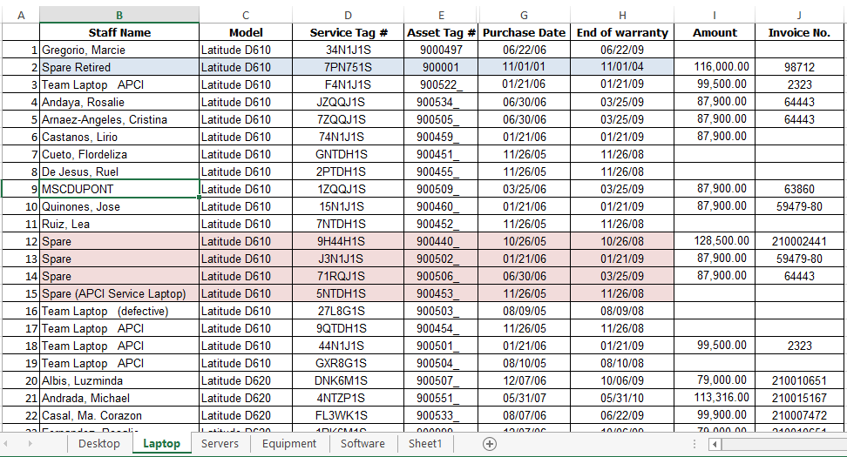

**C-2.3. Server Inventory Form**

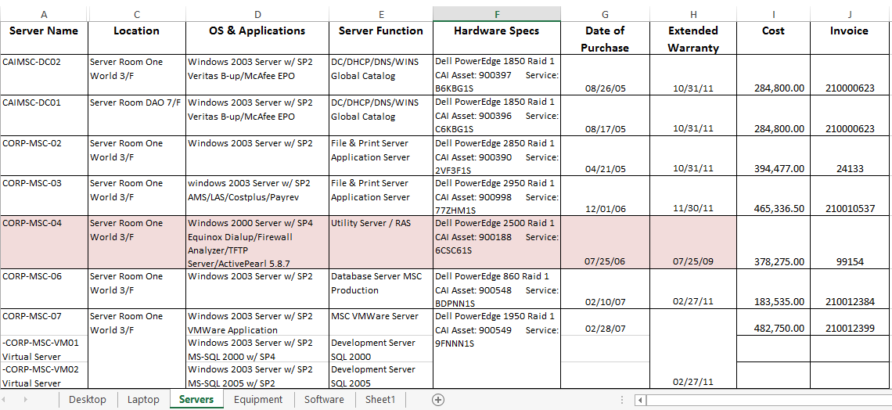

**C-2.4. Equipment Inventory Form**

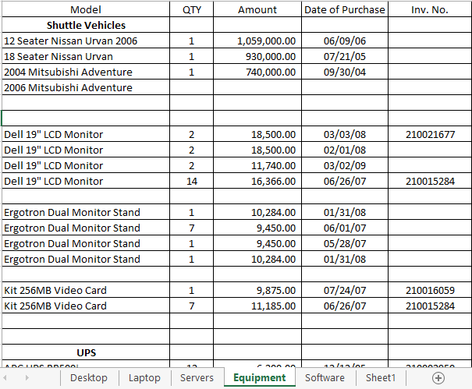

**C-2.5. Software Inventory Form**

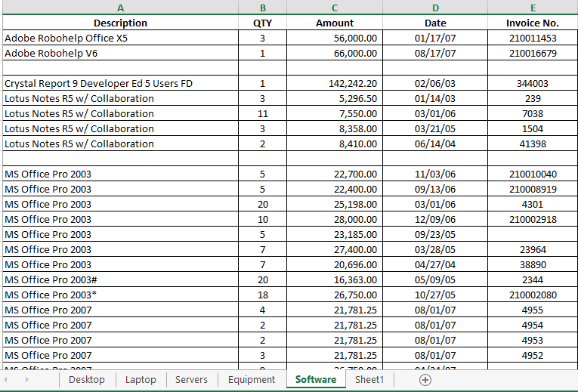

**C-3. Contract Form**

The contract form is accomplished by the manager if an item is classified as an IT asset.

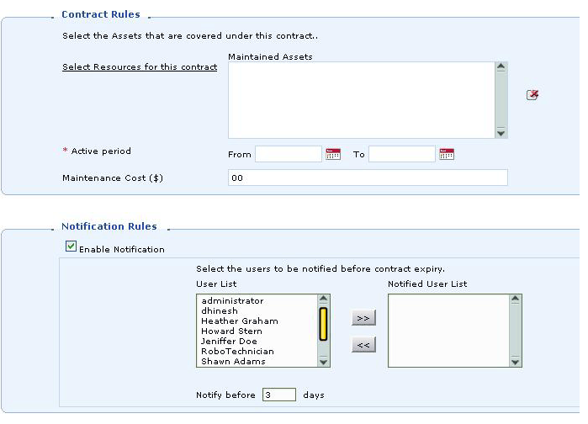

**C-4. Additional Details Provided by the Company**

The following includes additional details provided by the company through an e-mail correspondence involving Purchase Order details, Asset Management, and tracking of Inventory Reports.

**1. Purchase Order – includes**

* P.O. No. – (pre-numbered)
* Ø HARD-1097-15-0001 – Hardware
* Ø SOFT-1097-15-0001- Software
* Ø GEN-1097-15-0001 – General Items
* Supplier’s Name and Address
* Tracking of all Purchase Order
* Purchase order currency for foreign purchase orders
* Receives items from Purchase Orders and move them to asset inventory upon delivery of items
* Keep track of outstanding POs and completed purchases.

## 2. Asset Management

* Tracking the complete life cycle of the assets – including location
* Get the complete ownership and history for all assets
* Tracks contract information of all assets and notify on lease expiry - Set up e-mail notifications to renew contracts before expiry.
* Get **one view** of all your IT assets, Non-IT assets, components and consumables
* Import any type of asset from **CSV** files

**3.** **Inventory Reports – Tracking**

* Assets by Product Types
* Assets by Service Tag No.
* Assets by Asset Tag No.
* Assets by Expiry Date
* Assets by User Name
* Assets by Project Name
* Unassigned Assets (by Product Type)
* Assets in Contract (by Product Type)
* Assets not in Contract (by Product Type)

**Appendix D – References and Acknowledgement**

CAI-STA Philippines. (n.d.). from CAI: http://www.compaid.com/WhoWeAre/locations/philippines.aspx

We would like to acknowledge Ms. Rosalie Fernandez; Office, Administration, and Purchasing Manager of CAI-STA, for accommodating the team for the interviews.