I. Installation

1. Download Unreal Engine 5.7
Download the Epic Games Launcher
Link: https://www.epicgames.com/site/home
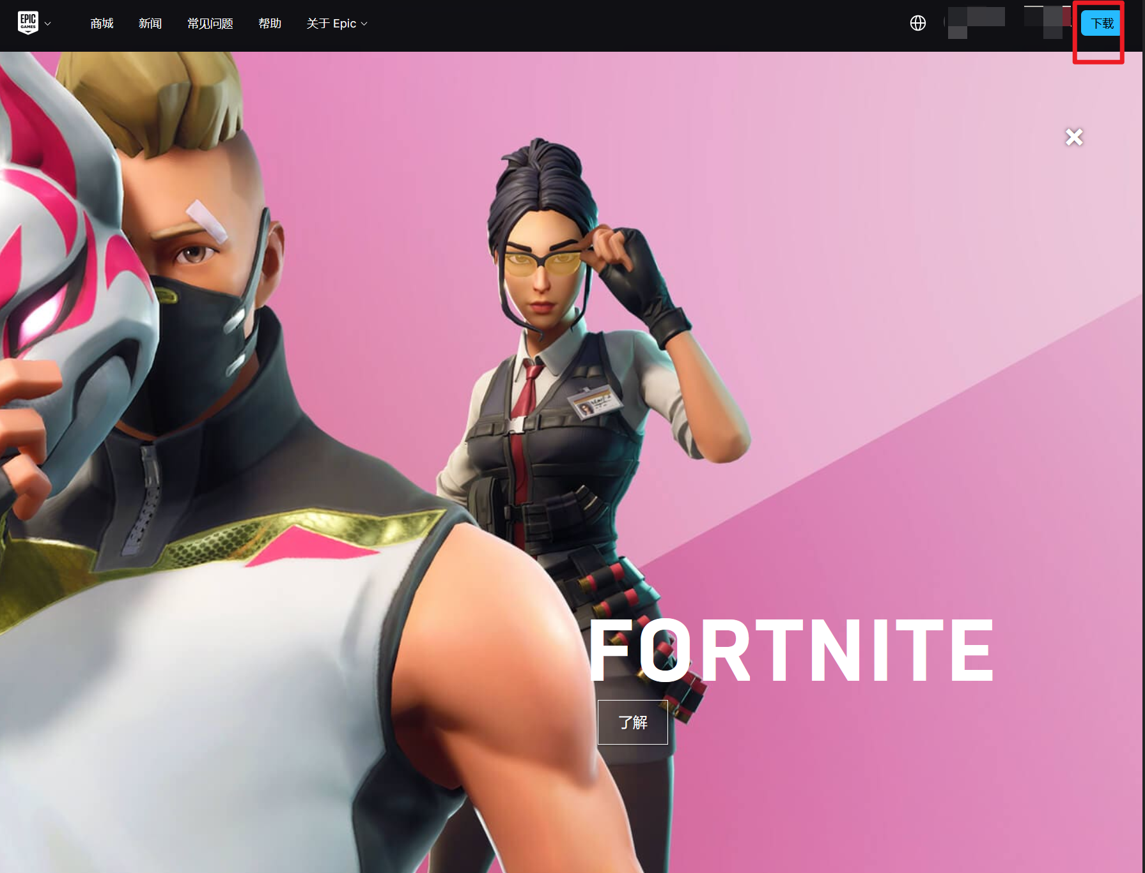
Open the launcher, select Unreal Engine > Library, and click the plus button next to Engine Versions.
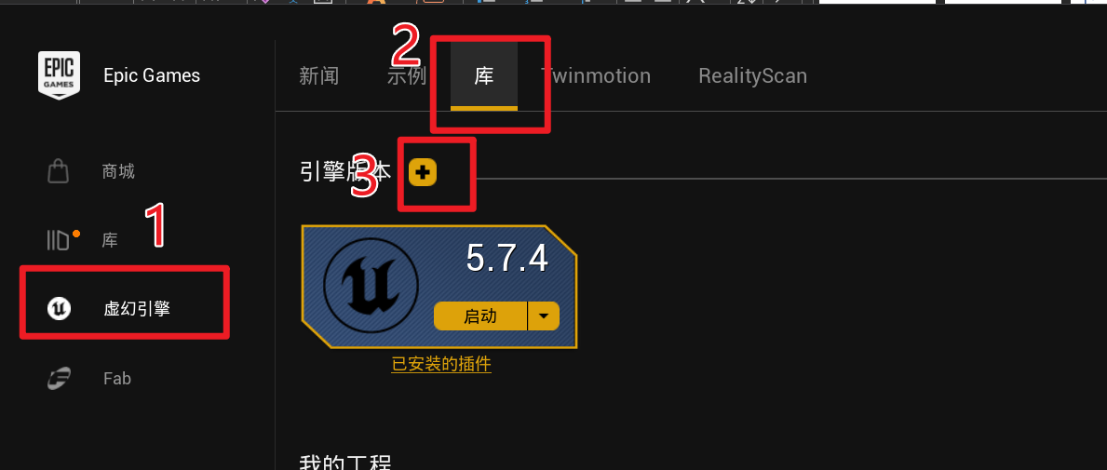
Open the version selector and choose 5.7.4. The screenshots do not show 5.7.4 in the drop-down because it is already installed on this computer.
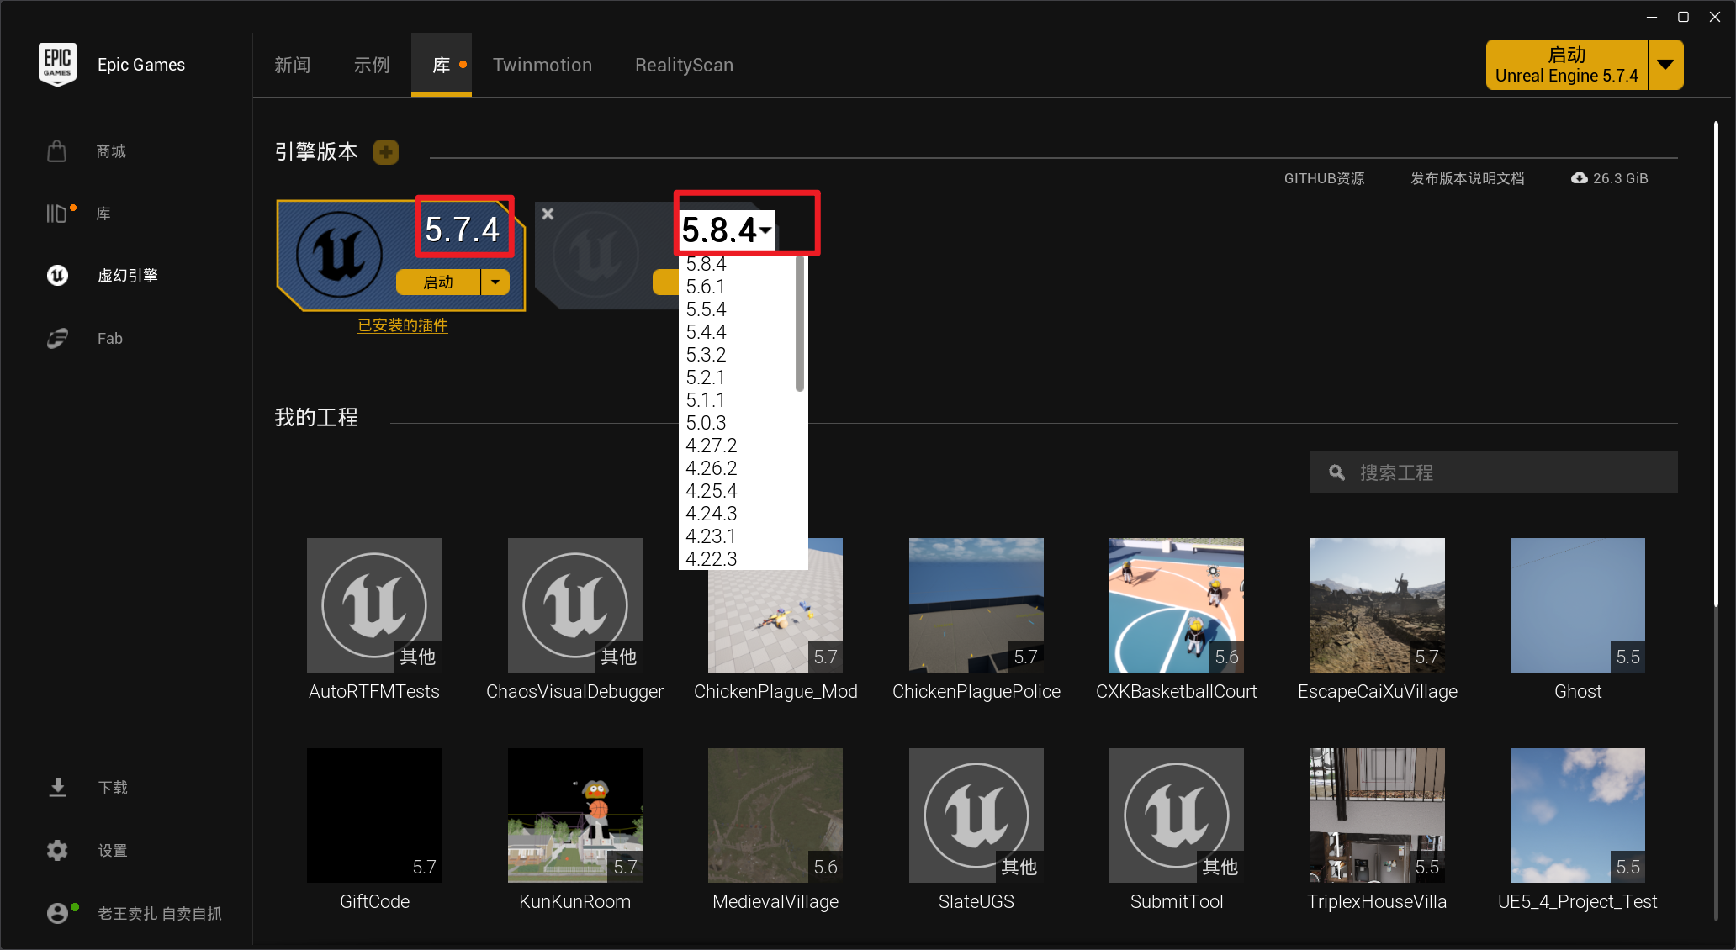
Choose the installation folder, then click Options.
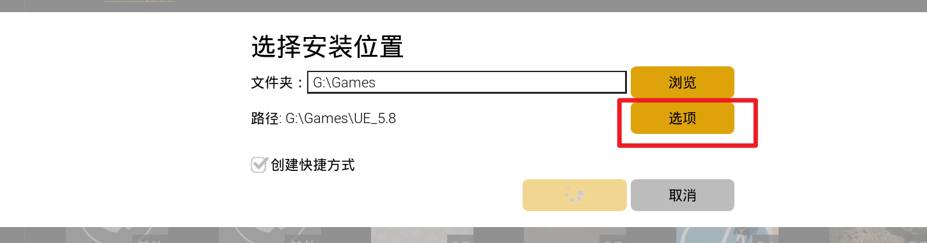
Clear every optional component and leave only the core components selected.
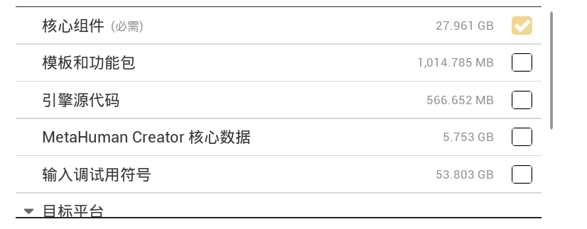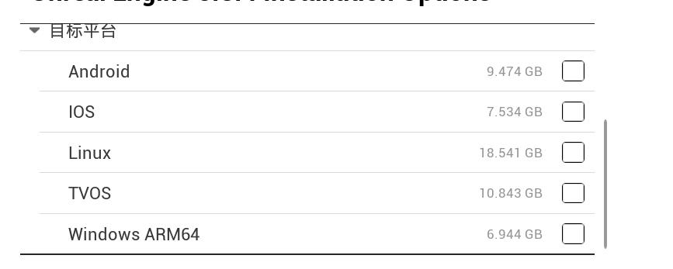
Then start the installation.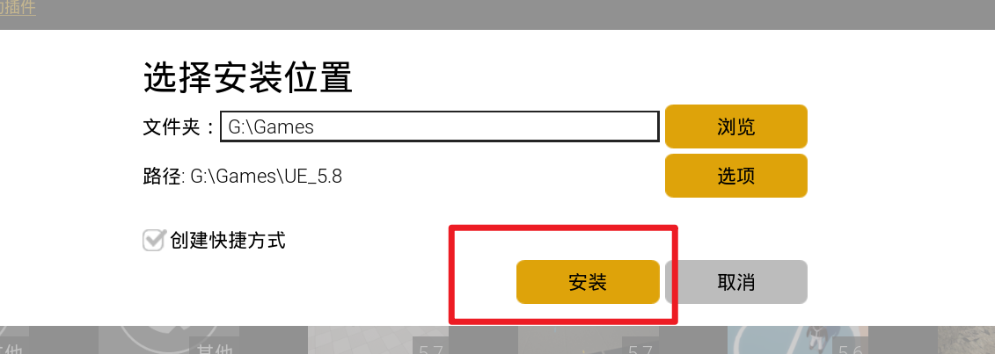

2. Open the Mod Project
Open this project with Unreal Engine 5.7.
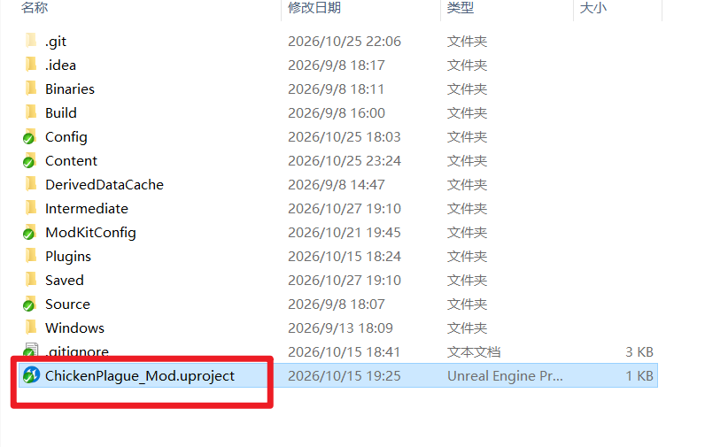
The default editor layout should look like this.
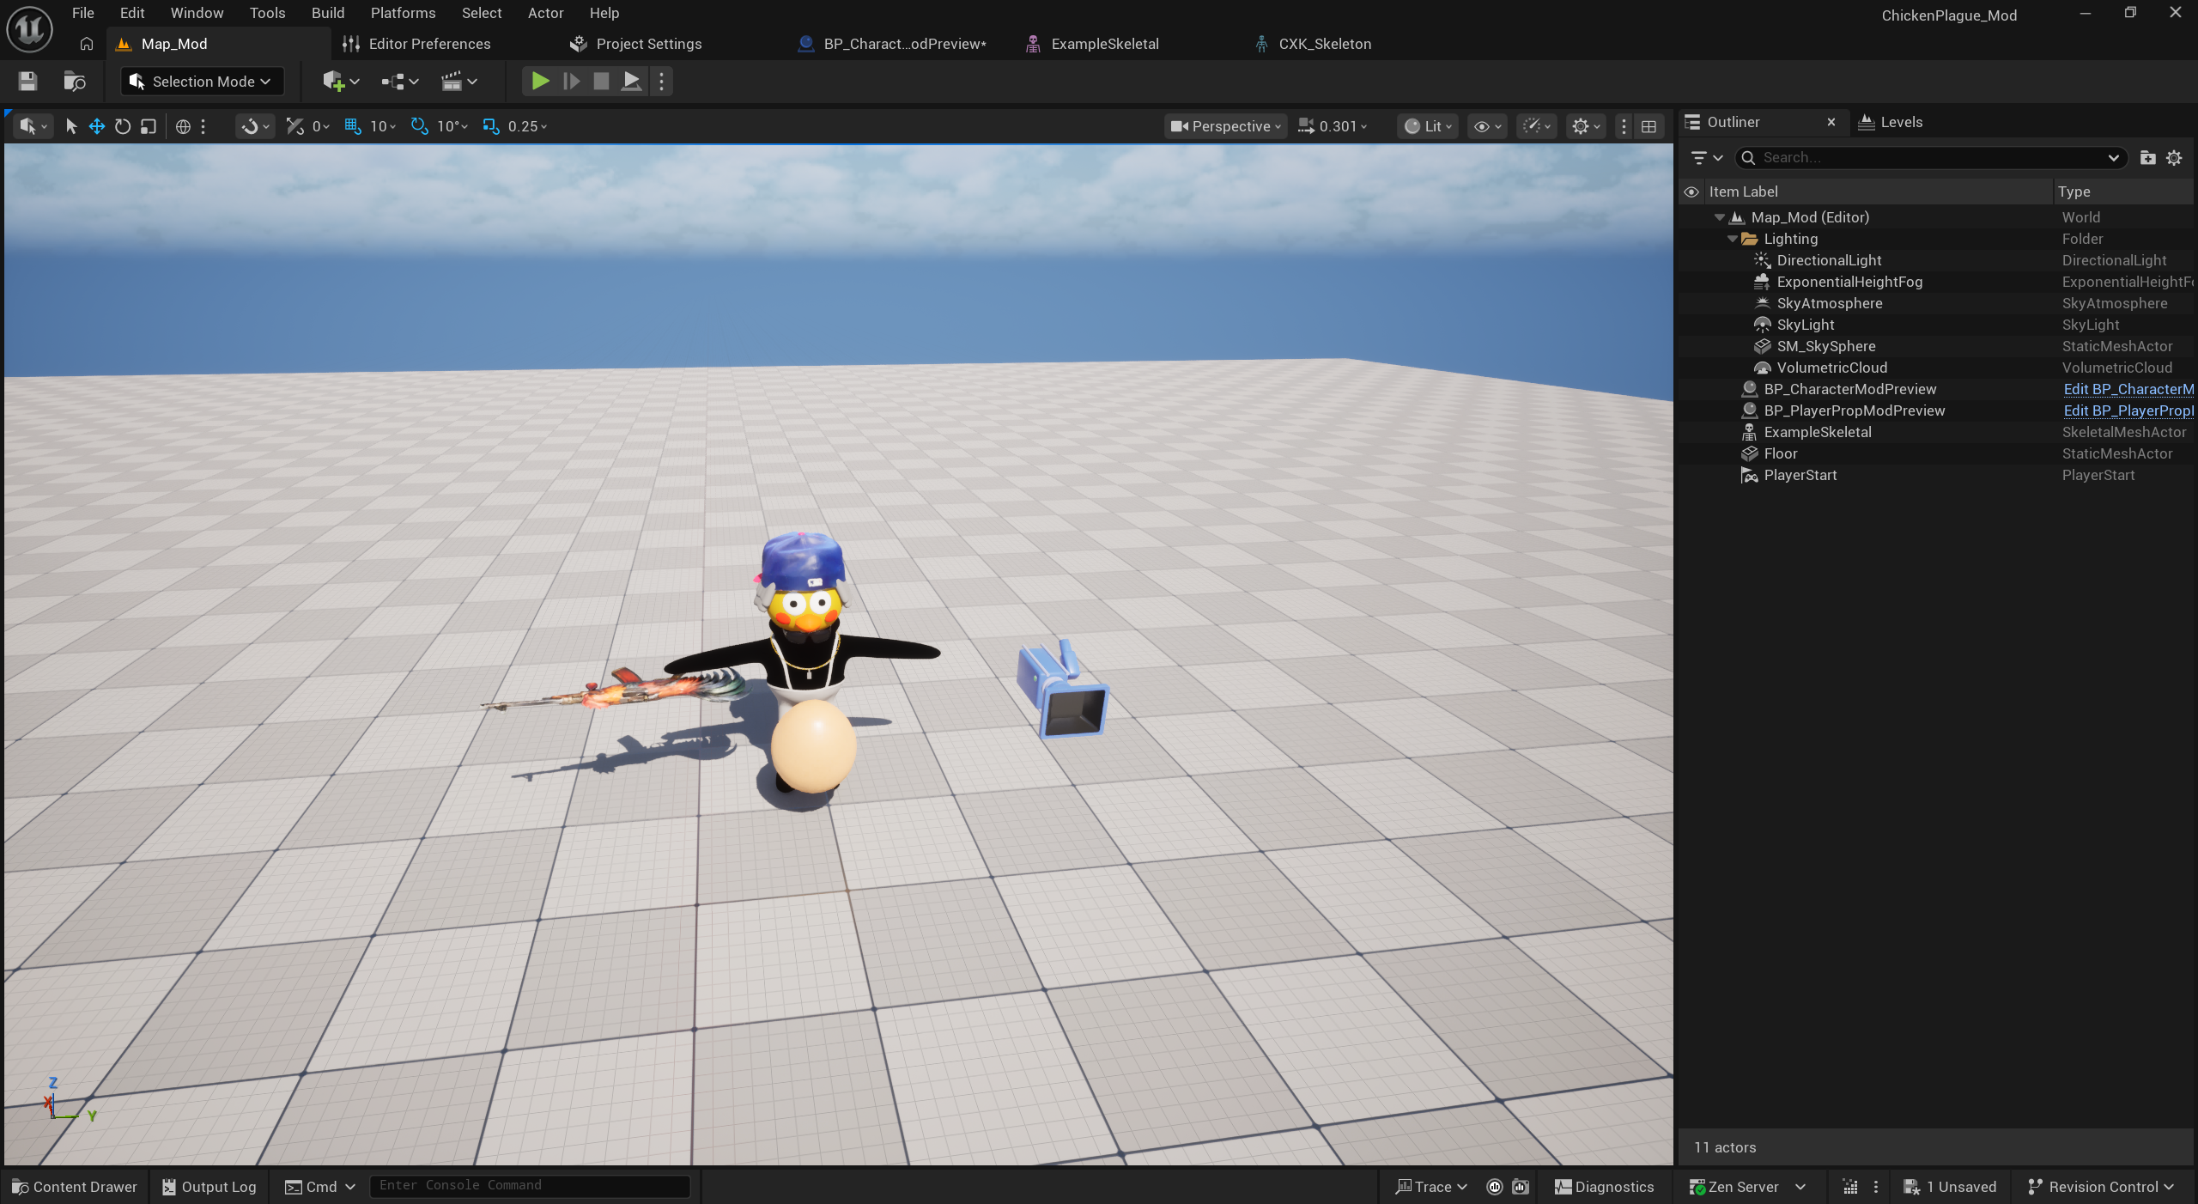
The important folders are shown below.
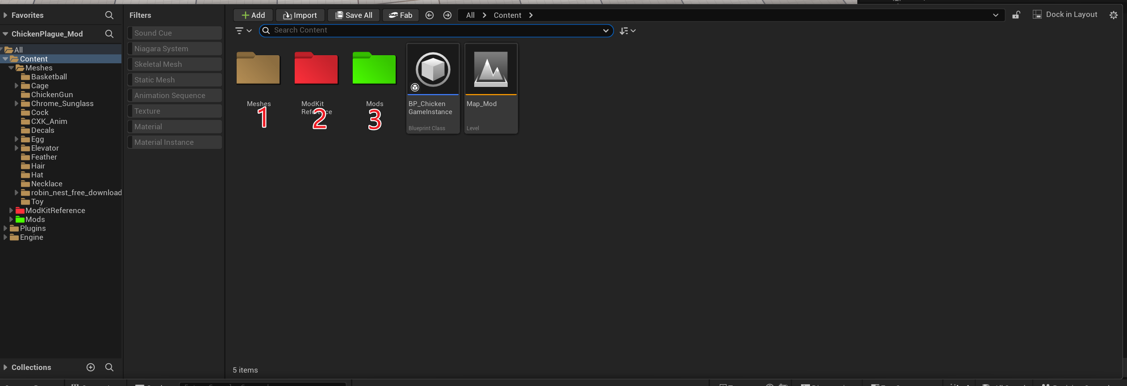
1: Ignore this folder. It contains references to assets from the release build.
2: Tools used while creating a mod.
3: The Mods folder. Every asset in your mod must be stored under Content/Mods/ModID/.
Do not modify Blueprint assets supplied with the project. Assets inside your own mod folder are the exception, and map mods may contain their own Blueprint assets.

II. ModKit Tools

1. Tool Overview
Open the ModKit tool.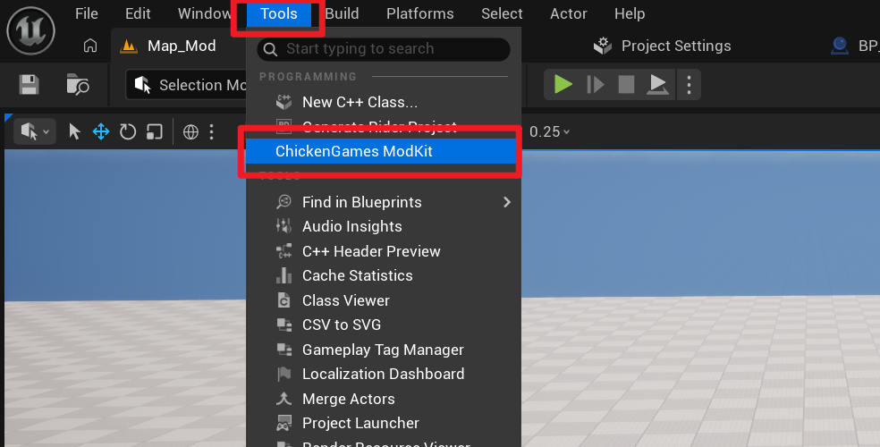
Main functions:
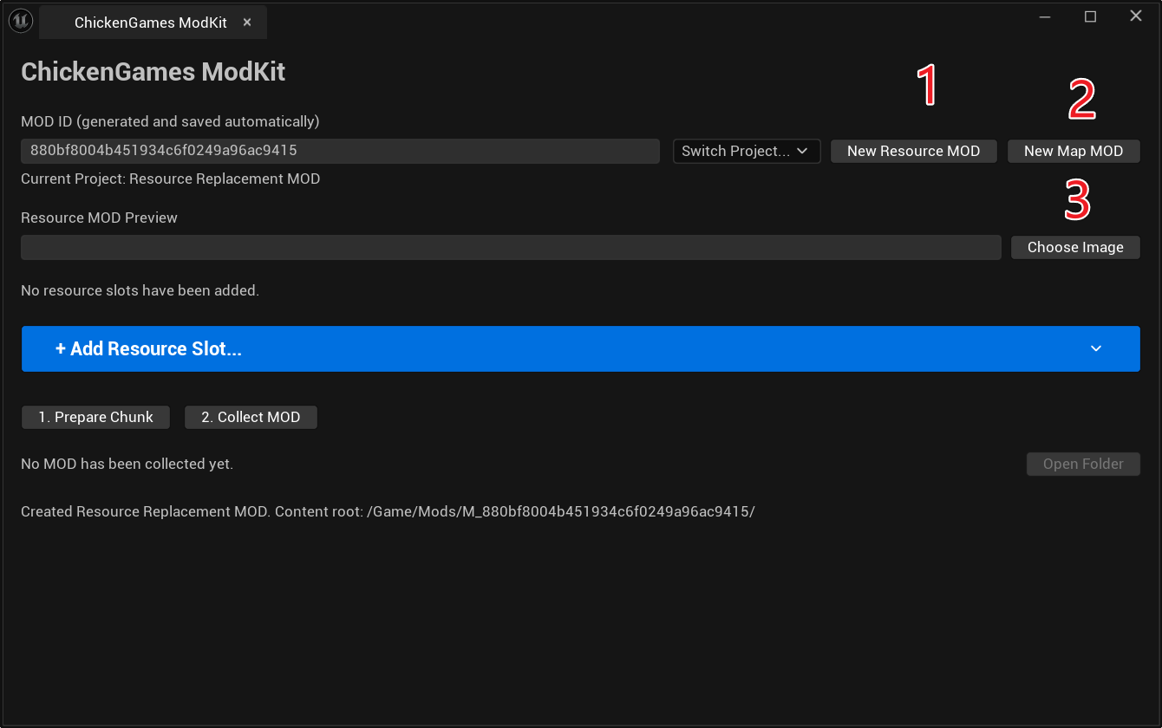
1: Create an asset mod.
2: Create a map mod.
3: Select the thumbnail for a mod.

Use Switch Project to work on another project. You can also create and maintain multiple projects.
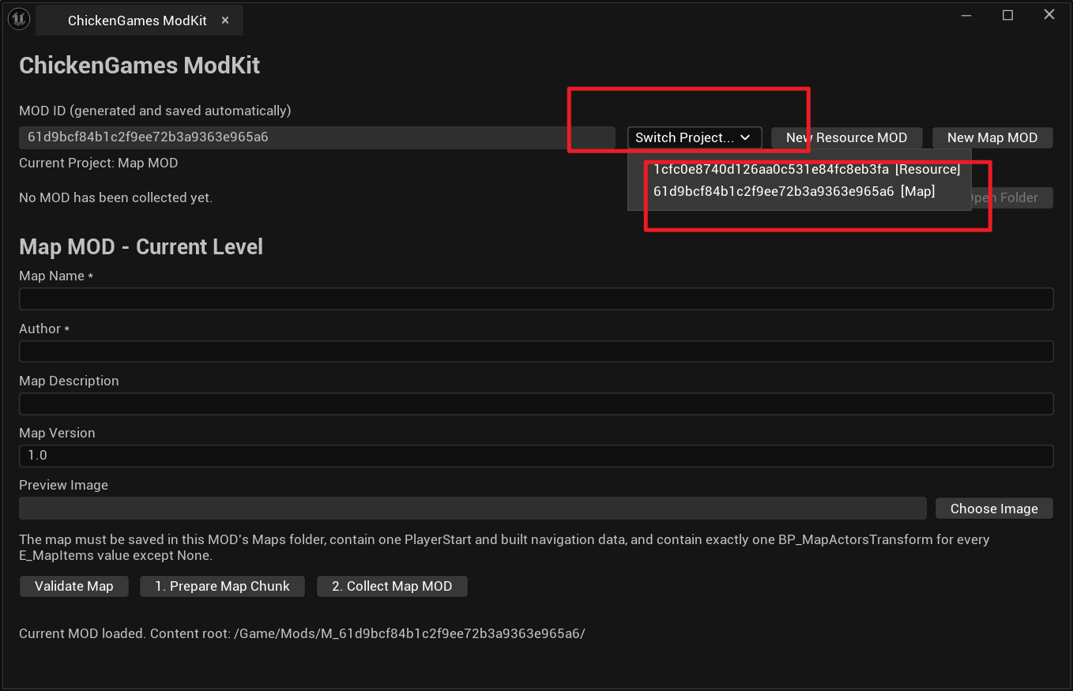

2. Create an Asset Mod
Click New Asset Mod.
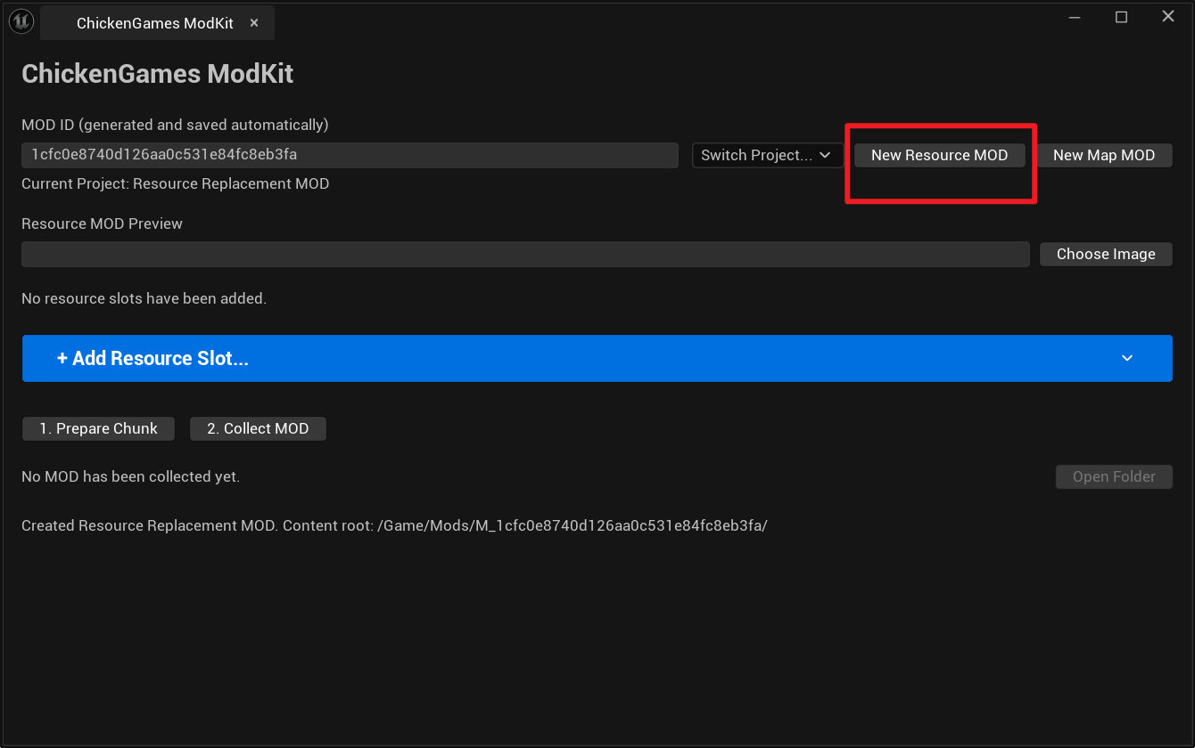
A folder matching the Mod ID will be created under the Mods folder. Put every asset used by this mod inside that folder.
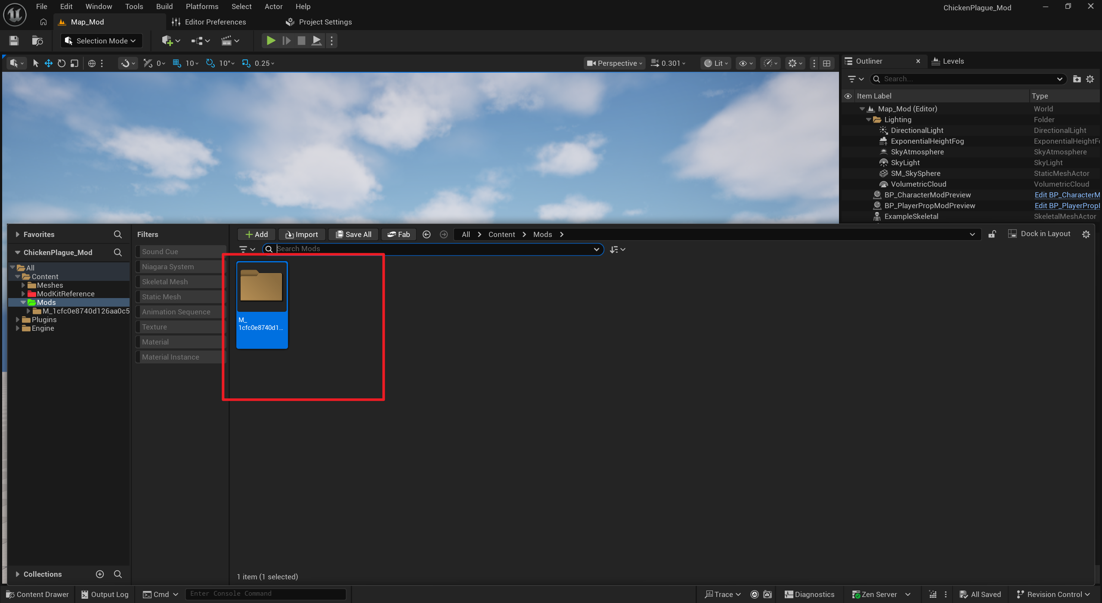

3. Create and Replace Assets

1. Character
Click Add Asset Slot.
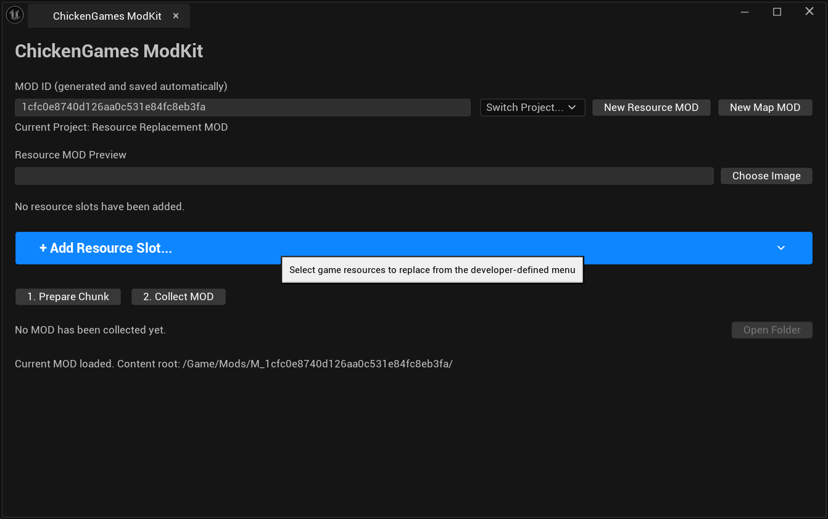
Choose the character you want to replace, then choose the replacement asset.
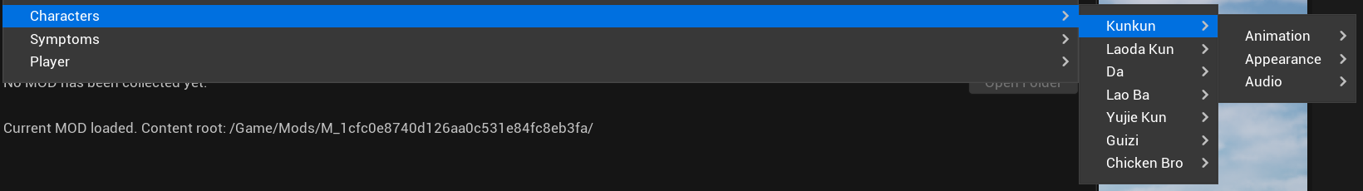

1. Replace the Skeletal Mesh
Export the reference model from this folder.
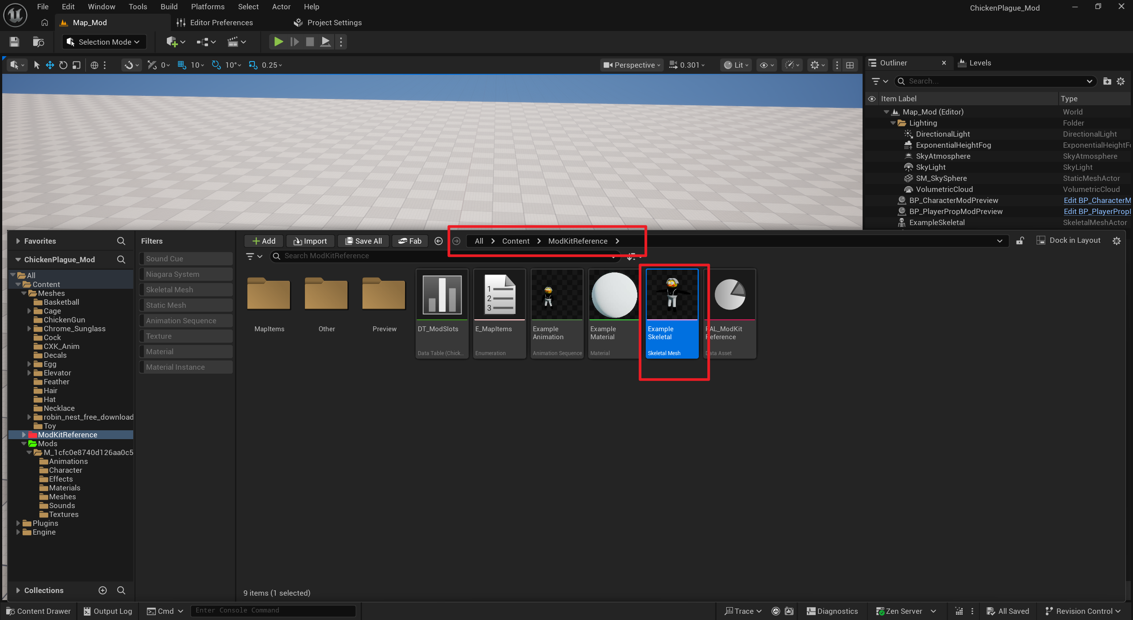
Right-click the asset and select Asset Actions > Export.
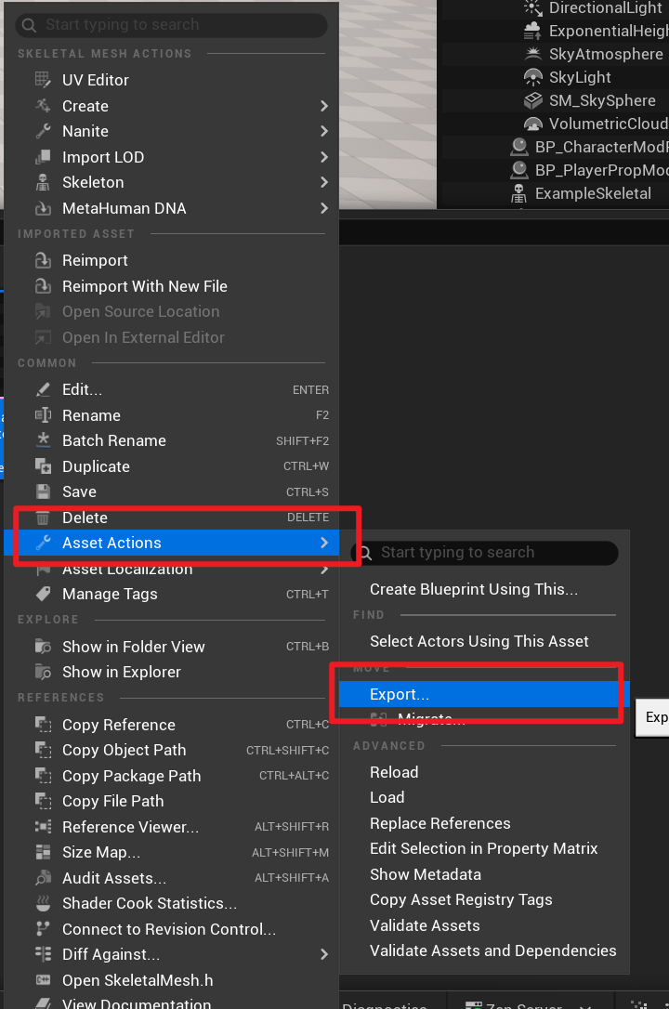
Choose a location, save the file, and confirm the export.
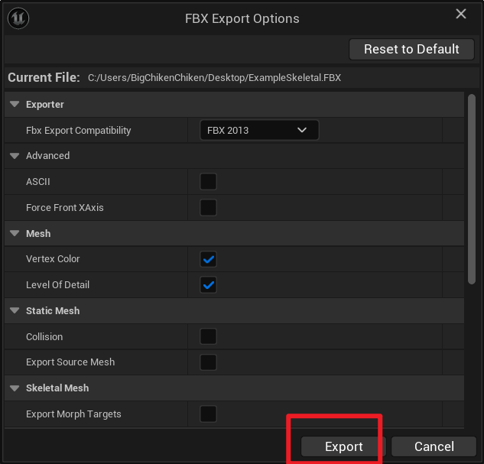
Open the exported file in your 3D modeling software.
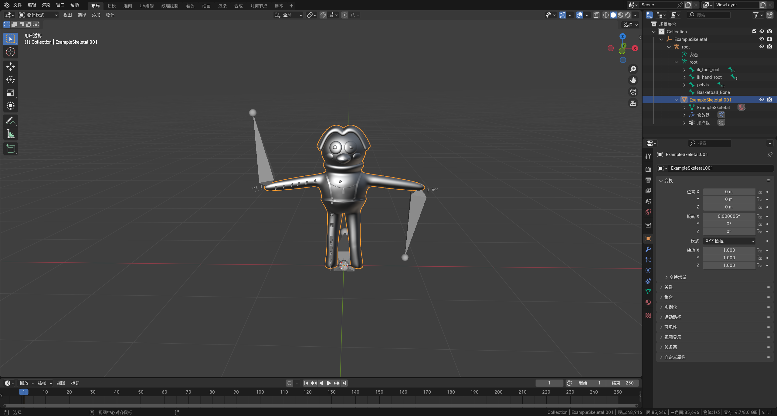
Delete the mesh geometry.
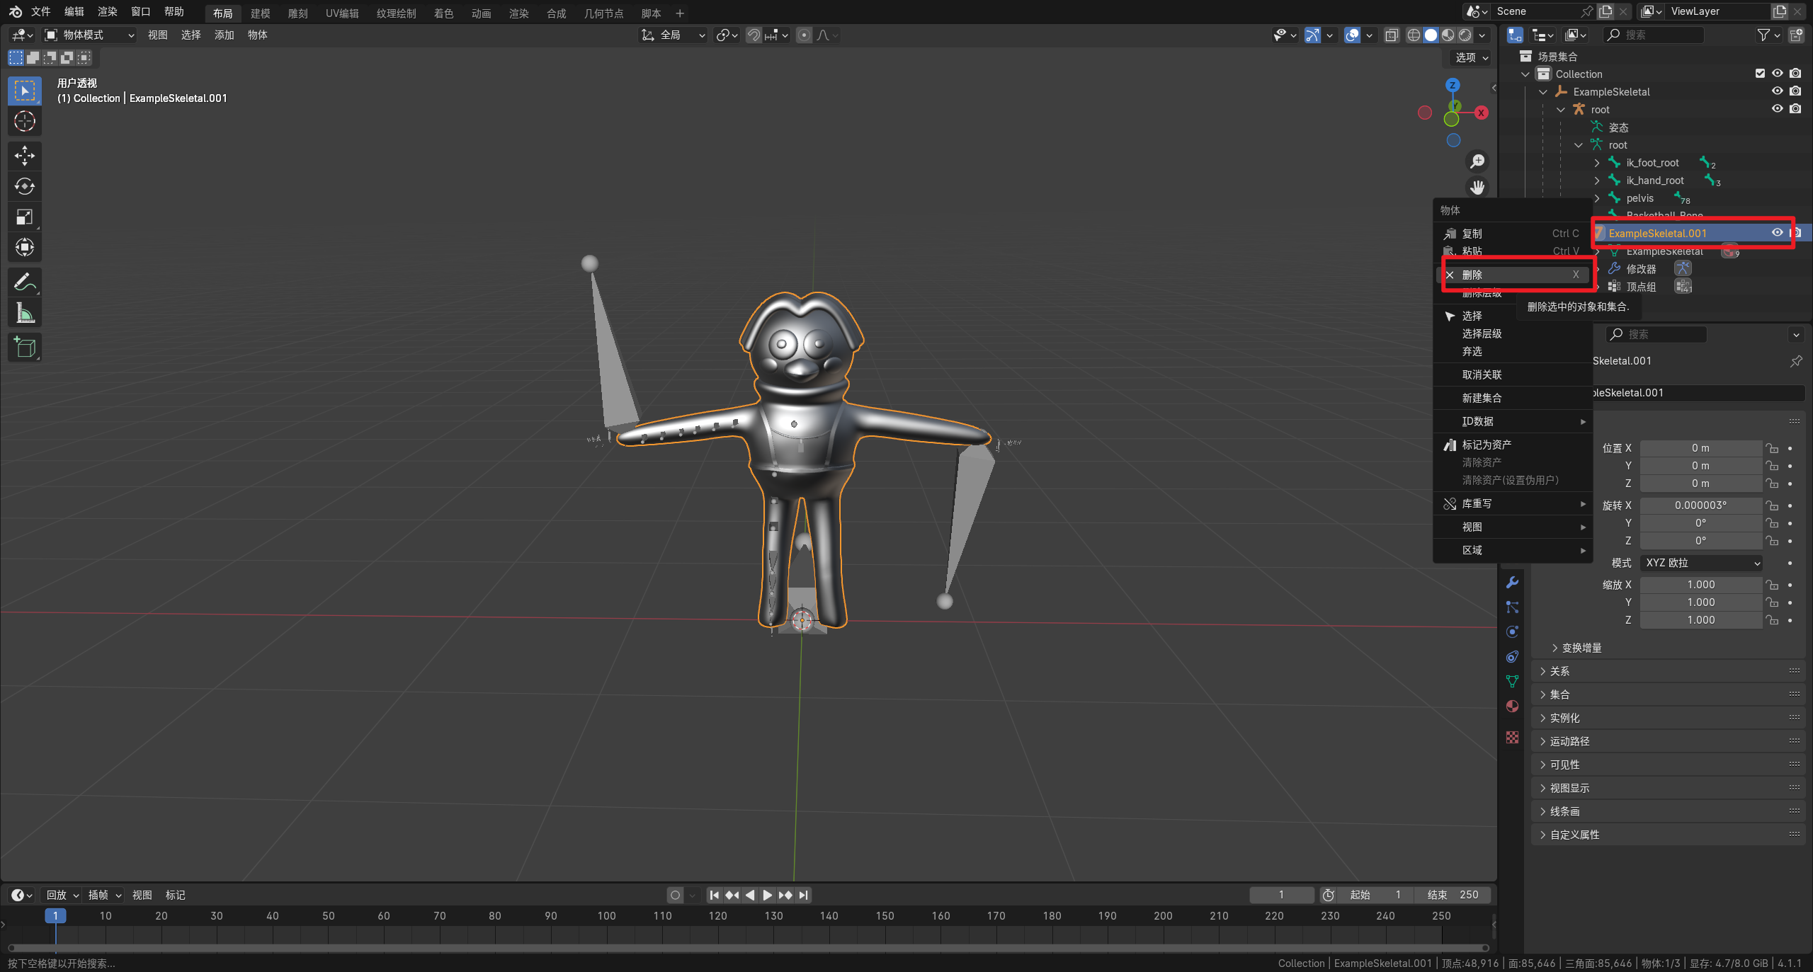
If the rig contains an ExampleSkeletal bone, select Root, clear its parent while keeping its transform, and then delete ExampleSkeletal.
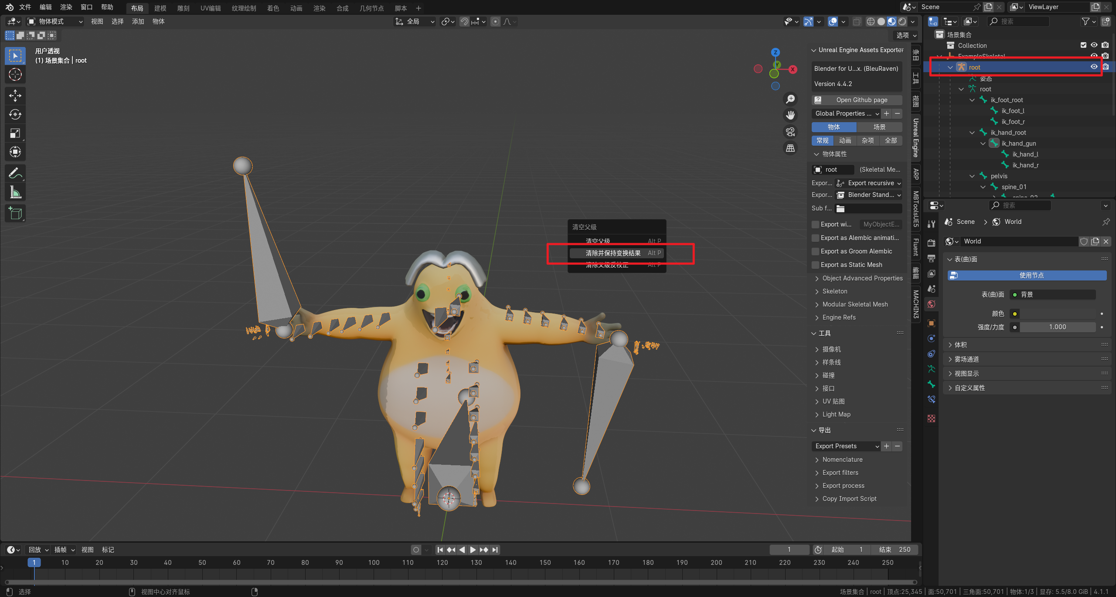
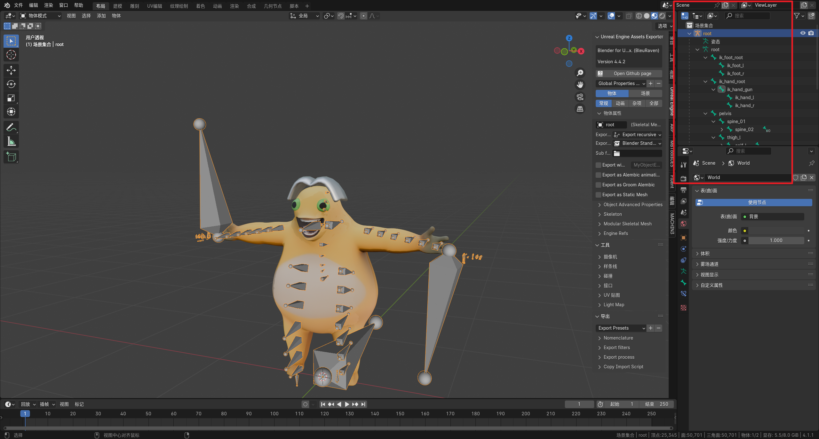

Import and bind your model. Avoid changing the skeleton or editing bone position and transform values.
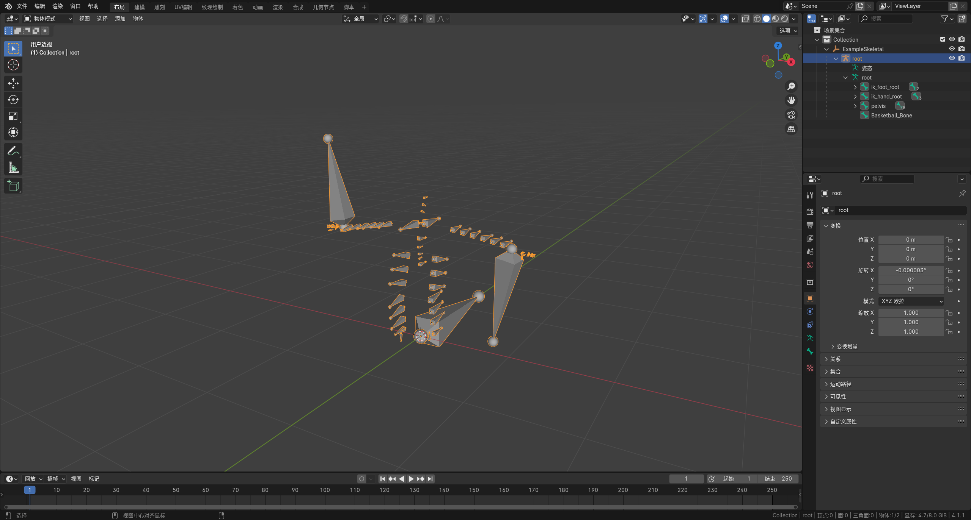
Set smoothing to Face, and disable Add Leaf Bones when exporting.
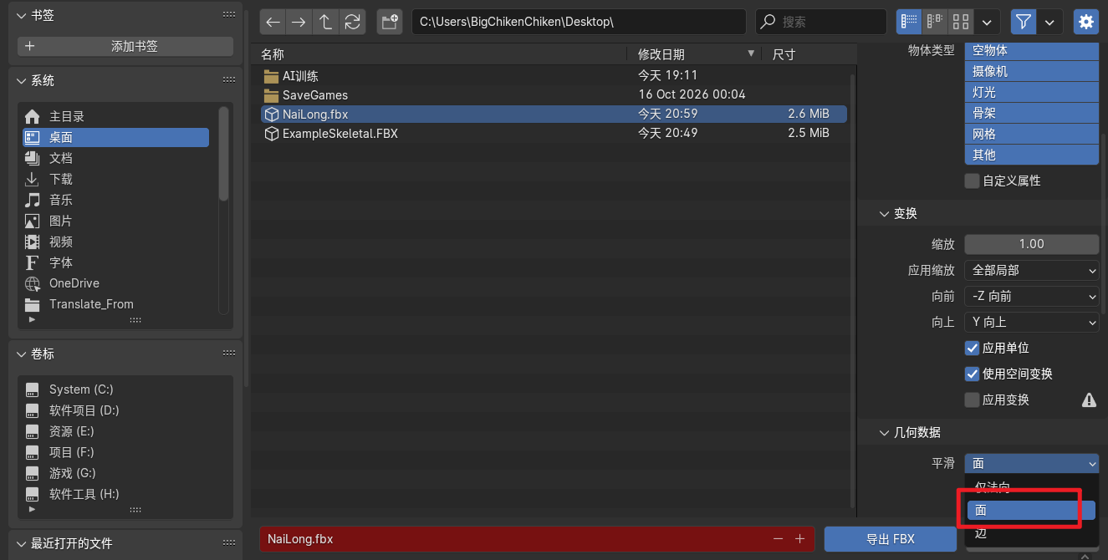
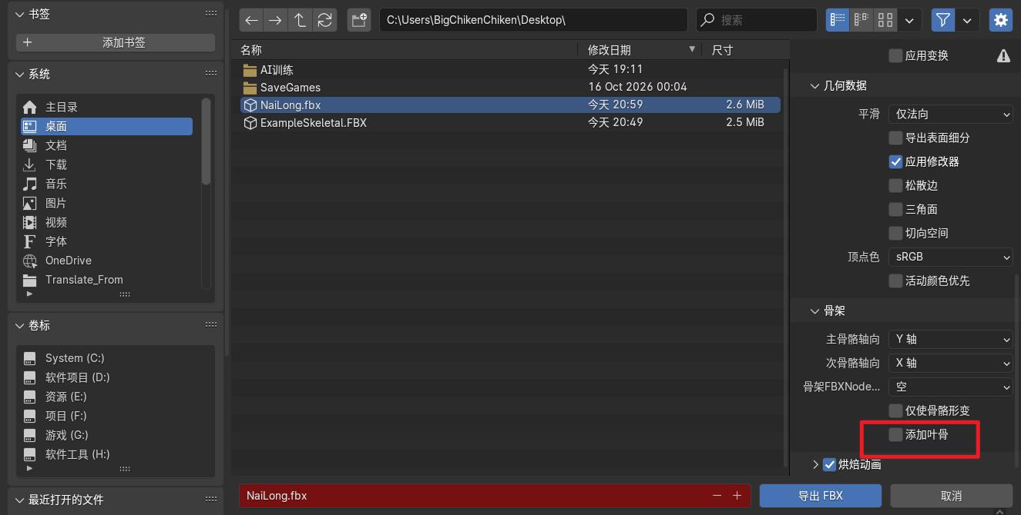
Drag the exported FBX into this folder and select this skeleton in the Skeleton field.
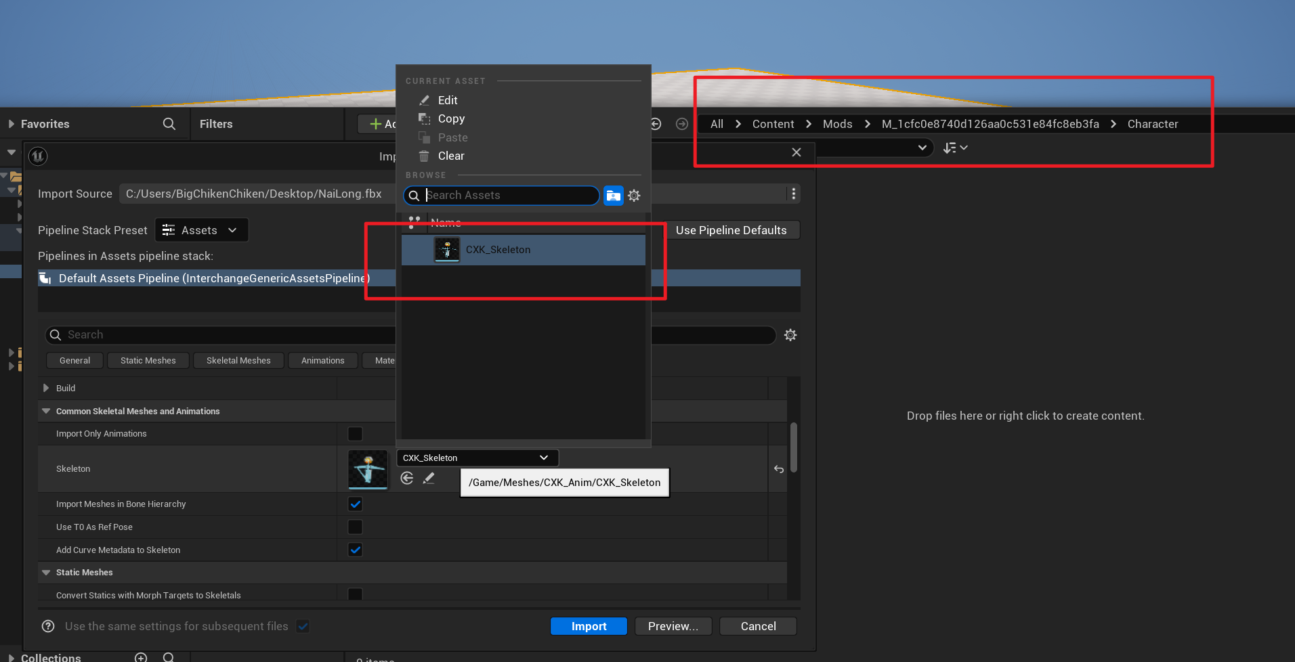
Import the textures.
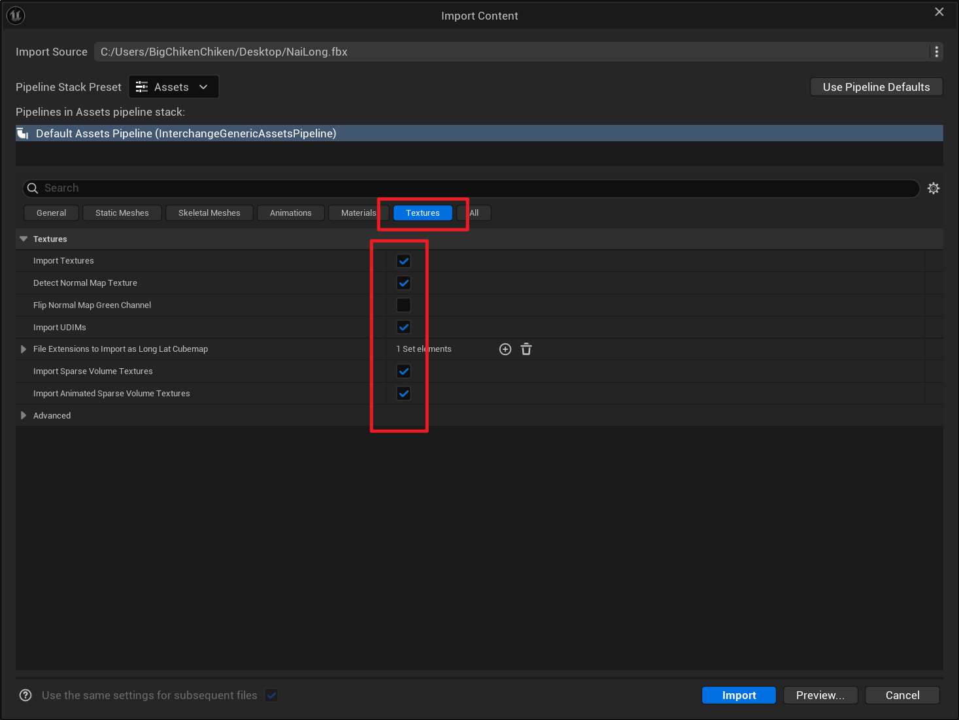
Import the materials.
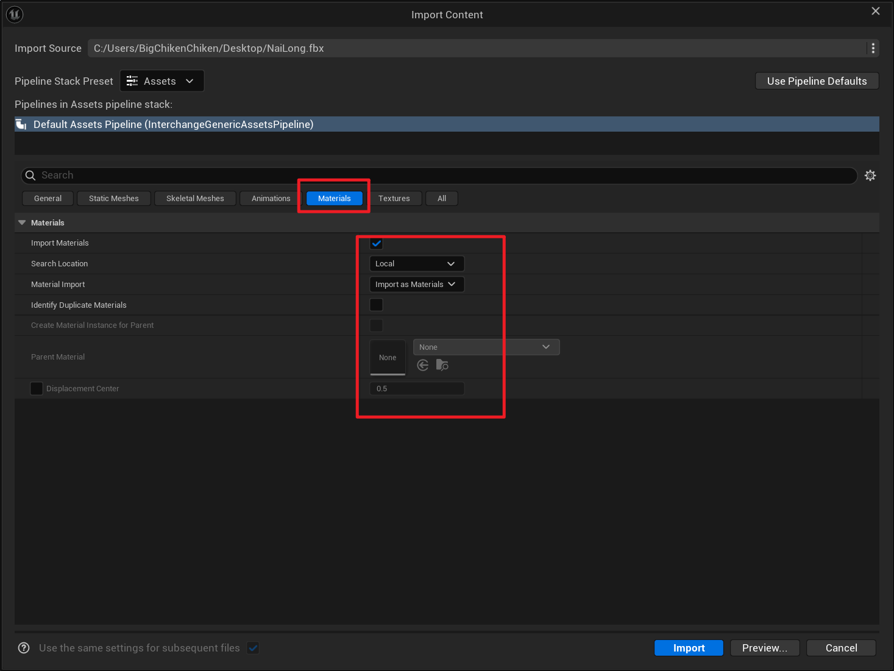
Click Import. The model should now import successfully.
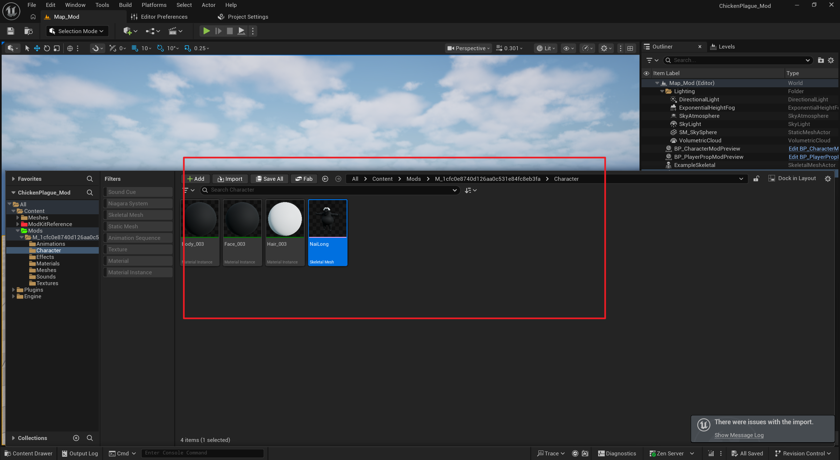
If a warning appears during import:
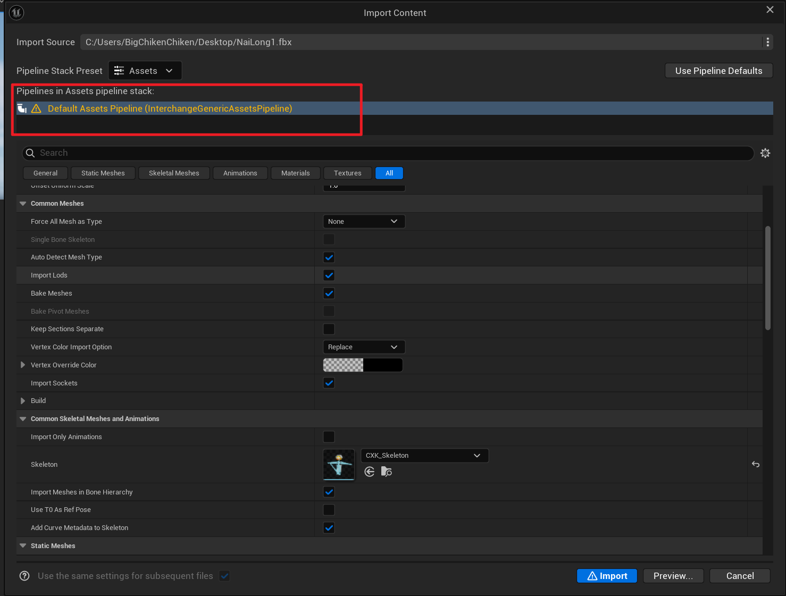
Scroll to the top and click Show Conflict.
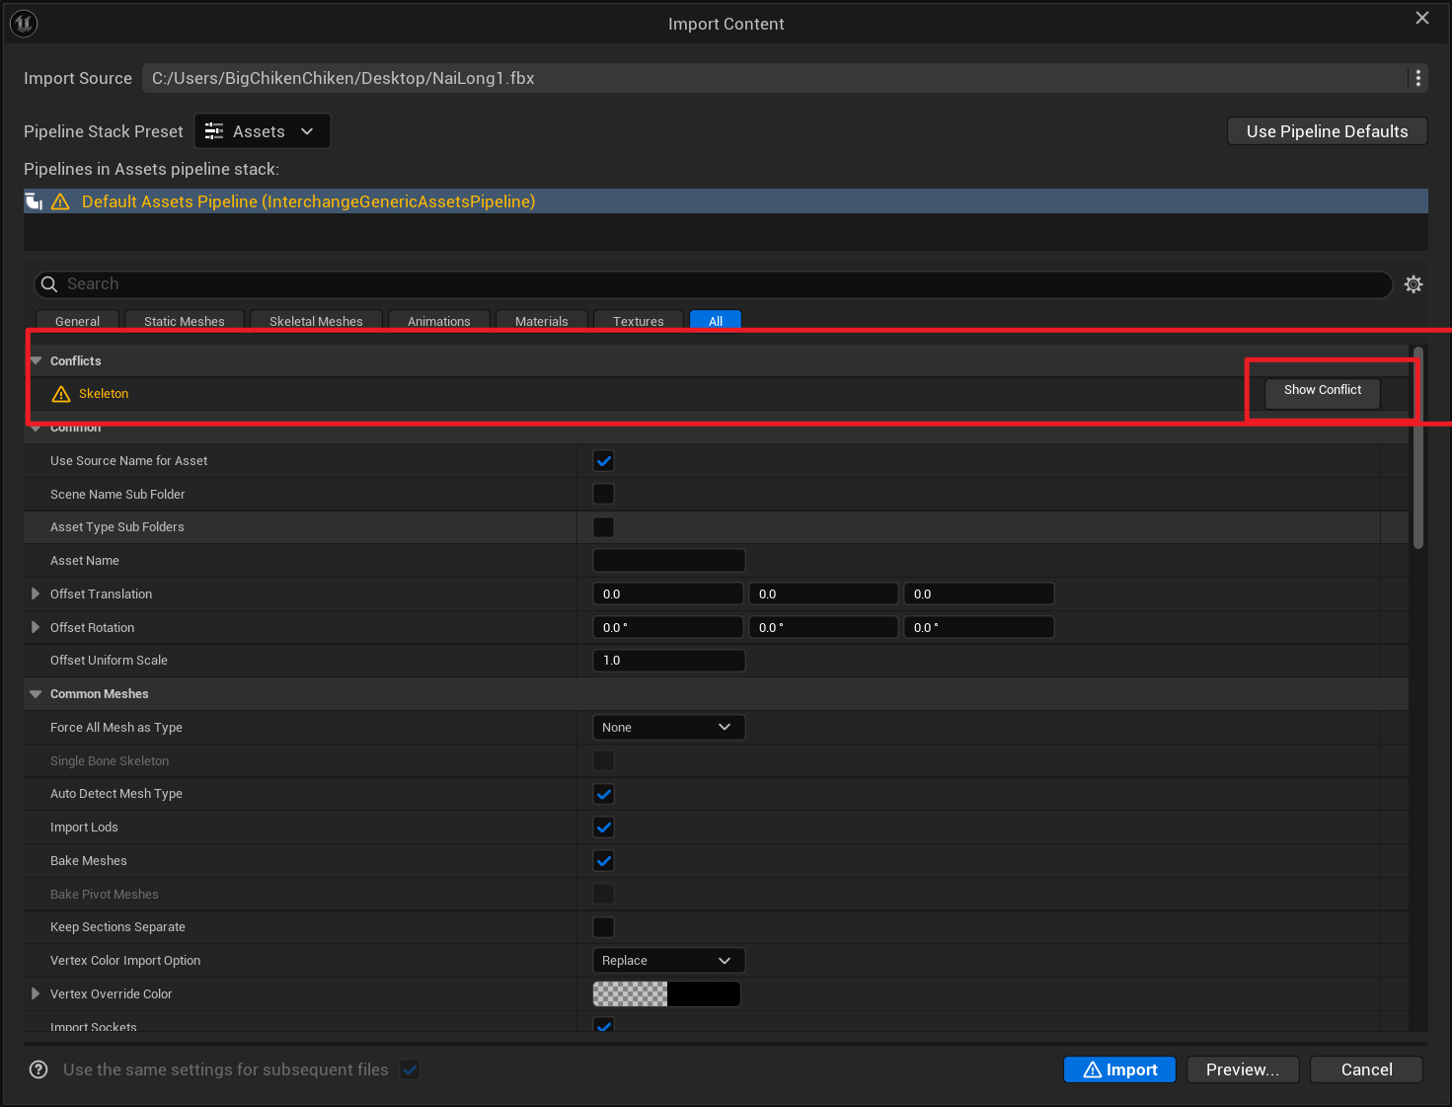
Compare the skeletons to see whether a bone is missing or has been added. In this example, the imported model contains an extra ExampleSkeletal bone. Delete the extra bone in your modeling software.
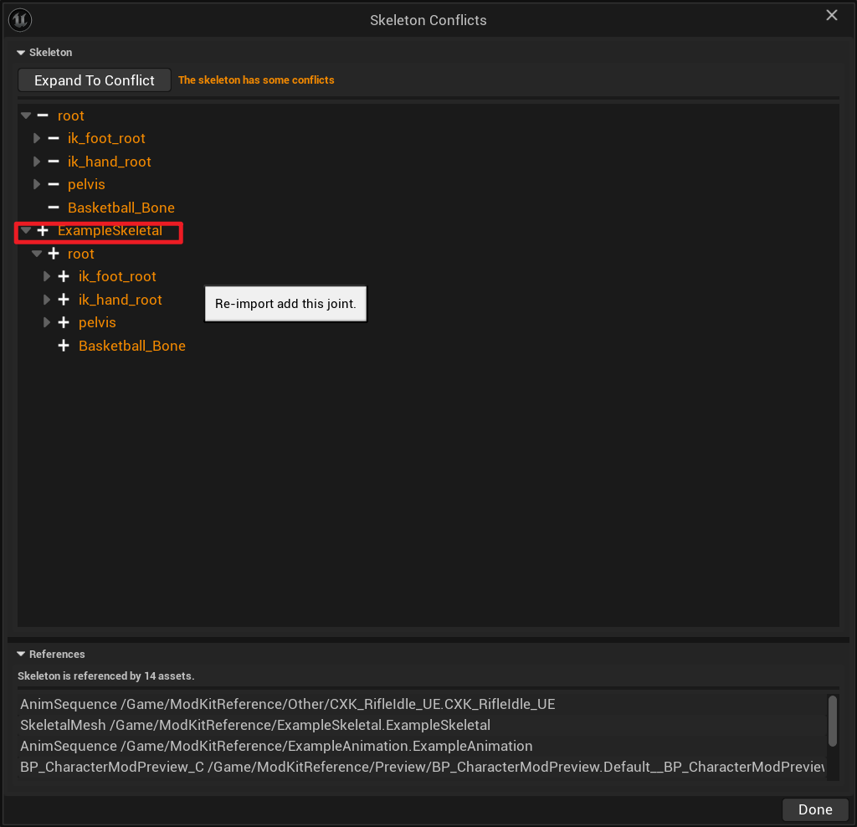
Return to the ModKit tool and add the Skeletal Mesh.
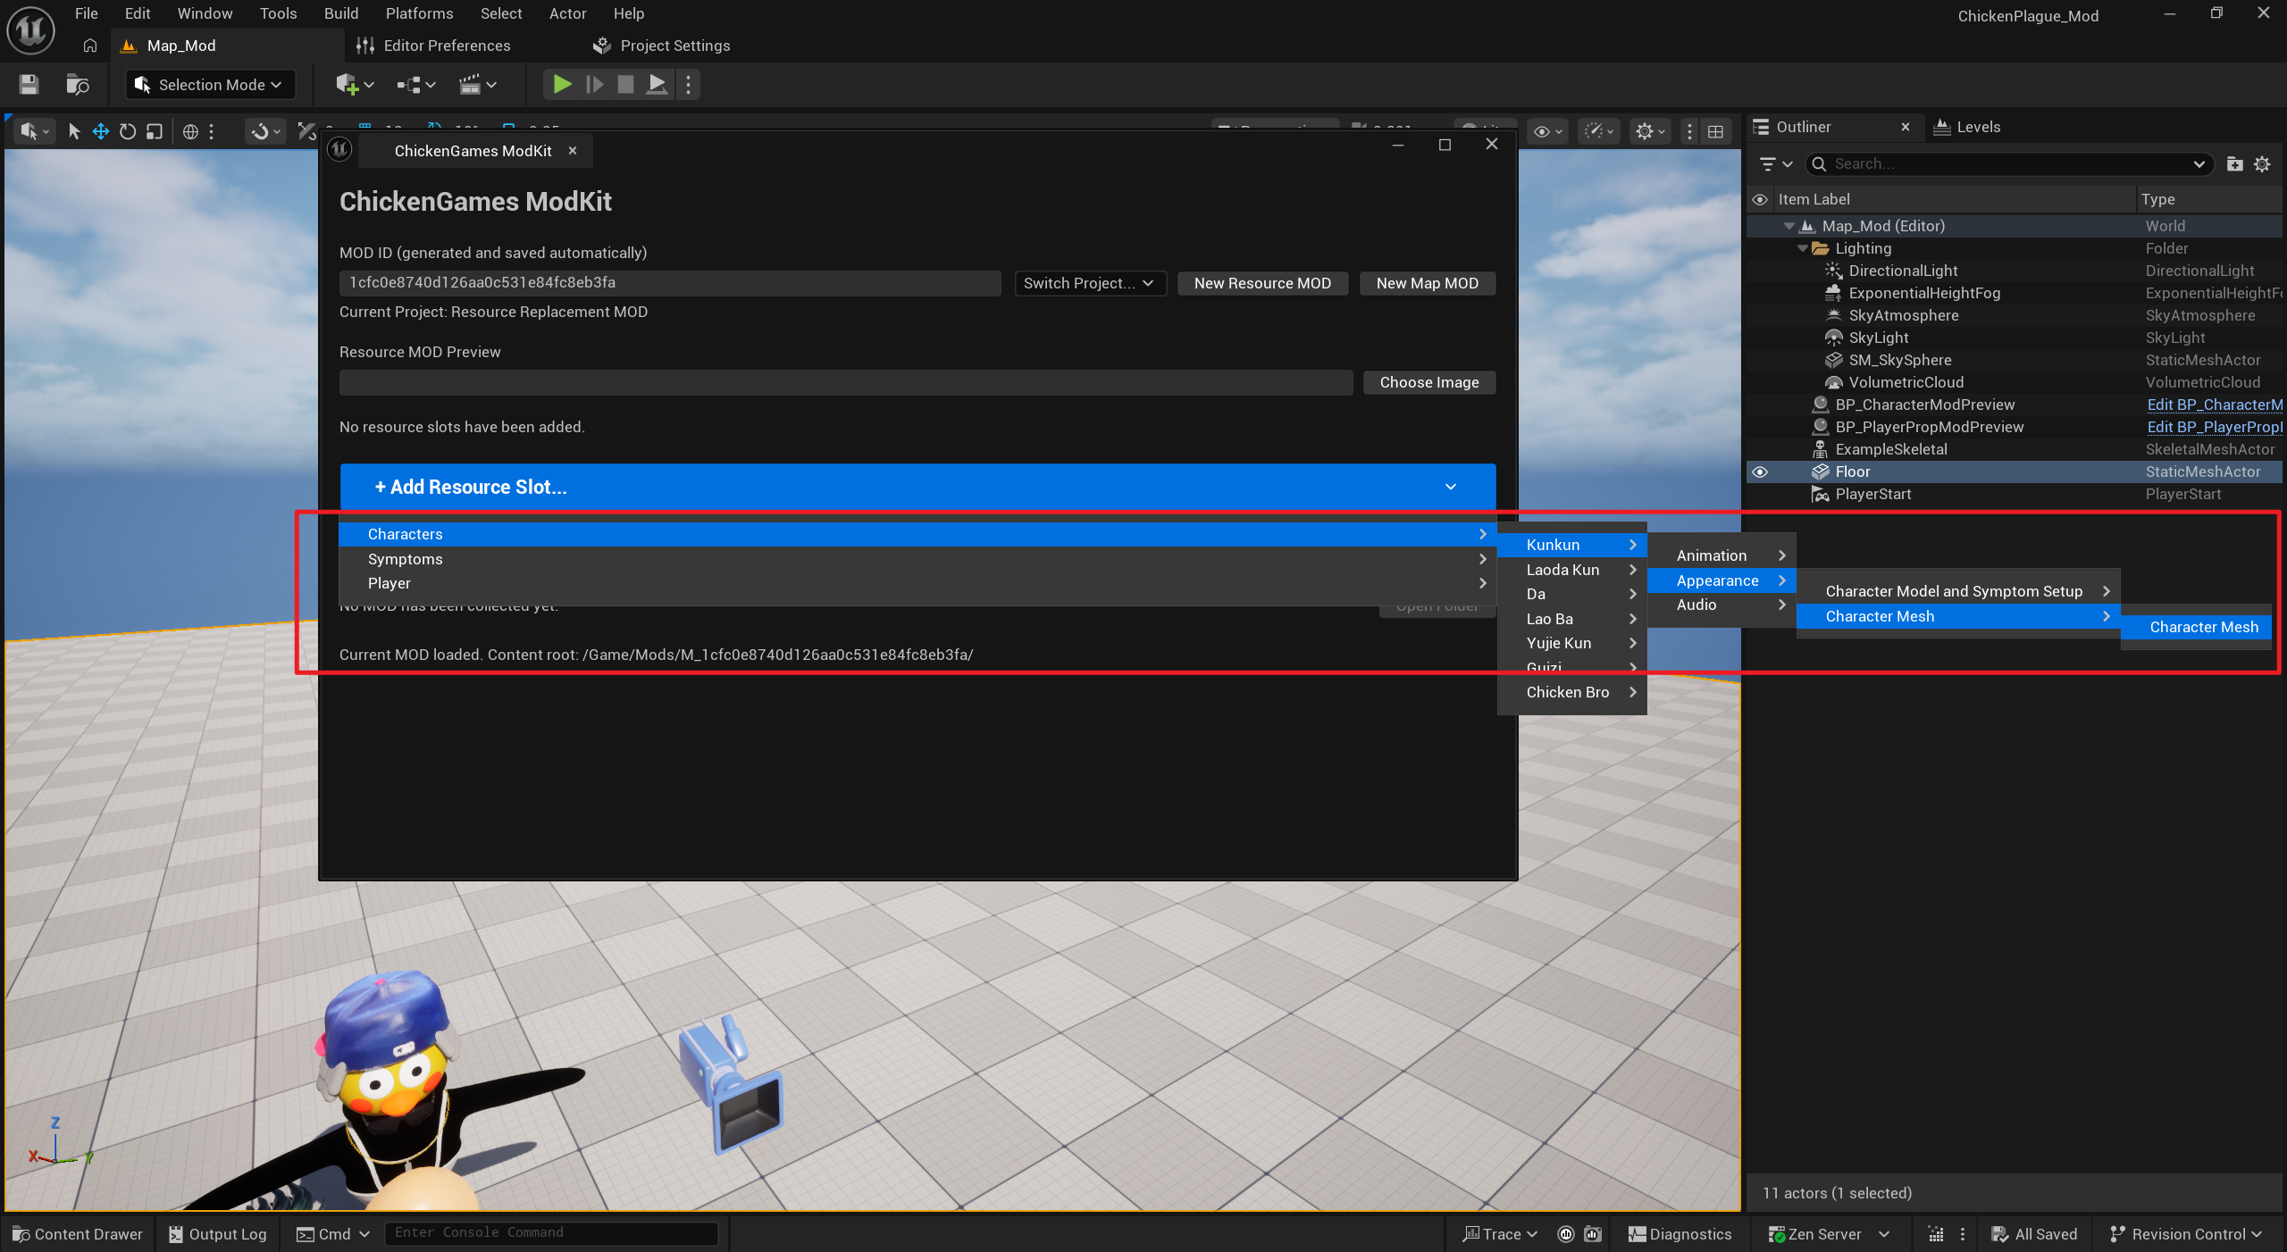
Click Add.
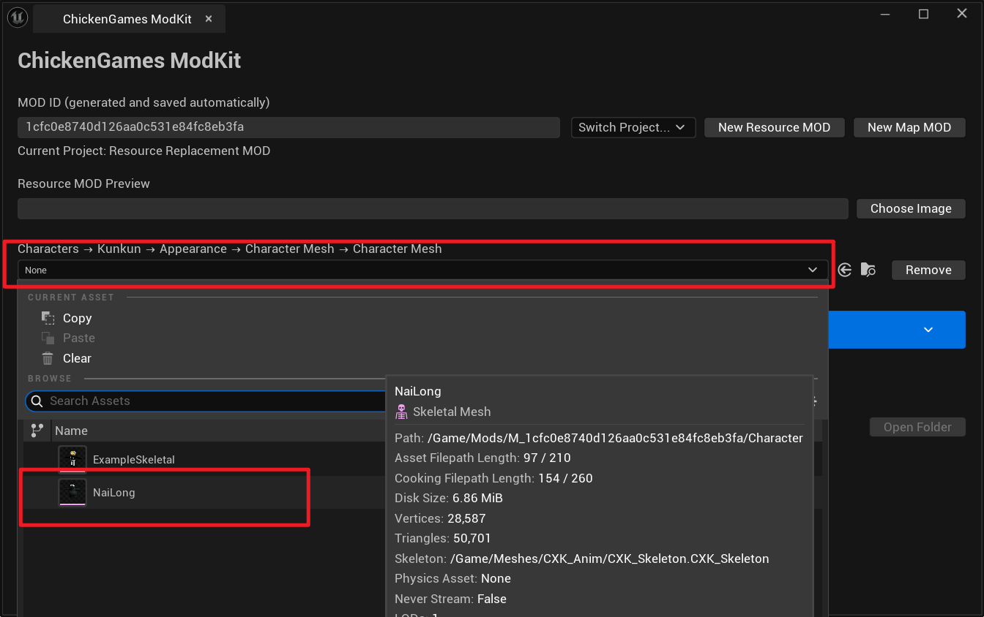
2. Adjust Attached Models
Select the character preview actor.
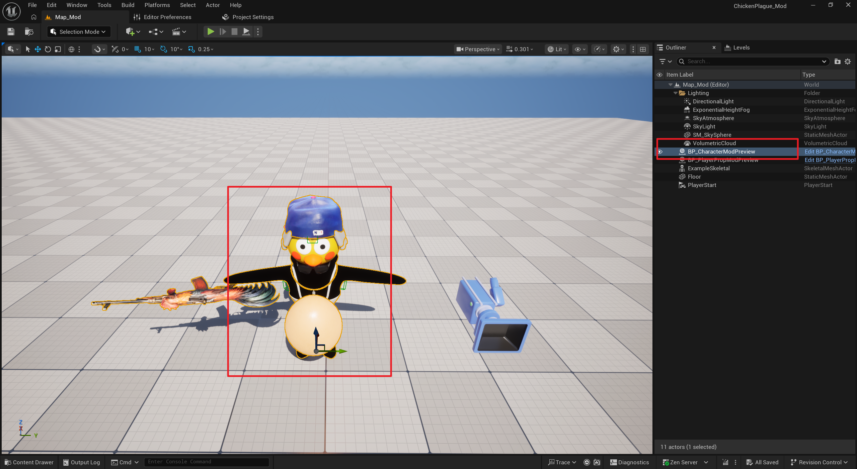

In the Details panel, select the CharacterMesh component and replace it with your model.
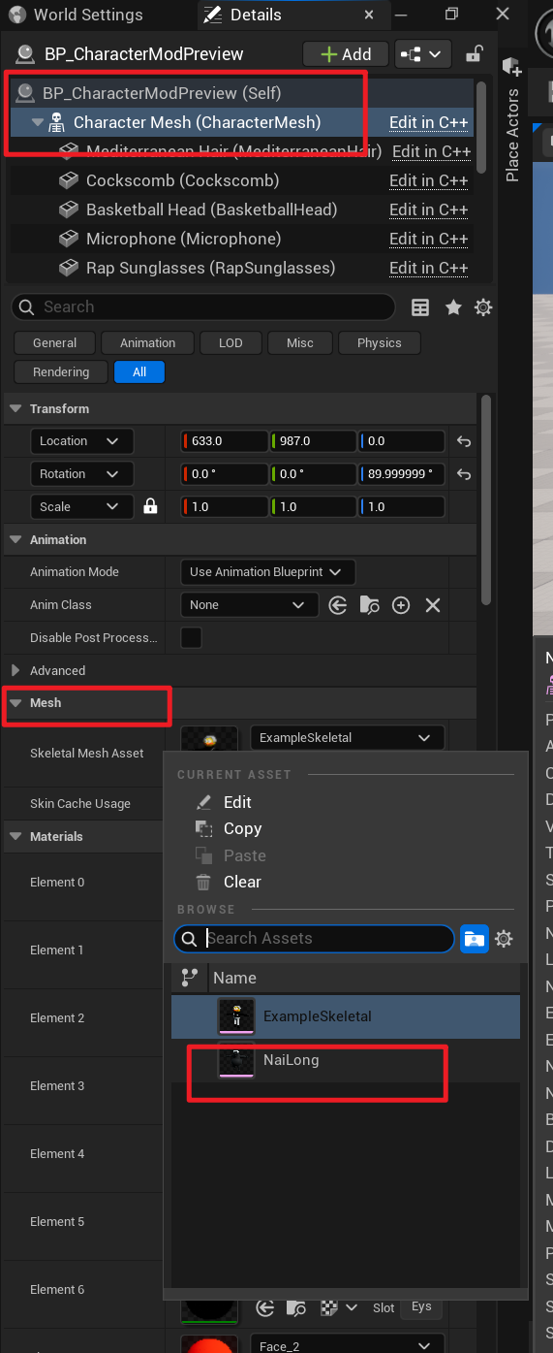
Adjust the model transform if its position is incorrect.
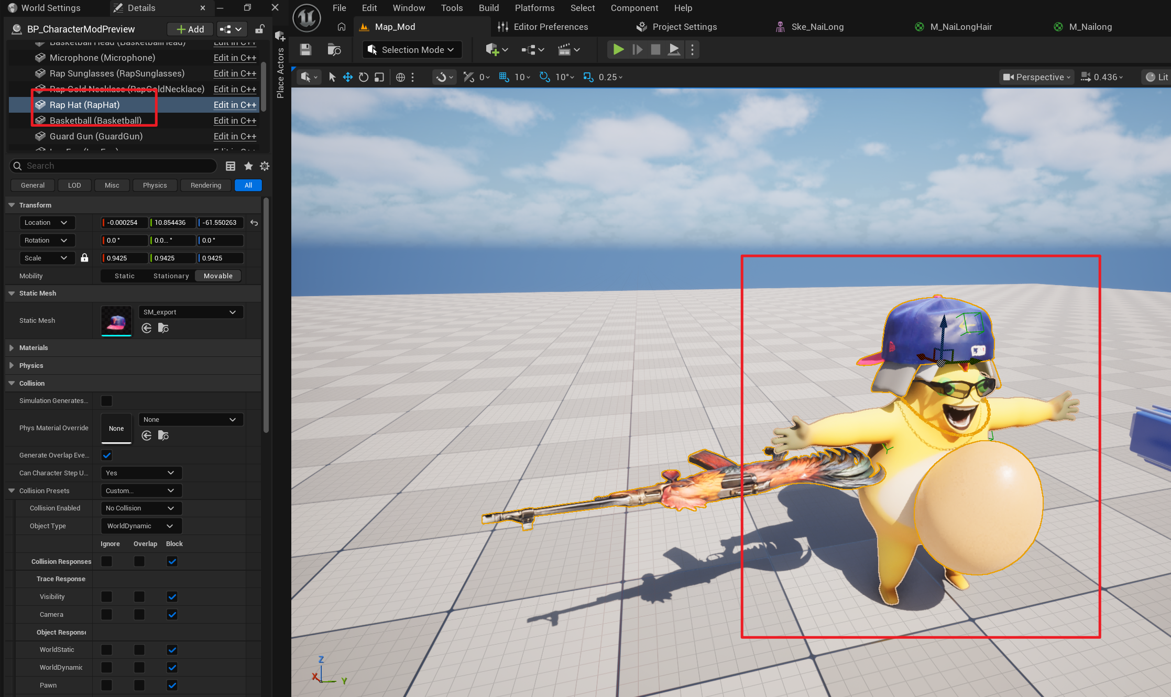
Important: all five chicken-footprint decal components must remain visible.
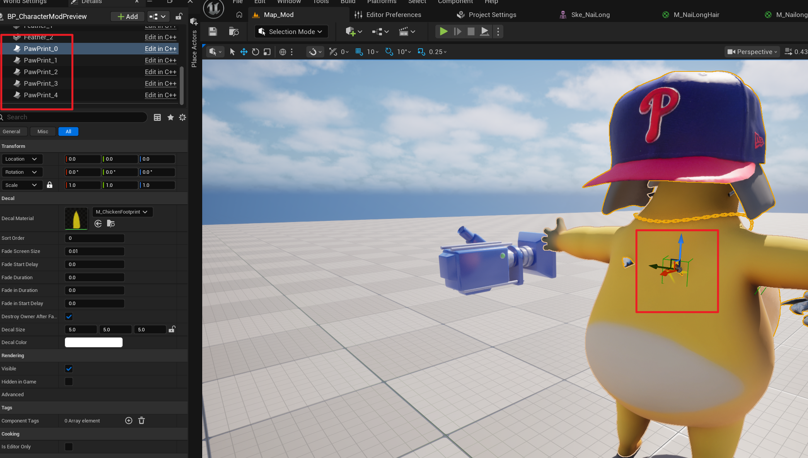
Create a new Data Asset inside the Mod ID folder.

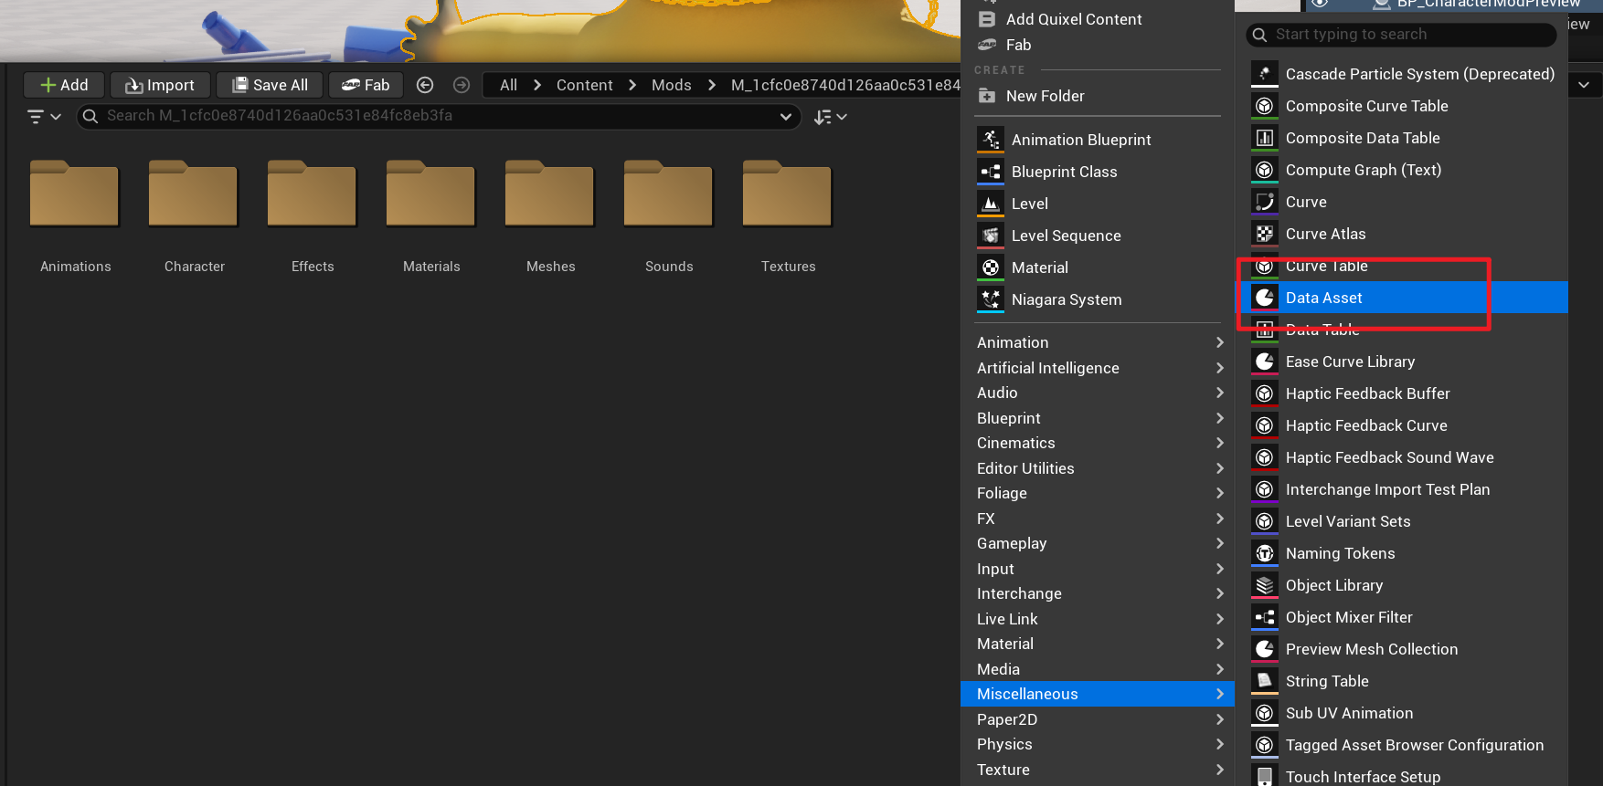
Choose this asset type and name it DA_ApearanceProfile.
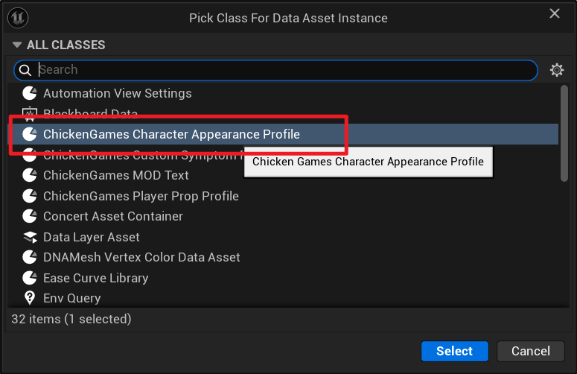
Select BP_CharacterModPreview (Self), assign the Data Asset you just created, and click Write AppearanceProfile.
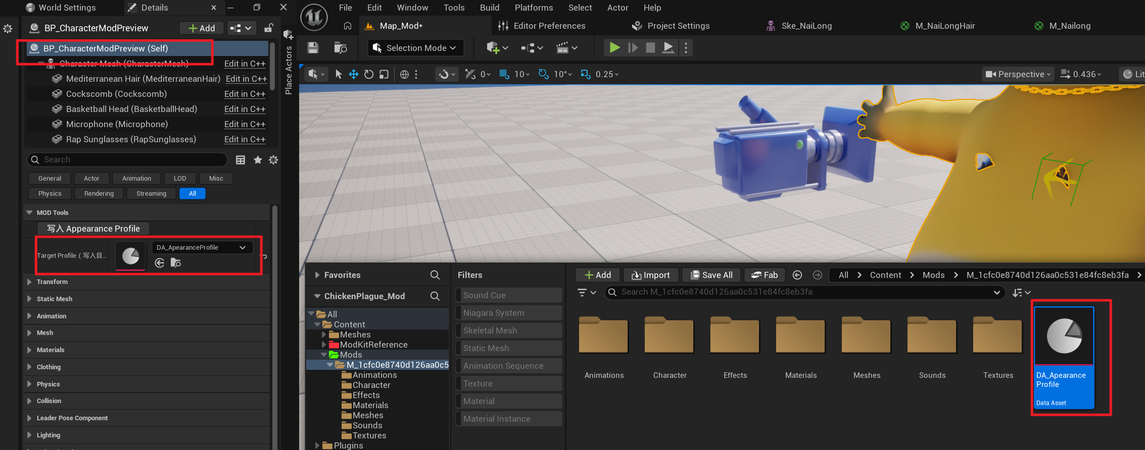
Open the Data Asset. Only the following three fields need to be filled manually. Leave the other generated fields unchanged.
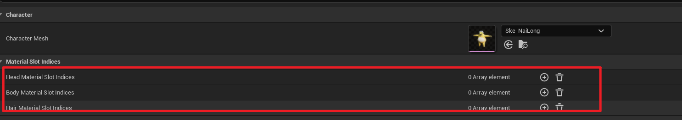
Click the plus button and enter the matching material-slot index. Material indices start at 0, so if the hair is the second material slot, enter 1.
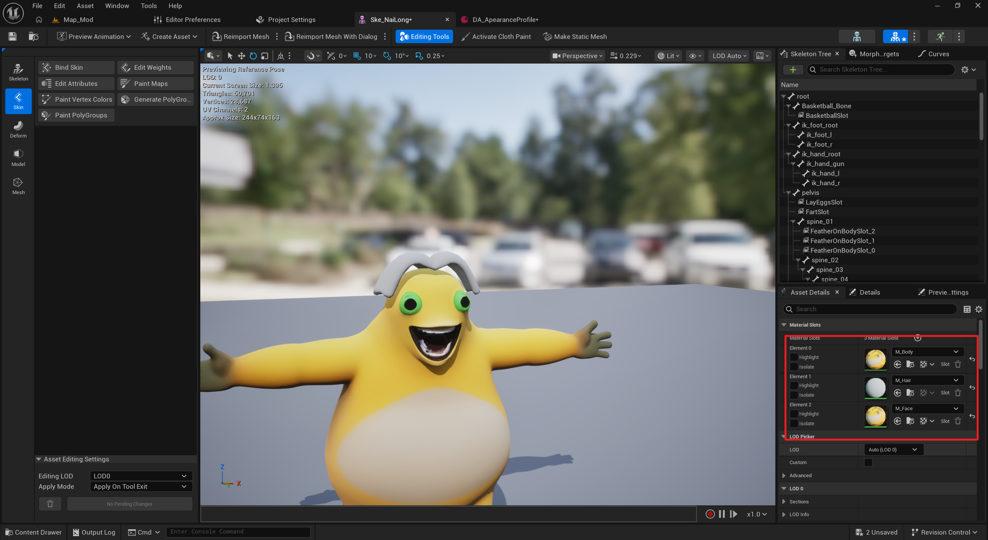
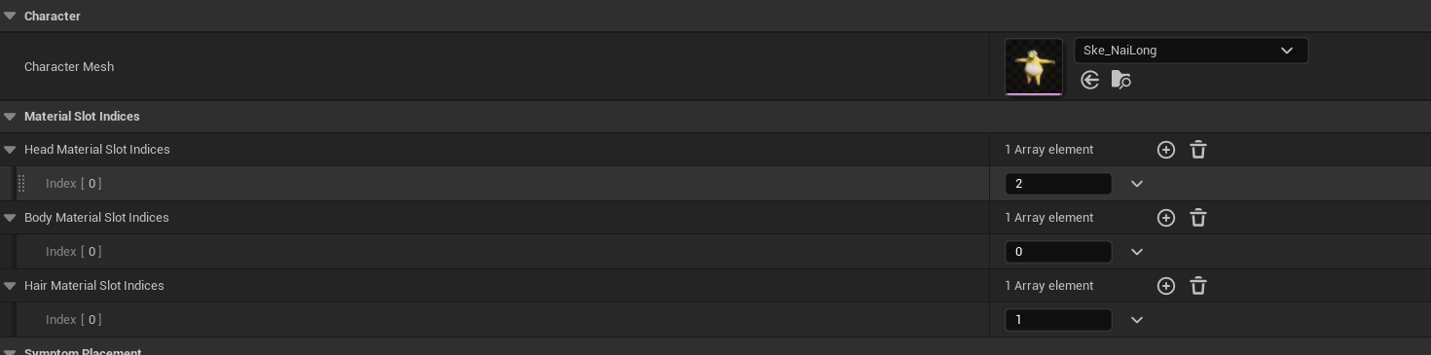
The first entry is the head material. Symptoms such as a flushed face use this material and tint it red.
The second entry is the body material. Symptoms that change body color, such as turning green, use this material.
The third entry is the hair material. The baldness symptom hides this material.

Important: copy these three material nodes into every material used by your model.
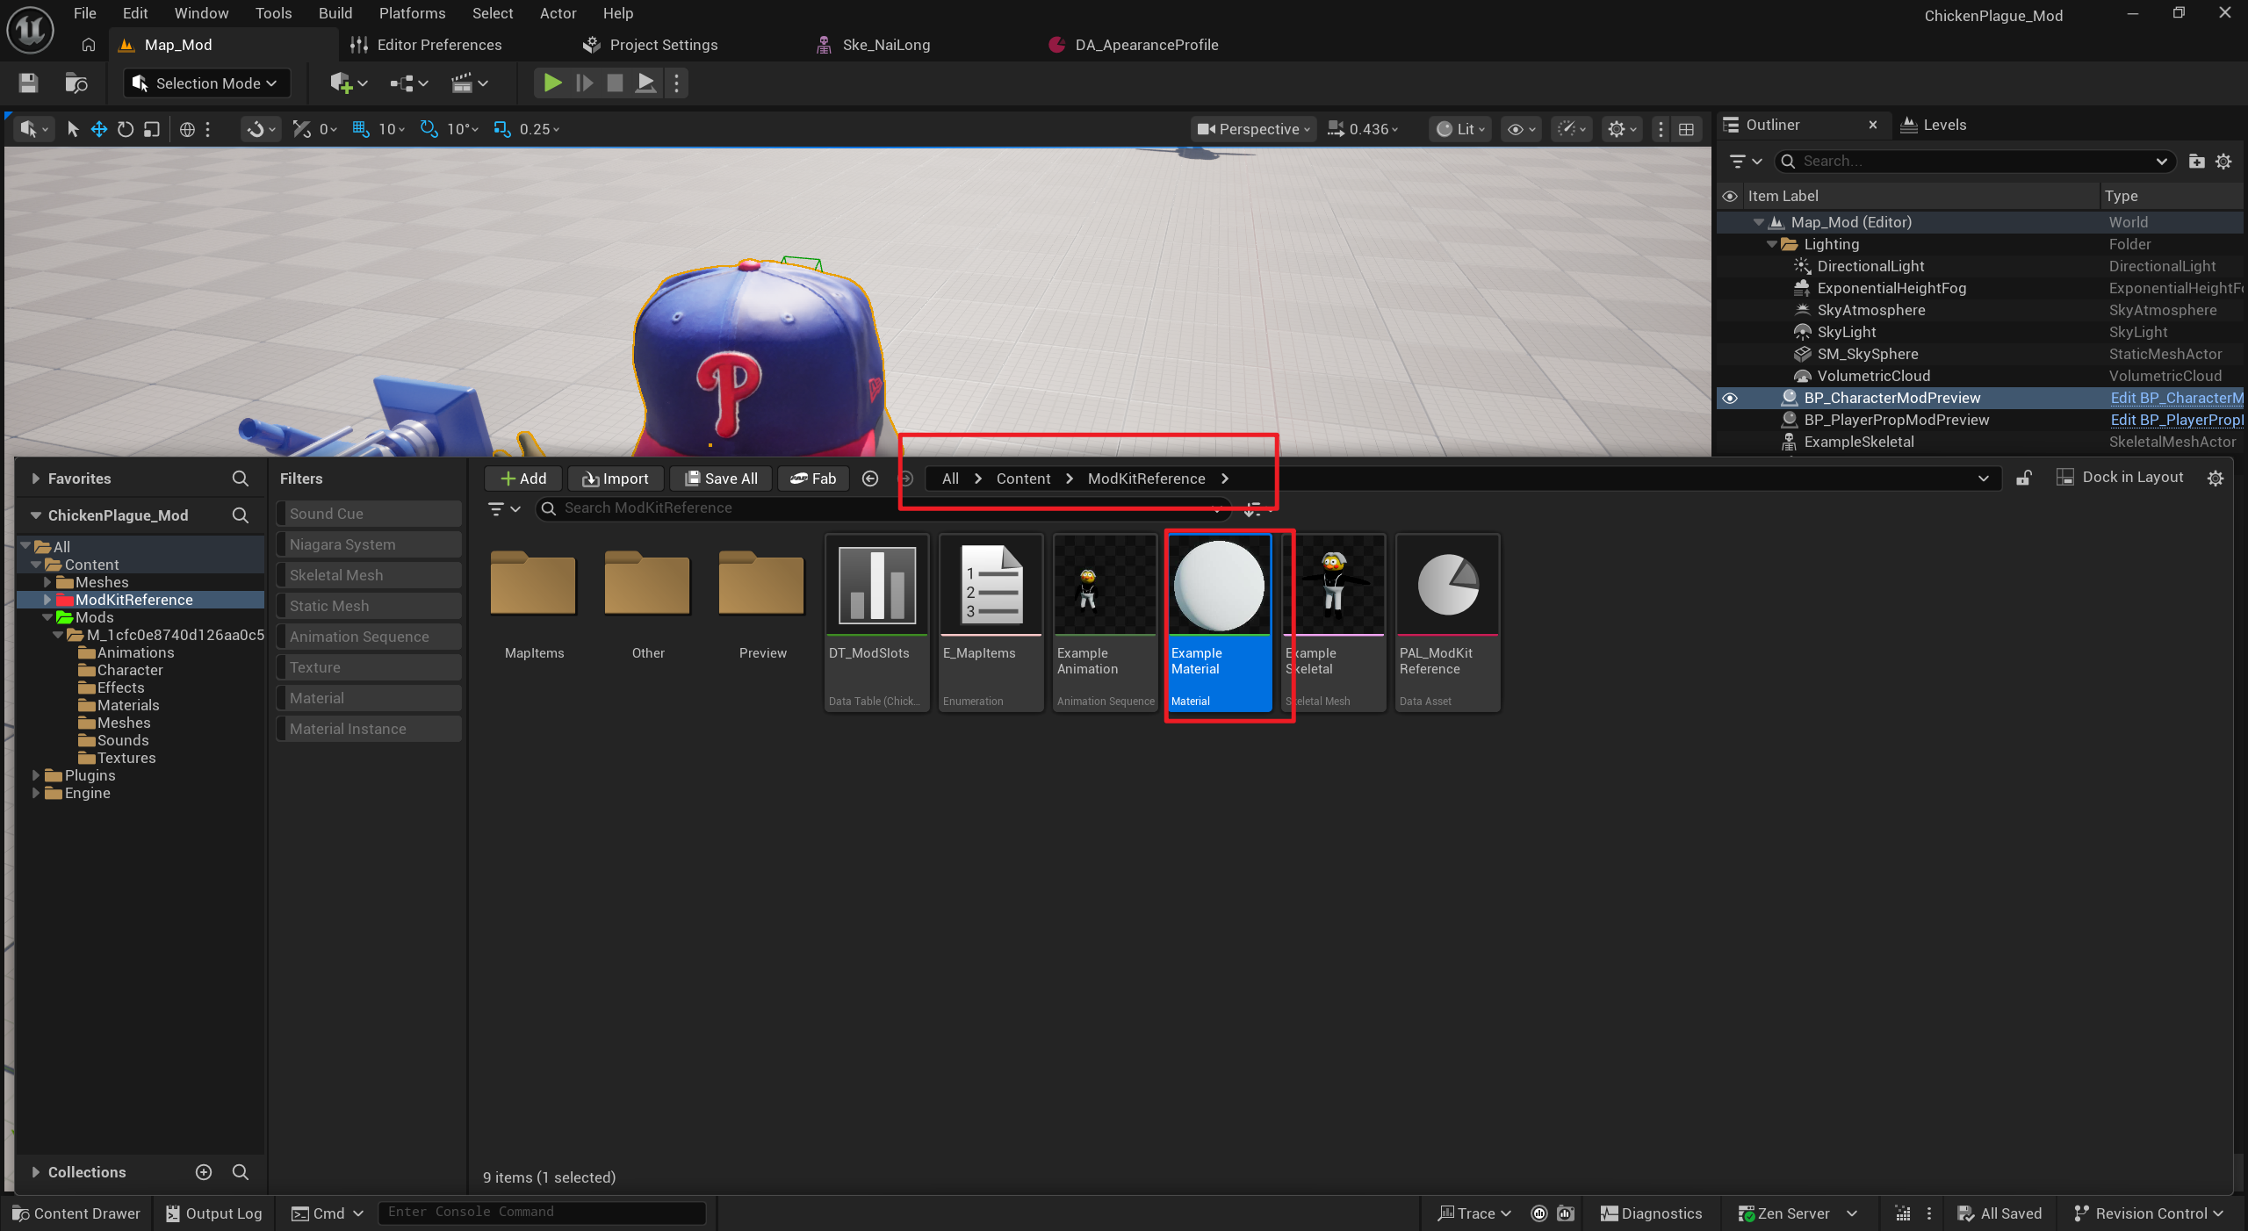
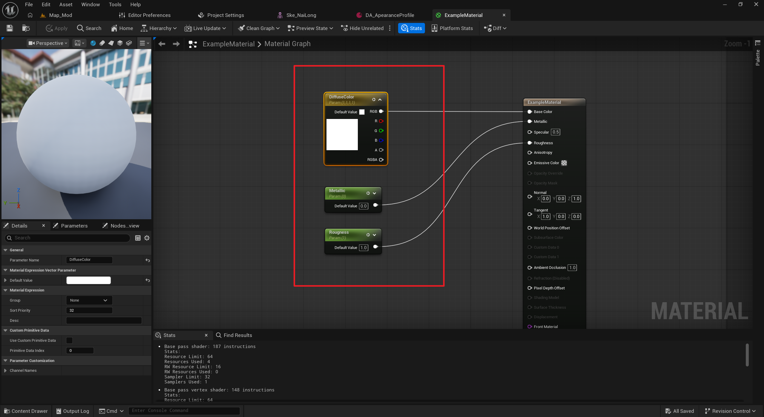
Finally, add the character configuration asset.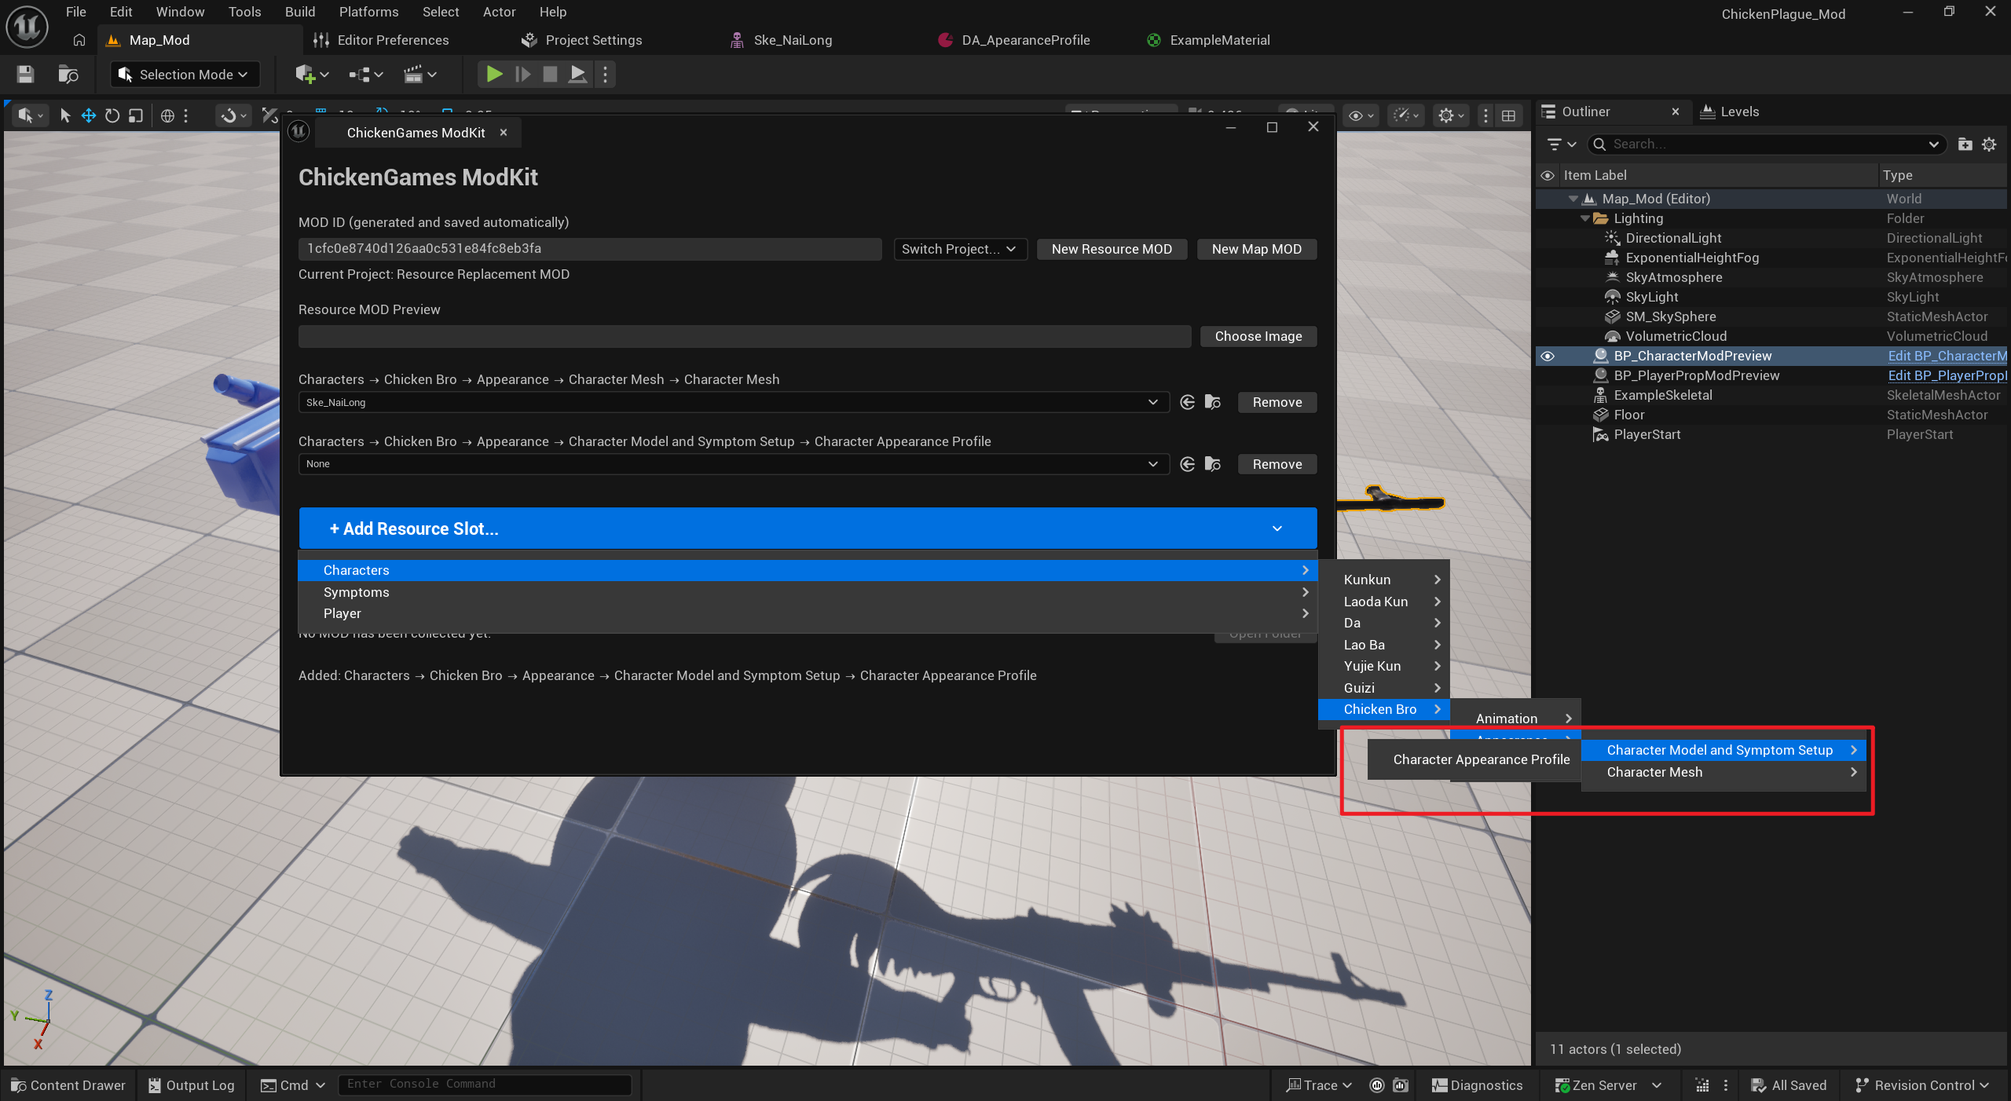
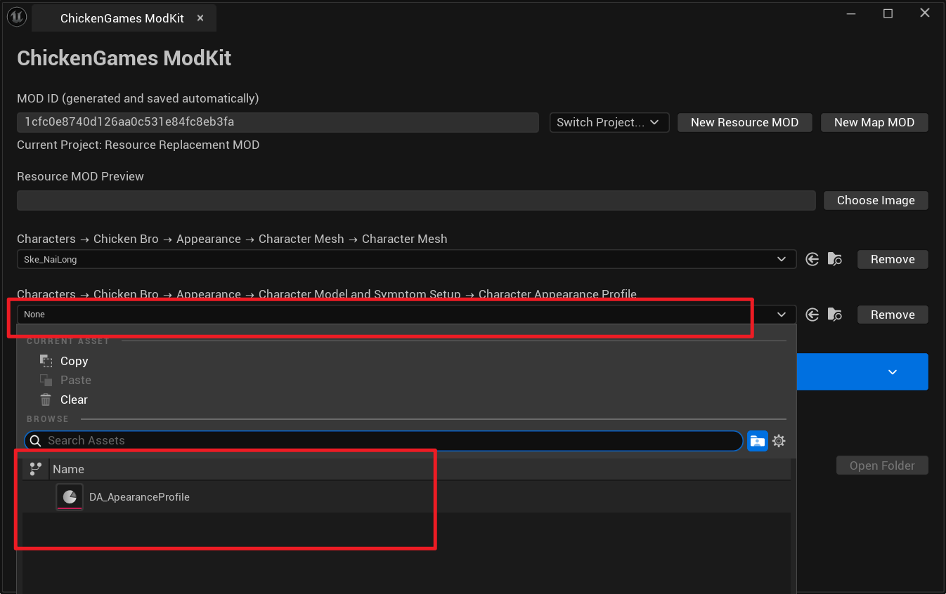
The character replacement mod is now ready.

2. Replace Animations
Add a slot for the animation you want to replace.
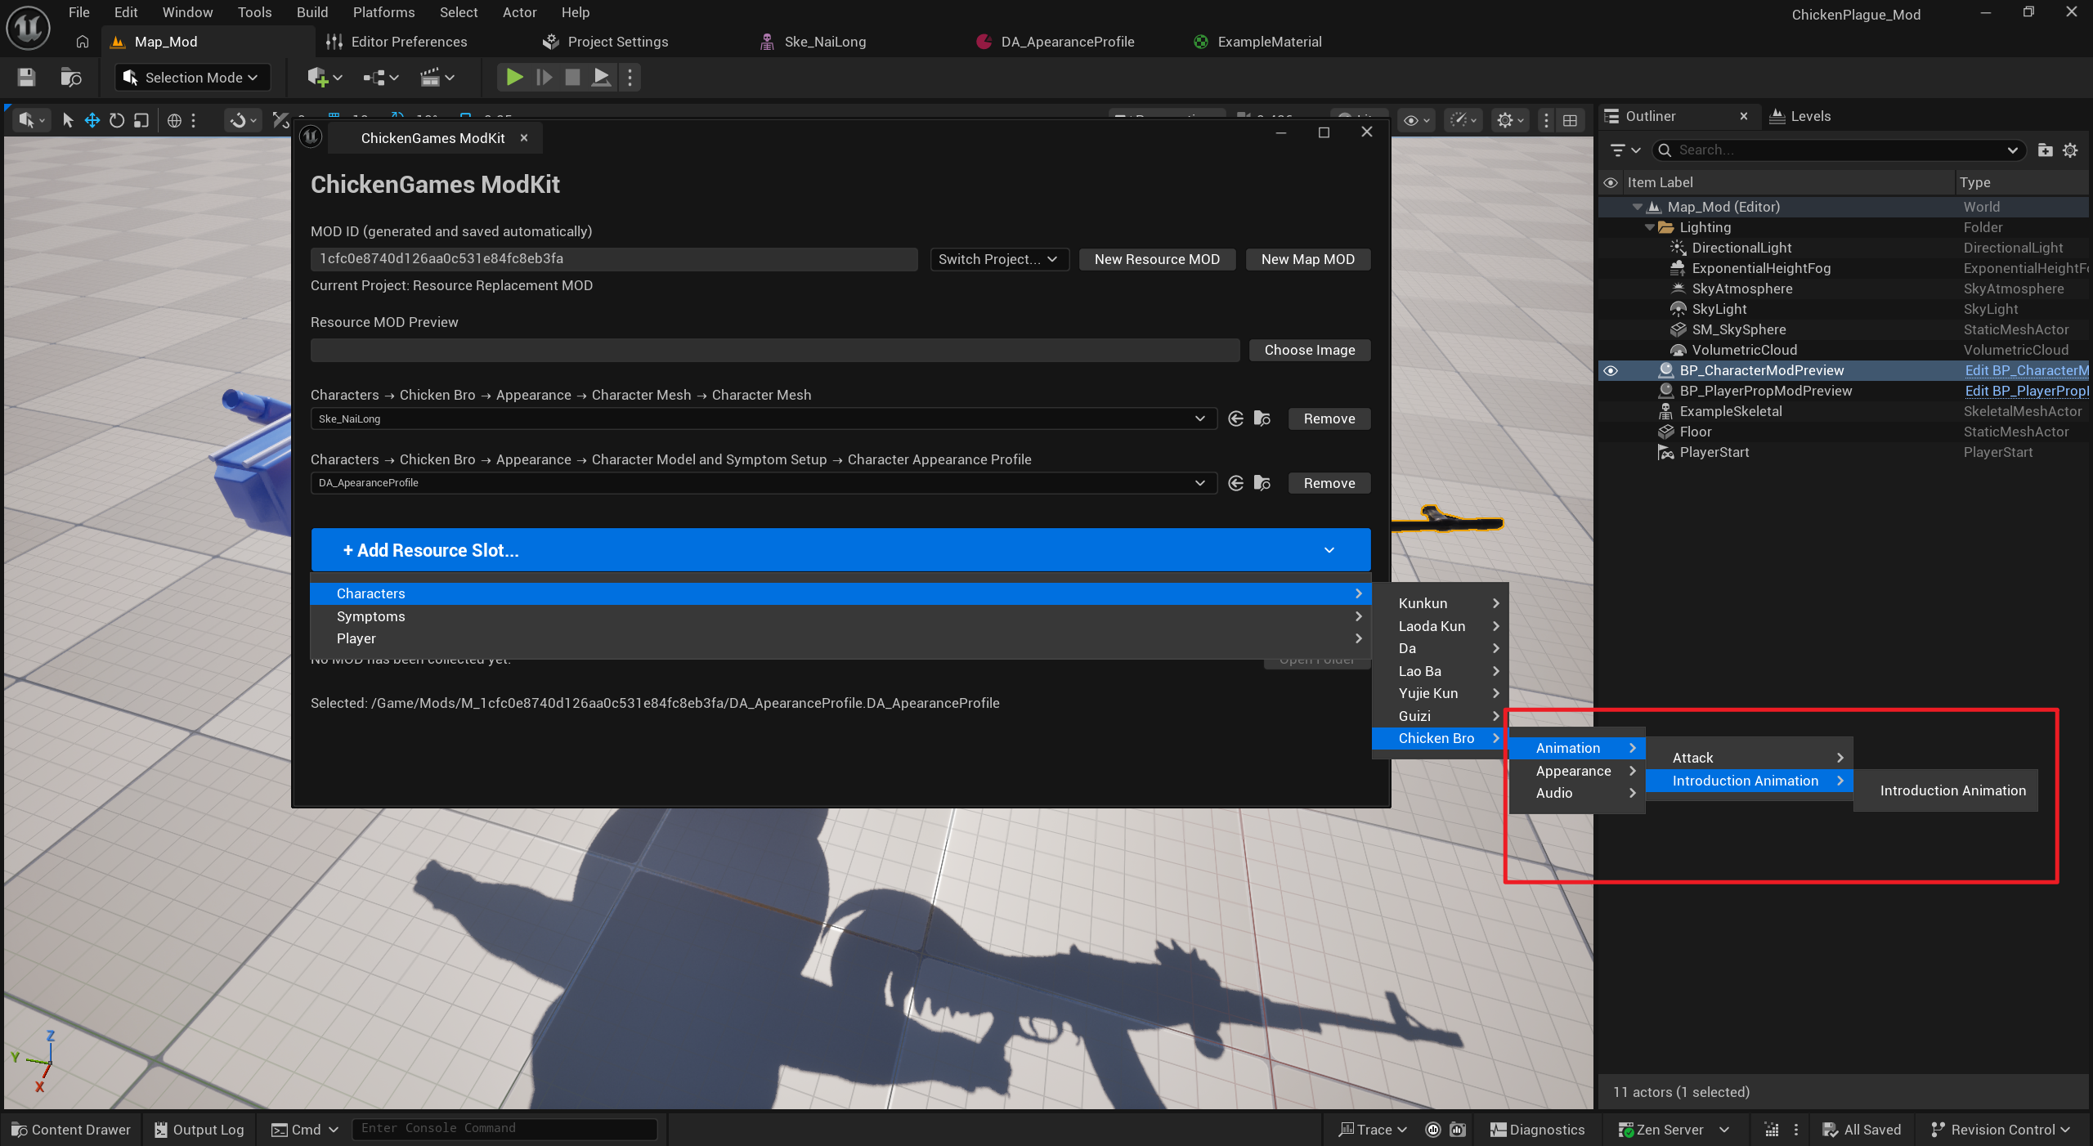
Import the animation into the Animations folder, select this skeleton, and enable Import Only Animations.
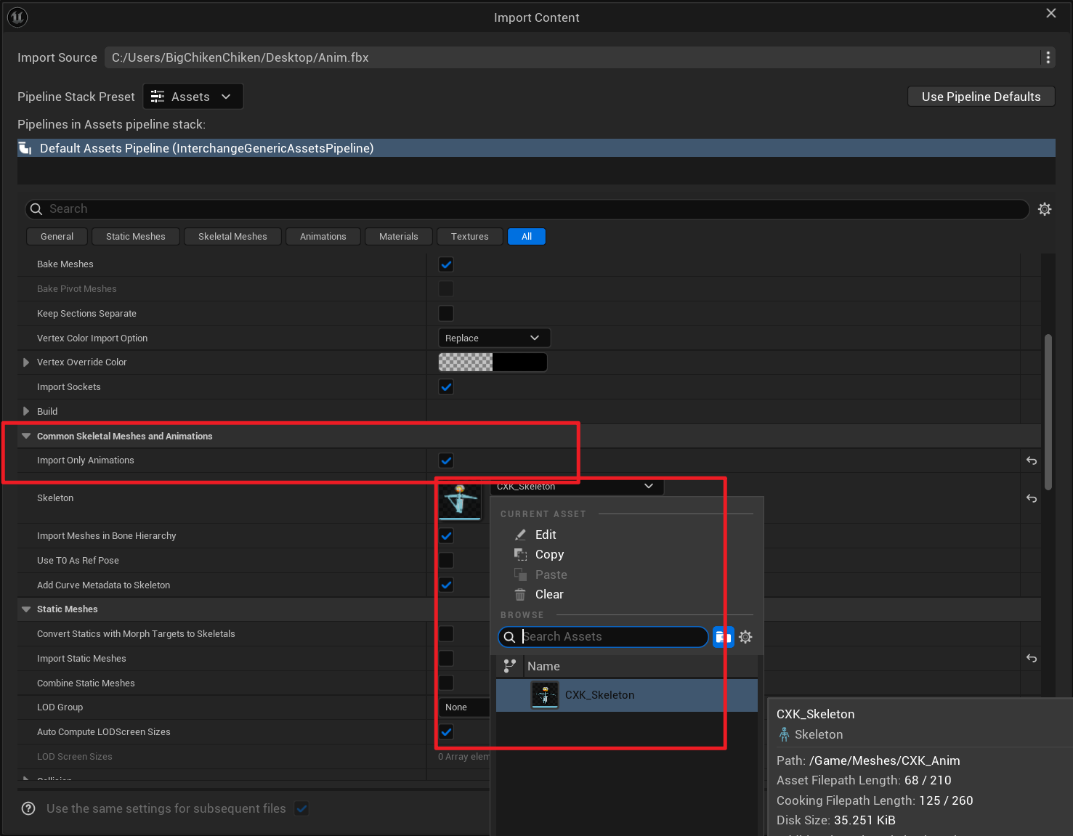
Right-click the animation and create an Anim Montage.
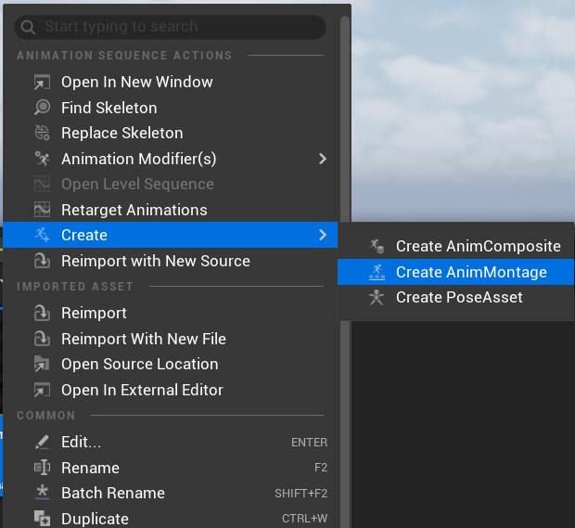
Assign the Anim Montage to the slot.
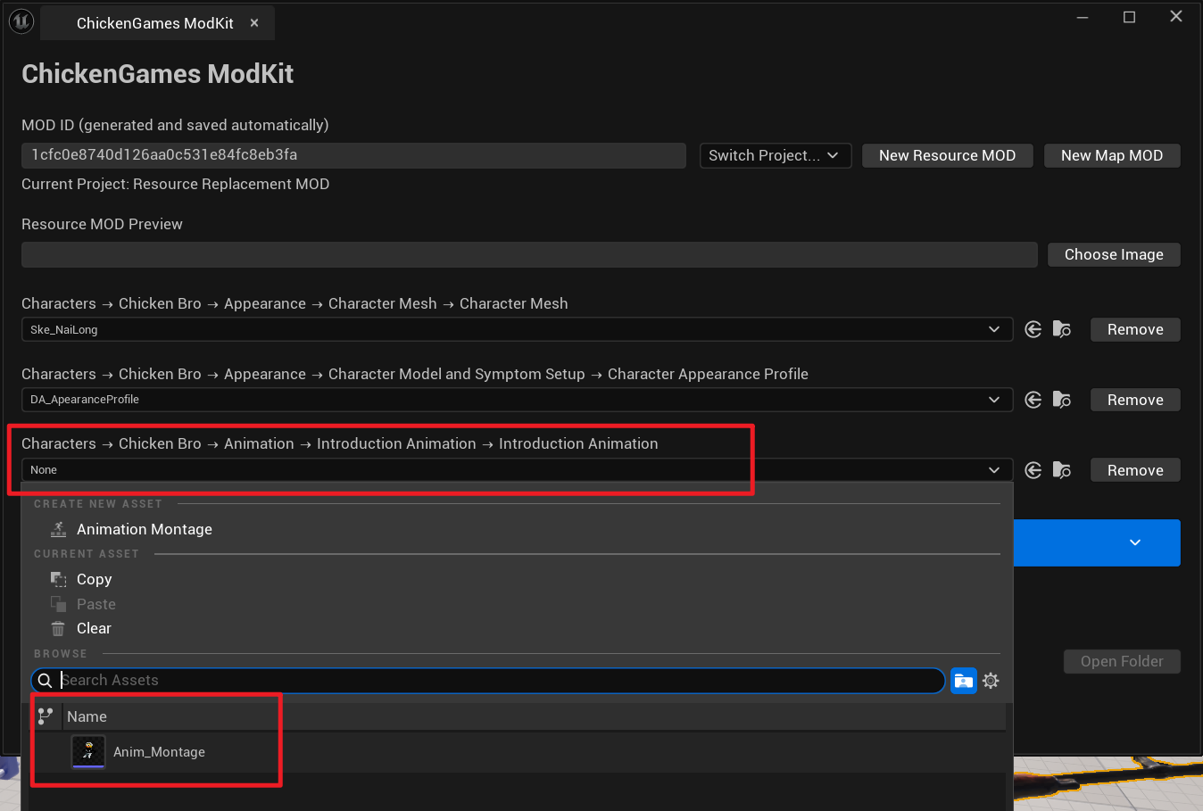
The fart-attack Anim Montage requires a Montage Notify so the attack-damage code can run.
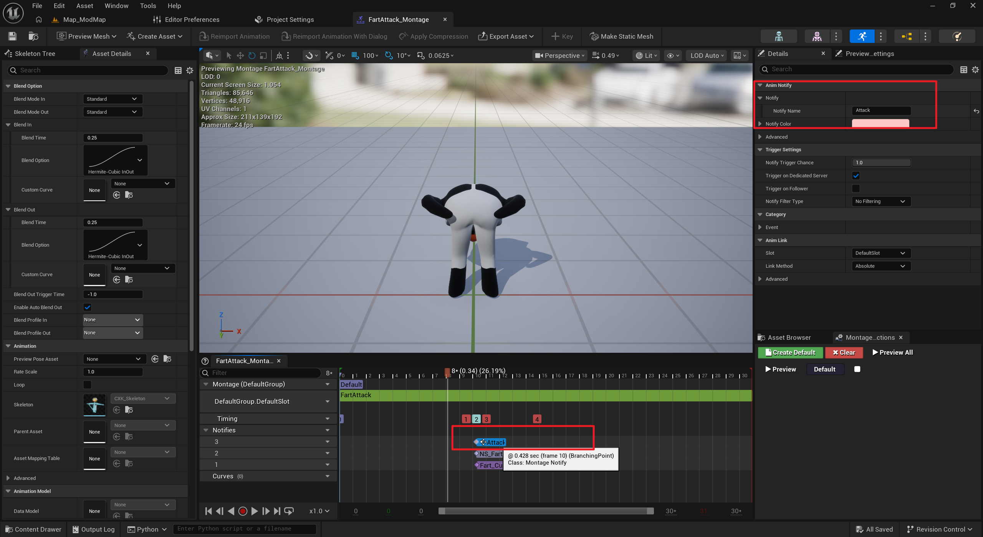
Right-click this row at position 1 and select Add Notify > Montage Notify.
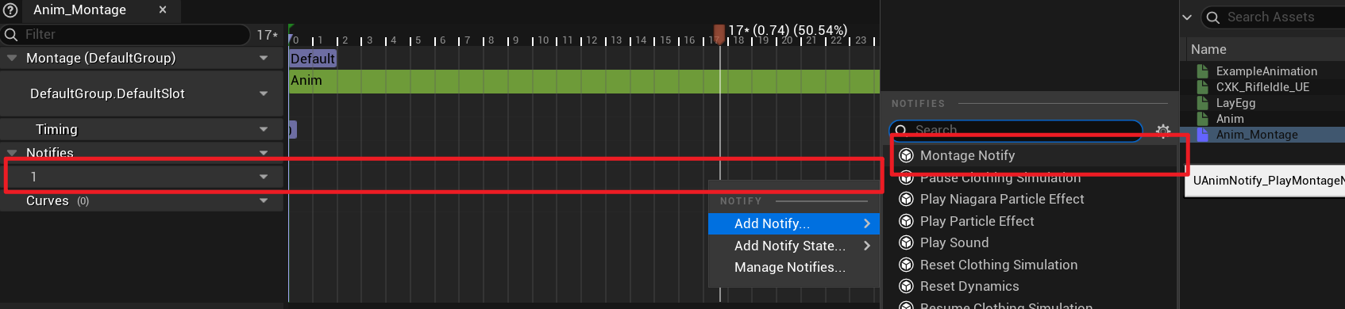
Name the notify Attack.
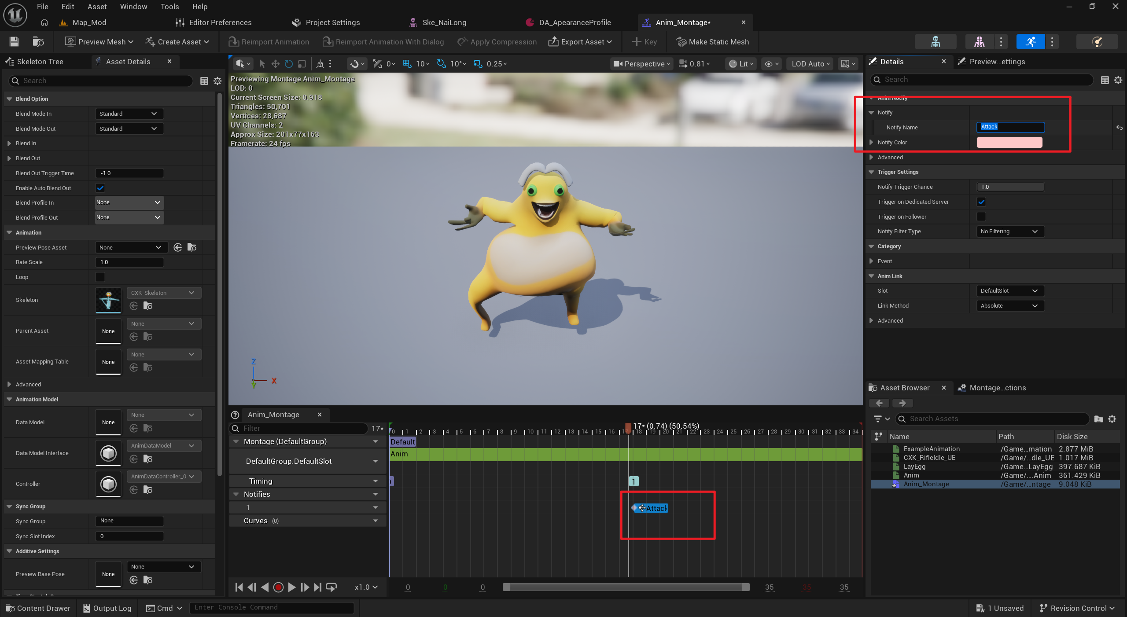

The egg-throwing attack requires a notify named ThrowEgg.
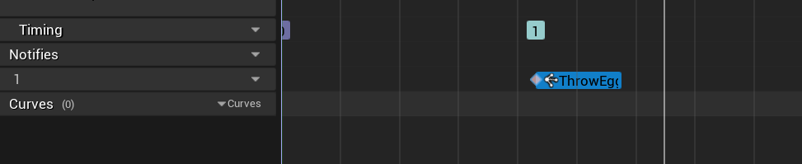
Other animations do not require notifies.

3. Sound Effects
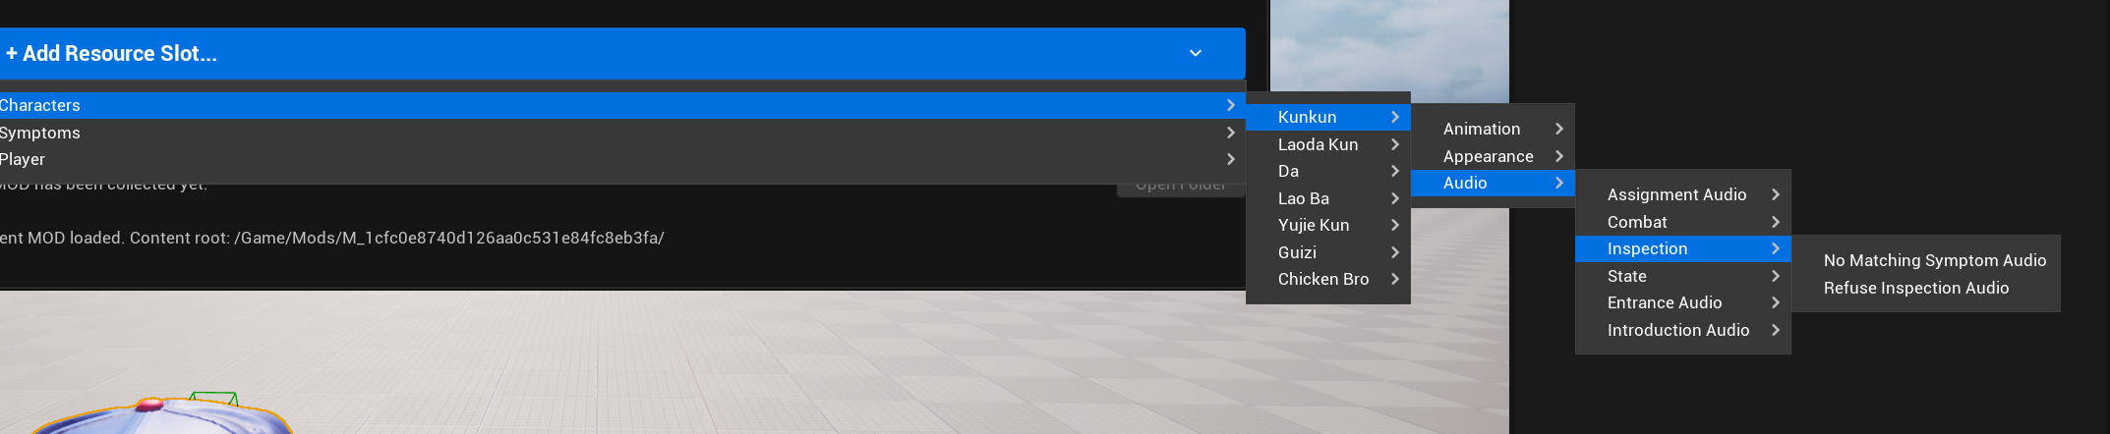
Drag the WAV audio file into the Content Browser.
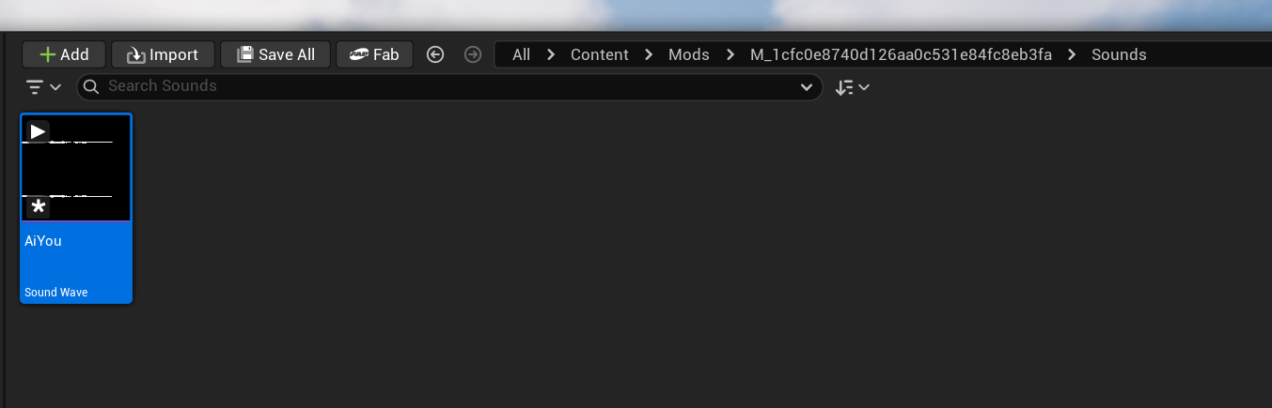
If the volume needs adjustment, right-click the sound and create a Sound Cue.
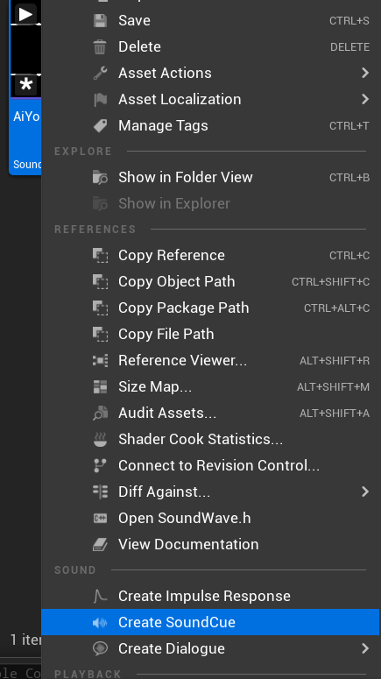
Open the Sound Cue, connect the nodes, and adjust the settings on the left.
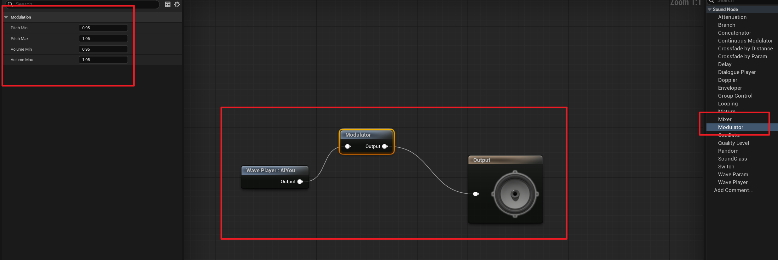
Assign the Sound Cue to the relevant slot.
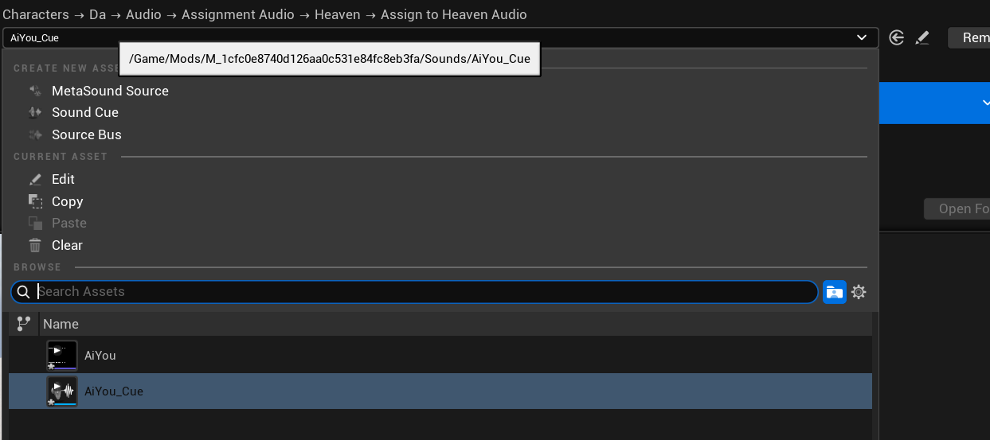

2. Replace Symptoms
Open the symptom menu and select the imported replacement asset.
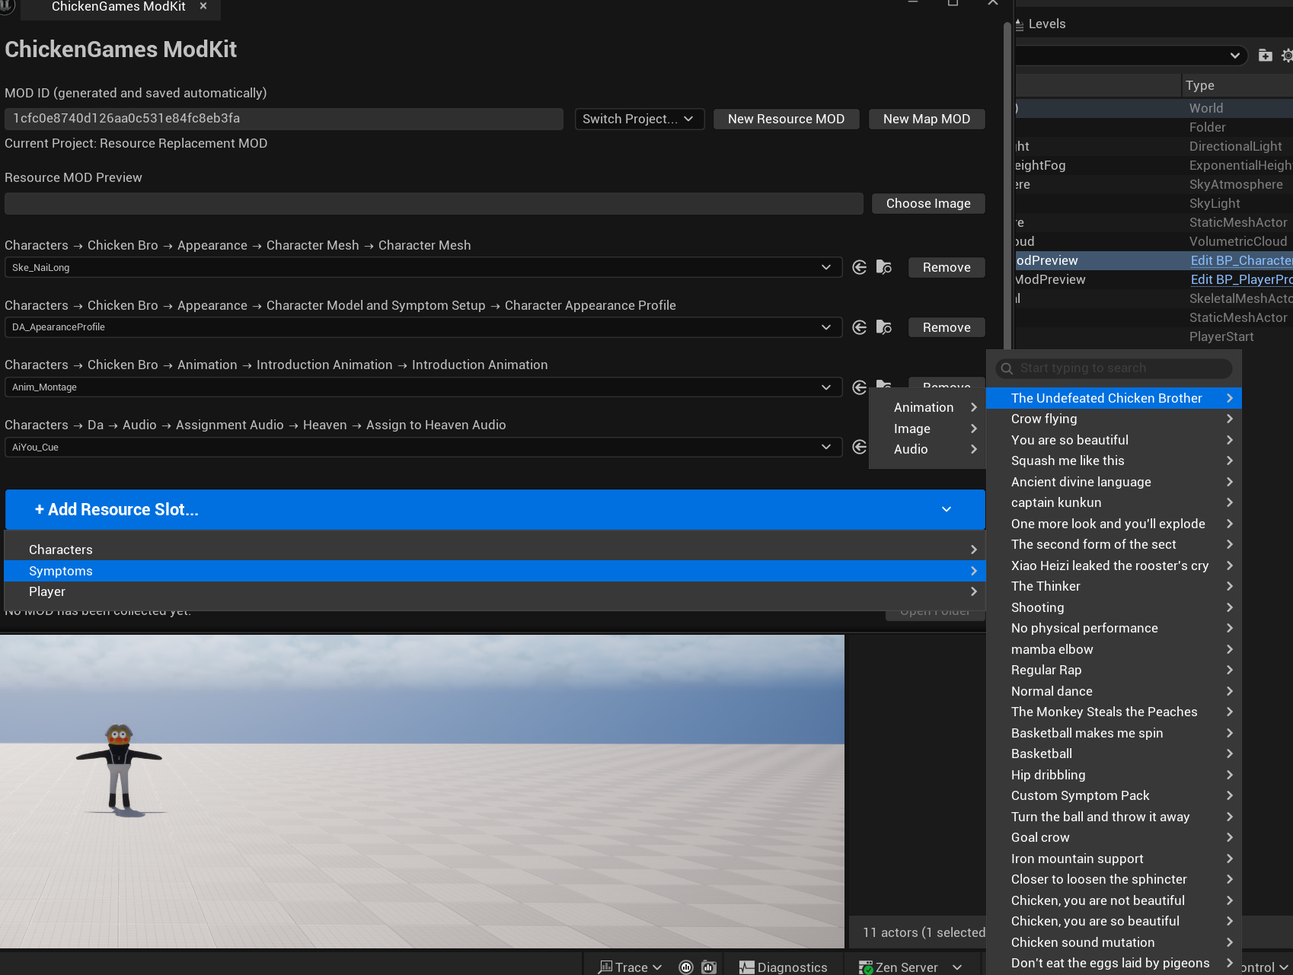
For animation, create an Anim Montage and assign it. For sound, create a Sound Cue and adjust its volume. Images must be imported as PNG files; JPG is not supported.

3. Replace Player Props
Select this camera actor in the level.
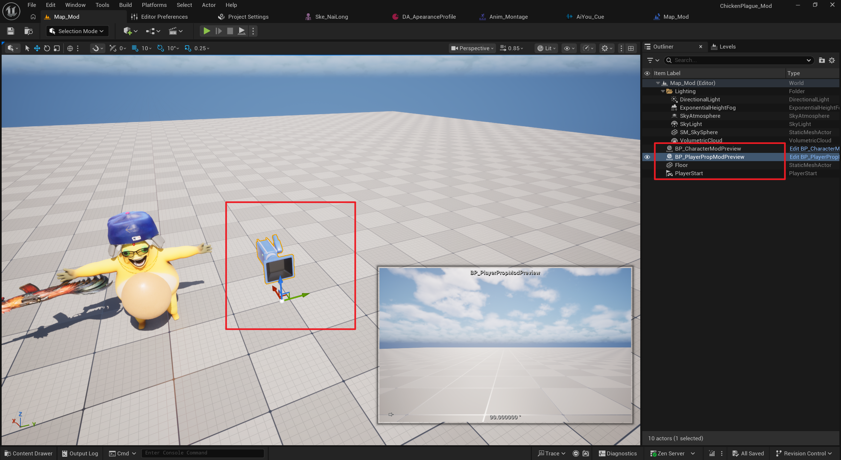
Find these five components in the Details panel. Modify only these components and leave everything else unchanged.
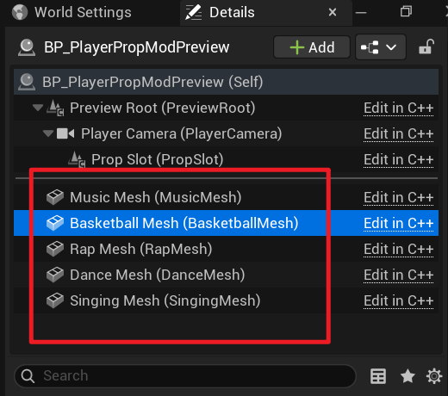
From top to bottom, the props are:
Screaming chicken, basketball, rap prop, speaker, and microphone.
Choose the Static Mesh you want to use, then adjust its position and scale while checking the preview window in the lower-right corner.
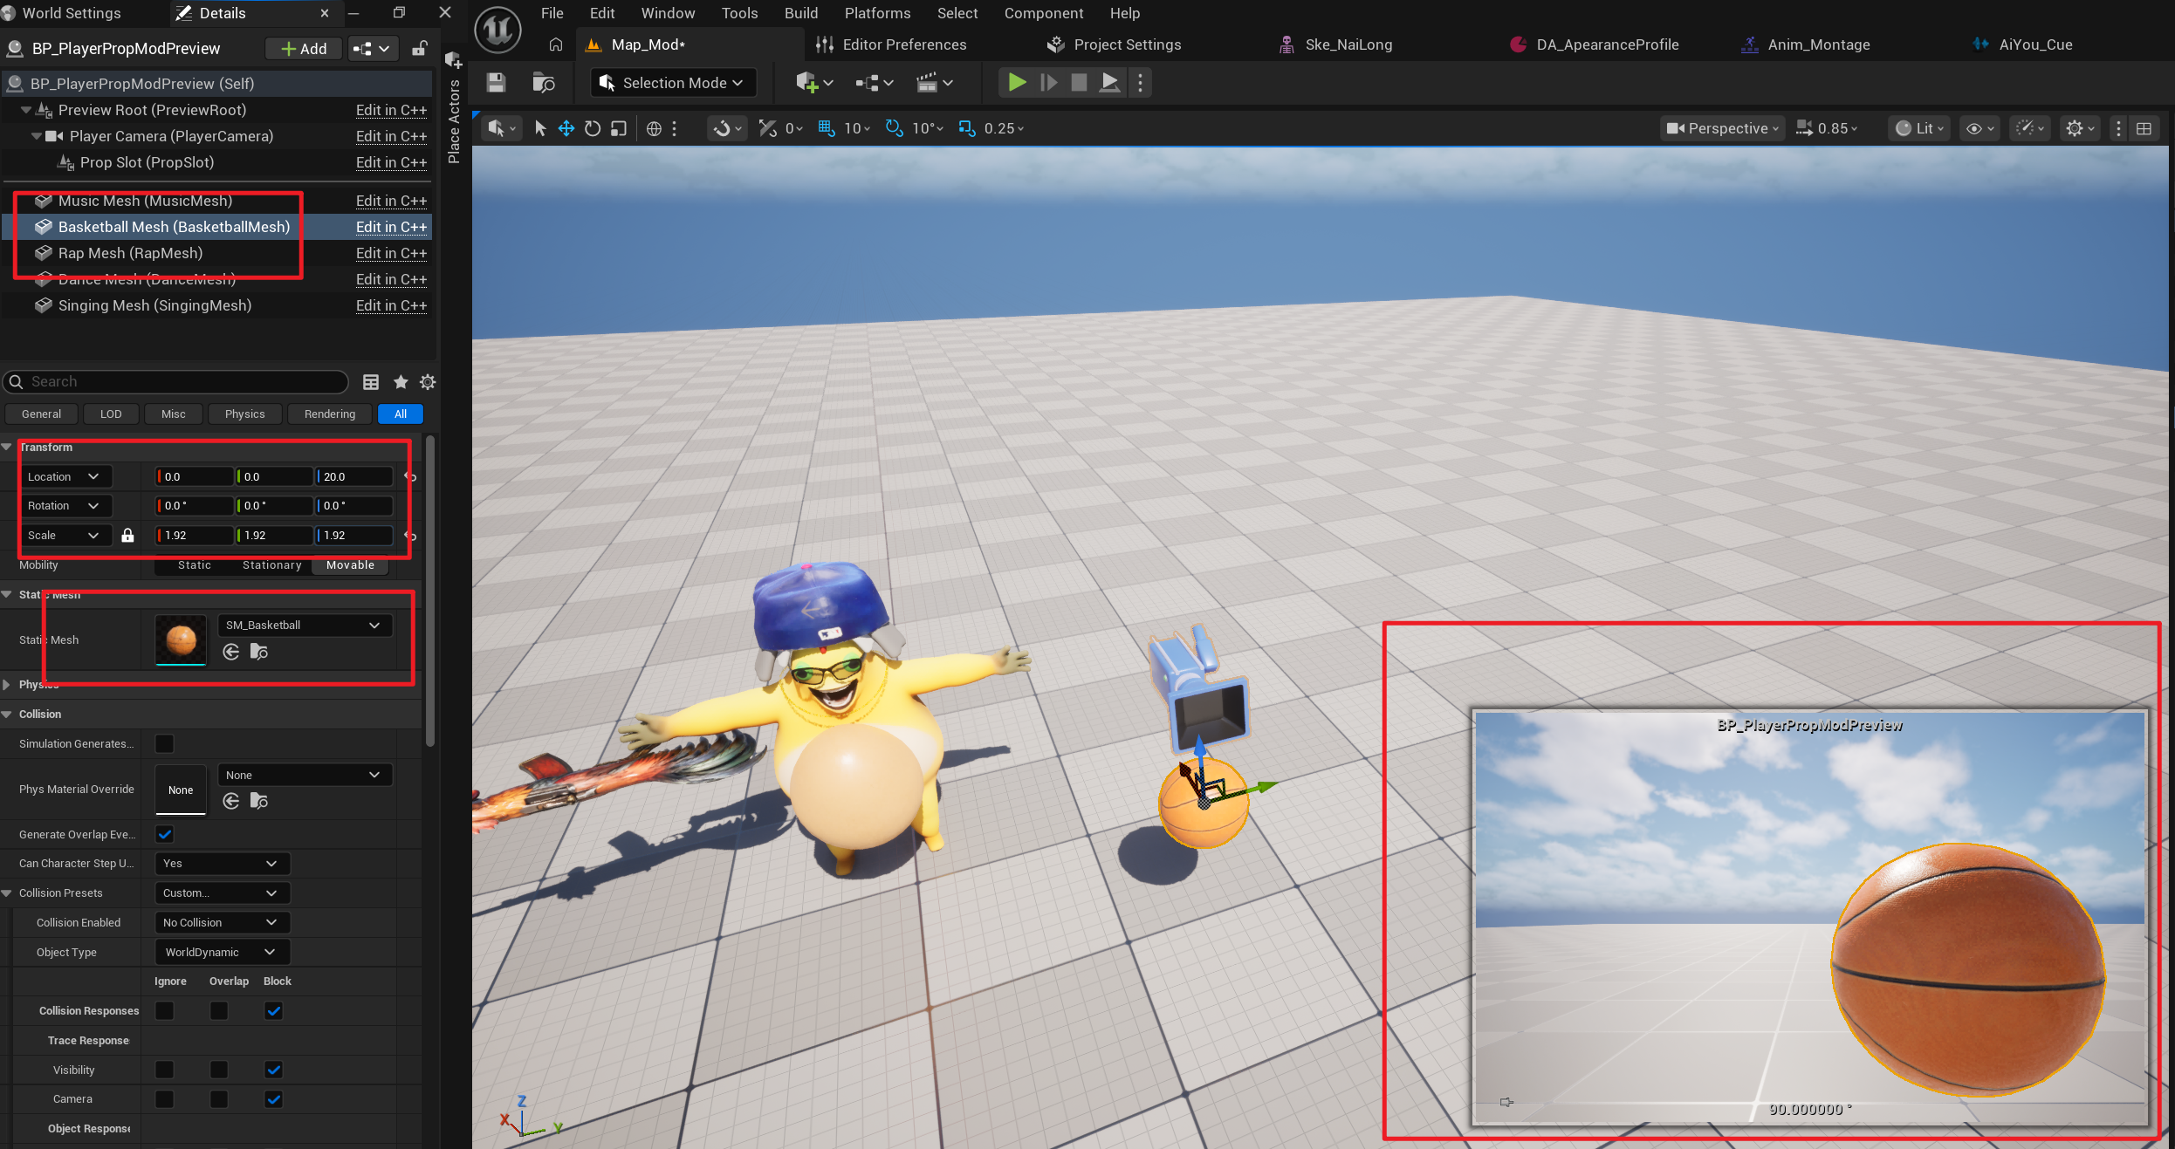
After all props are set up, create another Data Asset.
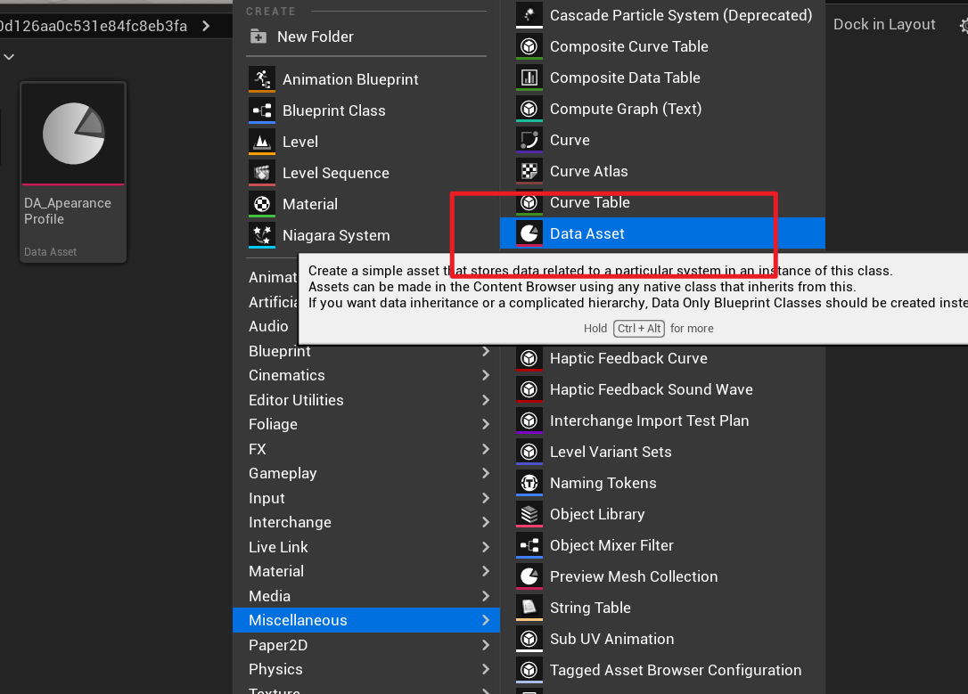
Choose this asset type and name it DA_PlayerProp.

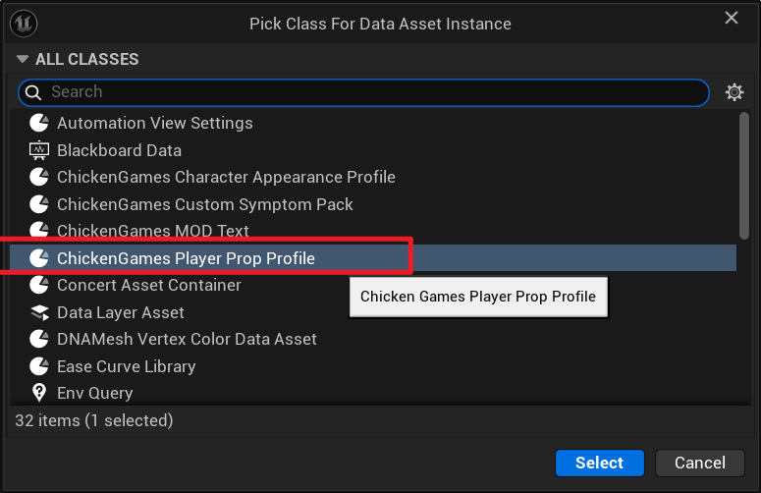
Assign it, then click Write PlayerPropProfile.
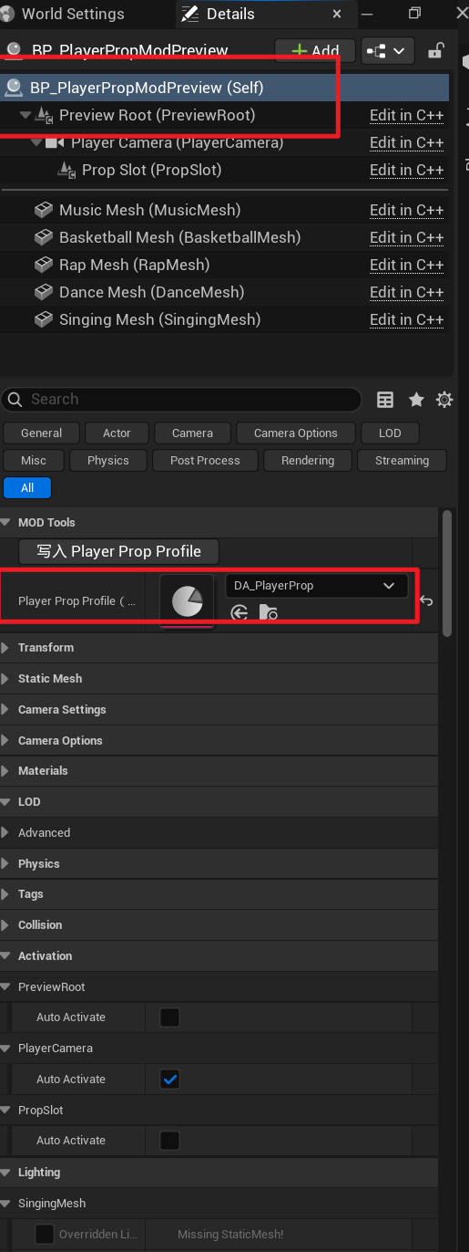
Do not edit DA_PlayerProp manually. Its values are generated automatically.
Add it to the appropriate slot.
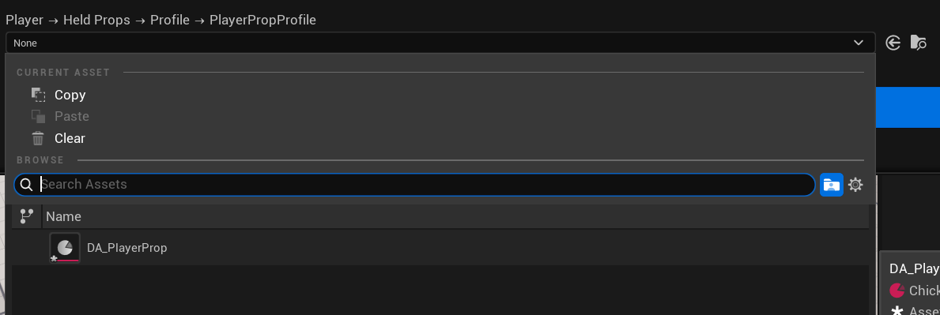
Remember to save your assets regularly.

4. Add a Custom Symptom
Add a custom-symptom slot.
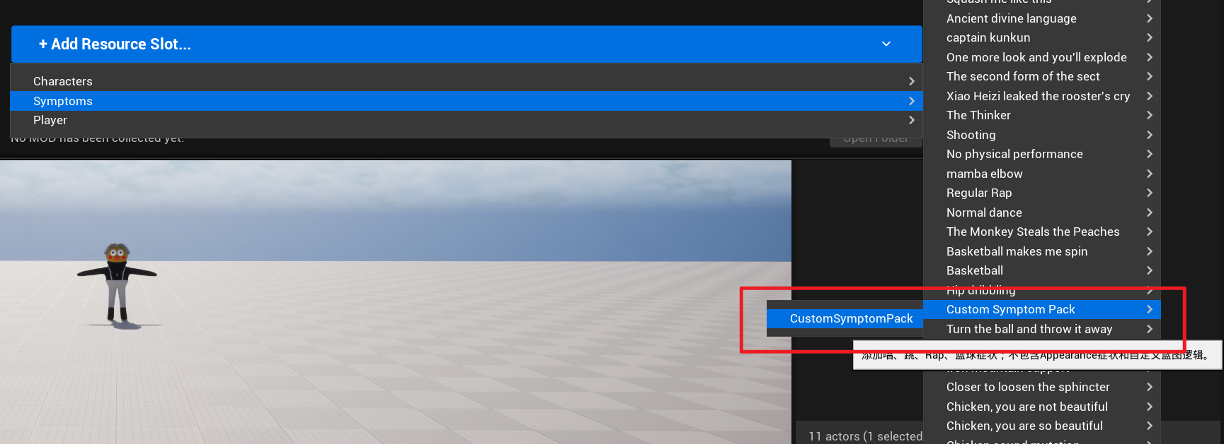
Create another Data Asset of this type and name it DA_CustomsSymptoms.
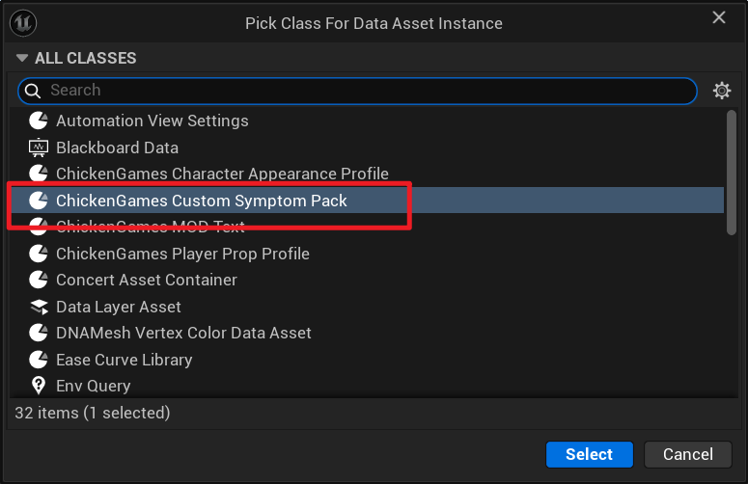
Custom symptoms cannot modify appearance-based symptoms.
Open the Data Asset.
For example, you can add a suspected-infection symptom called Singing.
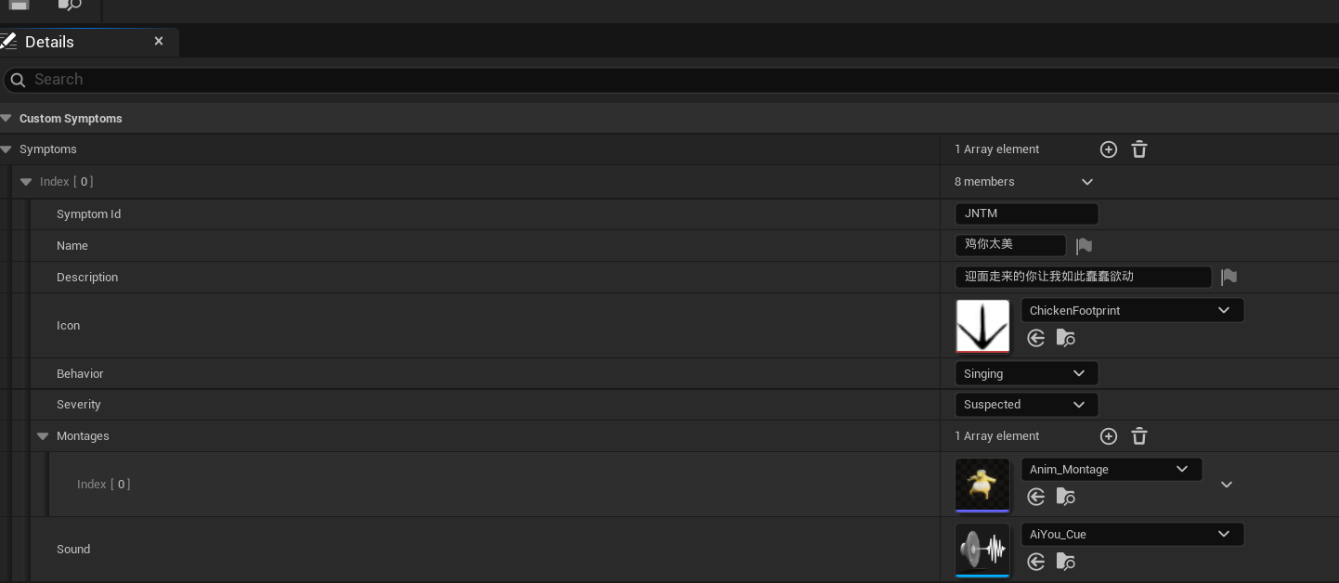
You can add multiple actions. One is selected randomly from the Montage array. Set Sound to the music that should play while the character sings.

5. Create a Map Mod
Click New Map Mod.
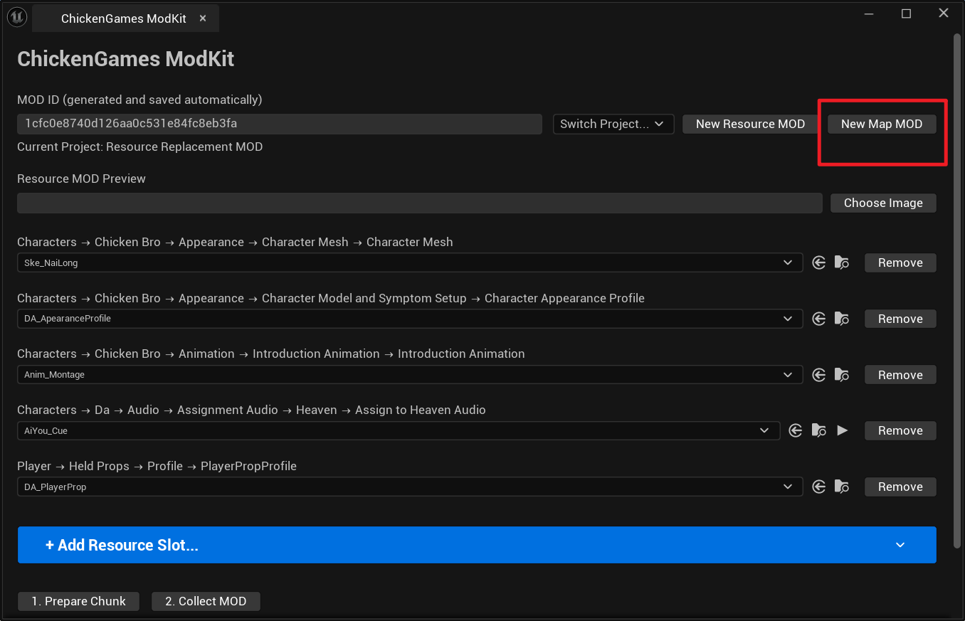
Enter the map name and author name.
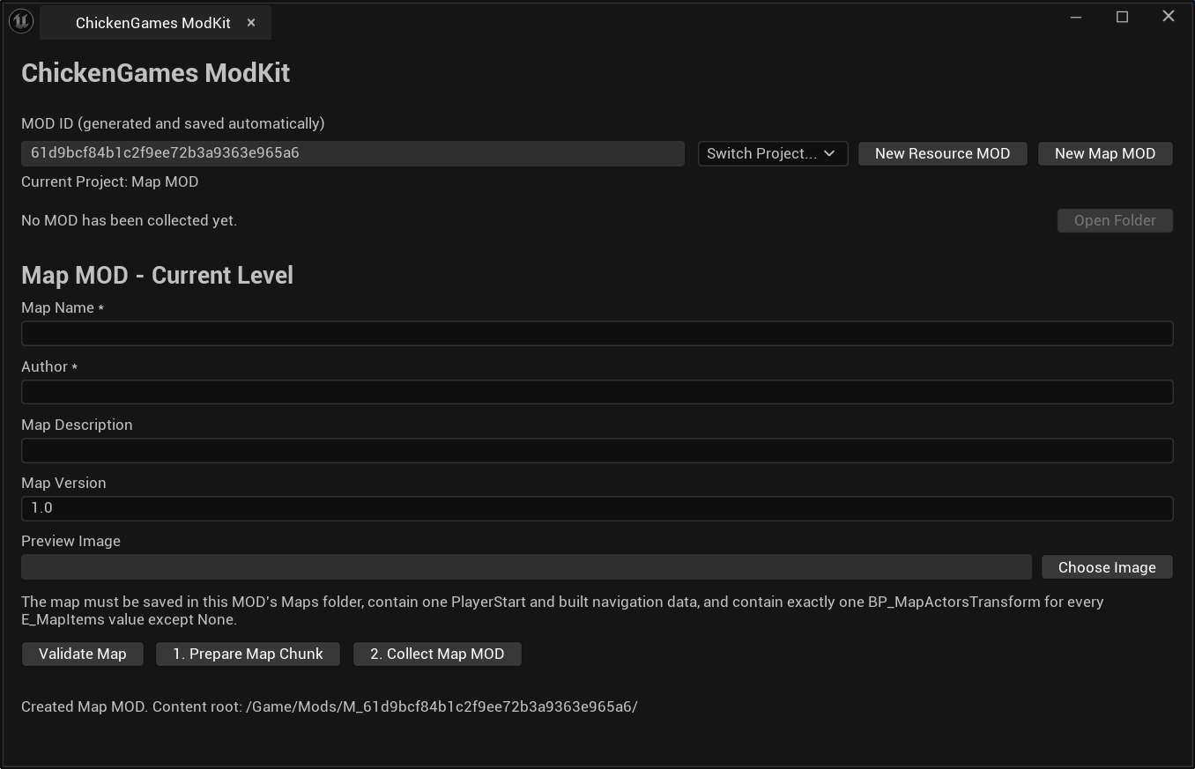
Open the folder for the generated Mod ID.
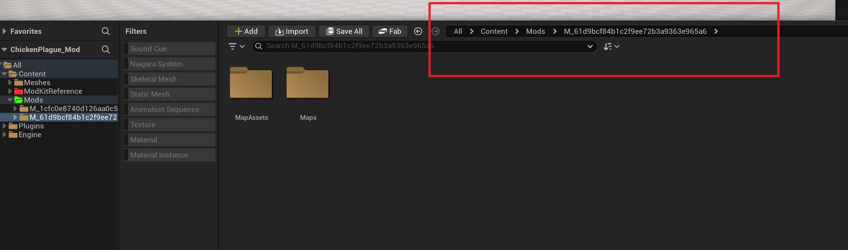
Every asset referenced by the map must be stored inside this folder.
Map requirements:

1. Drag This Actor into the Level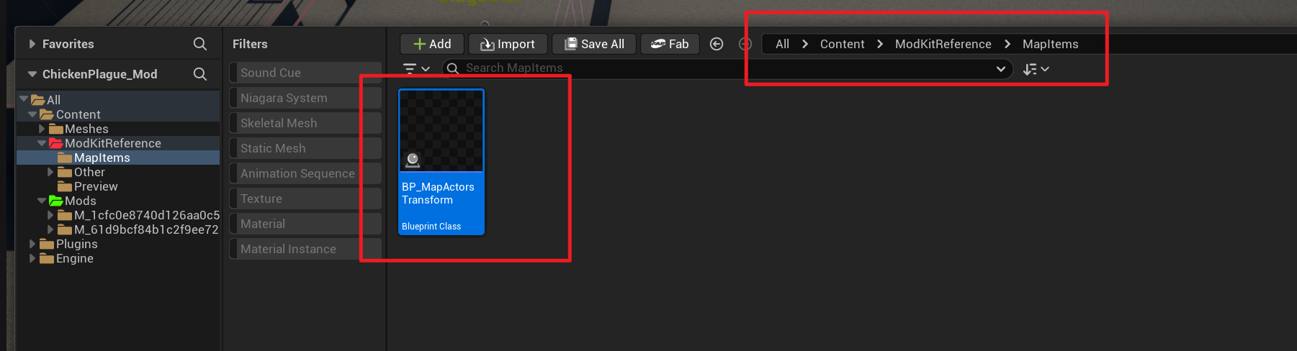
Add every required option to the map.
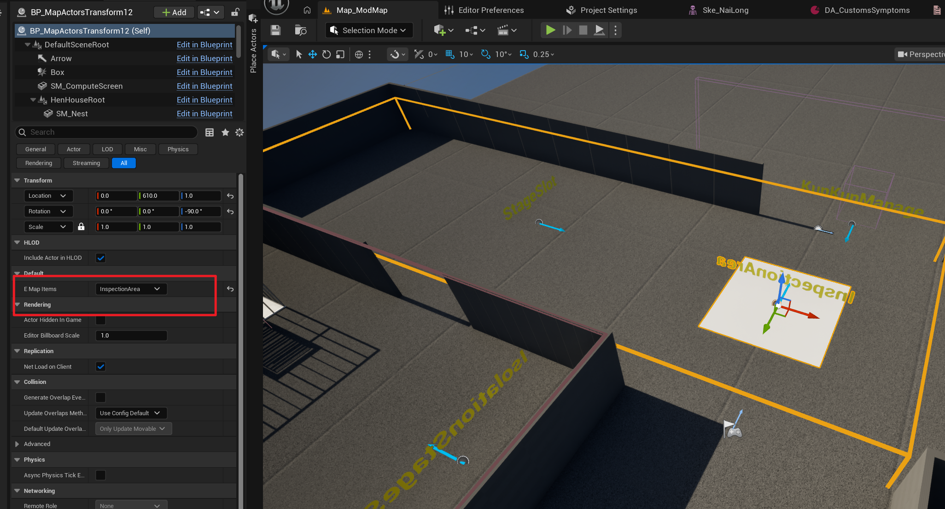
Open this enum asset to read the detailed description of each option.
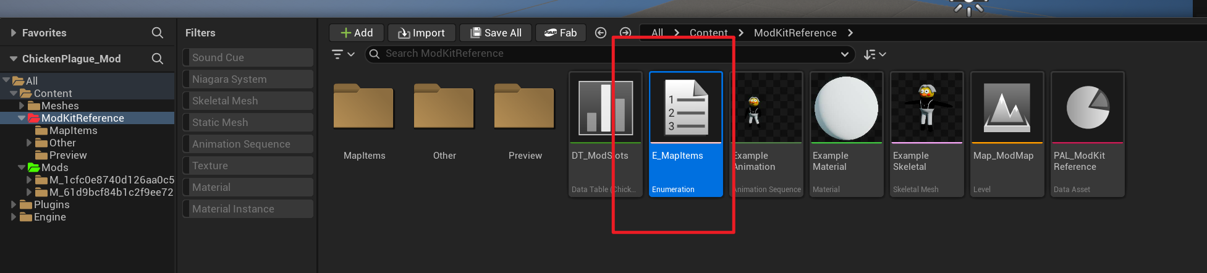
Use this example map layout as a reference.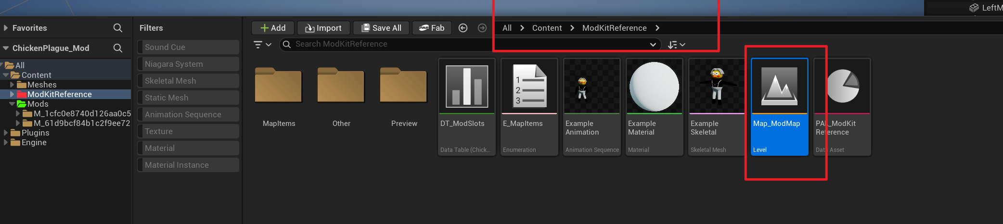

2. Required Engine Actors

1. Post Process Volume
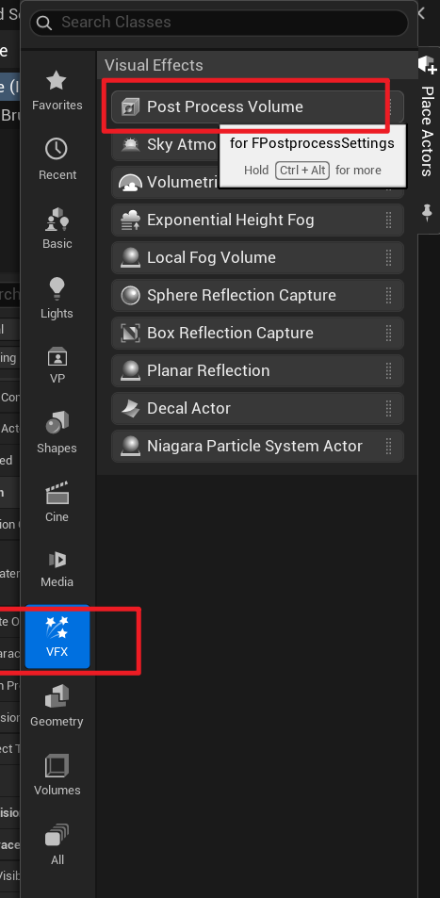
If the Place Actors panel is not visible, open it from here.
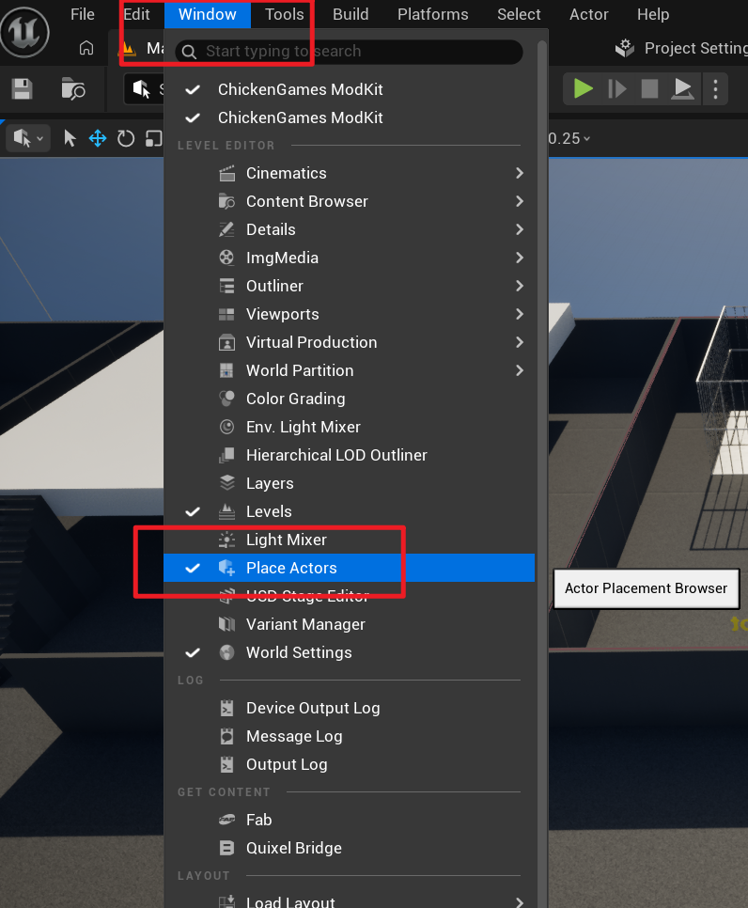
Select the Post Process Volume in the Outliner. Enable Infinite Extent, or resize the volume so it covers the entire map.
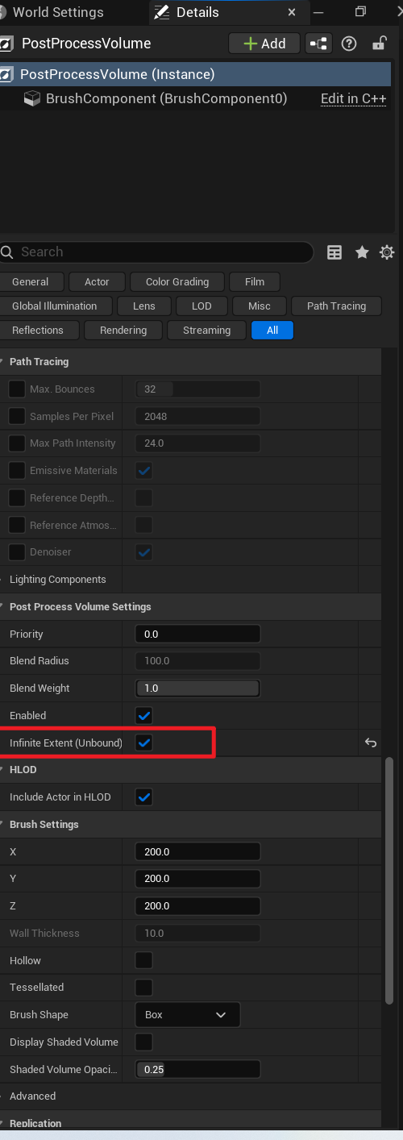

2. Nav Mesh Bounds Volume
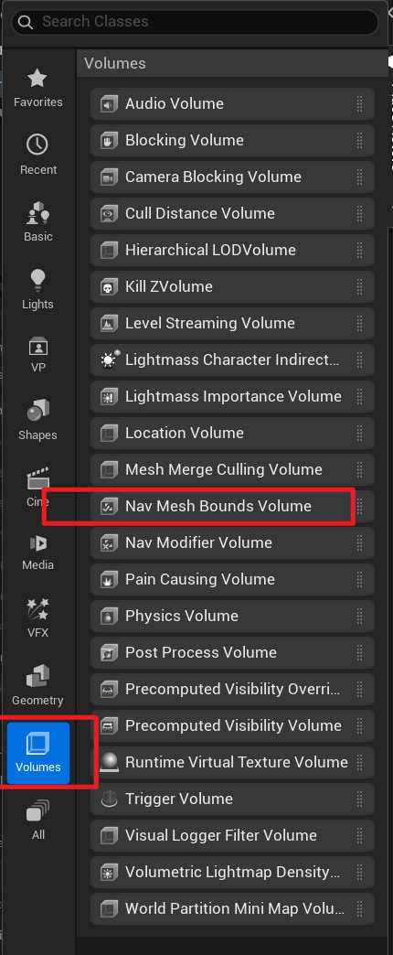
Resize it so it covers the whole playable map.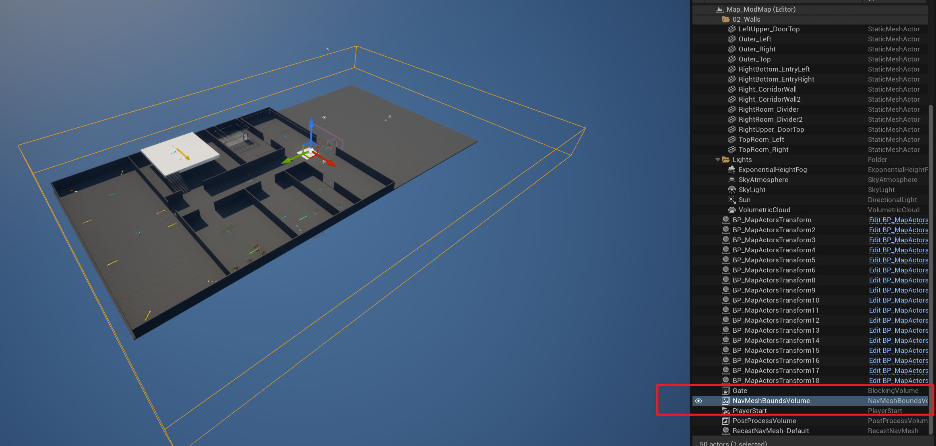
Press P to display navigation coverage. Areas without green coverage cannot be reached by AI.
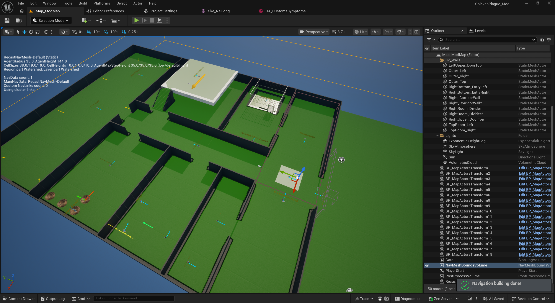
Pay special attention to the cage area. The navigation surface outside the cage must connect to the surface inside it.
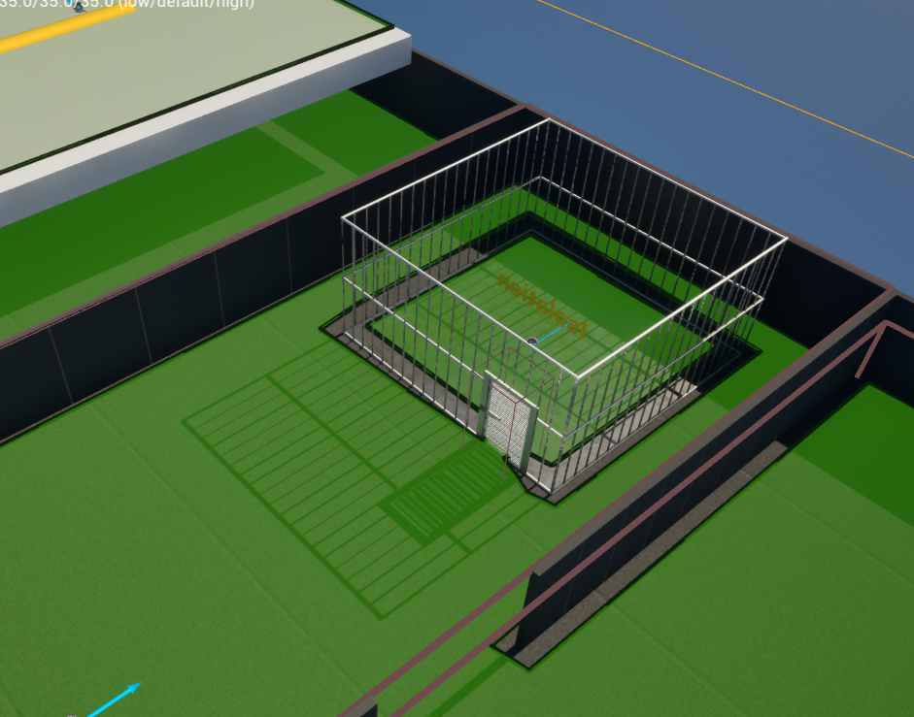
Also check the helipad and steps. The navigation surface must not be broken there.
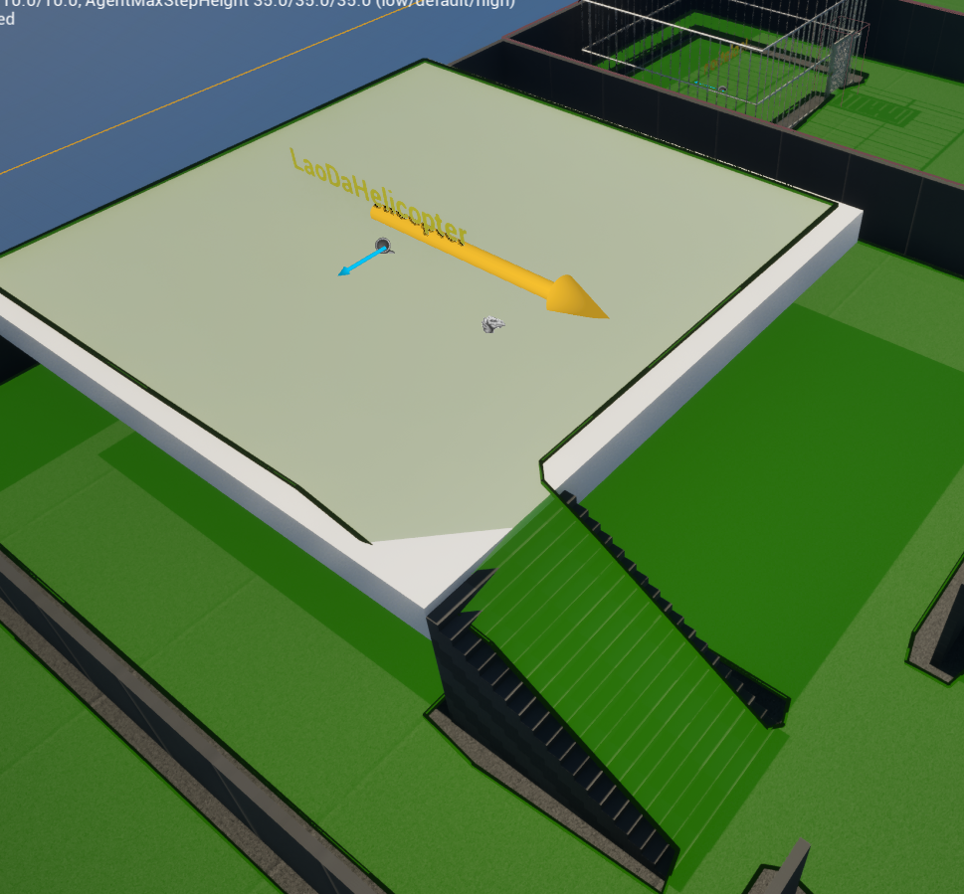

3. PlayerStart
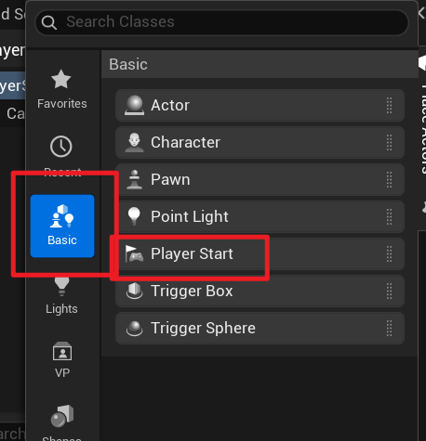
This is where the player enters the map. Place it beside the bed, using the same position and facing direction as the green arrow on the bed.
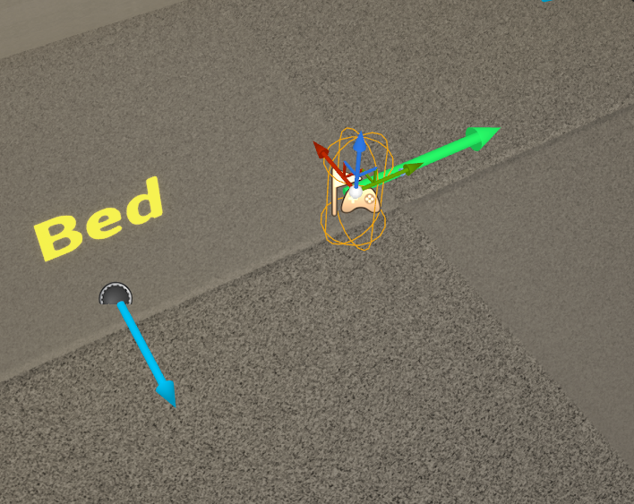

4. Invisible Wall at the Main Gate
This prevents characters from leaving the map.
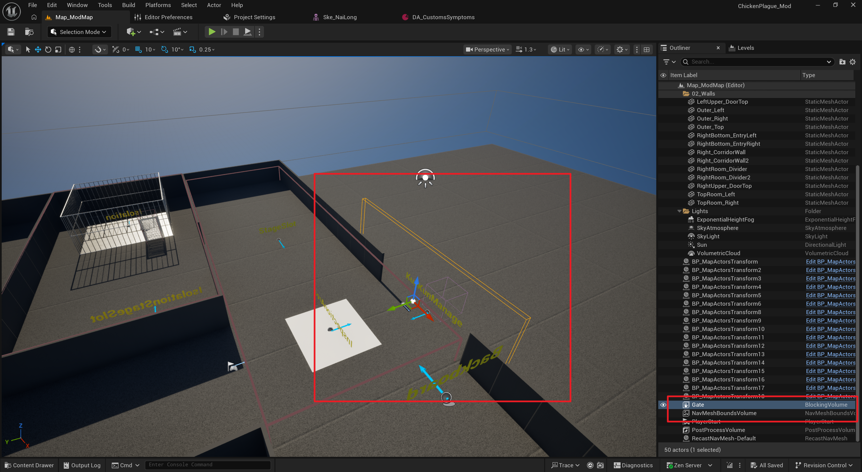
Use the collision settings shown here. You may wonder why this is not simply set to No Collision when every response is Ignore.
For compatibility with the ModKit, please keep the settings exactly as shown.
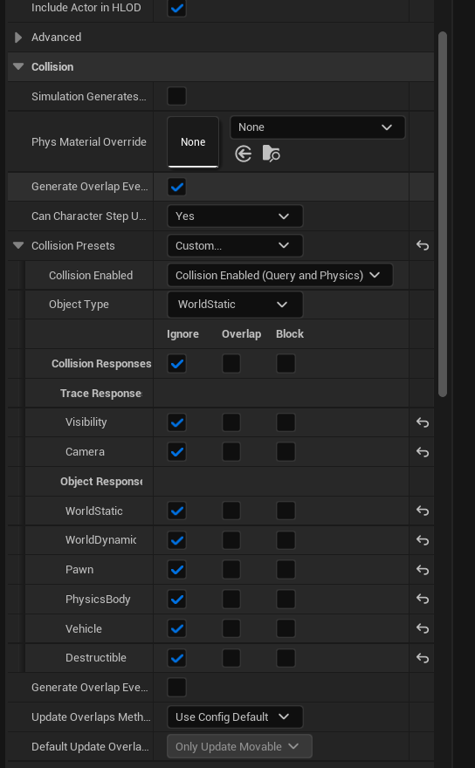

3. Replace the Cage Models
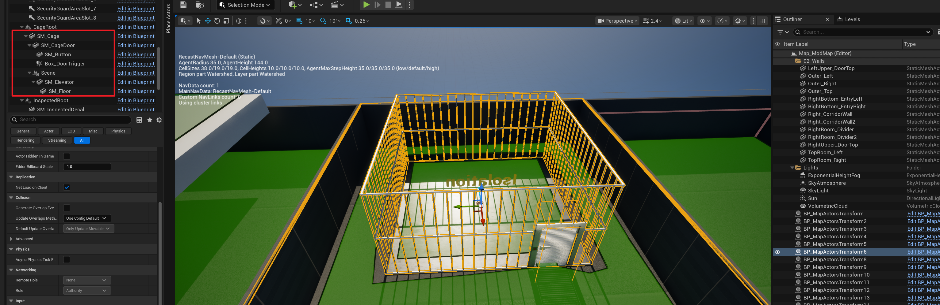
Select these components in the level, replace their Static Meshes, and adjust their transforms.
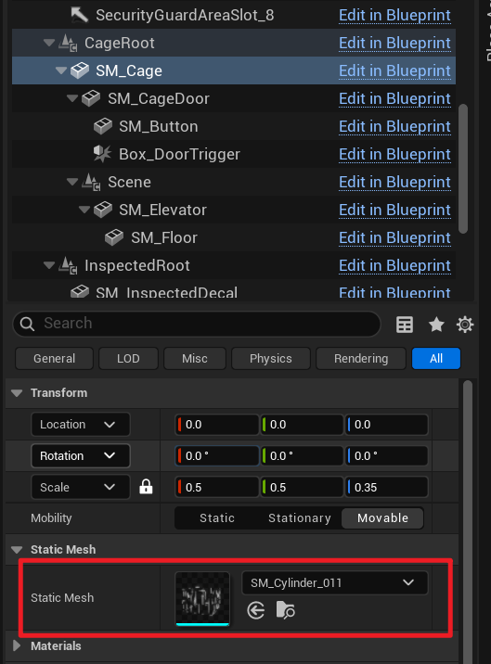

4. Replace the Chicken-Coop Model in the Hatching Area
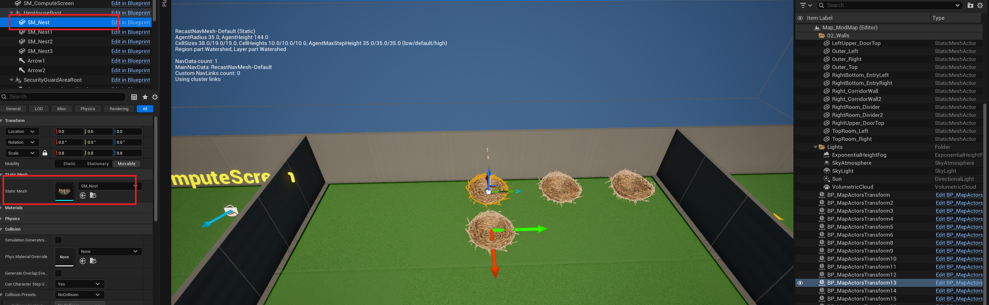
Replace only the first chicken-coop model, then adjust its transform. Coop upgrades spawn in the direction of the green arrow. After three coops have spawned, the next row starts in the direction of the red arrow.

5. Computer Screen
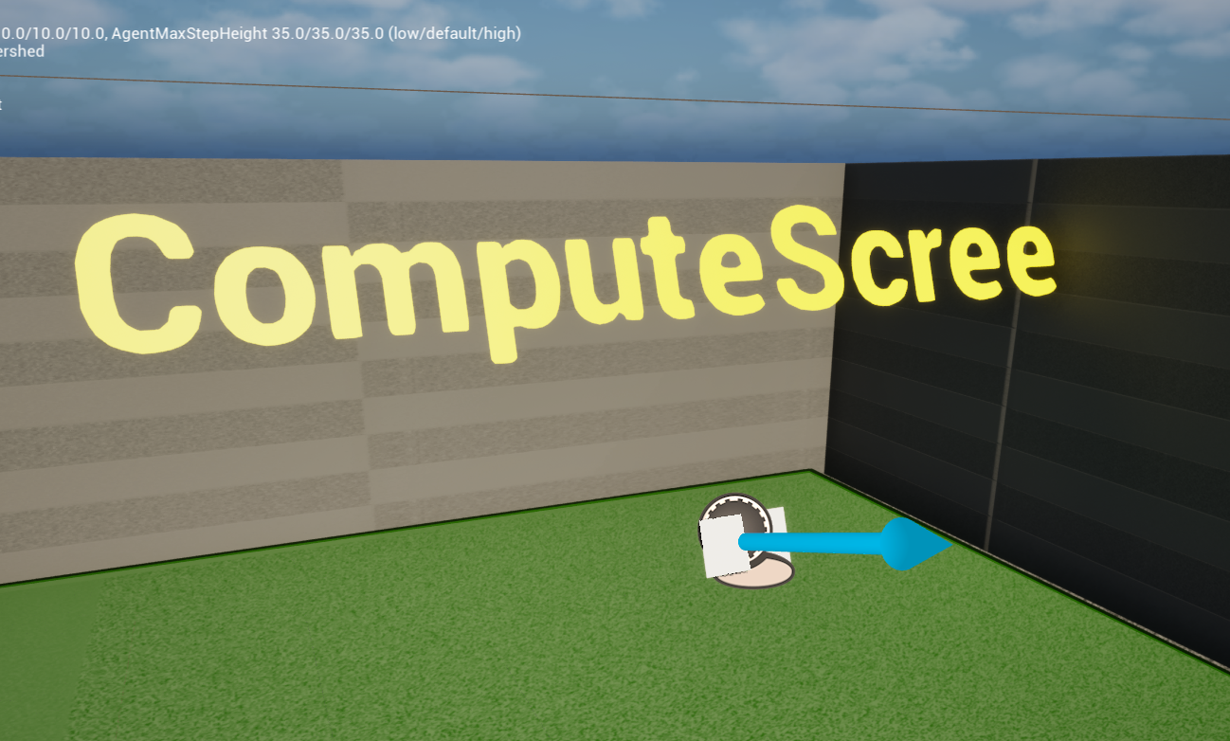
You can place a computer model here. Align this screen plane so it is parallel with the monitor display.

III. Packaging and Testing

1. Package an Asset Mod
Run the packaging steps in the order shown: 1, 2, then 3.
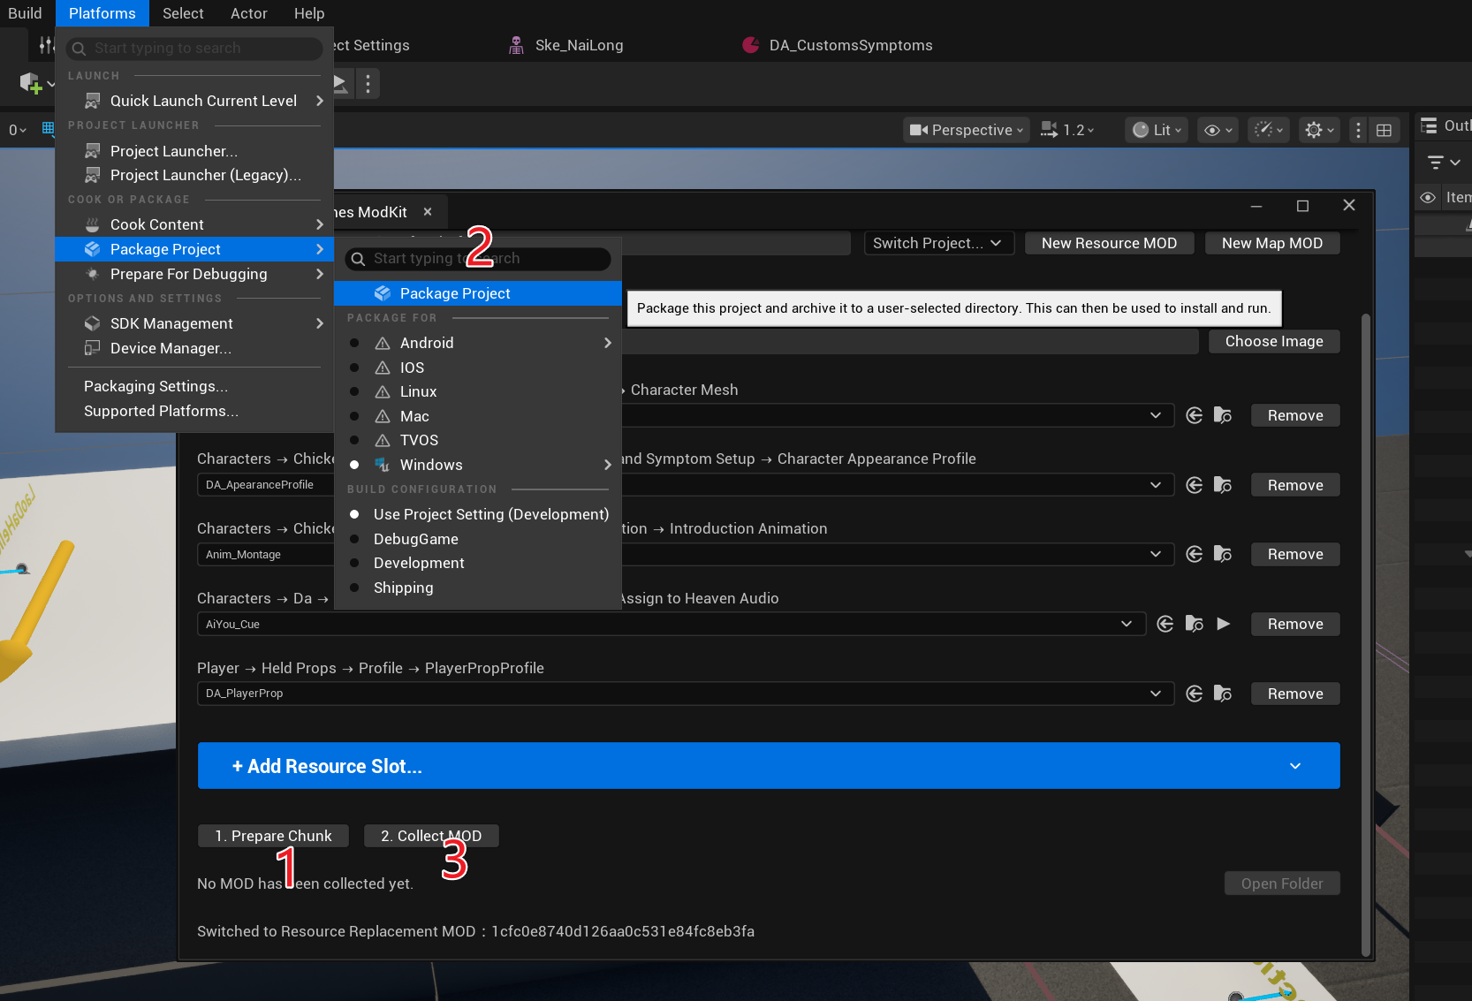
If the following message appears after validation, the mod is ready to package.
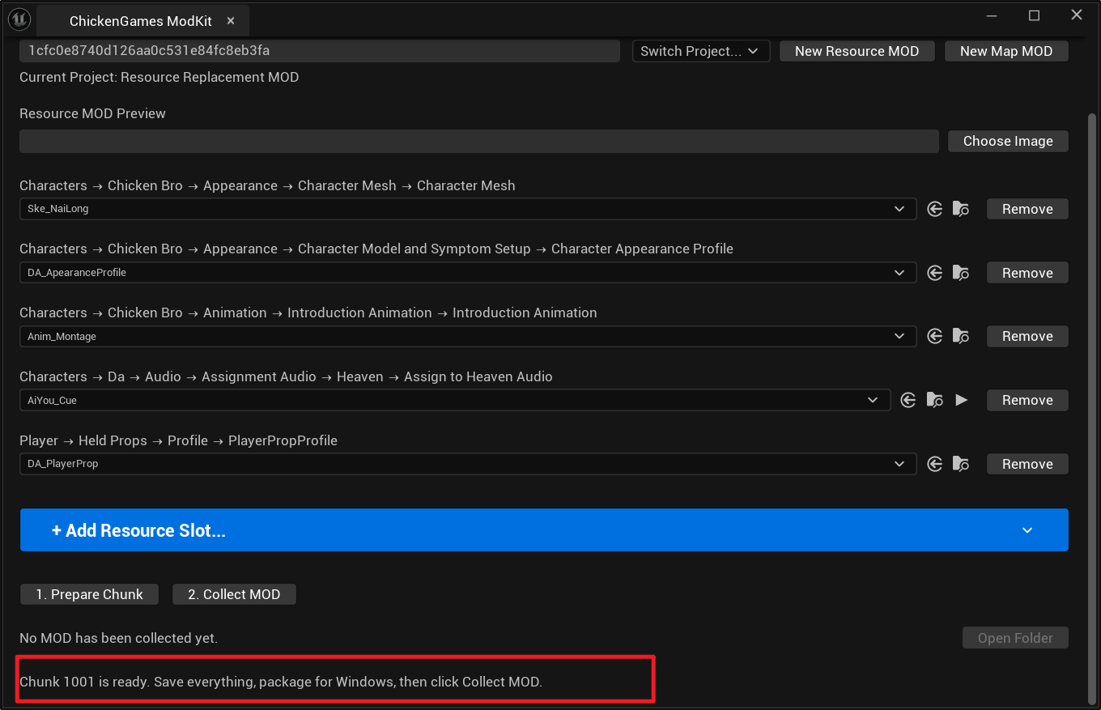
Chinese interface:
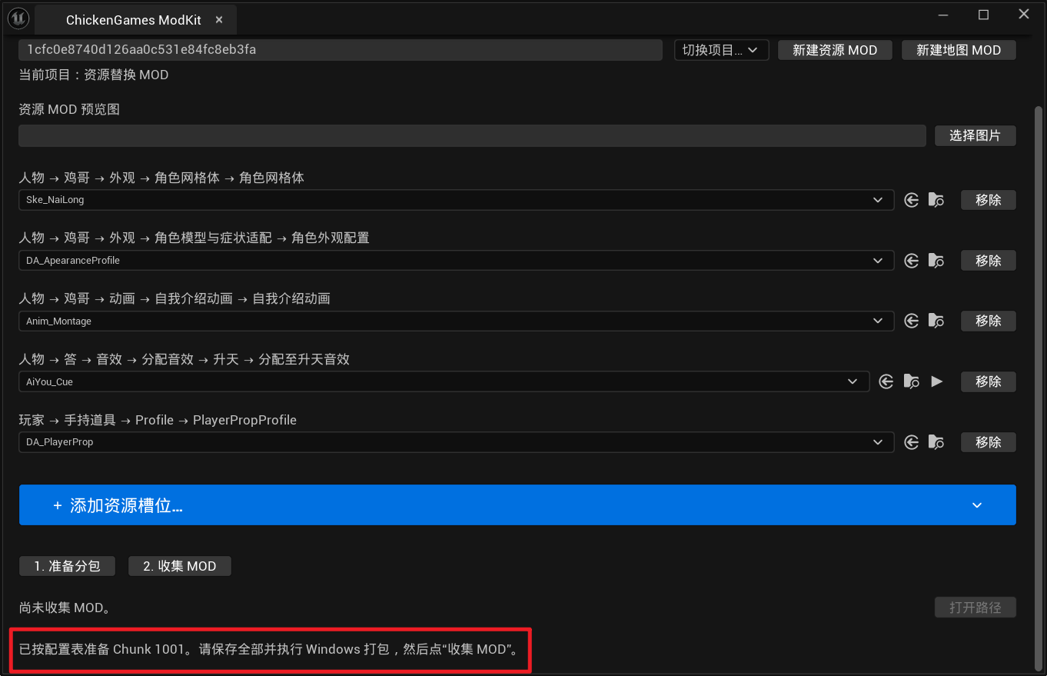
Start packaging and choose any output location.
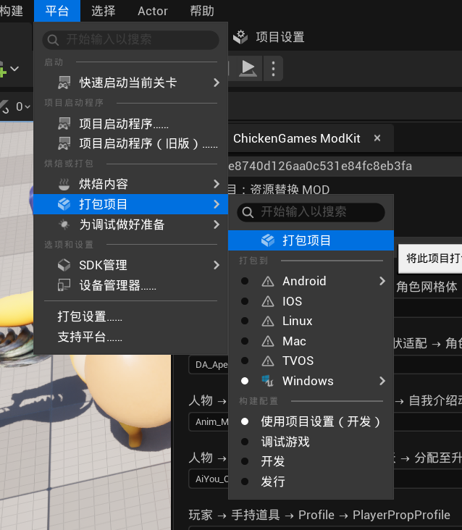

2. Package a Map Mod
Open the map created for your mod.
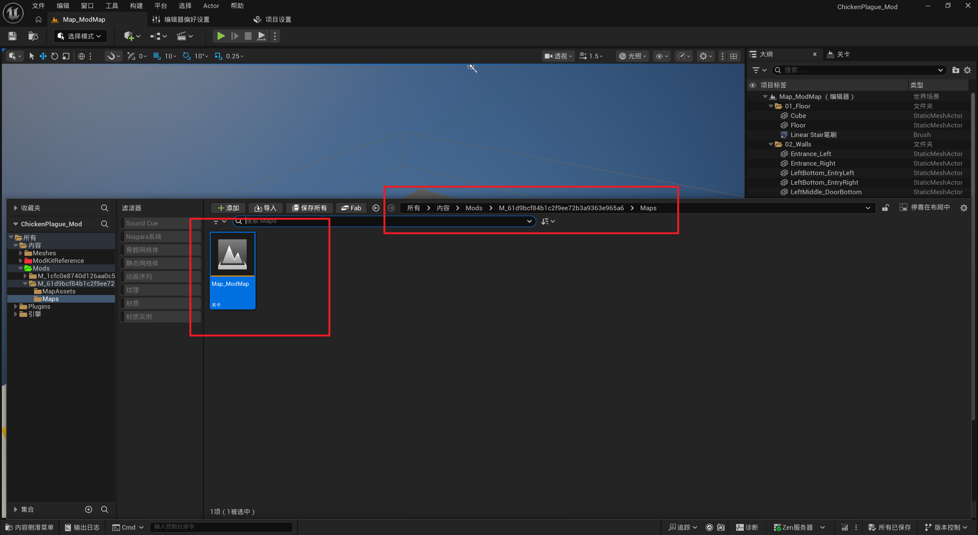
Run the steps in the order shown.
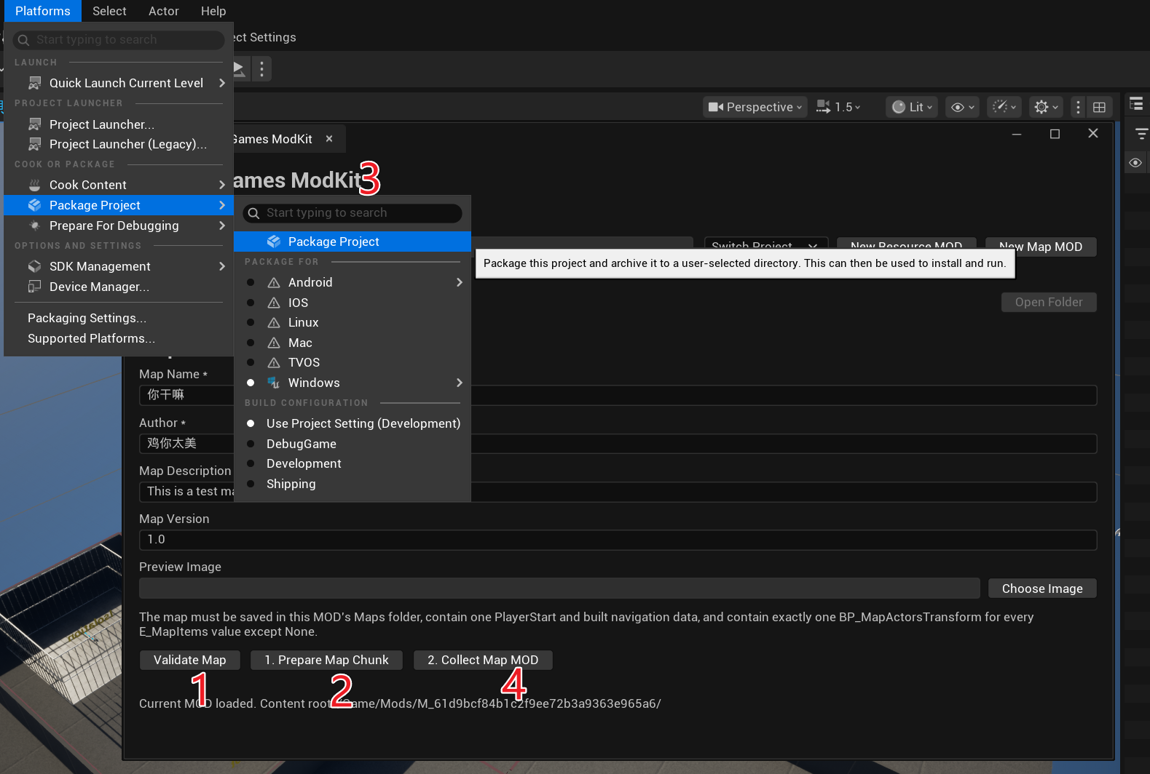
When map validation succeeds, the following message appears.
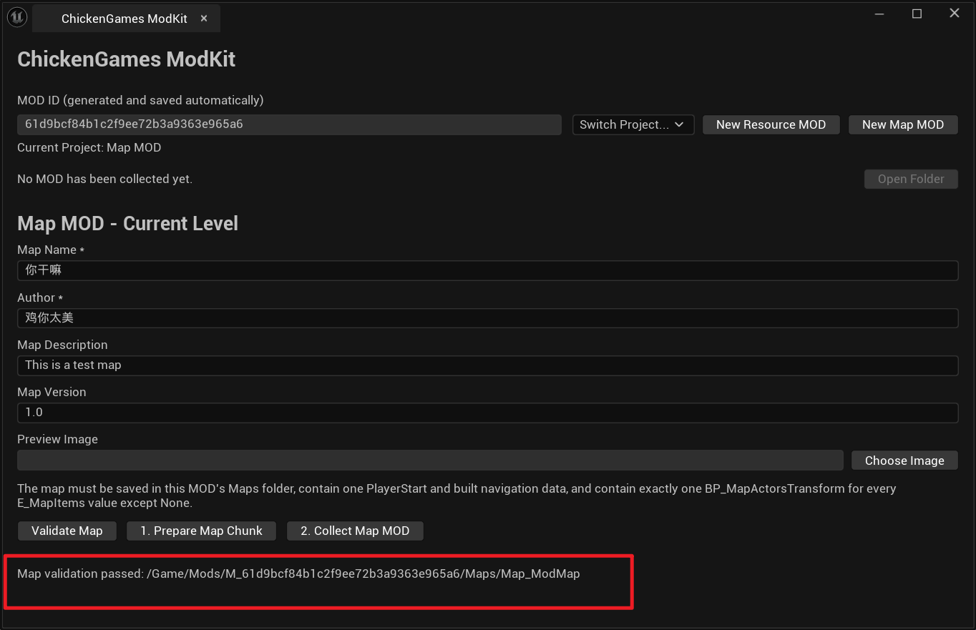
Chinese interface:
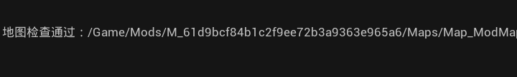

3. Test the Mod
After packaging succeeds, click Collect Mod, then click Open Folder.
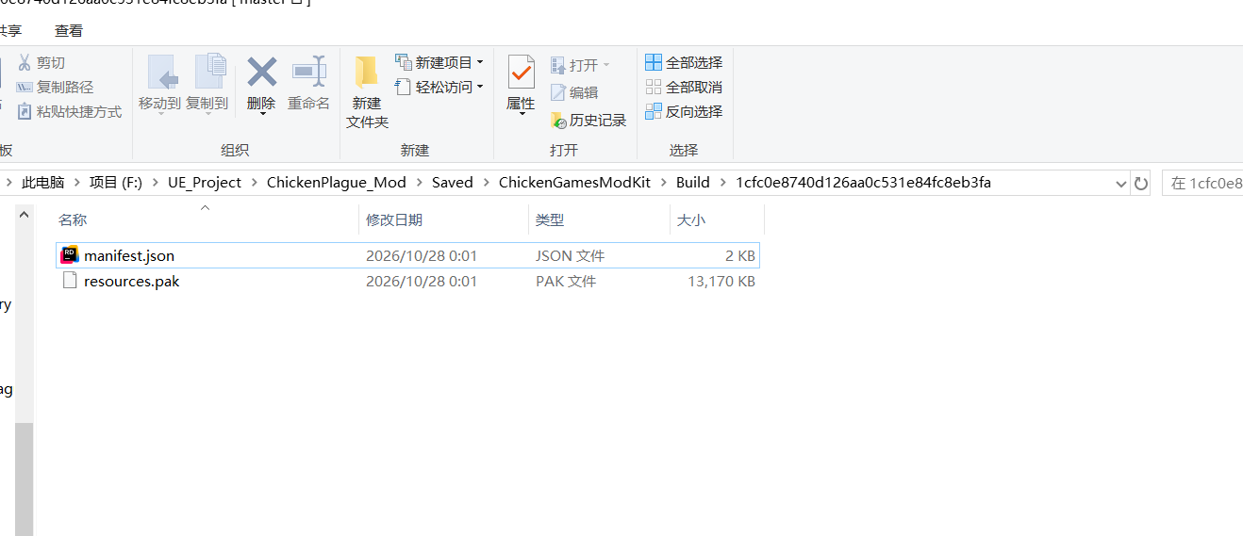
Go up one folder level.
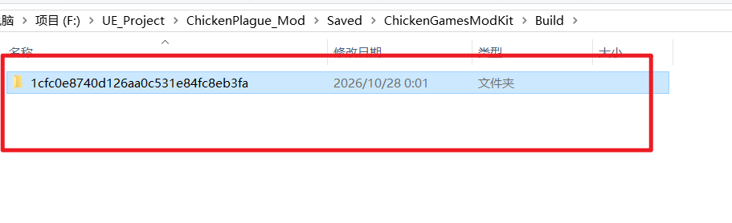
Copy the packaged mod into the Mods folder in the game installation directory.
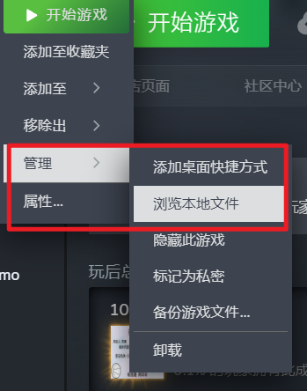
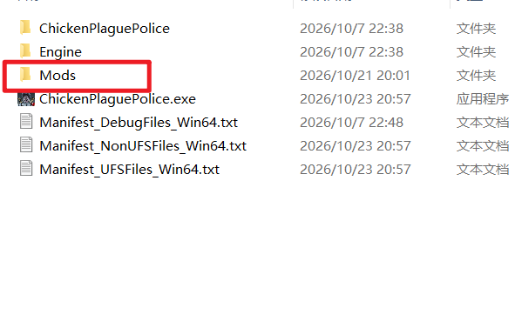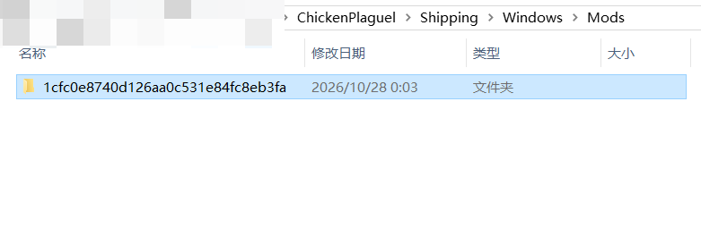
Add the -Mod launch option to enter and test a Mod map.