Deep Learning for HIV-1 Subtype Classification: A BiLSTM and Focal Loss Approach
Final Project - MSB7216: Deep Learning for Health Data

1. Abstract & Overview
Background: HIV-1 subtyping is essential for guiding antiretroviral therapy and tracking epidemiological spread, as different subtypes exhibit varying resistance profiles.
Previous Work: Existing bioinformatics tools heavily rely on computationally expensive Multiple Sequence Alignment (MSA) or manual k-mer feature engineering.
Problem Statement: MSA struggles with hypermutations and large gaps. Furthermore, genomic databases suffer from severe geographical class imbalance, making it difficult to train robust classifiers for minority subtypes.
Objective: To develop an automated, alignment-free Deep Learning classifier to categorize raw nucleotide sequences into Subtypes A, B, C, and D.
Significance: Eliminating the MSA bottleneck enables faster, more scalable, and highly accurate subtyping. By proving that bidirectional recurrent networks can natively learn phylogenetic features, this pipeline sets a foundation for real-time clinical deployment.

2. Introduction / Background
Human Immunodeficiency Virus Type 1 (HIV-1) exhibits extreme genetic diversity. The pol gene is clinically critical because it encodes the reverse transcriptase, protease, and integrase enzymes. Accurately identifying the viral subtype is essential for personalized medicine and epidemiological tracking. Traditional bioinformatics algorithms rely heavily on Multiple Sequence Alignment (MSA), a computationally expensive process. This project introduces an alignment-free deep learning pipeline designed to automatically extract phylogenetic features directly from raw nucleotide sequences.

3. Dataset Description
The dataset consists of HIV-1 pol gene sequences from the LANL HIV Sequence Database. A critical challenge is geographical bias. Subtype B dominates the dataset at ~52.2%, being the primary variant in North America and Western Europe. Subtypes A, C, and D are less represented. This severe class imbalance necessitated advanced loss optimization to prevent minority class suppression. The sequence lengths varied wildly before padding was applied.
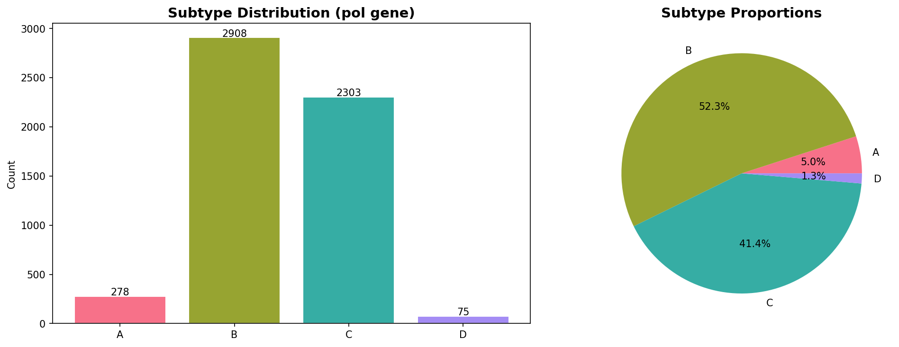
Figure: Subtype Distribution
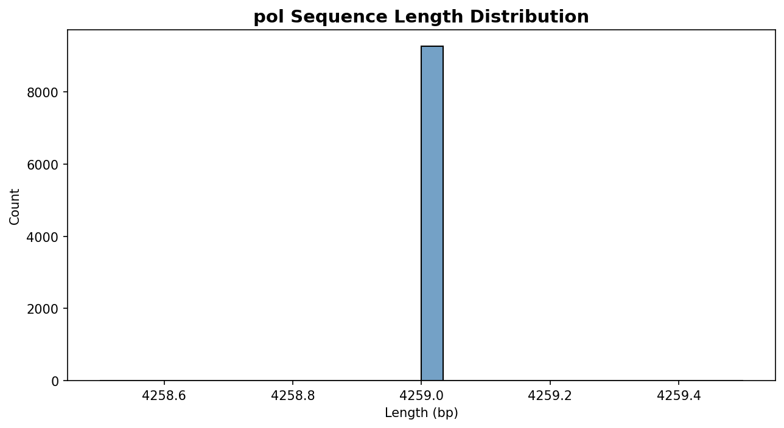
Figure: Sequence Lengths

4. Methodology

4.1 Processing (Encoding)
Sequences were cleansed of alignment gap characters ('-'). Two encodings were utilized: One-hot encoding for the MLP and CNN models, and integer label embedding for the BiLSTM and Transformer models. All sequences were padded/truncated to a uniform length of 3000bp.

4.2 Class Balancing
Initial iterations utilizing standard categorical cross-entropy caused catastrophic collapse into the majority class (Subtype B). The pipeline implemented pure Focal Loss (gamma=2.0) to dynamically down-weight easily classified majority examples and force the optimizer to focus heavily on hard-to-predict minority strains.

4.3 Experiments & Architectures
1. Baseline MLP (Approx. 73.8k Parameters): Global Average Pooling feeding into a 16-neuron dense layer with Dropout. Evaluates global nucleotide composition.
2. 1D-CNN (Approx. 200k Parameters): Convolutional networks designed to extract localized spatial motifs (k-mers). Architecture: Four Conv1d layers (filters increasing from 32 to 128, kernel sizes decreasing from 7 to 3), alternating with MaxPool and Dropout (0.5), ending in an AdaptiveAvgPool1d and a 64-neuron Dense layer.
3. BiLSTM (Approx. 2.1M Parameters): Designed to process sequence context bidirectionally to capture long-range biological dependencies. Architecture: Embedding Layer (128-dim), followed by a 2-layer Bidirectional LSTM (256 hidden units), ending in a 128-neuron Dense classifier with heavy Dropout (0.3).

4.4 Explainability
A Universal Saliency Map was implemented using Input-Gradient Attention to visualize model confidence. The algorithm plotted high-resolution attention maps over the DNA sequence to highlight exact biological regions driving the classification, successfully bypassing CNN-only limitations.

4.5 Deployment
A dynamic model-factory system automatically parses training histories, identifies the best architecture, loads the trained checkpoint natively, and exposes an inference pipeline.

4.6 Transfer Learning
An exploratory phase utilized DNABERT, a Transformer pre-trained on the human genome, fine-tuned for HIV subtyping to test cross-domain knowledge transfer. Due to the massive parameter count (100M+), sequence truncation and heavy gradient accumulation were required.

5. Results
The BiLSTM achieved an impressive 94.73% accuracy. The Baseline MLP achieved 65.27%. However, both the 1D-CNN and DNABERT collapsed entirely, predicting only the majority class (Subtype B) resulting in exactly 52.22% accuracy.
Model | Test Accuracy | Macro Precision | Macro Recall | Macro F1
Baseline MLP | 0.6527 | 0.5082 | 0.7472 | 0.5114
1D-CNN | 0.5222 | 0.1305 | 0.2500 | 0.1715
BiLSTM | 0.9473 | 0.6274 | 0.6982 | 0.6541
DNABERT | 0.5222 | 0.1305 | 0.2500 | 0.1715
The training curves illustrate how the Focal loss heavily penalized early instability, but the CNN ultimately failed to escape the local minima of predicting Subtype B.
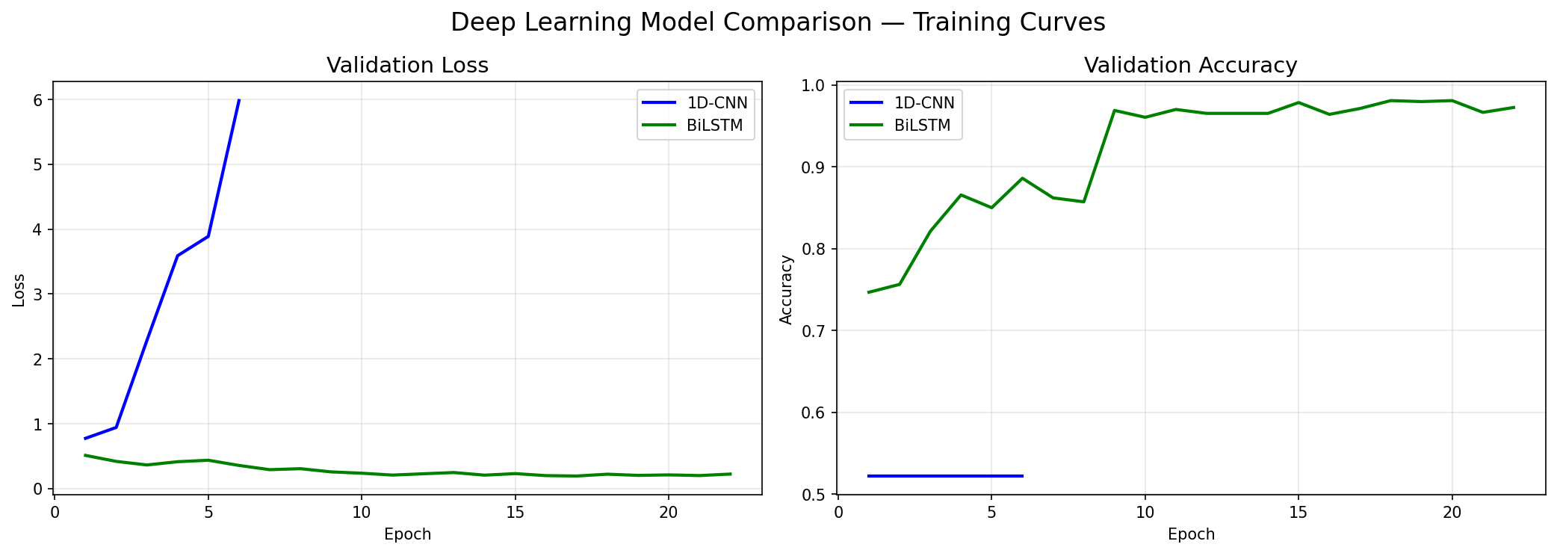
Figure: Model Comparison Curves
The per-class metrics output directly from Notebook 5 confirms that the BiLSTM accurately learned the minority class boundaries, generating high precision across the board.
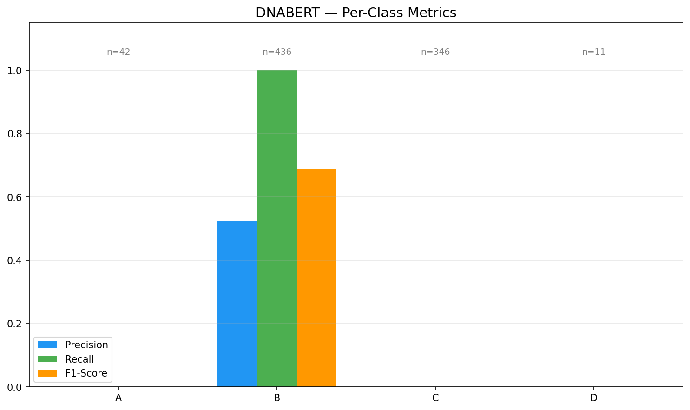
Figure: Best Model Per Class Metrics
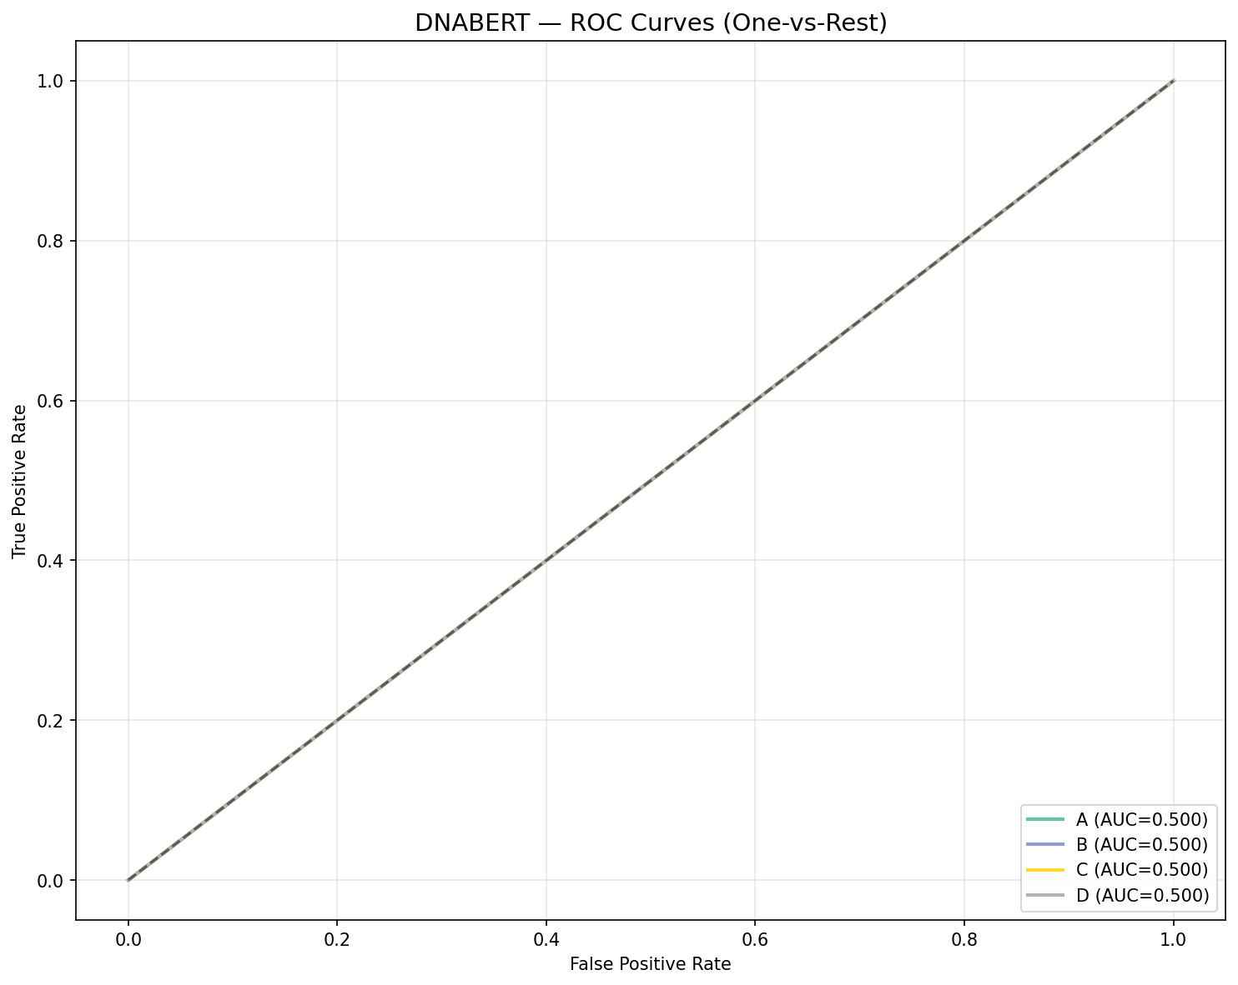
Figure: Best Model Roc
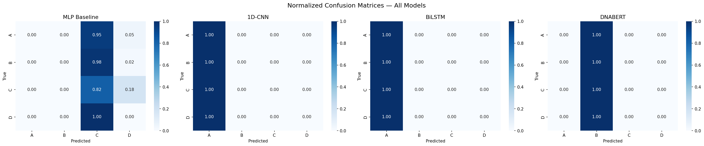
Figure: All Confusion Matrices

6. Error Analysis
Observed Trends: The BiLSTM misclassified approximately 5% of sequences, while the CNN and DNABERT experienced 100% minority-class misclassification (predicting everything as Subtype B).
Possible Causes & Implications: The Saliency Maps revealed that the BiLSTM focuses on highly conserved functional regions. When novel sequences exhibit hypermutation in these regions (viral drift), the model's confidence shatters. The CNN and DNABERT failures indicate that local spatial motifs (convolutions) and generic human-genome pre-training are highly susceptible to geographical class imbalance, completely ignoring minority strains.

7. Limitations and Challenges
1. Severe Geographical Imbalance: Despite Focal Loss, overcoming the 52% Subtype B dominance remains a fundamental challenge, as evidenced by the CNN's total collapse.
2. Computational Complexity: Transfer learning with DNABERT on 3000bp sequences was highly constrained by GPU VRAM, leading to suboptimal batch sizes and eventual model collapse.
3. Domain Gap: Pre-training Transformers on human genomes does not inherently translate to high-mutation viral genomes.

8. Conclusion and Future Work
Alignment-free Deep Learning via Bidirectional LSTMs successfully resolves HIV-1 subtyping, achieving 94.73% accuracy. It proves that sequential recurrent networks are far more resilient to biological class imbalances than spatial CNNs.
Future Work: The pipeline will be expanded to include Circulating Recombinant Forms (CRFs), and the deployment module will be hosted as a REST API for programmatic clinical access.

