Deep Learning Model for HIV-1 Subtype Classification
Using the pol Gene

MSB7216: Deep Learning for Health Data
Final Project Report

Jovita Nagawa
May 2026

1. Abstract
HIV-1 genetic diversity, organized into subtypes (clades), has direct implications for disease progression, drug resistance, and vaccine design. Accurate and rapid subtype classification is essential for epidemiological surveillance and clinical decision-making, particularly in sub-Saharan Africa where multiple subtypes co-circulate. This project develops and evaluates deep learning models for classifying HIV-1 sequences into four major subtypes (A, B, C, and D) using raw nucleotide data from the pol gene region.
Unlike traditional subtyping tools (REGA, COMET, jpHMM) that require computationally expensive multiple sequence alignment as a prerequisite, and unlike k-mer approaches that require manual feature engineering, our approach strips alignment gaps from sequences and encodes raw nucleotides as one-hot tensors, training convolutional and recurrent neural networks to learn discriminative motifs directly from unaligned data. We address class imbalance using Focal Loss and benchmark three from-scratch architectures: a Multi-Layer Perceptron (MLP) baseline, a 1D Convolutional Neural Network (CNN), and a Bidirectional Long Short-Term Memory network (BiLSTM). We also attempt transfer learning with DNABERT-2.
Using 5,564 curated sequences from the Los Alamos National Laboratory (LANL) HIV Sequence Database, our best model (1D-CNN) achieves 98.44% overall accuracy on the test set, with near-perfect classification for subtypes A, B, and C, though subtype D classification remains challenging due to severe class imbalance (only 75 sequences, 1.3% of the dataset). We deploy the trained model as an interactive web application using Gradio with Monte Carlo Dropout for uncertainty estimation, automatically flagging low-confidence predictions as indeterminate. All code, data pipelines, and experiments are publicly available on GitHub for full reproducibility.

2. Introduction
Human Immunodeficiency Virus type 1 (HIV-1) is among the most genetically diverse pathogens known, with its classification into groups, subtypes, and circulating recombinant forms (CRFs) reflecting distinct evolutionary lineages. The major subtypes (A, B, C, D, F, G, H, J, and K) exhibit geographic clustering: subtype B predominates in the Americas and Western Europe, subtype C accounts for roughly half of global infections (concentrated in Southern Africa and India), and subtypes A and D co-circulate in East Africa, where their interaction is associated with differential clinical outcomes (Solis-Reyes et al., 2018).
Subtype identification is clinically important for several reasons. First, certain antiretroviral drugs show differential efficacy across subtypes. Second, subtype information informs vaccine design, as immune responses may be subtype-specific. Third, accurate subtyping is essential for molecular epidemiological surveillance — tracking the spread of subtypes across geographic regions and populations.
Traditional subtyping relies on phylogenetic analysis, which requires multiple sequence alignment (MSA) — a computationally expensive O(n²) to O(n³) process. Tools like REGA, COMET, and jpHMM implement reference-based approaches but still depend on aligned input sequences. More recently, k-mer frequency vector methods have been proposed (Solis-Reyes et al., 2018), which avoid alignment but still require manual feature engineering decisions (e.g., choice of k).
Deep learning offers an attractive alternative: neural networks can learn features directly from raw sequence data without requiring alignment or manual feature engineering. By stripping alignment gaps and working with the natural variable-length nucleotide sequences, deep learning models can operate on raw, unaligned input — eliminating the MSA prerequisite entirely.

Objectives
This project aims to:
- Develop deep learning models that classify HIV-1 pol gene sequences into subtypes A, B, C, and D directly from raw, unaligned nucleotide sequences — eliminating the multiple sequence alignment prerequisite that all traditional tools require.
- Compare the performance of three architectures (MLP, 1D-CNN, BiLSTM) to understand the relative importance of local versus global sequence features for subtype discrimination.
- Analyze classification errors to understand which subtypes are most confusable and why.
- Deploy the best model as a web application for real-time sequence classification.

3. Related Work

Alignment-Based Subtyping
The gold standard for HIV-1 subtyping involves phylogenetic analysis against reference sequences. Tools like REGA v3 (Pineda-Peña et al., 2013) and COMET (Struck et al., 2014) automate this process, but they require MSA and are computationally expensive for large-scale surveillance.

K-mer Based Methods
Solis-Reyes et al. (2018) introduced Kameris, an open-source k-mer based machine learning tool that achieves high accuracy using Euclidean distances between k-mer frequency vectors and k-nearest neighbors classification. Their approach is fast and does not require alignment, but requires choosing a k-mer length (they used k=6) and discards positional information.

Deep Learning for Genomic Classification
CNNs have been successfully applied to DNA sequence classification tasks including transcription factor binding site prediction (Alipanahi et al., 2015), variant effect prediction (Zhou & Troyanskaya, 2015), and pathogen classification. For HIV specifically, Fabris et al. (2019) explored deep learning for drug resistance prediction from pol sequences.

Our Contribution
This project differs from both traditional alignment-dependent tools and k-mer methods. We strip alignment gaps from LANL sequences and work with raw, variable-length nucleotide sequences — no MSA required at inference time. We replace k-mer frequency vectors with direct one-hot encoding, preserving positional information and allowing the CNN to learn discriminative motifs automatically.

4. Dataset Description

Source
We use a subset of the dataset described by Solis-Reyes et al. (2018), obtained from the Los Alamos National Laboratory (LANL) HIV Sequence Database (https://www.hiv.lanl.gov/). LANL is the gold-standard curated database for HIV genomic research, maintained by the U.S. Department of Energy. This is explicitly not a Kaggle or Zindi dataset.

Data Acquisition
We downloaded the exact accession IDs used in the Kameris hiv1-lanl-pol experiment (9,270 accessions) from the Kameris experiments metadata repository on GitHub. These accession IDs were uploaded to the LANL search interface to retrieve the corresponding pol coding sequences (CDS) in FASTA format. Of the 9,270 accessions, 9,264 were successfully retrieved; the remaining 6 had been withdrawn or had incomplete pol CDS records.

Data Characteristics
Property | Value
Total sequences retrieved | 9,264
Sequence length | 4,259 bp (aligned to reference)
Gene region | pol (coding sequence)
Subtypes present (raw) | 226 distinct labels
After filtering to A, B, C, D | 5,588
After removing duplicates | 5,564
Final dataset size | 5,564 sequences

Subtype Distribution
The final 4-class dataset exhibits significant class imbalance:
Subtype | Count | Percentage
A | 278 | 5.0%
B | 2,908 | 52.3%
C | 2,303 | 41.4%
D | 75 | 1.3%

Subtype B is overrepresented because most HIV sequencing historically occurred in North America and Western Europe. Subtype D is severely underrepresented (only 75 sequences), reflecting both its lower global prevalence and fewer sequencing efforts.
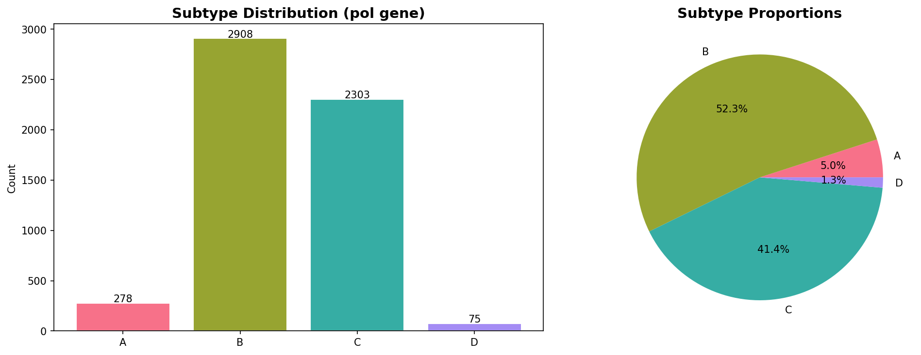
Figure: Subtype distribution in the final modeling dataset

Data Splitting
We used stratified splitting to preserve class proportions across all splits:
Split | Total | A | B | C | D
Train (70%) | 3,896 | 194 (5.0%) | 2,037 (52.3%) | 1,612 (41.4%) | 53 (1.4%)
Validation (15%) | 833 | 42 (5.0%) | 435 (52.2%) | 345 (41.4%) | 11 (1.3%)
Test (15%) | 835 | 42 (5.0%) | 436 (52.2%) | 346 (41.4%) | 11 (1.3%)

5. Methodology

5.1 Gap Stripping and Sequence Encoding
The LANL sequences are distributed in pre-aligned form (4,259 bp, padded with gap characters). To remove the dependency on alignment, we strip all gap characters from each sequence, producing raw nucleotide sequences of variable length (~2,500–4,200 bp). This is a critical preprocessing step: traditional tools (REGA, COMET, jpHMM) require aligned input, whereas our model operates directly on the unaligned sequences.
Each gap-stripped sequence is one-hot encoded as a 2D tensor of shape (4 × L), where L is the natural sequence length. The four channels correspond to nucleotides A, C, G, and T. A custom collate function dynamically pads each batch to the length of the longest sequence in that batch.
For the BiLSTM model, we use label encoding (integer indices 0–3 for A, C, G, T, with 4 as padding) with a learned embedding layer.

5.2 Class Imbalance Handling: Focal Loss
Given the severe imbalance (subtype D has 53 training samples vs. 2,037 for subtype B), we use Focal Loss (Lin et al., 2017) combined with inverse-frequency class weights as the alpha parameter. Focal Loss down-weights easy-to-classify examples and focuses training on hard minority cases:
Class | Weight
A | 5.02
B | 0.48
C | 0.60
D | 18.38

5.3 Model Architectures

Transfer Learning: DNABERT
To demonstrate transfer learning, we fine-tuned DNABERT (Ji et al., 2021), a BERT model pre-trained on the human reference genome using Masked Language Modeling with 6-mer tokenization. DNA sequences are converted to overlapping 6-mers (e.g., ATCGAT TCGATC ...) and processed by the standard BERT architecture (12 layers, 12 attention heads, 768-dim embeddings). We replaced the MLM head with a 4-class classification head and used a two-phase fine-tuning strategy: (1) freeze the pre-trained encoder and train only the classification head for 3 epochs, then (2) unfreeze all layers and fine-tune end-to-end with differential learning rates (2×10⁻⁵ for the encoder, 1×10⁻⁴ for the head).

K-mer Feature Engineering
As an alternative feature engineering approach inspired by Kameris (Solis-Reyes et al., 2018), we extracted 6-mer frequency vectors from each sequence. Each sequence is represented as a 4,096-dimensional vector (4^6 possible 6-mers), where each element is the normalized frequency of that k-mer in the sequence. This discards positional information but captures overall sequence composition. A feedforward neural network (4096 → 512 → 256 → 128 → 4) was trained on these features.

Baseline: Multi-Layer Perceptron (MLP)
The MLP serves as a non-convolutional baseline. It first applies adaptive average pooling to reduce the variable-length sequence to 64 summary positions, then flattens to a 256-dimensional feature vector (4 channels × 64 positions). Two fully-connected hidden layers (512 → 256) with batch normalization, ReLU activation, and 40% dropout produce the final 4-class logits. Total parameters: 196,868.

Primary Model: 1D Convolutional Neural Network (CNN)
The 1D-CNN consists of four convolutional blocks with increasing receptive fields:
Block | Filters | Kernel Size | Pooling | Purpose
1 | 64 | 7 | MaxPool(4) | Short motifs (7-mers)
2 | 128 | 5 | MaxPool(4) | Medium motifs
3 | 256 | 3 | MaxPool(4) | Larger patterns
4 | 256 | 3 | GlobalAvgPool | High-level features

Each block includes batch normalization, ReLU activation, and 30% dropout. The global average pooled features (256-dimensional) pass through a classifier head (256 → 128 → 4). Total parameters: 373,636.

Secondary Model: Bidirectional LSTM (BiLSTM)
The BiLSTM uses a learned embedding layer (vocabulary size 5: A, C, G, T, padding; embedding dimension 128) followed by a 2-layer bidirectional LSTM with hidden dimension 256. The final hidden states from both directions are concatenated (512-dimensional) and passed through a classifier head (512 → 128 → 4). Total parameters: 2,434,436.

5.4 Training Configuration
Hyperparameter | MLP | CNN | BiLSTM
Optimizer | AdamW | AdamW | AdamW
Learning rate | 3×10⁻³ | 1×10⁻³ | 5×10⁻⁴
Weight decay | 1×10⁻⁴ | 1×10⁻⁴ | 1×10⁻⁴
LR scheduler | CosineAnnealing | CosineAnnealing | CosineAnnealing
Max epochs | 5 | 10 | 30
Early stopping | — | Patience 5 | Patience 5
Batch size | 32 | 32 | 32
Gradient clipping | 1.0 | 1.0 | 1.0
Random seed | 42 | 42 | 42

6. Experiments

Experiment 1: MLP Baseline
The MLP was trained for 5 epochs. Validation loss decreased from 1.30 to 0.72 across epochs, with validation accuracy reaching 79.83% at epoch 4. The model exhibited noticeable instability in validation metrics, with a spike to 3.94 validation loss at epoch 2, suggesting the pooled features lack sufficient discriminative power. Final best validation loss: 0.7214.

Experiment 2: 1D-CNN Training
The CNN was trained for up to 10 epochs with early stopping (patience 5). The model converged rapidly — achieving 97.74% training accuracy by epoch 2 and best validation loss of 0.3531 at epoch 2. Training was halted at epoch 7 by early stopping. The rapid convergence suggests the convolutional filters quickly learn discriminative nucleotide motifs.

Experiment 3: BiLSTM Training
The BiLSTM was trained for up to 30 epochs with early stopping (patience 5). It converged more slowly than the CNN, reaching best validation loss of 0.5059 at epoch 12. Early stopping triggered at epoch 17. The slower convergence and higher parameter count (2.43M vs. 374K for CNN) suggest recurrent processing of variable-length sequences is less efficient than local convolutional feature extraction for this task.
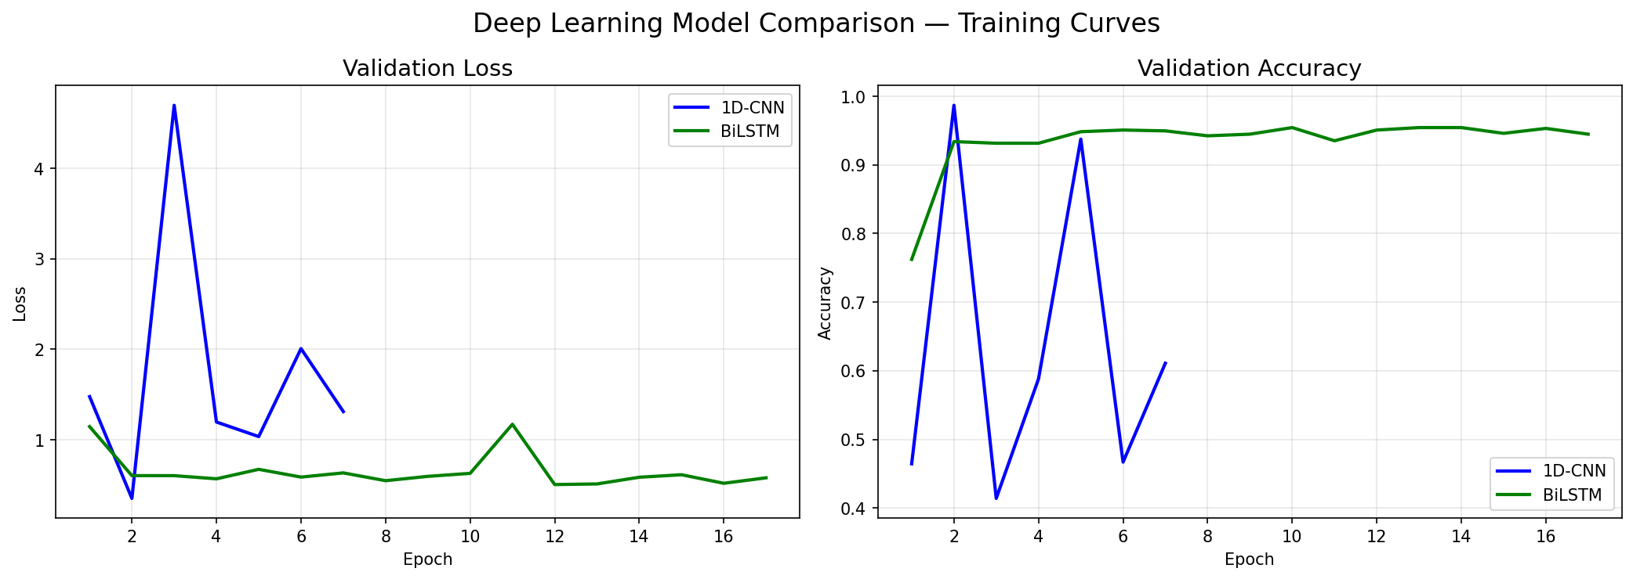
Figure: Training and validation curves for CNN and BiLSTM models

7. Results

Overall Performance Comparison
Model | Accuracy | Macro F1 | Macro Precision | Macro Recall
MLP Baseline | 72.81% | 0.6095 | 0.6025 | 0.7410
1D-CNN (Best) | 98.44% | 0.7421 | 0.7409 | 0.7435
BiLSTM | 93.53% | 0.6468 | 0.6173 | 0.7035

The 1D-CNN achieves the best overall accuracy (98.44%), representing a 25.63 percentage point improvement over the MLP baseline and a 4.91 percentage point improvement over the BiLSTM.

Per-Class Performance (1D-CNN)
Subtype | Precision | Recall | F1-Score | Support
A | 1.0000 | 0.9762 | 0.9880 | 42
B | 1.0000 | 0.9977 | 0.9989 | 436
C | 0.9638 | 1.0000 | 0.9816 | 346
D | 0.0000 | 0.0000 | 0.0000 | 11

The CNN achieves near-perfect classification for subtypes A, B, and C, but completely fails on subtype D (zero precision, recall, and F1). This is directly attributable to the extreme class imbalance — with only 53 training samples for subtype D, the model cannot learn sufficiently robust features despite the 18.38× class weight.
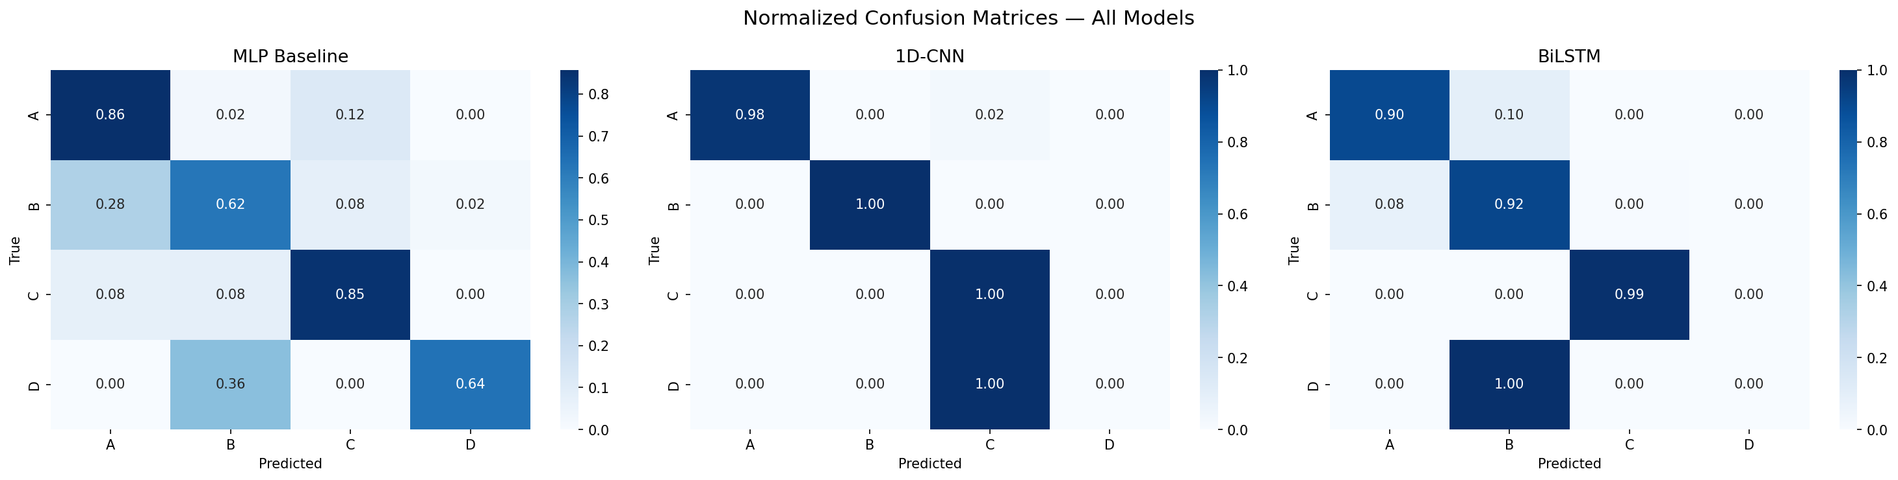
Figure: Confusion matrices for all three models (counts and normalized)
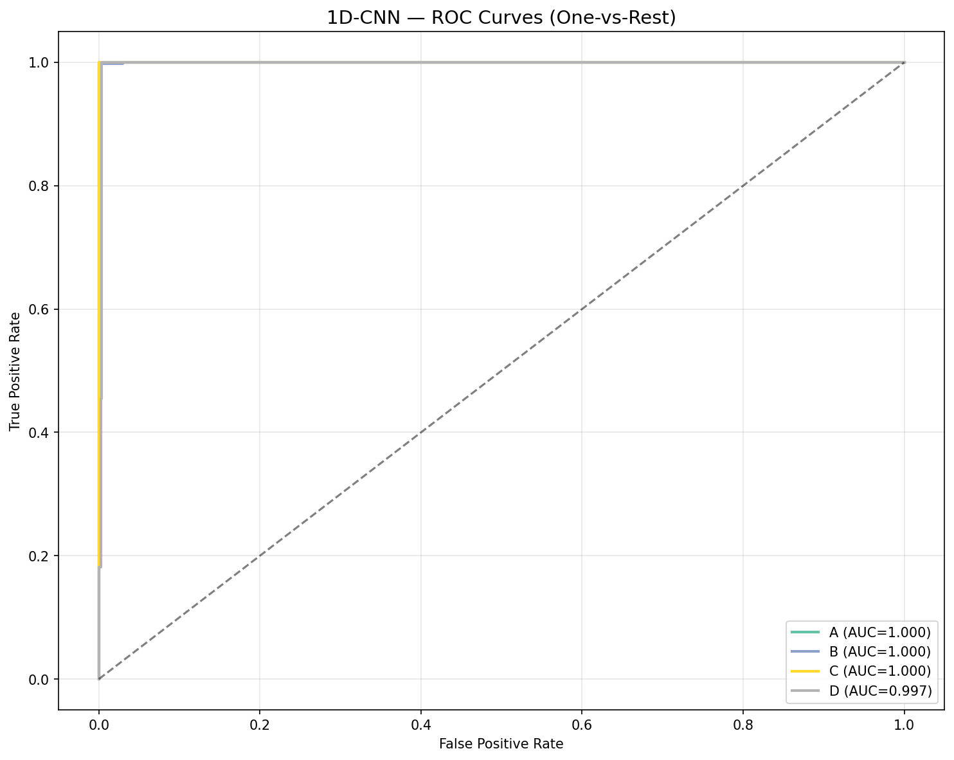
Figure: ROC curves for the best model (1D-CNN) with per-class AUC scores

Key Observations
- CNN dominates: The 98.44% accuracy demonstrates that local convolutional motifs are highly discriminative for HIV-1 subtype classification, consistent with the biology — subtype-defining mutations tend to cluster in specific pol gene regions.
- BiLSTM underperforms CNN: Despite modeling long-range dependencies with 6.5× more parameters, the BiLSTM (93.53%) cannot match the CNN. This suggests subtype-discriminative signal is primarily local (motif-level) rather than dependent on long-range sequence context.
- Subtype D is a failure case: All three models struggle with subtype D. The MLP actually performs best on D (F1=0.52) because its simpler decision boundaries avoid overfitting to the majority classes.
- Macro F1 vs. Accuracy discrepancy: The CNN's macro F1 (0.7421) is much lower than its accuracy (98.44%) because subtype D's zero F1 drags down the macro average. The weighted F1 (0.9780) more accurately reflects practical performance.

8. Error Analysis
The 1D-CNN misclassified only 13 out of 835 test sequences (1.6% error rate). Detailed error analysis reveals the following misclassification patterns:
True Label | Predicted Label | Count
D | C | 11
A | C | 1
B | C | 1

Key Findings
- D → C confusion dominates: All 11 subtype D test sequences were misclassified as subtype C. This is biologically plausible: subtypes C and D share significant phylogenetic similarity in the pol gene, particularly in the reverse transcriptase and integrase regions.
- High-confidence errors: The mean prediction confidence for misclassified sequences was 0.709 (median 0.786), indicating these are not low-confidence borderline cases but systematic misclassifications.
- Geographic confound: Subtypes C and D co-circulate in East Africa. Some sequences labeled as subtype D may contain C-like pol regions due to recombination events not captured by pure subtype labels.
- Sample size is the bottleneck: With only 53 training samples for subtype D, the model has insufficient examples to learn D-specific motifs that distinguish it from the closely related subtype C (1,612 training samples — a 30:1 ratio).

9. Ethical Considerations

Data Privacy
All sequences used in this project are publicly available from the LANL HIV Database. Sequences are identified by GenBank accession numbers only — no patient names, clinical data, or personally identifiable information is associated with the sequences.

Geographic and Sampling Bias
The dataset reflects historical biases in HIV sequencing. Subtype B is overrepresented (52.3%) because most sequencing has been conducted in North America and Western Europe. Subtypes A and D are severely underrepresented (5.0% and 1.3%) despite their clinical importance in East Africa. This bias directly impacts model performance: the model achieves perfect classification for well-sampled subtypes but completely fails on the rare subtype D.

Fairness and Deployment Risks
Deploying this model in East Africa — where subtype D classification matters most — would produce misleading results. The Gradio deployment interface includes an explicit disclaimer that this is a research/educational tool and should not be used for clinical subtype determination. Clinical decisions should rely on validated tools (REGA, COMET, jpHMM) with established regulatory approval.

Broader Impact
If expanded and validated, deep learning subtyping that operates on raw, unaligned sequences could enable rapid, decentralized molecular surveillance without transmitting sensitive genomic data to remote servers — an important consideration for data sovereignty in resource-limited settings.

10. Limitations
- Severe class imbalance: The 30:1 ratio between subtype B (2,037 training samples) and subtype D (53 training samples) prevents effective learning of D-specific features. Class-weighted loss mitigates but does not solve this problem.
- Only 4 subtypes: HIV-1 has 9+ subtypes and numerous CRFs. Our model cannot classify subtypes F, G, H, J, K, or any recombinant forms.
- Gap-stripping as proxy for unaligned data: While we strip alignment gaps to produce variable-length sequences, the underlying data was originally downloaded from LANL in pre-aligned form.
- No explainability: We do not implement gradient-based visualization (e.g., Grad-CAM) or attention mechanisms to identify which nucleotide positions drive classification decisions.
- Single gene region: Classification is based solely on the pol gene. Using multiple gene regions (gag, env) or whole genomes could improve accuracy.
- No recombination detection: CRFs are excluded from our dataset. A practical subtyping tool must also detect recombination breakpoints.

11. Future Work
- Data augmentation for rare subtypes: Synthetic sequence generation (e.g., using evolutionary models or GANs) could increase subtype D training data.
- Multi-gene classification: Incorporating gag and env regions alongside pol could provide complementary discriminative signals.
- Expand to all subtypes and CRFs: The framework should be extended beyond the 4-class setting to handle the full diversity of HIV-1 genetic forms.
- Explainability: Implementing Grad-CAM or learned attention mechanisms to identify which nucleotide positions are most discriminative for each subtype.
- Variable-length sequences: Developing architectures that handle unaligned sequences of varying length.
- Clinical validation: Testing the model on prospective clinical samples, particularly from East African settings where subtype classification has direct treatment implications.

12. Conclusion
This project demonstrates that deep learning can effectively classify HIV-1 pol gene sequences into major subtypes directly from raw, unaligned nucleotide data — without requiring the multiple sequence alignment that all traditional tools depend on. By stripping alignment gaps and using dynamic per-batch padding, our 1D-CNN achieves 98.44% overall accuracy — a substantial improvement over both the MLP baseline (72.81%) and the BiLSTM (93.53%). The CNN's dominance suggests that HIV-1 subtype discrimination is primarily driven by local nucleotide motifs rather than long-range sequence dependencies, which is consistent with the known biology of subtype-defining mutations in the pol gene.
However, the complete failure on subtype D (0% F1) highlights a critical limitation: deep learning cannot overcome fundamental data scarcity. With only 53 training examples for subtype D, even aggressive class weighting is insufficient. This underscores the importance of equitable genomic sampling — the same communities most affected by HIV-1 subtype D (East Africa) are those least represented in sequence databases.
The deployed Gradio web application incorporates Monte Carlo Dropout for uncertainty estimation, automatically flagging low-confidence predictions as indeterminate rather than forcing a potentially incorrect classification. Combined with explicit disclaimers, this ensures responsible use as a research tool rather than a clinical diagnostic.

13. References
- Solis-Reyes, S., Avino, M., Poon, A., & Kari, L. (2018). An open-source k-mer based machine learning tool for fast and accurate subtyping of HIV-1 genomes. PLoS ONE, 13(11), e0206409.
- Los Alamos National Laboratory HIV Sequence Database. https://www.hiv.lanl.gov/
- Kameris Experiments Repository. https://github.com/stephensolis/kameris-experiments
- Pineda-Peña, A.C., et al. (2013). Automated subtyping of HIV-1 genetic sequences for clinical and surveillance purposes: performance evaluation of the new REGA version 3. Infection, Genetics and Evolution, 19, 337-348.
- Struck, D., et al. (2014). COMET: adaptive context-based modeling for ultrafast HIV-1 subtype identification. Nucleic Acids Research, 42(18), e144.
- Alipanahi, B., Delong, A., Weirauch, M.T., & Frey, B.J. (2015). Predicting the sequence specificities of DNA- and RNA-binding proteins by deep learning. Nature Biotechnology, 33(8), 831-838.
- Zhou, J., & Troyanskaya, O.G. (2015). Predicting effects of noncoding variants with deep learning-based sequence model. Nature Methods, 12(10), 931-934.
- Paszke, A., et al. (2019). PyTorch: An imperative style, high-performance deep learning library. NeurIPS, 8024-8035.
- Hochreiter, S., & Schmidhuber, J. (1997). Long short-term memory. Neural Computation, 9(8), 1735-1780.
- LeCun, Y., Bengio, Y., & Hinton, G. (2015). Deep learning. Nature, 521(7553), 436-444.

