

CODY Complete
Capability Guide
  - Everything CODY can do and how to use it
This is my guide to CODY 0.15.6, my Windows assistant. It covers what he can do, how to talk to him, what each setting does and how to get things set up. I've included screenshots, example commands and a full settings reference so everything is in one place.
CODY brings together a desktop companion, voice commands, island widgets, AI chat, computer control and background tasks. He can handle quick things like checking the time or changing the volume, as well as longer jobs like building a website or helping with a document. The AI options are Claude Opus 5.5 and GPT 6.1 Sol with Medium reasoning. ElevenLabs handles text to speech.
Some features work straight away, while others need an app installed, an account connected or permission turned on. I've explained those requirements alongside the features, so it's easier to see what needs setting up.

Contents
01 How to use this guide 3
02 Starting CODY and finding your way around 4
03 Chat and everyday AI assistance 6
04 Hands free wake phrases 7
05 Push to talk and dictation 9
06 Microphones voices and speech settings 11
07 Time weather calculations and timers 12
08 System monitors and network information 13
09 Music video and audio control 14
10 Screenshots and MP4 screen recording 15
11 Opening arranging and editing in apps 16
12 Computer control and taking back control 17
13 Screen guidance drawings and desktop models 19
14 Browser connections and web tasks 20
15 Plugins and connected services 22
16 Background tasks and saved results 23
17 Permissions access modes and Windows privacy 25
18 Appearance personality and cursor customisation 27
19 Games and playful interaction 29
20 Files coding and project work 30
21 Example workflows you can try 31
22 Troubleshooting and practical limits 32
23 Quick command collection 33
24 Settings directory 35
25 Advanced tool reference 39
26 About this guide 44

01 How to use this guide

Find the right kind of help
Start with the voice chapters if you want to talk to CODY without typing. The utility chapters cover everyday things like the time, music, timers and screen recording. Computer control has its own section, including how to stop it. There's also a command list and a settings reference near the end.
The screenshots show CODY's interface. Your colours, microphone, connected accounts and permissions may look different depending on your settings.

How the features work
Built-in utilities handle specific requests using local application logic or a dedicated service. Time, dates, basic calculations, timers, volume changes and monitor widgets fall into this category. Weather still requires a network lookup even though it does not need a general AI conversation to interpret every result.
AI-assisted work covers explanations, writing, coding, research and multi-step tasks. The assistant interprets your goal and uses available backend tools where appropriate. The result depends on the active provider, account access, task complexity and the information you supply.
Connected and advanced capabilities include browser extensions, authenticated plugins, custom MCP servers, file tools and visual tools. They need the correct integration and permissions. A connection to one service does not automatically connect every other service or grant unrestricted Windows access.

What needs an internet connection
Wake detection and several everyday utilities run locally. AI replies, transcription and connected services can still need an internet connection and an account. CODY also needs the right Windows permissions for tasks that use other apps or files.

02 Starting CODY and finding your way around

Open the current app
Open C.O.D.Y from the Start menu or desktop shortcut. Version 0.15.6 includes the latest changes. Setup checks Microsoft runtime prerequisites and reuses an up-to-date installation. Settings, sign-in, chat history and projects are kept when reinstalling CODY.
The island sits at the top of the main display. When it's compact, it can show CODY alongside something useful like RAM usage, music, a timer or a quick answer. Open it to reach chat, background tasks, history and settings.

Compact and expanded views
The compact island keeps useful information available without occupying a large panel. The expanded chat view provides the conversation, message field, microphone and attachment controls. Settings uses a wider view so the navigation and individual options fit together. Background tasks has its own card-based view for work in progress and saved results.
The notch widens before opening downwards, with the content fading in as it opens. When it closes, the content fades out and the panel folds back up. You can open or close it again partway through the animation, and it stays attached to the top of the screen.

Visibility and startup choices
General settings offers Always visible, Activity only and On hover. Always visible is useful when you keep a monitor or media item in the island. Activity only reduces idle presence. On hover makes the compact companion available when you approach it. Active listening, recordings, timers and other activities can keep the interface visible when it is needed.
Launch at login needs a packaged app. When running from the project folder, use Start-CODY.bat. Settings save automatically, so there's no separate Save button to press after each change.
Tray menu. Click or right-click CODY in the system tray to open the compact menu. Open CODY returns to the island. The switches control computer actions and background running. Quit CODY closes the app. Click outside or press Esc to dismiss the menu.
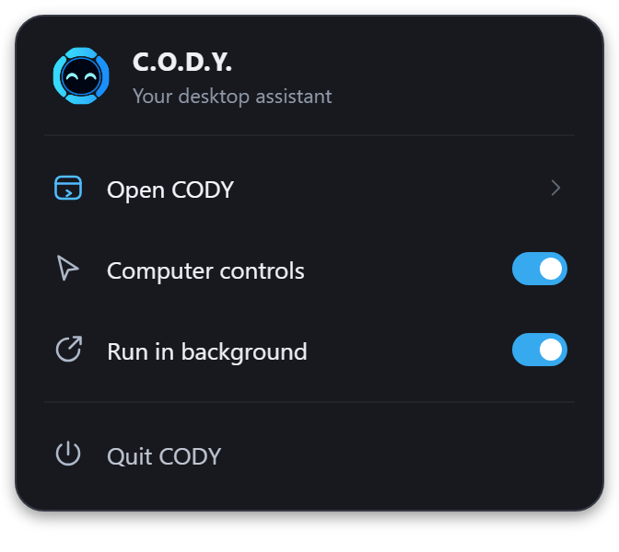

General settings reference
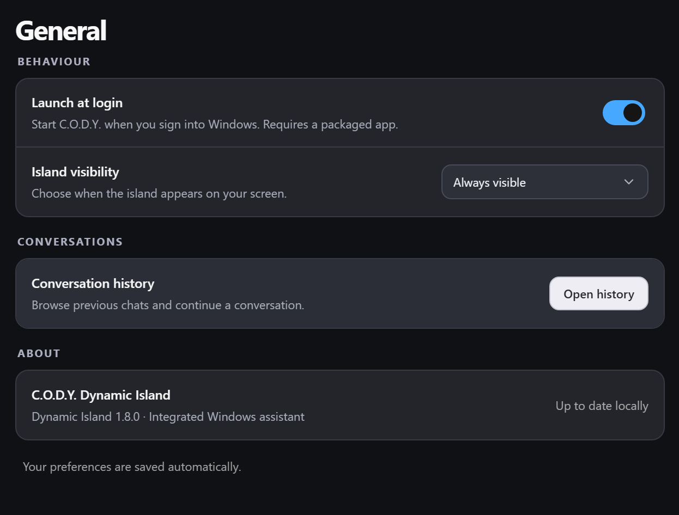
General settings controls startup, island visibility and access to conversation history.
Launch at login requires a packaged application. Use Island visibility to choose between always visible, activity only and on hover. Open history returns to previous conversations. These controls save automatically; the About row identifies the island component rather than the separate installer package version.

03 Chat and everyday AI assistance

Ask questions and continue a conversation
Type in the message box or use voice. You can ask CODY to explain something, plan a task, compare ideas, rewrite text or help with a project. Tell him what you want to achieve and mention anything he needs to keep in mind.
Follow-up messages can refer to the current conversation. For example, after asking for a draft, you can ask for a shorter version or a change of tone. When you switch to a different subject or project, starting a new chat helps keep the context clear. Conversation history lets you return to an earlier chat instead of rebuilding its context from scratch.

Work with attachments
The attachment control and drag-and-drop support let you supply files as task context. What CODY can do with a file depends on its type, the backend and the tools involved. A screenshot can help explain an interface problem. A text or source file can give the assistant concrete material to read. Attaching something does not automatically authorise unrelated changes elsewhere on the computer.
For a document, say what you want as well as what it should be about. For example, ask for a Word guide with screenshots and a command list. For code, tell CODY which project to work on and what should change. A screenshot helps when you're explaining a problem in an app.

Replies and spoken output
CODY can speak responses to voice requests, and Voice settings can also enable speech for typed replies. Speech output has its own selected voice and playback speed. The companion changes expression or state to reflect listening, thinking and speaking. During active computer control the pointer remains a pointer so the cursor does not change into a thinking or speaking symbol while it is being used to target controls.
Choose Claude, ChatGPT Codex or ChatGPT in Agents settings. Claude uses the existing assistant connection. Both GPT options use GPT 6.1 Sol with Medium reasoning. ElevenLabs handles spoken replies. The selected account and available tools determine which tasks CODY can carry out.

04 Hands free wake phrases

Speak without holding a shortcut
Enable Listen for C.O.D.Y. in Voice settings. You can then enable the phrases Hey Cody, OK Cody or Okay Cody, and the name Cody by itself. The switches let you choose which variants are allowed to wake the assistant. Turning off the master listening switch disables the hands-free wake system while leaving the keyboard shortcuts available.
Wake detection runs locally on this PC and uses the Windows default microphone. After a recognised wake phrase, the normal voice-recognition path handles the request. This distinction matters: local wake detection does not mean every spoken question, transcription or AI response stays entirely on the computer.
Try “Hey Cody, what is the time?” or “Okay Cody, show RAM usage.” You can say a two-word wake phrase and the request together. If you use Cody alone, say the name, wait for the listening chime, then continue. The bare name is more likely to trigger when it is mentioned in ordinary speech, so leave that option off if you prefer fewer accidental activations.

Know when CODY is listening
After the wake phrase is accepted, the listening state and audible cue give you confirmation that your request is being captured. Ordinary speech before a valid enabled wake phrase should not be treated as a command just because the microphone hears sound. If you do not see or hear the listening indication, repeat the phrase clearly rather than assuming the next sentence has already been captured.
CODY keeps a short bit of audio around the wake phrase to help catch the start of your request. Wake handling pauses while he's replying, during push-to-talk and during dictation, so those voice controls don't overlap.

Finish naturally or cancel the request
CODY uses speech activity, transcript changes and pauses to decide when you have finished. It allows longer thinking pauses after unfinished phrases rather than ending every request after the same short silence. It still needs a clear endpoint: finish your sentence and give it a short quiet moment.
Say “cancel,” “never mind,” or “stop listening” to discard a hands-free request. Those phrases are different from a request about cancellation, such as asking how to cancel something in an app. If an action has already begun, use the computer-control stop methods described later; cancelling a recording does not undo completed changes.

Voice settings reference
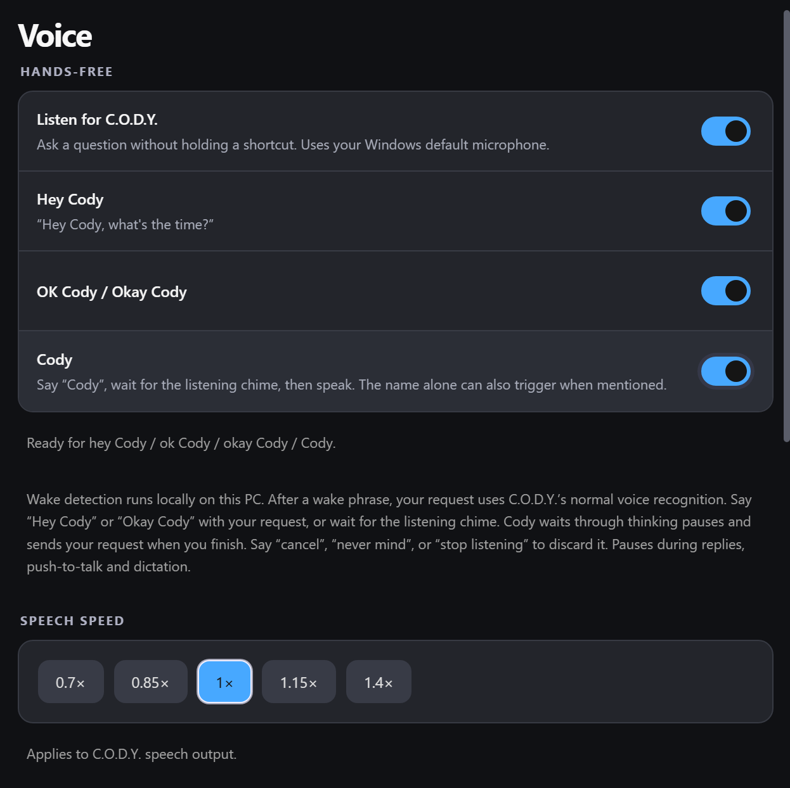
Voice settings includes wake phrase switches, speech speed, output voices and reply options.
Use the master hands-free switch before selecting individual wake phrases. Hey Cody and Okay Cody can be followed by the request; Cody alone works best with a pause for the listening cue. Lower controls set speech speed, speaking voice and reply behaviour. This screenshot shows the visible portion of the scrollable settings page.

05 Push to talk and dictation

Hold Ctrl and Alt to talk to CODY
Hold Ctrl + Alt to speak and release to finish the voice capture. Shortcuts settings can enable or disable the shortcut, and can change whether it starts the microphone or expands the island. Ctrl + Alt + C opens chat and focuses the message box. These are fixed shortcuts in the current interface, rather than an editor for arbitrary replacement key combinations.
Push-to-talk is useful when you want deliberate control over the capture interval, when the room is noisy or when hands-free wake detection is disabled. It also provides a way to interrupt computer use and tell CODY to stop. Release the keys once you have finished the instruction, then watch the state change to confirm the handoff.

Dictate directly into another app
Dictation is separate from asking the assistant a question. First select a text field in the destination application. Hold Ctrl + Win, speak, and release to insert your words into that field. The target field could be in a document, message composer or another editable control, provided Windows and the application allow the text to be inserted.
Double-tap Ctrl + Win to start hands-free dictation without continuing to hold the keys. Press Ctrl + Win again to finish and insert the text. Press Esc to cancel the current dictation recording. If the wrong field is selected, stop and correct the focus before trying again; dictation relies on the destination you selected.

Choose the right voice workflow
Use Hey Cody or Ctrl + Alt when you want CODY to answer or do something. Use Ctrl + Win when you just want your words typed into another app.
For example, “Explain this paragraph” belongs in assistant voice capture. A paragraph you want typed into Word belongs in dictation. If you want spelling corrected in existing text, use the proofreading request described in the productivity chapter rather than redictating the entire passage.

Shortcuts settings reference
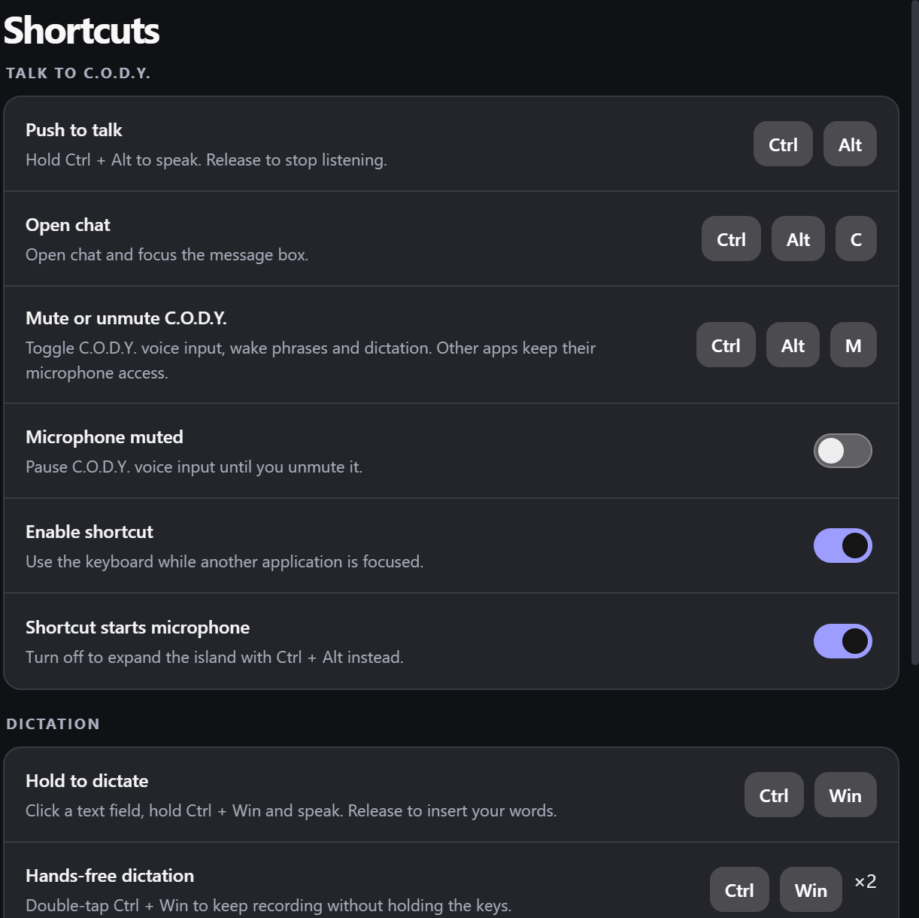
Top of Shortcuts with Ctrl + Alt + M and the microphone mute switch.
Ctrl + Alt is assistant push-to-talk. Ctrl + Alt + C opens chat. Ctrl + Win dictates into the selected field, while double-tapping that combination starts hands-free dictation. Press it again to finish, or Esc to discard the current dictation recording. The combinations are fixed in this interface.

06 Microphones voices and speech settings

Select and test an input device
Microphone settings includes access checking, English UK and English US recognition choices, a device selector, a refresh button and an input-level test. Use Refresh after connecting a headset or changing an audio device. The meter helps confirm that the selected device is receiving sound before you troubleshoot the recognition itself.
The hands-free wake listener uses the Windows default microphone, as stated in the interface. Do not assume changing a device inside one voice test automatically changes the Windows default input used by wake detection. If the meter works but Hey Cody misses you, compare the selected microphone with the default Windows input device.

Choose an output voice and speed
Voice settings lets you select a speaking voice and play a short sample. ElevenLabs provides text to speech for CODY's spoken replies. Available voices depend on the configured ElevenLabs service. The speech-speed buttons offer 0.7×, 0.85×, 1×, 1.15× and 1.4×. These change CODY's speech output rather than the speed at which you need to speak.
The voice colour shown in a selector is not the same setting as the companion's appearance. You can choose a preferred speaking voice and a different mascot colour. The same applies to the cursor colour and interface accent: they are separate controls, with an option for the cursor to follow the appearance accent.

Tune speech without changing Windows gain
Speak typed replies controls whether typed conversations are read aloud. Voice requests are spoken automatically through the voice path. Send voice requests automatically determines the release-to-send behaviour exposed by the voice UI. The animation-sensitivity setting changes the waveform presentation; it is not a replacement for Windows microphone gain or a fix for a poorly positioned microphone.
When troubleshooting clipped or missed speech, check the microphone, the capture indicator and which workflow you started before changing output voice settings. An output-voice problem affects what CODY says back; an input problem affects what it heard you say.

07 Time weather calculations and timers

Quick information in the island
Ask 'What is the time?' or 'What is today's date?' CODY can answer and show the result in the island. The time uses the computer's time zone and local settings.
Ask “What is the weather in London?” to request current conditions for a named town or city. A request without a place can use an approximate location from a network lookup. Approximate location can be wrong, especially with a VPN, so use a named city if the displayed place is not yours. The built-in quick weather route is for current conditions; more complicated forecast questions can go through the general assistant instead.
CODY can also handle simple calculations. Say the numbers and what you want to work out. For anything more involved, ask him to show the working so you can check it.

Temporary results over pinned information
When RAM or another monitor is pinned, a short answer such as time or weather can temporarily take the island's information slot. The result is shown for roughly ten seconds, then the pinned display returns. The pinned choice is preserved rather than being replaced by the one-off request. The same idea applies to short status cards for volume and app launches.

Set and check a timer
Try “Set a timer for five minutes,” “Start a 30 second timer,” or “Set a timer for one hour and thirty minutes.” The built-in timer accepts durations from one second to twenty-four hours. It supports one active timer: starting another replaces the previous running timer. Ask “How much time is left?” or “Show my timer” to check it, and “Cancel the timer” to clear it.
The timer's deadline is saved so CODY can restore it. Keep CODY running when you need the timer alert. It won't act like a Windows alarm while the app is closed, the computer is off or Windows is asleep.

08 System monitors and network information

Keep useful readings visible
Ask “Show RAM usage,” “Show CPU,” or “Show CPU and RAM” to keep telemetry in the compact island. You can hide an individual metric with a request such as “Hide RAM usage.” “Clear the island” or “Hide all monitors” removes the selected monitor display. Selections are saved, so a pinned metric can return when you reopen CODY.
RAM shows the percentage in use, along with used and total memory. CPU shows processor usage and can show temperature when a supported sensor is available. GPU readings also depend on the hardware and drivers. Unsupported readings show as unavailable.

Understand the limits of hardware readings
GPU usage, temperatures and FPS need a supported source on the computer. If one isn't available, CODY can't show that reading. The FPS widget is for supported game or app readings, rather than CODY's own animation speed.
Treat monitor readings as a convenient overview. They are useful for noticing high memory use or a change in load, but they do not replace a dedicated diagnostic session when you need per-process analysis, frame-time traces or a full hardware-health assessment.

WiFi information and speed tests
WiFi widgets can show the connected network, signal, radio details, receive and transmit link rates, and measured network traffic. “Show WiFi details” and “Show WiFi speed” ask for different information: a negotiated link rate is not the same as current transfer throughput.
Say 'Run a speed test' to check the connection and show the result in the island. This uses internet data. The result reflects the connection at the time of the test, and an interrupted test is shown separately from a completed one.

09 Music video and audio control

See and control playback
CODY can display media information in the island and control supported Windows media sessions. Spotify integration provides familiar play, pause, next-track and previous-track actions. Try “Play my music,” “Pause my music,” “Next track,” “Previous song,” or “What is playing?” Start playback in the music app if there is no active session for CODY to discover.
Media controls can also work with other players that support Windows media sessions. CODY uses the player shown in the island. If nothing is showing, start playback in the app first.

Change volume and playback position
“Set volume to 40 percent,” “Turn the volume up,” “Turn the volume down by ten,” “Mute,” and “Unmute” are supported patterns. Relative volume requests use a step, with a default ten-point change when no amount is supplied. Volume is clamped to the valid zero-to-one-hundred range.
For supported media sessions, requests such as “Skip forward thirty seconds” or “Go back ten seconds” can seek within playback. Whether seeking succeeds depends on the player and the media. It should not be confused with changing to the next track.

Play an exact title in Plezy
CODY can search for a title in Plezy and try to start the exact result. For example, say 'Play Iron Man on Plezy.' He checks the title and playback state, and should let you know if the title is missing or unclear.
Plezy needs to be installed and usable with the relevant media available. CODY does not bypass the application's account or library requirements. Distinguish opening the Plezy app, controlling an already active session, and searching for a particular title: they are related but separate tasks.

10 Screenshots and MP4 screen recording

Take a screenshot
Ask for a screenshot to capture the primary display. The built-in screenshot utility saves a PNG under Pictures in a C.O.D.Y subfolder and also copies the image to the clipboard. A saved-result card can provide a way to open the capture. Be aware of what is visible on screen before you capture it, especially if another app is showing private information.
Screenshots used as AI context are a separate part of a request. Capturing an image locally and attaching an image to an AI conversation are not the same operation. Tell CODY what you want it to inspect or explain, and review which content is being shared when the task uses an external AI service.

Record the primary screen
Try “Start screen recording,” “Pause the recording,” “Resume the recording,” and “Stop screen recording.” The recorder saves MP4 using H.264 encoding. Its current capture configuration is limited to up to 1920 by 1080 and up to thirty frames per second. The actual captured dimensions are bounded by the display and capture configuration.
Screen recording is currently video only. It doesn't record the microphone or system audio, so use a recorder with audio support if you need narration or sound.

Save and recover recording output
Recordings save under Videos in a C.O.D.Y subfolder. The app shows recording state and elapsed time, and can keep the island visible during capture. Pausing excludes the paused interval from the recording's active elapsed time. Stopping finishes the output and exposes the saved result.
The recorder writes data incrementally, uses a partial file during capture and has error handling for interruptions or a disk that cannot keep up. Partial output is not the same as a successfully finalised recording. If a recording fails, read the status, check available storage and test a short recording before attempting something important.

11 Opening arranging and editing in apps

Open common Windows applications
CODY has direct command patterns for applications such as Calculator, Notepad, Paint, File Explorer, Windows Settings, Edge, Chrome, Firefox, Spotify and Plezy. Try “Open Firefox” or “Launch Calculator.” Applications still need to be installed or available through Windows. More complicated requests can use computer control or backend tools rather than a simple app-launch command.
An opening card briefly confirms the app-related action in the island. If Windows takes time to start an application, allow it to appear before giving a follow-up that depends on its controls. A named app in a request should be specific enough to avoid confusing two similarly titled windows.

Arrange windows and keep an app on top
Try “Open Firefox and Notepad side by side” to request a two-app layout. The direct layout parser recognises supported application names and arranges them left and right. It needs permission to open applications and manipulate windows. If you have several windows of the same app, the available window information affects which one can be selected.
“Keep Notepad on top” and “Unpin Notepad” request an always-on-top state for a supported open app. Pinning is useful for keeping a reference beside other work. If the application is not open, the result should say so rather than claiming that an invisible window was pinned.

Correct spelling while keeping your wording
The proofreading path can capture selected text or an editable field and ask the backend to correct spelling while preserving your wording. Select the text you mean, or focus the intended field, before requesting the spelling fix. The app uses the captured target to reduce the chance of applying a response to whichever window happens to be focused later.
Proofreading is not intended to silently rewrite your tone, argument or structure. If you want a broader edit, ask for a rewritten version as an ordinary writing task and review the result before replacing your original text. In protected or inaccessible fields, the app may be unable to capture or insert text through the supported path.

12 Computer control and taking back control

Give CODY a clear desktop task
Computer control lets CODY use supported mouse, keyboard and screen-observation tools to work in Windows applications. A goal can involve opening a program, navigating menus, entering text, moving between controls or completing a multi-step workflow. State the intended final result, the app to use and any constraints that matter.
For example, “Open Firefox, find the requested video and pause it” gives a clear endpoint. In Blender, asking CODY to identify and separate two overlapping objects gives more context than “fix the screen.” For detailed work, ask it to verify the result rather than treating the last click as proof of success.

Mouse ownership during a task
In My mouse and keyboard mode, CODY uses the system input path. Physical mouse movement is paused during active control so an accidental nudge or trackpad movement does not move the target away from the AI. The custom pointer remains a mouse icon during listening, thinking and speaking states within computer use. Pointer travel is animated quickly between targets rather than simply teleporting visually.
Independent C.O.D.Y. cursor mode remains available in Cursor settings. It is useful when the target app supports the independent input method, but some apps ignore that separate input path. Choosing independent mode does not make every app compatible. System input is the more practical option for those applications, with the trade-off that CODY temporarily owns the pointer during the task.

Stop an active takeover
Press Esc to stop computer use. You can also use Ctrl + Alt and tell CODY to stop or cancel. Permissions includes a Stop controls button that takes back control and disables further computer actions. These are interruption controls; they cannot undo an already completed edit, submission or file operation.
The glow around the screen shows when computer use is active. It stays above ordinary apps, with the island above the glow. Protected Windows prompts, separate desktops and some exclusive fullscreen modes can still limit what CODY can display or control.

Reliability depends on the target app
Apps differ in scaling, accessibility support, custom drawing, keyboard handling and the time their controls take to appear. CODY may need a fresh screenshot or another observation before acting. If it is targeting the wrong thing, stop and explain the specific mismatch rather than repeatedly allowing the same action. A successful task should be described in terms of its visible result, not just a sequence of inputs.

Cursor settings reference
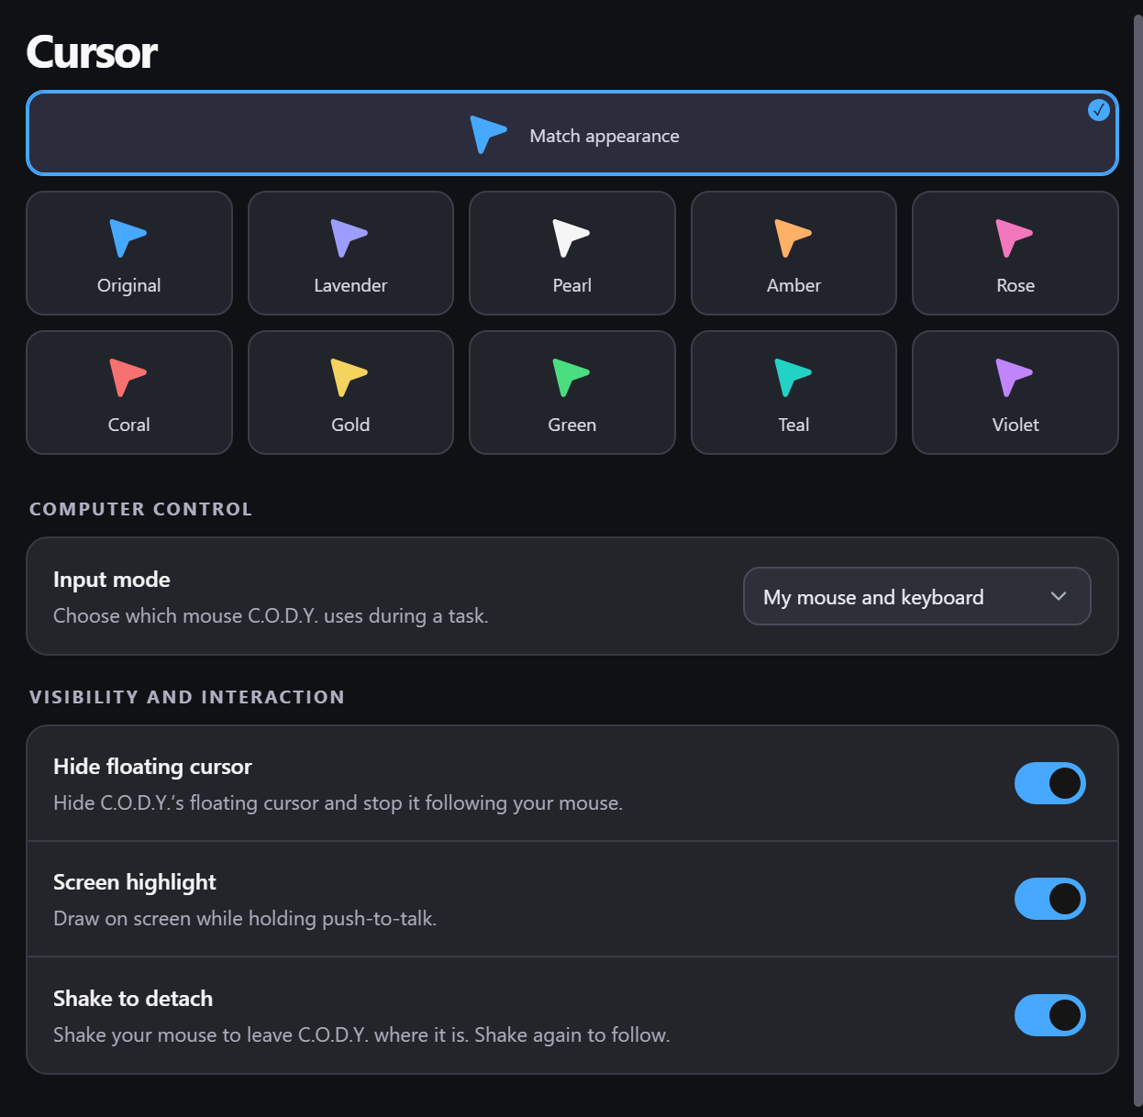
Cursor settings chooses system or independent input, pointer colour and floating-cursor behaviour.
Choose a pointer colour independently or use Match appearance. My mouse and keyboard uses system input during a task; Independent C.O.D.Y. cursor retains the separate input path. Hide floating cursor and Shake to detach affect the companion pointer behaviour. Screen highlight enables drawing while holding push-to-talk.

13 Screen guidance drawings and desktop models

Ask CODY to point at something
CODY's guidance tools can place highlights and annotations over the desktop to help explain an interface. You can ask it to point out a button, outline a control, circle an area or guide you through a menu. This can be useful when you want to perform the clicks yourself while CODY explains what to do next.
The drawing system supports circles, rectangles, arrows, lines, text, underlines, spotlights, free paths and grouped visual cards through its registered annotation commands. It can update, remove or clear drawings. Different routes can use the native drawing engine or the local overlay tools, so the exact available mark types depend on the active backend and permitted tool path.

Keep guidance readable and temporary
Annotations can have temporary, speech-linked or persistent lifetimes in the local visual system. A clear action removes them, and the visible Clear control is intended to make the desktop easy to reset. Drawings are guidance layered over an application; they do not edit the application's own document or replace a real selection inside that app.
Display scaling and multiple monitors can affect where an outline appears. If a drawing is in the wrong place, include the app, monitor and scaling settings when reporting it, and say what it should have outlined.

Create and manipulate desktop 3D visuals
The advanced visual system has scene and model tools for primitives and composite models. Registered actions include creating, moving, rotating, scaling, selecting, animating, recolouring and removing models. Material options include standard, matte, metal and glass. These capabilities are conditional on the active visual route, renderer, backend and permissions.
Desktop 3D models are visual aids. If you need an editable Blender scene or another specific file format, include that in the request so CODY can work in the right app and save the result you need.

14 Browser connections and web tasks

Chrome and Edge have separate entries
Chrome and Edge have separate cards in Plugins. Each opens setup for that browser, and connecting one doesn't connect the other. The setup can open the extensions page and show the bundled extension folder. Confirm installation in the browser when asked.
For an unpacked extension, open chrome://extensions or edge://extensions, turn on Developer mode and choose Load unpacked. Select the folder opened by Extension folder. CODY’s Chrome and Edge setup panels use the matching browser, and the extension uses CODY’s name and icon.

Ask for a browser task
With the browser integration connected and the relevant access allowed, CODY can work with pages, tabs and website controls through the backend's browser tools. Examples include navigating to a page, locating a control, entering text, reading visible information or following a multi-step website workflow.
Website sign-in, two-factor authentication, account access and site restrictions still apply. A plugin connection does not supply credentials for an unrelated website. Dynamic pages can change between observations, so a fresh read is often needed after navigation or a form update. A result should identify the actual page or visible content it used when that matters to your request.

Firefox and advanced browser routes
There's also a Firefox bridge with tools for reading pages, managing tabs, navigating, clicking, typing, scrolling and checking media. It uses a separate setup from the Chrome and Edge extension cards.
Use whichever browser route is actually configured for the task. If an integration is unavailable, CODY may need ordinary computer control instead. Read-only tasks and interactive tasks use different permissions, and a browser click may submit a form or change a setting just as a physical click would.

Plugins settings reference
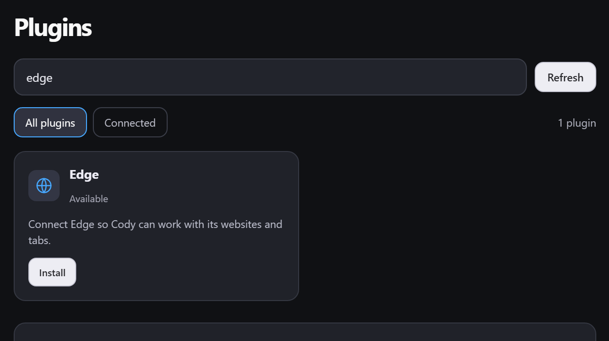
Edge appears as its own plugin card with its own setup entry. Chrome has a separate card.
Chrome and Edge each open their own CODY setup panel. Use Open Chrome or Open Edge, then Extension folder if adding the extension manually. Collapsing the island hides the panel, and reopening restores it. Browser callbacks return to CODY.
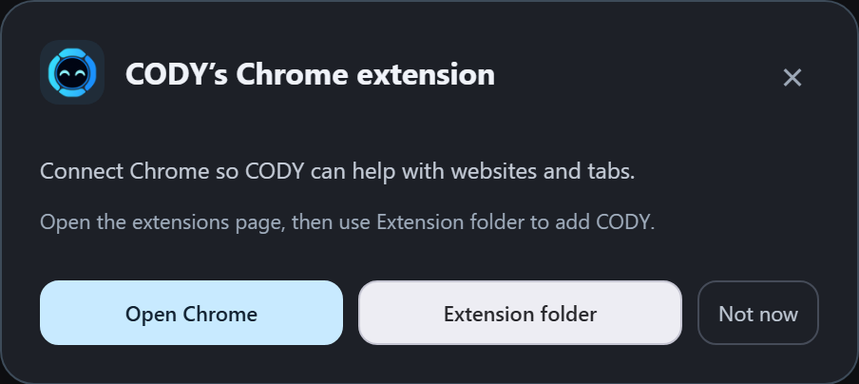

15 Plugins and connected services

Browse and manage the catalogue
Plugins has search, Refresh, All plugins and Connected filters. Each card shows the available setup or account controls. The list comes from the connected service, so it can change as integrations are added or removed.
Depending on the plugin, a card can offer Install, Connect, Configure, Manage, Add account, Disconnect or Remove. Some connections send you to a browser to finish sign-in. A waiting state means the connection process has started, not that CODY already has working access. Refresh or return to the app after completing the browser step.

Use connected accounts deliberately
A connected service can add data or actions to CODY's available tools. The actual abilities depend on the service's granted scopes, the account you selected and the backend integration. For example, being connected to a document service does not imply access to every file owned by every account.
Multi-account plugins can show connected accounts and account-level disconnect controls. Removing a connection stops using that integration; it is not the same as deleting the underlying account or its cloud data. Use the specific card and account you intend to change.

Add a custom MCP server
The Add an MCP plugin form accepts a name, server URL and optional API key. Some servers use a key; others require browser sign-in. Add the server and then complete Connect when the server requires authentication. Availability and supported tools are determined by that server, not by the text you enter as its display name.
Keep API keys out of chats, screenshots and shared documents. If a custom server won't connect, check the URL, sign-in or key, and whether it supports MCP. Try a simple request once it's connected before using it for a longer task.

16 Background tasks and saved results

Delegate work that needs several steps
Background tasks let the backend work on a longer request while the island remains available. Typical examples include producing a document, building a website or browser game, creating project files, researching material or carrying out an application task. The available tools, plan limits, account and permissions determine the actual scope.
Describe the output and the success condition. “Build a simple browser game and save a playable HTML result” gives a clearer target than “make something fun.” For a document, name the format, audience, depth and any visual requirements. For research, specify the question and what sources or evidence you expect the result to include. The Assistant AI selector in Agents chooses the AI for new requests; already-running Claude jobs retain their original connection.

Check the task cards
Task cards show an app icon, title, status, preview and buttons. Websites have a browser-style preview with the filename. Other results use a preview suited to the app, with the same general card size as browser tasks.
Use Open website or View task to open the result where offered. Details gives more context about the saved task. The overflow menu and remove control provide task-management actions. Clear finished clears completed entries from the task view; do not assume that clearing a card necessarily deletes every output file created by the task.

Keep track of the workspace and announcements
Choose the project folder in Agents settings, or reset it to %LOCALAPPDATA%\CODY\Agents. Existing projects and saved task links move to this CODY folder automatically. Permissions also shows the background-task folder. This is where projects are saved; other file access is controlled separately by permissions.
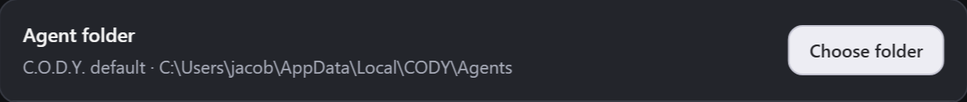
Settings includes announcements for starting or finishing jobs and cursor-side updates. These depend on backend availability, and CODY can stay quiet during calls, screen sharing or Do Not Disturb. Finished work remains available through chat or tasks. Auto-approve extra usage allows longer tasks to keep consuming the plan's agent allowance without another usage prompt; enable it only with that consequence understood.

Choosing the assistant AI
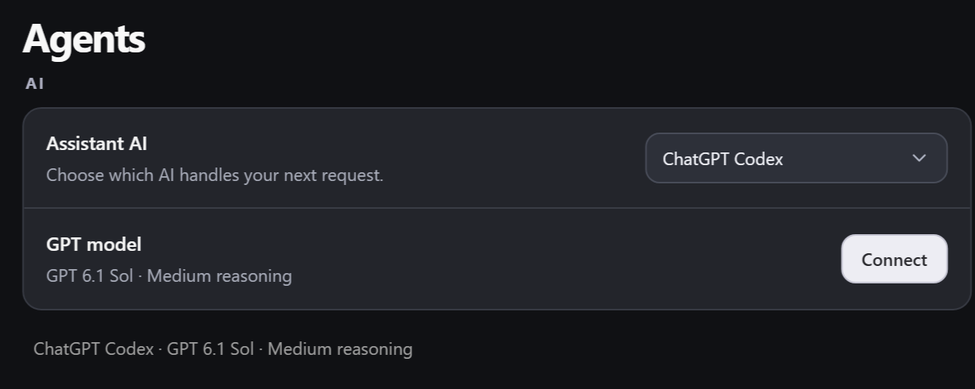
Agents settings includes the AI selector, GPT model and Connect button.
Open Settings, then Agents. Under AI, select Claude, ChatGPT Codex or ChatGPT. The selection saves automatically and applies to new typed and voice requests. Finish or stop a current request before switching. Direct utilities such as time, timers, volume and monitor widgets continue to use their built-in routes.
Claude uses the existing assistant connection. ChatGPT Codex uses your ChatGPT sign-in for Codex. Press Connect to check the account and access to GPT 6.1 Sol with Medium reasoning, or to open sign-in if needed.
ChatGPT uses the separate CODY-owned ChatGPT web session. Choose Connect to open it and sign in if needed. Before a message is sent, the browser route checks the model and reasoning selection. If GPT 6.1 Sol or Medium cannot be selected and verified, the request reports that problem instead of silently using a different model.
Both GPT choices use GPT 6.1 Sol with Medium reasoning. These are fixed choices rather than editable model fields. Changing the AI doesn't change the microphone, wake phrases or speech settings.
Capabilities differ between connections. Claude keeps its native plugins, attachments and background-job connection. Attached-file requests currently require Claude; GPT requests with attachments are rejected clearly rather than dropping the files. Existing native task cards remain visible when another AI is selected. The Codex bridge uses CODY permission-controlled tools, and the ChatGPT route depends on the web interface and sign-in.

17 Permissions access modes and Windows privacy

Choose how actions are approved
Ask for approval requests confirmation before computer actions and changes. Approve for me allows routine commands automatically while still asking before the native backend takes control. Full access permits the supported backend control and CODY tools without repeated approval cards. It does not override Windows, external account restrictions or unavailable software.
Custom exposes individual switches only while Custom is selected. It lets you choose native computer use, background-task computer use, app-context reading, extra-usage approval and individual quick-command categories. Returning to another access mode hides the custom switch list. A visible permission switch describes access policy, not proof that a particular tool is connected and working.

Understand the custom categories
The native controls cover computer use, whether background agents can use the mouse and keyboard, reading foreground app context and approving extra task usage. Local CODY categories include system information, app launching, audio, windows, keyboard and mouse, clipboard, screenshots, file reading, file editing, accessible UI controls, screen annotations, interactive 3D visuals, development commands and Firefox reading or interaction.
The local quick-command switches and native backend permissions are related but distinct. Disabling a local file tool is not a claim that every possible backend has lost all filesystem access. Read the descriptions beside the controls and use the native permissions to govern the native workflow. The project-folder selector is a workspace setting, not a sandbox guarantee for all backend activity.

Review Windows privacy access
Agents shows Windows access for Files and Folders, Documents, Pictures, Contacts, Calendar, Microphone, Camera and Location. Select a row to open the relevant Windows setting. These show the access Windows allows; the available tasks still depend on CODY's connected tools.
Use Stop controls when you need to disable computer actions, and Esc for an immediate active-control interruption. Review permissions after a workflow change instead of assuming that the mode name communicates every detail. For an important operation, ask CODY to state the intended change and verify the result, especially when a task affects another application or external service.

Permissions settings reference
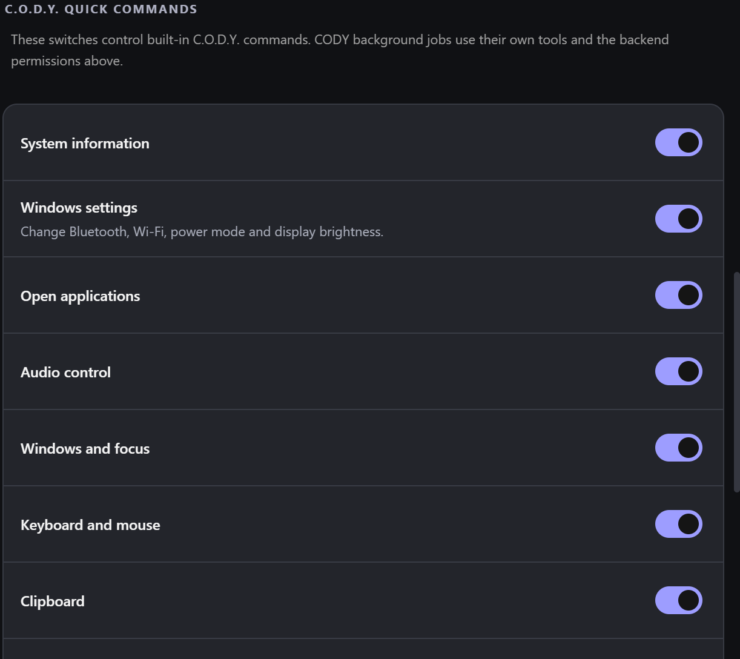
Custom permissions includes Windows settings for Bluetooth, Wi-Fi, power mode and brightness.
Enable computer control is the main switch. Access level chooses when CODY asks for approval. Custom reveals individual permission switches. Stop controls disables further computer actions. The project-folder control sets where background work is saved.

18 Appearance personality and cursor customisation

Choose how the companion looks
Appearance offers Original, Lavender, Pearl, Amber, Rose, Coral, Gold, Green, Teal and Violet. The companion colour is separate from the chosen speaking voice. Interface accent controls selected states and highlights. Cursor settings can use Match appearance or a dedicated colour, allowing the companion, interface and pointer to be coordinated or intentionally different.
The compact island has Small, Medium and Large size options. Reveal style can be Liquid, Smooth or Instant. Animation speed can be Slow, Normal, Fast or Reduced motion. Reduced motion removes the main transitions, and the interface also respects the operating system's reduced-motion preference. These settings affect presentation rather than increasing the accuracy of computer control.

Make the personality quieter or more expressive
Behaviour settings includes occasional mouse following, facial reactions, playful emotions and a personality level of Off, Subtle or Expressive. The companion can blink, wink, look curious, squint, pretend to sleep and react to activity when the relevant behaviour is enabled. Pause playful reactions suppresses spontaneous idle expressions.
Animation sensitivity changes how the island waveform responds visually; it does not alter Windows microphone gain. The floating cursor has its own Hide floating cursor and Shake to detach settings. Shaking can leave CODY in place and shake again to resume following, according to the enabled interaction behaviour.

Keep pointer behaviour clear during computer use
During computer control, the pointer is kept in its mouse shape even if the assistant is thinking or speaking. This provides a stable target indicator. The edge glow indicates the active control session, while the island remains above the glow. These visual indicators make a takeover easier to recognise, but the reliable stop action remains Esc or the voice stop route.

Appearance settings reference
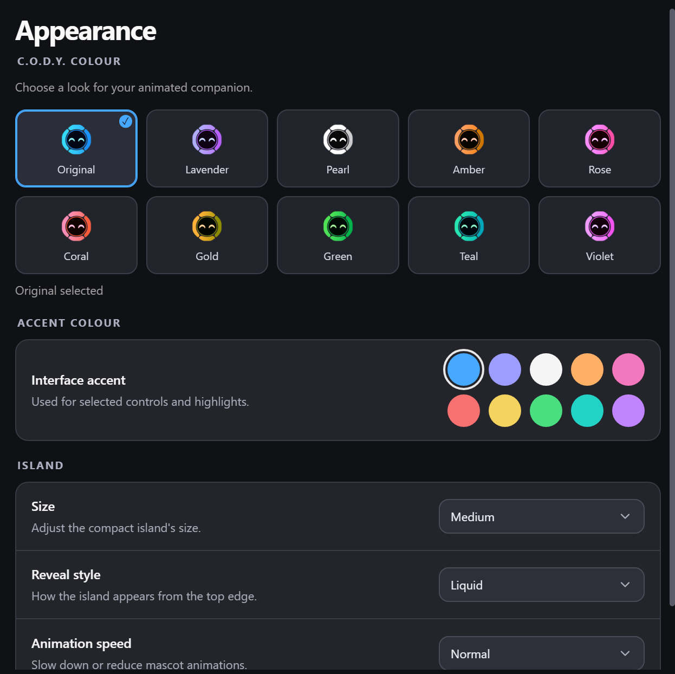
Appearance separates companion colour, interface accent, island size and motion settings.
The colour cards change CODY's look. Interface accent changes selected controls and highlights. Pointer colour is separate in Cursor settings. Size changes the compact notch, while Reveal style and Animation speed change how it moves.

19 Games and playful interaction

Play rock paper scissors
CODY includes a built-in rock paper scissors game. Ask “Let us play rock paper scissors” or “Play rock paper scissors” to start. Choose rock, paper or scissors through the game controls or the supported voice interaction. The game tracks your wins, CODY's wins and draws during the current game, and shows the round result.
CODY picks his move before showing the result. Rock beats scissors, scissors beats paper, and paper beats rock. Matching choices are a draw.

Continue or stop a game
Say “Play again,” “Another round,” or “Rematch” to continue after a result. A new choice after a result can begin the next round. “Stop the game” or “Stop playing” closes the game. Starting a new game resets the score. The island has a dedicated compact game presentation so the interaction does not need a separate large game window.
The game and CODY's idle reactions have separate controls. You can turn off playful reactions and still ask to play a game.

20 Files coding and project work

Create and improve useful outputs
With the appropriate backend and tools, CODY can assist with documents, text, project files, websites and code. It can explain source, propose changes, help diagnose errors and carry out a multi-step project request. The background task system can retain the resulting work and expose an opening action from a task card.
Ask for an editable output when you need to keep working on it. Specify Word for a document, HTML for a simple local website or game, or the actual project and language for a code change. A polished screenshot of a result is not a substitute for an editable file or a functioning app. Ask CODY to identify where it saved the output and how it checked it.

Advanced local file and development tools
The registered local tool layer includes listing and searching folders, reading text, creating and replacing files, patching a matching section, copying, moving, renaming, backups, restores, comparisons, folder creation and ZIP operations. Development actions include approved terminal commands, JavaScript syntax checks, tests and project builds.
These are permission-controlled tools rather than an unconditional promise that every file on the computer is accessible. Some local file tools use an approved working folder, while native backend jobs have their own access policy. Tell the assistant which folder and files belong to the task, and make the intended scope clear before requesting a broad cleanup or rewrite.

Historical context and memory tools
The advanced memory tools can import supported records, find earlier context, update or delete records and export the collection. They are separate from chat history. There's no Memory page in the island settings at the moment.
Earlier context helps CODY understand a request, but your current instruction still takes priority. The memory service has its own protected storage. Ordinary chat state is stored locally as JSON, so don't assume all chats, exports, attachments and backups are encrypted.

Keep the project maintainable
The C.O.D.Y folder has the launchers, CODY-App, Releases, Archive and the README. CODY-App is the active project. Inside it, frontend holds the interface, work holds native source, run/current holds the engine, tools holds maintenance scripts and reports holds checks. Use Start-Development.bat or Build-Engine.bat inside CODY-App when working on the app.
CODY uses CODYEngine.exe for its engine and wake listener, and CODYBrowserHost.exe for the browser connection. Windows shows CODY names and icons for these processes. Keep the native runtime libraries with the app: their internal assembly identities are fixed dependencies. Archive holds older development material, while account details, chats and saved projects are preserved separately.

21 Example workflows you can try

A hands free information check
Enable Hey Cody and leave a monitor such as RAM pinned. Say “Hey Cody, what is the time?” Watch for the listening indication and finish speaking naturally. The time should appear briefly, then the pinned monitor should return. Try a named-city weather request next to avoid any ambiguity about approximate network location.

A focused writing session
Open your document editor, select a text field and dictate with Ctrl + Win. Release to insert the passage. If you want advice about the passage, use Ctrl + Alt to ask CODY rather than continuing dictation. Select a specific section before requesting a spelling correction. Review any broader rewrite before replacing text you need to preserve.

A controlled application task
Choose the appropriate access mode, then give a task with a visible endpoint. For example, ask CODY to open Firefox, find a particular page and leave it on screen. During a system-input takeover, avoid trying to move the mouse. If the wrong page or control appears, press Esc and clarify what should happen next.

A recorded demonstration
Arrange the target app, close private material and start a short screen recording. Perform the demonstration, pause if you need to prepare the next step, resume and stop when finished. Open the MP4 and check it before sharing. Remember that the current recorder is video-only; narrating into the microphone does not add an audio track.

A background deliverable
Ask for a concrete output such as a single-page website or a detailed document, including the audience and visual requirements. Check the background task card for progress. Open the saved result and inspect it. If you want another version, refer to the actual output and say what should change rather than starting a second vague task with no connection to the first.

22 Troubleshooting and practical limits

CODY misses the wake phrase
Check that hands-free listening and the intended phrase are enabled. Confirm the Windows default microphone, speak the complete phrase clearly and wait for the listening cue when using Cody alone. Try push-to-talk to separate a wake-detection issue from a broader recognition or backend problem. Noise, microphone distance and speech variation can affect detection.

CODY wakes too often or ends a request too early
Disable the bare-name trigger if ordinary conversation includes the word Cody. Use Hey Cody or Okay Cody for a more deliberate trigger. If a capture starts accidentally, say cancel or stop listening. For a long request with several thinking pauses, push-to-talk gives you direct control over when the recording ends. Automatic endpoint detection improves the workflow but cannot perfectly infer every unfinished thought.

A control action does not work
Check that computer control is enabled and that the access mode permits the action. If the app ignores the independent cursor, try the system-input mode. Identify whether the problem is app launching, focus, coordinate targeting, an inaccessible control, an unavailable browser integration or a real permission denial. Those causes need different fixes.

A monitor or browser connection is unavailable
Unavailable temperature or FPS readings can mean no supported provider exists. A missing weather result can be a network or location-lookup problem. A browser card that says Available is not yet proof of an active extension connection. Open the correct browser's setup, complete installation and sign-in if needed, and refresh the plugin view.

A task or recording fails
Read the actual error before repeating the request. A task can depend on account access, allowance, a connected tool, the target app or a file path that changed. A recording needs supported H.264 encoding and writable storage. Keep the failed output separate from a verified finished result and ask CODY to check the deliverable before reporting success.

Check the result
CODY should tell you if something failed or still needs setup. After a task, check the saved file or the result in the app. Protected Windows prompts, unavailable services and unsupported app controls can still stop a task from completing.

23 Quick command collection
Here are some commands to try. Add Hey Cody or another enabled wake phrase when using hands-free listening. AI tasks need the selected account and tools to be ready.
- What is the time?
- What is today's date?
- What is the weather in London?
- Set a timer for five minutes.
- Start a thirty second timer.
- How much time is left?
- Cancel the timer.
- Show RAM usage.
- Show CPU and RAM.
- Hide RAM usage.
- Show GPU.
- Show WiFi details.
- Show WiFi speed.
- Run a speed test.
- Clear the island.
- What is playing?
- Play my music.
- Pause my music.
- Next track.
- Previous song.
- Set volume to forty percent.
- Turn the volume up by ten.
- Mute.
- Unmute.
- Skip forward thirty seconds.
- Go back ten seconds.
- Open Firefox.
- Open Calculator.
- Open Firefox and Notepad side by side.
- Keep Notepad on top.
- Unpin Notepad.
- Take a screenshot.
- Start screen recording.
- Pause the recording.
- Resume the recording.
- Stop screen recording.
- Show my background tasks.
- Play rock paper scissors.
- Another round.
- Stop the game.
- Play Iron Man on Plezy.
- Explain the controls in this application.
- Point out the Add button.
- Clear the drawings.
- Help me correct the spelling in this selected text.
- Create a simple website and save the result as HTML.
- Explain this code and identify the likely bug.
- Write a detailed document for this audience using these files.
- Cancel.
- Never mind.
- Stop listening.
For percentage commands, recognition may convert a spoken number to digits before it reaches the direct parser. If a phrase fails, use a straightforward version such as “Set volume to 40 percent.” Cancel, never mind and stop listening apply to the current voice request; Esc remains the immediate active-computer-control stop key.

24 Settings directory
This section lists the controls in Settings. Some only appear when Custom is selected or after the connected service has loaded. Your selected values may differ from the examples.

General
Control | Purpose or choices
Launch at login | Start C.O.D.Y. when you sign into Windows. Requires a packaged app.
Island visibility | Choose when the island appears on your screen. Options: Always visible, Activity only, On hover.
Conversation history | Browse previous chats and continue a conversation.
C.O.D.Y. Dynamic Island | Dynamic Island 1.8.0 · Integrated Windows assistant

Voice
Control | Purpose or choices
Speaking voice | Select and preview an available ElevenLabs speaking voice.
Speech speed | 0.7×, 0.85×, 1×, 1.15× or 1.4×.
Listen for C.O.D.Y. | Ask a question without holding a shortcut. Uses your Windows default microphone.
Hey Cody | “Hey Cody, what's the time?”
OK Cody / Okay Cody | On or off control; see the relevant chapter for its behaviour.
Cody | Say “Cody”, wait for the listening chime, then speak. The name alone can also trigger when mentioned.
Preview selected voice | Listen to a short sample of C.O.D.Y.'s voice.
Speak typed replies | Replies to voice requests are spoken automatically.
Send voice requests automatically | Release the microphone control to send your request.

Microphone
Control | Purpose or choices
Microphone access | Check that C.O.D.Y. can use your microphone.
Language | Recognition language for your speech. Options: English (UK), English (US).
Microphone | Select an available recording device. Options: System default.
Refresh devices | Ask Windows to list connected microphones.
Input levels | Test the selected microphone and watch the input-level meter.

Appearance
Control | Purpose or choices
Companion colour | Original, Lavender, Pearl, Amber, Rose, Coral, Gold, Green, Teal or Violet.
Interface accent | Used for selected controls and highlights.
Size | Adjust the compact island's size. Options: Small, Medium, Large.
Reveal style | How the island appears from the top edge. Options: Liquid, Smooth, Instant.
Animation speed | Slow down or reduce mascot animations. Options: Slow, Normal, Fast, Reduced motion.

Shortcuts
Control | Purpose or choices
Push to talk | Hold Ctrl + Alt to speak. Release to stop listening.
Open chat | Open chat and focus the message box.
Enable shortcut | Use the keyboard while another application is focused.
Shortcut starts microphone | Turn off to expand the island with Ctrl + Alt instead.
Hold to dictate | Click a text field, hold Ctrl + Win and speak. Release to insert your words.
Hands-free dictation | Double-tap Ctrl + Win to keep recording without holding the keys.
Finish hands-free dictation | Press Ctrl + Win again to finish and insert the text.
Cancel dictation | Discard the current recording.

Cursor
Control | Purpose or choices
Pointer colour | Match appearance or choose a dedicated colour from the available palette.
Input mode | Choose which mouse C.O.D.Y. uses during a task. Options: My mouse and keyboard, Independent C.O.D.Y. cursor.
Hide floating cursor | Hide C.O.D.Y.’s floating cursor and stop it following your mouse.
Screen highlight | Draw on screen while holding push-to-talk.
Shake to detach | Shake your mouse to leave C.O.D.Y. where it is. Shake again to follow.

Behaviour
Control | Purpose or choices
Occasionally follow mouse | He can watch your cursor as one of his random moods.
Facial reactions | Smiles or looks curious when you hover.
Playful emotions | Pretend sleep, squinting, winks and curious reactions.
Personality | Choose how expressive the mascot should be. Options: Off, Subtle, Expressive.
Animation sensitivity | Changes the island waveform, not Windows microphone gain.
Pause playful reactions | Disable C.O.D.Y.'s spontaneous idle expressions.

Plugins
Control | Purpose or choices
Search and filters | Search the catalogue, refresh it and switch between all or connected plugins.
Chrome and Edge | Separate browser cards open setup for the selected browser.
Plugin connection controls | Install, connect, configure or manage, with additional account controls where supported.
Add an MCP plugin | Supply a name, server URL and optional API key, then connect if sign-in is required.

Agents
Control | Purpose or choices
Connect selected AI | For ChatGPT Codex, check the ChatGPT account and requested model. For ChatGPT, open its web sign-in session.
GPT model | GPT 6.1 Sol with Medium reasoning for either GPT option. Hidden when Claude is selected.
Assistant AI | Choose Claude, ChatGPT Codex or ChatGPT. The choice saves and controls new typed and voice requests.
Agent folder | Choose where agent projects are created. The default is %LOCALAPPDATA%\CODY\Agents; existing projects and task links are migrated automatically.
Reset to default folder | Restore the default agent workspace in local app data.
Auto-approve extra usage | Let long tasks keep running without asking each time. Uses more of your account's AI allowance.
Speak when a job starts or finishes | Cody tells you what a job got done.
Show updates beside the cursor | A job's reply appears in a bubble next to your cursor when it finishes.

Permissions
Control | Purpose or choices
Enable computer control | Allow CODY takeovers and C.O.D.Y. computer commands.
Access level | Choose Ask for approval, Approve for me, Full access or Custom. Individual permission switches appear only in Custom.
Emergency stop | Take back control and disable further computer actions.
Computer use | Allow native mouse and keyboard control of apps.
Background task computer use | Let background agents use the mouse and keyboard when computer use is enabled.
Read on-screen app context | Let the assistant include foreground app context in its replies.
Approve extra task usage automatically | Allow background tasks to continue using the account's AI allowance without asking each time.
System information | Allow built-in commands to read system status and display information.
Open applications | Allow app-launch and app-list commands. Some layout actions also need window access.
Audio control | Allow built-in volume, mute and supported media playback commands.
Windows and focus | Allow commands that inspect, focus or arrange supported Windows app windows.
Keyboard and mouse | Allow local commands that type, send shortcuts, move the pointer or click.
Clipboard | Allow local tools to read or replace clipboard text.
Screenshots | Allow local screenshot tools and permitted visual-context capture.
Read files | Allow local file reading, listing, searching and comparison within the supported working-folder scope.
Edit files | Allow local creation, modification, backups and file-management actions.
Inspect and invoke accessible UI controls | Allow supported Windows accessibility inspection and named-control actions.
Screen annotations | Draw click-through highlights over the desktop.
Interactive 3D visuals | Create and manipulate desktop models.
Run project commands | Allow approved local development commands, syntax checks, tests and builds.
Read Firefox pages | Allow the configured Firefox bridge to read page and tab information.
Control Firefox pages | Allow the configured Firefox bridge to navigate and interact with pages.
Project folder | Default background task workspace

25 Advanced tool reference
These are CODY's local tools, grouped by what they do. They aren't extra keyboard shortcuts. Which ones CODY can use depends on the selected AI, connected integrations and permissions. The native assistant connection also has its own tools.

System info
Tool | Capability
system.status | Get CPU, memory and OS summary
screen.list | List actual displays and their DIP geometry

Applications
Tool | Capability
app.open | Open an approved Windows application
app.split | Open two approved applications and arrange their windows side by side Additional permission: windows.
app.list | List open applications
app.close | Gracefully close an approved application window

Audio
Tool | Capability
audio.set | Set Windows master volume (0–100)
audio.mute | Mute or unmute Windows audio
spotify.control | Control Spotify desktop playback
media.control | Control the media player displayed in the Island
plezy.play | Search for an exact title in the installed Plezy app and start playback

Windows
Tool | Capability
window.list | List open visible windows
window.pin | Pin or unpin an approved app window above other apps Additional permission: applications.
window.focus | Focus a specific existing window
window.minimize | Minimize a specific visible window
window.maximize | Maximize a specific visible window
process.list | List running processes

Keyboard mouse
Tool | Capability
keyboard.hotkey | Send an approved keyboard shortcut to active window
keyboard.type | Type text into the currently focused application
text.proofread | Correct spelling in the selected text or current editable field using CODY, preserving wording Additional permission: uiAutomation.
mouse.move | Move the Windows mouse cursor
mouse.click | Click in the active Windows desktop

Clipboard
Tool | Capability
clipboard.read | Read the clipboard locally
clipboard.write | Replace the clipboard text

Screenshots
Tool | Capability
screen.capture | Capture a screen image; AI visual requests attach it to CODY after permission checks

Files read
Tool | Capability
files.list | List files inside the approved working folder
files.read | Read a file inside the approved working folder
file.list | List approved folder
file.search | Search approved folder
file.read | Read file content for AI
file.diff | Compare proposed text

Files write
Tool | Capability
files.write | Write a file inside the approved working folder
file.create | Create a text file
file.write | Replace file with backup
file.replace | Replace one matching section
file.patch | Patch one matching section
file.backup | Back up a file
file.restore | Restore a backup
file.copy | Copy a file
file.move | Move a file
file.rename | Rename a file
file.delete | Delete a file with recoverable backup
folder.create | Create a folder
archive.create | Create a ZIP from an approved folder
archive.extract | Extract a ZIP into a new approved folder

Ui automation
Tool | Capability
desktop.inspect | Inspect named Windows UI controls
desktop.click | Invoke a named accessible button

Developer tools
Tool | Capability
terminal.run | Run an approved development command
code.check | Check JavaScript syntax
code.test | Run project tests
code.build | Build approved project

Browser read
Tool | Capability
browser.pageInfo | Read active Firefox page title and URL for CODY
browser.getDom | Read page content and form elements for CODY
browser.readText | Read rendered webpage text from a bounded DOM selector
browser.readComments | Read displayed YouTube comments and their visible like counts
browser.listTabs | List C.O.D.Y-owned Firefox tabs
browser.wait | Wait for a page element

Browser interact
Tool | Capability
browser.navigate | Navigate a C.O.D.Y Firefox tab to an HTTP(S) URL
browser.newTab | Open a new C.O.D.Y Firefox tab
browser.switchTab | Switch between C.O.D.Y-owned tabs
browser.closeTab | Close the C.O.D.Y browser tab
browser.click | Click a Firefox webpage element (may submit a form)
browser.type | Type text into a Firefox webpage
browser.keypress | Press a key in Firefox
browser.select | Select an option in a Firefox form
browser.scroll | Scroll an open Firefox page
browser.hover | Hover over a Firefox element

Annotations
Tool | Capability
draw.circle | Click-through desktop annotation: circle
draw.rectangle | Click-through desktop annotation: rectangle
draw.arrow | Click-through desktop annotation: arrow
draw.line | Click-through desktop annotation: line
draw.text | Click-through desktop annotation: text
draw.underline | Click-through desktop annotation: underline
draw.spotlight | Click-through desktop annotation: spotlight
draw.path | Click-through desktop annotation: path
draw.card | Click-through desktop annotation: card
draw.clear | Click-through desktop annotation: clear
draw.remove | Click-through desktop annotation: remove
draw.update | Click-through desktop annotation: update
draw.batch | Click-through desktop annotation: batch
draw.status | Click-through desktop annotation: status

Desktop 3D visuals
Tool | Capability
scene.status | Inspect the current desktop visual scene and its objects.
scene.create | Create a desktop visual scene using the supported scene renderer.
scene.move | Move the visual scene within the supported display placement.
scene.clear | Remove the objects from the visual scene.
model.createPrimitive | Create one supported primitive such as a box, sphere, cylinder, cone or torus.
model.create | Create a model from a supported collection of parts and transforms.
model.generate | Request a generated model through the configured visual-generation path.
model.generateDetailed | Request a more detailed model through the configured generation path.
model.load | Load a model from an asset registered with the visual system.
model.move | Change the position of a model.
model.rotate | Change the rotation of a model.
model.scale | Change the size of a model.
model.animate | Apply a supported animation to a model.
model.select | Select a model in the visual scene.
model.setMaterial | Change a supported model material or colour.
model.remove | Remove a model from the visual scene.

26 About this guide
I've put this guide together around the features and settings in CODY. The interface and installer can show different version numbers because they're different parts of the app. The project can also contain updates that aren't in the saved installer yet.
The screenshots illustrate CODY's interface. The refreshed pictures dated 3 November show CODY 0.15.6, with example settings selections and a sample weather reading.
The AI options in this guide are Claude Opus 5.5 and GPT 6.1 Sol with Medium reasoning, with ElevenLabs for text to speech. Some features need extra setup, and I've included that next to the relevant controls.
For changes to CODY, use CODY-App. The interface is under frontend/original-cody/src and the native code is under work. The README explains the folder layout. The browser extension and native connection use CODY names. Older account callbacks remain supported for sign-in compatibility. I’ll keep this guide updated as CODY changes.

Recent changes and next improvements
Updated 3 November 2026
These changes are included in CODY 0.15.6. Install the update and restart CODY to load them. The earlier screenshots remain useful for finding controls, but may show the older layout.

Expanded chat layout
Use Expand chat in the header to switch to the larger view. The welcome message and suggestion cards now sit in the centre of the available conversation area. The cards and text resize with the panel, and the conversation and message box share a centred width. On narrow displays the suggestions use one column. Returning to compact chat restores the compact layout.

Tap outside to shrink CODY
With the panel open, tap outside CODY to fold it back into the compact island. Taps inside keep the panel open. The listener now collects Windows pointer presses instead of sampling mouse-button state, so quick touchscreen taps can use the same outside-press behaviour as the mouse. Press locations are converted for Windows display scaling. File pickers and screen-capture tools keep their existing dismissal protection. Tap the collapsed island once to open it, whether CODY is awake or asleep. No hover or second tap is required, and the click generated by that same tap does not close it again.

What has been checked
The expanded layout was checked in Electron at normal and narrow sizes, including centring, card resizing, aligned message and input widths, and returning to compact mode. Eight focused tests pass for pointer-event delivery, display-scaling conversion, outside dismissal, protected dialogs, expanded chat, first-tap opening while awake or asleep, and keeping the panel open after the same tap generates a click. The Windows pointer watcher also compiled, started and stopped successfully. A physical touchscreen check is still needed, including quick taps and tapping the on-screen keyboard.

Suggested next improvements
These are proposals, not completed features. First, enlarge small header and composer touch targets. Next, keep the message box visible when the on-screen keyboard opens, and treat keyboard taps as typing rather than outside dismissal. Add an optional Keep open control for longer sessions. Then check layout, touch input and display scaling across portrait screens and monitors with different scaling settings.

Windows settings commands
Source update 3 November 2026
CODY can now handle these short typed and spoken requests locally through the existing computer-control permissions. These additions are included in the CODY 0.15.6 installers.
In Settings > Permissions > Custom, enable Windows settings to allow radio, power-mode and brightness changes. Full access includes this permission. Status checks use System information. Opening a Settings page uses Open applications. The Ask profile requests approval before acting.
Bluetooth and WiFi. Say "turn on Bluetooth", "turn Bluetooth off", "turn on Wi-Fi" or "turn Wi-Fi off". To read the state, say "check Bluetooth status" or "check Wi-Fi status". "Show Wi-Fi" still displays the island monitor. Turning radios off can disconnect wireless devices or networking.
Power mode. Say "turn on power saver" to select Best power efficiency for the current power source. "Turn off power saver" selects Balanced; it does not restore a previous custom mode. "Set power mode to best performance" and "show power mode" are also supported. Battery and plugged-in modes are separate, and CODY changes only the current one. These controls require supported Windows 11 power APIs; device policy or an active Energy saver mode can prevent a change.
Display brightness. Say "set brightness to 50 percent" or "check brightness". Values run from 0 to 100. This works with active displays that expose Windows brightness controls. External monitors may need their own controls.
Windows Settings pages. Say "open Bluetooth settings", "open Wi-Fi settings", "open display settings" or "open energy saver settings". Other supported pages are power, sound, notifications, storage, keyboard, mouse, network and Windows Update.
Energy saver and verification. Windows Energy saver or Battery saver is separate from the power mode. Asking CODY to turn that saver on or off opens its Settings page and explains that the toggle still needs changing there. CODY does not claim that opening the page changed the toggle. Radio changes need Windows permission and supported hardware. Successful radio, power-mode and brightness replies require Windows to confirm the requested state.
Checks completed. All 316 JavaScript tests pass, including typed and voice routing, permissions, invalid arguments, cancellation and failure handling. Generated PowerShell scripts pass syntax checks. Read-only checks on this PC successfully read Bluetooth, Wi-Fi, power mode and brightness. State-changing operations were tested with mocked Windows responses; the checks did not change the PC settings.

Microphone mute shortcut and indicators
Source update 3 November 2026
Mute and unmute. Press Ctrl + Alt + M once to mute CODY voice input. Press it again to unmute. Holding M does not toggle repeatedly. The same control is in Settings > Shortcuts > Microphone muted. The mute setting is saved across restarts.
What gets muted. This switch applies only to CODY. It stops an active CODY voice capture and blocks push to talk, wake phrases, voice-game capture, microphone tests and CODY dictation until you unmute. A muted capture is cancelled rather than submitted as a partial request. The Windows microphone remains available to other applications, and typed requests still work.
Muted animation. The normal mascot face changes to a coral microphone inside the signature ring. A diagonal line draws across the microphone, then stays visible for as long as CODY is muted. The indicator remains visible in Activity only and On hover visibility modes, and takes priority over the face and WiFi status glyph.
Unmute animation. When you turn the microphone back on, the slash clears and the microphone changes to blue. Two short sound waves appear, then the normal mascot returns after about 1.25 seconds. Unmuting makes voice input available without starting a recording. If wake phrases are enabled, local wake detection can resume.
Motion and previews. Reduced-motion settings keep a static status icon. Both microphone states can be tested in the developer animation studio without using the real microphone or changing the live mute setting.
Build and checks. The native engine builds successfully. All 332 JavaScript tests pass, including held-key behaviour, blocked manual and wake capture, cancellation without submission, typed commands while muted, voice games, wake detector shutdown and rapid toggles. Native dictation tests pass. Electron rendering checks confirm the muted icon, disabled microphone button, unmute animation and return to the face. These changes include the updated native engine in the CODY 0.15.6 installers.
Shortcut availability. Ctrl + Alt + M works while another app is focused when Windows can register the shortcut. If another application has already reserved it, use the focused CODY window or the Shortcuts setting.

Drawing Clear button visibility
Source fix 3 November 2026. The on-screen Clear button now depends on visible drawing content or a live model, rather than a narration stream or an allocated canvas. Starting a response with no drawing, replacing a drawing with an empty response, clearing the canvas or fading a drawing hides the old control. Empty containers and invisible 3D placeholders do not count as drawings. Clear and close controls remain available while genuine drawings or models are being generated.
The working-copy native engine has been rebuilt. Seventeen focused native checks cover empty canvases, real drawing content, live models, cleared and faded states, and non-drawing node types. This fix is included in the CODY 0.15.6 installers. Isolated live checks also pass: narration-only responses keep Clear hidden, empty responses remove old controls, genuine generating drawings retain Clear and close buttons, and clearing the remaining content removes the controls. Closing one card keeps Clear available if a separate model or screen annotation still exists.

Pinned clock and weather
Source update 3 November 2026
Keep the clock visible. Say or type "show clock" to pin a live local clock and date in the island. The clock uses 24-hour time and follows the Windows local time zone. "Show time", "show clock 24/7" and "pin clock" also work. The clock keeps updating across midnight and has no timeout.
Keep weather visible. Say "show weather" to pin current weather, or "show weather in Derby" to choose a city. A named-city choice is saved and retained when you later say "show weather". Say "show weather here" to return to approximate local weather. The card shows temperature in Celsius, the place name and an icon for current conditions. The tooltip includes the conditions, source and refresh time.
Refresh and connection. Pinned weather refreshes every five minutes while CODY is running. Failed lookups retry after one minute. If a lookup fails, the pin stays selected and shows Weather unavailable. CODY does not present an old temperature as a fresh reading. Weather needs an internet connection and a usable location; a named city can help when approximate location detection fails.
Use with RAM and other pins. Clock and weather use the same persistent island items as RAM, CPU and the other monitors. Multiple selected items rotate in the existing display. You can say "show clock and weather and RAM". Pins are saved across restarts and remain selected until you hide or clear them. Active voice input, recording and temporary result cards can briefly take priority.
Hide pins and ask quick questions. Say "hide clock", "hide weather", "stop showing clock", "hide clock and weather" or "clear the island". Hiding one item keeps the others. Questions such as "what is the time?" and "what is the weather in Derby?" continue to provide temporary answers rather than changing your pins.
Checks completed. All 332 JavaScript tests pass. Checks cover command parsing, local voice routing without an AI request, clock/date rollover, persistence, independent removal, weather refresh and retry timing, and ignoring late weather results after a pin is hidden or its city changes. Electron checks confirm the clock and weather text, details and icons. These additions are included in the CODY 0.15.6 installers.

Current interface pictures
Captured 3 November 2026 from the CODY 0.15.6 interface. These features are included in the 0.15.6 installers.
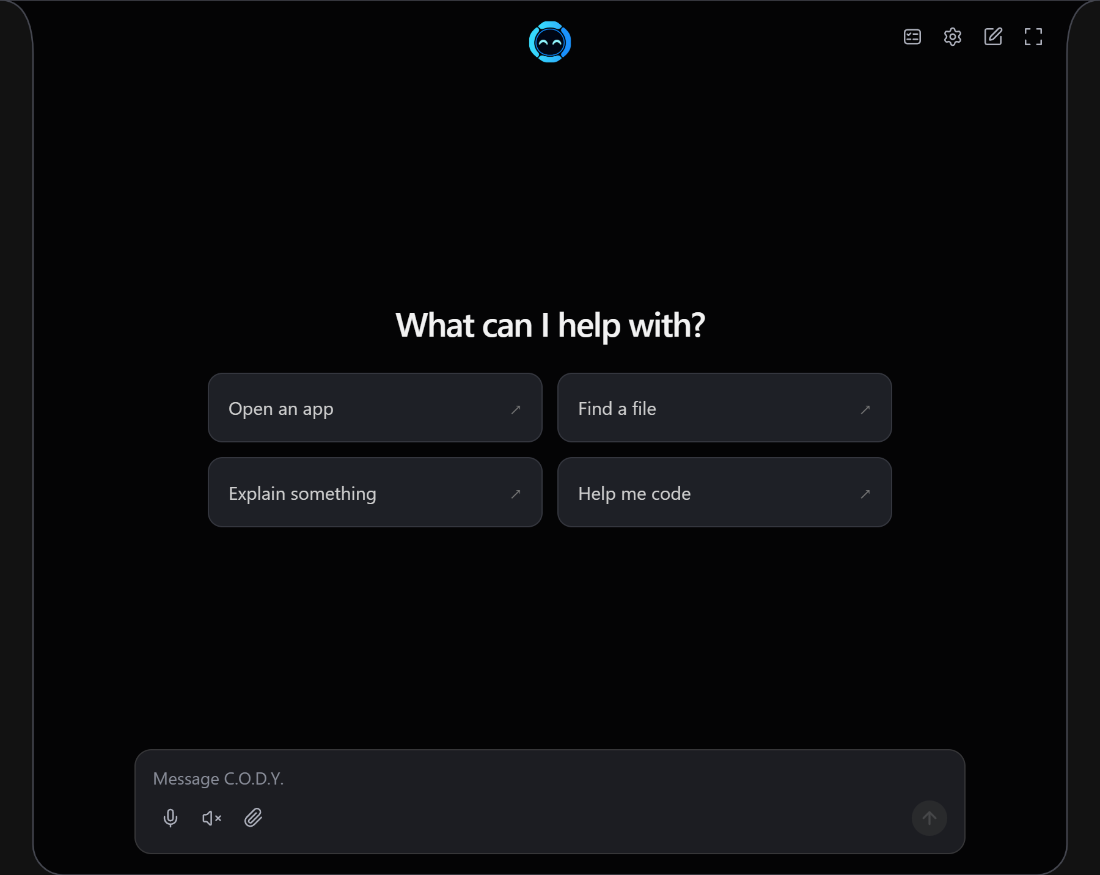
Expanded chat with centred suggestions and a centred message box.

Clock weather and microphone indicators
Pinned items stay selected until hidden. The weather picture uses an example reading; the unmute picture captures one moment of the brief animation.

Show clock pins a live local clock and date.

Show weather pins temperature, location and conditions. Example reading shown.

Ctrl + Alt + M mutes CODY voice input and leaves the crossed-out microphone visible.

Unmuting briefly shows a blue microphone with sound waves before the face returns.

