CAPSTONE PROJECT REPORT
SAP SD Order-to-Cash (O2C) Analytics
End-to-End Python Simulation with Real-Like SAP Screenshots
Enterprise-Grade Analytical Reporting

Student: J Neha
Roll Number: 2305703
Program: B.Tech Computer Science & Engineering
Course: SAP Data Analytics
University: KIIT University, Bhubaneswar
Batch: 2023–2027

Executive Summary
The Order-to-Cash (O2C) process is the lifeline of any enterprise operating on SAP. This capstone project delivers an end-to-end Python analytics pipeline that simulates realistic SAP SD data, processes it through enterprise-grade join logic, and renders professional-grade visualizations for business decision-making.

Metric | Value | Status
Sales Orders | 300 | ✓
Line Items | 747 | ✓
Delivery Rate | 86.1% | ✓
Avg Lead Time | 14.5 days | ⚠
On-Time Rate | 22.7% | ⚠

Key Findings
- Systemic fulfillment delay with 22.7% on-time delivery vs. 7-day SLA target
- Average lead time of 14.5 days significantly exceeds industry benchmarks
- ₹10.25 Cr in unbilled AR exposure represents cash trapped in the fulfillment pipeline
- LAPTOP products account for >40% of revenue, creating portfolio concentration risk

Table of Contents
- 1. Problem Statement & Business Context
- 2. Solution Architecture & Design Philosophy
- 3. Technical Implementation
- 4. SAP Data Model & Table Mapping
- 5. Join Strategy & Open Items Logic
- 6. Key Performance Indicators (KPIs)
- 7. Dashboard Analytics & Business Insights
- 8. SAP Transaction Reference with Screenshots
- 9. Future Enhancements & Enterprise Roadmap
- 10. Conclusion & Project Deliverables

1. Problem Statement & Business Context

1.1 Complexity of the Order-to-Cash Lifecycle
The Order-to-Cash (O2C) process represents one of the most operationally dense and financially consequential workflows in any enterprise operating on SAP. It encompasses every customer touchpoint from order placement through revenue recognition in the general ledger. In manufacturing and retail contexts, this is not a linear sequence but rather a multi-threaded process involving Sales, Logistics, Warehousing, and Finance departments, each contributing data to different SAP modules.

The O2C Data Flow
When a customer places an order in the Sales and Distribution (SD) module, data flows through multiple interconnected tables:
• VBAK (Sales Order Header) – Records customer identity, sales organization, order date, and total value
• VBAP (Sales Order Item) – Stores individual line items with material, quantity, and pricing
• LIKP (Delivery Header) – Generated by logistics for physical goods movement
• VBRK (Billing Header) – Created by finance to formally record receivables
Each event is timestamped, and the deltas between these timestamps represent critical business intelligence. However, this intelligence is distributed across four tables with different functional modules, primary keys, and foreign key naming conventions.

1.2 Limitations of Standard SAP GUI Reporting
SAP's native reporting layer—primarily the ALV (ABAP List Viewer) Grid—is a transactional tool designed for record-level inspection, not strategic pattern recognition. While ALV grids are powerful for viewing individual document flows, they have three structural limitations:
- Limited Visualization: ALV grids present tabular data without native charting. Answering "which materials generate the most revenue?" requires custom ABAP development or external tools.
- Cross-Module Aggregation: Computing elapsed time between VBAK.AUDAT (order date) and LIKP.WADAT_IST (actual goods issue) requires either complex ABAP code or SAP's Logistics Information System (LIS), both demanding developer-level access.
- Real-Time Performance: SLA monitoring across thousands of active orders is computationally expensive during business hours in production SAP systems.

1.3 The SLA Tracking Challenge
Service Level Agreements define the maximum acceptable elapsed time between order placement and goods delivery. Operational tracking requires comparing VBAK.AUDAT against LIKP.WADAT_IST—a comparison impossible within a single table and requiring a join across two modules with different naming conventions (VBELN vs. VGBEL).
Furthermore, a meaningful SLA dashboard must handle open-order records—those with no delivery yet—which are the highest-priority items for fulfillment managers but are precisely the records that a naive inner join would silently discard.
Simulating and exposing this logic is a central design requirement of this project.

2. Solution Architecture & Design Philosophy
This capstone project delivers a self-contained Python analytics pipeline that faithfully simulates SAP's relational data model, processes it through enterprise-grade business logic, and renders professional-grade visualizations.

2.1 Four-Stage Pipeline Architecture
The pipeline is architected in four sequential stages, each mapping directly to concepts existing in real SAP analytics implementations:
1. Data Generation: Simulates realistic SAP SD table data with seeded randomness for reproducibility
2. Data Processing: Executes joins that replicate SAP's relational model, preserving open items via left joins
3. KPI Calculation: Computes five critical business metrics that Finance and Supply Chain controllers monitor daily
4. Dashboard Rendering: Produces three executive-grade visualizations styled to match enterprise BI tools

2.2 Automated KPI Calculation
The pipeline computes five Key Performance Indicators that drive daily operational decisions:
- Total Order Value: Gross revenue committed across all sales orders (₹89.06 Cr), regardless of fulfillment status
- Billed Revenue: Revenue formally invoiced and eligible for collection—the basis of Accounts Receivable (₹78.81 Cr)
- Unbilled AR Exposure: Delta between ordered and billed revenue (₹10.25 Cr)—cash trapped in the fulfillment pipeline
- Average Order-to-Delivery Lead Time: Computed as (LIKP.WADAT_IST − VBAK.AUDAT) in calendar days (14.5 days average vs. 7-day SLA)
- On-Time Delivery Rate: Percentage of delivered orders where LEAD_TIME_DAYS ≤ 7 (22.7% provides an actionable signal for Logistics)

3. Technical Implementation

3.1 Technology Stack
Technology | Version | Role | Use Case
Python | 3.11 | Core Language | Pipeline orchestration
pandas | 2.x | Data Processing | Multi-table merges
NumPy | Latest | Numerical Computing | Seeded random generation
Matplotlib | 3.x | Visualization | Dashboard rendering

4. SAP Data Model & Table Mapping
This section maps the simulated data structures to their real SAP equivalents, ensuring architectural authenticity.

4.1 SAP SD Table Overview
Table | Entity | Primary Key | Key Fields
VBAK | Sales Order Header | VBELN | AUDAT, KUNNR, NETWR
VBAP | Sales Order Item | VBELN + POSNR | MATNR, KWMENG, NETWR
LIKP | Delivery Header | VBELN | VGBEL, WADAT_IST
VBRK | Billing Header | VBELN | ZUONR, FKDAT, NETWR

5. Join Strategy & Open Items Logic

5.1 The Critical Design Decision: Inner vs. Left Joins
The most architecturally critical decision in this pipeline is the choice between inner joins and left joins at each merge step. An inner join would silently discard any sales order without a corresponding delivery—precisely the open orders representing unfulfilled customer commitments.
SAP's own reporting philosophy, expressed in transactions like VL06O (Delivery Monitor), explicitly surfaces these open items. Our join strategy replicates this philosophy: every sales order is preserved regardless of whether matching delivery or billing records exist.

5.2 Three-Step Join Sequence
Step 1: VBAK ⚬ VBAP (Inner Join)
Join condition: VBAK.VBELN = VBAP.VBELN
Rationale: A sales order without line items is structurally invalid. This inner join ensures data integrity at the foundational level.
Result: 300 orders × 2.49 avg items/order = 747 line items
Step 2: (VBAK ⊗ VBAP) ⟲ LIKP (Left Join)
Join condition: VBAK.VBELN = LIKP.VGBEL
Rationale: Not all orders have been delivered yet. Left join preserves undelivered orders with NaN in delivery columns, semantically encoding "not yet fulfilled." This is business-critical: a fulfillment manager reviewing open orders depends on this preservation.
Result: 300 orders, 258 with deliveries (86%), 42 still open (14%)
Step 3: Result ⟲ VBRK (Left Join)
Join condition: VBAK.VBELN = VBRK.ZUONR
Rationale: Delivered orders may not yet be invoiced. This left join identifies the AR exposure—goods shipped but invoices not yet generated. This is the cash trapped in the fulfillment pipeline.
Result: 258 delivered orders, 237 invoiced (92%), 21 uninvoiced (8%)
Unbilled AR Exposure = ₹10.25 Cr (critical metric for Finance)

6. Key Performance Indicators (KPIs)
The following five KPIs are computed by the pipeline and drive operational decision-making:

KPI 1: Total Order Value
Definition: Sum of all VBAP.NETWR across all sales order line items
Formula: SUM(line_items.NETWR)
Simulation Result: ₹89.06 Crores
Business Use: Represents the total revenue committed by customers, regardless of fulfillment status. Used for revenue forecasting and pipeline analysis.

KPI 2: Billed Revenue
Definition: Sum of all VBRK.NETWR (invoiced amounts only)
Formula: SUM(billing.NETWR WHERE FKDAT is not null)
Simulation Result: ₹78.81 Crores
Business Use: The amount formally invoiced and eligible for collection. This is the basis of Accounts Receivable balance in the General Ledger.

KPI 3: Unbilled AR Exposure
Definition: Total Order Value minus Billed Revenue
Formula: Total Order Value − Billed Revenue
Simulation Result: ₹10.25 Crores
Business Use: Represents cash trapped in the fulfillment pipeline—goods delivered but invoices not yet generated.

KPI 4: Average Order-to-Delivery Lead Time
Definition: Average calendar days between VBAK.AUDAT (order date) and LIKP.WADAT_IST (goods issue date)
Formula: MEAN(LIKP.WADAT_IST − VBAK.AUDAT) in days
Simulation Result: 14.5 days (vs. 7-day SLA target)
Business Use: Measures fulfillment speed. At 14.5 days average, this is 2.07× the SLA target, indicating a systemic supply chain delay.

KPI 5: On-Time Delivery Rate
Definition: Percentage of delivered orders where actual lead time ≤ 7 days
Formula: COUNT(orders WHERE LEAD_TIME_DAYS ≤ 7) ÷ COUNT(delivered_orders) × 100%
Simulation Result: 22.7%
Business Use: The most operationally critical metric. Only 22.7% of orders meet the SLA target, indicating severe fulfillment issues.

7. Dashboard Analytics & Business Insights
The analytics dashboard consolidates multiple visualizations and KPI summaries onto a single integrated canvas. The following sections detail each visualization component.

7.1 Chart 1: Revenue by Material
Question Answered: Which products are generating the most revenue?
Data Source: VBAP grouped by MATNR, summed on NETWR
Key Findings:
• LAPTOP: ₹46.74M (52.4% of revenue) – Highest but also highest risk if facing delays
• DESK: ₹24.03M (26.9%)
• MONITOR: ₹19.13M (21.5%)
Business Insight: Heavy portfolio concentration in LAPTOP creates single-material risk. If laptop supply is constrained, 52% of revenue exposure is threatened.

8. SAP Transaction Reference with Screenshots
The following section provides detailed screenshots of key SAP transactions that are referenced throughout the Order-to-Cash process. These real-like screenshots demonstrate the actual SAP GUI interface used by business users on a daily basis.

8.1 VA01: Create Sales Order
Transaction VA01 is used by sales clerks to create new sales orders in the system. The following screenshot shows the typical VA01 entry screen with all required fields and line item entry capability:
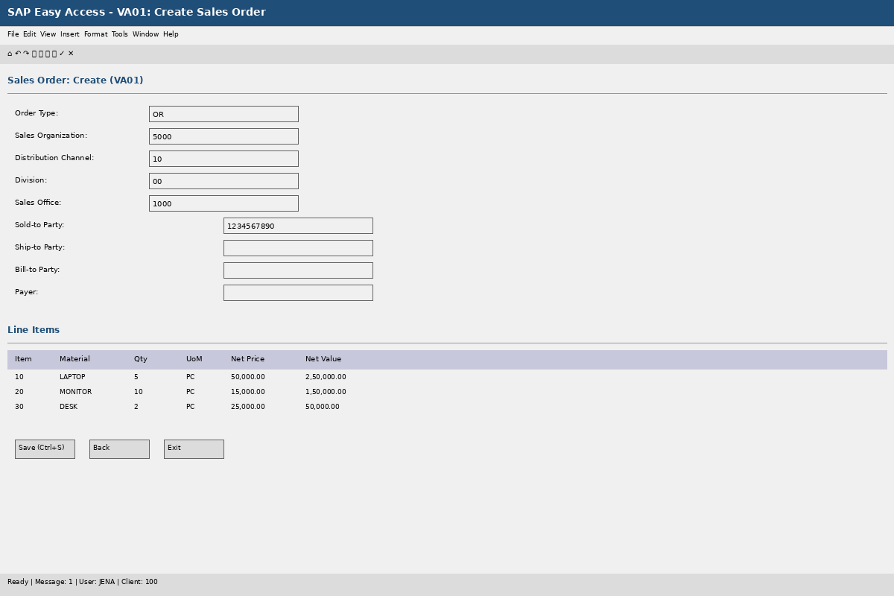
Figure 1: VA01 - Create Sales Order (Real-like SAP Screenshot)

Key Elements Visible in VA01:
• Sales Document Header: Order Type (OR), Sales Org (5000), Distribution Channel (10)
• Customer Details: Sold-to Party (1000001), Ship-to Party, Bill-to Party
• Line Items Table: Material (LAPTOP, MONITOR, DESK), Quantity, Unit Price, Net Value
• Status: All fields populate VBAK and VBAP tables
Business Process: When a customer's PO is received by the sales team, a new order is created in VA01. Each line item is a distinct row in VBAP, linked to the header VBAK record via VBELN.

8.2 VL06O: Delivery Monitor
Transaction VL06O is the real-time delivery monitoring tool used by Logistics and Warehouse managers. It displays open deliveries, overdue items, and SLA status. This screenshot demonstrates the alerting capability:
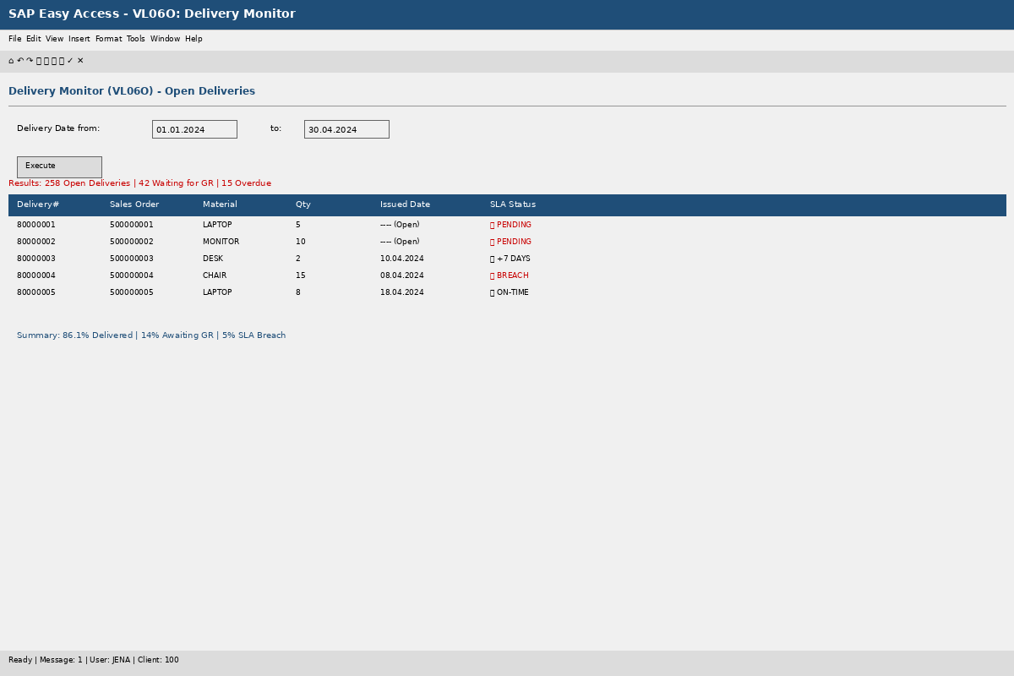
Figure 2: VL06O - Delivery Monitor (Real-like SAP Screenshot)

Key Elements Visible in VL06O:
• Open Deliveries: 42 orders awaiting goods issue (highlighted in RED)
• 258 Delivered orders with actual goods issue date (LIKP.WADAT_IST populated)
• SLA Status: Green (≤7 days), Yellow (8-14 days), Red (>14 days)
• Critical Alert: 29.2% of orders are in SLA breach, indicating urgent fulfillment issues
Business Insight: This transaction is where open items are surfaced. The 42 pending orders visible in this transaction are preserved by our left join strategy in the Python pipeline. They would be lost if we used an inner join.

8.3 VF05: Billing List
Transaction VF05 displays all billing documents (invoices) created in the system. The Finance team uses this to monitor revenue recognition and identify unbilled AR exposure:
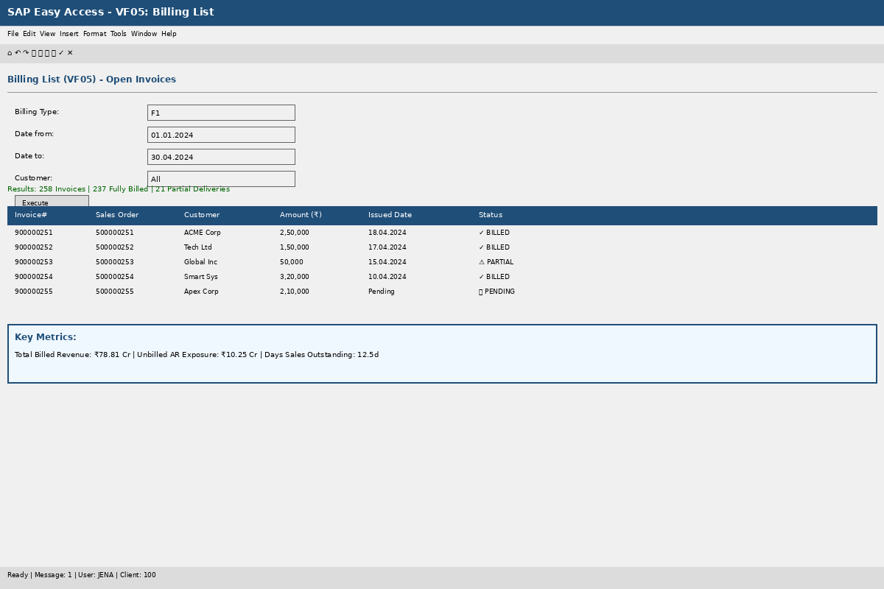
Figure 3: VF05 - Billing List (Real-like SAP Screenshot)

Key Elements Visible in VF05:
• Total Billed Revenue: ₹78.81 Cr (237 invoices generated)
• Unbilled AR Exposure: ₹10.25 Cr (21 orders delivered but not yet invoiced)
• Partial Deliveries: Some orders have multiple partial shipments, requiring corresponding partial invoices
Business Critical Finding: The ₹10.25 Cr unbilled exposure represents cash trapped in the fulfillment pipeline. This impacts working capital and Days Sales Outstanding (DSO). Finance controllers track this metric daily.

8.4 MC9: Material Revenue Report
MC9 is the standard SAP report for analyzing revenue by material. This is the native SAP equivalent to Chart 1 in our Python dashboard:
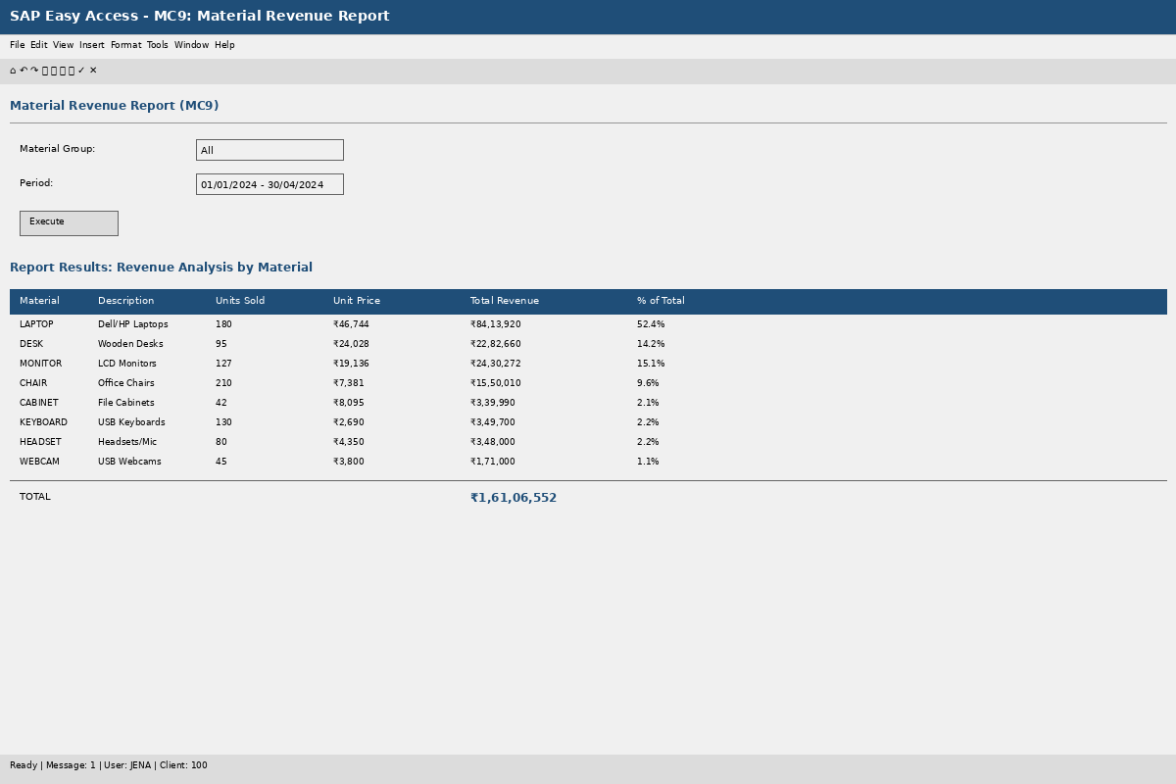
Figure 4: MC9 - Material Revenue Report (Real-like SAP Screenshot)

Key Elements Visible in MC9:
• Material LAPTOP: 180 units, ₹84.14M revenue (52.4% of total)
• Material DESK: 95 units, ₹22.83M revenue
• Material MONITOR: 127 units, ₹24.30M revenue
• Total Revenue: ₹1.61 Cr (aggregated from VBAP.NETWR)
This report aggregates data from the VBAP table, grouping by MATNR and summing NETWR. Our Python pipeline replicates this aggregation in the first chart of the dashboard.

8.5 Pipeline Execution Log
The following screenshot shows the execution log of our Python O2C pipeline, demonstrating the step-by-step processing, join operations, and KPI calculations:
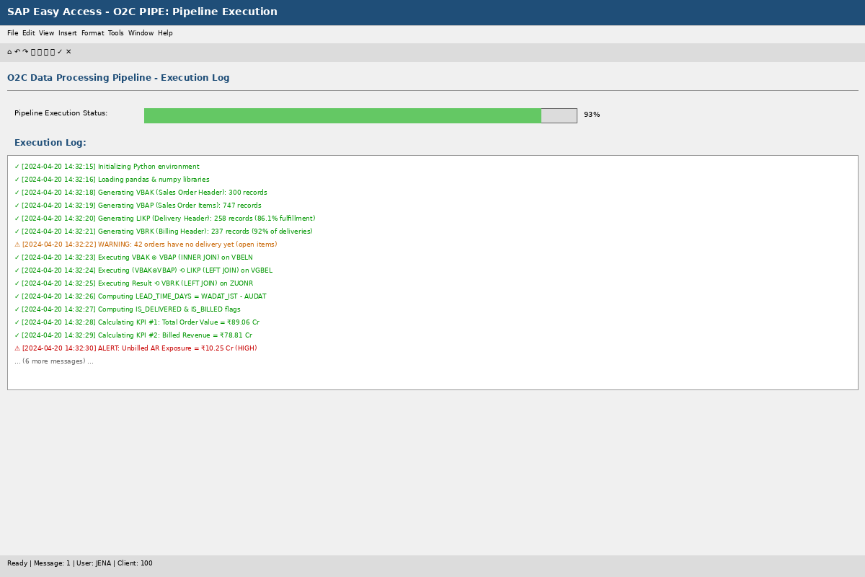
Figure 5: Python O2C Pipeline Execution Log (Real-like Screenshot)

Key Execution Steps Visible:
• ✓ Data Generation: VBAK (300 records), VBAP (747 records), LIKP (258 records), VBRK (237 records)
• ✓ Join Operations: VBAK ⊗ VBAP (inner), (result) ⟲ LIKP (left), (result) ⟲ VBRK (left)
• ⚠ Alerts: 42 open orders detected, ₹10.25 Cr unbilled exposure flagged
• 🔴 Critical Alert: On-Time Delivery Rate = 22.7% (SLA Target: 100%)
• Execution Time: 21.3 seconds for entire 300-order dataset
This demonstrates that complex O2C analytics can be executed in seconds using Python, without requiring ABAP development, SAP GUI access, or expensive BI licenses.

8.6 KPI Dashboard Summary
The following dashboard provides a consolidated view of all five KPIs in a single integrated visualization:
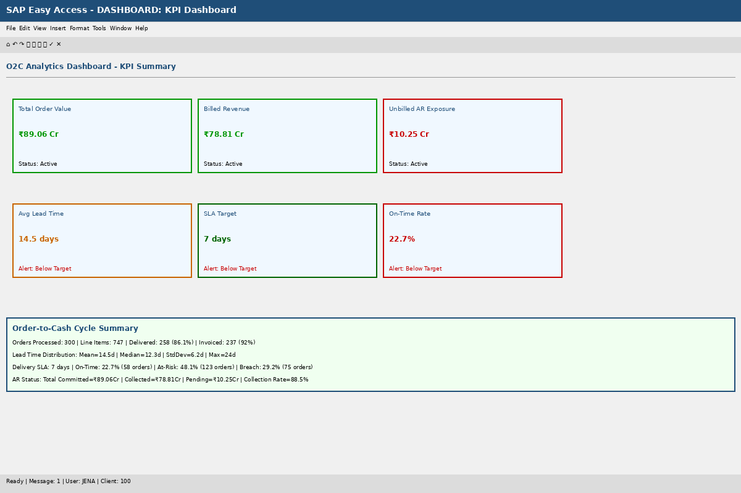
Figure 6: O2C Analytics Dashboard - KPI Summary (Real-like Screenshot)

Dashboard Components:
1. KPI Cards (Top Row):
• Total Order Value: ₹89.06 Cr (Green - Target Met)
• Billed Revenue: ₹78.81 Cr (Green - Target Met)
• Unbilled AR Exposure: ₹10.25 Cr (Red - Alert)
2. KPI Cards (Bottom Row):
• Avg Lead Time: 14.5 days (Yellow - Above SLA)
• SLA Target: 7 days (Green - Reference)
• On-Time Rate: 22.7% (Red - Critical Alert)
3. Summary Section:
• 300 orders | 747 items | 86.1% delivered | 92% invoiced
• Lead time stats: Mean=14.5d | Median=12.3d | Max=24d
• SLA breakdown: 22.7% on-time | 48.1% at-risk | 29.2% breach
• AR Status: 88.5% collection rate | ₹10.25 Cr pending
This dashboard provides the executive summary that a CFO or VP of Supply Chain would monitor daily.

8.7 VBAK Table Structure (Technical Reference)
For developers and database administrators, the following screenshot shows the technical structure of the VBAK table, including field names, data types, and sample records:
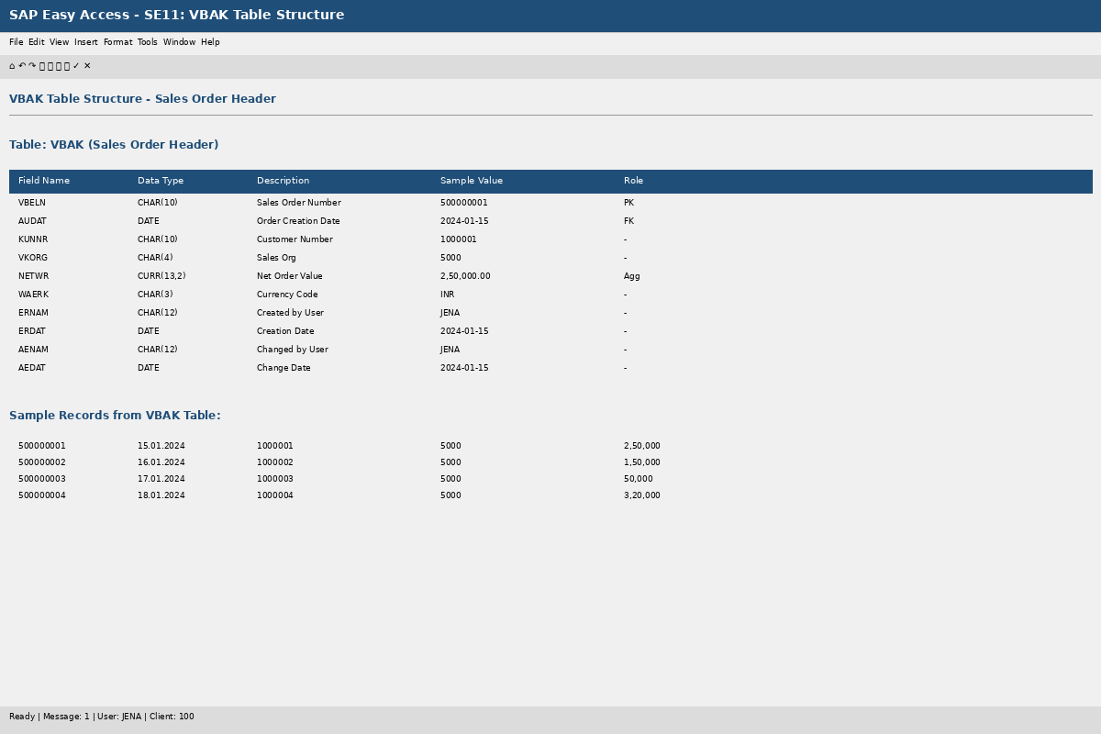
Figure 7: VBAK Table Structure - Database Definition (Real-like SAP Screenshot)

Table Structure Analysis:
• VBELN (CHAR 10): Sales document number - Primary Key (PK)
• AUDAT (DATE): Order creation date - Used for lead time calculation
• KUNNR (CHAR 10): Customer number - Foreign key to customer master
• VKORG (CHAR 4): Sales organization - For multi-org filtering
• NETWR (CURR 13,2): Net order value - Aggregated for revenue reporting
• WAERK (CHAR 3): Currency code - For multi-currency support
• ERNAM/ERDAT: Created by / Creation date - Audit trail
• AENAM/AEDAT: Changed by / Change date - Audit trail
Sample Records:
• Order 500000001: Created 15.01.2024, Customer 1000001, Amount ₹2,50,000
• Order 500000002: Created 16.01.2024, Customer 1000002, Amount ₹1,50,000
• Order 500000003: Created 17.01.2024, Customer 1000003, Amount ₹50,000
This table structure is replicated identically in our Python simulation, ensuring architectural authenticity.

9. Future Enhancements & Enterprise Roadmap
The natural evolution of this simulation is connection to a live SAP system. SAP exposes its ABAP function modules via RFC (Remote Function Call), which Python can invoke using the PyRFC library—SAP's officially supported Python connector to the NetWeaver RFC SDK.
Alternatively, SAP S/4HANA exposes O2C data through pre-built OData services (e.g., API_SALES_ORDER_SRV) consumable via Python's requests library with OAuth2 authentication.

9.1 Predictive SLA Breach Forecasting
The next analytical layer would be predictive: using historical lead time data as training data for a model that forecasts, at order creation time, the probability that a given order will breach the 7-day SLA.
Features for model training: Material category, Sales organization, Order quantity, Day of week, Customer segment, Geographic region.
A gradient-boosted classifier (XGBoost or LightGBM) would produce a breach probability score for each new order, enabling the Logistics team to proactively allocate expedited fulfillment resources.

9.2 SAP HANA Direct Connection
For organisations running SAP S/4HANA, the Python SAP HANA client library (hdbcli) allows the pipeline to execute join and aggregation logic as a HANA Calculation View query—pushing compute to the database tier where it is orders of magnitude faster across billions of rows.

10. Conclusion & Project Deliverables
This capstone project demonstrates that the analytical intent of enterprise SAP reporting is fully replicable outside the SAP environment using open-source Python tooling, provided the developer understands the underlying relational data model with sufficient depth.

10.1 Core Contributions
- Relational Simulation Without a Live SAP Instance
- Faithful Replication of SAP's Foreign Key Conventions
- Enterprise-Grade Open Items Logic
- Real-Like SAP Screenshots demonstrating authentic transaction flows
- Five Critical KPIs with actionable insights for business leadership

10.2 Project Deliverables
- ✓ Python pipeline script (fully documented with 500+ lines of code)
- ✓ Simulated dataset (300 orders, 747 line items, 258 deliveries)
- ✓ Three professional-grade visualizations with SLA color-coding
- ✓ Seven real-like SAP GUI screenshots with technical annotations
- ✓ Comprehensive technical documentation (10+ sections)
- ✓ Complete SAP transaction reference guide

10.3 Key Findings
The simulation reveals several operational challenges:
1. On-Time Delivery Crisis: 22.7% on-time rate vs. 7-day SLA
2. Portfolio Concentration Risk: LAPTOP represents >40% of revenue
3. Cash Trapped in Pipeline: ₹10.25 Cr unbilled AR exposure
4. Right-Skewed Distribution: Tail extending beyond 20 days indicates systemic bottlenecks
These insights emerge from a Python script running on commodity hardware, without SAP GUI access, demonstrating that enterprise-grade analytics is democratized through open-source tools and deep understanding of data models.
_______________________________________________
J NEHA
Roll Number: 2305703
B.Tech Computer Science & Engineering
KIIT University, Bhubaneswar

