## Introduction

Microplastics, commonly defined as plastic particles <5 mm in size, are a rapidly emerging ecological threat (Zhang et al. 2021). These plastic particles are moved by ocean circulation and can be deposited into intertidal zones, concentrating the distribution and ecological impacts (Wu et al 2022). Some crab species have been found to actively consume available microplastics, reducing food intake and limiting energy for growth (Not et al. 2020, Watts et al. 2015). Acting as scavengers and filter feeders, the hairy shore crab (*Hemigrap*sus *oregonensis*) is particularly at risk of encountering microplastics in the form of both accumulated particles in food items, and suspended particles in the water. Encountered microplastics reduce gill function in addition to replacing food intake and gut space, further contributing to the energetic burden and environmental threat caused by these particles (Zhang et al. 2021, Watts et al 2016).

Past studies on microplastic effects on crabs have focused on individual plastic types such as polypropylene fibers, polyethylene microbeads, and tire treads (Watts et al. 2015, Urbina et al. 2023, FISH 497C Tire Tread Team 2024). However, no research has been conducted examining the effects of mixed microplastics on *H. oregonensis*. In this study, *H. oregonensis* had a mix of microplastics introduced into their diet to better mimic the variety of plastic particles that they are likely to be exposed to in the wild. Lactate levels and plastic accumulation in body tissues were measured after three weeks of exposure to identify if a mix of microplastics will impact the respiratory and digestive systems of *H. oregonensis*. We hypothesize that mixed microplastics will be retained in crab tissues and elevate lactate levels due to physiological stress.

## Methods

Several dozen *H. oregonensis* were collected haphazardly from a rocky intertidal shore in the Puget Sound for several projects, of which 18 individuals were used for this study. Each crab was then placed in an individual jar with a mesh top to contain microplastic treatment and a shell hide. Jars were separated and placed into two 10-gallon tanks based on feeding treatment: fed or unfed (Fig. 1). Each tank had an air stone to oxygenate and circulate water through the jars. Water was maintained at a constant temperature of 13 Celsius and a salinity of approximately 30 ppt throughout the experiment. Each week, water in jars was exchanged with new water and mortality was assessed.

All feeding was done after one week of acclimation to lab conditions. Microplastics were prepared by filing blue plastic bottle caps, creating microplastics in a variety of sizes and plastic types. Microplastics were then soaked in mussel juice for 48 hours to induce higher rates of feeding in the crabs. 25 mg of microplastics were given to each individual, with those in the fed group also given 2.5g of mussel meat.

At the end of three weeks post-feeding, hemolymph was extracted from all crabs and tested for l-lactate levels (fed n = 1, unfed n = 4). Then, each crab was placed in the freezer for 15 minutes to humanely euthanize it before being dissected. Dissections were conducted examining stomach, hindgut, and gill tissue for presence of microplastics (Fig. 2). Weights of each crab were measured to normalize microplastic counts. Average lactate levels in each surviving crab were directly compared to each other, due to the limited sample size of this study.

## Results

There was significant mortality in the first week of the experiment, with eight individuals in the fed group and five individuals in the unfed group dying, respectively. Following this, all crabs were removed from individual jars and placed into larger tanks and no mortality ensued in the following two weeks of the experiment.

Dissections of all crabs, both living and dead, did not find microplastics retained in any of the examined tissues (Fig. 2).

Average lactate levels were higher in the unfed crabs than in the fed crab (209.6 ± 108.1, 36.9 ± 5.5, Fig. 3).

## Discussion

The high mortality of crabs within the first week was likely caused by the experimental design and not by outside factors. Post-mortem dissections found that all such crabs had discolored gills, a feature associated with hypoxic, high ammonia environments in crabs (Nash et al. 1988, Lee et al. 2023). This was most likely caused by the mesh tops of the jars inadvertently restricting water exchange between the jars and the larger reservoir of water in the tank. This resulted in diffusion being the main source of oxygen into the jars, rather than mixing, causing hypoxia. Additionally, the waste material produced by the food and fed crabs further contributed to hypoxia as respiration and decomposition used up available oxygen, and waste such as ammonia built up in the jars, contributing to mortality and discolored gills. Due to this high mortality, sample sizes were dramatically reduced, limiting statistical power and potentially skewing results. Fed group mortality reduced the sample to only one survivor, meaning that average lactate values for the group are based on two replicates from the same crab. Thus, the ability to infer treatment effects between the two groups is limited.

Dissections of surviving crabs yielded the result of no retained microplastics in any tissues, in contrast with previous research investigating uptake of microplastics in crabs (FISH 497C Tire Tread Team 2024, Watts et al. 2015, Watts et al. 2014). The microplastics produced from bottle caps may not have been dense enough to sink, preventing the crabs from ingesting them, unlike denser particles used in prior studies. Alternatively, the short exposure time may have not been long enough for microplastics to build up in tissues and cause a physiological response (Urbina et al. 2023). Ultimately, high mortality and inaccessibility of plastic to the crabs makes it difficult to draw strong conclusions from these dissection results.

Lactate is used as a proxy of anaerobic metabolism, which can be used as an indicator of stress and hypoxia in crabs (Booth et al. 1982, Maciel et al. 2008, Burke 1979). Lactate levels may also be impacted by social behaviors, with aggressive contact between crabs causing increased lactate levels (Matsumasa & Murai 2004). These behaviors may explain the elevated lactate levels in the unfed group, as they were housed together after the first week of the experiment and may have competed for favorable shell hides. However, these dynamics were not quantified, limiting their use for interpretation. Future studies should include behavioral observations to distinguish physiological stress from social aggression.

Overall, these results indicate that small, floating microplastics are unlikely to acutely impact *H. oregonensis*, as their rate of uptake is too slow or nonexistent on shorter timescales, although this conclusion is limited by low sample size and confounding factors. This data could be used as a model for other species of crabs, such as invasive species like the European Green crab (*Carcinus* *maenas*) and Asian shore crab (*Hemigrapsus sanguineus*). However, more research is needed to better understand the impacts of microplastics on *H. oregonensis*. It would be valuable to identify which plastics they are most likely to consume in the wild and the long-term impacts of those plastics. Additionally, it would be useful to use fluorescence-labeled plastics to provide more reliable detection. This would help to inform policy on which plastics to prioritize to reduce ecological impacts, allowing for more effective and efficient restoration and conservation efforts.

## Figures

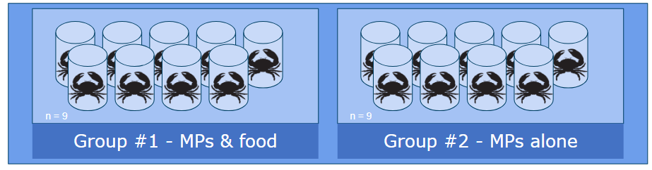

**Figure 1**. The rectangles display the experimental setup, with nine jars with individual crabs were placed for each fed and unfed treatment. All jars were submerged in the larger water tank.

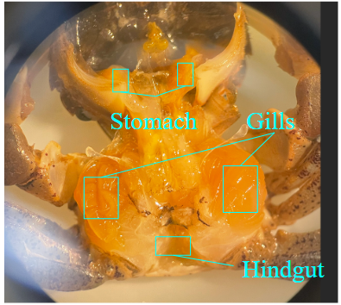

**Figure 2**. Representative example of dissected *H. oregonensis* with stomach, gill, and hindgut tissues labeled. No blue microplastic particles are apparent.

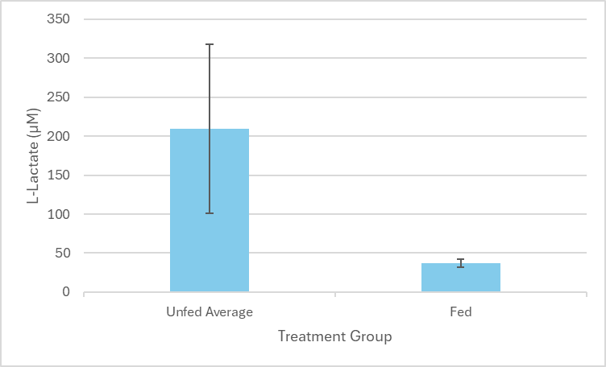

**Figure 3**. Bar graph of l-lactate levels. Unfed group represents an average of the treatment group (n = 4), while fed group represents two tests from the same individual (n = 1). Error bars represent one standard deviation.

## References

Booth CE, McMahon BR, Pinder AW (1982) Oxygen uptake and the potentiating effects of increased hemolymph lactate on oxygen transport during exercise in the blue crab, Callinectes sapidus. Journal of Comparative Physiology B 148:111–121. doi: [10.1007/BF00688894](https://doi.org/10.1007/BF00688894)

Burke EM (1979) Aerobic and anaerobic metabolism during activity and hypoxia in two species of intertidal crabs. The Biological Bulletin 156:157–168. doi: [10.2307/1541040](https://doi.org/10.2307/1541040)

Lee Y, Byeon E, Kim D-H, Maszczyk P, Wang M, Wu RSS, Jeung H-D, Hwang U-K, Lee J-S (2023) Hypoxia in aquatic invertebrates: Occurrence and phenotypic and molecular responses. Aquatic Toxicology 263:106685. doi: [10.1016/j.aquatox.2023.106685](https://doi.org/10.1016/j.aquatox.2023.106685)

Maciel JES, Souza F, Valle S, Kucharski LC, da Silva RSM (2008) Lactate metabolism in the muscle of the crab *Chasmagnathus granulatus* during hypoxia and post-hypoxia recovery. Comparative Biochemistry and Physiology Part A: Molecular & Integrative Physiology 151:61–65. doi: [10.1016/j.cbpa.2008.05.178](https://doi.org/10.1016/j.cbpa.2008.05.178)

Matsumasa M, Murai M (2005) Changes in blood glucose and lactate levels of male fiddler crabs: effects of aggression and claw waving. Animal Behaviour 69:569–577. doi: [10.1016/j.anbehav.2004.06.017](https://doi.org/10.1016/j.anbehav.2004.06.017)

Nash G, Anderson IG, Shariff M (1988) Pathological changes in the tiger prawn, Penaeus monodon Fabricius, associated with culture in brackishwater ponds developed from potentially acid sulphate soils. Journal of Fish Diseases 11:113–123. doi: [10.1111/j.1365-2761.1988.tb00531.x](https://doi.org/10.1111/j.1365-2761.1988.tb00531.x)

Not C, Lui CYI, Cannicci S (2020) Feeding behavior is the main driver for microparticle intake in mangrove crabs. Limnology and Oceanography Letters 5:84–91. doi: [10.1002/lol2.10143](https://doi.org/10.1002/lol2.10143)

Urbina MA, da Silva Montes C, Schäfer A, Castillo N, Urzúa Á, Lagos ME (2023) Slow and steady hurts the crab: Effects of chronic and acute microplastic exposures on a filter feeder crab. Science of The Total Environment 857:159135. doi: [10.1016/j.scitotenv.2022.159135](https://doi.org/10.1016/j.scitotenv.2022.159135)

Watts AJR, Lewis C, Goodhead RM, Beckett SJ, Moger J, Tyler CR, Galloway TS (2014) Uptake and Retention of Microplastics by the Shore Crab Carcinus maenas. Environ Sci Technol 48:8823–8830. doi: [10.1021/es501090e](https://doi.org/10.1021/es501090e)

Watts AJR, Urbina MA, Corr S, Lewis C, Galloway TS (2015) Ingestion of Plastic Microfibers by the Crab Carcinus maenas and Its Effect on Food Consumption and Energy Balance. Environ Sci Technol 49:14597–14604. doi: [10.1021/acs.est.5b04026](https://doi.org/10.1021/acs.est.5b04026)

Watts AJR, Urbina MA, Goodhead R, Moger J, Lewis C, Galloway TS (2016) Effect of Microplastic on the Gills of the Shore Crab Carcinus maenas. Environ Sci Technol 50:5364–5369. doi: [10.1021/acs.est.6b01187](https://doi.org/10.1021/acs.est.6b01187)

Wu P, Zhang H, Singh N, Tang Y, Cai Z (2022) Intertidal zone effects on Occurrence, fate and potential risks of microplastics with perspectives under COVID-19 pandemic. Chemical Engineering Journal 429:132351. doi: [10.1016/j.cej.2021.132351](https://doi.org/10.1016/j.cej.2021.132351)

Zhang T, Sun Y, Song K, Du W, Huang W, Gu Z, Feng Z (2021) Microplastics in different tissues of wild crabs at three important fishing grounds in China. Chemosphere 271:129479. doi: [10.1016/j.chemosphere.2020.129479](https://doi.org/10.1016/j.chemosphere.2020.129479)

FISH 497C Tire Tread Team (2024) Impacts of Starvation and Tire-Wear Feeding on Hemigrapsus oregonensis Health.