Bydgoszcz, {$DATE}

{$ID}/ENG/I/{$Y}

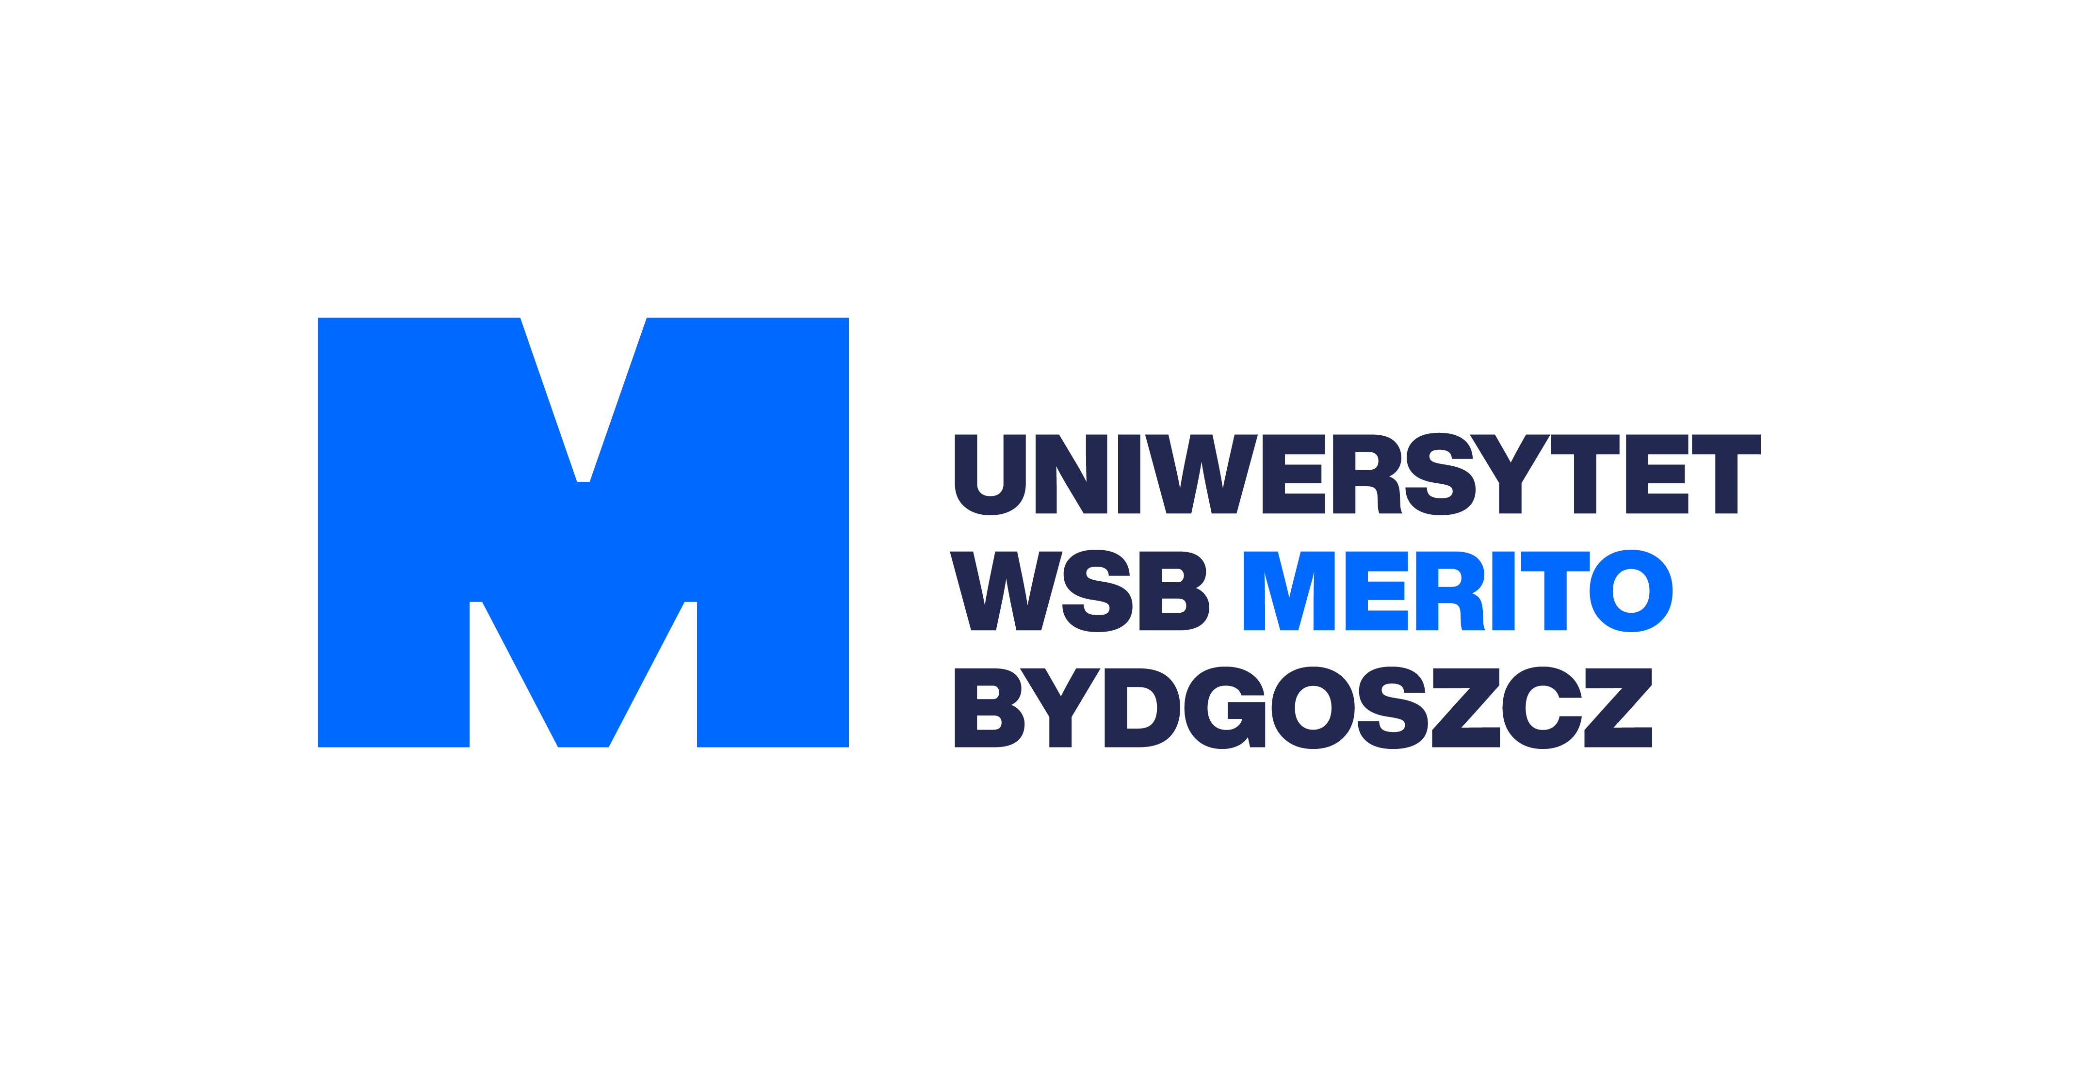

# **ADMISSION LETTER**

This is to certify that **{$NAME}** born **{$BIRTH}** in **{$CITY}** the citizen of **{$COUNTRY}**, passport number **{$PASSPORT}** an applicant for studies at University WSB Merito in Toruń, Branch in Bydgoszcz, has been accepted for studies to the first year in {$CYCLE}-cycle studies in **{$DEGREE}’s Degree studies** in the academic year {$Yx1}.

The direction of studies is **{$FACULTY}**

Specialty **{$SPECIALITY}**

Faculty **Finansów i Zarządzania w Bydgoszczy**

Semester start month: {$INTAKE}

Duration of studies: {$SEM_COUNT} semesters

Deadline for tuition fees payment: {$DEADLINE}

Student is obligated to come to Poland no later than {$ARRIVE_DEADLINE}

{$INTERVIEW}

Tuition fee: **{$TUITION_CUR} ({$PAIDCUR} ALREADY PAID {$DATE_PAID_T}) FULL REFUNDABLE**

Administrative fee: **{$ADM_CUR} (ALREADY PAID {$DATE_PAID_A}) NOT REFUNDABLE PAYMENT**

Application fee: **{$APP_CUR} (ALREADY PAID {$DATE_PAID_A}) NOT REFUNDABLE PAYMENT**

Bank Name: **PEKAO SA**

Bank Address: **Bank PEKAO SA Oddział w Bydgoszczy 85-001 Bydgoszcz, ul. Jagiellońska 34** Account holder name: **Uniwersytet WSB Merito w Toruniu**

SWIFT: **PKOPPLPW**

IBAN**: {$BANKDETAILS}**

Account Number: **{$BANKDETAILS}**

Thank you for entrusting your future education to us.

Best Regards,