Łódź, {$DATE}

{$ID}/ENG/I/{$Y}

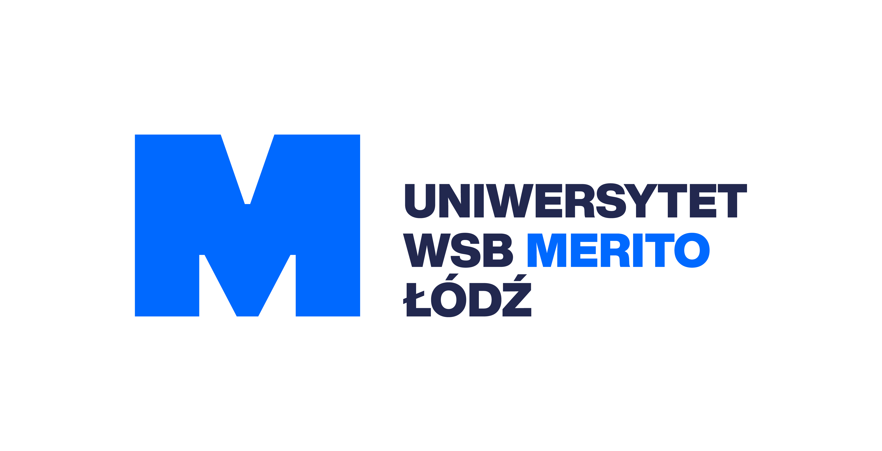

**INVITATION**

**{$NAME}**

born **{$BIRTH}**

passport number**{$PASSPORT}**

Dear **{$NAME}**

We have a great pleasure to inform you that you have been accepted to WSB Merito University in Torun, Brach in Lodz for **{$FACULTY}** for next academic session started on {$DATESTART}.

WSB Merito faculty, staff and students welcome you to our academic community. You can feel confident that being part of the WSB Merito your future education is in good hands and your educational goals will be met.

The Department of International Cooperation will help you to arrange accommodation when you will join our campus.

Our University course catalog is available at: https://www.merito.pl/lodz/

Congratulation on your acceptance to WSB Merito University in Torun, Branch in Lodz. The entire University looks forward to your participation in our active learning community.

Please remember that it is your responsibility to arrange and cover the costs of health insurance and a Polish Visa for the time of your studies. Travel costs are also to be covered by yourself.

This invitation is to help you receive a Polish Visa at the Polish Embassy in your country.

Thank you for entrusting your future education to us.

Best Regards,