Group 1

[www.Healthyyouthforlife.or](http://www.healthyyouthforlife.org)g

**Preface:**

We came together and made a group, to help children of this country make the healthier choices in their lives. We hope this can help the parents and teachers understand that the choices we make when we are younger help to shape how we make changes as adults. We are here to shape the minds of the children today to change the minds of adults tomorrow.

**Introduction**

**Project Overview**

**Executive summary:**

Our project is to create an educational website for children, parents and teachers to better help their children of this nation make a healthier choice. Our website will have games that will help instill healthier choices, by making it a game it gives healthy competition to all the students when they play the game and look at the results of their game when it is updated on the leaderboard. From this teachers/parents can review all of the progress that the child has accomplished, from here you can advise the parents or the teacher can adjust the teaching methods to better guide the child in the most appropriate methods.

**Project Deliverables:**

The project will produce a working website that allows users to log in and view content from the organization. The site will also include the following:

* An online game available to student logins
* A leaderboard that will connect with a database to display the highest scores for each player.
* A profile system that allows student users update and display their avatars and username
* An online system that allows for communication between parents and teachers on a students progress
* A donation link that will allow any user to make donations to the site.
* A home page for which the organization can post any updates to the site to keep users updated on events

**Evolution of SPMP**

The project will be completed in the following sequence:

* Set up a host and domain for the site.
* Create the website and create pages for Students, Teachers, and Parents
* Create a donation link that will allow all users to make donations
* Set up a database to existing user profiles, leaderboard scores, comments and notes written by teachers
* Develop the website to display content provided by the client for their website
  + Web documents
  + About Us
  + Contact Us
  + Periodic Updates to homepage
  + Events, etc
* Implement the game into the website and check to see that leaderboard scores and game scores are accurate
* Test and Debug existing code

As this is based on real world scenarios, we can not expect everything to flow as expected. There are a number of relevant changes and details that will need to be accounted for throughout the process. For debugging and and testing code as we go along, we will constantly be backing up saved data in case we need to pull from the github repository. Should a revision be needed for the our group will come together and discuss with the client a reasonable course of action.

In the event that the client would like to add extra functionality the team will meet and discuss the possible outcomes to creating said functionality. Our plan will then be to decide at what step in the repository to build from and continue with development and debugging. Considering the expected deadline is nearing, there will be a limit to the amount of changes that we can reasonably be expected to incorporate into our design. As such, there will be a cut off date midway through our design phase as for what the project will contain so that there will be time to test and debug the final product.

**Project Constraints:**

The time given to complete this project, a little less than 3 months, is a very large constraint because we have other classes that can take up our time giving us less time than we think we have. The websites budget is completely dependent on what the group feels like they can support monetarily or if we need to find another place to host our domain we will need to shell out more money which can stack up quickly.

The website needs to be robust, meaning that it should protect a users information. As such student and teacher logins must be matched with existing records on school databases and be verified before accounts are created.

User accounts must be verified by existing school databases before student and teacher logins are created. Teachers must provide a teacher ID, school name and class number in order for to be able to comment and interact with students of their class. Students must have an affiliated parent login, Student ID, school that they currently attend and a class number to be connected with their teacher which will allow the teacher to interact with the student’s profile.

User’s are parent logins if and only if they have an affiliated student user that is created using the parents address, and credit card information.

**Organizational Structure**



The client is responsible for giving management and the project team the requirements for the project to get us to the final website. Management’s job is to handle the website management and to control the high level architecture of the project while keeping everyone else focused on the tasks they have been given. Project team is comprised of all others related to the team that aren’t management or the client, they are responsible for their own jobs, i.e. getting the database ready for implementation and testing. Working Together management and the project team are to get the infrastructure of the website up and running for testing.

**Project Responsibilities**

A few of the major functions of this website will be games, leaderboards, progress reports, parents page, teachers page, donations. Games will give the kids a fun way to compete with other students and learn the aspects of making healthy choices. The leaderboards give the drive to want to do better between the kids. The progress reports give the parents and teachers ways to see how the children are doing and what they need to improve upon. Donations is a way for the website and the school to supplement the money the Department of Education.

**Management Objectives and priorities**

Our management philosophy here at HealthyChoiceForLife.org we believe the children come first and we put that into everything we do from the safety of the child’s account on the website to the way we want them to learn important life lessons. We believe that the grant that granted us the ability to make this site. We plan on making ourselves readily available to the schools and department of education.

**Risk Management**

Contractual risks:

-Running out of money

-improper requirements that does not meet what we have set our company to management

Size of the project:

-if the project tacts on so much more than originally requested then we will be over the date projected

Complexity of the project:

-the tasks for the projects are too great for the skill or the tasks for our company to handle

Staff:

-if we have an issue where we lack the staff to complete this project we would need to relinquish the project

Client:

-if the client dislikes what we did for the project, we need to have proper communication for this to not happen since this is the primary goal

**Technical Process**

We plan to host the website on wix.com, and we have looked into the current applications to put into it, for the donations we will use stripe or paypal (whichever is easier for the wix site to host). We have also looked into simple games in order to help the kids gain more healthy lifestyle choices.

For our follow-up project support we plan on training an admin from the board of education or the school board, whomever they choose to go through the training that would help them maintain the site after our company is done with it.

**Work Packages**



**WBS Diagram**

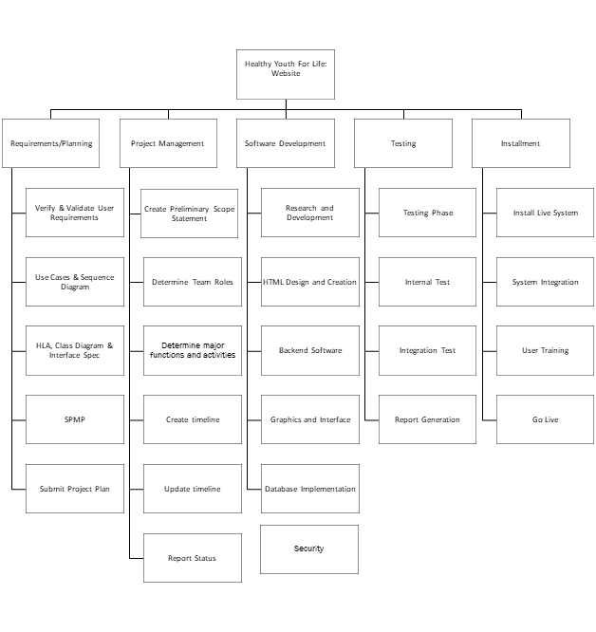

Schedule

