**FWB-P-Nov-22-0491 Supplementary materials**

Table S1 A list of metrics and descriptive terms used to describe predator-prey interactions. PRE = Predation Related Event. Predator presence in the sonar window was used to determine if a Predation Related Event (PRE) had occurred. See section 2.3.1 for further detail.

|  |  |  |
| --- | --- | --- |
| **Term** | **Description** | **Data type** |
| Duration of PRE | Duration of a PRE from the point when a predator enters the sonar window until the end point of prey shoal response. | Continuous |
| *Predator metrics taken during a single PRE* | | |
| Number of predators present | Number of predators present | Discrete |
| Predator species | (1) Great Cormorant (*Phalacrocorax carbo*) (2) Northern pike (*Esox lucius*). | Discrete, categorical |
| Predator size | Length of predator (cm) | Continuous |
| Predator attack | (0) no attack (1) attack. | Discrete, categorical |
| Number of attacks | Number of predator attacks | Discrete |
| Duration of attack | Duration of predator attack | Continuous |
| Time until attack | Time from when predator enters sonar window until first attack | Continuous |
| Predator attack rate | Number of attacks per minute (*n attacks∙minute-1*) | Continuous |
| *Prey shoal metrics taken during a single PRE* | | |
| Prey shoal size | Number of prey in a shoal (ImageJ) | Discrete |
| Prey shoal area | Area in m2 of a prey shoal (ImageJ) | Continuous |
| Prey shoal density | Prey shoal size divided by prey shoal area (*n∙m2*) | Continuous |
| Prey shoal density response | Extent of prey density response to a predator (change in density pre- and post-behavioural reaction) | Continuous |
| Prey shoal areal response | Extent of prey areal response of a prey shoal to predator (change in area pre- and post-behavioural reaction) | Continuous |
| Prey shoal behavioural response to predator | (0) no response (1) flee (2) flee (into weed screen) (3) flee (away from weed screen) (4) avoid (5) avoid (into weed screen) (6) avoid (away from weed screen) | Discrete, categorical |
| Duration of prey shoal behavioural response | Duration of a behavioural response | Continuous |
| Number of prey shoal behavioural responses | Number of behavioural responses | Discrete |
| Weed screen switching rate | Number of times prey switch sides at the weed screen (*n switches∙minute-1*) | Continuous |

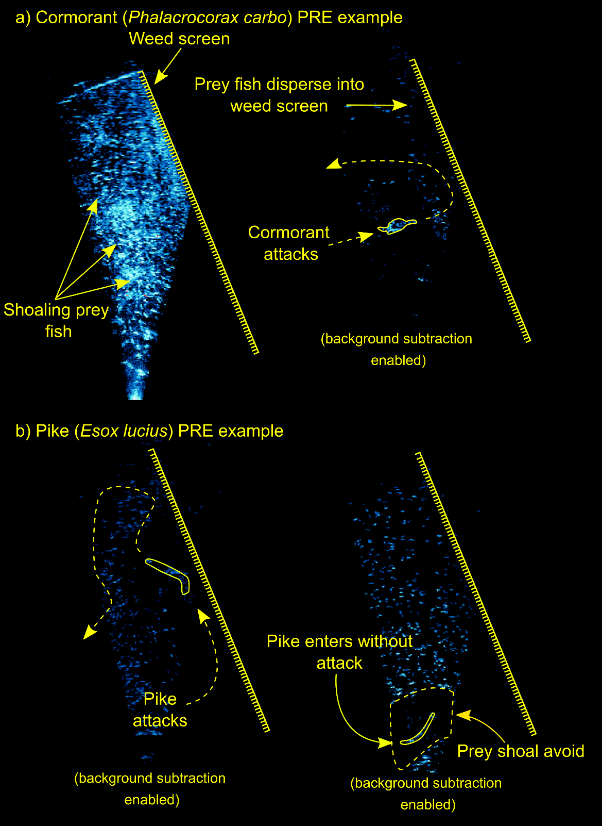

Figure S1 A schematic representation of a) cormorant PRE showing prey shoal and cormorant attack, b) pike PRE showing an attack, and no attack with prey avoidance.