**JEMA-D-22-10851 Supplementary materials**

Table S1 Data summary table containing river level recorded on the Yorkshire Ouse, temperature recorded at the point of sample (DIDSON) and fish count assorted by year, month and light period as derived from visual fish counts of DIDSON sonar captured between November 2017 and January 2020. mAOD = Meters above ordnance datum.

|  |  |  |  |  |  |  |  |  |  |  |  |  |  |  |  |  |  |  |  |
| --- | --- | --- | --- | --- | --- | --- | --- | --- | --- | --- | --- | --- | --- | --- | --- | --- | --- | --- | --- |
|  | **River level (Ouse) (mAOD)** | | | | **Temperature ( ̊C)** | | | | **Fish count (individuals·2m2 h-1)** | | | | | | | | | | |
|  | Day | | | | | Night | | | | |  |
| Year (Month) | *median* | *IQR* | *min* | *max* | *median* | *IQR* | *min* | *max* | *median* | *IQR* | *min* | *max* | *sum* | *Median* | *IQR* | *Min* | *Max* | *sum* | *total* |
| Year one |  |  |  |  |  |  |  |  | 6 | 8 | 0 | 19 | 3239 | 2 | 3 | 0 | 14 | 2261 | 5500 |
| November | 5.30 | 0.50 | 5.20 | 7.80 | - | - | - | - | 11 | 7 | 0 | 19 | 1495 | 3 | 2 | 0 | 9 | 651 |  |
| December | 5.60 | 0.30 | 5.20 | 6.00 | - | - | - | - | 6 | 6 | 0 | 18 | 742 | 2 | 5 | 0 | 3 | 661 |  |
| January | 6.20 | 0.80 | 5.50 | 8.00 | - | - | - | - | 3 | 6 | 0 | 13 | 504 | 2 | 4 | 0 | 14 | 565 |  |
| February | 5.70 | 0.40 | 5.30 | 6.50 | - | - | - | - | 4 | 5 | 0 | 4 | 498 | 2 | 2 | 0 | 8 | 384 |  |
| Year two |  |  |  |  |  |  |  |  | 4 | 8 | 0 | 20 | 4045 | 2 | 4 | 0 | 19 | 3847 | 7892 |
| September | 5.25 | 0.25 | 5.00 | 6.40 | 12.70 | 2.10 | 11.40 | 15.10 | 0 | 2 | 0 | 8 | 173 | 0 | 1 | 0 | 14 | 166 |  |
| October | 5.10 | 0.20 | 4.90 | 7.25 | 11.54 | 1.50 | 6.11 | 14.30 | 0 | 2 | 0 | 8 | 219 | 0 | 1 | 0 | 8 | 134 |  |
| November | 5.30 | 0.30 | 4.90 | 6.70 | 7.80 | 2.90 | 5.50 | 9.80 | 5 | 3 | 1 | 13 | 786 | 2 | 2 | 0 | 9 | 513 |  |
| December | 6.25 | 0.90 | 5.30 | 7.50 | 6.30 | 0.80 | 3.50 | 8.80 | 6 | 5 | 0 | 15 | 630 | 2 | 3 | 0 | 14 | 641 |  |
| January | 5.25 | 0.10 | 5.00 | 5.90 | 4.60 | 2.30 | 1.30 | 6.70 | 10 | 4 | 0 | 17 | 938 | 6 | 4 | 0 | 17 | 1648 |  |
| February | 5.40 | 0.50 | 5.10 | 7.90 | 5.40 | 3.00 | 0.60 | 8.30 | 10 | 4 | 0 | 20 | 1299 | 3 | 3 | 0 | 19 | 745 |  |
| Year three |  |  |  |  |  |  |  |  | 3 | 5 | 0 | 22 | 2698 | 1 | 2 | 0 | 19 | 1540 | 4238 |
| September | 5.30 | 0.80 | 5.10 | 8.30 | 14.50 | 4.60 | 13.40 | 15.00 | 1 | 3 | 0 | 8 | 224 | 0 | 0 | 0 | 4 | 48 |  |
| October | 6.70 | 1.50 | 5.60 | 8.60 | 11.05 | 2.00 | 7.30 | 13.50 | 3 | 6 | 0 | 22 | 837 | 1 | 4 | 0 | 1 | 387 |  |
| November | 6.50 | 0.60 | 5.70 | 7.20 | 7.70 | 1.60 | 4.70 | 10.00 | 3 | 3 | 0 | 12 | 511 | 1 | 1 | 0 | 8 | 288 |  |
| December | 6.30 | 1.00 | 5.65 | 7.90 | 5.70 | 1.50 | 3.80 | 7.60 | 2 | 3 | 1 | 7 | 124 | 1 | 1 | 0 | 7 | 149 |  |
| January | 5.70 | 0.60 | 5.55 | 7.40 | 5.55 | 1.30 | 3.50 | 7.10 | 10 | 7 | 2 | 19 | 1002 | 2 | 2 | 0 | 19 | 668 |  |

Table S2 Generalised linear mixed model (GLMM) selection for the effects of river temperature, river level and photo period on the temporal dynamics of fish counts across the channel entrance. The random effect of month was included in all the models. Dispersion factor not calculated for zero inflated models. GLMM constructed with *glmmTMB* package in R 4.0.2.

|  |  |  |  |  |  |
| --- | --- | --- | --- | --- | --- |
| Model | Model formula | Distribution | Df | Dispersion factor | AIC |
|  |
| mod1_y1_p | (total~lvl+lvl_stage+photo+(1|month) | Poisson | 8 | 2.23 | 6875 |
| mod2_y1_nb | (total~lvl+lvl_stage+photo+(1|month) | Negative binomial | 9 | 0.97 | 6244 |
| mod3_y1_nb_zi | (total~lvl+lvl_stage+photo+(1|month) | Negative binomial + zero inflation | 10 | - | 6214 |
|  |
| mod1_y2_p | total~temp+lvl+lvl_stage+photo+(1|month) | Poisson | 9 | 2.25 | 8915 |
| mod2_y2_nb | (total~temp+lvl+lvl_stage+photo+(1|month) | Negative binomial | 10 | 1.41 | 8539 |
| mod3_y2_nb_zi | (total~temp+lvl+lvl_stage+photo+(1|month) | Negative binomial + zero inflation | 11 | - | 8430 |
|  |
| mod1_y3_p | (total~temp+lvl+lvl_stage+photo+(1|month) | Poisson | 10 | 2.24 | 5814 |
| mod2_y3_nb | (total~temp+lvl+lvl_stage+photo+(1|month) | Negative binomial | 11 | 1.21 | 5454 |
| mod3_y3_nb_zi | (total~temp+lvl+lvl_stage+photo+(1|month) | Negative binomial + zero inflation | 12 | - | 5456 |

Table S3 Results of the fitted GLMM models for years one, two and three of the fish count data. Random effects and fixed effects are given, and the p values also reported for each parameter. GLMM constructed with *glmmTMB* package in R 4.0.2.

|  |  |  |  |  |  |  |  |  |  |  |  |  |  |  |  |  |  |  |  |  |  |  |
| --- | --- | --- | --- | --- | --- | --- | --- | --- | --- | --- | --- | --- | --- | --- | --- | --- | --- | --- | --- | --- | --- | --- |
| **Model** | | | | | | | | | | | | | | | | | | | | | | |
| Year one *(mod3_y1_nb_zi)* | | | | | | | Year two *(mod3_y2_nb_zi)* | | | | | | | | Year three *(mod3_y3_nb_zi)* | | | | | | | |
| **Random effects** | | | | | | | **Random effects** | | | | | | | | **Random effects** | | | | | | | |
| Groups | Name | | Variance | | | Std. dev. | Groups | | Name | | Variance | | Std. dev. | | Groups | Name | | Variance | | Std. dev. | | |
| Month | (intercept) | | 0.002368 | | | 0.04866 | Month | | (intercept) | | 1.59 | | 1.261 | | Month | (intercept) | | 0.2406 | | 0.4905 | | |
| Number of obs: 1336, groups: month, 4 | | | | | | | Number of obs: 1968, groups: month, 6 | | | | | | | | Number of obs: 1343, groups: month, 5 | | | | | | | |
| **AIC = 6214** | | | | | | | **AIC = 8430** | | | | | | | | **AIC = 5456** | | | | | | | |
| **Fixed effects** | | | | | | | **Fixed effects** | | | | | | | | **Fixed effects** | | | | | | | |
|  | **Est.** | **Std. error** | | **Z** | **Pr(>|z|)** | |  | **Est.** | | **Std. error** | | **Z** | | **Pr(>|z|)** |  | **Est.** | **Std. error** | | **Z** | | **Pr(>|z|)** |
| *(Intercept)* | 7.4987 | 0.6475 | | 11.581 | **<0.001** | | *(Intercept)* | 1.3367 | | 0.7033 | | 1.900 | | **0.057** | *(Intercept)* | 4.5359 | 0.6088 | | 7.450 | | **<0.001** |
| *lvl* | -1.0629 | 0.1084 | | -9.801 | **<0.001** | | *temp* | -0.1292 | | 0.0180 | | 7.143 | | **<0.001** | *temp* | -0.0433 | 0.0267 | | -1.620 | | 0.105 |
| *lvl_stage Falling* | 0.3890 | 0.0875 | | 4.447 | **<0.001** | | *lvl* | -0.2270 | | 0.0685 | | -3.315 | | **<0.001** | *lvl* | -0.4445 | 0.0882 | | -5.037 | | **<0.001** |
| *lvl_stage Stable (reference)* | 0.0326 | 0.0929 | | 0.352 | 0.725 | | *lvl_stage Falling* | 0.2300 | | 0.0857 | | 2.682 | | **0.007** | *lvl_stage Falling* | -0.1047 | 0.0862 | | -1.215 | | 0.224 |
| *photoDay* | 0.2172 | 0.0670 | | 3.241 | **0.001** | | *lvl_stage Stable (reference)* | 0.3400 | | 0.1041 | | 3.264 | | **0.001** | *lvl_stage Stable (reference)* | 0.0082 | 0.0886 | | 0.093 | | 0.926 |
| *photoDusk* | 0.0866 | 0.0744 | | 1.163 | 0.244 | | *photoDay* | -0.1028 | | 0.0471 | | -2.183 | | **0.029** | *lvl_stage Stable*  *(elevated)* | -0.1337 | 0.5775 | | -0.232 | | 0.816 |
| *photoNight* | -0.6868 | 0.0618 | | -11.097 | **<0.001** | | *photoDusk* | -0.1167 | | 0.0532 | | -2.193 | | **0.028** | *photoDay* | -0.0886 | 0.0731 | | -1.211 | | 0.225 |
|  |  |  | |  |  | | *photoNight* | -0.7510 | | 0.0435 | | -17.238 | | **<0.001** | *photoDusk* | -0.1458 | 0.0842 | | -1.731 | | 0.083 |
|  |  |  | |  |  | |  |  | |  | |  | |  | *photoNight* | -1.1382 | 0.0703 | | -16.185 | | **<0.001** |

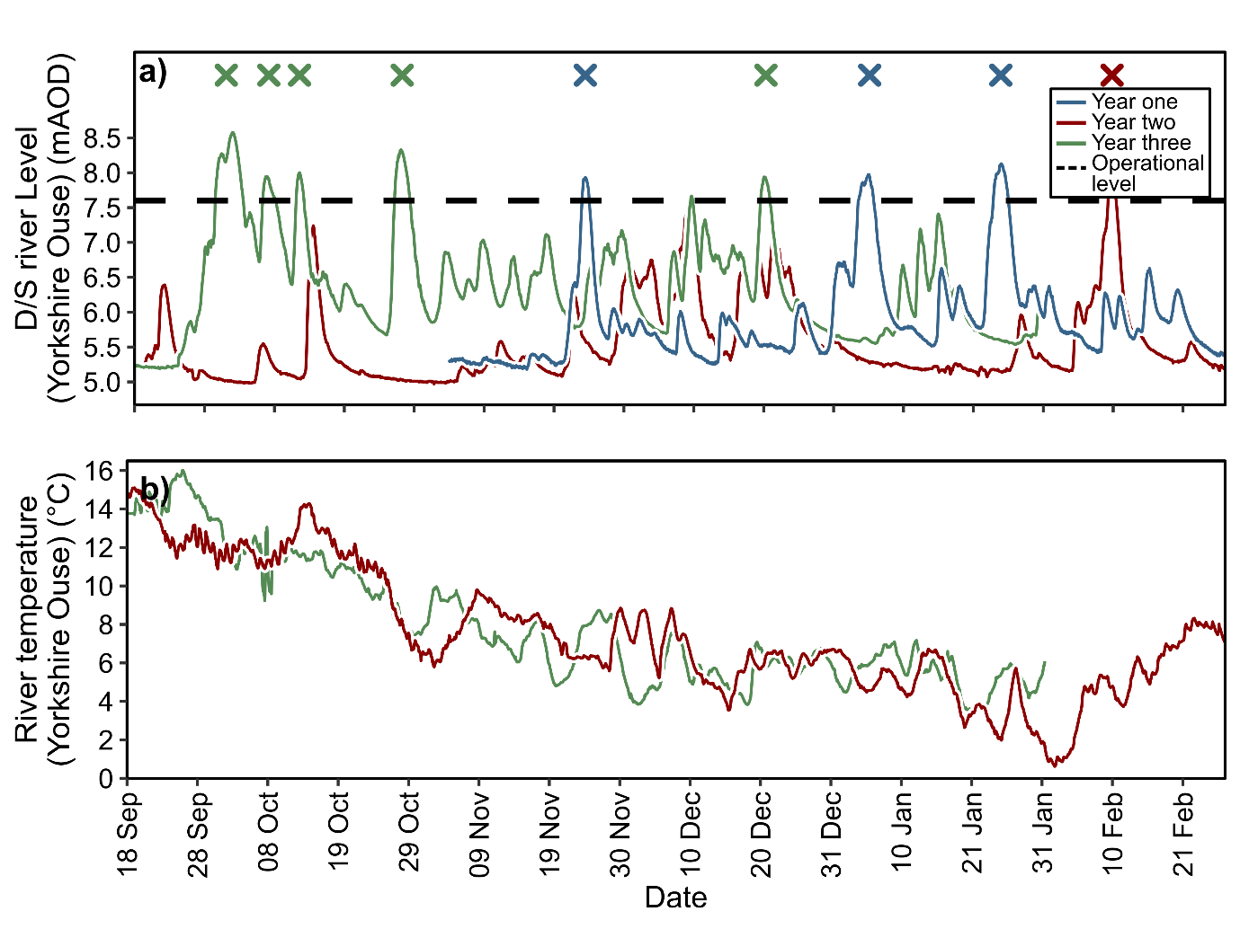

Figure S1 River level (mAOD) recorded in the Yorkshire Ouse (L2404/SE6057951091) (a). The dashed line measuring 7.6mAOD is indicative of pump operation. The labels X mark pump events. River temperature (°C) recorded in the Yorkshire Ouse at the point of sample.

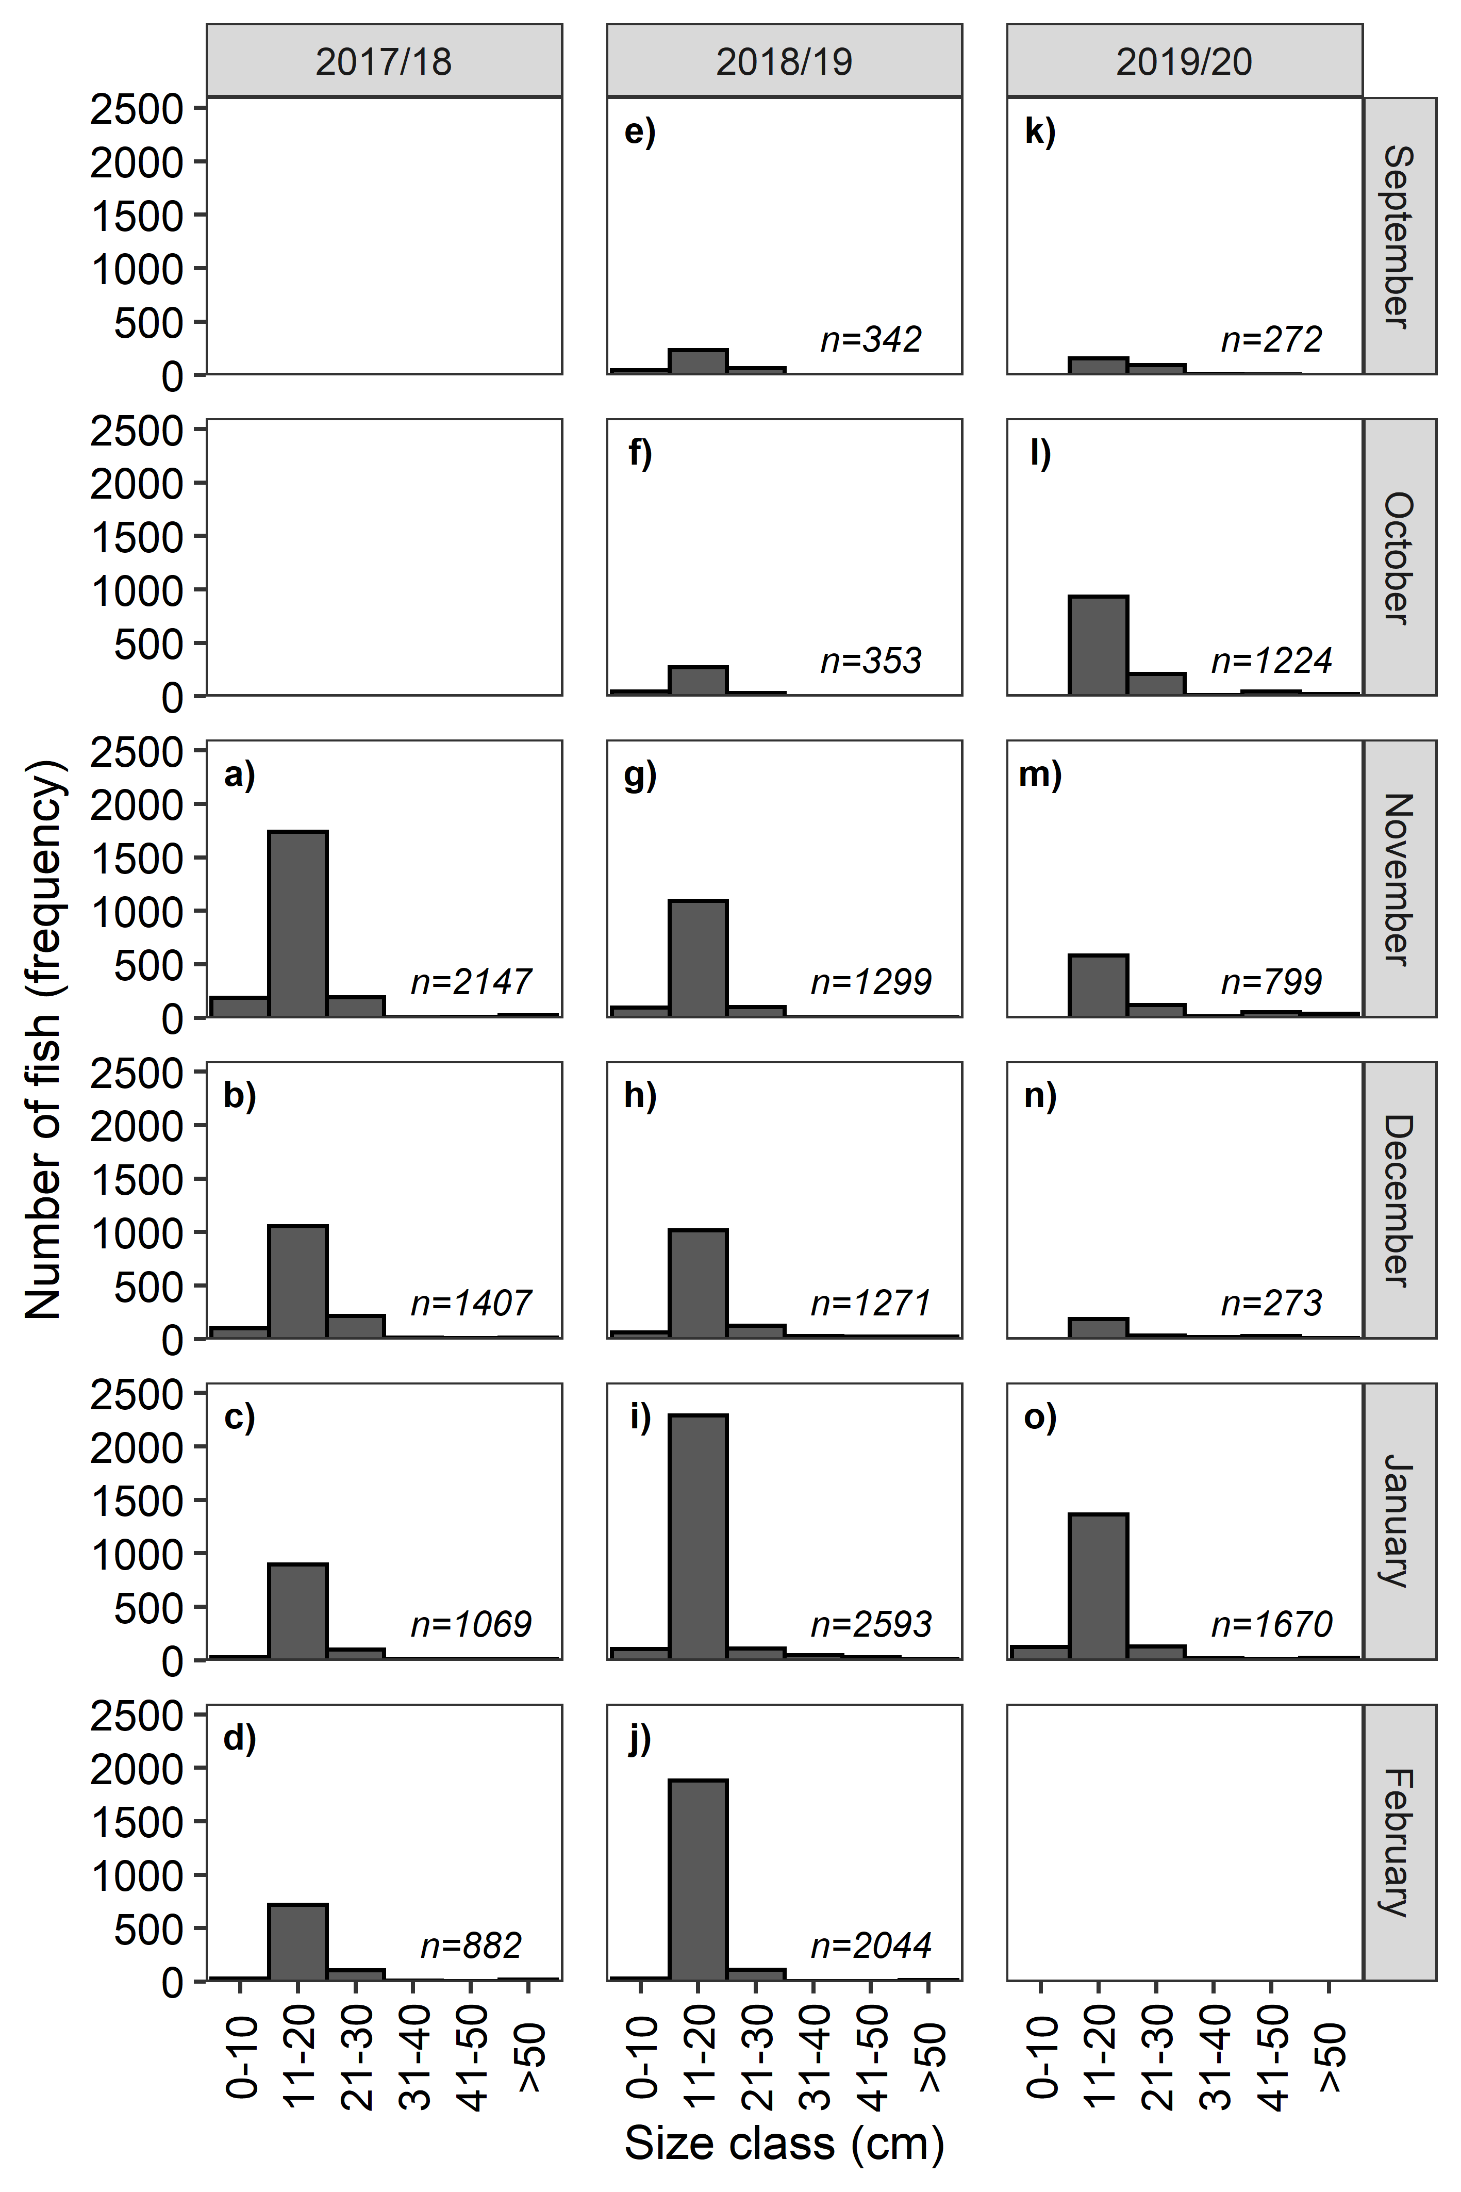

Figure S2 Length-frequency histograms