Cover Page Guidelines

Lab 5
Unit Testing



Joseph Oddi Obong
B00165928

Department of Engineering
School of Informatics & Engineering
Institute of Technology, Blanchardstown
Dublin 15.

Software Design and Quality
06/12/2025
Contents
Task 1 3
Part 1.1 3
Part 1.2 5
Task 2 9

Table of Figures
Figure 1: “sudo apt install python3 -y” for Debian 13 – GNOME 3
Figure 2: Running hello.py 4
Figure 3: Single testing with print statements 5
Figure 4: Single testing without the print statements 6
Figure 5: HelloUnitTest.py with assertEqual variable changed from 15 to 14 7
Figure 6: Running UnitTest2.py 8
Figure 7: Running test_employee.py 9
Figure 8: Changing the name on the email to intentionally get an error 10

Task 1

Part 1.1
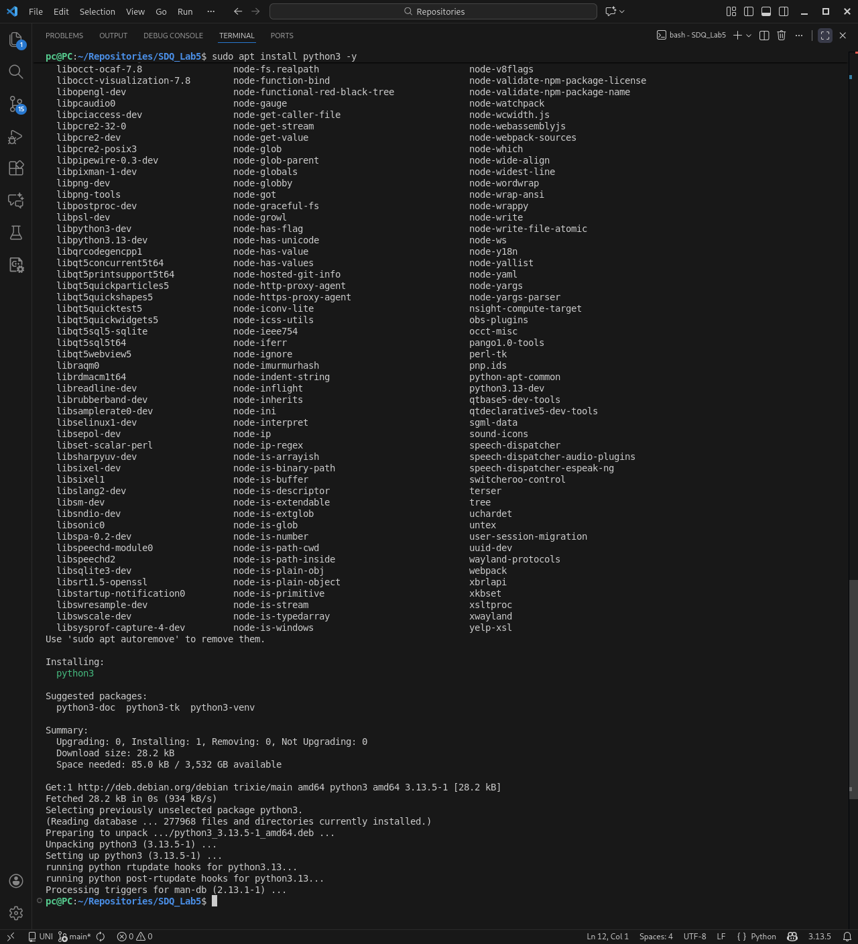
Figure 1: “sudo apt install python3 -y” for Debian 13 – GNOME

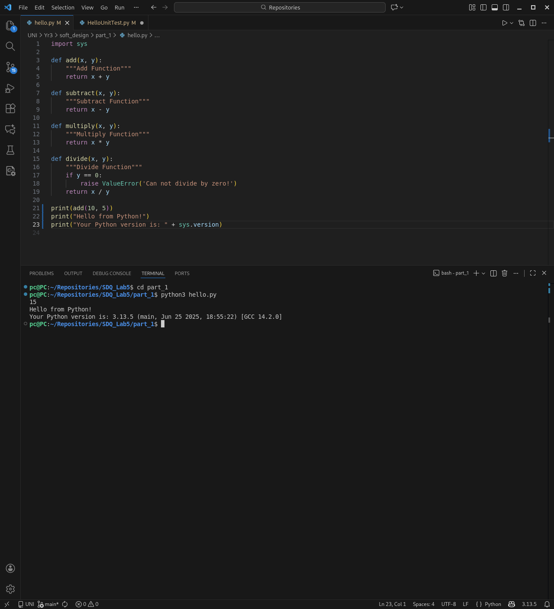
Figure 2: Running hello.py

Part 1.2
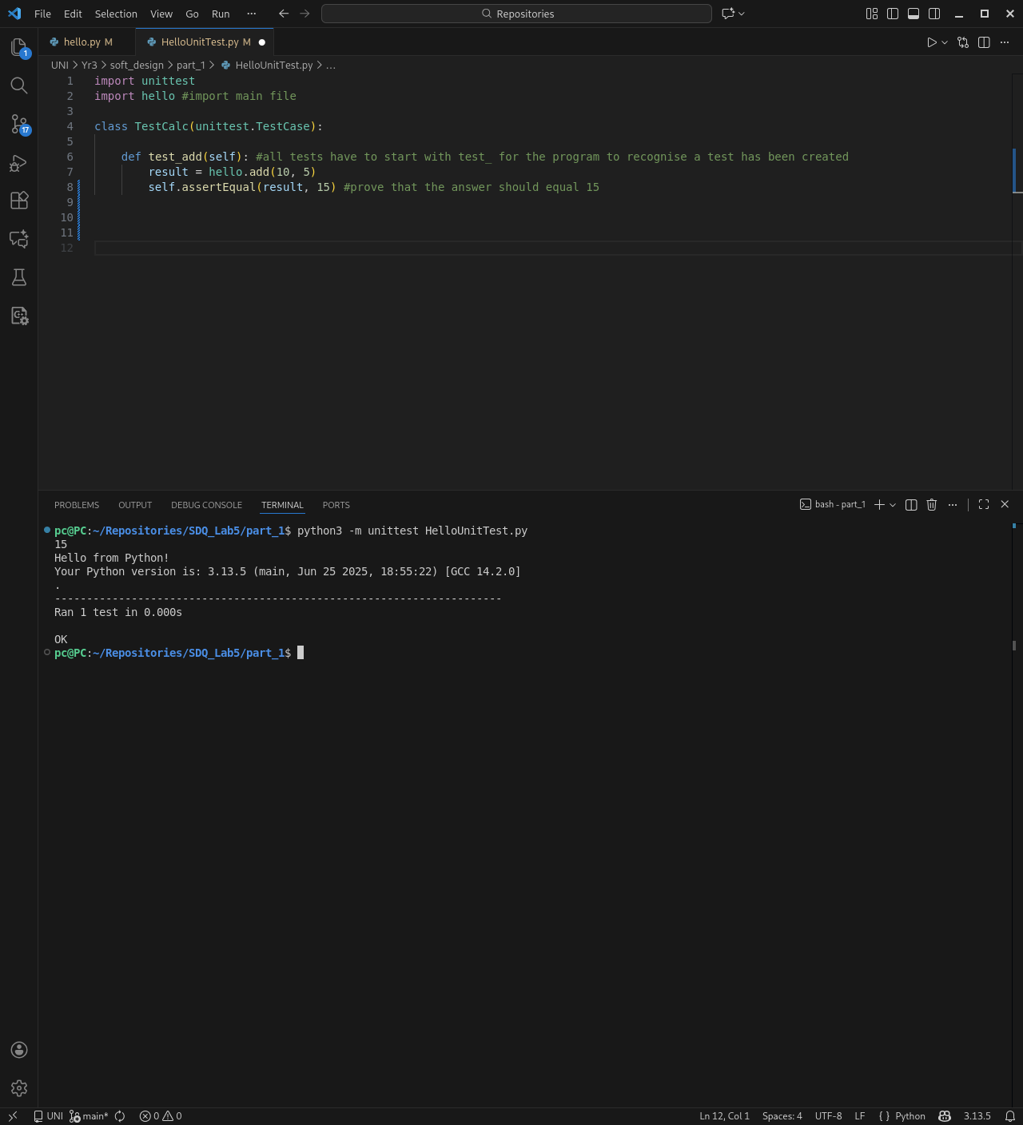
Figure 3: Single testing with print statements
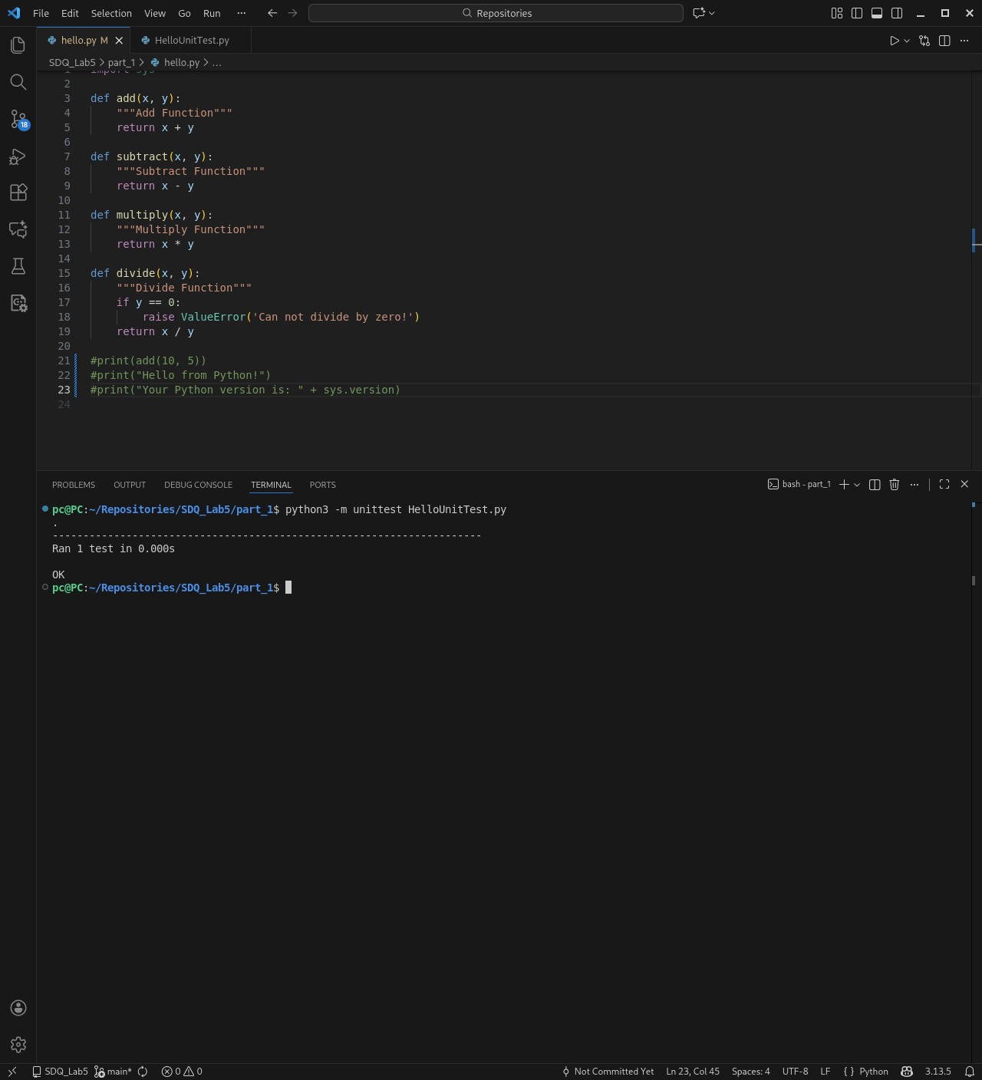
Figure 4: Single testing without the print statements
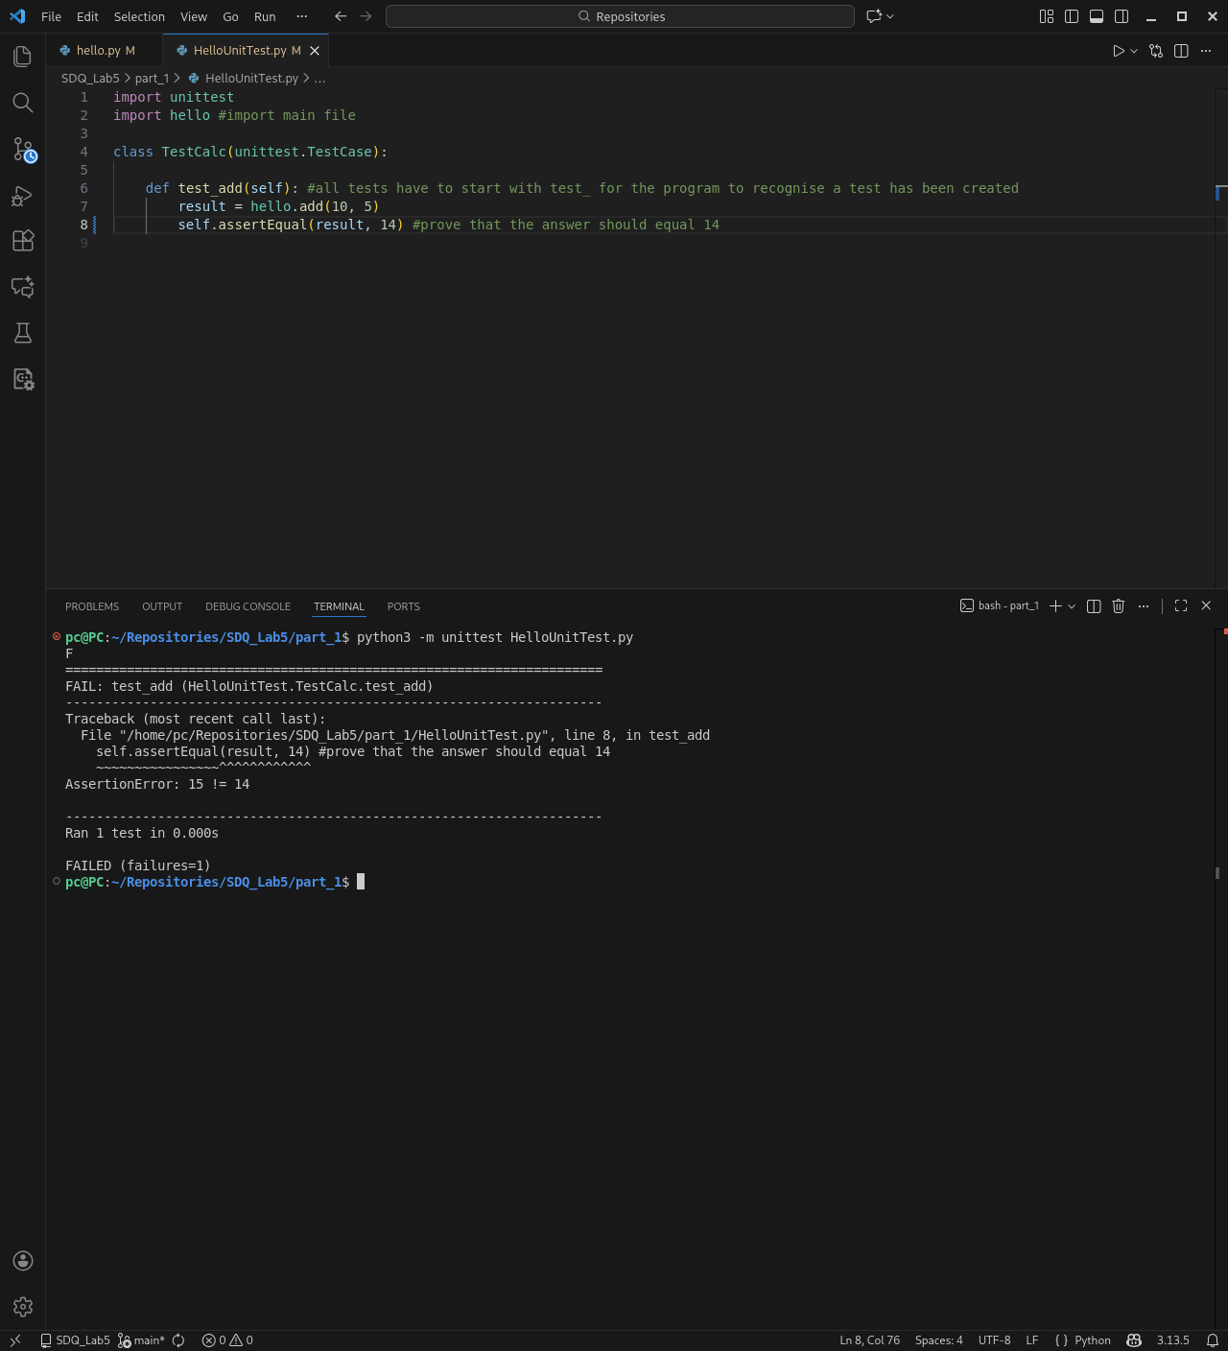
Figure 5: HelloUnitTest.py with assertEqual variable changed from 15 to 14
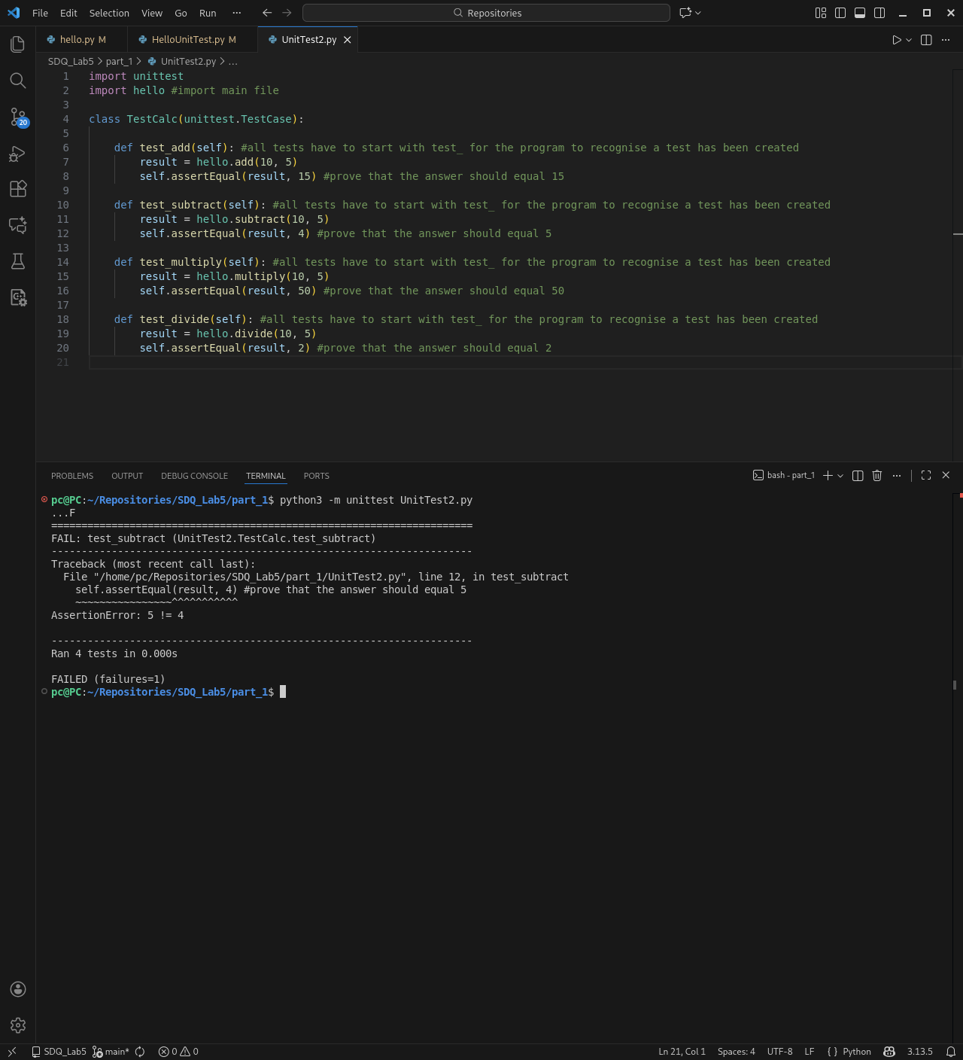
Figure 6: Running UnitTest2.py

Task 2
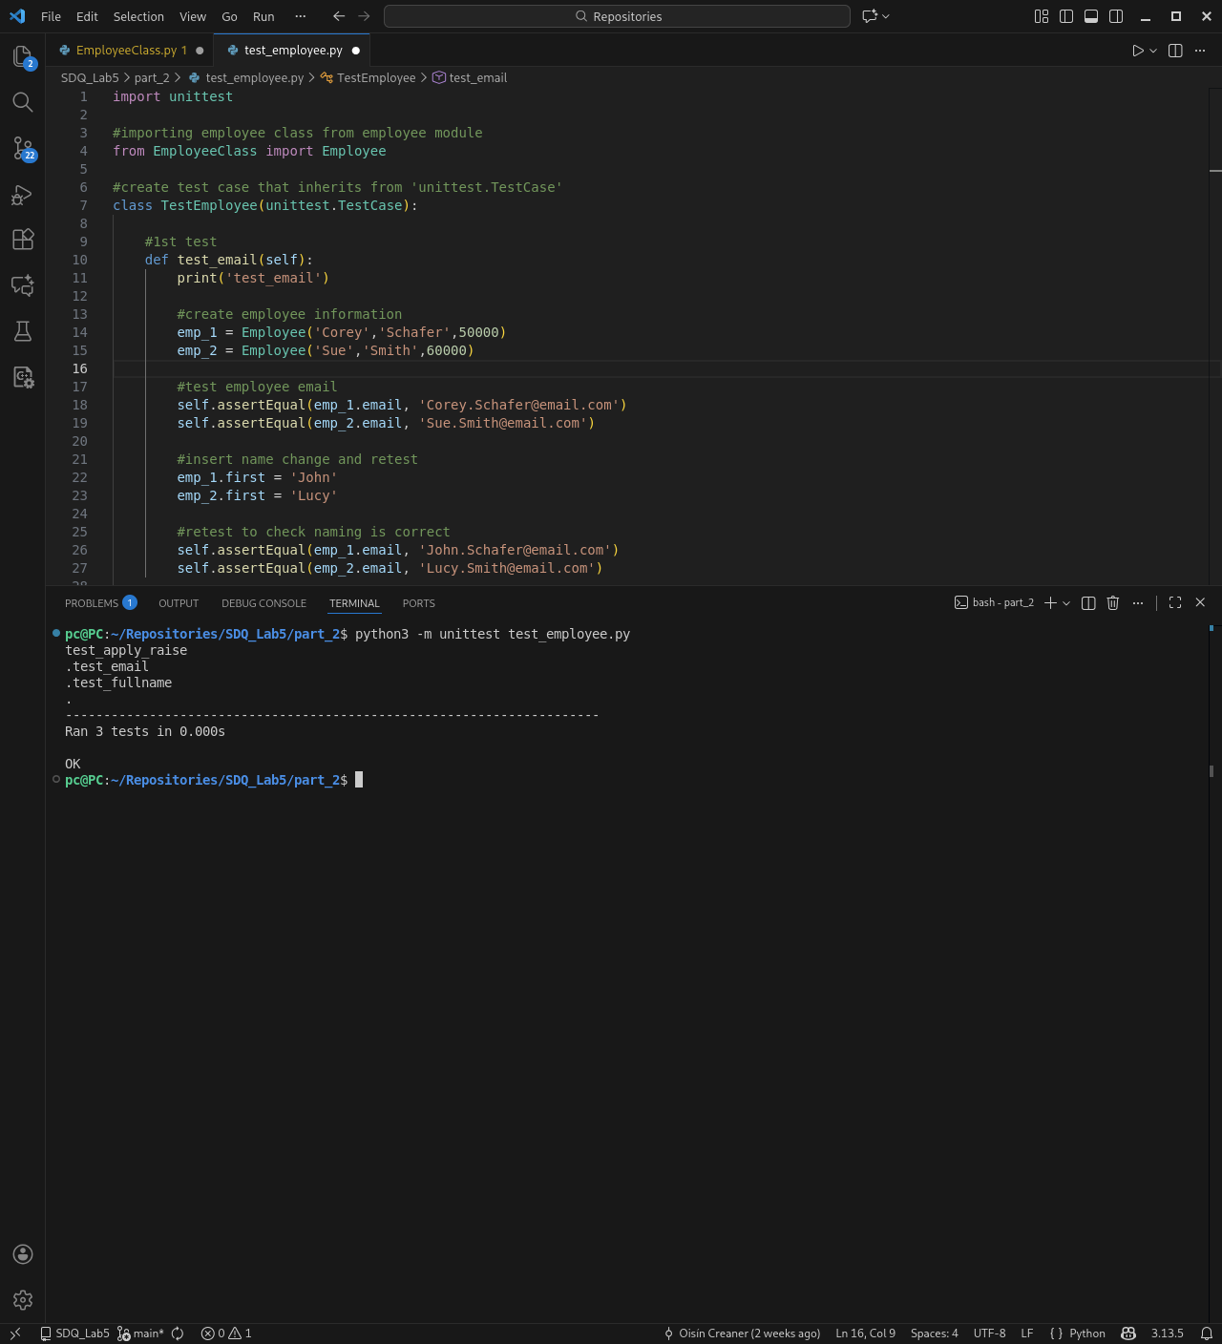
Figure 7: Running test_employee.py
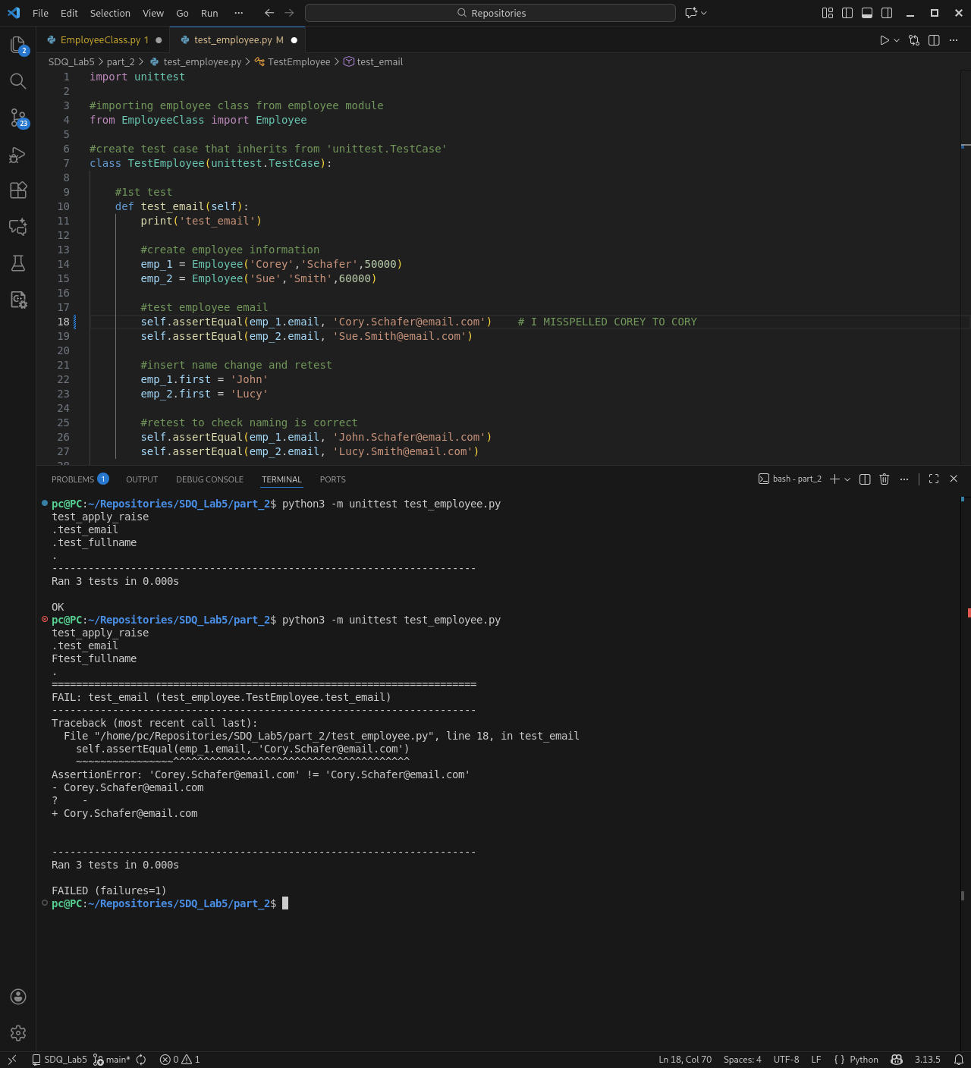
Figure 8: Changing the name on the email to intentionally get an error

