Digital Video (Xmedia recode)

# Information about the video

Show informations about the video right klick on the videotrack

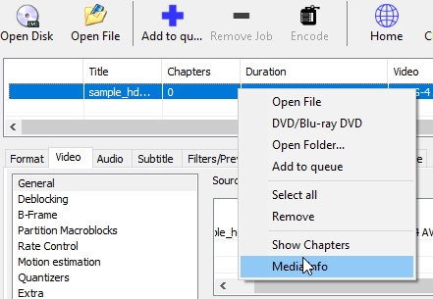

# Format Settings

Ein Bild, das Text, Screenshot, Display, Zahl enthält.

# Video Settings

Je nach verwendeten Codec sind unterschiedliche Settings verfügbar

Einstellbar unter **Allgemein**

**MPEG-2: MPEG-4 AVC / H.264:**

Ein Bild, das Text, Screenshot, Schrift, Zahl enthält.
Ein Bild, das Text, Screenshot, Schrift, Zahl enthält.

**Settings**

* Use the Codec MPEG-4 AVC / H.264  
  (For Chrominance-Testing use 4:2:0 and 4:4:4 – see below)
* Set **Datarate to 200.000** (This value has to be set to a high value to see the influence of the other parameters e.g. 200.000 kbit/s)
* Set **Minimum Quantizier** to 20 or higher (in order to achieve lower Datarates. So the Datarate-Cut-Off will not exceeded)

Use **MPEG-4 AVC / H.264** for the following tests

**GOP-size**

**B-Frame**

**Bewegungsabschätzung**

**Quantisierung** (Min / Max Quantiser)

*The minimum Value influences the low frequency part. The maximum value influences the high frequency part*

**Chrominance-testing**

Compare 4:2:0 and 4:4:4 using the corresponding Codec

Ein Bild, das Text, Screenshot, Schrift, Software enthält.

**What to document**

Check out different settings of videoquality:

What are the differences in filesize?

What are the differences in the videoquality? Do you see any? Make screenshots where you see the differences and describe them.

Which principle is behind the used compression types

Always write down the most important settings. For example:

* Codec
* Color Mode (set via Profile)
* Bitrate (limits the maximum Bitrate).
* Profile
* GOP size
* Minimum Quantizer
* Maximum Quantizer

Try similar Settings for HEVC / H.265

# Filters/Preview

Set the start and stop points to a duration of about 5-10 seconds in order to achieve faster Coding