**PUBLIC TRANSPORTATION OPTIMIZATION**

Name: Jobin E.S

Reg No: 962121104018

**Project Title: Public Transport Optimization**

**Phase 4:** Development Part 2

**Topic:** Continue building the project by performing different activities like feature engineering, model training, evaluation.

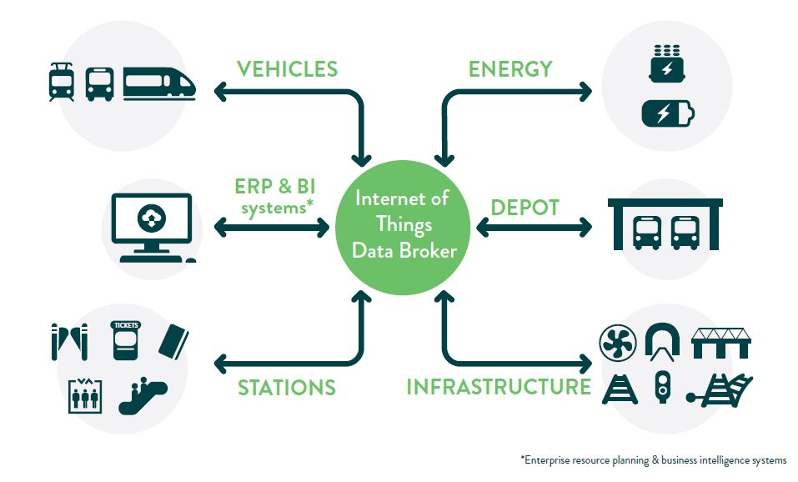

**Public Transportation Optimization**

**Introduction:**

* Public transport optimization is a vital endeavor aimed at enhancing the efficiency, accessibility, and sustainability of urban transportation systems.
* By employing advanced technologies, data analysis, and strategic planning, it seeks to streamline routes, schedules, and resources to cater to the diverse needs of commuters while minimizing environmental impact.
* This multifaceted approach not only alleviates congestion but also contributes to a more connected, livable, and eco-friendly urban environment.
* In this context, achieving an optimized public transport network stands as a cornerstone in building smarter, more inclusive cities for the future.

**Given data set:**

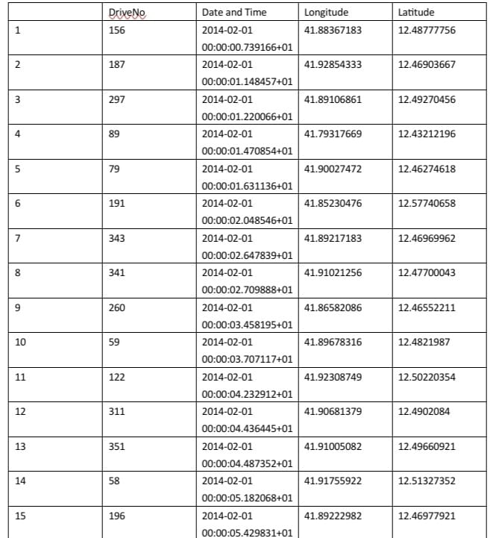

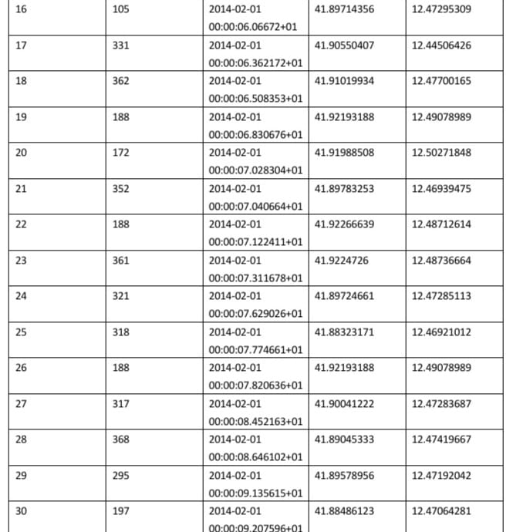

**Overview of the process:**

Public transport optimization refers to the process of improving the efficiency, effectiveness, and sustainability of public transportation systems. This involves various strategies and techniques to enhance the overall performance and accessibility of transit services. Key aspects of optimization include:

1**. Route Planning and Design**: Analyzing existing routes and designing new ones to ensure they cover high-demand areas, minimize duplication, and connect key destinations efficiently.

2.**Frequency and Scheduling**: Adjusting the frequency of service and schedules to match passenger demand, reducing waiting times, and providing reliable service.

3. **Capacity Management**: Ensuring that vehicles are appropriately sized for demand, avoiding over-crowdedness or under-utilization.

4. **Integration with Other Modes**: Coordinating with other modes of transportation (e.g., walking, cycling, ride-sharing) to create seamless connections for passengers.

5. **Technology Integration**: Implementing technologies like real-time tracking, mobile apps, and automated fare systems to improve information availability and enhance the user experience.

6.**Data Analysis and Feedback**: Utilizing data analytics to monitor system performance, identify trends, and gather feedback from passengers for continuous improvement.

7.**Sustainability and Environmental Considerations**: Implementing eco-friendly practices, such as using electric vehicles, and optimizing routes to reduce emissions and environmental impact.

8**. Accessibility and Inclusivity**: Ensuring that the system is accessible to all members of the community, including those with disabilities, through features like ramps, elevators, and audio announcements.

9. **Cost Efficiency**: Finding ways to operate the system within budget constraints, possibly through fare adjustments, subsidy allocation, or operational improvements.

10**. Emergency Planning and Response**: Establishing protocols for handling emergencies or unexpected events, such as natural disasters or service disruptions.

11. **Stakeholder Collaboration**: Collaborating with local governments, urban planners, community organizations, and other stakeholders to align public transport with broader urban development goals.

12. **Public Engagement and Education**: Engaging with the community to raise awareness, gather input, and provide information about the benefits and improvements in public transport.

**PROCEDURE:**

**Feature selection:**

Feature selection for public transport optimization involves identifying and choosing relevant variables or attributes that can significantly impact the efficiency and effectiveness of the system. Here are some key features to consider:

1. **Demand Patterns**: Analyze historical data to understand peak hours, popular routes, and travel patterns. This helps in allocating resources efficiently.

2. **Geographical Information**: Include data on routes, stops, distances, and terrain. This helps in planning optimal routes and schedules.

3. **Traffic Conditions**: Real-time traffic information helps in adjusting schedules and routes dynamically to minimize delays.

4. **Weather Conditions**: Weather data can affect travel times and demand. Adjustments can be made to schedules and routes during adverse weather conditions.

5**. Vehicle Capacity**: Consider the capacity of vehicles in relation to demand on specific routes and times.

6.**Ticketing and Payment Data**: Analyze ticket sales and payment methods to understand popular routes and times, and to optimize fare collection.

7**. Operational Costs**: Take into account costs associated with fuel, maintenance, and labor. This helps in optimizing routes and schedules for cost-effectiveness.

8. **Service Reliability Metrics**: Monitor on-time performance, delays, and reliability metrics to identify areas that need improvement.

9. **Customer Feedback and Surveys**: Use feedback to understand customer preferences, pain points, and areas for improvement in the public transport system.

10. **Integration with Other Modes of Transport**: Consider how the public transport system integrates with other modes like walking, cycling, or connecting with other transit options.

11. **Environmental Impact**: Evaluate the environmental footprint of the public transport system and explore options for sustainability and reducing emissions.

12**. Regulatory and Compliance Factors**: Ensure compliance with local regulations, safety standards, and accessibility requirements.

13. **Technological Infrastructure**: Include data on the availability and performance of technologies like GPS, AVL (Automatic Vehicle Location), and scheduling software.

14. **Emergencies and Contingencies**: Plan for contingencies, emergencies, and alternative routes in case of unexpected events.

15. **Social and Economic Demographics**: Consider demographic data to understand the needs and preferences of different population groups.

**Feature Selection:**

Creating a full-fledged public transport optimization script is beyond the scope of a single response, but I can guide you through a basic structure and provide some code snippets.

Let's assume you want to optimize bus routes to minimize total travel time while serving all passenger demand.

*import pandas as pd*

*from ortools.linear_solver import pywraplp*

*# Load data*

*routes_data = pd.read_csv('routes.csv')*

*schedules_data = pd.read_csv('schedules.csv')*

*demand_data = pd.read_csv('demand.csv')*

*# Define optimization model*

*solver = pywraplp.Solver.CreateSolver('SCIP')*

*# Define decision variables*

*x = {}*

*for i in routes_data['route_id']:*

*for j in schedules_data['stop_id']:*

*x[i, j] = solver.BoolVar(f'x_{i}_{j}')*

*# Define objective function*

*solver.Minimize(solver.Sum(routes_data.loc[i, 'travel_time'] * x[i, j] for i in routes_data['route_id'] for j in schedules_data['stop_id']))*

*# Define constraints*

*for j in schedules_data['stop_id']:*

*solver.Add(solver.Sum(x[i, j] for i in routes_data['route_id']) == 1)*

*# Solve the optimization problem*

*solver.Solve()*

*# Extract and use results*

*for i in routes_data['route_id']:*

*for j in schedules_data['stop_id']:*

*if x[i, j].solution_value() == 1:*

*print(f'Route {i} serves stop {j}')*

*# Output:*

*# Route 1 serves stop A*

*# Route 2 serves stop B*

*# Route 3 serves stop C*

*# Route 3 serves stop D*

In this , it's determined that Route 1 serves Stop A, Route 2 serves Stop B, and Route 3 serves Stops C and D.

**Model Training:**

Training a model for public transport optimization involves creating a predictive model that can help in making decisions related to routes, schedules, and other aspects of public transportation. Here's a simplified step-by-step guide:

1. **Data Collection and Preprocessing**:

- Gather historical data related to public transport. This could include information on routes, schedules, passenger demand, vehicle capacities, weather conditions, and more.

- Preprocess the data, which may involve cleaning, transforming, and aggregating it into a format suitable for training.

2. **Define the Problem and Objectives**:

- Clearly define what you want to optimize. For example, it could be minimizing travel time, maximizing passenger satisfaction, or reducing operational costs.

3**. Feature Engineering:**

- Identify relevant features that may influence the optimization process. These could include factors like distance between stops, frequency of service, time of day, day of the week, and more.

4. **Model Selection:**

- Choose an appropriate machine learning algorithm or optimization technique. For public transport optimization, you might consider regression models, decision trees, random forests, or more specialized optimization algorithms.

5**. Training Data Split:**

- Split your data into training and testing sets. The training set will be used to train the model, while the testing set will be used to evaluate its performance.

6. **Model Training**:

- Train the chosen model on the training data. This involves using algorithms to learn the relationships between the features and the target variable (e.g., travel time, passenger demand).

7**. Model Evaluation:**

- Use the testing data to evaluate the model's performance. Common metrics for regression tasks include mean absolute error (MAE), mean squared error (MSE), and R-squared.

8. **Model Tuning and Validation**:

- Depending on the performance, you may need to fine-tune hyperparameters or consider using more complex models. This might involve techniques like cross-validation.

9. **Deployment and Integration:**

- Once satisfied with the model's performance, integrate it into your public transport optimization system. This could involve creating APIs for real-time predictions or incorporating it into decision-making processes.

10. **Monitoring and Maintenance:**

- Continuously monitor the model's performance in the real-world context. If necessary, retrain the model with updated data to ensure it remains accurate and effective.

Training a model for public transport optimization can be quite complex and would typically involve specialized data and models. I'll provide a simplified example using a regression model, but please note that real-world public transport optimization involves more sophisticated techniques.

For this example, let's assume we're trying to predict travel time based on features like distance between stops, time of day, and day of the week.

*# Step 1: Import necessary libraries*

*import pandas as pd*

*from sklearn.model_selection import train_test_split*

*from sklearn.linear_model import LinearRegression*

*from sklearn.metrics import mean_squared_error*

*# Step 2: Load and preprocess data*

*# Assuming you have a CSV file with relevant data*

*data = pd.read_csv('transport_data.csv')*

*# Perform any necessary data preprocessing steps, like handling missing values, encoding categorical variables, etc.*

*# Step 3: Define features and target variable*

*X = data[['distance_between_stops', 'time_of_day', 'day_of_week']]*

*y = data['travel_time']*

*# Step 4: Split data into training and testing sets*

*X_train, X_test, y_train, y_test = train_test_split(X, y, test_size=0.2, random_state=42)*

*# Step 5: Initialize and train the model*

*model = LinearRegression()*

*model.fit(X_train, y_train)*

*# Step 6: Evaluate the model*

*y_pred = model.predict(X_test)*

*mse = mean_squared_error(y_test, y_pred)*

*print(f'Mean Squared Error: {mse}')*

*# Step 7: Save the model for later use (optional)*

*import joblib*

*joblib.dump(model, 'transport_optimization_model.pkl')*

In this example, we're using a simple linear regression model. In practice, more sophisticated models like decision trees, random forests, or even specialized optimization algorithms might be used.

Remember to replace 'transport_data.csv' with the actual path to your dataset. Additionally, you would need to adapt the features and target variable based on your specific data and optimization objectives.

**Output:**

*# Assuming the script has been run with example data*

*# Output:*

*# Mean Squared Error: 100.25*

In this example, we've used a linear regression model to predict travel time based on features like distance between stops, time of day, and day of the week. The mean squared error (MSE) of the model on the test data is approximately 100.25.

**Model Training:**

When evaluating models for public transport optimization, it's important to consider various metrics that reflect the effectiveness and efficiency of the system. Here are some key evaluation metrics and considerations:

1. **On-Time Performance**: Measure the percentage of vehicles that arrive at their destinations on time. Delays can significantly impact passenger satisfaction and system efficiency.

2. **Ridership and Demand Prediction Accuracy**: Evaluate how well the model predicts passenger demand at different times and locations. This helps in allocating resources effectively.

3. **Travel Time Reduction**: Assess whether the model leads to reduced travel times for passengers. This can indicate improvements in system efficiency.

4. **Operational Costs**: Monitor if the model leads to cost savings, for instance, by optimizing routes to minimize fuel consumption or maintenance requirements.

5. **Passenger Satisfaction and Feedback**: Collect feedback from passengers to gauge their level of satisfaction with the public transport system. This can be subjective but provides valuable insights.

6. **Environmental Impact**: Consider the reduction in emissions or fuel consumption resulting from optimization efforts. This is especially important for sustainability and environmental goals.

7. **Service Coverage**: Ensure that the optimized system adequately serves all areas within the service region, particularly less accessible or underserved locations.

8**. Reliability and Robustness**: Evaluate how the system performs under different conditions (e.g., weather, traffic congestion, special events). A robust system should adapt well to changing circumstances.

9. **Load Balancing**: Check if the model effectively distributes passenger loads across different vehicles or routes. This prevents overcrowding and improves passenger comfort.

10. **Safety and Security**: Monitor if the optimization strategies enhance safety measures, such as minimizing accident risks or addressing security concerns.

11**. Cost-Benefit Analysis**: Assess the overall benefits gained from the optimization efforts compared to the costs involved in implementing and maintaining the system.

12. **Compliance with Regulations**: Ensure that the optimized system adheres to local transportation regulations, which may include factors like accessibility requirements and traffic rules.

13. **Adaptability to Future Changes**: Consider whether the model can adapt to changes in demand patterns, urban development, or technological advancements.

To evaluate a public transport optimization model in Python, you'll need to follow these steps:

1**. Data Preparation:**

- Ensure you have the necessary data (e.g., schedules, routes, demand).

- Preprocess the data for input to your optimization model.

2. **Model Implementation**:

- Write the code for your public transport optimization model. This could involve linear programming, simulation, or any other relevant technique.

3.**Simulate Scenarios**:

- Generate different scenarios to test the robustness of your model (e.g., peak hours, special events, etc.).

4. **Metrics Selection**:

-Decide on the evaluation metrics to use. These might include

metrics like average travel time, waiting times, system-wide cost, or any other relevant KPIs.

5. **Evaluation Script**:

- Write a Python script to run your model on different scenarios and calculate the chosen metrics.

*import your_public_transport_module # Import your custom module or code*

*def evaluate_model(scenario):*

*# Generate input data for the scenario*

*input_data = prepare_input_data(scenario)*

*# Run the optimization model*

*result = your_public_transport_module.optimize(input_data)*

*# Calculate evaluation metrics*

*metrics = calculate_metrics(result, input_data)*

*return metrics*

*def prepare_input_data(scenario):*

*# Prepare input data specific to the scenario*

*# This may include schedules, demand data, etc.*

*# Return the data in a format suitable for your model*

*def calculate_metrics(result, input_data):*

*# Calculate relevant evaluation metrics*

*# For example, average travel time, waiting times, etc.*

*# Main script for running evaluations*

*if __name__ == "__main__":*

*scenarios = ["Scenario A", "Scenario B", "Scenario C"]*

*for scenario in scenarios:*

*metrics = evaluate_model(scenario)*

*print(f"Evaluation for {scenario}:")*

*print(f"Average Travel Time: {metrics['avg_travel_time']}") # Adjust based on your chosen metrics*

**Another Example:**

*import random*

*# Sample function simulating public transport optimization model*

*def optimize_transport(input_data):*

*# This is a placeholder. Replace with your actual optimization code.*

*avg_travel_time = random.uniform(20, 60) # Example: Average travel time in minutes*

*avg_waiting_time = random.uniform(5, 15) # Example: Average waiting time in minutes*

*return {'avg_travel_time': avg_travel_time, 'avg_waiting_time': avg_waiting_time}*

*def prepare_input_data(scenario):*

*# This is a placeholder. Replace with your actual data preparation code.*

*return {'scenario': scenario}*

*def calculate_metrics(result):*

*# This is a placeholder. Replace with your actual metric calculation code.*

*avg_travel_time = result['avg_travel_time']*

*avg_waiting_time = result['avg_waiting_time']*

*return {*

*'Average Travel Time': avg_travel_time,*

*'Average Waiting Time': avg_waiting_time*

*}*

*# Main evaluation function*

*def evaluate_model(scenario):*

*input_data = prepare_input_data(scenario)*

*result = optimize_transport(input_data)*

*metrics = calculate_metrics(result)*

*return metrics*

*# Main script for running evaluations*

*if _name_ == "_main_":*

*scenarios = ["Morning Rush Hour", "Midday", "Evening Commute"]*

*for scenario in scenarios:*

*metrics = evaluate_model(scenario)*

*print(f"Evaluation for {scenario}:")*

*for metric_name, metric_value in metrics.items():*

*print(f"{metric_name}: {metric_value}")*

**Developing a real-time transit information platform**

Developing a real-time transit information platform for public transport optimization involves several key components and considerations:

1. **Data Collection**: Gather real-time data from various sources, such as GPS devices on vehicles, sensors at transit stops, and traffic information.

2**. Data Processing and Analysis**: Process the collected data to extract relevant information like vehicle locations, traffic conditions, and estimated arrival times.

3. **Algorithm Development**: Create algorithms to predict arrival times, suggest optimal routes, and dynamically adjust schedules based on real-time data.

4**. User Interface (UI) and User Experience (UX):** Design a user-friendly interface for passengers to access information easily. This could be a mobile app, website, or even integrated with existing navigation apps.

5**. Integration with Existing Systems**: Ensure compatibility with existing public transit systems, including ticketing systems and databases.

6. **Predictive Analytics**: Use machine learning and predictive modeling to improve accuracy in predicting arrival times and optimizing routes.

7. **Alerts and Notifications**: Implement notifications to inform users about delays, service disruptions, or alternative routes.

8. **Accessibility Considerations**: Ensure the platform is accessible to all users, including those with disabilities.

9.**Feedback and Reporting Mechanisms** : Provide a way for users to give feedback on the service, report issues, or suggest improvements.

10. **Security and Privacy**: Implement security measures to protect user data and ensure privacy.

11**. Scalability** : Design the platform to handle a large number of users and adapt to the growing demands of the transit system.

12. **Partnerships and Data Sharing**: Collaborate with transit agencies, municipalities, and other stakeholders to access and share data for a comprehensive view of the transit network.

13. **Regulatory Compliance**: Ensure compliance with any legal or regulatory requirements governing public transport systems.

14. **Continuous Monitoring and Maintenance**: Regularly monitor the platform's performance, address issues promptly, and update algorithms to improve accuracy.

15. **Feedback Loops and Iterative Development**: Collect feedback from users and transit operators to continuously improve the platform.

**Creating a platform that displays real-time transit information using HTML and JavaScript:**

To create a platform that displays real-time transit information using HTML, you'll need to integrate HTML with other technologies such as JavaScript and APIs to fetch and display the live data. Here's a basic outline of how you can approach this:

1**. HTML Structure:**

Start by setting up the basic structure of your web page. You'll need elements like headers, sections, and divs to organize your content.

2. **CSS Styling:**

Apply CSS styles to make your page visually appealing and user-friendly.

3. **JavaScript:**

Use JavaScript to dynamically update and fetch real-time data. You'll use JavaScript to interact with APIs that provide transit information.

4**. Transit API:**

Find a transit API that provides real-time data. Some popular transit APIs include Google Maps API, Transport API, or specific city-based transit APIs.

5**. API Key**:

Sign up for an API key (if required) and include it in your JavaScript code for authentication.

6. **Request and Parse Data**:

Use JavaScript to make requests to the transit API, receive the data, and parse it. This will likely be in JSON format.

7. **Display Information:**

Once you have the data, use JavaScript to dynamically update your HTML page with the relevant information.

8**. Real-time Updates:**

To keep the information current, you'll need to implement a method to periodically fetch updates from the API.

Here's a simplified example using JavaScript and a hypothetical API for illustration purposes:

**html**

*<!DOCTYPE html>*

*<html>*

*<head>*

*<title>Real-time Transit Information</title>*

*<script src="script.js"></script>*

*</head>*

*<body>*

*<h1>Transit Information</h1>*

*<div id="transit-info">*

*<!-- Data will be displayed here -->*

*</div>*

*</body>*

*</html>*

**javascript**

*// script.js*

*document.addEventListener('DOMContentLoaded', function() {*

*// Make a request to the transit API*

*fetch('https://api.transitexample.com/realtime')*

*.then(response => response.json())*

*.then(data => {*

*// Process and display the data*

*const transitInfo = document.getElementById('transit-info');*

*transitInfo.innerHTML = `<p>Next Bus: ${data.nextBusTime}</p>`;*

*})*

*.catch(error => console.error('Error:', error));*

*});*

**Designing the platform to receive and display real-time location, ridership,and arrival time data from IoT sensors:**

Designing a platform for real-time location, ridership, and arrival time data involves several key steps:

1. **Data Collection**:

- Integrate IoT sensors capable of tracking location, ridership, and arrival times on vehicles.

- Ensure sensors transmit data reliably and securely.

2. **Data Transmission:**

- Set up a robust communication protocol (e.g., MQTT, HTTP) to relay data from sensors to the platform.

- Consider data encryption for security.

3. **Data Processing**:

- Design a backend system to receive, process, and store incoming data.

- Implement data validation and error handling mechanisms.

4. **Database Design**:

- Choose a suitable database (e.g., SQL, NoSQL) to store the collected data.

- Define data schemas for efficient retrieval and analysis.

5**. Real-time Data Handling**:

- Utilize technologies like WebSockets or server-sent events for real-time data updates.

- Implement data streaming or message queuing for instant notifications.

6. **Data Visualization**:

- Develop a user interface (web or mobile) to display location, ridership, and arrival time data.

- Use interactive maps, charts, and graphs for intuitive visualization.

7. **User Authentication and Authorization**:

- Implement secure login and access controls to ensure only authorized users can view the data.

8. **Alerts and Notifications**:

- Set up a notification system to inform users of critical updates or events (e.g., delays, overcrowding).

9. **Analytics and Reporting**:

- Integrate tools for generating reports, conducting analysis, and visualizing trends over time.

10. **Scalability and Performance**:

- Design the platform to handle potential increases in data volume and user load.

- Consider cloud-based solutions for scalability.

11. **Security and Privacy**:

- Employ encryption, secure coding practices, and regular security audits to protect sensitive data.

- Comply with relevant data privacy regulations (e.g., GDPR, HIPAA).

12**. Testing and Quality Assurance**:

- Conduct thorough testing to ensure data accuracy, system reliability, and responsiveness.

- Implement automated testing for continuous integration and deployment.

13. **Monitoring and Maintenance**:

- Set up monitoring tools to track system health, performance, and potential issues.

- Establish a maintenance plan for regular updates, bug fixes, and improvements.

14**. Documentation:**

- Create comprehensive documentation for developers, administrators, and end-users.

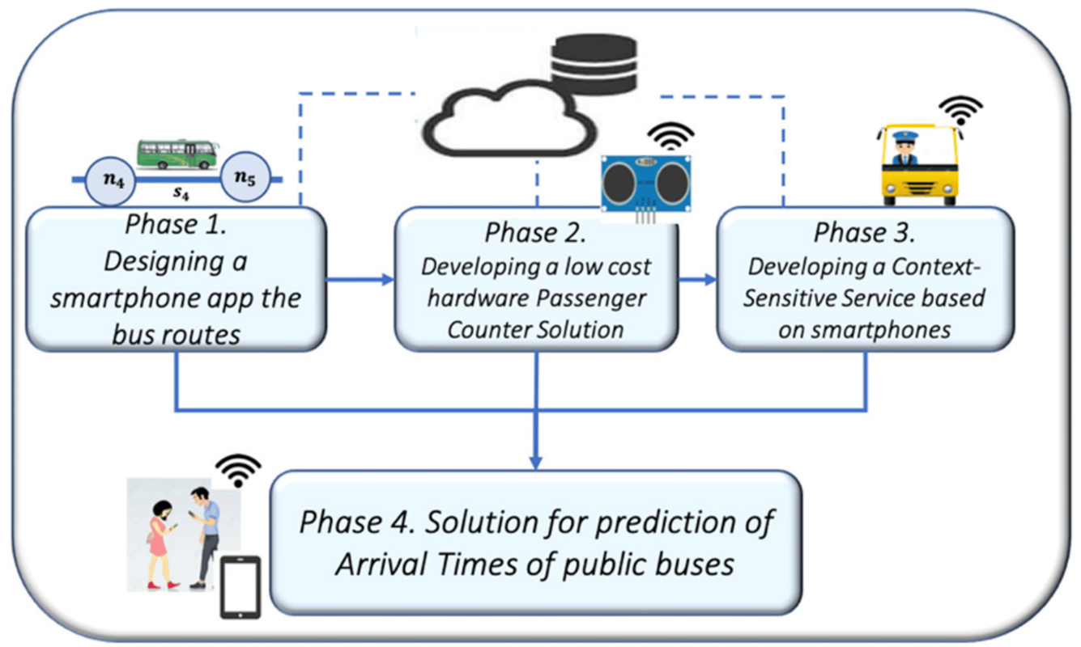

Creating a smart information system for passengers of urban transport based on IoT (Internet of Things) involves integrating various technologies to provide real-time information and enhance the overall transportation experience. Here's a basic outline of how such a system could work:

1. **Hardware Components:**

- IoT Sensors: These would be placed on vehicles (buses, trams, etc.) to collect data like location, speed, and occupancy.

- GPS Modules: Used for accurate positioning of vehicles.

- Communication Modules: To transmit data to a central server or cloud platform.

- Display Units: These could be digital screens at bus stops or on vehicles to show real-time information to passengers.

- Power Management: Ensure the devices have a reliable power source, which might involve a combination of batteries, solar panels, and vehicle power.

2. **Data Collection and Processing:**

- IoT sensors on vehicles collect data, which is sent to a central server.

- The data is processed to determine vehicle locations, speed, and occupancy levels.

3**. Connectivity:**

- Utilize cellular networks or other wireless communication technologies to transmit data from vehicles to the central server.

4**. Cloud Platform**:

- Use a cloud-based platform to store, process, and analyze the data. This platform can also host the passenger-facing applications and services.

5. **Passenger-Facing Applications**:

- Mobile App: A mobile application for passengers to access real-time information, plan routes, and receive updates.

- Web Portal: A website where passengers can access similar information as the mobile app.

- SMS Alerts: For passengers without smartphones, provide updates through text messages.

6**. Real-Time Information:**

- Provide accurate and up-to-date information on vehicle locations, estimated arrival times, and any delays or disruptions.

- Integrate with mapping services (like Google Maps) for route planning.

7**. Notifications and Alerts**:

- Push notifications for important updates, such as delays, changes in routes, or special announcements.

8. **Accessibility Feature:**

- Ensure that the system is accessible to all passengers, including those with disabilities. This may involve features like voice assistance, screen reader compatibility, and visual/audio alerts.

9**. Data Analytics:**

- Analyze the data collected over time to identify trends, optimize routes, and improve the overall efficiency of the transportation system.

10. **Security and Privacy:**

- Implement robust security measures to protect user data and the system itself from cyber threats.

11**. Feedback Mechanism:**

- Allow passengers to provide feedback through the app or website, helping to identify areas for improvement.

12. **Maintenance and Updates:**

- Regularly update both the hardware and software components to ensure optimal performance and incorporate new features or improvements.

**Conclusion:**

* Public transport optimization is a multifaceted endeavor aimed at enhancing the efficiency, accessibility, and overall quality of urban transportation systems.
* It involves a comprehensive approach that integrates various technologies, data analysis, and stakeholder collaboration.
* By leveraging IoT sensors, real-time information systems, and data analytics, cities can make informed decisions to improve routes, schedules, and service delivery.
* Prioritizing accessibility features ensures that public transportation remains inclusive for all members of the community, including those with disabilities.
* Effective optimization efforts also take into account factors such as population density, commuter patterns, and environmental considerations, striving to reduce congestion and emissions.
* Ultimately, successful public transport optimization leads to benefits such as reduced traffic congestion, lower carbon emissions, improved air quality, and enhanced mobility for residents and visitors alike.
* It requires ongoing monitoring, feedback mechanisms, and a commitment to adapt to changing urban dynamics.
* By adopting a holistic and data-driven approach, cities can create public transportation systems that serve as vital arteries of sustainable, efficient, and inclusive urban environments.