Some articles about ‘Decreasing Universe Theory’ (D.U.T.)
================================================
João Carlos Holland de Barcellos

DUT Click to Key Word Search Click to References Click to OSF-Files
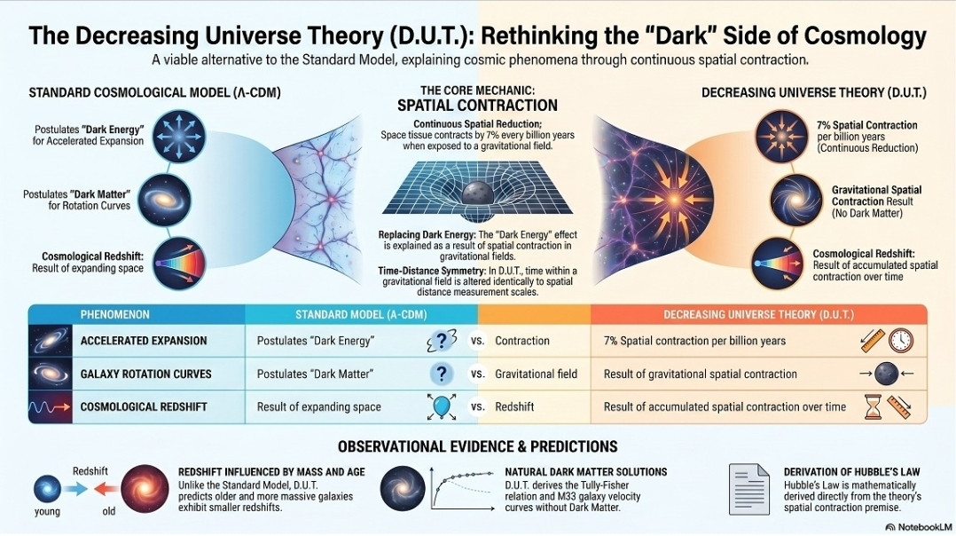

It is interesting to first read the theory summarized by some "AI":

1-You can read to the Texts summary:
https://jocaxx.github.io/DUniverse/Shorts/Shorts_AI.pdf
2-You can listen to the Audio summary:
Short (6min): https://jocaxx.github.io/DUniverse/Abstract/DUT_ENG_1.m4a
Medium (17min): https://jocaxx.github.io/DUniverse/Abstract/DUT_ENG_2.m4a
Long (51min): https://jocaxx.github.io/DUniverse/Abstract/DUT_ENG_3.m4a

3-You can see to the Video summary :
VID1: Introduction to the D.U.T.
VID2: Rigorous DUT testing
VID3: Cosmological Time Dilatation
VID4: A Review
VID5: DUT + Jocaxian Nothingness
VID6: FAQ - Frequent Asked Question
VID7: Galaxies Without Dark Matter
--------------------------
English:
VID1:youtube.com/watch?v=gcmEemWJnDc
VID2:youtube.com/watch?v=qy9lzkGobX0
VID3:youtube.com/watch?v=XzohGNxpvPg
VID4:youtube.com/watch?v=O5qmpoyv-oo
VID5:youtube.com/watch?v=qESWYMFfxOc
VID6:youtube.com/watch?v=z8fweGEfaVI
VID7:youtube.com/watch?v=GKK35nngRYc
--------------------------
Portugues
VID1:youtube.com/watch?v=T1xxj9hOgOU
VID2:youtube.com/watch?v=EhpLsV_0Q6U
VID3:youtube.com/watch?v=t-LR1kzAzxU
VID4:youtube.com/watch?v=HvehECmmtTw
VID5:youtube.com/watch?v=Y3B8us7zdUw
VID6:youtube.com/watch?v=_k8xsKss1wg
VID7:youtube.com/watch?v=mbTVkIAlUGY
---------------------------
Spanish
VID1:youtube.com/watch?v=cxLm-zTnDeg
VID2:youtube.com/watch?v=Mt-hSGkoF6o
VID3:youtube.com/watch?v=yJgXlPNK07E
VID6:youtube.com/watch?v=rptZN-XcEL0
VID7:youtube.com/watch?v=8utPI476ZLI
---------------------------
French
VID1:youtube.com/watch?v=faX6QPKUVKY
VID2:youtube.com/watch?v=IEnsP8ODs5c
VID3:youtube.com/watch?v=Mz8K5iH0lrs
VID6:youtube.com/watch?v=tAEvyfIBp4Q
VID7:youtube.com/watch?v=iSxDa2Po8ko
--------------------------
OSF Files : https://osf.io/fsvhm/overview
(*) = Very Imporant

Decreasing Universe Theory: Dark Matter X Gravitational Gradient
"In the Decreasing Universe Theory ("DUT"), "Dark Matter" is explained as an illusory effect caused by the differential contraction of stars relative to their distance from a galaxy's massive nucleus[1][17]. This article presents a systematic analysis of 47 galaxies, demonstrating that the apparent dark matter fraction (fDM) correlates with a gravitational gradient factor derived from DUT principles. We show that galaxies with massive bulges and large radial extents exhibit high dark matter fractions, while compact galaxies with dense bulges (NGC 1277) and diffuse galaxies without bulges (NGC 1052-DF2, DF4, DF9) show negligible dark matter effects — exactly as predicted by the DUT model ""(July/2026)
https://jocaxx.github.io/DUniverse/Todos/DUT_Dark_Matter_Correlation_ENG.pdf

What if the Universe Is NOT Expanding? (Douglas Giles)
" Philosopher Thomas Kuhn argued that science is “a series of peaceful interludes punctuated by intellectually violent revolutions” in which “one conceptual world view is replaced by another.” (The Structure of Scientific Revolutions, 1962) The longer-lasting, more tranquil periods of “normal science” are guided by a dominant paradigm. Astrophysics has been in such a peaceful interlude for decades with its belief that the universe is expanding. The expanding universe theory is a paradigm that guides how astrophysicists’ thinking about the universe."
https://insertphilosophyhere.com/what-if-the-universe-is-not-expanding/

Summary of the “Decreasing Universe Theory”
The Decreasing Universe theory (D.U.T.) proposes that the gravitational field continuously contracts space and everything within it — rulers, atoms, and clocks alike. This single effect provides an alternative explanation for two of the central puzzles of modern cosmology:
● The apparent accelerated expansion of the universe, without requiring dark energy. ● The anomalous orbital velocities of stars in galaxies, without invoking dark matter. "(July/2026)
https://jocaxx.github.io/DUniverse/Todos/DUT_Summary.pdf

Decreasing Universe Theory: Galaxies without Dark Matter (NGC 1052-DF2, DF4, and DF9)
"In the DUT (Decreasing Universe Theory) model, "Dark Matter" is explained as an effect of the differential contraction of stars relative to their distance from the massive core of the galaxy. We will see that there may exist galaxies in which this effect is very small, whose causes corroborate the evidence of this model. "(July/2026)
https://philpapers.org/archive/BARDUT-4.pdf
https://jocaxx.github.io/DUniverse/Todos/DUT_NGC1052_ENG.pdf
(*)Observational Evidence of Intrinsic Differential Redshifts in Galaxy Pairs: A Test of the Decreasing Universe Theory (DUT)
“In this work, we analyze a highly controlled sample of 𝑛 = 700 galaxy pairs in dense environments (including the Virgo, Fornax, and Hydra clusters). The data reveal a persistent systematic asymmetry, where the massive primary component exhibits a lower redshift than predicted in 56.28% of the cases. The statistical hypothesis test rejects random symmetry with a Z-score of 3.33 and a p-value of 0.00043 (99.957% confidence level).” (Jun/2026)
https://jocaxx.github.io/DUniverse/Todos/DUT_GAL_Eng.pdf

(*)Decreasing Universe Theory: Cosmological Time Dilation and the SN1A Explosion
“We will show that, within the “Decreasing Universe Theory” (DUT), time inside a gravitational field is altered in the same way as spatial distance measurement scales. At the cosmic level (timescales of millions of years), this effect becomes perceptible and explains the variation in the measured duration of Type Ia Supernova (SN1A) explosions.”(May/2026)
https://vixra.org/pdf/2604.0064v1.pdf
https://oaskpublishers.com/assets/article-pdf/decreasing-universe-theory-cosmological-time-dilation-and-the-sn1a-explosion.pdf
-------------------------------------------------------------------------------------------------------------------
DUT FAQ: Frequently Asked Questions about the "Decreasing Universe Theory"
“This document presents the fundamentals of the Decreasing Universe Theory (DUT), proposing that the origin of everything lies in the concept of "Jocaxian Nothingness" rather than the traditional Big Bang. The central premise suggests that gravity causes a continuous contraction of matter and physical systems, challenging the perception of an accelerated expansion of the cosmos. Unlike other models, the DUT envisions space as an unchanging vacuum where only material elements decrease in scale over time. The text argues that this new perspective requires a revision of General Relativity, while remaining compatible with the principles of Quantum Mechanics. Finally, the author clarifies frequently asked questions to establish the DUT as an alternative and comprehensive theoretical framework for modern cosmology. ”(JUN/2026)
https://jocaxx.github.io/DUniverse/Todos/FAQ_DUT_ENG.pdf

Decreasing Universe Theory: The Tully-Fisher Relation
“Starting from the 'Decreasing Universe Theory' (DUT), particularly from the formula that explains the dark matter illusion, we will derive the Tully-Fisher relation for spiral galaxies.”(May/2026)
https://jocaxx.github.io/DUniverse/Todos/TullyF_Eng.pdf
Analysis of Mass-Redshift Correlation in Velocity-Matched Subgroups: A Rigorous Test for the Decreasing Universe Theory
"The Decreasing Universe (D.U.) theory proposes that the gravitational field induces a continuous spatial contraction, predicting that more massive galaxies should exhibit a smaller redshift at the same distance [1]. The main obstacle to testing this prediction is the noise introduced by the galaxies' peculiar velocities. This study applies a rigorous methodology to isolate the effect of mass by analyzing the correlation between stellar mass and redshift in galaxy subgroups with controlled distance, age, and radial velocity. The results show that, by minimizing dynamical noise, the negative correlation predicted by the D.U. theory emerges in specific subsamples, suggesting that the intrinsic gravitational effect may be detectable"(Apr/2026)
https://oaskpublishers.com/assets/article-pdf/analysis-of-mass-redshift-correlation-in-velocity-matched-subgroups-a-rigorous-test-for-the-decreasing-universe-theory.pdf

The Age of Galaxies as a Determining Factor for Redshift: An Analysis from the Perspective of the Decreasing Universe Theory

"The Decreasing Universe (D.U.) theory proposes that the gravitational field induces a continuous contraction of space, offering an alternative explanation for cosmological redshift. A crucial and logical deduction from this theory is that a galaxy's time of exposure to the gravitational field, i.e., its age, should directly influence the observed redshift. Older galaxies,having accumulated more time under spatial contraction, should exhibit a smaller redshift. This article examines this prediction, using the observed redshift difference between old (elliptical) and young (spiral) galaxies in clusters as a primary observational test for the D.U. theory."(Mar/2026)
https://medcraveonline.com/PAIJ/PAIJ-10-00406.pdf

´The “Decreasing Universe” model: an alternative perspective to accelerated expansion'

"The understanding of the universe’s evolution has been dominated
by the Standard Cosmological Model, known as ?-CDM. This widely
accepted model postulates the existence of dark matter and, crucially,
dark energy to explain the observed accelerated expansion of the
universe.1 However, dark energy remains an entity of unknown and
undetectable origin, presenting a significant theoretical challenge.2..."(Jun/2025)
https://medcraveonline.com/PAIJ/PAIJ-09-00378.pdf

(*)´Decreasing Universe: The 'Dark Matter' Effect'
"After a brief review of the Decreasing Universe (D.U.) model, we will derive a formula and the graph for the apparent velocity of stars (of a Messier_33 galaxy) as a function of their radial distance from the galactic center. This formula reproduces the same velocity curve traditionally attributed to dark matter. "(Apr/2025)
https://www.wecmelive.com/open-access/decreasing-universe-the-dark-matter-effect.pdf

´Decreasing Universe: The CMB and the Age of the Universe'
" We will use the “Decreasing Universe” (D.U.) theory to estimate the age of the Universe based on the average wavelength of the Cosmic Microwave Background (CMB) radiation.(May/2025)
https://www.iosrjournals.org/iosr-jap/papers/Vol17-issue3/Ser-1/G1703016264.pdf
´Decreasing Universe: Redshifts and Distance Data Refute the L-CDM Mode'
"To evaluate and compare the “Decreasing Universe theory” with the LCDM model, I created a potentially falsifiable prediction and the data was extracted and analyzed."(Mar/2025)
https://www.wecmelive.com/open-access/decreasing-universe-redshifts-and-distance-data-refute-the-lcdm-model.pdf

(*)´Decreasing universe: the distance as a function of redshift (new)'
"Using the “Decreasing Universe” model1 we will show evidence that this new model of the dynamics of the Universe is less disruptive and more adequate than the traditional L-CDM model that postulates the existence of Dark Energy.
We will also develop, from this new theory, a simple and straightforward mathematical formula that provides the distance of the galaxy as a function of its redshift."(Fev/2025)
Correct: https://jocaxx.github.io/DUniverse/Todos/No_Dark_Energy.pdf
Wrong: https://medcraveonline.com/AAOAJ/AAOAJ-09-00220.pdf

(*)´Derivation of Hubble’s Law and its relation to dark energy and dark matter'
"From the “Decreasing Universe” model,1,2 establishing the contraction of space tissue When exposed to a gravitational field, we derive the Hubble Law and, from there, we will explain the effect “Dark Energy” ".(Mar/2019)
https://medcraveonline.com/OAJMTP/OAJMTP-02-00049.pdf

Derivation of Hubble's Law and the End of the Darks Elements
'From the “Decreasing Universe” model, establishing the contraction of space tissue when exposed to a gravitational field, we derive the Hubble Law and, from there, we will explain the effects “Dark Energy” and “Dark Matter”.'(Apr/2019)
https://www.scirp.org/journal/paperinformation?paperid=91689
´The Equivalence Principle and the End of the Dark Energy'
"We will make a new approach for an effect known as “Dark Energy” by an effect on gravitatio nal field.[1] In an accelerated rocket, the dimensions of space towards movement due to „Lorentz Contraction" are on continuous reduction.Using the equivalence principle, we presume that in the gravitational field, the same thing would happen.In this implicates in „dark energy effect". The calculi show that in a 7%-contraction for each billion years would explain our observation of galaxies in accelerated separation."(Jan/2017)
https://www.ijera.com/papers/Vol7_issue1/Part-1/C0701011314.pdf

´The Gravitational Field and the Dark Energy'
"I herein write on a new idea about cosmology that seeks to solve the dark energy and darkmatter problem by eliminating the need to postulate its existence. (Jul/2016)
https://www.researchgate.net/publication/357878234_The_Gravitational_Field_and_the_Dark_Energy
https://ijrdo.org/index.php/as/article/view/1311/1238

´The Universe, According to Jocax'
"We will address some of the main questions regarding our Universe, such as theories about its origins, types of Universes (Virtual Universe, Parallel Universes), and questions about its finiteness, purpose, eternity, and its end."(JUN/2025)
https://oaskpublishers.com/assets/article-pdf/the-universe-according-to-jocax.pdf
´Jocaxian’s Train'
"This article presents two simple and analog situations related to classic mental experience known as “Einstein’s Train”, which explains the temporal dilatation regarding special relativity theory, and then it points a logical contradiction between them."(2017)
https://www.omicsonline.org/open-access-pdfs/jocaxians-train-2476-2296-1000154.pdf
´Jocaxian’s time definition'
"Time has always been a mystery of philosophy and physics since its beginnings. We propose a new definition of time that, in addition to being objective, promotes a better understanding of this very important concept."(Jan/2023)
https://medcraveonline.com/AAOAJ/AAOAJ-07-00165.pdf

´Jocaxian’s Theorems’
https://medcraveonline.com/PAIJ/PAIJ-09-00387.pdf

(*)´The Jocaxian’s nothingness'
"This article explains a theory about the origin of the laws of physics and the Universe"
https://medcraveonline.com/AAOAJ/AAOAJ-08-00211.pdf
Videos about Jocaxian Nothingness:
Jocaxian Nothingness English:
Text:https://jocaxx.github.io/DUniverse/Todos/Gemini_JN_EN.pdf
Vid1:https://www.youtube.com/watch?v=70nDj0MHAqw
Vid2:https://www.youtube.com/watch?v=PVpjV6EHWtk
O Nada Jocaxiano Portugues:
Text:https://jocaxx.github.io/DUniverse/Todos/Gemini_JN.pdf
VID1:https://www.youtube.com/watch?v=eNaN7PgVzy0
VID2:https://www.youtube.com/watch?v=UyRd7zr-Pf8

---- End ----

Another Articles:
https://jocaxx.github.io/DUniverse/Abstract/Pub_Abstract.pdf

Oldest D.U.T. :
The END Of The DARK ENERGY
Forum List | Follow Ups | Post Message | Back to Thread Topics
Posted by Joao Carlos Holland De Barcellos on June 19, 2011 19:09:36 UTC
http://www.astronomy.net/forums/general/messages/4886.shtml
SCRIBD:
https://pt.scribd.com/document/53743944/Universo-Diminuinte-Eng

(All files : https://jocaxx.github.io/DUniverse/Todos/Lista_Pdf.html )

e-mail: jocaxx@gmail.com

