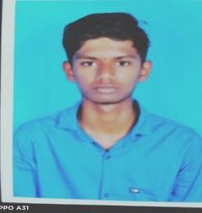Girish v

Chitradurga

[girishvgirishv46@gemail.com](mailto:girishvgirishv46@gemail.com)

7795132495

**Career objective**

To work for an an organization which provides me the opportunity to improve

My skills and knowledge to grow along with the objective of the organization

**Education**

|  |  |  |  |
| --- | --- | --- | --- |
| **QUALIFICATION** | **INSTITUTE** | **YEAR OF PASSING** | **PERCENTAGE** |
| **BEGREE** | Nagarjuna collage of engineering & technology | 2021-2022 | 75% |
| **PU** | Viswamanava collage | 2019-2021 | 82% |
| **SSLC** | Viswamanava high school | 2019 | 76% |

**TECHNICAL SKILLS**

* Java
* Python
* C++
* C programing

**PERSONAL STRENGTHS**

* Comprehensive problem sloving
* Ability to del with people ­­­­diplomatically
* Whillingness to learn technology
* Excellent analytical capabilities, self motivation, quick learner.

**EXTRA CURRICULAR ACTIVITIES**

* Dance
* Drawing

**HOBBIES**

* Playing
* Reading
* watching movies

**PERSONAL DETAILS**

**Date of birth:**28-09-2002

**Father name:** Venkatesh T

**Mother name:** Nagarathana R

**Languages known:** English,kannada

**Nationality:** Hindu

**Marital status:** singal

**Permanent address:** Hariyabbe palya ,Hariyabbe ,Hiriyur,Chitradurga

**DECLARATION**

I hereby declare that the above mentioned information is correct up to my

Knowledge and I bear the responsibility for the correctness of the above

mentioned particulars.

**Place: chitradurga**

**Date:28-11-2022**

Girish V

**2**