**Level 0 to 1:**

**In this level first you list out the files inside the host.**

**As per the description I found the file readme**

**To red the file the cat method is used**

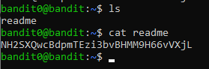

**Level 1 to 2:**

**In this level the home directory had the file “-“.**

**To read a dashed file I used the command cat ./- .**

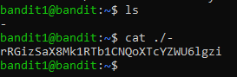

**Level 2 to 3:**

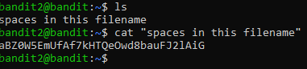

**In this level we are said to opena file name with spaces in the home directory**

**To read a filename with spaces we use cat “<filename>”**

**Level 3 to 4:**

**In the level we have been said to find the password in ahidden file inside a inhere file directory.**

**To find the hidden file use ls –a**

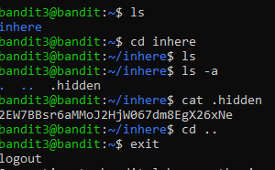

**Level 4 to 5:**

**In this level it is said to find the only readable format of password from the directory inhere.**

**To find the directory we use ls**

**Then move to inhere using cd**

**Use find . –type |xargs file to find the only human readable file**

**Then use cat to red the file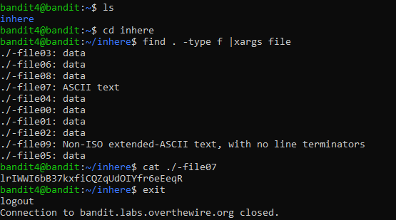e**

**Level 5 to 6**

**In this we are asked to find file with certin criterias inside he inhere directory**

**Used find . –size 1033c**

**C is used to denote bytes here**

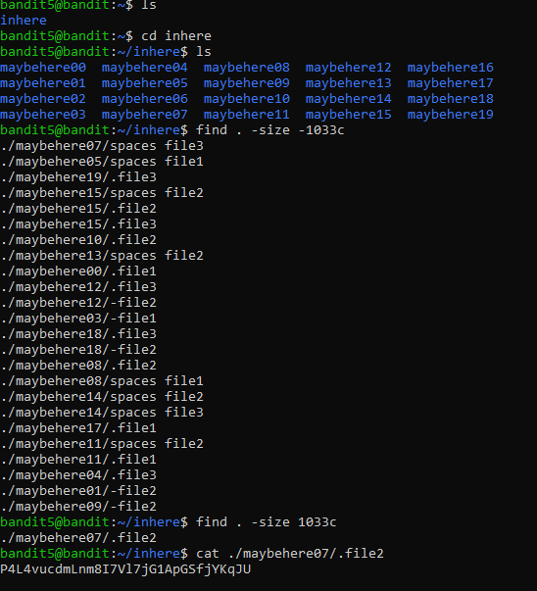

**Level 6 to 7:**

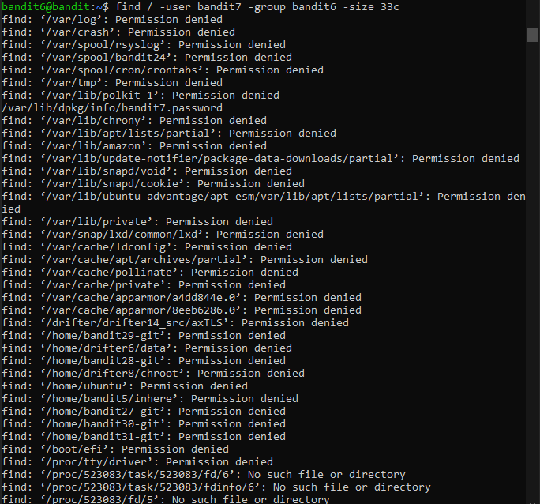

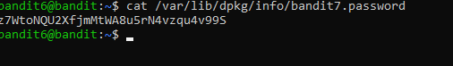

**In this question to find the file in the etire server with the criteria we use find / -user <username> -group <groupname> -size <size>**

**After finding the password file from the output**

**We cat it out to get the password**

**Level 7 to 8**

**To extract data from a file inside a directory we use grep**

**Grep ‘data’ filename**

**Since data.txt is very huge when opened to grab data from the bunch we use grep**



**Level 8 to 9**

**To get data that occurs only once in the file**

**We use sort file name | uniq –u**

**If we use uniq as such they will only consider the adjacent string.**

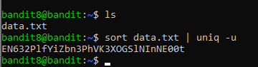

**Level 9 to 10**

**In this level we are asked to find the password from the file preceeded by many = signs.**

**Using strings we find the password.**

**To extract the password we use strings data.txt | grep =**

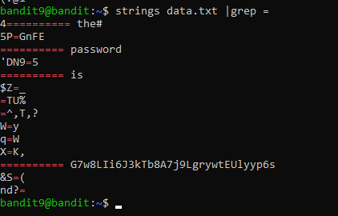

**Level 10 to 11:**

**First we cat the file data.txt to see the base64 data**

**Then use echo “ “ |base64 –d**

