🌾 AgriVision
AI-Powered Smart Detection of Crop Stress & Pests

Problem Statement
Farmers face yield losses due to undetected crop stress, pests, and diseases. Traditional methods of scouting are time-consuming, inconsistent, and inefficient.

Solution: AgriVision
AgriVision leverages YOLOv8 and computer vision to provide smart, real-time detection of crop stress, pests, and diseases from drone footage, images, or live camera feeds.

Workflow
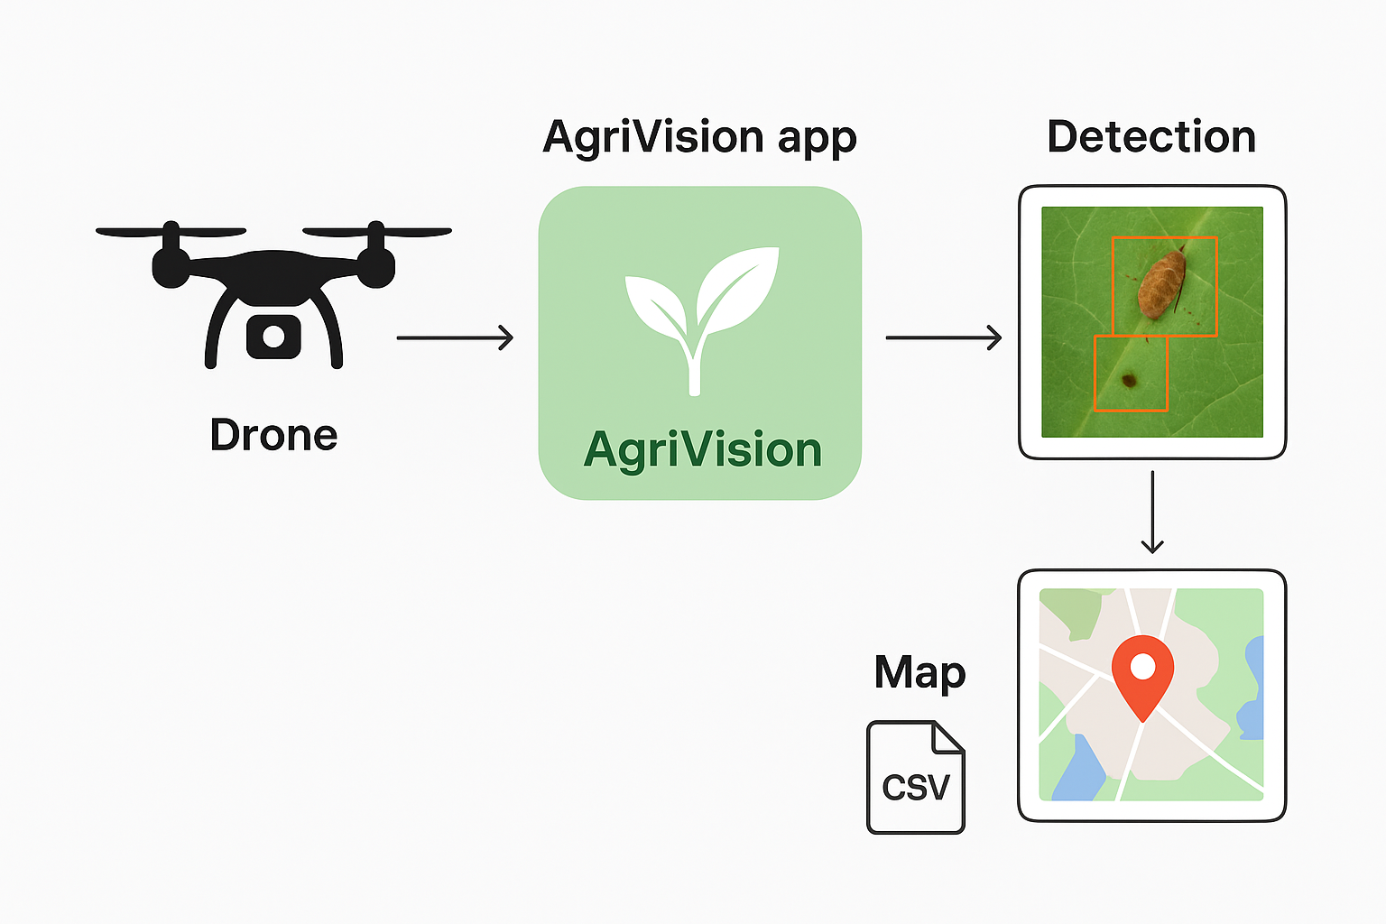

Features
- ✅ Image Detection – Upload an image to detect crop issues.
- ✅ Video Detection – Replay drone footage with GPS heatmap & detections.
- ✅ Live Camera/Drone Mode – Real-time detection from webcam or RTSP feed.
- ✅ GPS Integration – Parse .srt files or add live coordinates.
- ✅ CSV Export – Download detections for analysis.
- ✅ PWA Support – Installable as an offline app.
- ✅ Docker Ready – Run anywhere with containerization.

Roadmap
- Improve FPS with lighter YOLO variants for live mode.
- Integrate real-time drone telemetry.
- Fuse weather & soil sensor data for richer insights.
- Deploy on edge/mobile devices for offline use in the field.

Thank You
AgriVision – Empowering Smart Agriculture with AI 🌱

