|  |  |
| --- | --- |
| **Soal Praktikum**  *Practicum Case* | LogoBINUS-University |
| T0016  Algorithm and Programming |
| **Teknik Informatika**  *Computer Science* | **O1-T0016-SU01** |
| **Periode Berlaku** Semester Ganjil 2014/2015  ***Valid on*** *Odd Semester Year 2014/2015* | **Revisi 00**  *Revision 00* |

## Learning Outcomes

* Choose the right sorting and searching algorithm in problem solving

## Topic

* Session 10 – Sorting

## Sub Topics

* Creating a program to sort data using simple sorting algorithm

## Soal

*Case*

Bluejack Theater is a new theater. They want to maka an application using file*.* Here are the description:

* First, the program will read the file soal11.txt. there is informastion on those program, like movie title, airtime, dan available seat.
* Program consists of 6 menus:
  1. Movie List
  2. Sort ascending by airtime
  3. Sort descending by movie title
  4. Add movie
  5. Ticket reservation
  6. Exit
* If user chooses **Movie List** (menu ‘**1**’), then the program will display movie list (**movie** **title**, **airtime**, and **available** **seat**) obtain from the files soal11.txt.
* If user chooses **Sort** **ascending** **by** **airtime** (menu ‘**2**’), then list of movies will be sorting in ascending based on the airtime. Then display the message "**Please see the movie list in the Menu '1 '**".
* If user chooses **Sort** **descending** **by** **movie title** (menu ‘**3**’), then list of movies will be sorting in descending based on the movie title. Then display the message "**Please see the movie list in the Menu '1 '**".
* If user chooses Add movie (menu ‘**4**’), then:
  + Ask user to input **new movie title**. The length of **title** must be **between 1 and 10 characters**.
  + Ask user to input **airtime movie (hour)**. The **airtime** must be **between 0 and 32 hour**.
  + Ask user to input **airtime movie (minutes)**. The **airtime** must be **between 0 and 59 minutes**.
  + Show message “**successfully add movie**”.
* If user chooses **Ticket reservation** (menu ‘**5**’), then:
  + Ask user to input **movie title**. The length of **title** must be **between 1 and 10 characters**.
  + If a movie wants to be ordered is not in the movie list, then display the message “**this movie can't play in bluejack theater..**”
  + If a movie that will be ordered there in the movie list, then asked to input the number of tickets ordered. Validate the number of tickets a minimum and maximum number of seats empty film. Then print messages “**successful order**”
* If user chooses **Exit** (menu ’**6**’), then program will end.

**Please run the EXE file to see the sample program.**

**Print Screen of Initial Program**

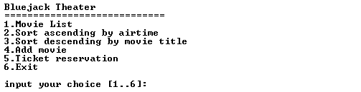

**Print Screen of Movie List (Menu ’1’)**

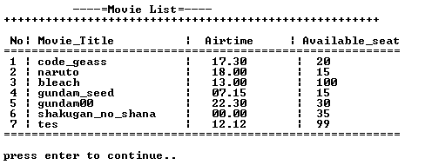

**Print Screen of Sort ascending by airtime (Menu ’2’)**

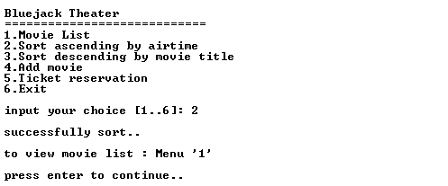

**Print Screen of Sort ascending by movie title (Menu ’3’)**

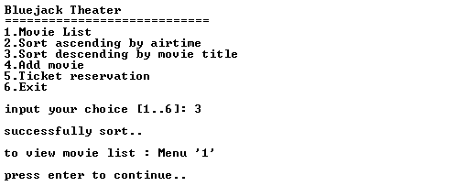

**Print Screen of Add movie (Menu ’4’)**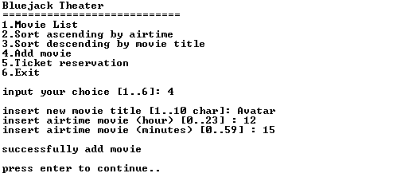

**Print Screen of Ticket reservation (Menu ’5’)**

