1. Simulate these data in AVL tree ( + for insert, - for delete)

+ 50, + 100, + 30, + 25, + 10, + 5, - 50, + 40, + 75, + 80, + 60 , - 10

1. Simulate these data in 2-3 Tree ( + for insert, - for delete)

+50, + 100, + 75, + 20, + 10,+ 55, + 60, - 20, - 55, - 75

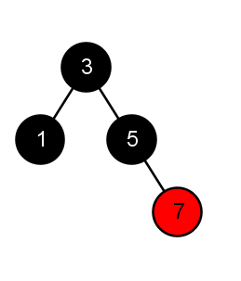

1. Based on tree above, do procedure below in sequence (please draw step by step):

Do insert: 11,13,15 after that

Do delete: 1,3,13

Do insert: 80,88,10 after that

Do delete: 5.

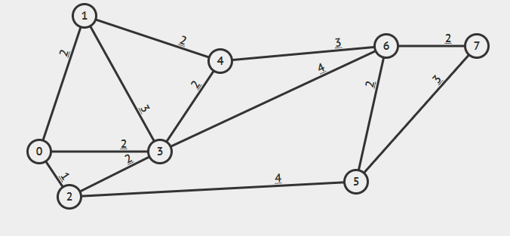

1. A. Find the Minimum Spanning Tree, using Prims or Kruskal

B. What is the shortest Path, Start node 1 , end node 5