Tugas UX: Total Design (Wireframe, Sitemap, Taskflow, Prototype), MOBA

* Joel Robert Justiawan (2101629672)
* Rama Firdaus (1801419562)
* Ayong Susanto (1801402643)

# Wireframe

1. Boot Process
   1. Company Logo
   2. Splash Screen
   3. Login Screen
2. Main Menu
   1. Lobby
      1. Main  
         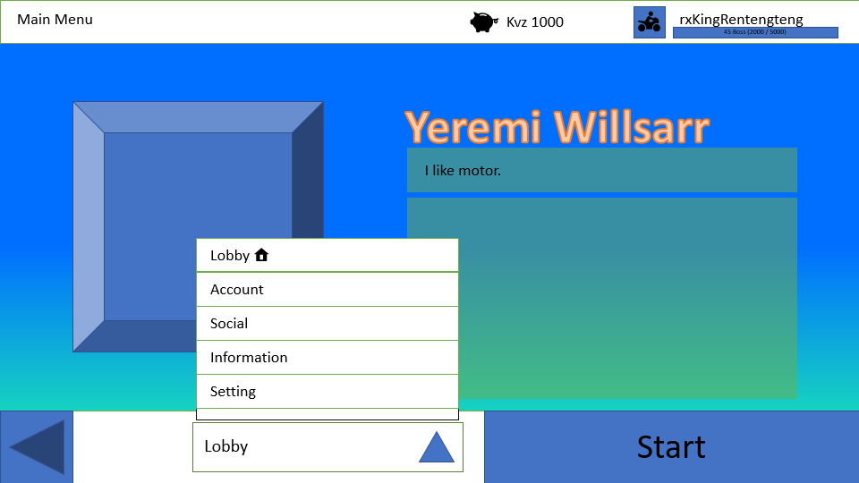
   2. Account
      1. Profile
      2. Inventory
      3. Statistics
      4. Gifts
   3. Social
      1. Chat
      2. Friend
      3. FInd or Create
      4. Leaderboard
      5. Shop Trade
   4. Information
      1. News
      2. Event
      3. Status
      4. Announcement
   5. Setting
      1. Video
      2. Sound
      3. Language
      4. Control
      5. Gameplay
      6. About
3. Start Game
   1. Select Game Mode  
      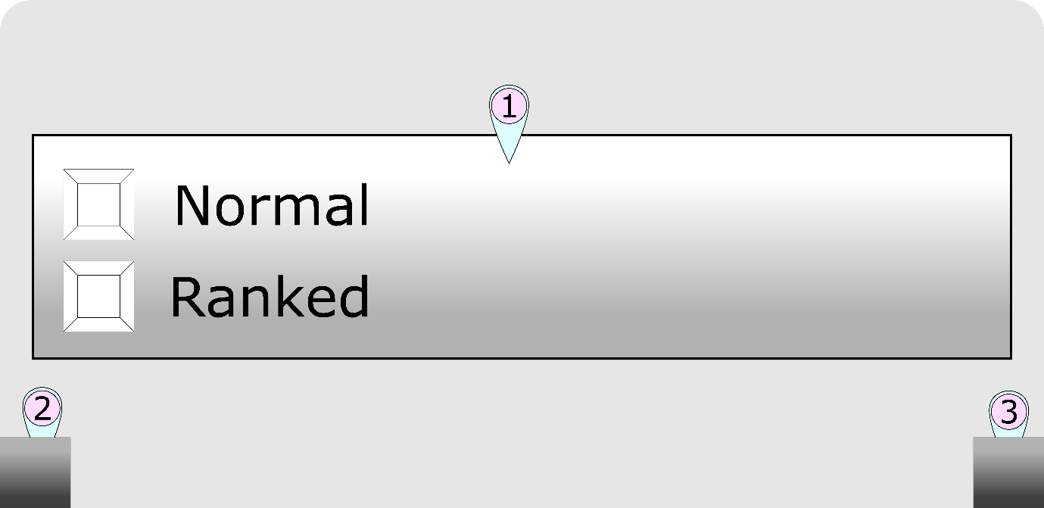
   2. Select Character
4. Mode Selection
5. Back
6. Next
   1. Gameplay
   2. Result

# Sitemap

1. Boot Process
   1. Company Logo
   2. Splash Screen
   3. Login Screen
2. Main Menu
   1. Lobby
      1. d
   2. Account
      1. Profile
      2. Inventory
      3. Statistics
      4. Gifts
   3. Social
      1. Chat
      2. Friend
      3. Find or Create
      4. Leaderboard
      5. Shop Trade
   4. Information
      1. News
      2. Event
      3. Status
      4. Announcement
   5. Setting
      1. Video
      2. Sound
      3. Language
      4. Control
      5. Gameplay
      6. About
3. Start Game
   1. Select Game Mode
   2. Select Character
   3. Gameplay
   4. Result

# Berkas Terkait

<https://binusianorg-my.sharepoint.com/personal/joel_justiawan_binus_ac_id/Documents/Perkedel_UXPrototype_PPTXversion.pptx>

<https://binusianorg-my.sharepoint.com/personal/joel_justiawan_binus_ac_id/Documents/PartOfSitemapTaskflowingNEW.vsdx>

# Sumber Referensi

1. Gambar esport <https://www.bing.com/images/search?view=detailV2&id=A4A53BDEA3A79112CABBEE7CC38224E6933C0314&thid=OIP.ISQtTNo7uCKOzTMe_s3BZQHaE8&mediaurl=https%3A%2F%2Fwww.hgunified.com%2Fwp-content%2Fuploads%2F2017%2F04%2F8-5.jpg&exph=1000&expw=1500&q=esport&selectedindex=0&ajaxhist=0&vt=0&eim=0,1,2,6>