|  |  |
| --- | --- |
| **Soal Praktikum**  *Practicum Case* |  |
| T0026  Data Structures |
| **Teknik Informatika**  *Computer Science* | **C1-T0026-RZ01** |
| **Periode Berlaku** Semester Pendek 2016/2017  ***Valid on*** *Compact Semester Year 2016/2017* | **Revisi 00**  *Revision 00* |

## Learning Outcomes

* Demonstrate how to create any learned data structure
* Analyze the usage of data structure in application

## Topic

* Session 02 - Single Linked List

## Sub Topics

* Pointer of Struct
* Malloc
* Free
* Operator
* Push Head
* Push Tail
* Push Middle
* Pop Head
* Pop Tail
* Pop Middle

## Soal

*Case*

Mr. Ali Use is a seller of daily needs. Due to his rice stock system is not too good, he asks you to make a program using a stack with a concept of array of struct. Here are the descriptions of the program:

* Program always show rice stock in stack view.
* Program consists of 3 menus:

1. Stock Rice Sack

2. Sell Rice Sack

3. Exit

* If user chooses **Stock Rice Sack**, then:
  + Ask user to input **type of rice**. Validate that **the type of the rice** must be **‘long, ‘medium’, or ‘short’ with case sensitive**. Then add **the type of the rice** with **‘grain’** automatically.
  + Ask user to input **weight of rice sack**. Validate that the weight must be **between** **10 and 100 kilograms**.
  + Maximum data that can be stored in the rice stack is only **10**. If the data has reached **10**, then show the message **“--- The Rice Storage is Full ---”**
  + If data has been successfully inputted, show the message **“--- Add Rice Sack Success ---”**
* If user chooses **Sell Rice Sack,** then:

- If there is no data in linked list, then show the message **“--- The Rice Storage is Empty ---”**.

**-** If data is already in the linked list, the program will delete the last data in the stackand show the message **“--- Sell Rice Sack Success ---”**

* If user chooses **Exit**, then:

- Delete all data.

- Program ends.

**Please run the EXE file to see the sample program.**

**Print Screen of Main Menu**

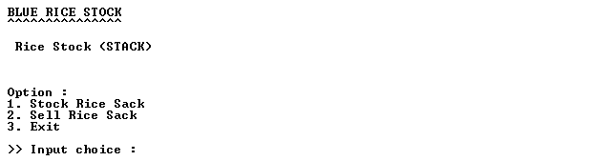

**Print Screen of Stock Rice Sack Menu (Menu ‘1’)**

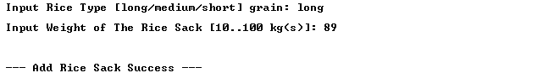

**Print Screen of Main Menu after Doing Stock Rice Sack Menu**

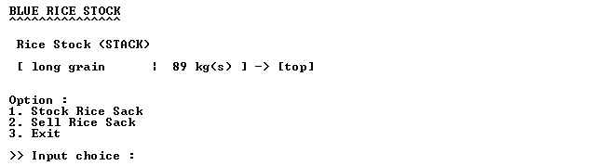

**Print Screen of Sell Rice Sack Menu (Menu ‘2’)**

