|  |  |
| --- | --- |
| **Soal Praktikum**  *Practicum Case* |  |
| T0026  Data Structures |
| **Teknik Informatika**  *Computer Science* | **C1-T0026-YW01** |
| **Periode Berlaku** Semester Pendek 2016/2017  ***Valid on*** *Compact Semester Year 2016/2017* | **Revisi 00**  *Revision 00* |

## Learning Outcomes

* Demonstrate how to create any learned data structure
* Analyze the usage of data structure in application

## Topic

* Session 03 - Double Linked List

## Sub Topics

* Push Head
* Push Tail
* Push Middle
* Pop Head
* Pop Tail
* Pop Middle

## Soal

*Case*

Mr. Brea Stanley is a famous dress designer. He wants to run a dress shop independently and he needs a program to support the cashier. Therefore, he asks you as a programmer to make a program using queue and array of struct concept. Here are the descriptions of the program:

* Program consists of 3 menus:

1. View Queue

2. Add Customer to Queue

3. Serve Customer

4. Exit

* If user chooses **View Queue**, show **the queue view** that contains **No**, **Customer’s Name**, **Dress Name**, and **Price**.
* If user chooses **Add Customer to Queue**, then:

**-** Ask user to input **customer’s name**.It **must be in alphabets only** and the length must be **between 3 and 20 characters**.

**-** Ask user to input **dress name**.The length must be **between 3 and 20 characters**.

**-** Ask user to input **dress price**. **The dress price** must be **between $50 and $999**.

**-** Maximum customer in the queue is **10**. If it has reached **10** customers, then show the message **“--- Maximum Customer in a Queue is 10 ---”**

If not, then show the message **“--- Success to Add Customer into Queue List ---”**

* If user chooses **Serve Customer**, then:
  + Program will delete the data using the queue concept.
  + If there is no data in the list, then show the message **“--- There is No Customer in Queue ---”**.
  + If data has been successfully deleted, then show the message **“--- [customer’s name] Has Been Served ---”**
* If user chooses **Exit**, then:

- Program ends and exit.

**Please run the EXE file to see the sample program.**

**Print Screen of Main Menu**

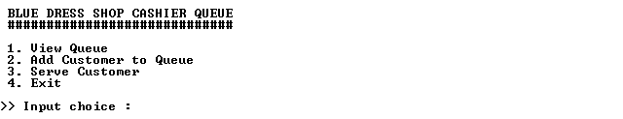

**Print Screen of View Queue Menu (Menu ‘1’)**

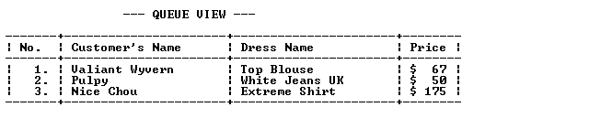

**Print Screen of Add Customer to Queue Menu (Menu ‘2’)**

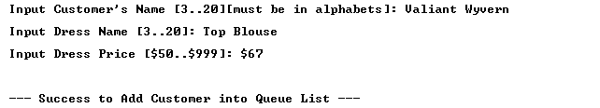

**Print Screen of Serve Customer Menu (Menu ‘3’)**



**Print Screen of View Queue Menu (Menu ‘1’) After Choosing Serve Customer Menu**

