Soal Praktikum  Practicum Case | 
M0564 | ISYS6123
Introduction to Database Systems
Sistem Informasi  Information System | C1-M0564-RB01
Periode Berlaku Semester Ganjil 2015/2016  Valid on Odd Semester Year 2015/2016 | Revisi 00  Revision 00
Learning Outcomes
- Construct query of SQL that suitable with the problem

Topic
- Session 08 – SQL – Data Manipulation (Basic Queries 2)

Sub Topics
- SQL Aggregate Functions
- Group By
- Having
- Compute / Compute By
- Sub queries (IN, EXISTS, ALL, SOME)
Sintaks
Syntax

ALIAS

For field name
SELECT “field_name”
AS “field_alias”
FROM “table_name”

for table name
SELECT “field_name”
FROM “table_name”
AS ”table_alias”

IN
SELECT “field_name”
FROM “table_name”
WHERE “field_name” IN(value1, value2, ..)

EXISTS
SELECT “field_name”
FROM “table_name”
WHERE EXISTS (value1, value2, ..)

SELECT INTO
SELECT “field_name”
INTO “new_table [IN externaldatabase]”
FROM source

Tabel Relasional
Relational Table
Bluejack_University

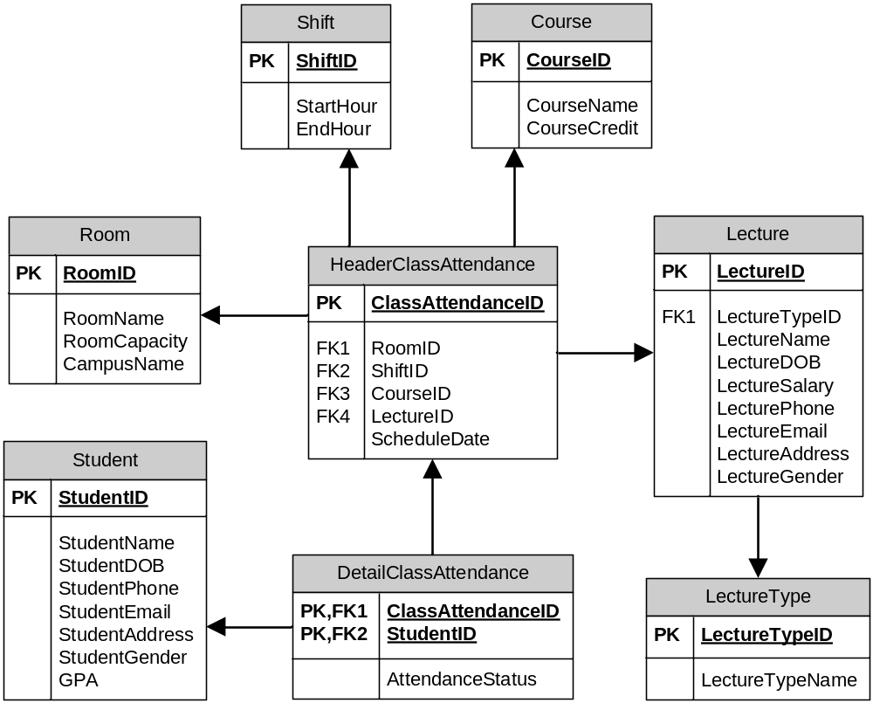

Soal
Case

- Display LectureTypeName for every lecture type whose type id is ‘LT001’, ‘LT002’, or ‘LT003’.
(in)
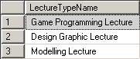

- Display CourseName for every course whose id is not ‘CO001’, ‘CO005’, or ‘CO007’.
(not in)
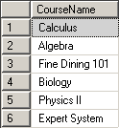

- Display StudentID, GPA, and StudentGender for every student that two days after the student’s class date is the 20th day.
(in, day, dateadd)
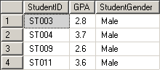

- Display CourseID and CourseName for every course which the room’s capacity is more than 41 and the course’s name is only one word.
(not in, charindex)
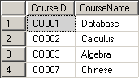

- Display LectureName and Gender (obtained from the first letter of LectureGender) for every lecture who has taught student that has only one word of name.
(left, exists, charindex)
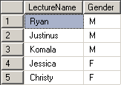

- Display StudentID, StudentName, and GPA for every student who didn’t have a class after the 16th day.
(not exists, day)
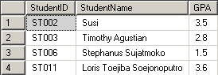

- Display LectureName and LectureSalary (obtained by adding ‘ IDR’ after the LectureSalary) for every lecture whose salary is above the average salary.
(cast, avg, alias subquery)
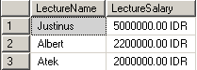

- Display MaxAttend and StudentName for every student who is the most frequently had class in ‘ATF618’.
(count, max, group by, alias subquery)
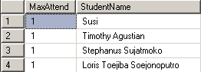

- Display StudentID, StudentName, StudentPhone, and StudentAddress for every student whose id is lower than all students’ id that had class on the 18th day.
(right, all, day)
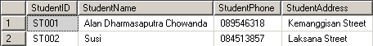

- Display RoomID, RoomName, and LectureName for every room which id is higher than all room’s id that has been used before 19th day.
(right, some, day)
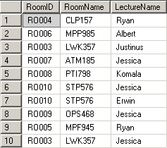

If you don’t understand, please ask your assistant!

