CHAPTER III
METHODOLOGY

Approved Title: Property Management, Smart Lock (RFID + Mobile Key / ESP32) & Tracking System for Hacienda de LuisAna — Luisiana, Laguna, Philippines
Section: PENDING CONFIRMATION — not specified in repository
Group: PENDING CONFIRMATION — not specified in repository
Members: John Rey Carlo A. Gemao (only member identified in repository; full group roster requires confirmation)
Date: October 31, 2026
Working Chapter III draft based on materials present in the project repository.
Confirm pending academic/client details and reconcile draft IDs with approved Chapters I–II before submission or recruitment.

CHAPTER III
METHODOLOGY
This chapter presents the research design, population and sampling plan, data analysis, collection procedures, requirements, instruments, traceability, software design, development and testing, prototype status, and implementation plan for the approved Hacienda de LuisAna system. The repository does not contain the approved Chapters I–II or verified participant counts; open confirmations are explicitly identified rather than invented.

1. Research Design
This study will use a developmental-descriptive design. The developmental component is appropriate because the approved project is a role-separated property-management system for Hacienda de LuisAna: a Guest website and an Admin Android application backed by cloud services. It will address analysis, design, integration and verification of booking, payment-proof review, rates, stays, communications, access-log and consent-based location workflows. The descriptive component will characterize task outcomes and perceived quality after participants use a controlled prototype or pilot build; it will not claim causal effects or operational improvement without comparative evidence.
The study setting is Hacienda de LuisAna in Luisiana, Laguna. The units of analysis will be (a) approved system workflows and test cases and (b) eligible system users/evaluators, separated by role. The exact Chapter I objectives, research questions, approved respondent counts, Chapter II models and earlier activity package are not present in the supplied repository. Accordingly, the objective labels and requirements IDs used in this draft are working traceability labels derived from the software and repository documentation, not claims of previously approved wording. Before recruitment or final submission, the adviser and client must reconcile them against the signed/approved Chapters I–II and earlier models.
At this checkpoint (October 31, 2026), the repository contains substantial web and Flutter application code, service modules, cloud rules, infrastructure configuration and a Smart Lock simulator. Repository files document a partial verification report dated October 1, 2026. Those artifacts establish implementation evidence only; they do not establish live client acceptance, complete canonical emulator coverage, an instrument pilot, an end-user quality survey, an operational pilot, or connected ESP32 hardware. These activities will remain planned until dated records show otherwise (Hacienda de LuisAna Project Repository, 2026a, 2026b).

Development approach and phase gates
The team will use an iterative and incremental Agile-inspired lifecycle (Agile Manifesto, 2001), rather than treating Agile as the research design. Short, reviewable iterations fit the two applications and shared cloud contracts, where changes to booking rules, payments or roles can affect both clients. Each iteration will start from a controlled requirement, implement a vertical workflow, run relevant tests, record defects and obtain client/adviser review before expanding scope. The lifecycle is planned as six gated phases; a gate is not passed solely because code exists.
Figure 1
Project-specific iterative development and evaluation sequence
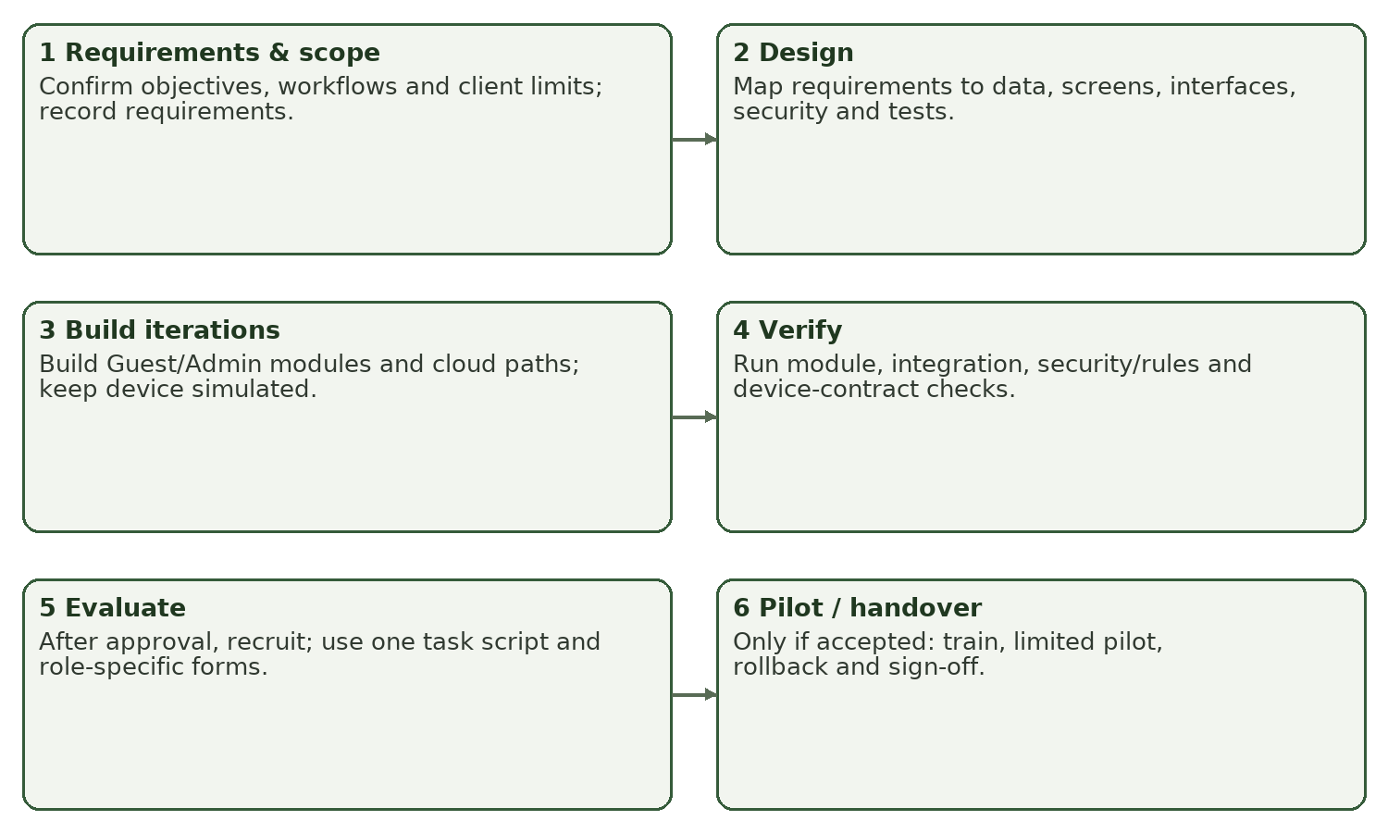
Figure 1 shows the planned sequence from scope confirmation through implementation. Evaluation and pilot steps are conditional on required permissions, instrument review, and acceptance. The six-step diagram is a project method, not a copy of the Chapter II conceptual framework.
Table 1.
Planned lifecycle phases and schedule
PHASE / TARGET | PARTICIPANTS / ACTIVITIES | OUTPUT / EXIT CRITERION | STATUS AT CHECKPOINT
1. Scope and requirements confirmation  Nov. 2–6, 2026 (planned) | Researchers review Chapter I–II, client workflow, repository and approved activity files; confirm each requirement, role and exclusion with client/adviser. | Baseline requirements register, objective crosswalk, client review record; proceed only after scope/IDs are confirmed. | Existing code/docs reviewed; formal client confirmation not evidenced.
2. Design and instrument preparation  Nov. 9–13, 2026 (planned) | Researchers align architecture/data/UI models; client reviews operating rules; qualified reviewers inspect draft instruments. | Approved design views, revised instruments, review log; no unsupported validation claims. | Repository architecture/design documentation exists; thesis model approval pending.
3. Iterative implementation / integration  Nov. 16–27, 2026 (planned refinement) | Developers integrate web, mobile and cloud paths in small increments; owner reviews working scenarios; device remains simulated unless hardware is authorized and supplied. | Versioned build, change log, passing applicable module/integration tests; open defects recorded. | Substantial modules are present in repo; exact release build and client acceptance not evidenced.
4. Verification and pilot readiness  Nov. 30–Dec. 4, 2026 (planned) | Researchers/testers run controlled tests; inspect permissions, duplicate actions, connectivity and recovery; client confirms readiness. | Test log, defect/retest log, readiness decision; security-sensitive failures block pilot. | Phase 0 report dated Oct. 1 records partial verification and blocks; newer execution evidence required.
5. Instrument pilot and user evaluation  Dec. 7–11, 2026 (provisional) | After approvals: recruit eligible users, consent, identical demonstrations/tasks, surveys/interviews; collect nonresponse/deviation logs. | De-identified dataset, collection log, completed role-specific instruments. | Not yet documented; dates depend on permissions and academic calendar.
6. Limited pilot, handover or prototype-only closeout  Dec. 14–18, 2026 (provisional) | Only if client approves: configure limited environment, train Admin, monitor, rollback if needed; otherwise deliver prototype and evaluation report only. | Signed acceptance or documented decision not to deploy; guides, backup/rollback and known-limitations list. | Not yet performed; no deployment or sign-off evidence in supplied sources.

The six phases implement the repository’s two-role/two-application architecture and shared lifecycle rather than replacing the approved Chapter II framework. Because the framework and exact research objectives were absent, the adviser must verify that this workflow aligns with them before final sign-off.

2. Population of Study
The intended site is Hacienda de LuisAna, Luisiana, Laguna, as identified in the project title and project records. The target population will be the people who can give relevant evidence about the actual system: the owner/operator or authorized Admin; eligible Guests who can complete guest workflows; and qualified technical evaluators who can inspect implementation properties outside ordinary user knowledge. Researchers and repository contributors are not automatically study participants. The system documentation describes a single Admin role and Guest role, but does not provide verified roster counts or a dated source from the client; therefore no population count or final sample is asserted here.
Table 2.
Population and planned selection
PARTICIPANT CATEGORY | VERIFIED POPULATION N / SOURCE | PLANNED SAMPLE N | SELECTION AND JUSTIFICATION
Owner / authorized Admin | Pending client confirmation. Obtain current operator roster and written confirmation from the owner; record source and date before recruitment. | If one eligible Admin is verified, invite the full eligible population (census); final n depends on consent. | Complete enumeration is appropriate for the small, role-critical operator group; participation remains voluntary. Do not infer roster count solely from architecture documentation.
Guest end users | Pending. Obtain a client-approved count/frame of eligible recent or prospective users, with privacy-preserving recruitment and date/source logged. | To be set after frame and study design are approved; purposive usability participants may be used for formative task evaluation, not population prevalence estimates. | Invite eligible adults with booking/site-use experience; stratify only if meaningful and feasible. Do not recruit from private booking records without authorization.
Technical evaluators | No verified roster in repository; identify qualified candidates and document qualifications before invitation. | No fixed number imposed by this draft; adviser approves a number based on review scope and availability. | Purposive selection of evaluators with relevant software engineering, information security, cloud/database, mobile or usability expertise. Document years/credentials or equivalent experience.
Researcher/developer test team | Not a respondent population. | Not applicable. | Developers may execute technical tests but should not substitute their opinions for independent user/evaluator ratings.

Eligibility will be: Admin participants currently authorized by the client to perform the relevant duties; Guest participants who are adults, can provide informed consent, and can complete the assigned guest scenarios without access to another Guest’s account; technical evaluators with documented relevant qualifications and no undisclosed conflict affecting their judgment. Exclude individuals unable to consent, underage participants unless the required guardian consent and assent process is approved, persons without relevant role/experience, and anyone whose participation would require exposing another person’s identifiable or payment data.
Recruitment will use a client-approved invitation and neutral explanation of voluntary participation, withdrawal, confidentiality, and non-effect on accommodation or services. The final sample and group allocation will be recorded before collection; refusals and nonresponse will be counted without pressure or repeated coercive contact. No Slovin calculation is supplied because verified N, sampling frame, probability design and a proportion-estimation objective are absent. A convenience/purposive usability sample cannot be presented as a probability estimate. Expert qualifications and participant numbers require adviser approval, not invention.
Population confirmation record to complete before data collection: client contact/role, frame description, verified N by group, source document and date, inclusion/exclusion decision, invitation count, consenting count, refusal/nonresponse count, final n and reason for any change.

3. Statistical Treatment of Data
The analysis will be descriptive unless the approved research questions require a defensible comparison. This project’s current evidence plan asks how well defined workflows operate and how users/evaluators perceive specified quality attributes; respondent categories alone do not justify a t-test or ANOVA. Technical test results and perception ratings will be reported separately. No results, means, significance tests or acceptance claims are reported in this methodology draft.
Table 3.
Objective-to-analysis matrix (working objective labels; confirm against Chapter I)
OBJECTIVE / EVIDENCE | VARIABLE, UNIT & SOURCE | INSTRUMENT / ANALYSIS | PLANNED INTERPRETATION
O1. Describe/confirm current booking and property-management workflows. | Workflow step, responsible role, exception and observed/documented occurrence; unit = workflow/task; source = owner interview, approved forms and observation. | Interview guide + workflow observation sheet; summarize process sequence, recurring exceptions and agreed requirements. Qualitative notes will be coded by topic with a codebook and reviewed against source records. | Report agreed current-state process and evidence-backed gaps; distinguish reported issue from directly observed fact.
O2. Develop role-appropriate guest and Admin workflows. | Requirement acceptance outcome; test case pass/fail; unit = one unique test execution under defined conditions. | Requirements register, use-case walkthrough and test scripts; frequency and percentage of valid test cases passing, with defects and environment. | Compare only with predeclared acceptance criteria; unresolved critical defects block acceptance.
O3. Verify cloud data, authorization, privacy, and integrations. | Unauthorized read/write outcome, data integrity, response time, location expiry/deletion and storage behavior; units = test attempt, request, or seconds. | Security/rules, integration, connectivity and recovery protocols; counts/rates, median and range or percentile for repeated timings; report exact N and conditions. | Report technical properties based on tests/logs, not survey perceptions. State unavailable emulator/staging/device tests explicitly.
O4. Evaluate user-perceived product quality. | Role-specific item responses (ordinal 1–5); unit = one respondent-item, summarized by construct and role. | Researcher-made role-specific questionnaire, after expert review and pilot; response frequencies/valid percentages; item median and IQR; justified construct mean may supplement. | Use valid denominator per item; summarize Guests and Admin separately; do not combine incomparable forms or present perceived security as proof.
O5. Assess operational readiness / implementation feasibility. | Task completion, assistance needed, error/recovery, readiness checklist, interview themes; unit = session or checklist criterion. | Observed task script, deviation log and client readiness/acceptance checklist; frequency, percentages, task times, thematic summary. | State readiness only if required client approvals, thresholds and sign-off are met; otherwise retain prototype-only status.

For categorical task outcomes, percentage = 100 × f / valid N, where f is the count in a category and valid N is the number of applicable, non-missing observations for that item or test. Ordinal responses will be coded 5=Strongly agree, 4=Agree, 3=Neither agree nor disagree, 2=Disagree, 1=Strongly disagree. Missing, not observed and not applicable (N/A) will use separate codes and will not be treated as zero or as a neutral response. Report valid N next to each summary; exclude N/A and missing responses from denominators. Positive items will not be reverse-coded. Any negative item will be explicitly reverse-coded using 6−response before an approved scale aggregation.
For a multi-item construct approved as a single scale, the unweighted frequency-weighted mean will be Σ(fr)/Σf over valid responses, with r the response value and f its frequency. Items will be combined only if they measure the same construct and the instrument plan establishes direction and equal weights before collection. Classify the unrounded mean, then display two decimals: 4.20–5.00 strongly agree; 3.40–below 4.20 agree; 2.60–below 3.40 neither agree nor disagree; 1.80–below 2.60 disagree; 1.00–below 1.80 strongly disagree. This is the course’s proposed interpretation scheme, not an ISO-prescribed scale.
Task duration will be measured in seconds from the stated start event to successful completion, under the same test environment and task instructions. The protocol will predefine repetitions and report median and range (and valid n) where skew or small samples make a mean misleading. A technical pass threshold must be confirmed against client requirements before testing; no latency target is invented in this draft. If approved comparative questions are later added, the researcher will specify hypotheses, unit, independence or pairing, assumptions, alpha=.05, suitable effect size and confidence interval before collection; Welch’s t-test, paired t-test, ANOVA or a justified nonparametric alternative will be chosen only where outcome and design support it. No such inferential comparison is currently proposed (NIST/SEMATECH, n.d.; Tejada & Punzalan, 2012).

4. Data Collection Procedure
Requirements elicitation, instrument review/pilot, software testing and final stakeholder evaluation are separate activities. No recruitment or access to personal booking/payment data will begin until the required institutional review/clearance and client permissions have been confirmed. Only synthetic/anonymized records will be used in public screenshots and test demonstrations. Signed consent forms and any identifiable raw records will be stored separately in approved restricted storage; the manuscript will use coded or aggregate evidence.
Table 4.
Data collection sequence and records
STEP / WHEN | WHO / WHERE / SOURCE | PROCEDURE AND INSTRUMENT | EVIDENCE / STATUS
1. Permission and baseline confirmation  Before recruitment | Researcher, adviser, Hacienda owner; approved institutional channel and private client meeting. | Request site permission, clarify current workflow and approved data access, verify objectives/FR IDs, roster and deployment boundaries. | Permission/clearance record and signed scope confirmation. Not evidenced in repository; planned.
2. Requirements elicitation  After permission | Researcher with owner/Admin; on-site or secure interview; no Guest records unless authorized. | Semi-structured interview, workflow walk-through, document review; observe a booking-to-stay scenario using anonymized/synthetic data; record deviations and source/owner for each need. | Interview notes, observation sheet, dated requirements register and owner review. Current repo documents describe workflows; formal elicitation records not found.
3. Instrument review and pilot  Before final evaluation | Qualified reviewer(s), adviser, then small eligible pilot group not included in final sample if feasible. | Review content coverage, clarity, role appropriateness and privacy; revise/version instruments; pilot timing and comprehension; assess internal consistency only for a coherent multi-item construct and adequate data. | Reviewer comments, version history, pilot log and revision record. Not yet evidenced.
4. System and technical verification  After stable build | Researcher/tester; isolated demo/test project, approved staging if available, Android emulator/device and supported browsers. | Execute scripted unit/module, integration, system, rules/security, connectivity/recovery and simulator/device-contract tests; use synthetic data only; log result, environment, evidence and defects. | Test record with actual results only when run; known repository report is partial and dated 2026-10-01.
5. Participant recruitment and consent  Only after approvals | Researcher; client-approved invitation; private location or secure remote session. | Screen eligibility, provide information sheet, obtain consent, explain withdrawal/no service impact; minors excluded unless institution-approved assent/guardian process exists. | Coded recruitment and consent log; signed forms kept separately/restricted. Planned.
6. Demonstration and evaluation  After stable version | Researcher facilitates; Guest, Admin and technical evaluator each get role-specific tasks. | Use same approved build, task script, setup, time limits and neutral assistance rules within each group; capture completion, help, errors, time, deviations and questionnaire response. | Task sheets, questionnaire version, anonymous session IDs, deviation/nonresponse log. Planned.
7. Data checking, analysis, retention | Researcher; approved encrypted/restricted storage. | Check completeness/range/duplicates; resolve only against source where permitted; code, de-identify and restrict access; retain for institution-approved period then securely delete. | Data dictionary, cleaning log, access/retention record and analysis file. Retention period must be confirmed by institution before collection.

The researcher will log instrument version, date/time, location/device/browser/build, role category, task order, assistance, interruptions and deviations for each session. Incomplete or erroneous records will be flagged rather than silently imputed; correction requires source evidence and a logged correction. No personal screenshots or payment receipts will be published. The current project contains private payment-proof handling, guest identity and optional short-lived location-sharing; these data require particular minimization and restricted access (Hacienda de LuisAna Project Repository, 2026c).

5. Requirement Analysis
The repository’s current-state workflow is a two-role arrangement. Guests use the website to browse accommodations, rates and availability; submit a booking; manage only their own booking; upload payment proof; communicate with the Admin; and submit a review after a completed stay. The authorized Admin uses the Android app to review and manage bookings, payments/refunds, rates, rooms, stays, guest communications, reviews, CRM, analytics and access-log/smart-lock simulation. Firebase Auth and database rules define the two roles. The sources explicitly exclude a Staff/Host role, Admin website, Guest booking flow in Flutter, instant payment integration, live ESP32/RFID hardware, and a route/history tracking feature. Location is an opt-in, temporary live stream, not a retained movement trail (Hacienda de LuisAna Project Repository, 2026c, 2026d).
Because formal client interview/observation records and approved Chapter I–II requirement IDs were not included, the following register is a controlled working baseline inferred from current repository design documentation and code inventory. It must be checked against the client and earlier approved requirements before it is labelled final. Labels FR-01–FR-12 and NFR-01–NFR-06 are introduced here solely to make Chapter III traceable; they are not represented as previously approved IDs.
Table 5.
Working requirements register (confirm IDs and acceptance with client/adviser)
ID / PRIORITY | SOURCE / OWNER / ROLE | REQUIREMENT OR BUSINESS RULE | ACCEPTANCE CONDITION / STATUS
FR-01 / Must | APP_PLAN.md; owner confirms / Guest | Guest browses accommodations, published rates and availability on website. | Approved rates and availability are visible; unpublished/invalid rates cannot be used for a new quote. Working repository surfaces; client sign-off pending.
FR-02 / Must | Booking flow, booking policy / Guest | Guest submits a booking with their identity, dates, accommodation and party size; booking is linked to the authenticated/anonymous identity. | Valid input creates one owned record; invalid/too-soon, conflicting or duplicate/retried submissions do not create an unauthorized or duplicate booking. Server boundary/test state to verify.
FR-03 / Must | APP_PLAN / Guest | Guest reads and changes only their own permitted booking fields and can withdraw it when allowed. | Guest A cannot read/change Guest B; rules reject forbidden state/money changes. Test in canonical environment remains required.
FR-04 / Must | APP_PLAN, ADR-0012 / Guest and Admin | Guest uploads proof of external payment; Admin alone verifies/rejects proof and records verified amount. OCR is assistive, not proof of payment. | Private file path and role restrictions hold; OCR output never triggers automatic verification; Admin action and reason are recorded.
FR-05 / Must | APP_PLAN, booking lifecycle / Admin | Admin performs allowed approval, rejection, payment, cancellation/refund, check-in, stay, checkout and completion transitions. | Only permitted transitions occur; required reason/amount and money/date constraints are enforced; activity record accompanies each supported state change.
FR-06 / Must | APP_PLAN / Admin and Guest | Admin publishes rates/policies; Guest website reads the published version to quote new bookings. | Invalid rate schedule cannot publish; new booking stores applicable financial/policy snapshot; historical records are not silently repriced.
FR-07 / Must | APP_PLAN / Admin | Admin manages accommodation status and views operational/booking summaries. | Admin-only controls; visible status/metrics derive from source records and report errors rather than inventing cloud data.
FR-08 / Must | APP_PLAN / Guest and Admin | Guest and Admin communicate in a private conversation; messages/attachments remain role- and membership-restricted. | Only conversation members can read; attachment validation and configured retention rules hold; no public media URL.
FR-09 / Must | APP_PLAN / Guest and Admin | Eligible Guest can submit a post-stay review; Admin moderates and may publish a separate approved testimonial. | Only eligible Guest review; Guest text is not exposed publicly by default; Admin moderation actions are auditable.
FR-10 / Must | ADR-0013 / Guest and Admin | Guest may opt in to time-limited location sharing; Admin can view only during valid consent window. | Consent metadata contains no coordinates; location is ephemeral and stops/deletes on expiry, stop or disconnect; no retained trail.
FR-11 / Conditional / confirm scope | APP_PLAN / Admin | Admin Smart Lock module displays access logs and can exercise the simulator. | Simulator events are clearly labelled; no claim of physical door actuation. This is current implemented scope; hardware connection is excluded pending client-approved device.
FR-12 / Proposed future / not implemented | Approved title and device concept / Admin, device | RFID and Mobile Key access through an ESP32 lock gateway. | Not accepted as working functionality until authorized hardware, firmware, credential protocol, safety review, integration tests and deployment evidence exist. Must reconcile title versus current scope.
NFR-01 / Must | Auth and rules design / Guest/Admin | Access control must enforce Guest/Admin authorization at trusted data/service boundaries, not only UI visibility. | Canonical rules tests show allowed and denied cases for each role; critical unauthorized access is zero in defined test set; staging review remains open.
NFR-02 / Must | Privacy / client and adviser | Minimize personal/payment/location data; private proofs and messages; consent-expiring location. | Data flow and permissions reviewed; no sensitive sample data in manuscript; permission and retention behavior verified.
NFR-03 / Must | Operational / owner | Errors and unavailable connectivity must be visible; no silent substitution of demo data for cloud failure. | Forced read/write failure yields explicit error and no false success; recovery/retry recorded. Threshold for recovery time requires client confirmation.
NFR-04 / Must | Compatibility / client | Guest site operates on agreed current browsers; Admin build targets supported Android device/OS. | Record supported browser/device/OS matrix before evaluation; no specific coverage claim until verified.
NFR-05 / Target pending | Performance / owner | Common booking, Admin list and conversation tasks meet client-approved response-time limits under defined network and dataset conditions. | Baseline and numerical threshold to be approved before test; measure seconds across predefined repeated runs; currently no validated threshold.
NFR-06 / Must | Maintainability / team | Controlled source, change history, versioned builds, repeatable test and release procedure. | Version/commit and build configuration recorded; tests and deployment checklist reproducible; no release sign-off yet.

Technology boundaries supported by the repository are React 18/Vite/TypeScript guest website; Flutter Android Admin app; Firebase Auth, Cloud Firestore, Firebase Storage/Realtime Database and Cloud Functions in the documented architecture; private Supabase Storage for payment-proof files; browser OCR and on-device OCR assistive functions. Hosting and production settings must be verified at the actual deployment checkpoint; repository configuration alone does not prove production state. The system requires connectivity for cloud business records; no local business-data database is documented for the Admin app. The ESP32, firmware and physical RFID reader are not in the repository. The scope excludes instant payment processing, unapproved KYC, route history, unrelated staff roles and unapproved extensions.
Requirement approval procedure: owner/source and role are recorded for every line; the client confirms business rule and acceptance; adviser confirms alignment with approved objectives and prior models; a version/date is assigned; any change records issue, reason, affected FR/NFR, model, screen, test and approval. Conflicts are resolved in favor of the latest approved source, not informal draft workflow notes. The single source of truth remains pending formal confirmation.

6. Research Instrument
The draft instruments below are researcher-made and are not yet validated. They are derived from the system workflows documented in the repository and will be revised after Chapter I–II alignment and client review. Instrument versions, dates, reviewer qualifications and changes will be recorded. The applicable product-quality reference is ISO/IEC 25010:2023, whose product quality model has nine characteristics: functional suitability, performance efficiency, compatibility, interaction capability, reliability, security, maintainability, flexibility and safety (ISO, 2023). This study will not call a questionnaire “ISO-certified”; user items capture perceived quality only. Technical characteristics will be checked through technical review and tests.
Table 6.
Instrument blueprint
INSTRUMENT / WHO | OBJECTIVE / CONSTRUCT | ITEMS OR METRICS | SCORING / STATUS
A. Owner/Admin semi-structured interview; owner/authorized Admin | O1 requirements and workflow; O5 feasibility. | Interview questions A1–A8 below; workflow, exception, role, record, approval and readiness. | Thematic coding and requirements evidence; draft, review pending.
B. Workflow observation and task sheet; researcher observes Guest/Admin separately | O1–O3 and O5; completion, time, assistance, errors, deviation. | Tasks B1–B8, event/time and outcome fields below. | Pass/fail by approved criterion; seconds; counts; draft test protocol.
C. Guest perception questionnaire; eligible Guest | O4 perceived functional suitability, interaction capability, reliability and compatibility. | G1–G8; 1–5 agreement + missing/not observed/N/A. | Item frequencies, median/IQR; construct score only after review and pilot.
D. Admin perception questionnaire; authorized Admin | O4 perceived functional suitability, interaction capability, reliability and performance efficiency of observable tasks. | A9–A16; same 1–5 scale. | Separate Admin summaries; no cross-role averaging without construct equivalence.
E. Technical evaluator checklist; qualified evaluator / test engineer | O2–O3; performance, compatibility, reliability, security, maintainability, flexibility and safety where applicable. | T1–T12; observed test evidence, severity, status and comments. | Evidence-based checklist; not converted into end-user Likert score.
F. System-test record; researcher/tester | O2–O3; task outcome, latency, access-control, recovery, device/simulation. | Case ID, build, environment, preconditions, steps, expected/actual, status and defect. | Pass/fail/blocked/not run; quantitative values with unit and repetitions.

Draft instrument A — owner/Admin interview guide
1. Please describe the current process from a Guest first viewing availability through post-stay completion. Which steps are manual, and who performs each?
2. What information must be recorded at booking, payment review, stay, refund, guest communication and property-status steps? Which records are authoritative?
3. What booking/date/payment exceptions occur, and how should the system respond? Give an anonymized example; do not disclose names or payment credentials.
4. Which actions may only an authorized Admin perform? What evidence and reason should be recorded for approval, rejection, verification, refund and access changes?
5. What devices, browsers, Android versions, network conditions and physical lock components are actually available at the site? Is an ESP32/reader installed and authorized for testing?
6. What does “tracking” mean to the client: temporary opt-in live location, booking status, or another approved scope? Confirm consent, duration, visibility and deletion expectations.
7. What must be true before the client would accept a limited pilot? What is a critical failure, fallback procedure and rollback condition?
8. May the researcher document anonymized workflows and requirements? What records are prohibited from collection or sharing?

Draft instrument B — observation and task script
Facilitator instruction: use the approved test build and synthetic records; read the task statement without coaching; start the timer at the defined first action and stop at the expected completion state; record help, errors, deviations and participant comments. Do not test against production unless written authorization specifies a safe procedure.
1. Guest: browse availability and a published rate; identify a valid stay; record whether the user can distinguish available, unavailable and unknown.
2. Guest: submit a valid booking with synthetic identity and dates; verify the resulting reference/status and ownership.
3. Guest: attempt a too-early or invalid booking and a repeated submission after a simulated timeout; record server/UI response and duplicate outcome.
4. Guest: open own booking, upload an approved dummy proof, and attempt only permitted action; verify no automatic payment verification.
5. Admin: sign in with approved test Admin; review booking and reject/approve only under the approved test rule; record audit/activity outcome.
6. Admin: verify/reject dummy proof, publish a valid rates fixture, and attempt an invalid rates fixture; record constraints and permission outcome.
7. Guest/Admin: exchange a message; test a non-member access attempt and attachment constraints in a safe test environment.
8. Guest/Admin: if included and authorized, initiate, stop and expire a location-sharing session; verify consent, stream expiry/deletion and absence of historical trail. Smart Lock steps use simulator only unless a separate hardware authorization and safety protocol are approved.

Draft instrument C/D — role-specific perceived-quality questionnaire
Respondent instructions: Think only about the demonstration and tasks you just completed. Choose one response for each item: 5 Strongly agree, 4 Agree, 3 Neither agree nor disagree, 2 Disagree, 1 Strongly disagree. Select “Not observed” or “N/A” rather than guessing. You may skip any item or stop at any time. These responses describe your perception, not a security certification.
• Guest G1: I could find the accommodation, rate and availability information needed to start a booking. (Functional suitability)
• Guest G2: The booking steps and status information were understandable. (Interaction capability)
• Guest G3: I could identify which booking information was required before submitting. (Functional suitability)
• Guest G4: The website gave a clear response when I entered invalid or unavailable dates. (Reliability/interaction capability)
• Guest G5: I could locate the status and permitted actions for my own booking. (Interaction capability)
• Guest G6: The website made it clear when payment proof was uploaded but not yet verified. (Functional suitability)
• Guest G7: The messages and optional location-sharing controls explained what would be shared and for how long. (Interaction capability/privacy-relevant perception)
• Guest G8: The website worked on the browser/device used in this session. (Compatibility)
• Admin A9: I could locate bookings requiring an Admin decision. (Functional suitability)
• Admin A10: The booking detail presented the dates, payment evidence and allowed next actions clearly. (Interaction capability)
• Admin A11: The system prevented or clearly rejected an action that was not allowed in the current state. (Reliability)
• Admin A12: The rates editor made it possible to identify incomplete or inconsistent settings before publishing. (Functional suitability)
• Admin A13: The app made cloud/network errors visible instead of reporting a false success. (Reliability)
• Admin A14: I could locate the relevant stay, communication and access-log information without confusing it with a physical lock operation. (Interaction capability)
• Admin A15: The Admin app responded acceptably for the tasks in this session. (Perceived performance; pair with measured timing)
• Admin A16: The app was usable on the Android device used in this session. (Compatibility)

Draft instrument E — technical evaluator checklist
• T1 Functional suitability: each approved workflow meets its acceptance criteria; cite test IDs.
• T2 Performance efficiency: report measured response time, defined network/device, repetitions and threshold source; N/A if no threshold approved.
• T3 Compatibility: test agreed browser/Android matrix and record exact versions.
• T4 Interaction capability: inspect role-specific clarity, validation and recovery against tasks.
• T5 Reliability: test duplicate events, failed writes, retry/recovery and data consistency.
• T6 Security: review Auth, rules, server trust boundaries, storage privacy and access-denial tests; do not infer security from a user survey.
• T7 Maintainability: inspect modular boundaries, changeability and repeatable tests/build records.
• T8 Flexibility: assess supported configuration and deployment boundaries; exclude unsupported claims.
• T9 Safety: assess physical-lock failure/safe fallback only if actual hardware enters scope; for current simulator mark “not observed / hardware not implemented.”
• T10 Traceability: confirm each approved FR links to design, module and test.
• T11 Data minimization: check location stream expiration and proof/media access restrictions.
• T12 Overall technical disposition: accepted / conditionally accepted / not accepted with evidence and severity.
Scale and validation plan: two or more qualified reviewers (number to be determined by adviser; no fixed quota assumed) will review item relevance, clarity, role access and coverage. A small pilot will test comprehension, administration time and missing/N/A behavior; pilot responses will be excluded from final evaluation if the instrument changes. Internal consistency (for example, an appropriate coefficient) will be considered only for a validated multi-item construct with sufficient data, not as a substitute for content validity. Any revisions will be documented and approved before final administration. No completed validation or reliability evidence is currently available.

7. Requirements Documentation
This section establishes traceability for the working FR-01–FR-12 and NFR-01–NFR-06 register in Table 5. The repository has useful technical models and decision records, but the approved Chapter I–II requirements package and its DFD/ERD/UML artifacts were not supplied. Therefore the mapping below is a Chapter III traceability draft to current repository responsibilities, not proof that a particular earlier diagram contains the same IDs. The project owner and adviser will replace/confirm every label against the approved baseline before sign-off.
Table 7.
Working requirement-to-model, module and test traceability
FR / DFD PROCESS + ERD DATA | USE CASE / RESPONSIBILITY + OBJECT SCENARIO | SCREEN / MODULE | TEST / ACCEPTANCE EVIDENCE
FR-01; provisional DFD-P1 Browse; ERD/config: accommodations, site_config/rates, derived availability from bookings. | UC-G1 Browse; logical responsibility: availability/rates read services (not an approved UML class); object scenario: Guest queries dates and sees available/unavailable/unknown. | Guest Home, stay/rate and availability views. | TC-01; published valid data visible; unavailable/unknown handled distinctly.
FR-02; provisional DFD-P2 Submit; ERD: bookings, booking quotes/hold coordination, profiles/identity, rates. | UC-G2 Submit booking; responsibility: submitBooking/booking service; scenario: authenticated or anonymous Guest submits valid dates once, then retries after simulated timeout. | Guest Book flow, payment/confirmation status. | TC-02, TC-03; valid record once; invalid/duplicate request rejected or idempotently handled.
FR-03; provisional DFD-P3 Own booking; ERD: bookings, profiles, activity. | UC-G3 View/withdraw own booking; responsibility: Guest auth adapter + rules; scenario: Guest A requests Guest B booking and changes protected money field. | Guest Account/My Bookings, booking history. | TC-04; own record accessible; cross-Guest access and protected-field edits denied.
FR-04; provisional DFD-P4 Proof/review; ERD: bookings, private proof object/path, activity. | UC-G4 Upload / UC-A1 Review; responsibility: payment-proof service and Admin verification; scenario: OCR extracts a candidate but Admin alone decides proof validity. | Guest payment proof flow; Admin proof viewer and verification queue. | TC-05; private path; OCR does not verify; only authorized Admin records result.
FR-05; provisional DFD-P5 Lifecycle/refund; ERD: bookings, rates/policy snapshot, activity. | UC-A2 Admin decision/stay; responsibility: applyAdminAction/booking lifecycle; scenario: Admin attempts allowed transition, then terminal/invalid transition. | Admin Booking list/detail, stays, refund workflow. | TC-06; legal transition only; reasons/amounts enforced; activity entry exists.
FR-06; provisional DFD-P6 Publish rates; ERD: site_config/rates and booking policy stamp. | UC-A3 Publish rates; responsibility: validatePublishedRates/publishRates; scenario: valid settings publish, malformed schedule is refused. | Admin Rates; Guest quote view. | TC-07; invalid configuration blocked; published version applied to new quote.
FR-07; provisional DFD-P7 Manage status/report; ERD: rooms/status, bookings, rate inventory. | UC-A4 Manage property status/report; responsibility: Admin rooms/analytics modules; scenario: Guest tries status update, Admin updates and reconciles synthetic summary. | Admin Rooms, Dashboard, Analytics. | TC-08; Admin-only change; displayed totals reconcile to synthetic fixture.
FR-08; provisional DFD-P8 Conversation; ERD: conversations, messages, message attachments. | UC-G5/A5 Message; responsibility: membership, attachment and retention services; scenario: member reads/sends while non-member attempts access. | Guest messages; Admin inbox; private attachment view. | TC-09; member-only read/write, limits and retention rule verified.
FR-09; provisional DFD-P9 Review; ERD: reviews and separate public_reviews. | UC-G6 Submit review / UC-A6 Moderate; responsibility: review policy/service; scenario: completed stay may submit; ineligible stay is denied; Admin publishes separate testimonial. | Guest review form; Admin review management. | TC-10; only eligible review; private review remains separate from public testimonial.
FR-10; provisional DFD-P10 Location session; ERD: location_sessions (consent) and ephemeral live_location stream. | UC-G7 Share/stop / UC-A7 View; responsibility: live-location service and rules; scenario: Guest stops or session expires while Admin panel is open. | Guest conversation share controls; Admin location panel. | TC-11; opt-in, expiry/stop, no coordinate in durable consent record, no route history.
FR-11; provisional DFD-P11 Simulate/access log; ERD: access_logs (simulated source). | UC-A8 View/simulate; responsibility: Smart Lock module; scenario: Admin records synthetic granted/denied event without commanding a door. | Admin Smart Lock screen, explicitly marked simulation. | TC-12; event shows simulated source and does not claim door actuation.
FR-12; no approved DFD process or physical-device ERD entity supplied; hardware data model/firmware/API absent in repository. | Device UC and class responsibility N/A at current prototype stage; object scenario deferred until hardware/interface and safety protocol are approved. | No working physical-device screen; simulator only. | TC-13 hardware integration marked NOT IMPLEMENTED / NOT RUN; requires separate authorization and real-device criteria.

NFR traceability: NFR-01 maps to Firebase Auth, Firestore/Storage/Realtime Database rules and security tests TC-04/05/09/11; NFR-02 maps to private proof/message storage and location expiry TC-05/09/11; NFR-03 maps to connection/retry/recovery TC-03/14; NFR-04 maps to browser/Android compatibility TC-15; NFR-05 maps to performance measurements TC-16 after threshold approval; NFR-06 maps to Git version, build configuration, CI and release record. Each test case retains the relevant NFR and evidence. “N/A” for FR-12 model implementation is justified only until hardware is supplied/approved; it is not a claim that hardware testing passed.
Specification maintenance: the researcher will maintain one versioned requirements register linked to the repository commit/release and approved Chapter I–II models. Change entries will include date, initiator, reason, affected objective/FR/NFR, design/data/model/screen/test changes, client decision and adviser disposition. Formal client approval and revision records are pending; repository decision records document software design evolution but are not a substitute for signed academic/client requirements approval.

8. Design of Software, Systems, Product and/or Processes
The design baseline is a two-client, shared-cloud architecture. Guests use the responsive React/Vite website; the Admin uses the Flutter Android app. Firebase Auth and Firestore provide identities and business records; role and record-level authorization are enforced by cloud rules and approved service boundaries. Private payment proofs use Supabase Storage in the current implementation, while message attachments use authenticated Firebase Storage and temporary location uses Realtime Database. The exact active production endpoints/settings must be confirmed before deployment. The physical ESP32/RFID/mobile-key connection is a future boundary; current Smart Lock UI is a simulator/log viewer, not a connected lock (Hacienda de LuisAna Project Repository, 2026c, 2026e).
Figure 2
Current architecture and deployment boundary
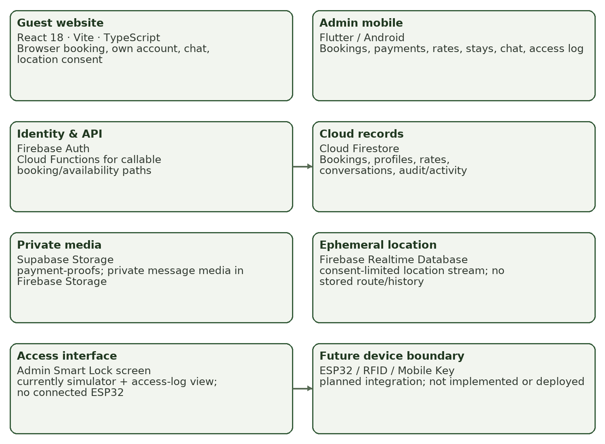
Figure 2 summarizes the repository-documented components and the boundary between implemented software and unimplemented physical lock hardware. Arrows indicate planned/current data exchange, not proof that every external service is deployed or tested.
Figure 2 shows that guest and Admin clients share cloud records but do not share privileges. Public browsing is separate from authenticated booking operations; Admin actions pass role checks and business invariants. A Cloud Function/callable boundary is documented for specific booking/availability operations; deployment state and feature flags must be verified. Error handling must preserve a visible failure rather than create a false success or replace live data with demo records. The Admin app has no documented local business database; normal business workflows depend on network access.
Figure 3
Role-based navigation and workflow views
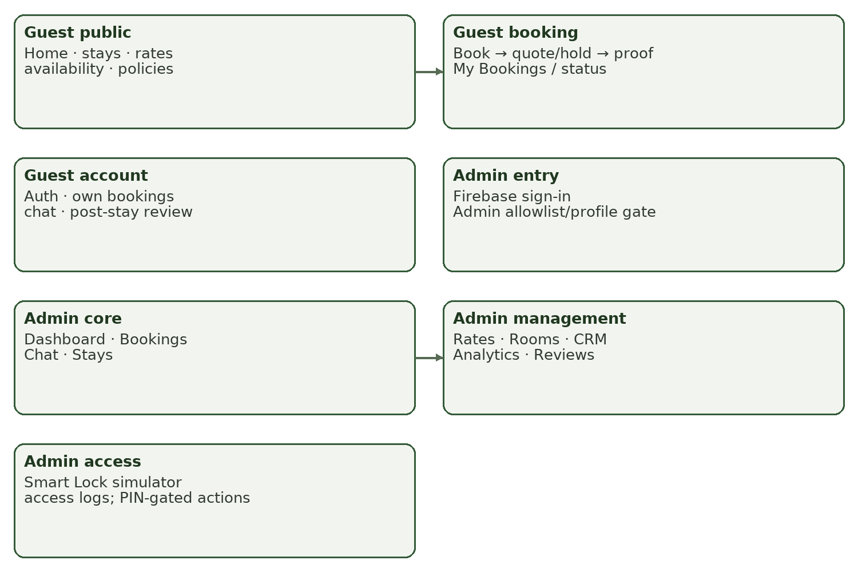
Figure 3 is a navigation map reconstructed from repository screens. It shows role separation and identifies the Smart Lock simulator as distinct from an actual device connection.
The next views are reconstructed Chapter III design aids, not previously approved activity diagrams. Their P1–P11 identifiers align with the provisional process labels used in Table 7. The adviser must replace or reconcile these views with the signed Context/Level 0/Level 1 DFD, ERD and UML baseline when supplied; no missing model is represented as approved.
Figure 4
Context and Level 1 data-flow view (provisional)
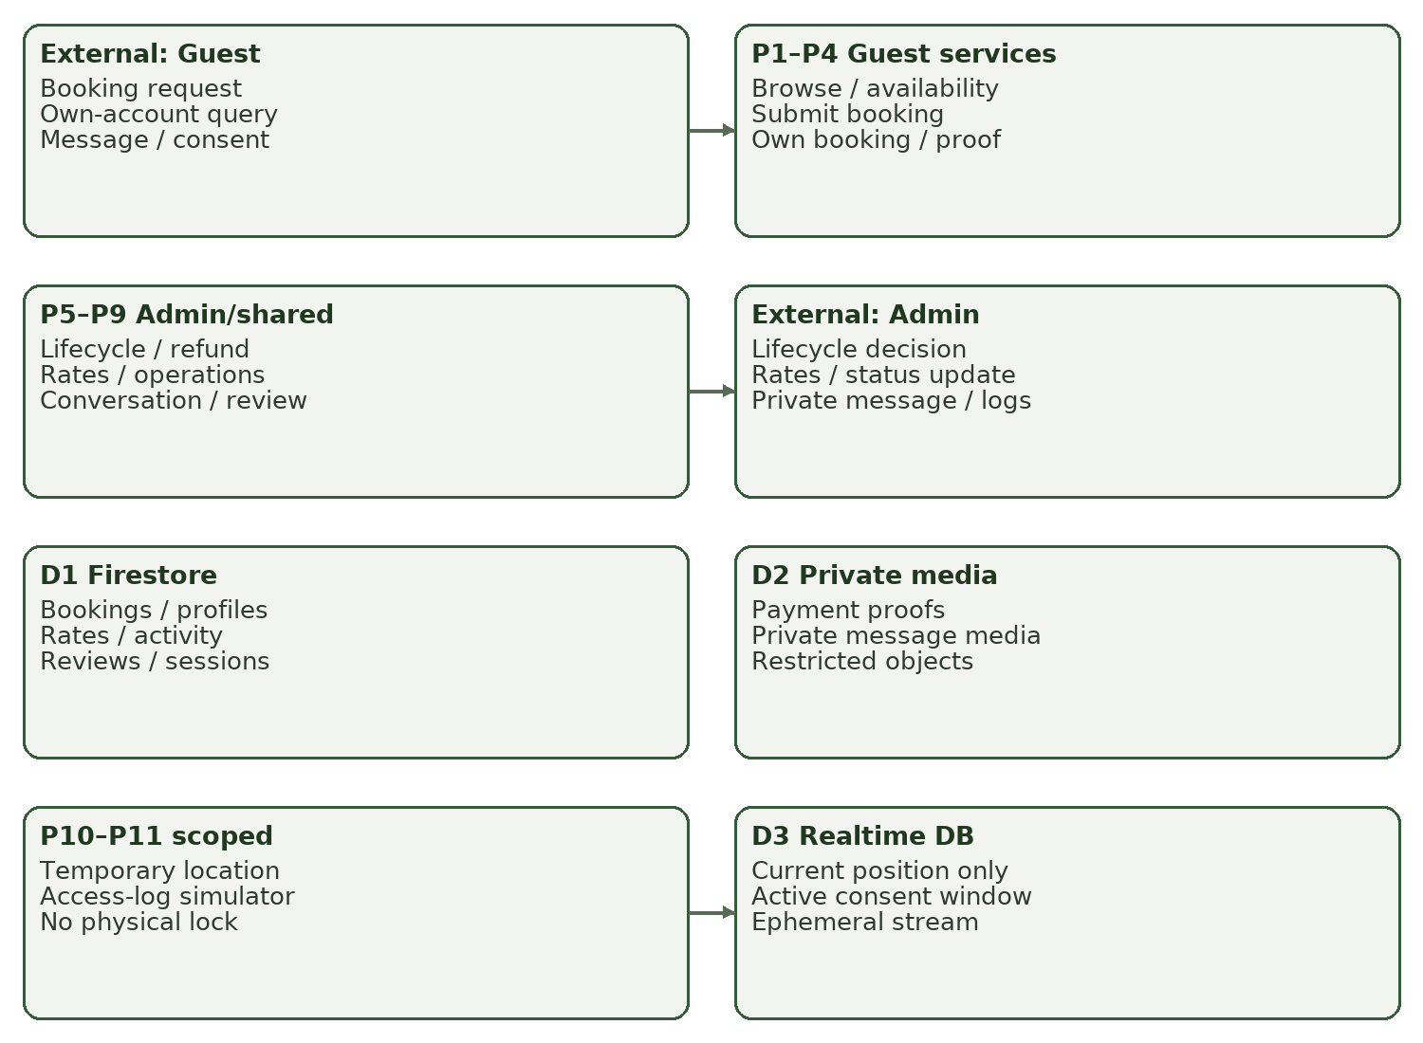
Figure 4 identifies Guest and Admin external actors, major workflow process groups and the project’s persistent/ephemeral data stores. P1–P11 are draft process labels for traceability; arrows summarize system exchanges rather than assert deployment of every service.
Figure 5
Conceptual entity relationship view (provisional)
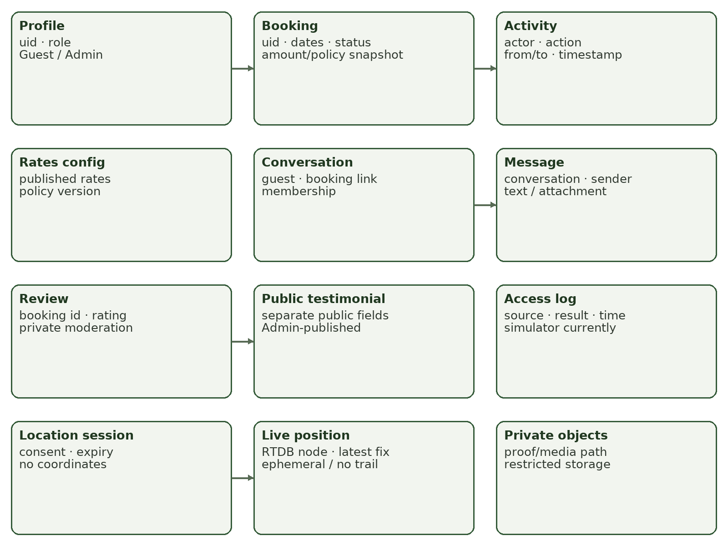
Figure 5 summarizes repository-named data entities and selected relationships: profiles own bookings; bookings have activity and eligible reviews; a private review can produce a separate public testimonial; conversations contain messages; location consent is separate from an ephemeral position. The diagram is conceptual, not an approved ERD; field-level rules remain in repository schemas and Table 8.
The data relationship rules are: one Guest identity may own multiple Bookings; each Booking may have an append-only Activity sequence and, when eligible, one private Review; an Admin may separately create or withdraw a public testimonial from a Review. A Conversation belongs to its Guest and may be associated with a Booking; Messages belong to a Conversation. Published rate settings are stored separately, while a Booking retains the applicable policy/financial snapshot. A location session records consent and expiry only; coordinates are written to a separate ephemeral Realtime Database node. These are repository-derived relationships and require final comparison with the approved ERD.
Figure 6
UML sequence diagram: Guest booking submission and Admin review (provisional)
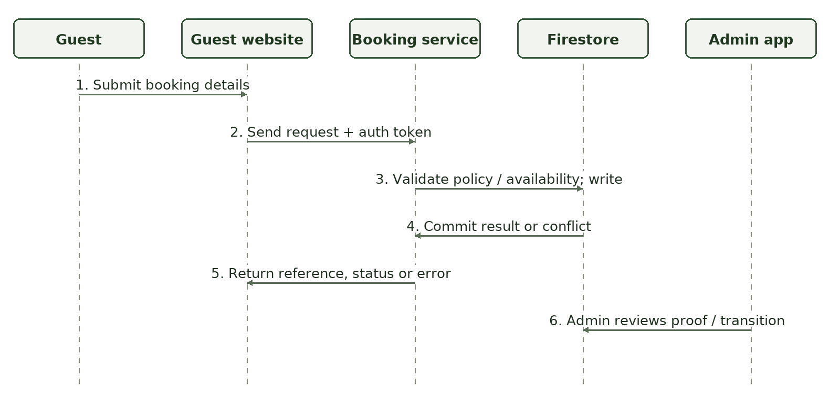
Figure 6 traces the Guest, website, booking service, Firestore and Admin app interactions for a submission and later Admin review. It is a repository-derived UML sequence view, not an approved Chapter II model or proof of a completed transaction test; duplicate/retry and availability behavior still require verification against deployed callable/rule configuration.
Table 8.
Core data dictionary and storage boundaries
ENTITY / STORE | KEY FIELDS OR PURPOSE | ACCESS / RETENTION RULE
bookings/{id} — Firestore | uid, ref_id, guest_name/contact, accommodation, check_in/out, guests, status, payment fields, totals, policy stamp, hold, reasons and timestamps. | Guest reads own booking/limited fields; Admin management subject to rules. Financial snapshots should not silently change.
bookings/{id}/activity/{seq} — Firestore | actor/actor_id, from_status, to_status, at, action and reason. | Append-only activity evidence for supported lifecycle changes; preserve as required by approved retention policy.
profiles/{uid} — Firestore | Role is guest or admin; user profile association. | Own profile reads; Admin role assignment via trusted policy; no Staff/Host roles.
site_config/rates — Firestore | Accommodation rate schedules, occupancy, holiday dates, deposit, down-payment/refund policy and version/effective date. | Public read of published values; Admin write; validate before publication.
conversations/{id}/messages — Firestore | Conversation membership, message text, timestamps and attachment reference. | Member-only access, page-limited reads, message-size and configured retention constraints.
payment-proofs — Supabase Storage | Private payment proof bytes and paths associated with booking/user. | Private bucket, authenticated authorization path; avoid public URLs and use approved signed access.
messageAttachments — Firebase Storage | Private message image objects. | Authenticated conversation access; file type/size constraints; not public.
location_sessions/{conversationId} — Firestore | Consent/session metadata, expiry, stream reference; no coordinate. | Guest-owned consent; Admin access only as authorized and time-valid; metadata retention to be confirmed.
live_location/{conversationId}/{guestUid} — Realtime Database | Latest ephemeral coordinate/accuracy/time while session is valid. | Temporary current position only; overwrite, stop/expiry/disconnect removes or blocks access; no route history.
access_logs — Firestore | Simulated/recorded access event fields; source must identify simulator versus physical device. | Admin-facing access log. Current screen supports simulation/read; no repository firmware gateway.

Data exchange protocol: website and mobile clients authenticate with Firebase Auth, then read/write only permitted data through Firebase client SDKs, rules and specific server callables. Proof upload uses the configured private storage boundary and proof references are associated with booking records; OCR produces a candidate value only. Location sharing requires explicit Guest initiation, writes consent/session metadata separately from the temporary position, and ends after stop/expiry/disconnect. Access events from the current simulator are not physical lock events. Any future device integration must define credential format, device identity, authorization, replay/duplicate handling, clock/connectivity failure, safe door state, local buffering, synchronization and revocation before testing.
Interface design is role-specific. Guest navigation centers on browse, booking, account/status, messages and post-stay review. Admin navigation centers on sign-in, dashboard, bookings, communications/stays and management screens for rates, rooms, CRM, analytics, reviews and simulated access logs. The repository contains these screen modules; actual screenshots from an approved build were not supplied for this manuscript. Figure 3 is a schematic map, not a screenshot or user-tested mockup.
Data/model alignment: repository records name bookings, profiles, site_config/rates, conversations/messages, reviews/public_reviews, access_logs, location_sessions and live_location. Before final submission, the approved ERD/DFD/UML must be placed here or cited with exact version and checked for each field/relationship. No earlier approved diagram package was in the repository files supplied for this work, so this draft does not pretend to reproduce it. Model coverage for the physical lock is legitimately absent at the current prototype stage and must be added only if the client/adviser confirms the hardware feature remains in scope.

9. Development and Testing
Development will proceed in vertical increments: (1) lock the requirement and model baseline; (2) prepare isolated fixtures and versions; (3) refine guest browse/booking/identity; (4) integrate Admin booking and lifecycle; (5) integrate rates, payment proof and private storage; (6) add communications, reviews and temporary location; (7) verify Admin management and simulator boundaries; (8) conduct regression, security, compatibility and recovery tests; (9) package a versioned pilot build only after acceptance. Existing repository code contains React/TypeScript, Flutter/Dart, Firebase rules and functions, Supabase storage policies, test suites and build scripts. The code is managed in Git; each test report must identify commit, dependency versions, runtime/device, environment and fixture. Never run destructive or test commands against live credentials/data.
The repository’s Phase 0 report dated October 1, 2026 identifies partial characterization and safety work, and states canonical gaps: Firestore/Realtime Database/Storage emulator tests were blocked by emulator-download constraints, Flutter tests were not runnable in that environment, and live/staging verification remained unavailable. The report also records safety test results and limitations. These are dated repository evidence, not a full validation of the current build; any subsequent result must be independently re-run and logged at the new commit (Hacienda de LuisAna Project Repository, 2026a).
Table 9.
Planned test cases and acceptance criteria
ID / LINK | SCENARIO / PRECONDITION / INPUT | EXPECTED OUTPUT / THRESHOLD | ACTUAL / STATUS
TC-01 / FR-01 | Valid published fixture; Guest opens browsing, rates and availability. | Correct accommodation/rate/status shown; unknown distinguished from unavailable; no stale fabricated value. | Not yet run for this protocol.
TC-02 / FR-02 | Valid Guest identity, valid dates, published rates and synthetic data; submit once. | One booking owned by caller, expected status/reference and price snapshot; exact expected field values match fixture. | Not yet run.
TC-03 / FR-02, NFR-03 | Submit invalid/too-early dates; simulate repeated request or timeout/retry. | Invalid request refused; retry creates no unintended duplicate; error visible; no false success. | Not yet run.
TC-04 / FR-03, NFR-01 | Guest A attempts read/write of Guest B booking and protected money/status fields. | Every unauthorized access/patch denied; own permitted read/action works. Zero unauthorized successes in defined test set. | Not yet run in canonical current environment.
TC-05 / FR-04, NFR-02 | Upload synthetic proof; exercise OCR and Admin verification roles. | File remains private; OCR is suggestion only; Guest cannot verify; Admin action and amount/reason validated. | Not yet run.
TC-06 / FR-05 | Exercise allowed and disallowed lifecycle transitions, conflicts, required reason, payment and refund fixture. | Only allowed state transition succeeds; date/money invariant and audit/activity evidence match expected. | Not yet run.
TC-07 / FR-06 | Publish valid then malformed rates; book using versioned fixture. | Invalid rates blocked; valid quote uses expected schedule/snapshot; historic fixture unchanged. | Not yet run.
TC-08 / FR-07, NFR-01 | Guest attempts Admin property-status operation; Admin edits synthetic status and views summary. | Guest denied; Admin permitted; summary reconciles exactly with fixture. | Not yet run.
TC-09 / FR-08, NFR-02 | Member sends message/valid image; non-member attempts read; oversize/invalid file tested. | Only members read; limits enforced; attachment private; retention/expiry behavior matches approved policy. | Not yet run.
TC-10 / FR-09 | Eligible and ineligible synthetic booking attempts review; Admin moderates. | Eligibility enforced; private review not public; separate testimonial appears only after authorized publish. | Not yet run.
TC-11 / FR-10, NFR-02 | Guest consents, sends position in test session, stops/lets expire/disconnects; Admin reads. | No consent/no active window means no read; expired/stopped stream unavailable/deleted; no durable coordinate or history. | Not yet run; multi-store canonical checks needed.
TC-12 / FR-11 | Use Smart Lock simulator to create allowed/denied event. | Screen clearly labels simulation; audit fields consistent; no claim/command of physical unlocking. | Not yet run under formal protocol.
TC-13 / FR-12 | Physical RFID/ESP32 integration test. Preconditions require approved hardware/firmware and safety plan. | Not applicable to current build; do not pass. Future threshold, cases and safe fallback require separate approved protocol. | NOT IMPLEMENTED / NOT RUN.
TC-14 / NFR-03 | Disconnect network during read/write; restore connectivity and retry. | Clear failure state; no duplicate/false success; state reconciles on recovery within client-approved target. | Not yet run; recovery-time threshold pending.
TC-15 / NFR-04 | Run agreed browser and Android matrix on recorded versions. | Core approved workflows complete on each agreed combination; no unsupported combinations claimed. | Not yet run; matrix pending client confirmation.
TC-16 / NFR-05 | Measure agreed common task end-to-end under defined network/device and repeated runs. | Report seconds, n, median/range (and percentile if justified) versus owner-approved threshold; no threshold yet. | Not yet run; numerical target pending confirmation.
TC-17 / NFR-01 | Test role transitions, signed URL authorization, location consent/expiry and rule boundary. | Unauthorized attempts denied; no exposure of private proof, message, other booking or expired position. | Partial earlier repo evidence only; formal current test not yet run.

Test levels: unit/module tests cover pure booking rules, validation, money calculations, state transitions and UI logic; integration tests cover both clients with Auth, Firestore, Storage, functions and Realtime Database contracts; system tests run the complete role scenarios in an isolated environment; acceptance tests are client-approved tasks and criteria; performance tests measure a defined end-to-end task; security tests verify allowed and denied cases at data/service boundaries; device tests are simulator-only until hardware is available. Testers record preconditions, steps, expected/actual values, date, build, environment, evidence, status, defect ID, correction and retest. A failed or blocked test is never recoded as passed. Critical privacy, authorization, money-integrity or safety defects block acceptance/pilot. Thresholds not established by the client remain pending, not guessed.
Each test case is planned, not reported as executed, unless actual dated logs are added. The only completed test statements in this draft are those explicitly attributed to the repository’s October 1, 2026 Phase 0 report. That report is partial and environment-constrained; it does not establish complete testing, production security, hardware function or client acceptance.

10. Description of Prototype
The prototype is the current source repository, a multi-module software implementation in progress, not evidence of a fully accepted or deployed production system. The current implementation includes a Guest website and Android Admin app, cloud-service integration code, role/rules configuration, a Smart Lock simulator and temporary live-location modules. The physical ESP32/RFID reader/mobile-key hardware gateway is not present or wired. No public demo credentials or stable, approved build link was supplied. Figures 7 and 8 are schematic mockups prepared to show intended role-specific screen content; they are not screenshots and do not assert that each visual element has been tested.
Figure 7
Guest booking workflow screen (schematic mockup)
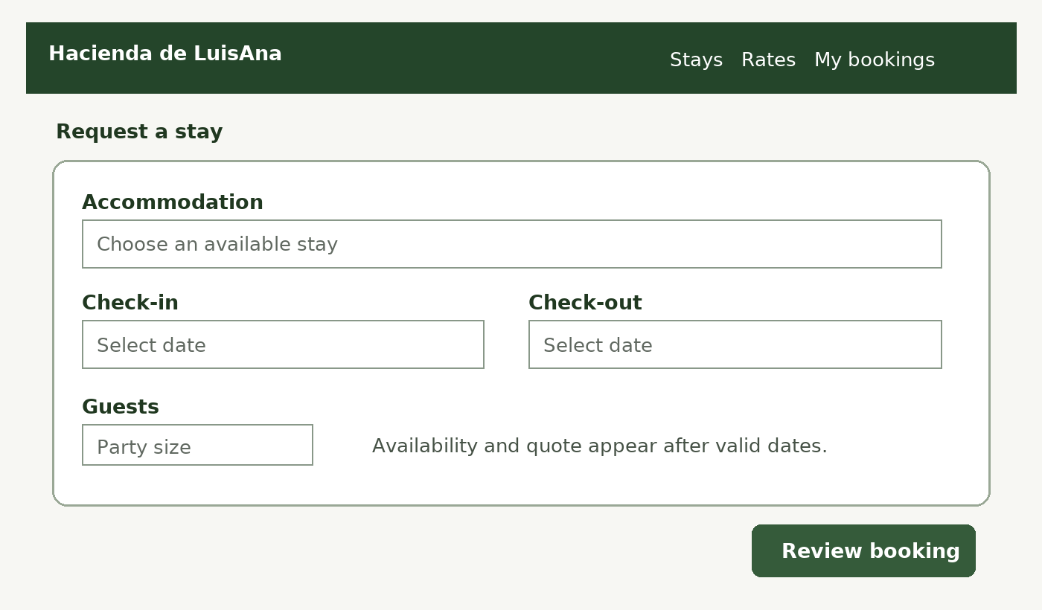
Figure 7 is a proposed Guest website wireframe for selecting an accommodation, dates and party size before reviewing a booking. It illustrates FR-01 and FR-02 inputs and is labelled as a mockup, not a screenshot or proof of live booking functionality.
Figure 8
Admin booking detail and payment review (schematic mockup)
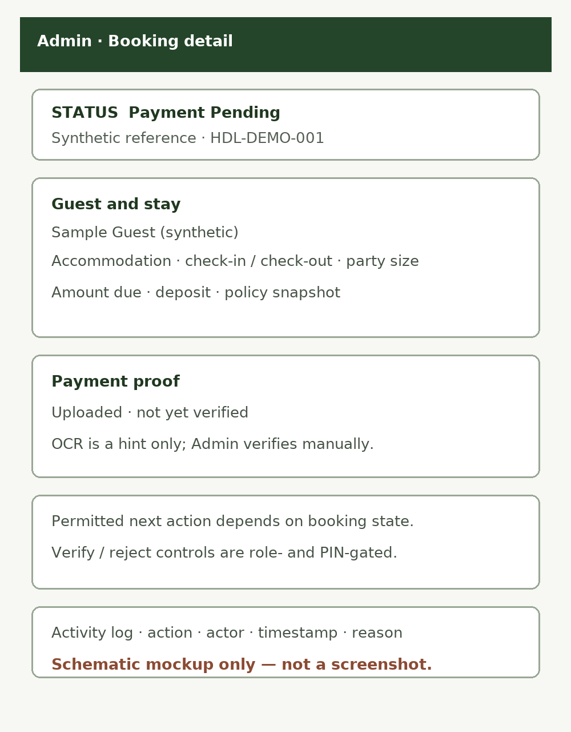
Figure 8 is a proposed Admin mobile view using only synthetic sample labels. It separates booking status, payment proof (pending manual review), permitted actions and activity history; it does not show real guest/payment information or connected hardware. It illustrates FR-04 and FR-05, not an evaluated build.
Table 10.
Prototype inventory and status
MODULE / INTENDED USER | INPUT → OUTPUT / LINKED FR | REPOSITORY STATUS AT 2026-10-31 | LIMITATION / FIGURE
Guest public browse / Guest | Browse request → accommodation, published rate and availability display; FR-01. | Web modules exist in src/; prototype code present. | Production deployment/version not verified. Figures 3 and 7 are schematic.
Guest booking and account / Guest | Dates, guest information, identity, payment proof → booking/status/history; FR-02–04. | Web booking/account modules and service code present. | Live flags/server deployment and canonical tests need verification; use synthetic records for evaluation. Figure 7 is a mockup.
Guest messaging/review/location / Guest | Text/media, post-stay review, explicit location consent → private message/review/temporary stream; FR-08–10. | Repository contains web components and service code. | No end-user evaluation documented; location is ephemeral, not route history.
Admin booking/payment/stays / Admin | Booking, proof and action fields → lifecycle/refund/activity outcome; FR-04–05. | Flutter screen/service code present. | No acceptance sign-off; deployment/build state must be confirmed. Figure 8 is a mockup.
Admin rates/rooms/CRM/analytics/reviews / Admin | Configuration and records → management and summary screens; FR-06–09. | Flutter modules are present per APP_PLAN and source tree. | Current client configuration and acceptance not evidenced.
Admin Smart Lock simulator / Admin | Synthetic event/action → simulated access-log display; FR-11. | Simulator and access-log screen exist. | Clearly simulated; no ESP32, RFID reader or physical actuation.
Physical RFID/Mobile Key/ESP32 / Admin and hardware | Credential/read/event → authorization and lock operation; FR-12. | Not implemented in repository; no firmware/gateway. | Not a functional prototype feature; excluded from pilot until approved hardware protocol.

Prototype access and build instructions will be supplied only after confirming a safe build and approved non-production environment. Development instructions in the repository include running a Vite website and Flutter Android app; these are developer commands, not a public prototype link or proof of deployable release. Any final demonstration will identify exact commit, build, test dataset, simulated services and nonfunctional features. Use anonymized/synthetic screenshots; display current implementation status beside any device illustration.

11. Implementation Plan
The implementation plan is conditional and deliberately distinguishes prototype completion from live deployment. Before any pilot, the client will confirm hosting, Firebase project and service configuration, applicable privacy/consent notices, supported browser/Android devices, backup/recovery, operational contact, data migration needs and lock boundary. Production credentials must never be copied into the manuscript or test fixtures. If physical RFID/ESP32 access remains in the approved scope, it requires an explicit safety review, hardware inventory, credential lifecycle, offline/revocation and rollback plan before commissioning.
Table 11.
Provisional implementation and handover schedule
TASK / OWNER | DATES / PREREQUISITE | RESOURCES / OUTPUT | ACCEPTANCE / STATUS
Confirm scope, environment and permission / Researcher + owner + adviser | Nov 2–6, 2026; institutional/site clearance. | Approved objectives/FR IDs, service inventory, authorized test environment, permission record. | Signed scope and environment checklist; planned.
Prepare release candidate and backups / Developer + technical evaluator | Nov 9–13; confirmed scope, safe configuration. | Versioned source/build; synthetic fixture; backup/restore procedure; no live credentials in test. | Reproducible build and restore check; planned.
Deploy/configure limited test environment / Authorized technical operator | Nov 16–18; release candidate, service approvals, security review. | Hosting/services, rules, storage, authorized Android device, monitoring and access list. | Health/access checks and rollback path pass; planned, no production deployment claim.
Run system/security/compatibility tests and fix defects / Testers + developer | Nov 19–27; test environment ready. | Tables 9 test log, defects/retests, agreed devices/network, private synthetic data. | All critical cases pass; other deviations accepted in writing or pilot blocked; planned.
Train Admin and rehearse fallback / Researcher + owner | Nov 30–Dec 4; accepted test candidate. | Admin quick guide, booking/payment/recovery scenarios, contact and fallback sheet. | Owner demonstrates critical workflows and fallback; planned.
Instrument evaluation / Researcher + eligible respondents | Dec 7–11; review/consent, pilot instrument revision, stable build. | Role-specific forms, session records, controlled scenarios and secure storage. | Completed collection log and data quality check; planned, date subject to approvals.
Limited operational pilot OR prototype-only closeout / Owner + adviser | Dec 14–18; all readiness criteria, written client permission. | Limited participant cohort, monitoring, support channel, rollback. If readiness fails, no deployment; document prototype-only disposition. | Signed acceptance or documented deferral; no pilot/deployment evidence yet.
Handover and support review / Researcher + owner | After acceptance only; approved pilot closeout. | Version/build, source handover, user/Admin guides, known issues, backup/restore, maintenance contact. | Owner acknowledges turnover; support/retention arrangements approved; planned.

Readiness, fallback and handover checklist
• Do not migrate or copy production personal/payment data into a test project without written permission, minimization and a documented rollback.
• Before pilot: verify current production/test project identity, authorized accounts, least privilege, rules, private storage, location consent/expiry, backups, restore evidence, logging, supported devices, contact and incident procedure.
• Fallback: stop new online submissions if authoritative availability or payment state cannot be confirmed; use the client-approved phone/email/manual process without promising availability; reconcile later under Admin review and preserve an audit record.
• Rollback: disable access or revert the last accepted build/configuration; protect booking and financial records; do not manually alter or delete business records to conceal an incident. Physical lock failure requires the owner’s approved safe manual-access procedure; no such hardware procedure is asserted as existing.
• Handover requires build/version identification, user and Admin instructions, known limitations, support/incident contact by role, retention/deletion schedule, backup/restore evidence, client acceptance, and adviser/owner approval. All remain planned until dated evidence exists.
Schedule dates after October 31, 2026 are proposed planning dates, not commitments or completed activities. The owner and institution must confirm the academic calendar and permissions. If no permission, suitable test population, stable build, or acceptance evidence is available, the study will report the prototype and limitations and defer deployment rather than imply a live system trial.

References
Agile Manifesto. (2001). Manifesto for Agile Software Development. https://agilemanifesto.org/
Hacienda de LuisAna Project Repository. (2026a, October 1). Phase 0 report (tests & safety preparation) [Internal project report]. docs/phase0/REPORT.md.
Hacienda de LuisAna Project Repository. (2026b, September 24). App plan: Two roles, two apps [Internal project design document]. docs/APP_PLAN.md.
Hacienda de LuisAna Project Repository. (2026c). Context and domain glossary [Internal project documentation]. CONTEXT.md.
Hacienda de LuisAna Project Repository. (2026d). Hacienda de LuisAna flow, corrected [Internal project workflow documentation]. docs/HDL_FLOW_CORRECTED.md.
Hacienda de LuisAna Project Repository. (2026e). Data stores and application architecture [Internal project documentation]. docs/DATA_STORES.md; docs/FIREBASE_SETUP.md.
International Organization for Standardization. (2023). ISO/IEC 25010:2023: Systems and software engineering—Systems and software Quality Requirements and Evaluation (SQuaRE)—Product quality model. https://www.iso.org/standard/78176.html
NIST/SEMATECH. (n.d.). e-Handbook of statistical methods. https://www.itl.nist.gov/div898/handbook/
Tejada, J. J., & Punzalan, J. R. B. (2012). On the misuse of Slovin’s formula. The Philippine Statistician, 61(1), 129–136. https://www.psai.ph/docs/publications/tps/tps_2012_61_1_9.pdf

