**What is this repo ?**

This repository is a implementation of FastAi library on pytorch for Vision and Nlp real datasets. You can find the original files on Kaggle, or use these codes to your daily tasks.

This repo includes:

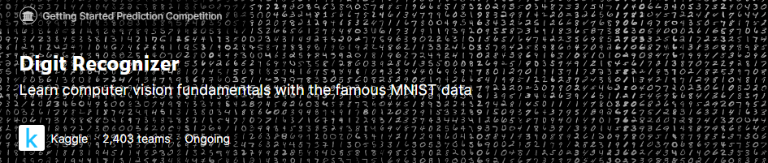

* Mnist - Digit Recognizer

Vision Task, for understanding the fundamentals of vision with dl.

I am showing the implementation of FastAI V1 lib.



* Statoil/C-CORE Iceberg Classifier Challenge

Vision Task, I am showing the implementation of FastAI V1 lib.

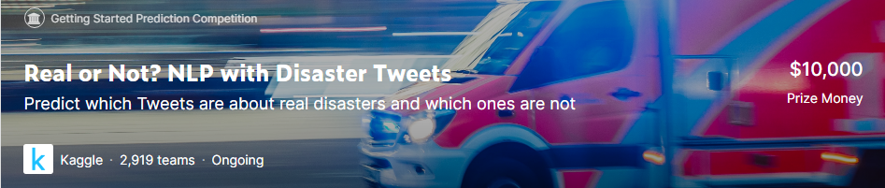

* Nlp Task, weight and corpus of fastai (Wkitext103)
* Fastai with 🤗Transformers (BERT, RoBERTa, XLNet, XLM, DistilBERT) - (WIP)

Enjoy!!