RIPv1–RIPv2 Network Design
and Implementation Documentation
Cisco Packet Tracer Dual-Domain Routing Project

Network 1 | 172.16.0.0/21 · Fixed /24 · RIPv1
Network 2 | 10.10.0.0/24 · VLSM · RIPv2
WAN boundary | 10.0.0.0/29 · Two /30 links
Name: | Castillon, Donessa Merced
Status | Implemented and connectivity-verified

Prepared as the technical record of addressing, routing, and verification

Table of Contents
Table of Contents 2
1. Executive Summary 3
2. Project Objectives 3
3. Logical Topology 3
4. Addressing Design Summary 4
4.1 Allocation validation 4
5. Network 1 — RIPv1 and Fixed-Length Subnetting 4
6. Network 2 — RIPv2 and VLSM 4
7. WAN Boundary Addressing 5
8. Router Interface Address Register 5
9. End-Device Addressing 5
10. Routing Protocol Implementation 6
10.1 RIPv1 domain 6
10.2 RIPv2 domain 6
10.3 RIPv1/RIPv2 boundary compatibility 6
10.4 Recommended operational settings 7
11. Verification Evidence 7
11.1 RIPv1 verification 7
11.2 RIPv2 verification 8
11.3 Cross-domain ping verification 9
12. Recommended Verification Commands 9
13. Troubleshooting Guide 10
14. Documentation Corrections and Notes 10
15. Conclusion 10

In Microsoft Word, right-click this field and select Update Field to refresh page numbers.

1. Executive Summary
This project implements two routed network domains connected by two redundant WAN serial links:
- Network 1 (left side) uses the base block 172.16.0.0/21, fixed-length /24 subnets, and RIPv1.
- Network 2 (right side) uses the base block 10.10.0.0/24, VLSM, and RIPv2.
- The WAN boundary uses 10.0.0.0/29, divided into two /30 point-to-point links.
The design contains eight routers, eight LANs, eight internal serial links, and two cross-domain WAN links. The left and right domains use different RIP versions, so their boundary interfaces require explicit RIP version compatibility. End-to-end ping tests confirm communication between a host in the RIPv1 domain and a host in the RIPv2 domain.

2. Project Objectives
The network was designed to:
- Apply fixed-length subnetting to the left-side 172.16.0.0/21 allocation.
- Apply VLSM efficiently to the right-side 10.10.0.0/24 allocation.
- Use RIPv1 for the left routing domain and RIPv2 for the right routing domain.
- Connect the routing domains using two independent /30 WAN links.
- Preserve RIPv2 VLSM information inside Network 2.
- Provide alternate routing paths if an internal or boundary link fails.
- Verify local and cross-domain reachability using IOS show commands and PC ping tests.

3. Logical Topology
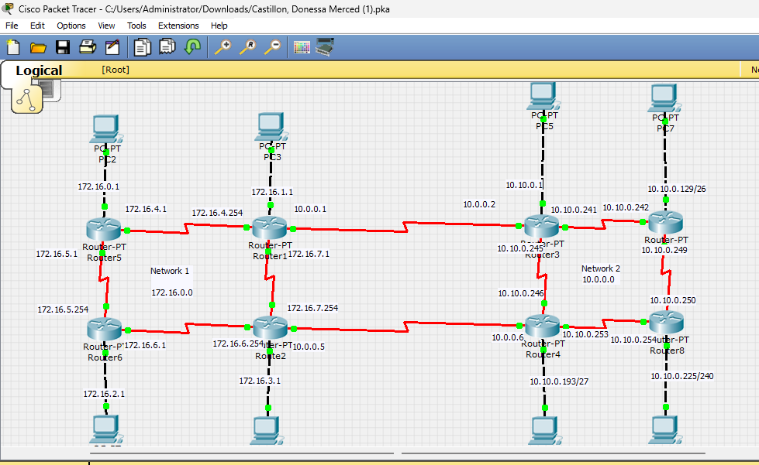
Figure 1. Complete topology. Router1–Router3 form the upper WAN boundary, while Router2–Router4 form the lower WAN boundary.
The topology is arranged as two four-router rings:
- Left ring: Router5, Router1, Router2, and Router6.
- Right ring: Router3, Router7, Router8, and Router4.
- Upper boundary: Router1 to Router3.
- Lower boundary: Router2 to Router4.
Each router serves one directly connected PC LAN. The ring layout and the two WAN boundary links provide more than one possible path between the routing domains.

4. Addressing Design Summary
Routing domain | Address block | Subnet method | Routing protocol | Allocation result
Network 1 | 172.16.0.0/21 | Fixed-length /24 | RIPv1 | Four LANs and four serial networks
Network 2 | 10.10.0.0/24 | VLSM | RIPv2 | Four variable-size LANs and four /30 serial networks
WAN boundary | 10.0.0.0/29 | Two /30 links | RIP boundary exchange | Router1–Router3 and Router2–Router4

4.1 Allocation validation
- A /21 contains 2,048 addresses. Dividing it into /24 networks produces exactly eight subnets, covering 172.16.0.0 through 172.16.7.255 without overlap.
- The right-side VLSM plan consumes the entire /24: 128 + 64 + 32 + 16 + 4 + 4 + 4 + 4 = 256 addresses.
- A /29 contains eight addresses and divides exactly into the two required /30 point-to-point links.

5. Network 1 — RIPv1 and Fixed-Length Subnetting
Base network: 172.16.0.0/21 Subnet mask used throughout: 255.255.255.0 (/24) Routing protocol: RIPv1
Label | Connection | Network address | Prefix | Subnet mask | First usable | Last usable | Broadcast
LAN 1 | Router5–PC2 | 172.16.0.0 | /24 | 255.255.255.0 | 172.16.0.1 | 172.16.0.254 | 172.16.0.255
LAN 2 | Router1–PC3 | 172.16.1.0 | /24 | 255.255.255.0 | 172.16.1.1 | 172.16.1.254 | 172.16.1.255
LAN 3 | Router6–PC0 | 172.16.2.0 | /24 | 255.255.255.0 | 172.16.2.1 | 172.16.2.254 | 172.16.2.255
LAN 4 | Router2–PC1 | 172.16.3.0 | /24 | 255.255.255.0 | 172.16.3.1 | 172.16.3.254 | 172.16.3.255
Serial 1 | Router5–Router1 | 172.16.4.0 | /24 | 255.255.255.0 | 172.16.4.1 | 172.16.4.254 | 172.16.4.255
Serial 2 | Router5–Router6 | 172.16.5.0 | /24 | 255.255.255.0 | 172.16.5.1 | 172.16.5.254 | 172.16.5.255
Serial 3 | Router6–Router2 | 172.16.6.0 | /24 | 255.255.255.0 | 172.16.6.1 | 172.16.6.254 | 172.16.6.255
Serial 4 | Router1–Router2 | 172.16.7.0 | /24 | 255.255.255.0 | 172.16.7.1 | 172.16.7.254 | 172.16.7.255

RIPv1 is classful and does not include subnet masks in its updates. Fixed /24 subnetting is therefore used consistently inside the left routing domain.

6. Network 2 — RIPv2 and VLSM
Base network: 10.10.0.0/24 Routing protocol: RIPv2 Summarization setting: no auto-summary
Label | Connection | Network address | Prefix | Subnet mask | First usable | Last usable | Broadcast
LAN 1 | Router3–PC5 | 10.10.0.0 | /25 | 255.255.255.128 | 10.10.0.1 | 10.10.0.126 | 10.10.0.127
LAN 2 | Router7–PC7 | 10.10.0.128 | /26 | 255.255.255.192 | 10.10.0.129 | 10.10.0.190 | 10.10.0.191
LAN 3 | Router4–PC4 | 10.10.0.192 | /27 | 255.255.255.224 | 10.10.0.193 | 10.10.0.222 | 10.10.0.223
LAN 4 | Router8–PC6 | 10.10.0.224 | /28 | 255.255.255.240 | 10.10.0.225 | 10.10.0.238 | 10.10.0.239
Serial 1 | Router3–Router7 | 10.10.0.240 | /30 | 255.255.255.252 | 10.10.0.241 | 10.10.0.242 | 10.10.0.243
Serial 2 | Router3–Router4 | 10.10.0.244 | /30 | 255.255.255.252 | 10.10.0.245 | 10.10.0.246 | 10.10.0.247
Serial 3 | Router4–Router8 | 10.10.0.248 | /30 | 255.255.255.252 | 10.10.0.249 | 10.10.0.250 | 10.10.0.251
Serial 4 | Router7–Router8 | 10.10.0.252 | /30 | 255.255.255.252 | 10.10.0.253 | 10.10.0.254 | 10.10.0.255

The VLSM allocation is ordered from largest to smallest LAN. The remaining sixteen addresses are divided into four /30 point-to-point networks, each providing exactly two usable addresses.

7. WAN Boundary Addressing
Base network: 10.0.0.0/29 Purpose: Interconnection between the RIPv1 and RIPv2 routing domains
Label | Connection | Network address | Prefix | Subnet mask | Left router IP | Right router IP | Broadcast
WAN 1 | Router1–Router3 | 10.0.0.0 | /30 | 255.255.255.252 | 10.0.0.1 | 10.0.0.2 | 10.0.0.3
WAN 2 | Router2–Router4 | 10.0.0.4 | /30 | 255.255.255.252 | 10.0.0.5 | 10.0.0.6 | 10.0.0.7

8. Router Interface Address Register
The physical serial port numbers may vary according to the installed Packet Tracer modules. The logical link name should therefore be matched to the actual interface using show ip interface brief before pasting a configuration.
Router | Logical interface/link | IPv4 address | Prefix
Router5 | LAN to PC2 | 172.16.0.1 | /24
Router5 | Serial to Router1 | 172.16.4.1 | /24
Router5 | Serial to Router6 | 172.16.5.1 | /24
Router1 | LAN to PC3 | 172.16.1.1 | /24
Router1 | Serial to Router5 | 172.16.4.254 | /24
Router1 | Serial to Router2 | 172.16.7.1 | /24
Router1 | WAN to Router3 | 10.0.0.1 | /30
Router6 | LAN to PC0 | 172.16.2.1 | /24
Router6 | Serial to Router5 | 172.16.5.254 | /24
Router6 | Serial to Router2 | 172.16.6.1 | /24
Router2 | LAN to PC1 | 172.16.3.1 | /24
Router2 | Serial to Router6 | 172.16.6.254 | /24
Router2 | Serial to Router1 | 172.16.7.254 | /24
Router2 | WAN to Router4 | 10.0.0.5 | /30
Router3 | LAN to PC5 | 10.10.0.1 | /25
Router3 | Serial to Router7 | 10.10.0.241 | /30
Router3 | Serial to Router4 | 10.10.0.245 | /30
Router3 | WAN to Router1 | 10.0.0.2 | /30
Router7 | LAN to PC7 | 10.10.0.129 | /26
Router7 | Serial to Router3 | 10.10.0.242 | /30
Router7 | Serial to Router8 | 10.10.0.253 | /30
Router4 | LAN to PC4 | 10.10.0.193 | /27
Router4 | Serial to Router3 | 10.10.0.246 | /30
Router4 | Serial to Router8 | 10.10.0.249 | /30
Router4 | WAN to Router2 | 10.0.0.6 | /30
Router8 | LAN to PC6 | 10.10.0.225 | /28
Router8 | Serial to Router4 | 10.10.0.250 | /30
Router8 | Serial to Router7 | 10.10.0.254 | /30

9. End-Device Addressing
The first usable address on every LAN is assigned to the router and used as the default gateway. The sample PC assignments shown in the topology and connectivity test use the second usable address.
PC | Connected router | IPv4 address | Subnet mask | Default gateway
PC2 | Router5 | 172.16.0.2 | 255.255.255.0 | 172.16.0.1
PC3 | Router1 | 172.16.1.2 | 255.255.255.0 | 172.16.1.1
PC0 | Router6 | 172.16.2.2 | 255.255.255.0 | 172.16.2.1
PC1 | Router2 | 172.16.3.2 | 255.255.255.0 | 172.16.3.1
PC5 | Router3 | 10.10.0.2 | 255.255.255.128 | 10.10.0.1
PC7 | Router7 | 10.10.0.130 | 255.255.255.192 | 10.10.0.129
PC4 | Router4 | 10.10.0.194 | 255.255.255.224 | 10.10.0.193
PC6 | Router8 | 10.10.0.226 | 255.255.255.240 | 10.10.0.225

10. Routing Protocol Implementation

10.1 RIPv1 domain
Router5 and Router6 require only the 172.16.0.0 classful network statement. Router1 and Router2 also activate RIP on their 10.0.0.0/30 WAN interfaces.
router rip
version 1
network 172.16.0.0
network 10.0.0.0
passive-interface FastEthernet0/0
The network 10.0.0.0 line is required only on Router1 and Router2. Router5 and Router6 should omit it because they have no directly connected 10.x.x.x interface.

10.2 RIPv2 domain
All right-side routers use RIPv2 with automatic classful summarization disabled so that the /25, /26, /27, /28, and /30 masks remain in routing updates.
router rip
version 2
no auto-summary
network 10.0.0.0
passive-interface FastEthernet0/0
In Cisco IOS RIP configuration, network 10.0.0.0 is a classful activation statement. It enables RIP on the connected 10.10.0.0/24 VLSM interfaces and the 10.0.0.0/29 WAN interfaces; it does not redefine Network 2 as 10.0.0.0.

10.3 RIPv1/RIPv2 boundary compatibility
RIPv1 and RIPv2 do not exchange updates reliably if the RIPv2 WAN interface accepts only version 2. Apply interface-specific receive settings on both right-side boundary links:
! Router3 interface facing Router1
interface <serial-to-Router1>
ip rip receive version 1 2
! Router4 interface facing Router2
interface <serial-to-Router2>
ip rip receive version 1 2
For an explicit, symmetric configuration, the left boundary interfaces can be set to send RIPv1 and receive RIPv2:
! Router1 interface facing Router3, and Router2 interface facing Router4
interface <boundary-serial-interface>
ip rip send version 1
ip rip receive version 1 2
The right boundary routers continue sending RIPv2. The left routers can receive those updates and advertise a classful 10.0.0.0/8 reachability route inside Network 1. The right routers receive the RIPv1 172.16.0.0/16 summary and advertise it through Network 2 using RIPv2.

10.4 Recommended operational settings
- Make each PC-facing FastEthernet interface passive so hosts do not receive RIP advertisements.
- Configure clock rate only on the DCE end of each serial connection.
- Apply no shutdown to every router interface.
- Keep no auto-summary on every RIPv2 router.
- Configure both WAN boundary interfaces for RIPv1 reception on the RIPv2 side to preserve redundancy.

11. Verification Evidence

11.1 RIPv1 verification
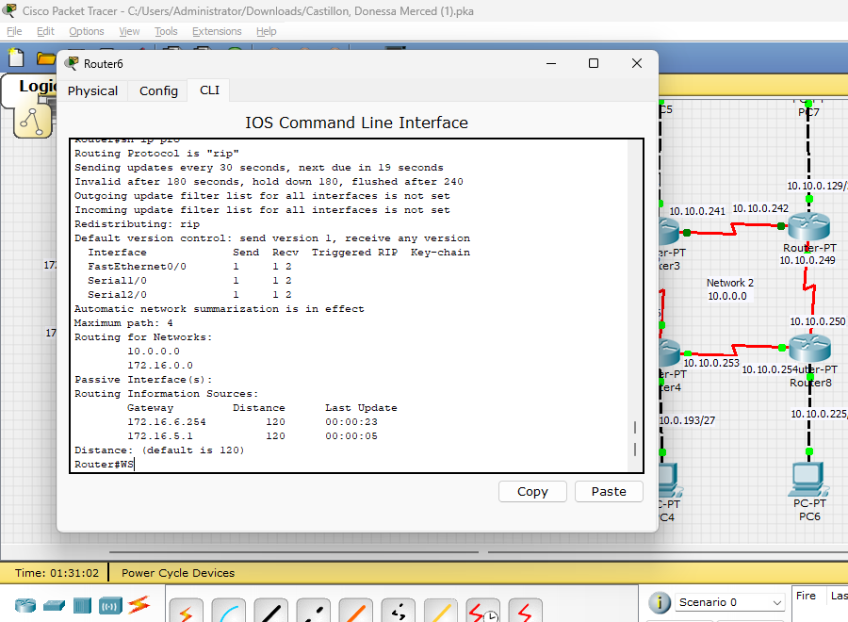
Figure 2. The show ip protocols output verifies RIP operation on the left. It shows version 1 transmission, RIPv1/RIPv2 reception capability, automatic summarization, and learned routing information from neighboring 172.16.x.x routers.

11.2 RIPv2 verification
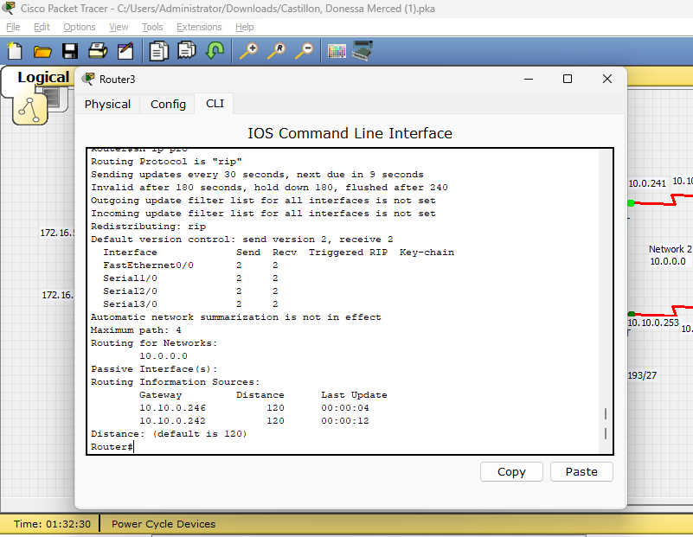
Figure 3. Router3 is operating with RIPv2, sends and receives version 2 on its internal interfaces, and has automatic summarization disabled. The listed sources 10.10.0.242 and 10.10.0.246 correspond to its Router7 and Router4 neighbors.
The captured Router3 output shows version-2-only reception on the displayed interfaces. For complete dual-WAN failover, the Router3 interface toward Router1 should be changed to ip rip receive version 1 2; the same rule applies to Router4 toward Router2.

11.3 Cross-domain ping verification
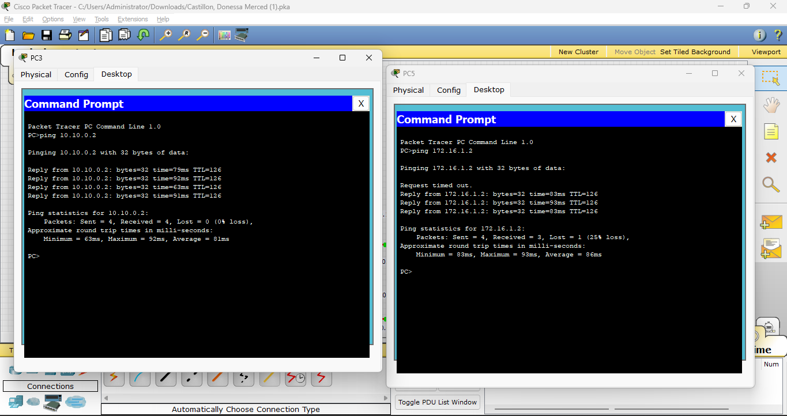
Figure 4. PC3 (172.16.1.2) successfully reaches PC5 (10.10.0.2), and PC5 successfully reaches PC3. The first request from PC5 times out while the remaining three replies succeed. In Packet Tracer, this commonly occurs during initial ARP resolution and does not indicate a persistent routing failure.
Test | Source | Destination | Observed result | Status
Cross-domain ping 1 | PC3 (172.16.1.2) | PC5 (10.10.0.2) | 4 of 4 replies, 0% loss | Pass
Cross-domain ping 2 | PC5 (10.10.0.2) | PC3 (172.16.1.2) | 3 of 4 replies after initial timeout | Pass
RIPv1 operation | Router6 | show ip protocols | RIP version 1 transmission and neighbor updates shown | Pass
RIPv2 operation | Router3 | show ip protocols | RIP version 2 and no auto-summary shown | Pass

12. Recommended Verification Commands
Run the following commands on every router after configuration or topology changes:
show ip interface brief
show ip protocols
show ip route
show ip route rip
show interfaces serial
Recommended functional tests:
- Ping each PC's default gateway.
- Ping another LAN inside the same routing domain.
- Ping from PC3 (172.16.1.2) to PC5 (10.10.0.2).
- Ping from PC5 to PC3.
- Shut down WAN 1 temporarily and repeat the cross-domain ping to test WAN 2.
- Restore WAN 1, shut down WAN 2, and repeat the test through WAN 1.
- Restore all interfaces and confirm both RIP paths return to the routing tables.

13. Troubleshooting Guide
Symptom | Likely cause | Corrective action
A PC cannot reach its gateway | Incorrect PC mask/gateway or router LAN interface is down | Check the PC IPv4 settings and show ip interface brief
Left-side local routes are missing | RIPv1 not enabled on a 172.16.x.x interface | Add network 172.16.0.0 and verify the interface is up
Right-side VLSM routes appear with wrong masks | RIPv2 is missing or auto-summary is enabled | Configure version 2 and no auto-summary
Right side cannot learn 172.16.0.0/16 over a WAN link | Boundary RIPv2 interface rejects RIPv1 updates | Configure ip rip receive version 1 2 on that interface
Left side cannot reach 10.10.0.0/24 | Boundary update is missing or the left router has no route to 10.0.0.0/8 | Check RIP neighbors, boundary interface versions, and show ip route rip
Serial interface is down/down | Cable or module problem | Check the selected ports and physical connection
Serial interface is up/down | Encapsulation mismatch or missing DCE clock | Match encapsulation and configure DCE clock rate
First ping fails but later pings work | ARP resolution or initial route convergence | Repeat the ping after a few seconds
Failover works through only one WAN | Only one RIPv2 boundary interface accepts RIPv1 | Apply boundary compatibility to Router3 and Router4

14. Documentation Corrections and Notes
- The right-side base allocation is `10.10.0.0/24`. If the topology label displays “Network 2 10.0.0.0,” it should be relabeled to 10.10.0.0/24.
- The separate `10.0.0.0/29` allocation belongs only to the two WAN boundary links.
- The IOS command network 10.0.0.0 under RIP is expected because IOS uses the classful major network in the RIP process. It does not conflict with the VLSM addressing table.
- Router interface numbers are hardware-dependent in Packet Tracer. The IP-to-link assignments in this document are authoritative; confirm actual port numbers with show ip interface brief.
- The supplied screenshots demonstrate successful end-to-end communication. A separate link-failure test should be captured if proof of both WAN paths is required for assessment.

15. Conclusion
The completed design meets the required subnetting and routing objectives. Network 1 uses all eight /24 subnets derived from 172.16.0.0/21, while Network 2 uses the complete 10.10.0.0/24 block efficiently through VLSM. Two /30 WAN links derived from 10.0.0.0/29 connect the domains. RIPv1 supports the fixed-length left side, RIPv2 preserves the variable-length right side, and boundary interface version controls allow routes to pass between them. The supplied ping evidence confirms successful communication between hosts in the two routing domains.

