Add Relay Ladder event format

1. Background
Nova Event Admin currently supports Solo Sprint and Team Circuit but not checkpoint relay configuration.

2. Goal
Allow Event Operators to configure valid Relay Ladder drafts and allow Event Admins to publish them.

3. Requirements
Sequence | Module | Prototype | Logic
1 | Basic Information  Relay Ladder configuration | 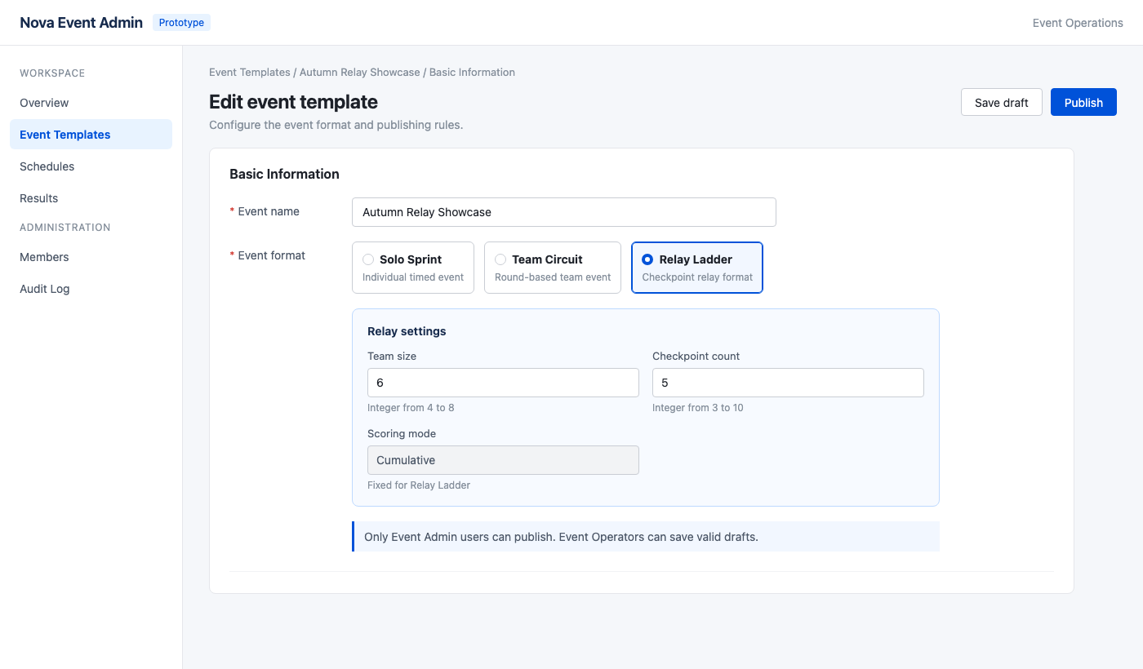 | - [Added content] Add Relay Ladder to Event format.  - [Trigger] Show Relay settings when selected.  - [Field source] Team size 4–8; checkpoints 3–10; scoring Cumulative.  - [Validation] Require both ranges before saving.
2 | Draft and Publish  Save and publish permissions | No additional prototype | - [Trigger] Enable Save draft after validation.  - [Permission] Operators save drafts; Admins publish.  - [Boundary] Existing formats remain unchanged.

4. Non-goals
Do not change Solo Sprint or Team Circuit behavior.

