ROTARY CLUB OF HASSAN
Rotary International — District 3181

MINUTES OF MEETINGS
Rotary Year 2026–27
RI Theme: "Creating Lasting Impact"
Team AIKYAM
MEETING 3
Induction Programme for Newly Inducted Members

Date | 16 July 2026
Venue | Chiranthana, K. R. Puram, Hassan
PROCEEDINGS
The meeting was called to order by President Rtn. Dr. Geetha Kiran A.
The programme was organized to formally welcome and familiarize the newly inducted members with the Rotary Club of Hassan.
The newly inducted members introduced themselves, sharing their professional backgrounds, interests, and aspirations for contributing to Rotary service.
Past District Governor (PDG) Rtn. M. K. G. Kumar addressed the gathering and welcomed the new members into the Rotary family. He highlighted the significance of Rotary's service initiatives and encouraged active participation in club activities.
Immediate Past District Governor (IPDG) Rtn. Palaksha spoke about the functioning and achievements of the club and assured the new members of his continued support and guidance in all future activities.
The President thanked the speakers for their inspiring words and encouraged the new members to actively engage in the club's service projects and fellowship activities.
The meeting concluded with the Vote of Thanks proposed by Rtn. Sunitha Somashekar, Secretary.
PHOTOGRAPHS
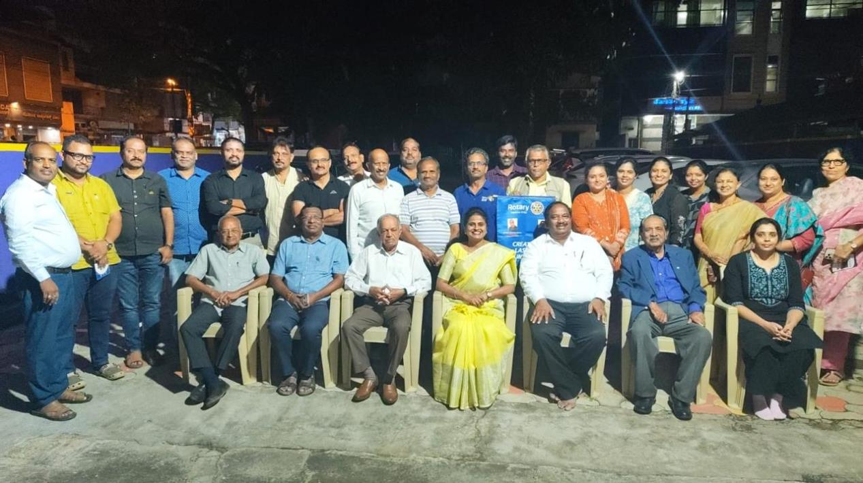
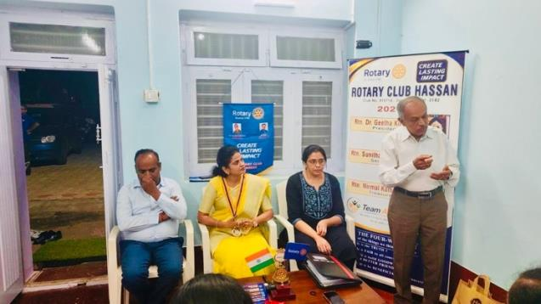 | 