ROTARY CLUB OF HASSAN
Rotary International — District 3181

MINUTES OF MEETINGS
Rotary Year 2026–27
RI Theme: "Creating Lasting Impact"
Team AIKYAM
MEETING 4
Orientation Session for Newly Inducted Members

Date | 23 July 2026
Venue | Chiranthana, K. R. Puram, Hassan
PROCEEDINGS
The meeting was called to order by President Rtn. Dr. Geetha Kiran A.
The orientation programme was organized to provide the newly inducted members with a comprehensive understanding of Rotary International, its history, organizational structure, and leadership responsibilities.
PDG Rtn. Ramesh delivered an informative session on the origin and evolution of Rotary. He traced Rotary's journey from its establishment in 1905 to its transformation into one of the world's largest humanitarian service organizations. He highlighted Rotary's major milestones, flagship service initiatives, global reach, and the enduring values that continue to guide Rotarians worldwide.
IPDG Rtn. Palaksha presented the organizational structure of Rotary International. He explained the hierarchy from Rotary International to Zones, Districts, Clubs, and Club Committees, emphasizing the leadership responsibilities at every level. He elaborated on the pivotal role of the Club President in providing leadership and coordination while explaining how the Secretary, Treasurer, Directors, Committee Chairs, and members collectively contribute to achieving the club's goals.
Rtn. Pradeep delivered a detailed presentation on the roles and responsibilities of all office bearers and committee members. He emphasized teamwork, accountability, effective communication, and active participation as key elements for a successful Rotary year.
The President thanked all the resource persons for their insightful presentations and encouraged the new members to uphold Rotary's ideals through active participation and dedicated service.
The meeting concluded with the Vote of Thanks delivered by Rtn. Sunitha Somashekar, Secretary.
PHOTOGRAPHS
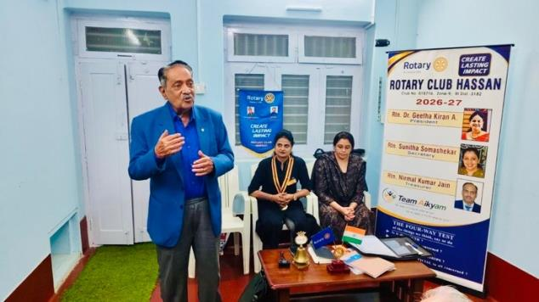 | 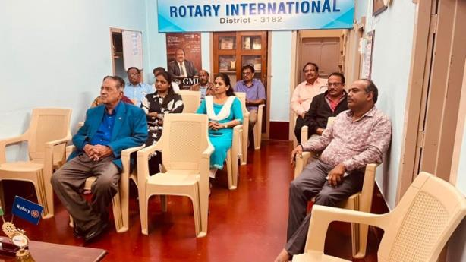

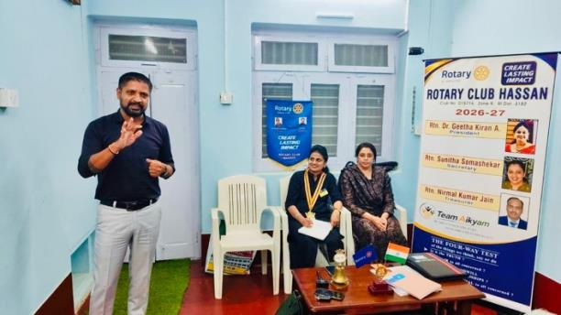 | 