AP6412 Group Report — The Art of Weaving
Group members:
Zhang Qichen (branch member/jokiller), Gong Xiaoya (branch member/xiaoya)
Engine: Godot 4.7, GDScript · Route B (one game, 2D and 3D versions)
Repository: https://github.com/JOKILLER-git/TheArtOfWeaving · Tags: v0-weaving-prototype, v0.1-knit-prototype, 2d-baseline, 3d-final

1. Game overview
Concept. The Art of Weaving is a calm, tactile knitting game inspired by the “no failure, just put it right” feel of A Little to the Left. The player holds the end of a strand of yarn and knits a small swatch, one stitch at a time, by physically hooking the yarn through the loops of the row below.
Core idea — the gesture is the stitch. Real knitters never “choose” whether a strand passes over or under another; they perform a motion and the crossing follows from it. The game models this directly: - Drag the yarn tip upward through the eye of the next loop → a new loop is pulled through. - The working yarn is either behind or in front of the fabric. Hooking with the yarn behind makes a knit stitch (V); with the yarn in front it makes a purl stitch (horizontal bump) — exactly as in real knitting, where the yarn is brought forward before purling. - Wrapping the yarn once around the point where it leaves the fabric moves it to the other side.
Objective and progression. Each level shows a small pattern chart (V = knit, — = purl). The player knits the chart row by row; rows alternate direction like real flat knitting. Eleven levels form a tutorial-to-mastery curve: First Stitch → A Row → Snip (find and cut a mistake) → First Purl → Purl Row → Turn → Rib Row → Rib → Seed → Ridges → Basket.
Outcome. A level ends when the swatch matches the chart. The game rates it with 1–3 stars knitted on screen (0 mistakes = 3, ≤2 = 2, otherwise 1) and moves on automatically. After the last level, an end screen shows a wall of all finished swatches. There is deliberately no failure state; mistakes are handled gently (see 5.3).
Creative / visual features. Almost no text UI — every action is an object:
Action | Object
Start the game | Pull the yarn end across the title screen onto a glowing spool
Quit | Cut the title yarn with the scissors
Restart a level | Drag the scissors onto the yarn; the knitted loops unravel
Choose a level | Pull down the cord hanging from the progress beads; it unfolds into a clothesline of level cards held by clothespins
Results | Stars knitted in yarn
Yarn is rendered with real over/under layering (gap outlines, shading) so the player can always see which strand is in front.
Controls. Mouse only (drag). Shortcuts: R restart, H hint, Esc title, F11 fullscreen, F3 gesture debug overlay. In 3D: right-drag to tilt the view (±20°, springs back). A View button on the title screen switches between the 2D and 3D versions.
Route. Route B. The 2D version is frozen at tag 2d-baseline. The 3D version (3d-final) shows the same swatch as real 3D yarn tubes under a slightly tilted perspective camera. “In front of / behind the fabric” becomes actual depth: with the yarn behind, the working strand passes under the loops; after a wrap it lies on top; tilting the camera makes the interlacing visible from the side. All levels, rules, gestures, scoring, scissors, level select, title and end screens are the same in both versions.

2. Original design and assumptions

2.1 Design history (how the model was found)
- Loom weaving prototype (v0-weaving-prototype): the player toggled warp threads up/down with buttons, then inserted the weft. Playtesting showed that choosing over/under by buttons was tedious and not fun.
- Knitting gesture prototype (v0.1-knit-prototype, tasks T001–T003): one script validating the gesture idea. Iterations: readability of crossings (gap outlines), purl visually distinct from knit, and finally replacing the “press down = purl” gesture with a yarn side state + wrap after playtesting showed the asymmetry was awkward. Two toggle schemes (wrap vs. dragging a tool) were built side by side and compared; wrap was chosen.
- Refactor into layers (T004) before freezing the design, because the prototype mixed rules, input, drawing and audio in ~1250 lines.

2.2 Boundaries of the game model
The core (scripts/core/) contains everything that would stay true if the game were rendered differently: stitch types, the yarn’s side, the fabric grid, pattern charts and levels, the per-level rule state machine, scoring, progress rules and gesture recognition. It extends only RefCounted/Resource and never touches nodes, input devices, drawing or audio (verified by grep in every task).
Key decision: gestures are recognised in “fabric coordinates” (units of columns and rows, y up), not screen pixels. Any presentation only has to convert a pointer position into a fabric point; the recognisers, thresholds and rules are shared.

2.3 Anticipated future requirements (recorded before the 3D work)
Likely change | Reason for predicting it | Extension point
More stitches (yarn-over, k2tog, twisted) | The next basic stitches in real knitting; already in our chapter plan | StitchType subclasses registered in StitchRegistry; views read new_loop_in_front() instead of switching on K/P
More levels and patterns | Content growth in a puzzle game | Levels are LevelDefinition resources; no code change to add one
Different ways to switch yarn side | We prototyped two (wrap, tool) | GestureRecognizer abstraction; a new scheme is another recogniser
Colourwork / changing yarn | Common in knitting | Yarn and Fabric cells can gain colour data
A different presentation (3D) | Route B; also general “re-skin” risk | Rules separated from presentation; fabric-coordinate input

2.4 Validation of the predictions during 2D development
After the core existed, four rounds of new requirements arrived from playtesting (T005–T008). Evidence that the boundaries held:
Round | New requirement | Core impact
T005 | Title/end screens, level sequence | 0 core files changed
T006 | Stars, preset mistake + cut, 11 levels, wider spacing | 2 classes added (StarRating, LevelScore); 5 classes received backward-compatible optional fields/guards; 10 of 15 unchanged; old tests passed
T007 | Hook reliability, fullscreen | Changes confined to the 2 gesture recognisers (7 diagnosed causes, each with a regression test); public interfaces unchanged
T008 | Level select, best-stars progress | 1 class added (PlayerProgress); 0 existing core files changed

3. Class Maps and architecture

3.1 Layers (3D final)
Folder | What it does
app/ | Runs the game flow, shows the title and end screens, lets players choose levels, and saves progress.
presentation_shared/ | Provides shared classes for starting and restarting levels (KnitLevelView), converting coordinates (FabricScreenMapper), and tracking the yarn tip (YarnHandle).
presentation_2d/ | Draws the 2D game and provides overlays that both versions use.
presentation_3d/ | Draws the 3D game, controls the camera, and maps the mouse position onto the fabric.
core/ | Recognizes gestures, checks stitches, and keeps track of the current level. Both versions use the same rules and data.

3.2 Class Map — 2D baseline
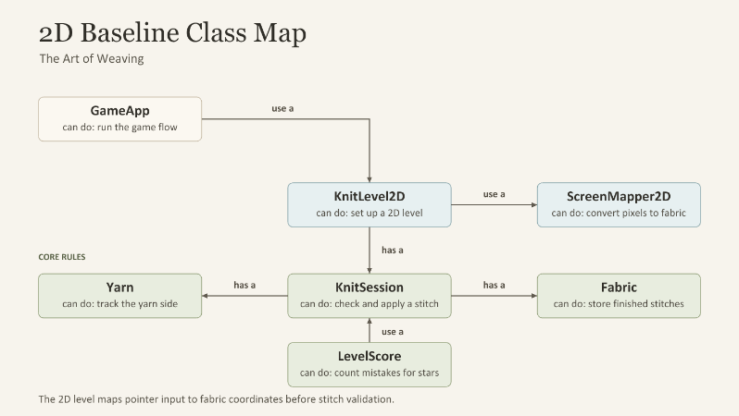

3.3 Class Map — 3D final
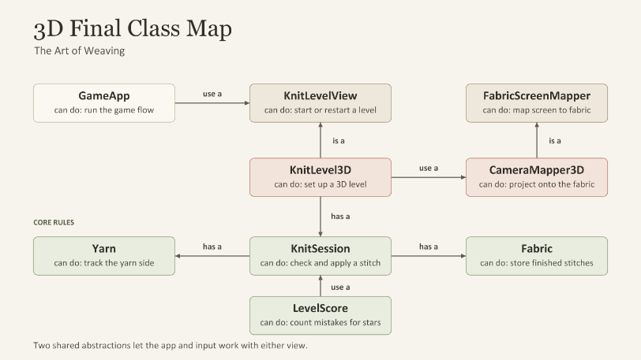

3.4 Core classes (Shared by 2D and 3D)
Class | Relationship | Can do
KnitSession | has a Yarn and a Fabric | Check whether a stitch is valid and update the fabric.
Yarn |  | Track whether the working yarn is in front of or behind the fabric.
Fabric |  | Store completed stitches.
LevelScore | use a KnitSession | Listen for mistakes and use the count to determine the star rating.

3.5 2D Baseline
Class | Relationship | Can do
GameApp | use a KnitLevel2D | Run the game flow from the title screen through the levels.
KnitLevel2D | has a KnitSession and use a ScreenMapper2D | Set up a 2D level and connect the view to the game rules.
ScreenMapper2D |  | Convert screen pixels to fabric coordinates.

3.6 3D Final Version
Class | Relationship | Can do
GameApp | use a KnitLevelView | Run either level view through the same game flow.
KnitLevelView |  | Provide a common way to start or restart a level.
KnitLevel3D | is a KnitLevelView, has a KnitSession, and use a CameraMapper3D | Set up a 3D level using the shared game rules.
FabricScreenMapper |  | Define how a view maps between screen and fabric coordinates.
CameraMapper3D | is a FabricScreenMapper | Project a ray from the camera through the pointer position onto the fabric plane.

3.7 Design considerations (SOLID where genuinely applicable)
- SRP. KnitSession owns rules only; LevelScore counts mistakes; StarRating converts mistakes to stars; PlayerProgress keeps best results; ProgressStore does file I/O. GameApp sequences levels; a level view only plays one level (sequence moved out in T005).
- OCP. New stitches = new StitchType subclass + registration; new levels = new resources; new star thresholds = data. T006–T008 added features mainly by adding classes and optional fields; the 3D version was added by adding a presentation layer, with no core change.
- LSP. HookGesture/WrapGesture are interchangeable as GestureRecognizer. KnitLevel2D/KnitLevel3D are interchangeable as KnitLevelView: the whole app flow test suite (131 checks) is re-run unchanged against the 3D level view by a subclass of the suite. ScreenMapper2D/CameraMapper3D are interchangeable as FabricScreenMapper (a test checks this).
- DIP. GameApp depends on KnitLevelView, not on a concrete level; overlays and pointer input depend on FabricScreenMapper/YarnHandle; views depend on StitchType’s crossing order rather than “if knit”.
- ISP / not applied. No interfaces for single-implementation classes (Fabric, Yarn); no event bus — Godot signals suffice.
- Trade-offs. (1) FabricLayout holds a reference to KnitSession because the anchor depends on rule state; this couples geometry to the session but avoids duplicating “where is the next stitch”. (2) The overlays reused by 3D keep their “2D” class names (HintView2D, Scissors2D…) because they are 2D screen overlays in both versions; renaming them would only have changed the frozen 2D code for cosmetic reasons.

4. Extensibility analysis (2D baseline → 3D final)

4.1 Change map
Layer | Added | Modified | Deleted | Unchanged | Why
core | 0 | 0 | 0 | 18 files (981 lines) | Rules, gestures, scoring are presentation-independent (git diff 2d-baseline 3d-final -- scripts/core is empty)
presentation_shared | 3 files (+102 lines) | — | 0 | — | Interfaces extracted so both versions plug into the same app and overlays
presentation_2d | 0 | 7 files (~19 lines changed; ~47 lines moved up into the new base classes) | 0 | 9 files | Only “depend on the interface” changes; 2D behaviour unchanged, 2D tests pass
presentation_3d | 5 files (+1010 lines) | — | — | — | Camera, ray input, tube meshes, 3D rope: the expected engine-specific differences
app | 0 | 2 files (game_app.gd depends on KnitLevelView; title_screen.gd view button) | 0 | all others | Choose the view by setting; demo toggle
scenes / config | 2 scenes | project.godot main scene (1 line) | 0 | — | game_app_3d.tscn differs from game_app.tscn by the level view setting
tests | 2 files (+134 lines) | 1 line in app suite | 0 | — | 3D suite inherits the app suite and adds 3D checks
legacy | — | — | loom-weaving prototype and single-script knit prototype | — | Unused since T004/T005; still available at tags v0-weaving-prototype, v0.1-knit-prototype

4.2 Core Change Ratio
Definition. CCR = (lines added + modified + deleted in scripts/core/ between 2d-baseline and 3d-final) ÷ (lines in scripts/core/ at 2d-baseline). We also report the file-level ratio.
Result. CCR = 0 / 981 = 0 % (file level: 0 / 18 core files). For context, the share of all code changes that landed in each layer: core 0 %, shared abstractions ≈ 8 %, 3D presentation ≈ 80 %, 2D/app adjustments ≈ 2 %, tests ≈ 10 % (by changed/added lines).
What this proves and what it does not. It shows the 2D/3D difference was absorbed where we predicted — in presentation (rendering, camera, coordinate mapping) — and that gesture recognition in fabric coordinates made input reusable through a ray–plane intersection. It does not mean the 2D code was perfect: we still had to extract two abstractions (FabricScreenMapper, KnitLevelView) that would have been worth introducing earlier; the 2D code was touched only to depend on them.
GitHub evidence: compare https://github.com/JOKILLER-git/TheArtOfWeaving/compare/2d-baseline…3d-final · PRs https://github.com/JOKILLER-git/TheArtOfWeaving/pulls?q=is%3Apr

5. Implementation and verification

5.1 How to run
Godot 4.7 → Import project.godot → F5. The game starts fullscreen in the 3D version; the View button on the title screen switches to 2D (and back). F11 toggles fullscreen. Alternatively run scenes/app/game_app.tscn (2D) or scenes/app/game_app_3d.tscn (3D) directly, or check out the tags.

5.2 Automated checks (results at 3d-final)
- tests/core/core_rules_suite.gd — rules, gestures, scoring, progress: 174/174
- tests/app/app_flow_suite.gd — sequence, flow, level select, quit: 131/131 (run in both the 2D and the 3D app)
- tests/presentation_3d/presentation_3d_suite.gd — 168/168: inherits the app suite with the 3D level view, plus mapper round-trip error (fabric→screen→fabric ≤ 2.6e-6 columns across 11 levels incl. tilted view), on-screen checks for all levels, mapper substitutability, 3D scissors flow, working-yarn depth sign.
- Every gesture-failure cause found in T007 has a regression test.
- Each task was also verified by playing the game with injected mouse input and inspecting screenshots.

5.3 Reproducible demonstration scenarios (invalid actions / unusual states)
- Wrong yarn side: Level 5 (Purl Row), hook without wrapping → loop forms then slips off, pencil hint appears, counted as a mistake (fewer stars).
- Wrong loop: hook any eye that is not the next stitch → the correct eye flashes; nothing changes.
- Preset mistake: Level 3 (Snip) starts with a wrong stitch → hooking is blocked, the wrong loop is circled, scissors wiggle; cut → restart from cast-on.
- After completion: dragging the yarn does nothing; no errors.
- Level select while playing: the level pauses; closing returns to the same state.
- Gesture debug (F3): shows hit zones and why a hook was ignored.

5.4 Known limitations
- A fast hook that curls in from the lower-left can be read as the start of a wrap (geometrically indistinguishable from a small wrap); accepted trade-off.
- Progress is per run by default (demo setting).
- 3D: the unravel effect is a simplified 2D overlay; the wrap hint circle is drawn in screen space and does not tilt with the camera; yarn colour is slightly brighter under 3D lighting.
- 3D tests need a rendering window (camera projection), so they are run in-game rather than headless.

6. GitHub and AI evidence
- Repository: https://github.com/JOKILLER-git/TheArtOfWeaving
- Personal branch: https://github.com/JOKILLER-git/TheArtOfWeaving/tree/member/jokiller · [member 2 branch]
- Pull requests (#1 2D version, #2 3D version, #3 legacy cleanup + class maps): https://github.com/JOKILLER-git/TheArtOfWeaving/pulls?q=is%3Apr
- Tags: https://github.com/JOKILLER-git/TheArtOfWeaving/tags · Compare 2D → 3D: https://github.com/JOKILLER-git/TheArtOfWeaving/compare/2d-baseline…3d-final
- AI workflow. One Claude conversation acted as lead designer: discussed design with the student, wrote design documents and task cards (T001–T009) with acceptance criteria. Implementation was delegated to Claude sub-agents that edited the project, ran the game through the Godot AI editor plugin, injected mouse input, read logs and screenshots, and reported back. Every report was reviewed against screenshots and test output before committing; design decisions (rejecting “press down = purl”, choosing wrap over the tool, short tutorial levels, removing text UI, per-run progress for demos, freezing 2D, adding the 2D/3D view button) were made by the student.
- Examples where AI output was corrected or rejected: the first prototype never ran (two type errors fixed in T001); hook detection failures were diagnosed into 7 causes instead of tuned blindly (T007); persisted progress leaked test results into the demo (found by the student, fixed); the title layout was adjusted after the student’s review; a misplaced 2d-baseline tag was found by checking git diff and corrected.
- Full logs: ai-logs/jokiller/ (exported conversation + task cards).

7. Reflection — individual

7.1 Zhang Qichen
Learning gains. The biggest lesson was that the hardest part of object-oriented design is deciding what belongs to the model and what belongs to the presentation, not writing classes. My first prototype mixed rules, input, drawing and sound in one 1,250-line script. It worked as a demo, but I could not have changed how the game is shown without rewriting everything. Splitting it into a core rules layer and a presentation layer, and deciding that gestures are recognised in "fabric coordinates" (columns and rows) instead of screen pixels, is what later made the 3D version possible without touching a single core file. I also learned that an abstraction is easiest to justify when a second implementation actually exists. We introduced KnitLevelView and FabricScreenMapper only when the 3D version needed them, and I can now see they would have been worth designing earlier.
How course concepts were applied. Polymorphism shows up in StitchType: views ask a stitch whether its new loop lies in front (new_loop_in_front()) instead of checking "if knit", so a new stitch type would be a new subclass rather than new if statements. GestureRecognizer lets the hook and wrap gestures be fed the same pointer path. Single responsibility guided small rule classes such as KnitSession (rules), LevelScore (counting mistakes), StarRating (stars) and ProgressStore (saving). Dependency inversion appears where GameApp depends only on KnitLevelView. That is why the whole flow test suite could be re-run against the 3D level unchanged. I also learned to accept trade-offs: FabricLayout holds a reference to KnitSession because the yarn's anchor depends on rule state, which adds coupling but avoids duplicating logic.
Key challenge and resolution. The main challenge was making knit and purl feel natural with a mouse. Manually choosing over/under for every crossing was tedious, and our first purl gesture ("press down through the loop") forced an awkward detour. I realised that for each stitch the only real decision is which side of the fabric the yarn is on, so I proposed making "wrap the yarn" a separate action that flips that side. We built two versions, wrapping and dragging a tool, compared them, and chose wrapping. A second challenge came later: sometimes the yarn clearly passed through a loop but no stitch was made. Instead of tuning numbers by guesswork, we reproduced the failures and found seven distinct causes, each fixed with a regression test.
Personal contribution. I came up with the game concept and made the design decisions throughout: the wrap mechanic (and the tool alternative), short tutorial-style levels, removing text UI in favour of objects (pull the yarn to start, scissors to restart or quit, knitted stars, the clothesline level select), the 11-level difficulty curve, choosing Route B, and when to freeze the 2D version. I playtested every iteration and turned problems into concrete feedback. I also handled all Git operations (branch, commits, pull requests, tags) and reviewed the results before each merge.
How AI was used and assessed. I used Claude in two roles: a lead-designer conversation that discussed ideas with me and wrote task cards with acceptance criteria, and sub-agents that implemented each task in Godot, ran the game with simulated mouse input, and reported with test results and screenshots. AI was fast at implementing, but it could not judge whether something felt good to play. That judgement came from my playtesting. I did not accept output blindly: the first prototype had never been run and contained errors; the "press down = purl" gesture was rejected after playtesting; I noticed that test runs had leaked results into the demo save file; and a check before submission showed our 2d-baseline tag was on the wrong commit. I learned that AI output is only as reliable as the acceptance criteria and checks around it, and that I need to understand the architecture well enough to explain and defend it myself. (This reflection was drafted with AI assistance from my own project history and reviewed by me.)

7.2 Gong Xiaoya
- I used AI to break the project into smaller coding tasks.
- I learned to specify expected behavior and edge cases before asking AI to write code.
- I checked AI-generated code by reading it and running tests.
- When a fix failed, I reproduced the bug and gave AI the exact error and steps.

