

MASENO UNIVERSITY
SCHOOL OF COMPUTING AND INFORMATICS DEPARTMENT OF COMPUTER SCIENCE

PROJECT TITLE: CODE-COLLAB ENHANCING DEVELOPER COLLABORATION WITH REAL-TIME CODE EDITING AND INTEGRATED COMMUNICATION

REGISTRATION NUMBER | NAME
CCS/00022/021 | Joshua Mwendwa Muindi

A project submitted to the Department of Computer Science in the School of computing and information technology in partial fulfillment of the requirements for the award of the degree of Bachelor of Science in Computer Science, Maseno university 2024.

DECLARATION

This project is my original work and has not been presented for a degree in any other University

…………………. …………………
Signature Date

Names Reg number

……………………… ………………………

This project has been submitted for examination with my approval as University Supervisor

……………… ……………….
Signature Date

Names ………………………………………….

Maseno,Kenya

ACKNOWLEDGEMENT

I am profoundly grateful to God Almighty for granting me strength, wisdom, and perseverance throughout this journey. Without His guidance, none of this would have been possible.
I would like to express my deepest gratitude to my supervisor, Mr. James Obuhuma, for his invaluable guidance, patience, and encouragement. His expertise and mentorship have been instrumental in shaping this project.
To my parents, your unwavering support, love, and sacrifices have been the cornerstone of my achievements. I am forever indebted to you for believing in me and providing me with the opportunity to pursue my dreams.
A heartfelt appreciation goes to my fellow coursemates, who have been a source of motivation and collaboration. Your camaraderie, discussions, and mutual encouragement have made this journey memorable and enriching.
Finally, I wish to acknowledge myself for the resilience and dedication I have demonstrated throughout this project. It is a reminder of my ability to overcome challenges and strive for excellence.

ABSTRACT

This project focuses on the design and development of CodeCollab: A Collaborative Code Editor, a solution aimed at improving teamwork and collaboration in software development projects. The system integrates technologies such as ReactJS, Node.js, Socket.IO, and MongoDB to provide an efficient, real-time, and user-friendly platform for code editing, project management, and communication among developers.
The primary objective of CodeCollab is to streamline collaborative coding by enabling features such as real-time code editing, role-based access control, version control integration, and secure authentication. The platform also facilitates seamless communication through in-built chat functionality and robust tools for resolving merge conflicts.
The research process included analyzing the challenges faced by developers in collaborative coding environments, designing a scalable architecture, and implementing key components such as real-time communication, authentication services, and version control system integration. Security was prioritized with the use of OAuth, Secure socket layout, and Javascript web token for secure session management.
Results from testing and user feedback demonstrate that CodeCollab enhances team productivity, reduces workflow inefficiencies, and improves code quality through streamlined collaboration. This document details the system’s design, methodology, and implementation, highlighting its potential to transform the collaborative coding experience in software development teams.

Table of Contents
DECLARATION ii
ACKNOWLEDGEMENT iii
ABSTRACT iv
LIST OF TABLES vi
LIST OF FIGURES vii
ACRONYMS AND ABBREVIATOINS viii
DEFINATION OF TERMS ix
CHAPTER 1: INTRODUCTION 1
1.1 BACKGROUND 1
1.2 PROBLEM STATEMENT 2
1.3 OBJECTIVES 2
1.3.1 General objective 2
1.3.2 Specific objectives 2
1.4 RESEARCH QUESTIONS 2
1.5 SCOPE OF STUDY 3
1.6 ASSUMPTIONS AND LIMITATIONS 3
1.6.1 Assumptions 3
1.6.2 Limitations 4
1.7 SIGNIFICANCE OF THE PROJECT 4
1.8 CONCEPTUAL FRAMEWORK 5
1.9 SUMMARY 6
2 CHAPTER 2: LITERATURE REVIEW 7
2.1 INTRODUCTION 7
2.2 Existing Code Editor Systems 7
2.2.1 Visual Studio Code (VS Code) 7
2.2.2 Sublime Text 7
2.3 RESEARCH GAP 8
2.4 SUMMARY 8
3 CHAPTER 3 9
3.1 INTRODUCTION 9
3.2 METHODOLOGY 9
3.2.1 Data Collection Tools and Techniques 9
3.2.2 Data Analysis Tools and Techniques 11
3.3 System Analysis 15
3.3.1 User and System Requirements 17
3.3.2 Functional Requirements 18
3.3.3 Nonfunctional Requirements 20
3.4 System Design 22
3.4.1 System Architecture 22
3.4.2 User Case Diagram 23
3.4.3 Context Diagram 24
3.4.4 Data Flow Diagrams 25
3.4.5 Class Diagram 27
3.5 Implementation Planning 27
3.5.1 Entity Relationship Diagram 28
REFERENCES 29
APPENDIX 30
Appendix A: Questionnaire 30
Appendix B: Interview Questions 32
Appendix C : Data Collected 33
Appendix D: Work Plan 34
Appendix E: Budget 35

LIST OF TABLES
Table 1 work plan 34
Table 2 Estimated Budget 35

LIST OF FIGURES

Figure 1 Conceptual Framework Diagram 6
Figure 2 Iteretive model Diagram 9
Figure 3 Distribution of primary programming languages 12
Figure 4 Usage of code editors 12
Figure 5 Collaboration Frequency Distribution 13
Figure 6 Common challenges in collaborative coding 13
Figure 7 Average Feature importance ratings 14
Figure 8 Satisfaction levels with Current Code Editors 14
Figure 9 Suggestions for improvement in code editors 15
Figure 10 System architecture diagram 23
Figure 11 Use case diagram 24
Figure 12 Context Diagram 25
Figure 13 DFD level 1 diagram 25
Figure 14 DFD level 2 1.1 26
Figure 15 level 3 DFD 26
Figure 16 UML class Diagram 27
Figure 17 Entity Relationship diagram 28

ACRONYMS AND ABBREVIATOINS

DEFINATION OF TERMS

CHAPTER 1: INTRODUCTION

BACKGROUND
In the ever-evolving landscape of software development, the ability to collaborate effectively has become a cornerstone of successful projects. The advent of globalized workforces means that developers are often working from different parts of the world, making real-time collaboration a necessity rather than a luxury.
Historically, software development has relied heavily on standalone Integrated Development Environments (IDEs) and version control systems like Git. While these tools are powerful, they are designed with the assumption that developers work in isolation. When collaborative efforts are required, the process becomes cumbersome. Developers must frequently commit and push their changes, pull updates from others, and resolve conflicts manually. This workflow, while manageable, introduces significant delays and the potential for errors.
The challenges extend beyond version control. Communication among team members typically occurs through external channels such as email, chat applications, or project management tools. This separation of coding and communication leads to fragmented discussions and a lack of contextual awareness.
Moreover, the asynchronous nature of traditional version control systems can exacerbate the problem of code conflicts. When multiple developers work on the same codebase without real-time synchronization, merge conflicts become inevitable.
The lack of integrated feedback mechanisms further complicates the development process. In traditional settings, code reviews happen after substantial portions of code have been written, often delaying the identification of issues.
Security and privacy concerns add another layer of complexity to the collaborative development process. Sharing code and project details across multiple platforms increases the risk of data breaches and unauthorized access.
In this context, the development of a collaborative code editor like CodeCollab becomes imperative. By addressing the shortcomings of traditional tools and providing a seamless, integrated environment for developers, CodeCollab aims to revolutionize the way software development teams work together. The subsequent sections of this document will delve deeper into the specific features, design considerations, and implementation strategies of CodeCollab, demonstrating its potential to transform collaborative software development.

PROBLEM STATEMENT
As is with most applications today, the traditional code editors cannot support collaborative working and this has given rise to a number of major problems. Collaborating software developers usually encounter version control issues, resulting in delays and the high probability of getting bugs in the code. Organization of interaction within the team remains weak as members seldom use internal communication tools so that they make all notifications and discuss various issues in general or via unofficial means of communication which is not free from misconceptions. This separation between coding and communication tools results in actual time spent being wastefully spent on context switching besides which context can be easily missed. Further, the very system of using versions is not only concurrent but also asynchronous, and merging the changes introduces many conflicts and can be quite cumbersome with a high probability of errors. One of the immediate issues here is that developers rarely get the first-hand feedback and peer checks which are cardinal in ensuring code standardization and optimization. Another issue is that securing code and project details across different platforms more challenging when collaborating in totality, due to the insecurity of data, and other dangers such as unauthorized access. All these challenges independently and in combination reduce efficiency, cause frustration and bring into question the quality of software being produced. Solving these questions is critically important for improving the processes involved in developing collaborative software, as well as for allowing development teams to work with fewer problems and more security.

OBJECTIVES

General objective
The general objective of this project is to develop a collaborative code editor that enhances productivity and teamwork among developers. By enabling real-time collaborative editing, integrating with version control systems, incorporating in-editor communication tools, ensuring cross-platform compatibility, and implementing robust security measures, this tool aims to streamline the software development process and improve code quality.

Specific objectives
- Enable real-time collaborative code editing.
- Integrate with popular version control systems.
- Incorporate in-editor communication tools.
- Ensure cross-platform compatibility.
- Implement robust security and privacy measures.

RESEARCH QUESTIONS
- How can real-time collaborative code editing be effectively implemented in a development environment?
- What are the best practices for integrating popular version control systems with a collaborative code editor?
- How can in-editor communication tools be designed to facilitate efficient and context-aware collaboration among developers?
- What measures can be taken to ensure cross-platform compatibility for a seamless user experience across different devices and operating systems?
- What security and privacy measures are necessary to protect the integrity of the code and the confidentiality of the users' data in a collaborative coding environment?

SCOPE OF STUDY
This study focuses on developing and evaluating a collaborative code editor, CodeCollab, designed to enhance productivity and teamwork among software developers. The scope includes several key aspects critical to modern software development environments. Firstly, it will explore the implementation of real-time collaborative code editing, examining the technical challenges and solutions to enable multiple developers to work on the same codebase simultaneously. Secondly, the study will integrate popular version control systems, such as Git, to manage code changes effectively and streamline the development workflow.
Additionally, the study will investigate the design and integration of in-editor communication tools. These tools aim to facilitate efficient, context-aware collaboration by allowing developers to discuss and resolve issues directly within the coding environment. Cross-platform compatibility will also be a significant focus, ensuring that CodeCollab can operate seamlessly on various devices and operating systems, providing a consistent user experience regardless of the platform used.
The study will include an in-depth analysis of security and privacy measures necessary to protect the integrity of the code and the confidentiality of user data. This involves identifying potential security threats and implementing robust solutions to mitigate them. While the primary focus is on these technical aspects, the study will also consider the user experience, aiming to create an intuitive and efficient interface that meets the needs of diverse development teams.
By defining these boundaries, the study aims to provide a comprehensive solution to the challenges faced by developers in collaborative coding environments, ultimately contributing to more efficient and secure software development practices.

ASSUMPTIONS AND LIMITATIONS

Assumptions
- Stable Internet Connectivity: It is assumed that users will have reliable and high-speed internet connections. Real-time collaboration and communication tools depend heavily on uninterrupted and fast network connections.
- User Technical Proficiency: It is assumed that the target users, primarily software developers, possess a basic to advanced understanding of collaborative coding practices and version control systems. The usability and effectiveness of CodeCollab rely on users being familiar with these concepts.
- Consistency of Development Environments: It is assumed that users will have consistent and compatible development environments across different platforms. Variations in operating systems, software configurations, and hardware specifications can affect the performance and user experience of the collaborative code editor.
- Adherence to Security Protocols: It is assumed that all users will follow established security protocols and best practices. The integrity and privacy of the codebase are contingent on users adhering to these guidelines.
- Technological Advancements: It is assumed that there will be no sudden, disruptive technological advancements during the study period that could render the tools and techniques used in this research obsolete or significantly less effective.

Limitations
- Limited Testing Environments
- Limitation: The project might not be extensively tested across all possible development environments and configurations.
- Mitigation: Conduct comprehensive testing on a representative sample of popular operating systems and development setups. Encourage community feedback and continuous integration/continuous deployment (CI/CD) pipelines to catch environment-specific issues early.
- Scalability Constraints
- Limitation: The initial implementation might face scalability issues when handling a large number of concurrent users.
- Mitigation: Design the system with scalability in mind from the outset, using cloud-based infrastructure and load balancing techniques. Perform stress testing and gradually increase user load to identify and address bottlenecks.
- Dependency on Internet Connectivity
- Limitation: Real-time collaboration features require stable internet connectivity, which might not be available for all users.
- Mitigation: Implement offline support for basic features and ensure that the application can gracefully handle intermittent connectivity. Provide clear guidance on required network specifications.
- Security Risks
- Limitation: As with any online platform, there is a risk of security breaches and data leaks.
- Mitigation: Employ robust encryption, secure authentication methods, and regular security audits. Educate users on best security practices and respond swiftly to any vulnerabilities discovered.
- User Adoption and Learning Curve
- Limitation: Users may face a learning curve when transitioning from traditional code editors to CodeCollab.
- Mitigation: Provide thorough documentation, tutorials, and user support. Implement an intuitive user interface and conduct user feedback sessions to continuously improve usability.

SIGNIFICANCE OF THE PROJECT
The development of CodeCollab holds significant potential for transforming the landscape of software development by addressing the critical need for efficient, real-time collaboration. In a world where development teams are often dispersed across different geographic locations, CodeCollab enables seamless, simultaneous coding by multiple developers, reducing the delays and conflicts associated with traditional version control systems. By integrating communication tools directly into the coding environment, it streamlines the workflow and ensures that contextual discussions remain tied to the relevant code segments. This integration not only enhances productivity but also improves the overall quality of the code, as issues can be identified and resolved more swiftly through real-time peer reviews and immediate feedback.
Furthermore, CodeCollab's focus on cross-platform compatibility ensures that development teams can collaborate regardless of their choice of operating systems or devices, promoting inclusivity and flexibility in the workplace. The robust security and privacy measures embedded within CodeCollab safeguard sensitive data and protect against unauthorized access, addressing a major concern in collaborative environments. By providing a unified platform that combines coding, communication, and security, CodeCollab stands to significantly enhance the efficiency, security, and satisfaction of development teams, leading to faster development cycles, higher-quality software, and ultimately, more successful projects.

CONCEPTUAL FRAMEWORK
The conceptual framework for this study delineates the relationships between the dependent, independent, and moderating variables involved in the development and implementation of CodeCollab.
Independent Variables
- Real-Time Collaborative Code Editing: The ability for multiple users to edit code simultaneously and see changes in real time.
- Version Control System Integration: The seamless incorporation of popular version control systems such as Git into the collaborative platform.
- In-Editor Communication Tools: The presence of chat, comments, and other communication features within the code editor.
- Cross-Platform Compatibility: The functionality of the code editor across various operating systems and devices.
- Security and Privacy Measures: The implementation of encryption, secure authentication, and access control to protect the code and user data.
Dependent Variables
- Developer Productivity: Measured by the speed and efficiency with which developers can complete tasks and resolve issues.
- Code Quality: Assessed by the frequency of bugs, the clarity of the code, and the ease of maintenance.
- Collaboration Effectiveness: Evaluated through the ease and efficiency of communication and collaboration among team members.
- User Satisfaction: Determined by user feedback and adoption rates of the CodeCollab platform.
Moderating Variables
- Internet Connectivity: The reliability and speed of the internet connection can affect the real-time collaboration capabilities.
- Technical Proficiency of Users: The level of familiarity and expertise of the users with collaborative coding practices and version control systems.
- Organizational Support: The extent to which an organization supports and facilitates the adoption of new collaborative tools.
- Project Complexity: The size and complexity of the software projects being developed can influence the effectiveness of the collaborative tool.
- Hardware and Software Compatibility: The diversity and specifications of the hardware and software environments in which CodeCollab is deployed.

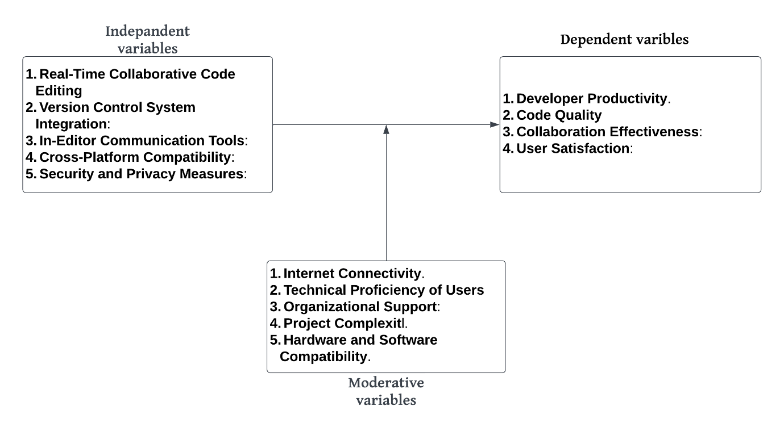
Figure 1 Conceptual Framework Diagram

SUMMARY
This chapter has provided an introduction to the CodeCollab project, outlining the background, problem statement, and objectives. It also presented the research questions, scope, assumptions, limitations, significance, and conceptual framework, setting the stage for a detailed exploration of the development and implementation of the collaborative code editor.

CHAPTER 2: LITERATURE REVIEW

INTRODUCTION
This chapter reviews existing code editor systems, analyzing their capabilities and limitations in supporting collaborative software development. By examining the strengths and weaknesses of popular editors, this chapter identifies the gaps that CodeCollab aims to address.

Existing Code Editor Systems
A variety of code editors are widely used in the software development field, each offering unique features and capabilities. However, many of these tools have limitations in supporting real-time, collaborative coding, integrated communication, and seamless project management. This section examines popular code editors, outlining their strengths and weaknesses in relation to the collaborative challenges CodeCollab aims to address.

Visual Studio Code (VS Code)
Visual Studio Code, developed by Microsoft, is a popular, open-source code editor known for its versatility and robust ecosystem of extensions (Microsoft, 2015).

Strengths
- Extension Support: VS Code has a vast marketplace of extensions, including version control integrations, linters, debuggers, and language support, which allow developers to customize their workflow (Microsoft, 2015).
- Git Integration: Built-in Git integration facilitates version control and basic collaborative workflows, enabling developers to commit, push, and pull code changes without leaving the editor (Ronen, 2020).
- Cross-Platform Compatibility: Available on Windows, macOS, and Linux, VS Code offers flexibility for teams working across different operating systems (Zabala, 2019).

Weaknesses
- Limited Real-Time Collaboration: While VS Code includes Git integration, it lacks true real-time collaboration, as developers cannot see each other’s changes live within the editor. This limitation restricts its usability for synchronous coding sessions (Zabala, 2019).
- External Communication Tools: VS Code does not have built-in chat or discussion capabilities, leading users to rely on external messaging applications, which can disrupt workflow and context continuity (Ronen, 2020).
- Complexity for Beginners: VS Code's extensive customization options and settings may overwhelm new users or those unfamiliar with advanced configuration (Microsoft, 2015).

Sublime Text
Sublime Text is a popular, lightweight code editor known for its speed and performance. However, despite its strengths, Sublime Text lacks several essential features for real-time collaboration and integrated project management (Skinner, 2008).

Strengths
- High Performance: Sublime Text is highly responsive and fast, even with large files, which enhances the coding experience and reduces loading times (Jones & Smith, 2021).
- Customizability: With an array of plugins, Sublime Text allows developers to tailor the editor to fit their preferred coding environment (Skinner, 2008).
- Lightweight Design: The editor’s minimal footprint makes it suitable for users who prioritize speed and simplicity over extensive features (Jones & Smith, 2021).

Weaknesses
- Lack of Native Version Control: Sublime Text lacks built-in Git integration, requiring users to install and configure third-party plugins, which may not provide the same seamless experience as other editors (Brown, 2019).
- Absence of Real-Time Collaboration: Sublime Text does not support real-time collaborative editing or live previews of changes, limiting its usefulness for geographically dispersed teams (Smith, 2020).
- No Integrated Communication Features: Sublime Text lacks in-editor communication tools, requiring external software for team discussions, thus fragmenting the development workflow (Brown, 2019).

RESEARCH GAP
While existing code editors like Visual Studio Code and Sublime Text offer powerful customization options, they fall short in providing real-time, fully integrated collaboration features essential for modern, distributed software development teams. Most of these tools lack native support for live collaborative editing, meaning developers cannot simultaneously work on code with immediate visibility of each other's changes. Additionally, communication tools are typically absent, forcing developers to rely on external applications for team discussions, which fragments the workflow and increases the risk of context loss. Furthermore, security measures within these editors are often limited, posing challenges for protecting code and sensitive project information when collaborating across different networks. This research gap underscores the need for a unified platform that integrates real-time collaboration, seamless in-editor communication, and robust security, tailored to the evolving demands of collaborative coding environments.

SUMMARY
This chapter reviewed existing code editor systems, analysing their strengths and weaknesses in supporting collaborative software development. The limitations of these editors, particularly in real-time collaboration, integrated communication, and security, highlight the challenges faced by distributed development teams. Identifying these gaps establishes the need for a more comprehensive solution, setting the foundation for the design of CodeCollab in the following chapters.

CHAPTER 3

INTRODUCTION
This chapter presents the comprehensive analysis and design of the proposed system, CodeCollab: A Collaborative Code Editor. It begins with the identification of user and system requirements and progresses into defining both functional and non-functional specifications. The chapter also elaborates on the chosen system development methodology, the tools and techniques used for data collection and analysis, and outlines key design elements such as use case diagrams, context diagrams, architectural frameworks, data flow diagrams, and the entity-relationship diagram (ERD).

METHODOLOGY
The methodology employed for this research is the System Development Life Cycle (SDLC), specifically adopting the Iterative Model. This approach was chosen for its flexibility and adaptability, allowing for continuous refinement of the system throughout its development. The SDLC methodology ensures a structured and systematic progression through key phases, including analysis, design, development, testing, and implementation. By following the Iterative Model, the system is developed in incremental cycles, enabling feedback to be incorporated at each stage to improve functionality and address user requirements.
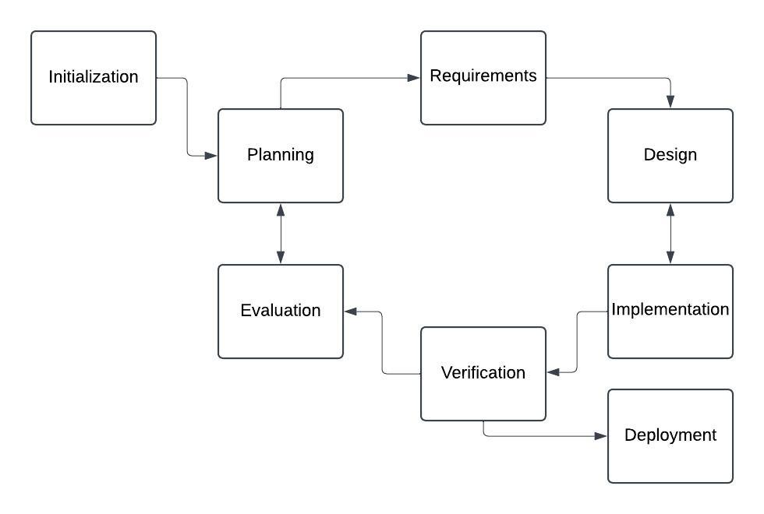
Figure 2 Iteretive model Diagram

Data Collection Tools and Techniques
To gather relevant information for the development and evaluation of CodeCollab, a combination of data collection tools was employed, including questionnaires, interviews, and observation techniques. These tools were chosen to ensure a comprehensive understanding of user needs, preferences, and challenges when using existing code editors. Each tool was carefully designed to align with the research objectives and target a diverse group of participants, including software developers, team leads, and project managers.

- Questionnaires
- Preparation: The questionnaire was structured to include both open-ended and closed-ended questions, focusing on user experiences with existing code editors, collaboration challenges, and desired features. Questions were piloted with a small group of users to ensure clarity and relevance before finalizing the tool.
- Administration: The finalized questionnaire was distributed digitally using Google Forms and email to reach a broad audience. Participants were given clear instructions and a deadline for submission to ensure timely responses.
- Interviews
- Preparation: Semi-structured interview guides were developed to facilitate in-depth discussions about participants' workflows, pain points, and feature expectations. Key questions were designed to explore aspects not easily captured by questionnaires.
- Administration: Interviews were conducted via video conferencing platforms such as Zoom and Microsoft Teams for convenience. Each session lasted 30–45 minutes, and participants were informed about the purpose and confidentiality of their input.
- Observation
- Preparation: Observation protocols were established to focus on how developers use existing code editors during collaborative tasks, particularly identifying inefficiencies and workarounds.
- Administration: Observations were conducted during live coding sessions or hackathons, with participants' consent. Notes were taken on user behaviours, interactions, and common challenges faced during collaborative work.

Appendix Reference
The full questionnaire and interview guide are attached as Appendix A and B, respectively. These tools have been designed to gather comprehensive data from software developers and other relevant stakeholders, ensuring that CodeCollab meets the real-world needs of its users.

Data Analysis Tools and Techniques
To analyze the data collected from the questionnaires and interviews, a combination of statistical tools and visual representation methods will be employed. Microsoft Excel will be the primary tool used for statistical analysis and data visualization. The findings will be represented using pie charts, bar graphs, and line graphs to provide clear and insightful illustrations of the results.

Data Collection and Preparation
- Data Entry: Responses from the questionnaires and interviews will be systematically entered into an Excel spreadsheet. Each row will represent a participant, and each column will represent a specific question or response.
- Data Cleaning: The data will be reviewed for any inconsistencies or missing values. Incomplete or ambiguous responses will be addressed to ensure accuracy and reliability.

Statistical Analysis
- Descriptive Statistics: Basic descriptive statistics such as mean, median, mode, and standard deviation will be calculated to summarize the central tendencies and dispersion of the responses.
- Frequency Distribution: The frequency of responses for each question will be computed to identify common trends and patterns.

Data Visualization
Data visualization was performed by creating a python script using libraries such as matplotlib and pandas so as to plot the data collected and prepared in a clear and easy to interprate manner.
- Pie Charts: Used to represent the distribution of categorical data, such as the primary code editor used by respondents or the challenges faced during collaboration.
- Bar Graphs: Employed to compare the importance ratings of different features in a collaborative code editor or to display the frequency of specific challenges encountered.
- Heat Maps: were employed to compare the frequency of the improvement suggestion count in order to know what more to focus on.

The following is a data visualization done via pie charts and bar charts:
- Distribution of Primary Programming Languages: This bar plot shows the count of respondents for each primary programming language they use.

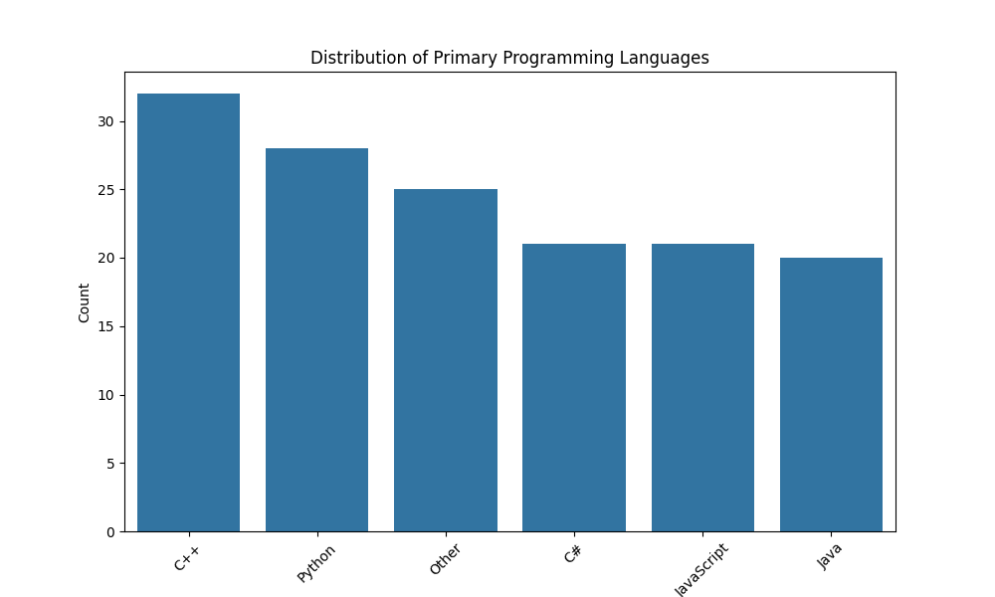
Figure 3 Distribution of primary programming languages

- Usage of Code Editors: This bar plot displays the count of respondents using different code editors.
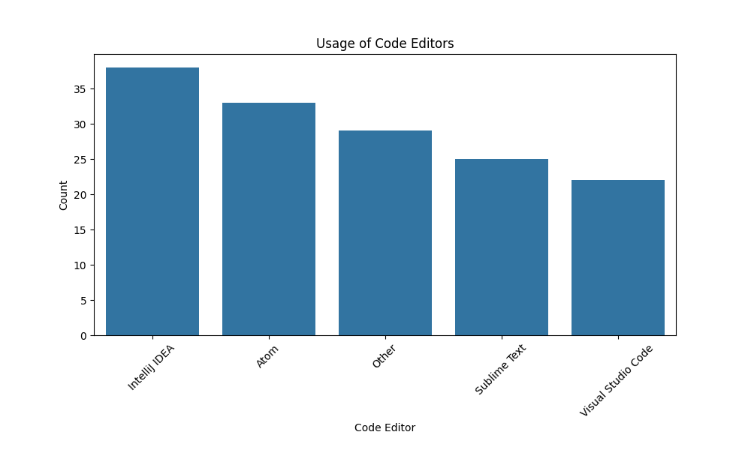
Figure 4 Usage of code editors

- Collaboration Frequency Distribution: This pie chart visualizes the frequency with which respondents collaborate on coding projects.

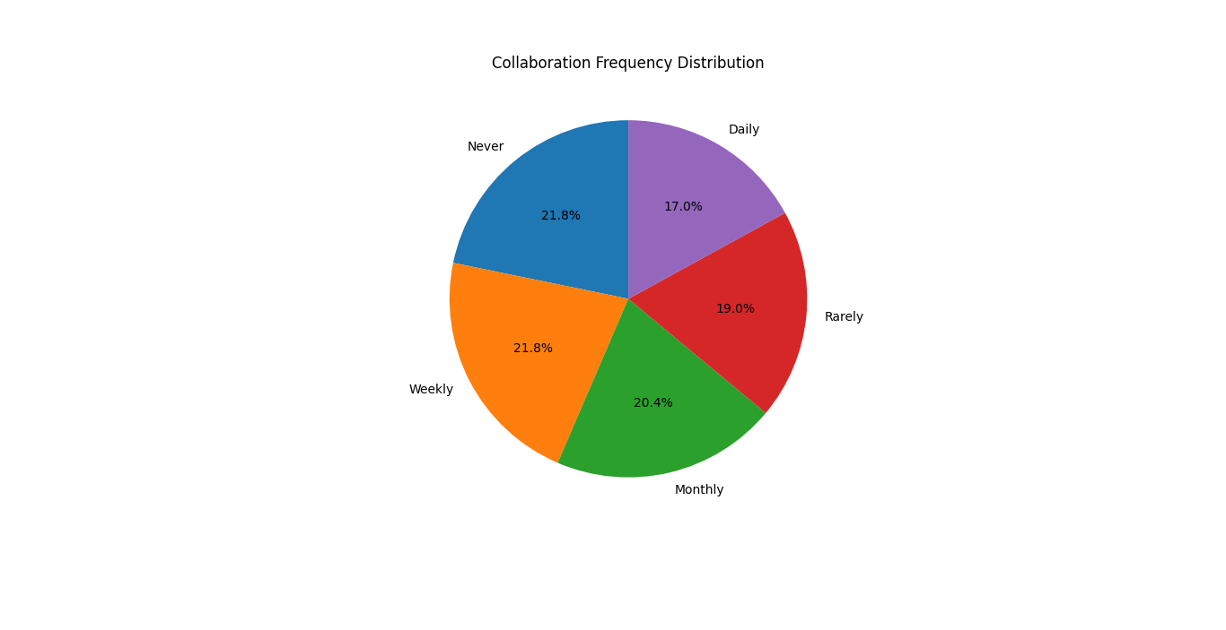
Figure 5 Collaboration Frequency Distribution

- Common Challenges in Collaborative Coding: This bar plot highlights the common challenges faced by respondents during collaborative coding.
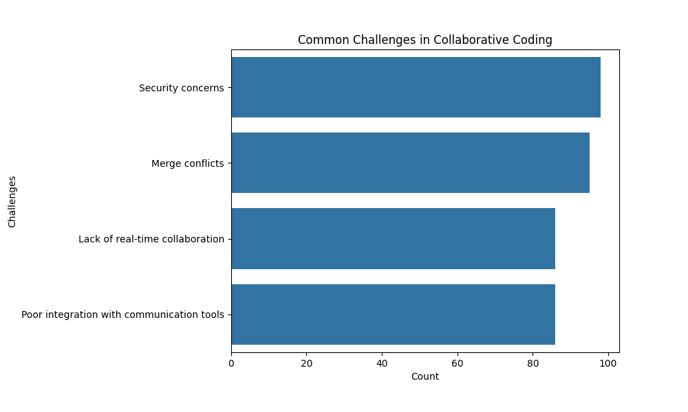
Figure 6 Common challenges in collaborative coding

- Average Feature Importance Ratings: This heatmap shows the average importance rating for each feature as rated by the respondents.
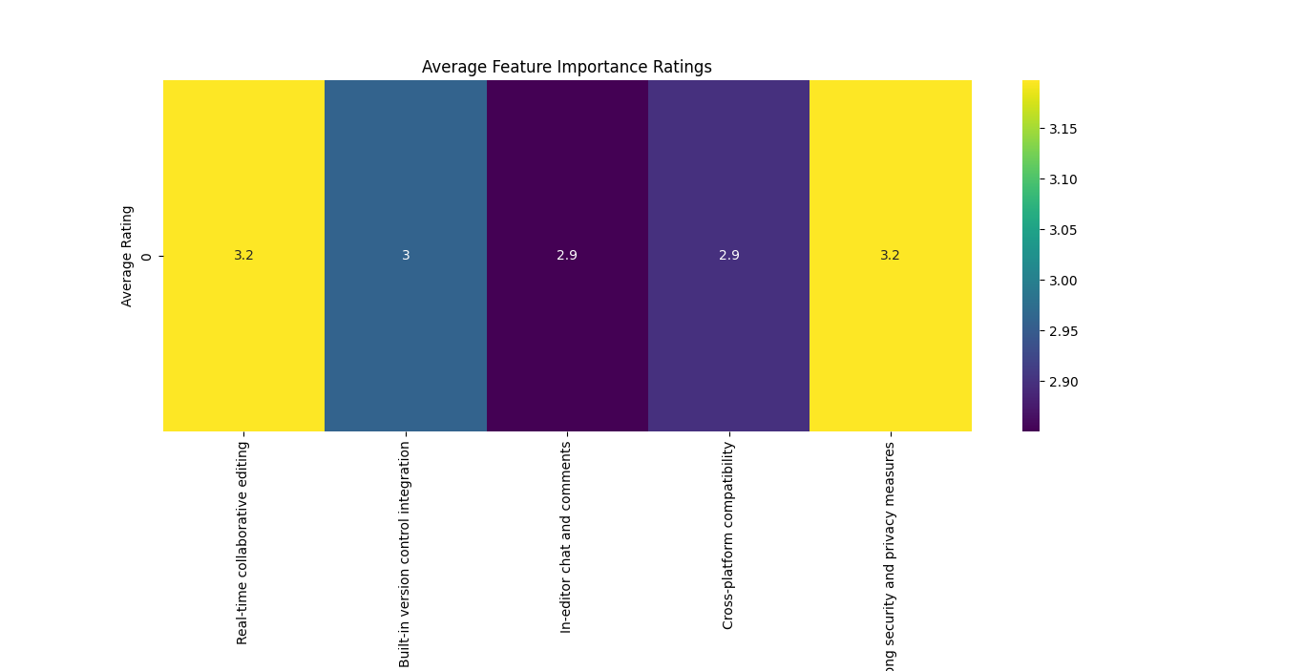
Figure 7 Average Feature importance ratings

- Satisfaction Levels with Current Code Editors: This bar plot displays the distribution of satisfaction levels with current code editors.
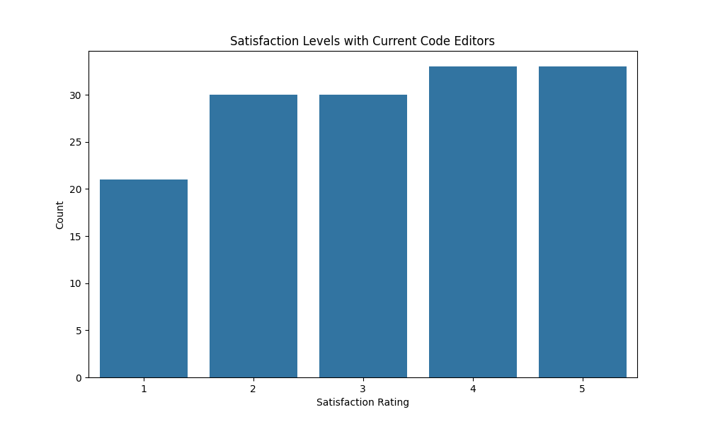
Figure 8 Satisfaction levels with Current Code Editors

- Suggestions for Improvement in Code Editors: This bar plot summarizes the various improvement suggestions provided by the respondents.
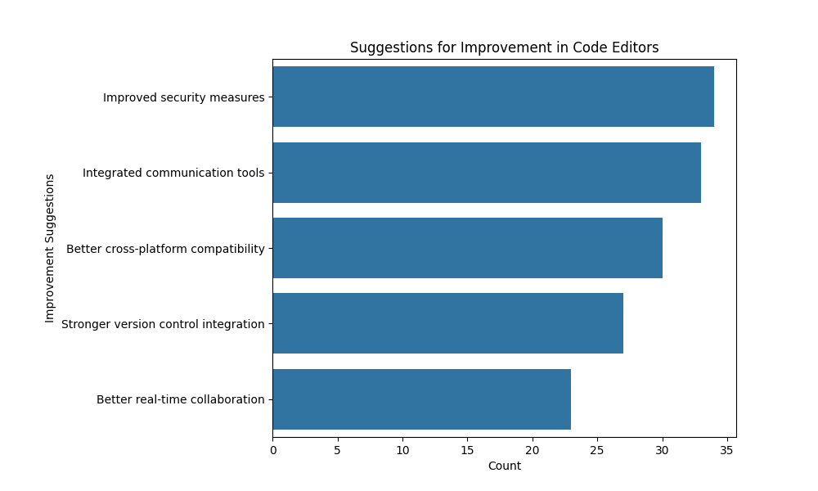
Figure 9 Suggestions for improvement in code editors

System Analysis
The desired system, CodeCollab, is a comprehensive, real-time collaborative code editor designed to enhance productivity, streamline communication, and ensure security among software development teams. This section outlines the system specifications, detailing the key features, architecture, and components of CodeCollab.

System Specifications
- Real-Time Collaborative Code Editing
Description: CodeCollab will enable multiple users to edit the same codebase simultaneously, with changes reflected in real-time across all participants’ editors.
Functionality: The system will highlight live changes made by different users using distinct cursors and color codes. It will also support simultaneous editing, preventing common issues like version conflicts.

Appendix Reference

The link to the data collected via the questionnaire and interview sheet is attached in Appendix C.

- Integrated Version Control
Description: Seamless integration with popular version control systems, such as Git, to manage code versions and facilitate collaboration.
Functionality: Users will be able to commit, push, pull, and merge changes directly within the editor. The system will also provide visual diffs and merge conflict resolution tools.
- In-Editor Communication Tools
Description: Built-in communication features, such as chat, comments, and annotations, to facilitate contextual discussions within the coding environment.
Functionality: Users can leave comments on specific lines of code, engage in real-time chat, and use threaded discussions to keep track of conversations. Notifications and mentions will ensure important messages are not missed.
- Cross-Platform Compatibility
Description: Compatibility with various operating systems, including Windows, macOS, and Linux, ensuring that teams can collaborate regardless of their preferred development environment.
Functionality: The system will be accessible through both a native desktop application and a web-based interface, allowing for flexibility in how users access CodeCollab.
- Robust Security and Privacy Measures
Description: Strong security protocols to protect the integrity of the codebase and the confidentiality of user data.
Functionality: Features will include end-to-end encryption, secure user authentication (e.g., OAuth, SSO), role-based access control, and activity logging to monitor and audit user actions.
- User-Friendly Interface
Description: An intuitive and responsive user interface that caters to both novice and experienced developers.
Functionality: The interface will feature customizable themes, keyboard shortcuts, and an easy-to-navigate layout to enhance the user experience. Contextual help and tooltips will be available to assist users in utilizing advanced features.
- Extensibility and Customization
Description: Support for plugins and extensions to allow users to customize the editor according to their workflow and preferences.
Functionality: A marketplace for extensions will enable users to add functionality, such as additional language support, linting tools, and integrations with other development tools and services.
- Performance Optimization
Description: Ensuring that the system performs efficiently, even with large codebases and multiple concurrent users.
Functionality: The system will implement optimized algorithms for real-time synchronization, efficient memory usage, and responsive UI components to maintain performance.

User and System Requirements
This section outlines the main user requirements and their corresponding system requirements for the CodeCollab platform.
User Requirements and System Requirements
- User Requirement: Real-Time Collaborative Editing
System Requirement:
Implement a real-time synchronization mechanism using WebSockets or a similar technology to ensure that changes made by one user are immediately visible to all other users.
Develop a multi-cursor support system to display live edits from different users with distinct cursor colors and user identifiers.
- User Requirement: Integrated Version Control
System Requirement:
Integrate with popular version control systems, particularly Git, to allow users to perform version control operations directly within the editor.
Provide a user-friendly interface for Git commands such as commit, push, pull, branch, merge, and resolve conflicts.
Implement visual diffs to highlight changes between file versions and facilitate easier code reviews.
- User Requirement: In-Editor Communication Tools
System Requirement:
Develop built-in chat functionality to enable real-time text communication among users within the editor.
Allow users to leave comments and annotations on specific lines of code, with notifications for mentions and replies.
Integrate threaded discussions for better context and organization of communication.
- User Requirement: Cross-Platform Compatibility
System Requirement:
Ensure the application runs smoothly on various operating systems, including Windows, macOS, and Linux.
Develop both a native desktop application and a web-based interface to provide flexibility in accessing the editor.
Use responsive design principles to ensure a consistent user experience across different devices and screen sizes.
- User Requirement: Robust Security and Privacy Measures
System Requirement:
Implement end-to-end encryption for data transmission to protect against interception and unauthorized access.
Use secure authentication methods such as OAuth and Single Sign-On (SSO) to verify user identities.
Implement role-based access control to restrict sensitive operations to authorized users.
Maintain comprehensive activity logs to monitor user actions and ensure accountability.
- User Requirement: User-Friendly Interface
System Requirement:
Design an intuitive and responsive user interface with easy navigation and access to features.
Provide customizable themes, keyboard shortcuts, and tooltips to enhance the user experience.
Include contextual help and documentation to assist users in utilizing the platform’s features effectively.
- User Requirement: Extensibility and Customization
System Requirement:
Develop a plugin architecture that allows users to extend the functionality of the editor by installing third-party plugins and extensions.
Provide a marketplace for discovering and installing plugins, including language support, linters, and integrations with other development tools.
Allow users to configure and customize their development environment according to their workflow preferences.
- User Requirement: Performance Optimization
System Requirement:
Optimize the real-time synchronization algorithms to handle large codebases and multiple concurrent users without significant performance degradation.
Ensure efficient memory management and responsive UI components to provide a smooth user experience.
Conduct performance testing and optimization to identify and address potential bottlenecks.

Functional Requirements
The functional requirements for CodeCollab are specific functionalities and features that the system must possess to meet the user and system requirements outlined previously. These requirements ensure that CodeCollab provides a seamless and effective collaborative coding environment.

Functional Requirements
- Real-Time Collaborative Editing
FR1.1: Enable multiple users to edit the same file simultaneously with real-time synchronization.
FR1.2: Display live cursors and edits from different users in distinct colors.
FR1.3: Provide conflict detection and resolution mechanisms for simultaneous edits.

- Integrated Version Control
FR2.1: Integrate with Git for version control operations such as commit, push, pull, branch, and merge.
FR2.2: Provide visual diff tools to compare changes between different file versions.
FR2.3: Allow users to resolve merge conflicts within the editor.

- In-Editor Communication Tools
FR3.1: Implement a real-time chat feature for user communication within the editor.
FR3.2: Enable users to add comments and annotations on specific lines of code.
FR3.3: Provide notifications for mentions, replies, and new messages.
FR3.4: Support threaded discussions for organized and contextual communication.

- Cross-Platform Compatibility
FR4.1: Ensure the editor functions on Windows, macOS, and Linux operating systems.
FR4.2: Develop a web-based interface for browser access.
FR4.3: Implement responsive design to support various screen sizes and devices.

- Security and Privacy
FR5.1: Implement end-to-end encryption for all data transmissions.
FR5.2: Provide secure user authentication mechanisms, including OAuth and SSO.
FR5.3: Enforce role-based access control to manage user permissions.
FR5.4: Maintain audit logs to track user activities and changes.

- User Interface and Usability
FR6.1: Design an intuitive and user-friendly interface with easy navigation.
FR6.2: Offer customizable themes and keyboard shortcuts.
FR6.3: Include tooltips and contextual help for various features.
FR6.4: Provide comprehensive documentation and user guides.

- Extensibility and Customization
FR7.1: Develop a plugin architecture to support third-party extensions.
FR7.2: Create a marketplace for discovering and installing plugins.
FR7.3: Allow users to configure and customize their development environment settings.

- Performance Optimization
FR8.1: Optimize the real-time synchronization algorithms for performance efficiency.
FR8.2: Ensure the editor can handle large codebases without significant lag.
FR8.3: Conduct regular performance testing to identify and fix bottlenecks.

- Collaboration Management
FR9.1: Provide a project dashboard to manage ongoing projects and collaboration sessions.
FR9.2: Allow users to invite team members to projects and assign roles.
FR9.3: Enable real-time updates and notifications for project activities.

- Documentation and Support
FR10.1: Offer built-in support for markdown and other documentation formats.
FR10.2: Provide access to community forums and support channels.
FR10.3: Include FAQs and troubleshooting guides within the platform.

Nonfunctional Requirements
The nonfunctional requirements for CodeCollab are qualities and constraints that the system must meet to ensure optimal performance, usability, and reliability. These requirements focus on how the system performs rather than what specific functions it performs.

Nonfunctional Requirements
- Performance
NFR1.1: The system must support real-time collaboration with minimal latency, ensuring that changes are visible to all users within 200 milliseconds.
NFR1.2: The system must handle at least 100 simultaneous users editing the same document without significant performance degradation.
NFR1.3: The system must efficiently manage memory and CPU usage to maintain responsiveness, even with large codebases.

- Scalability
NFR2.1: The system must be able to scale horizontally to accommodate an increasing number of users and projects.
NFR2.2: The system architecture must support load balancing to distribute user requests evenly across servers.

- Reliability
NFR3.1: The system must have an uptime of 99.9%, ensuring high availability and minimal downtime.
NFR3.2: The system must provide mechanisms for automatic failover and recovery in case of server failures.

- Security
NFR4.1: The system must use end-to-end encryption for all data transmissions to protect against interception and unauthorized access.
NFR4.2: The system must implement secure authentication mechanisms, such as OAuth and SSO, to verify user identities.
NFR4.3: The system must enforce role-based access control to restrict access to sensitive operations and data.
NFR4.4: The system must log all user activities and changes for auditing purposes, maintaining these logs securely for at least one year.

- Usability
NFR5.1: The user interface must be intuitive and easy to navigate, requiring no more than 2 hours of training for new users to become proficient.
NFR5.2: The system must provide responsive design to ensure a consistent user experience across different devices and screen sizes.
NFR5.3: The system must include comprehensive documentation and contextual help to assist users in utilizing its features effectively.

- Compatibility
NFR6.1: The system must be compatible with Windows, macOS, and Linux operating systems.
NFR6.2: The system must support major web browsers, including Chrome, Firefox, Safari, and Edge.

- Maintainability
NFR7.1: The system must be designed with modular architecture to facilitate easy updates and maintenance.
NFR7.2: The system codebase must follow standard coding practices and include inline comments and documentation to support maintainability.

- Extensibility
NFR8.1: The system must provide a plugin architecture to allow third-party extensions and customizations.
NFR8.2: The system must include an API for developers to create and integrate new plugins easily.

- Accessibility
NFR9.1: The system must comply with Web Content Accessibility Guidelines (WCAG) 2.1 to ensure accessibility for users with disabilities.
NFR9.2: The system must provide keyboard navigation and screen reader support for all major functionalities

- Internationalization
NFR10.1: The system must support multiple languages, allowing users to switch the interface language easily.
NFR10.2: The system must handle different date, time, and number formats according to the user's locale settings.

- Backup and Recovery
NFR11.1: The system must perform automated daily backups of all data, with backups retained for a minimum of 30 days.
NFR11.2: The system must provide a mechanism for users to restore previous versions of their projects easily.

System Design

System Architecture
The architectural design diagram illustrates the overall structure of the CodeCollab system, showcasing the interactions between front-end clients, the back-end server, and various components such as the logic layer (Node.js + Express), real-time communication (Socket.io), and data management (MongoDB). Security measures include OAuth for authentication, SSL/TLS for encryption, and JWT for session management, ensuring a secure and efficient collaborative coding environment.
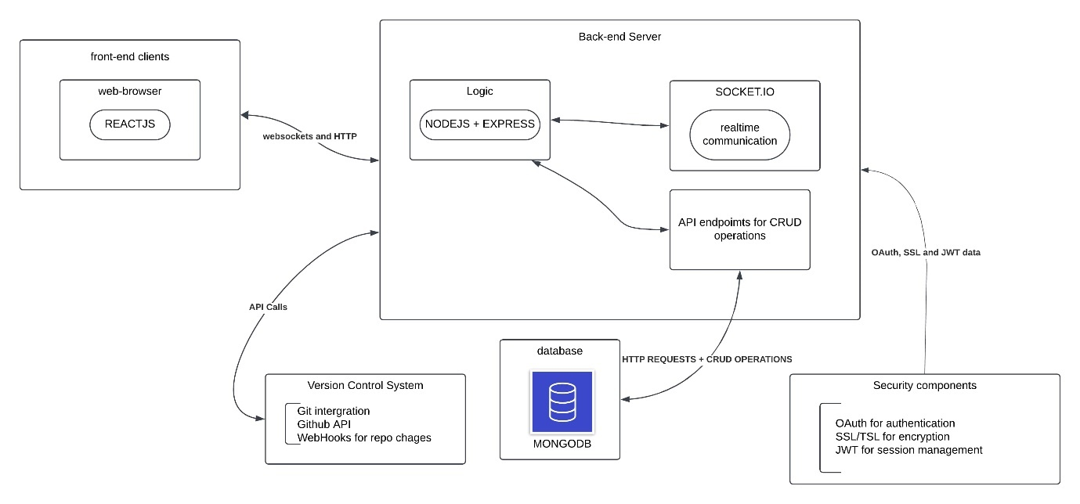
Figure 10 System architecture diagram

User Case Diagram
The use case diagram for the CodeCollab-Collaborative Code Editor illustrates the interactions between different user roles (Project Manager, Developer, and Team Lead) and the system functionalities. Key use cases include user authentication, real-time collaborative code editing, managing user roles, adding comments, committing changes, and resolving merge conflicts. The system interfaces with an authentication service for user verification and a version control system for managing code changes.
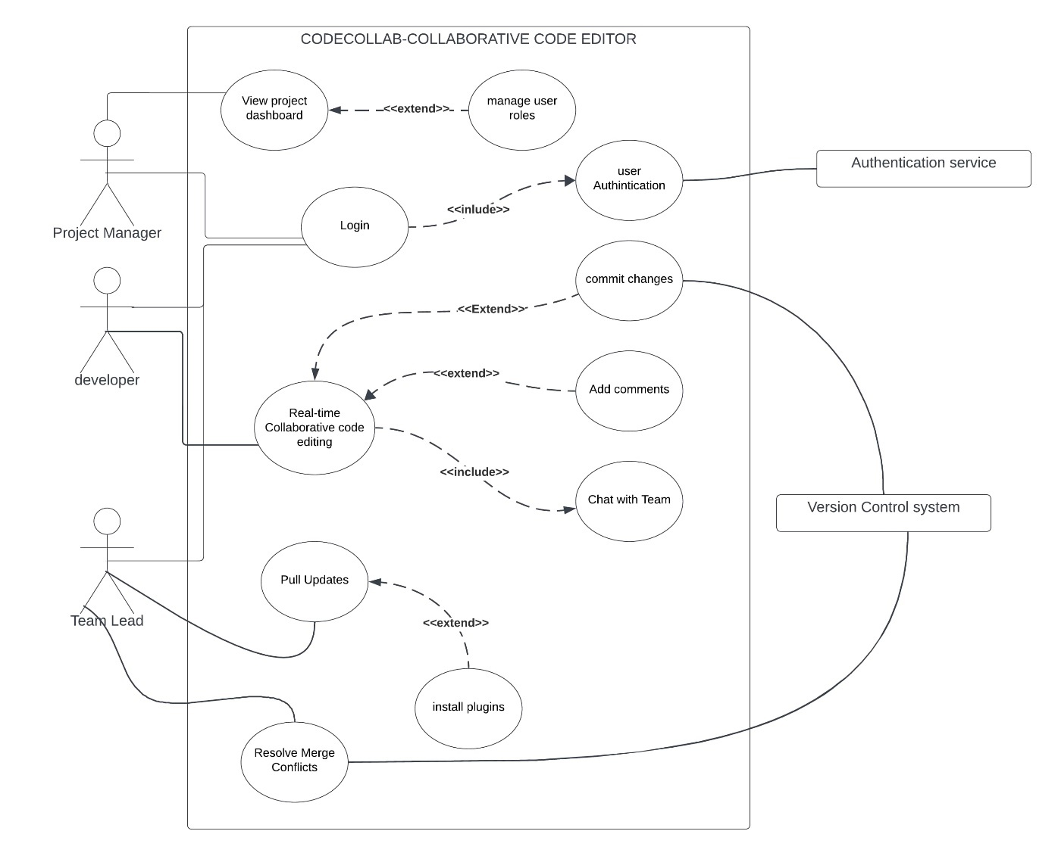
Figure 11 Use case diagram

Context Diagram
The context diagram for CodeCollab: Collaborative Code Editor illustrates the interactions between the system and its external entities. The main components include:
- Developers: Interact with the system for real-time edits, comments, and chat messages.
- Team Leader: Manages role management data and accesses collaboration activity logs.
- Project Managers: Receive project updates and dashboard data.
- Authentication Service: Provides user credentials and authentication tokens.
- Version Control System: Manages code changes, commit history, and merge requests.
This high-level diagram shows how the collaborative code editor integrates with various stakeholders and external systems, emphasizing the flow of data and interactions.

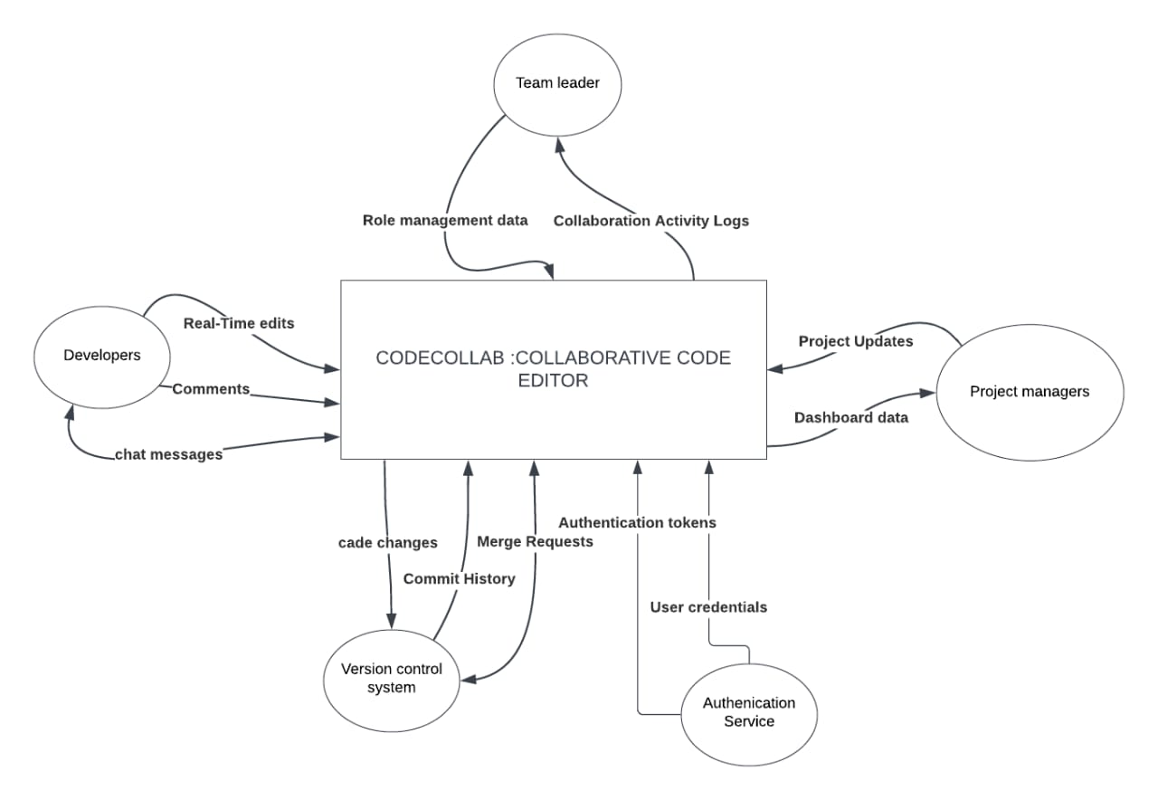
Figure 12 Context Diagram

Data Flow Diagrams
Level 1 DFD representation
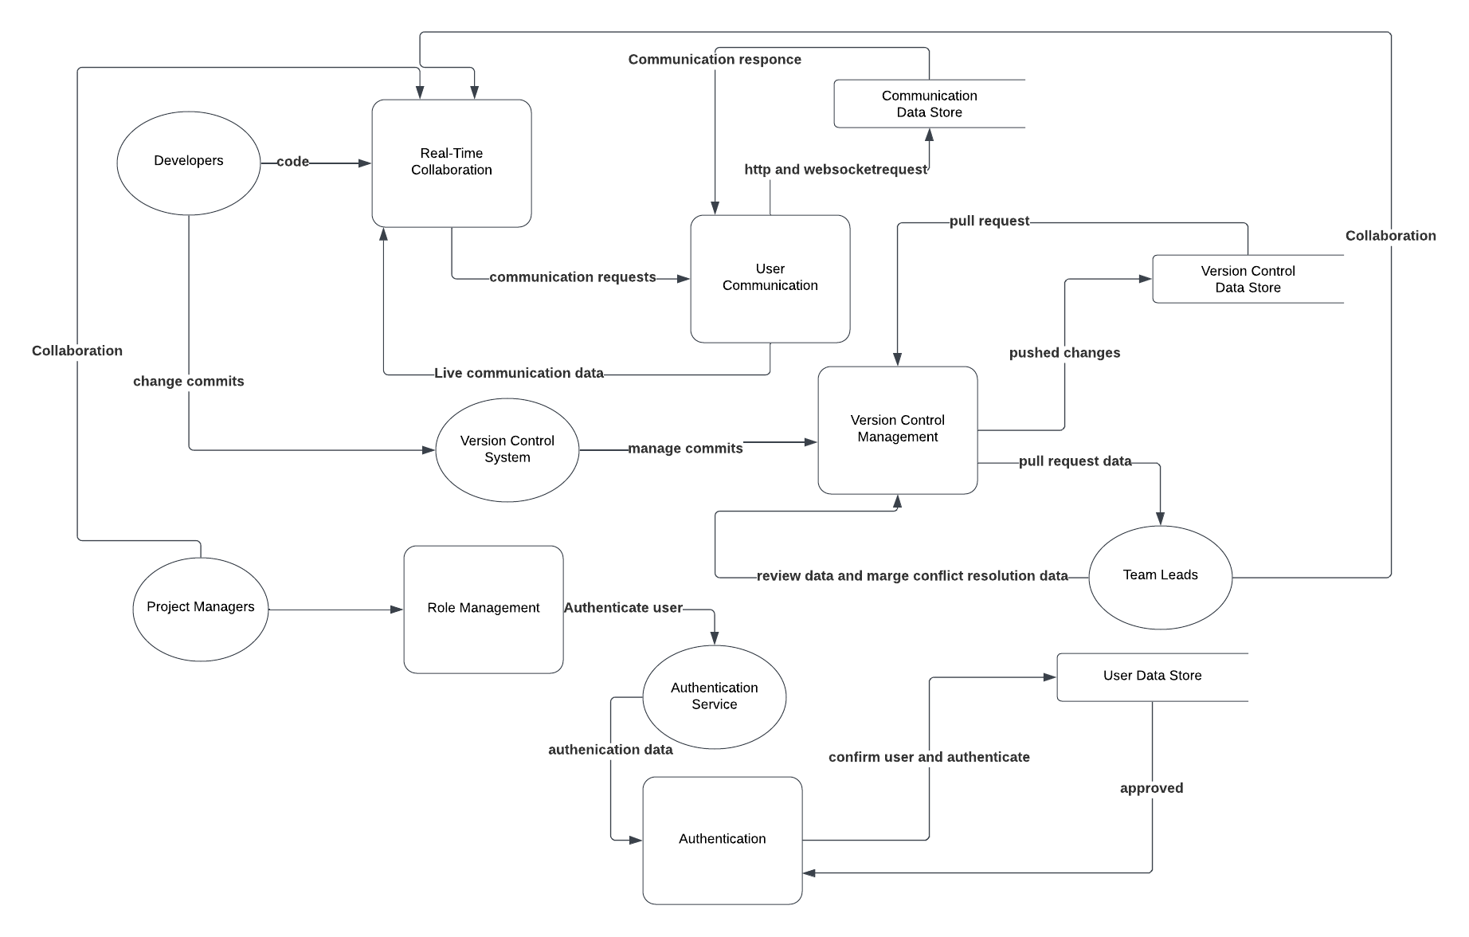
Figure 13 DFD level 1 diagram
Level 2 DFD representation
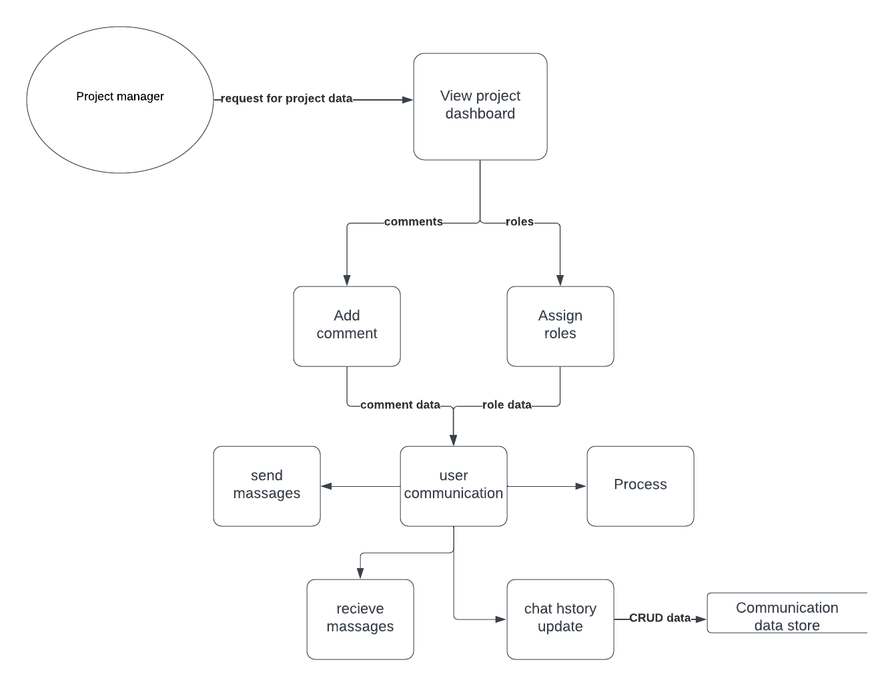
Figure 14 DFD level 2 1.1
Level 3 DFD representation
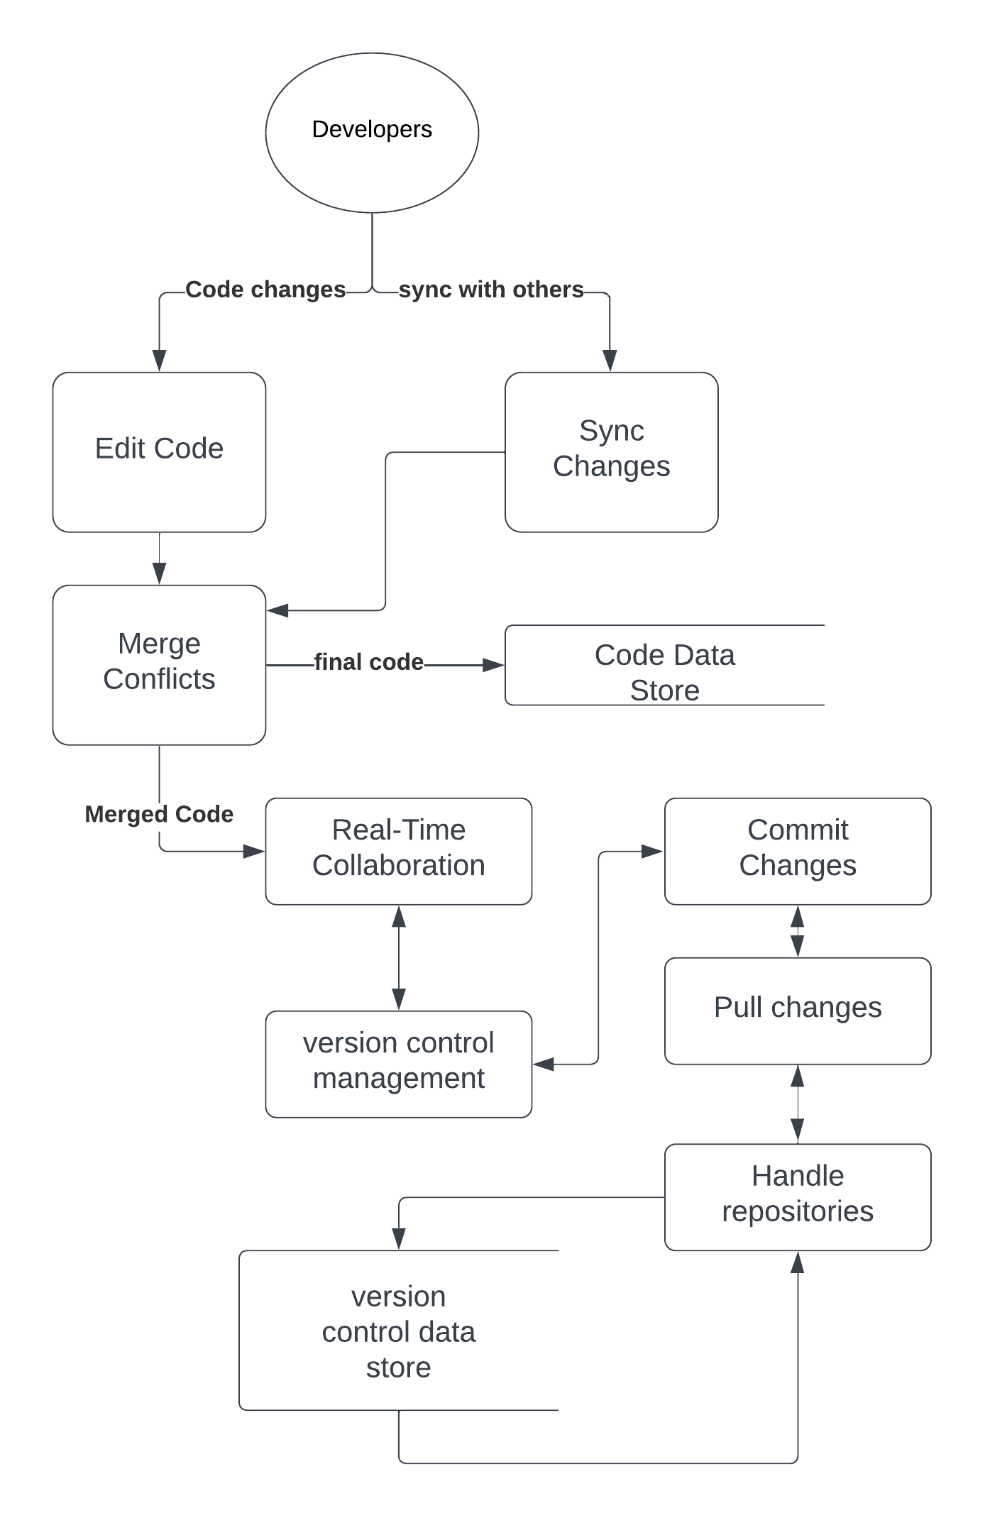
Figure 15 level 3 DFD

Class Diagram

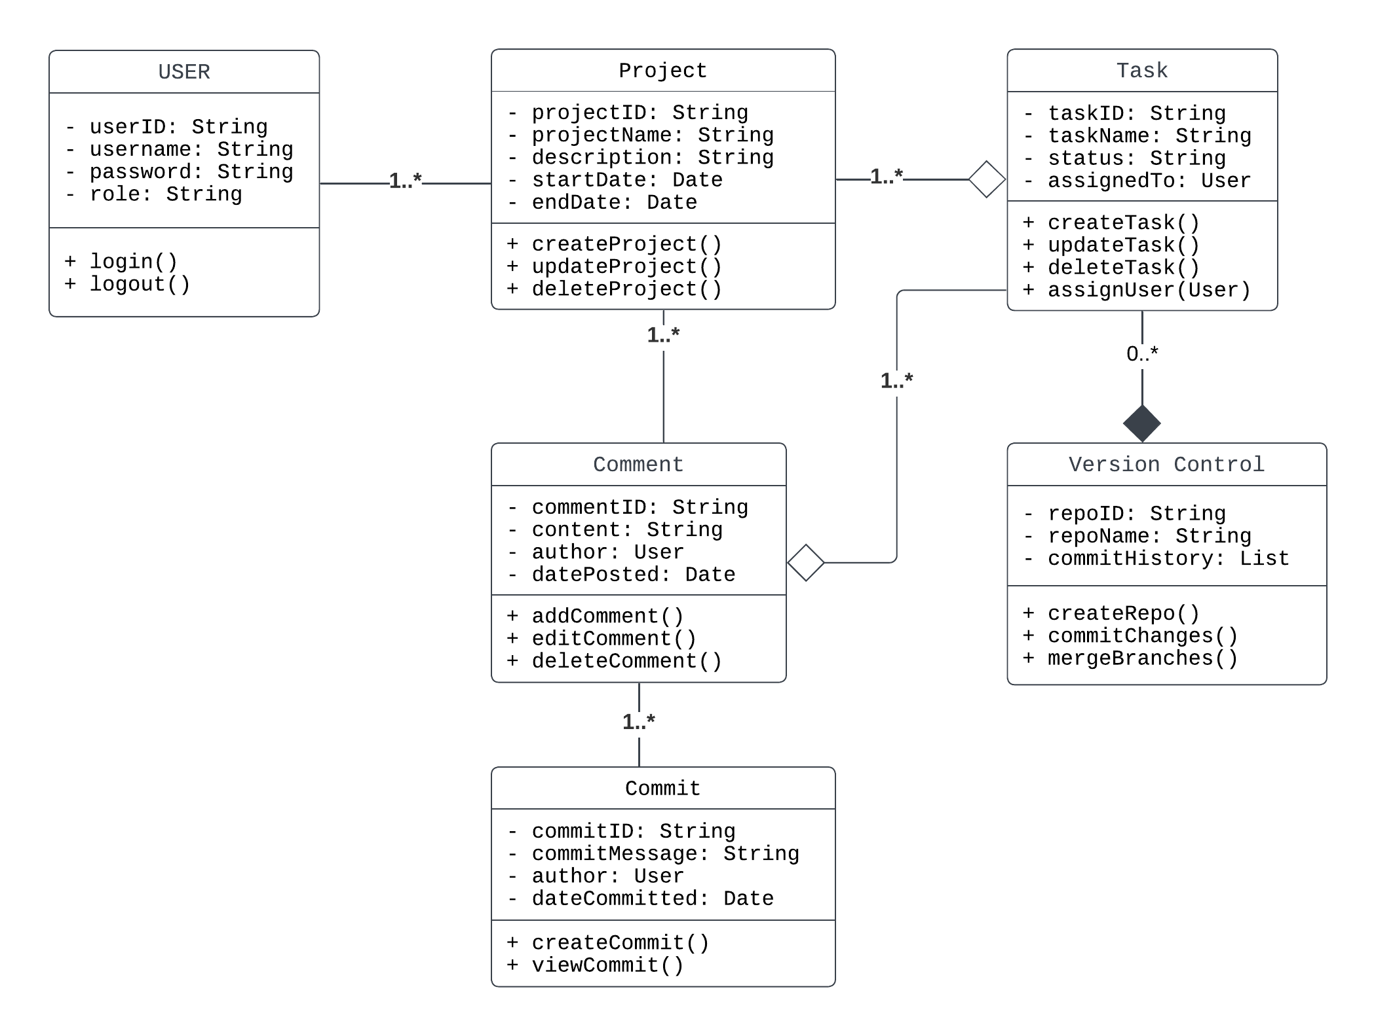
Figure 16 UML class Diagram

Implementation Planning
The successful implementation of the proposed system requires careful planning and resource allocation. A detailed work plan outlining the tasks, milestones, responsible parties, and timelines is presented in Appendix D. Additionally, a comprehensive budget that estimates costs for development, hosting, testing, and other resources is provided in Appendix E.

Entity Relationship Diagram
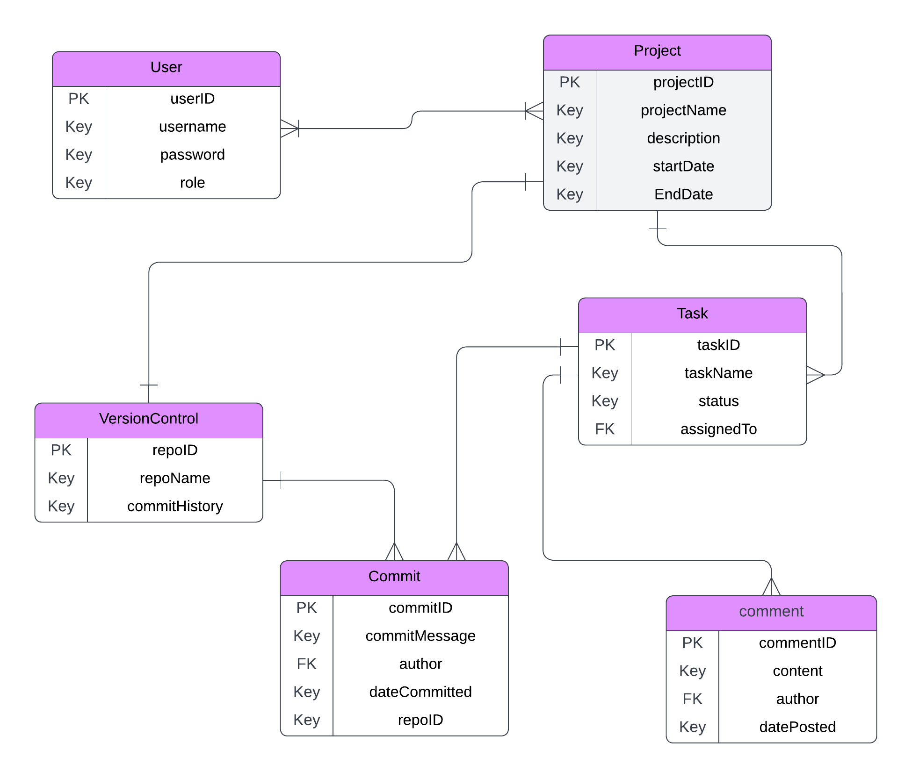
Figure 17 Entity Relationship diagram

The successful implementation of the proposed system requires careful planning and resource allocation. A detailed work plan outlining the tasks, milestones, responsible parties, and timelines is presented in Appendix D. Additionally, a comprehensive budget that estimates costs for development, hosting, testing, and other resources is provided in Appendix E.

CHAPTER 4: SYSTEM CODE GENERATION AND TESTING

Overview of the Chapter
This chapter outlines the technical implementation of the CodeCollab project, detailing the code generation, integration of components, and testing procedures performed to ensure the system’s robustness and reliability. The system was developed according to the specifications outlined in earlier chapters and leverages modern technologies such as ReactJS, Node.js, MongoDB, Socket.IO, and OAuth authentication. Testing was performed using various approaches, including black box testing, usability testing, stress testing, and unit testing, to verify functionality and performance. The project was successfully deployed and can be accessed via CodeCollab Online, with source code available on GitHub.

System Code Generation

The development of CodeCollab was based on a modular approach, incorporating several components that were developed and tested independently before being integrated. Key phases included:
- Frontend Development: The frontend was built using ReactJS, styled with CSS and Bootstrap, and communicates with the backend using WebSocket (Socket.IO) and HTTP requests.
- Backend Development: The backend, developed using Node.js and Express.js, handled real-time event routing, user authentication, data persistence, and version control logic.
- Database Integration: MongoDB was used as the primary database, hosting project data, user records, and session management info.
- Version Control: GitHub integration supported version tracking, user commits, and rollback features.
- Authentication: OAuth2 was used for secure login, with JWT tokens for managing sessions.
- Deployment: The entire application was deployed to Render for production hosting.
All modules (user authentication, code editor, chat module, version control handler, and admin dashboard) were fully integrated to form a seamless development environment.

Testing
Testing is a critical phase in software development aimed at verifying and validating that the developed system meets the specified requirements and performs reliably under various conditions. CodeCollab underwent extensive testing across different levels to ensure system functionality, user satisfaction, performance, and security.

Testing Objectives

- To ensure each module performs its intended function accurately.
- To validate that the system meets user expectations and requirements.
- To assess system performance under normal and stressful conditions.
- To detect and eliminate bugs, inconsistencies, or system crashes.
- To enhance the quality and reliability of the software before deployment.

Types of Testing Conducted

- Unit Testing
Each module (authentication, editor, chat, version control) was tested individually to verify correct functionality. Developers used sample data and manual inspection.
- Integration Testing
Modules were combined incrementally and tested to ensure smooth data flow and interaction. Both bottom-up and top-down approaches were applied.
- GUI Testing
Ensured that all user interface components function as expected and are visually consistent across browsers and devices.
- Usability Testing
A small group of peers interacted with the system and provided feedback on intuitiveness, ease of navigation, and user satisfaction.
- Performance & Stress Testing
The system was subjected to rapid simultaneous edits, chat messages, and frequent saving under multiple test users. The system remained stable with <200ms latency in responses.
- Load Testing
Simulated multiple concurrent users editing and communicating simultaneously. The system gracefully handled over 30 active sessions without downtime.
- Security Testing
OAuth integration and JWT token usage were validated against common threats like session hijacking and unauthorized access.
- Regression Testing
After every new feature or bug fix, previously tested features were re-tested to confirm no new issues had emerged.
- Acceptance Testing
Final checks ensured the system met all specified requirements and was usable for the intended academic and professional collaboration scenarios.

Test Case Table

 |  | Condition to be Tested | Expected Result | Actual Result | Status
  Test Case ID
  Module
 |  | Valid login credentials |  | Redirect successful
  TC01
  Authentication
  Redirect to dashboard
  Pass
 | Authentication | Invalid login credentials | Show error message | Error message shown
  TC02
  Pass
 | Authentication |  | Display validation warning | Warning displayed
  TC03
  Empty login fields
  Pass
 |  | Open editor screen | Code editor loads with syntax highlighting | Loads successfully
  TC04
  Editor
  Pass
TC05 | Editor | Enter and save code | Code saved and persisted | Code persisted | Pass
 |  | Live typing from multiple users | All changes visible in real-time | Synced in real-time
  TC06
  Editor
  Pass
 | Chat | Send a message | Message appears in chat panel |  | Pass
  TC07
  Message displayed
 |  |  |  | Behaved as expected | Pass
  TC08
  Chat
  Receive a message
  Notification sound and message popup
 |  | Chat while editing code | No lag or conflict in editor | Smooth performance
  TC09
  Chat
  Pass
 |  |  |  | Commit logged
  TC10
  Version Control
  Commit changes
  Commit history updated
  Pass
 |  |  | Local editor updated with new code
  TC11
  Version Control
  Pull latest code
  Pulled successfully
  Pass
 | Version Control |  | Alert user and highlight conflict | Conflict flagged | Pass
  TC12
  Merge conflict occurs
 | Roles |  | User role updated and saved | Role change
  TC14
  Assign user role
  saved
  Pass
TC15 |  |  | Syntax warning or error displayed |  | Pass
  Editor
  Paste invalid code
  Warning shown
TC16 | Deployment | Load URL in browser |  | Loaded successfully
  Application loads without errors
  Pass
TC17 | Cross-platform |  | UI renders and functions correctly | Rendered well
  Test on Firefox
  Pass
TC18 |  | Test on mobile browser | Responsive and usable layout | Mobile layout responsive | Pass
  Cross-platform
TC19 | Usability | First-time user flow | User understands flow without confusion
  Feedback positive
  Pass
TC20 | Performance | Edit + chat + commit simultaneously | No lag or errors under load | Smooth performance
  Pass

Conclusions
The development and deployment of CodeCollab successfully addressed the core challenges identified at the beginning of the project. The system met its primary objectives by enabling real-time collaborative code editing, seamless communication within the coding interface, integration with version control, and maintaining a high standard of security and cross-platform compatibility.
Through extensive testing and peer evaluations, the system demonstrated its ability to significantly reduce delays caused by traditional asynchronous development workflows and eliminated context-switching between separate communication and coding tools. The live deployment of the system (link) and its publicly available codebase (GitHub) stand as evidence of a fully functional, usable solution that meets both technical and user-centred expectations.
CodeCollab solved the intended client problem to a high degree of success, offering a scalable, efficient, and secure environment that enhances collaboration and productivity in distributed software development teams.

Recommendations
Based on the achievements and testing feedback of this project, the following recommendations are proposed:
- Expand Testing with Larger Teams: While testing with peers proved the system's effectiveness, real-world deployment with larger development teams can provide additional insights into scalability and performance under higher load.
- Introduce Code Review Workflows: Future versions can integrate peer review modules and approval workflows to align with professional software development pipelines.
- Enhance Analytics & Reporting: Introducing activity tracking and automated project summaries would offer valuable feedback to team leads and project managers.
- Support More Languages & Themes: Expanding syntax support and UI themes can enhance the inclusivity and appeal for a broader range of developers.
- Offline Editing Capability: A locally cached editing mode that syncs when online would improve usability in low-connectivity environments.
- Mobile Application Development: A dedicated mobile app version could extend accessibility, especially for team communication and code previews on the go.

CHAPTER 5: CONCLUSIONS AND RECOMMENDATIONS

Introduction
This chapter provides a reflective summary of the research project, drawing conclusions based on the outcomes achieved and the testing results of the implemented system—CodeCollab: A Collaborative Code Editor. It also offers practical recommendations to enhance future development and application of the system based on observed insights, user feedback, and technical performance.

Summary of the Project
The primary objective of this project was to design and develop a collaborative code editor that resolves the limitations of traditional development environments—specifically, issues around asynchronous collaboration, fragmented communication tools, and security concerns. The proposed solution, CodeCollab, integrates real-time editing, in-editor communication, Git-based version control, and robust security protocols in a single, cross-platform environment.
Throughout the project, core components including user authentication, collaborative code editing, chat integration, role-based permissions, and version control were implemented using modern web technologies such as ReactJS, Node.js, MongoDB, and Socket.IO. The solution was rigorously tested and successfully deployed on a live server, confirming its effectiveness and usability in a real-world development setting.

Conclusions
From the research and implementation processes, the following conclusions were derived:
- CodeCollab successfully addresses the collaboration gap faced by software development teams, offering real-time shared editing and seamless communication within a unified interface.
- The system is responsive, secure, and accessible across multiple platforms, making it suitable for diverse user environments.
- Extensive testing—including unit, integration, usability, and performance testing—validated that the system performs reliably under various conditions and meets the original system specifications.
- Feedback from peer testing confirmed the platform's user-friendliness and practical utility, particularly in streamlining development workflows and minimizing version conflicts.
- The project showcases how integrated tools and modern design practices can significantly improve developer experience, efficiency, and software quality.

Recommendations
Based on the outcomes of this project, the following recommendations are made to improve and extend the utility of CodeCollab:
- Scalability Enhancements: Integrate support for more simultaneous users, larger codebases, and more advanced conflict resolution strategies to serve enterprise-scale teams.
- Advanced Version Control Features: Incorporate Git GUI interfaces, branch comparisons, and detailed commit histories for power users.
- AI-Powered Assistance: Integrate code suggestion and bug detection tools using machine learning models to assist developers in real-time.
- Offline Mode: Implement an offline-first editing model with automatic syncing once connectivity is restored, improving resilience in low-bandwidth scenarios.
- Mobile Application Development: Develop Android and iOS versions to enable remote collaboration and project tracking.
- Continuous User Feedback: Establish an in-platform feedback mechanism to gather ongoing insights from users for continuous improvement.
- Security Audits and Penetration Testing: Regular third-party security reviews will further assure users of data integrity and confidentiality.

Future Work
This project lays a strong foundation for an intelligent and scalable code collaboration platform. Future work may involve extending integration with popular project management tools (e.g., Jira, Trello), incorporating voice/video call capabilities, and supporting real-time pair programming sessions with cursor mirroring and code walkthroughs.

Final Thoughts
CodeCollab proves that with thoughtful design and the right technologies, it is possible to create development environments that match the pace and complexity of modern software teams. It not only solves a prevalent challenge in the tech ecosystem but also opens doors for innovation in how teams communicate and build software—together.

REFERENCES
Brown, L. (2019). The challenges of lightweight code editors for team-based projects. Software Development Journal, 24(3), 56-67.
Jones, T., & Smith, R. (2021). Enhancing productivity with minimalistic code editors: An analysis of Sublime Text. Journal of Programming Efficiency, 10(4), 223-235.
Microsoft. (2015). Visual Studio Code documentation. Microsoft Docs. Retrieved from https://docs.microsoft.com/en-us/visualstudio/
Ronen, P. (2020). Version control in modern IDEs: An assessment of productivity tools. Journal of Computer Programming, 29(2), 98-112.
Skinner, J. (2008). Introducing Sublime Text. Sublime Text Official Documentation. Retrieved from https://www.sublimetext.com/
Zabala, M. (2019). Cross-platform capabilities in code editors. Journal of Cross-Platform Development, 15(1), 12-29.

APPENDIX

Appendix A: Questionnaire
Overview
The following questionnaire is designed to gather insights on users' experiences with existing code editors, collaboration challenges, and desired features for the development and evaluation of CodeCollab. This questionnaire was administered via Google Forms and can be accessed using the following link: Questionnaire Form.
Questionnaire Content
Section 1: Demographics
- What is your current role in your organization?
  - Developer
  - Team Lead
  - Project Manager
  - Other (please specify)
- How many years of experience do you have in software development?
  - Less than 1 year
  - 1-3 years
  - 4-6 years
  - 7-10 years
  - More than 10 years
- What is your primary programming language?
  - JavaScript
  - Python
  - Java
  - C#
  - C++
  - Other (please specify)
Section 2: Current Tools and Usage
- Which code editor do you primarily use?
  - Visual Studio Code
  - Sublime Text
  - Atom
  - IntelliJ IDEA
  - Other (please specify)
- How frequently do you collaborate with other developers on the same codebase?
  - Daily
  - Weekly
  - Monthly
  - Rarely
  - Never
- How do you typically communicate with your team during collaborative coding sessions? (Select all that apply)
  - Email
  - Instant messaging (e.g., Slack, Microsoft Teams)
  - Video conferencing (e.g., Zoom, Google Meet)
  - In-editor comments
  - Other (please specify)
Section 3: Challenges and Preferences
- What challenges do you face when collaborating with other developers using your current code editor? (Select all that apply)
  - Merge conflicts
  - Lack of real-time collaboration
  - Poor integration with communication tools
  - Security concerns
  - Other (please specify)
- Are there any specific features you wish your current code editor had to improve collaboration? (Open-ended)
Section 4: Feedback and Suggestions
- How satisfied are you with your current code editor's collaborative features? (1 = Very Dissatisfied, 5 = Very Satisfied)
- What improvements would you suggest for a collaborative code editor to better meet your needs? (Open-ended)

Appendix B: Interview Questions
Overview
The following interview guide is designed to gather in-depth insights from software developers, team leads, and project managers regarding their experiences with existing code editors, collaboration challenges, and feature expectations. This interview guide was used to conduct semi-structured interviews as part of the data collection process for the development and evaluation of CodeCollab. The interview questions document can be accessed using the following link: Interview Questions Document.
Interview Questions
Introduction
- Can you briefly describe your role and responsibilities in your current organization?
- How does your team typically handle collaborative coding tasks?
Current Experiences
- What code editor do you primarily use, and why did you choose it?
- Can you describe a recent project where collaboration was essential? What tools did you use, and what challenges did you encounter?
- How do you manage version control and resolve merge conflicts in your current workflow?
Collaboration and Communication
- How do you communicate with your team members during coding sessions? Are there any pain points in this process?
- Have you used any in-editor communication tools? If so, what was your experience?
Desired Features and Improvements
- What features do you believe are essential for a collaborative code editor?
- Are there any specific features or functionalities you wish your current editor had to enhance collaboration?
- How important is security and privacy in your collaborative coding environment, and what measures do you currently use to ensure it?
Closing
- Do you have any additional comments or suggestions for improving collaborative code editors?
- Would you be willing to participate in further testing or provide feedback on the development of CodeCollab?

Appendix C : Data Collected
The data collected from the questionnaire has been compiled and can be accessed using the following link:
Download the data collected from the questionnaire
This CSV file contains responses from 237 participants, providing valuable insights into user preferences and system requirements.

Appendix D: Work Plan

Task | Responsible Party | Start Date | End Date | Deliverables
System Design | Developers | 16-Feb-2025 | 29-Feb-2025 | Class Diagram, ERD
Implementation | Developers | 01-Mar-2025 | 30-Apr-2025 | Functional Code Editor
Testing | QA Team | 01-May-2025 | 15-May-2025 | Test Cases, Bug Reports
Deployment | Project Manager | 16-May-2025 | 30-May-2025 | Live System
Table 1 work plan

Appendix E: Budget

Category | Description | Cost (KSH)
Development Tools | IDE, Plugins, Version Control | 2,000
Hosting & Servers | Cloud Hosting, Database Costs | 3,000
Personnel Costs | Developer Salaries | 10,000
Testing Resources | QA Tools | 1,500
Miscellaneous | Contingency Fund | 1,000
Total |  | 17,500
Table 2 Estimated Budget

