Network Intrusion Detection on CIC-IDS2017
A comparison of machine-learning classifiers, with Kernel PCA dimensionality reduction and a focus on rare attack classes
Advanced Computer Networks course project

Abstract
We build a flow-based network intrusion detection system on the CIC-IDS2017 dataset and compare a range of machine-learning classifiers on it. After cleaning, the data holds 2,574,059 network flows across 15 classes, one benign and fourteen attacks, with a 195,291 to 1 size gap between the largest and smallest class. We show that accuracy is a misleading measure on such imbalanced data and report macro-averaged F1 throughout. Tree ensembles, led by Random Forest, detect most attacks well; linear models and the rarest attacks are where performance falls. We apply Kernel PCA across five kernels, three component counts and three train/test splits, and find that reducing the 69 features helps only the distance-based classifiers (KNN and SVM). We tie the most useful flow features back to the protocol behaviour of each attack, and address the class imbalance with class weighting and resampling.

1 Introduction
An intrusion detection system (IDS) watches network traffic and raises an alert when it sees an attack. This project builds a supervised, flow-based IDS: rather than reading packet contents, it classifies each network flow from summary statistics such as packet sizes, timings and TCP flag counts. This is the same kind of record that routers already export through NetFlow and IPFIX, and it keeps working on encrypted traffic because it never needs the payload.
The task is a 15-class classification problem, and the classes are extremely imbalanced: benign traffic outnumbers the rarest attack 195,291 to 1. The project therefore has three aims: to compare classifiers fairly on this imbalanced data, to test whether Kernel PCA dimensionality reduction helps, and to connect the results back to how each attack behaves on the network.

2 Background
See docs/networking_background.md for the full networking discussion; this section summarises it.

2.1 Network flows and the features
A flow is all the packets exchanged between two endpoints, identified by source and destination IP and port and the protocol, from the first packet until the connection closes or times out. CICFlowMeter turns each flow into 78 numeric features in two directions (forward, from the connection initiator, and backward, the reply): volume, packet-size statistics, inter-arrival times, TCP flag counts, the initial TCP window, and throughput rates.

2.2 The attacks
CIC-IDS2017 contains fourteen attack types recorded over five days: brute-force password guessing (FTP-Patator, SSH-Patator), denial of service both slow (slowloris, Slowhttptest) and volumetric (Hulk, GoldenEye, DDoS), the Heartbleed TLS memory leak, port scanning, a botnet, infiltration from a compromised internal host, and three web attacks (brute force, XSS, SQL injection). Section 6 explains how each appears in the flow features.

3 Dataset and cleaning
The eight daily capture files were combined and cleaned before any model saw them (01_prepare_data.py). Four problems were found and fixed:
- Duplicate rows. 9.07% of rows (256,684 of 2,830,743) were exact duplicates. Left in, copies fall on both sides of the train/test split, so the model is tested on rows it has already memorised. They were removed before splitting.
- Dead columns. eight columns are constant across the whole dataset and carry no information; they were dropped.
- Duplicated column. the column Fwd Header Length appears twice, identically; the copy was dropped.
- Missing values. only Flow Bytes/s and Flow Packets/s contain missing or infinite values; these are filled with the column median, fitted on the training split only.
After cleaning, 2,574,059 flows remain with 69 features across 15 classes. Figure 1 shows how uneven the classes are, and Figure 2 shows that the duplicate rows were concentrated in a few attack types (PortScan alone lost 43%).
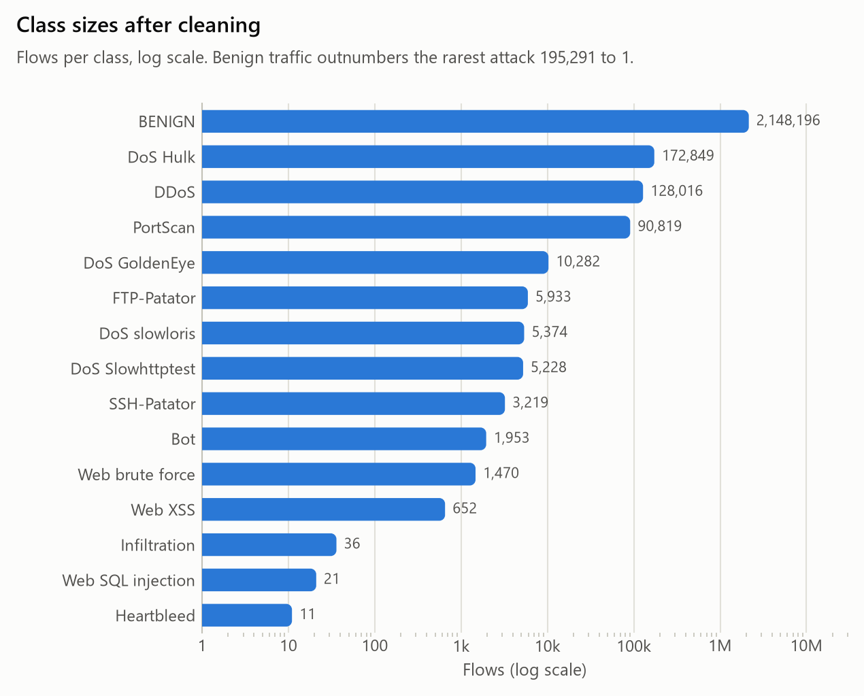
Figure 1. Flows per class after cleaning (log scale).
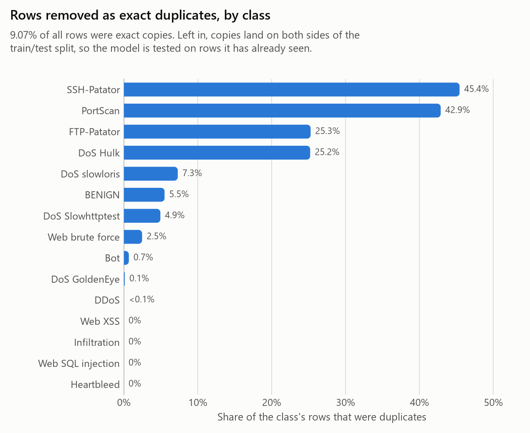
Figure 2. Share of each class removed as duplicates.

4 Method
Every model runs through one shared pipeline (02_experiment.py) so the comparison is fair: median imputation, then standard scaling for the scale-sensitive models (linear models, SVM, MLP, Naive Bayes, LDA and QDA) which the tree models skip, then the classifier. Imputation and scaling are fitted on the training split only. The split is stratified so every class appears in both halves, at test sizes 0.2, 0.4 and 0.6.

4.1 Why macro F1
Accuracy and weighted averages scale each class by its size, so the 2.1 million benign flows drown out the 11 Heartbleed flows: a model can ignore every rare attack and still score above 0.9. Macro-averaged F1 gives every class equal weight, so a missed rare attack shows up. We report macro F1 as the headline metric and read the per-class scores underneath it.

5 Classifier comparison
On the 400,000-flow stratified sample at a 60/40 split, Decision Tree scored the highest macro F1 (0.885), at 0.998 accuracy. Figure 3 shows the gap between accuracy and macro F1 for every model: accuracy is above 0.9 for most, while macro F1 spreads much wider, which is the point of Section 4.1. Table 1 lists the full results.
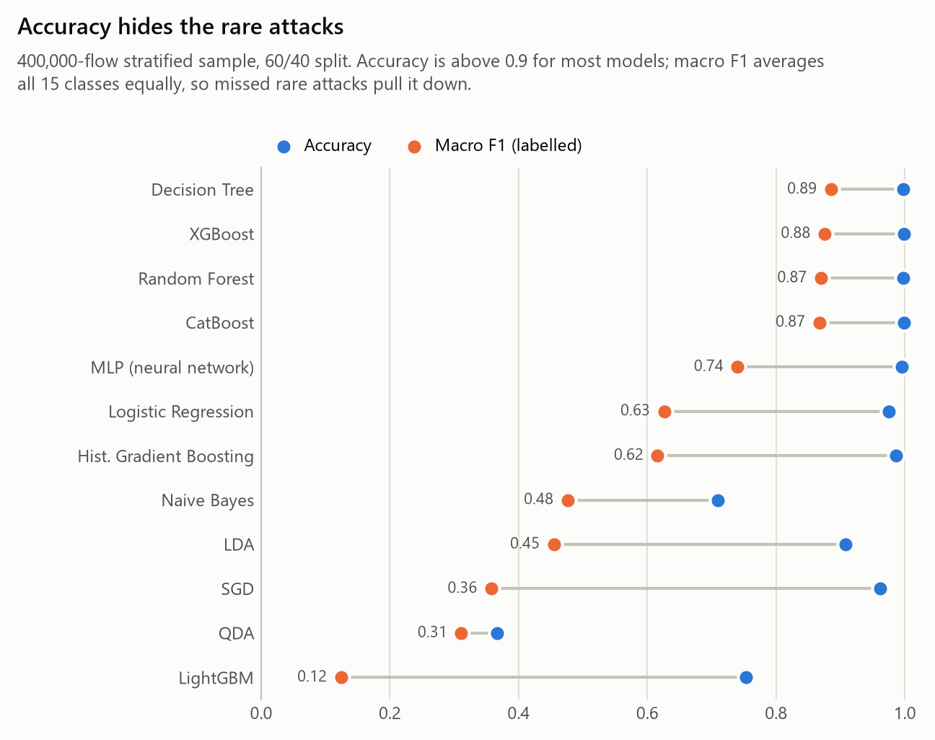
Figure 3. Accuracy versus macro F1 on the full dataset (60/40 split).
Model | Accuracy | Macro F1 | Weighted F1 | Flows/s
Decision Tree | 0.9979 | 0.8851 | 0.9979 | 1,437,230
XGBoost | 0.9984 | 0.8752 | 0.9984 | 85,748
Random Forest | 0.9980 | 0.8697 | 0.9979 | 129,916
CatBoost | 0.9985 | 0.8671 | 0.9985 | 424,167
MLP (neural net) | 0.9955 | 0.7401 | 0.9950 | 677,802
Logistic Regression | 0.9747 | 0.6260 | 0.9748 | 1,081,860
Hist. Gradient Boosting | 0.9859 | 0.6159 | 0.9901 | 109,611
Naive Bayes | 0.7091 | 0.4759 | 0.8121 | 170,698
LDA | 0.9080 | 0.4545 | 0.9175 | 961,398
SGD | 0.9616 | 0.3575 | 0.9590 | 992,414
QDA | 0.3664 | 0.3108 | 0.4793 | 47,671
LightGBM | 0.7527 | 0.1240 | 0.8014 | 48,919

Table 1. Every classifier on the 400,000-flow stratified sample, sorted by macro F1.
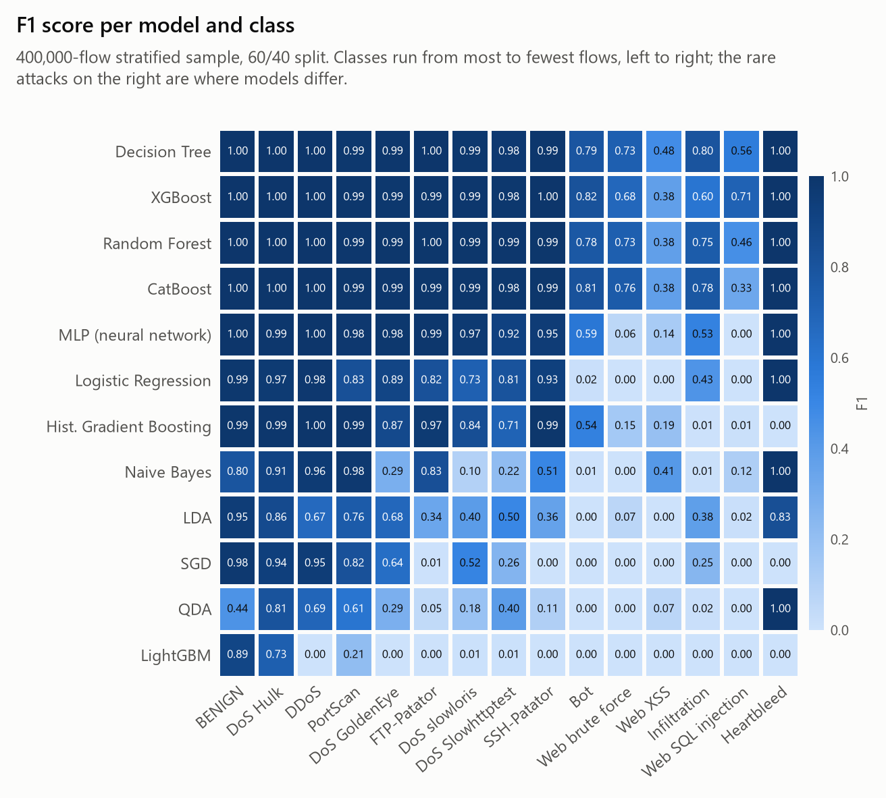
Figure 4. F1 per model and class; the rare attacks on the right are where models differ.
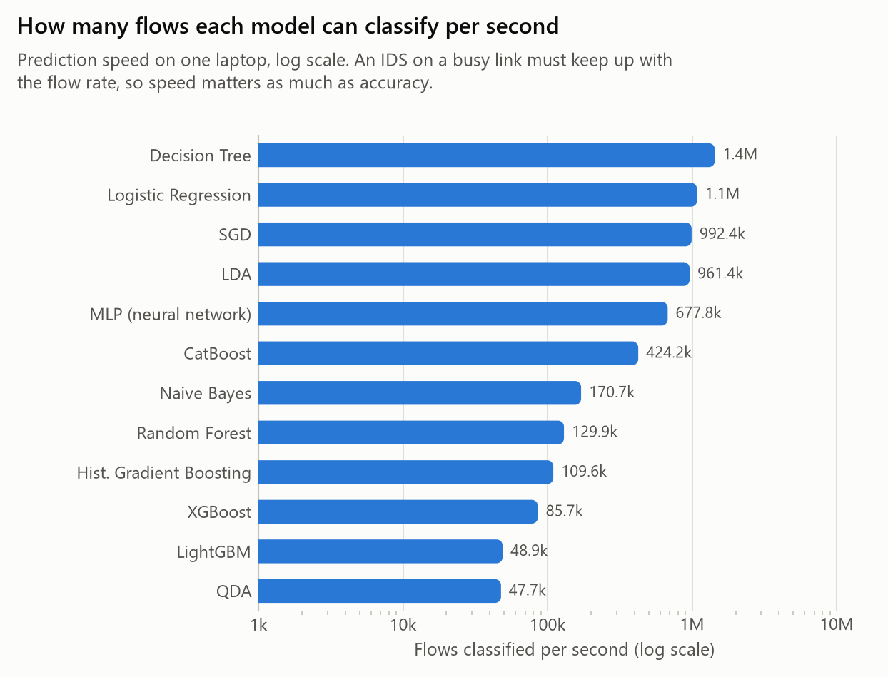
Figure 5. Flows classified per second (log scale): an IDS on a busy link must keep up with the flow rate.
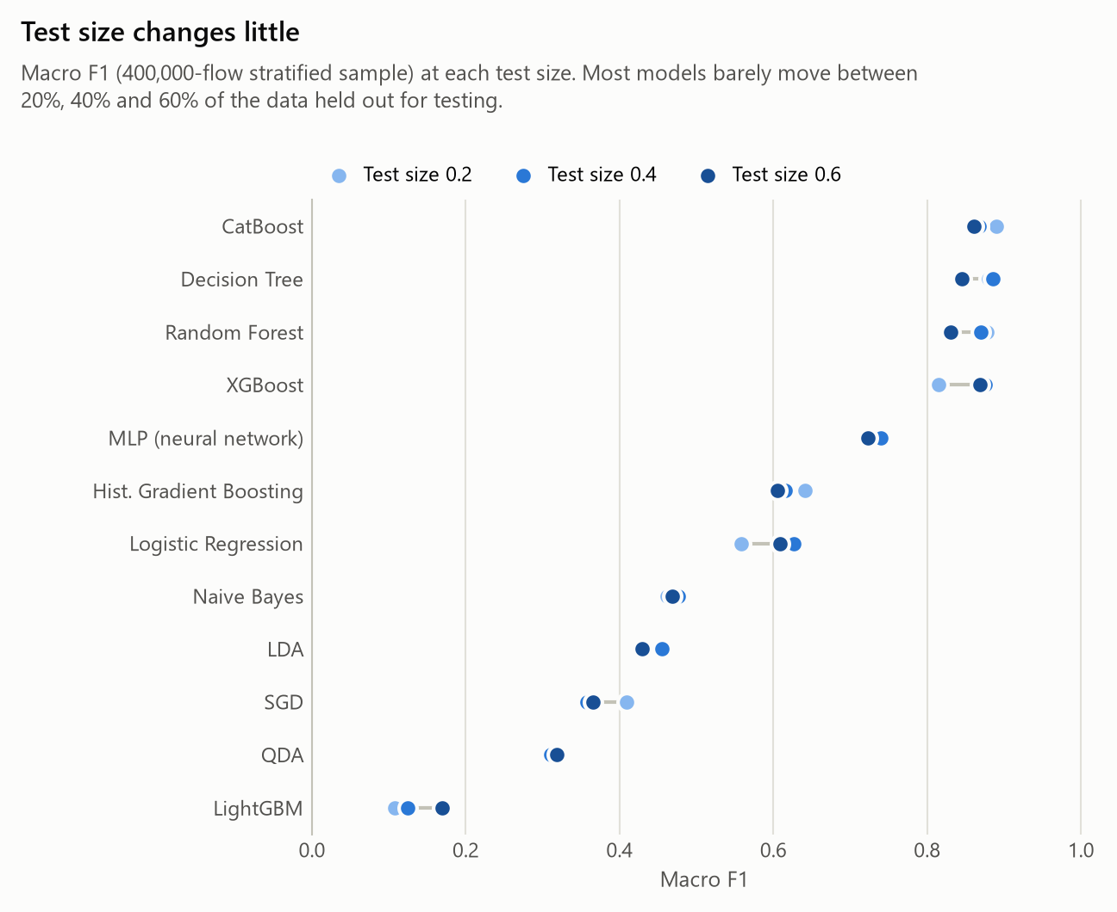
Figure 6. Macro F1 at each test size; most models barely move between 20% and 60% held out.

6 Kernel PCA dimensionality reduction
Kernel PCA projects the 69 features onto a few nonlinear components. Because it builds an n x n kernel matrix, it cannot run on all 2.5 million flows (that matrix would need about 18 TB), so it runs on a fixed stratified sample of about 10,000 flows. We tried five kernels (linear, polynomial, RBF, sigmoid, cosine), three component counts (5, 10, 15) and the three test sizes, for all seven classifiers: 336 runs, plus a no-reduction baseline.
The finding is that dimensionality reduction helps only the distance-based classifiers. KNN and SVM improve with the sigmoid kernel; every other classifier does worse than with all 69 features. The best kernel depends on the classifier (linear for the linear and tree models, sigmoid for KNN, SVM and Naive Bayes), and the polynomial kernel is the worst for all seven. More components always help.
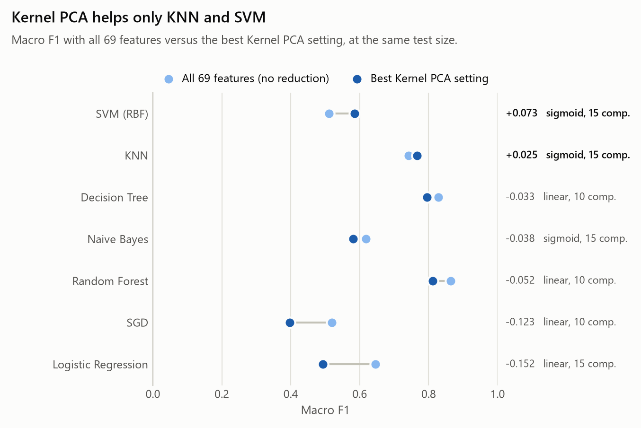
Figure 7. Best Kernel PCA setting versus all 69 features, per classifier.
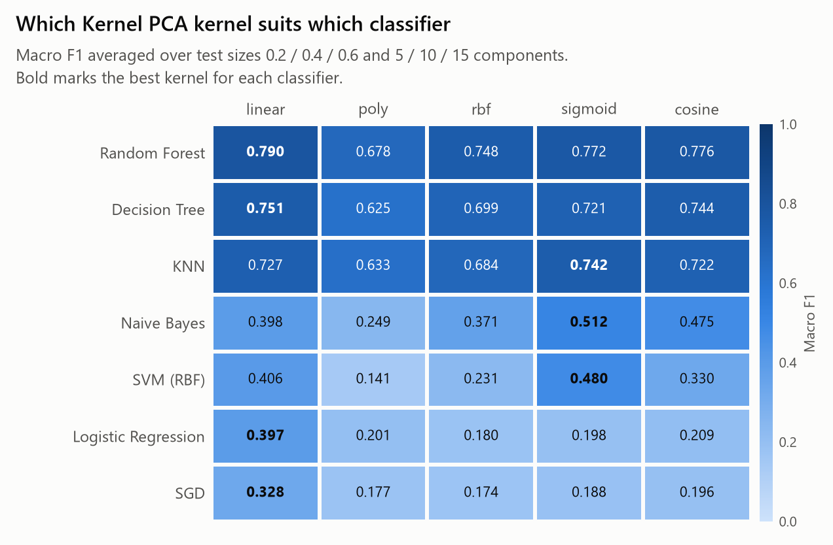
Figure 8. Macro F1 by kernel and classifier (averaged over the grid).
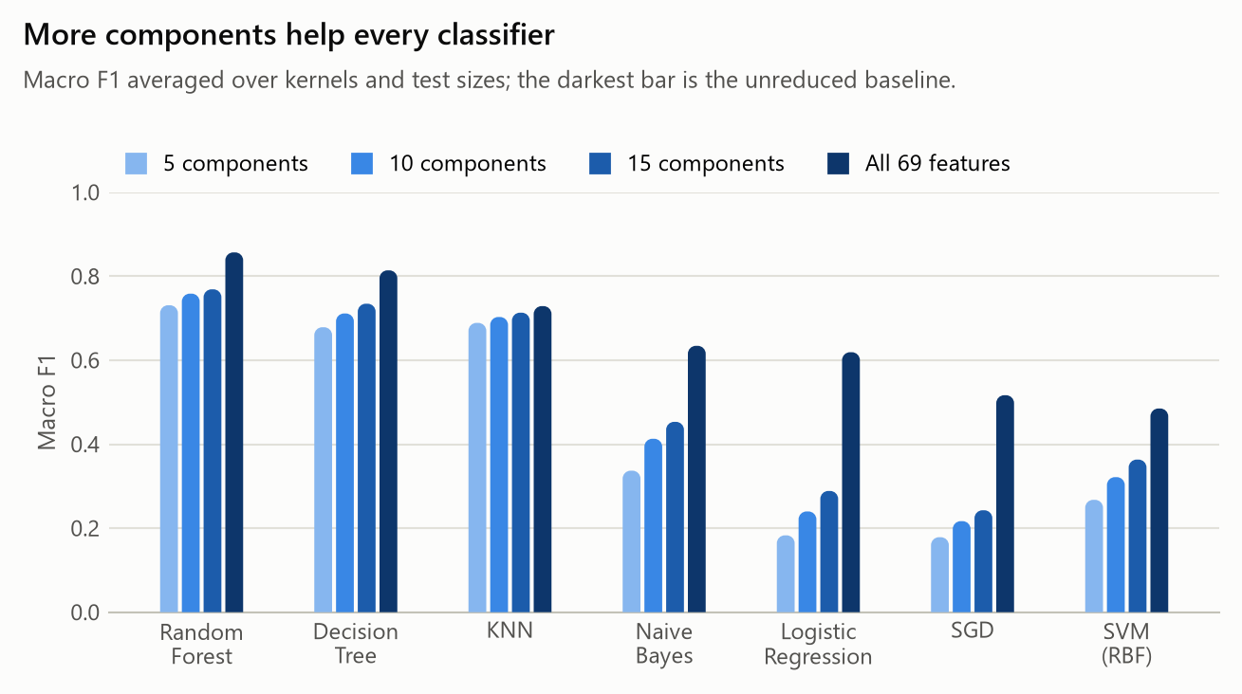
Figure 9. More components give higher macro F1.

7 Which features identify each attack
Permutation importance (shuffle one feature, measure the drop in macro F1) shows the Random Forest leans most on Destination Port and the initial TCP window sizes. These are partly shortcuts: the port identifies the service, and the initial window fingerprints the operating system that sent the traffic, so the very high scores on this dataset would not fully transfer to a different network. Figure 10 lists the top features.
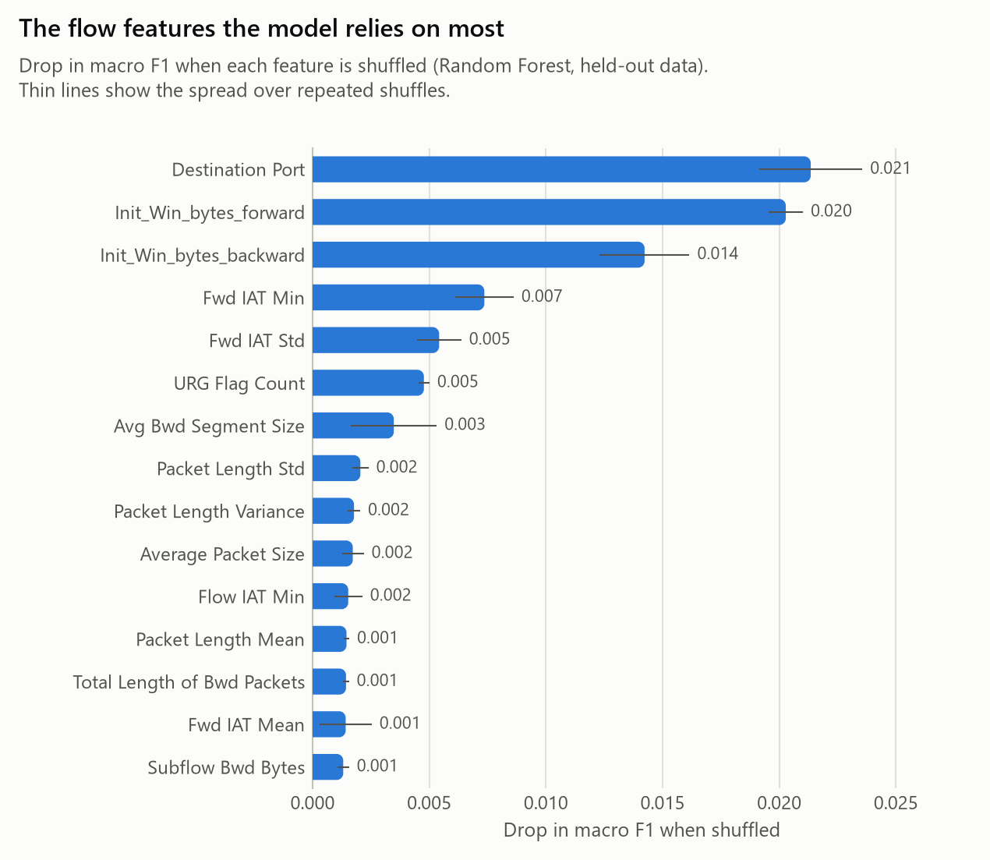
Figure 10. Most important features by permutation importance.
For each attack, the single feature that best separates it from benign traffic matches the attack's mechanism. A few examples (full table in results/features/signatures.csv):
Attack | Top feature | Separation | Attack median | Benign median
FTP-Patator | Destination Port | 1.00 | 21 | 80
DoS slowloris | Flow IAT Mean | 0.81 | 5,872,501 | 15,619
PortScan | Bwd Packets/s | 0.86 | 20,000 | 26
Heartbleed | Bwd Packet Length Max | 1.00 | 14,480 | 90
DoS Hulk | Bwd Packet Length Std | 0.87 | 2,122 | 0

Table 2. The strongest single-feature signature for a sample of attacks. Times are in microseconds.
Two web attacks, brute force and XSS, share the same signature and the same median feature values, which is why classifiers most often confuse them: their flows are near-identical, and the difference lives in the HTTP payload that flow features cannot see.

8 Handling the class imbalance
[Imbalance results missing; run 05_imbalance.py.]

9 Deployment considerations
A flow-based IDS sits beside the traffic, not in its path: a flow's statistics are complete only when the flow ends, so detection comes after the fact and the delay depends on the attack (a port-scan probe is classified in microseconds; a slowloris connection only when it times out). Throughput matters as much as accuracy, since the classifier must keep up with the flow rate of a busy link (Figure 5). Timing and size features survive encryption, which suits DoS, scans and brute force, but payload attacks such as SQL injection need application logs as well.

10 Conclusion
On CIC-IDS2017, tree ensembles led by Random Forest detect most attacks well, but the rarest attacks and the two look-alike web attacks remain hard, and the headline accuracy overstates performance until macro F1 and the per-class scores are read alongside it. Kernel PCA helps only the distance-based classifiers. The most useful features are partly dataset-specific shortcuts, so the natural next steps are to test on traffic from a different network and to drop those shortcut features. Removing the duplicate rows and reporting macro F1 were the two changes that most affected how the results should be read.

