Vision Series Test Plan Document

1. Revision History
Revision | Date | Description | Author
1.0 | 2026-04-10 | Initial draft of the Vision Series Test Plan | Test Architect

2. List of Figures
- Figure 1: Vision Series: three-step verification rail

3. List of Tables
- Table 1: MAG-CXP00002-NP Key Specifications
- Table 2: MAG-IMG002X1-NC Key Specifications
- Table 3: MAG-PSU00001-NP Key Specifications
- Table 4: MAG-VIS100xx-N Key Specifications

4. Introduction & Scope
This document outlines the manufacturing screening, electrical testing, and qualification flow for the Magics Technologies Vision Series to ensure suitability for space and nuclear environments. The Vision Series includes standalone radiation-hardened ICs (Image Sensor, Serializer, DC/DC Converter) and fully integrated electronic Vision Modules.
This test plan details the test conditions, test flows, test stages, and the production and trimming tests required to guarantee the reliability and performance of the products.

5. Applicable Standards
The testing and qualification procedures are aligned with the following industry standards for high-reliability semiconductor components:
- MIL-PRF-38535: General performance requirements for integrated circuits.
- MIL-STD-883: Test methods and procedures for microelectronics.
- ESCC 9000: Generic specification for monolithic integrated circuits (European space standard).
- ESCC 22900 / MIL-STD-883 TM1019: Radiation testing (Total Ionizing Dose).

6. Product Specifications & Acceptance Criteria
The key specifications for the Vision Series products are extracted from their respective datasheets. The acceptance criteria and test limits are defined in the production test plans.

6.1 MAG-CXP00002-NP (CoaXPress Serializer ASIC)
The MAG-CXP00002-NP is a camera interface ASIC that supports harsh environment video transmission over a 75-Ohm coax cable.
Table 1: MAG-CXP00002-NP Key Specifications
Parameter | Specification | Test Condition / Acceptance Criteria
Downlink Speed | 1.25 Gbps | Tested via functional interface test
Uplink Speed | 20 Mbps | Tested via functional interface test
Supply Voltage | 3.3V | VDD pin voltage test (LSL: 3.0V, USL: 3.6V)
Power Consumption | 272 mW (typical) | IDD current measurement
Clock Input | 10 - 40 MHz | Tested via PLL lock verification
Radiation Hardness (TID) | > 1 MGy (100 Mrad) | Guaranteed by design and lot acceptance
Radiation Hardness (SEE) | > 60 MeV.cm²/mg | Guaranteed by design
Production Tests: - Continuity Test: Verifies no open/short circuits on pins. - IDD Current Test: Measures standby and active current. - Trim Sweep: Trims internal references to target values. - Functional Test: Validates video transmission and SPI communication.

6.2 MAG-IMG002X1-NC (Full HD CMOS Image Sensor)
The MAG-IMG002X1-NC is a radiation-hardened Full HD CMOS digital image sensor with an active-pixel array of 1920x1080.
Table 2: MAG-IMG002X1-NC Key Specifications
Parameter | Specification | Test Condition / Acceptance Criteria
Resolution | 1920 x 1080 (Full HD) | Validated via image capture test
Frame Rate | Up to 30 FPS | Validated via continuous mode test
Dynamic Range | > 60 dB | Characterized during optical test
Supply Voltage | 1.8V (Digital), 3.3V (Analog) | VDD pin voltage test
Power Consumption | < 1W (typical) | IDD current measurement
Radiation Hardness (TID) | > 1 MGy | Guaranteed by design and lot acceptance
Radiation Hardness (SEE) | > 62.5 MeV.cm²/mg | Guaranteed by design
Production Tests: - Dark Pixel Readout: Verifies dark current levels without illumination. - Image Capture Test: Validates pixel array functionality and parallel output bus. - SPI Interface Test: Verifies register read/write operations.

6.3 MAG-PSU00001-NP (10W Synchronous Step-Down DC/DC Converter)
The MAG-PSU00001-NP is a single-phase synchronous buck converter designed for high-energy physics experiments.
Table 3: MAG-PSU00001-NP Key Specifications
Parameter | Specification | Test Condition / Acceptance Criteria
Input Voltage Range | 5V to 11V | UVLO High (LSL: 4.4V, USL: 4.8V)
Load Capability | 4A (active cooling) | IOL/IOH current tests
Switching Frequency | 1 - 3 MHz | Functional switching test
Input Leakage Current | - | LSL: -10mA, USL: 10mA
VIL (Input Low Voltage) | 0.73V (typical) | LSL: 0.67V, USL: 0.78V
VIH (Input High Voltage) | 0.815V (typical) | LSL: 0.77V, USL: 0.90V
Radiation Hardness (TID) | > 1 MGy | Guaranteed by design and lot acceptance
Radiation Hardness (SEE) | 64 MeV.cm²/mg | Tested free of destructive SEEs
Production Tests: - Power Short Test: Verifies no shorts on input/output (M0001, M0002). - Leakage Current Test: Measures IIL/IIH on control pins. - Threshold Voltage Test: Measures VIL/VIH and hysteresis. - UVLO Test: Verifies Under-Voltage Lockout thresholds.

6.4 MAG-VIS100xx-N (Electronic Vision Module)
The MAG-VIS100xx-N is a fully integrated electronic camera module comprising the Image Sensor, Serializer, and DC/DC Converters in a three-PCB stack.
Table 4: MAG-VIS100xx-N Key Specifications
Parameter | Specification
Components | MAG-IMG002X1, MAG-CXP0002, 2x MAG-PSU00001
Input Voltage | 9V (generates 3.3V and 1.8V internally)
Video Interface | CoaXPress 1.25 Gbps (75-Ohm coax)
Radiation Hardness | > 1 MGy TID (Si)
Operating Temp | 0 to 50 °C ambient

7. Test Stages & Verification Flow
The verification and testing of the Vision Series products follow a strict three-step horizontal process rail. This ensures that quality is maintained from the bare IC level up to the fully integrated module.
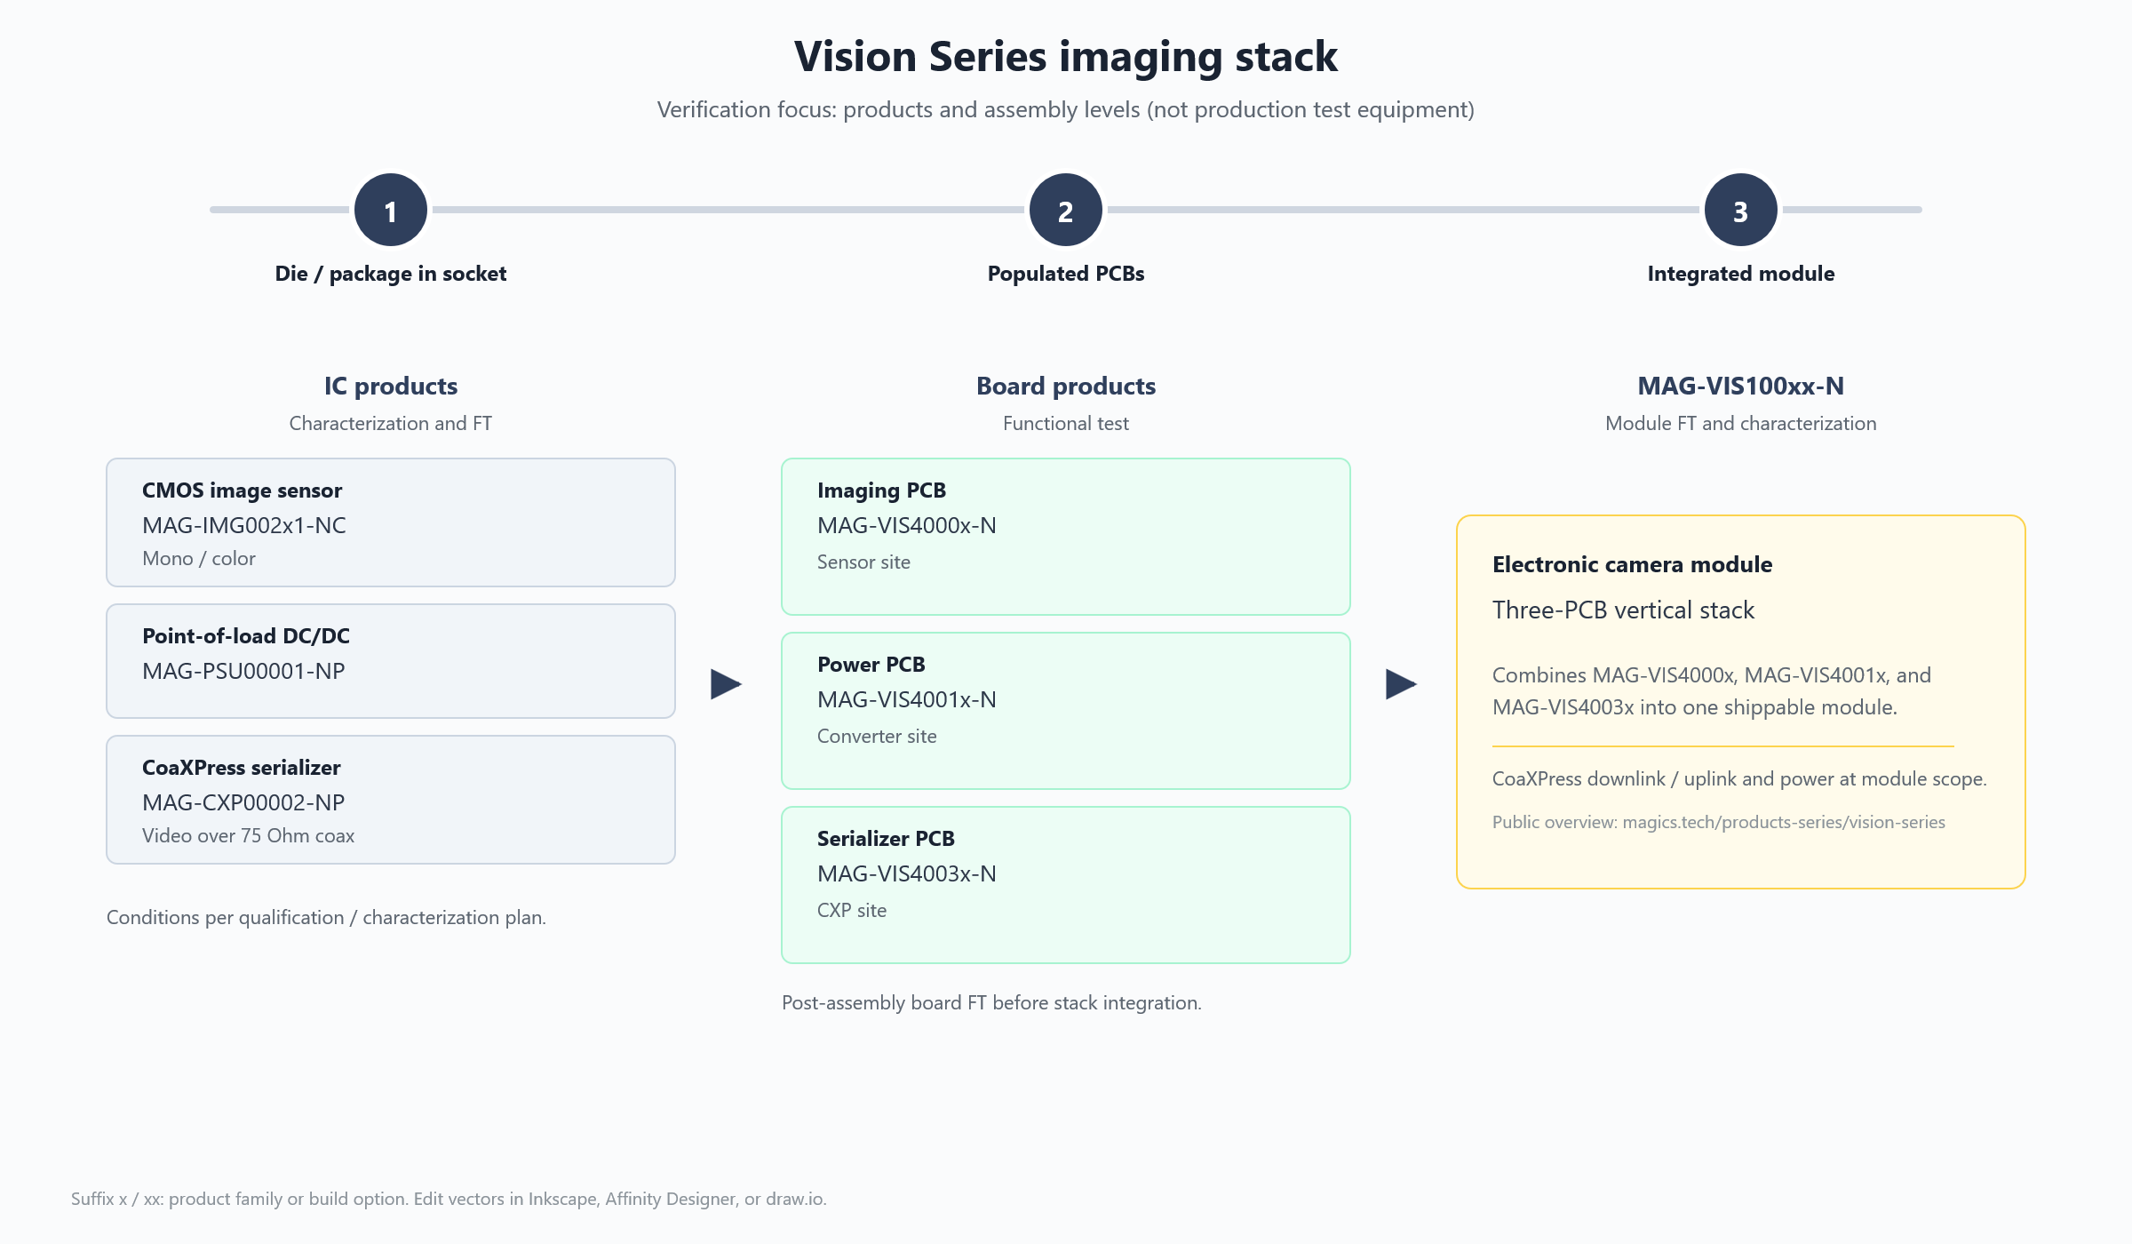 Figure 1: Vision Series: three-step verification rail

7.1 Stage 1: IC Products (Characterization and FT)
- Focus: Die / package in socket.
- Products: MAG-IMG002x1-NC, MAG-PSU00001-NP, MAG-CXP00002-NP.
- Description: 100% Final Test (FT) and characterization of the individual integrated circuits. Tests include continuity, leakage, parametric trimming, and functional verification according to the qualification plan.

7.2 Stage 2: Board Products (Functional Test)
- Focus: Populated PCBs.
- Products: MAG-VIS4000x-N (Imaging PCB), MAG-VIS4001x-N (Power PCB), MAG-VIS4003x-N (Serializer PCB).
- Description: Post-assembly board functional test (FT) before stack integration. Verifies that the soldering and board-level interconnects are reliable and that the individual sub-systems function correctly.

7.3 Stage 3: Integrated Module (Module FT and Characterization)
- Focus: Integrated module.
- Products: MAG-VIS100xx-N (Three-PCB vertical stack).
- Description: Final module FT and characterization. Verifies the CoaXPress downlink/uplink and power delivery at the module scope. Ensures the complete electronic camera module meets the datasheet specifications.

8. Test Conditions & Procedures
This section details the specific test conditions, stages, and procedures applied during the characterization and functional testing of the Vision Series products, as extracted from the product test plans.

8.1 Test Conditions
During functional verification and characterization testing, the temperature and supply voltage of the DUTs (Device Under Test) are varied to validate the ASIC specifications over the defined operating conditions.
Temperature Conditions: - RT (Room Temperature): 25°C ± 5°C - CT (Cold Temperature): 0°C ± 5°C (for Image Sensor) / -40°C ± 5°C (for DC/DC & Serializer) - HT (Hot Temperature): 85°C ± 5°C
Supply Voltage Conditions: Supply voltages are varied across their minimum, typical, and maximum specified ranges to ensure robust operation under all conditions.

8.2 Test Stages
The test stages required to validate the performance of the products include:
- Visual Inspection (VI): Examination of external surfaces, construction, marking, and workmanship. For the image sensor, this includes bond pad corrosion, wire bonding, and glass lid inspection.
- Connectivity Test (CONN): The initial stage of any test. It checks for shorts on the DUT interface to reduce the risk of destructive errors damaging the DUT or setup.
- Trimming (TRIM): Tuning of internal references and blocks. Trimming follows a specific sequence, starting with top-level blocks and proceeding to dependent blocks.
- Characterization (CHAR): Intended to test the electrical requirements of the DUTs over the operating conditions (temperature, load-current, and supply-level).
- Final Testing (FT): Confirms that the product is compliant (functional and/or parametric) against the test limits defined in the test plan. The goal is to screen devices for manufacturing defects.

8.3 Test Flow and Sequence
Every part follows a defined test flow: 1. Visual Inspection 2. Connectivity Test (CONN) 3. Trimming (TRIM) (if applicable) 4. Final Test (FT) / Characterization (CHAR)
The exact sequence of tests within these stages is defined in the product-specific test plans and is executed from top to bottom to ensure dependencies are respected (e.g., trimming top-level blocks before dependent blocks).

8.4 Test Procedures
The test procedures provide a high-level description, test configuration, test conditions, and acceptance criteria for each test. Key procedures include:
- Continuity / Power Short / Load Short: Verifies that there are no open or short circuits on the pins, ensuring the device is safe to power up.
- Leakage Current (IIL/IIH): Measures the input leakage current on control pins to ensure they meet specifications.
- Threshold Voltage (VIL/VIH): Measures the input low and high voltage thresholds and hysteresis for digital interfaces.
- Functional / Video Data Check: Validates the core functionality, such as video transmission, SPI communication, and pixel array readout.
- IDD Current: Measures the standby and active power consumption of the device.
Note: The specific test limits and acceptance criteria for these procedures are defined in the check_limits.xlsx files managed by the test engineering team.

