Vision Series Test Plan Document

1. Revision History
Revision | Date | Description | Author
1.0 | 2026-04-10 | Initial draft of the Vision Series Test Plan | Test Architect

2. List of Figures
- Figure 1: Vision Series: three-step verification rail
- Figure 2: MAG-IMG002x1-NC Production Test Flow
- Figure 3: MAG-IMG002x1-NC Trim Test Flow
- Figure 4: MAG-CXP00002-NP Production Test Flow
- Figure 5: MAG-PSU00001-NP Production Test Flow
- Figure 6: MAG-VIS100xx-N Production Test Flow

3. List of Tables
- Table 1: MAG-IMG002X1-NC Key Specifications
- Table 2: MAG-CXP00002-NP Key Specifications
- Table 3: MAG-PSU00001-NP Key Specifications
- Table 4: MAG-VIS100xx-N Key Specifications

4. Introduction & Scope
This document outlines the electrical testing for the Magics Technologies Vision Series to ensure suitability for nuclear environments. The Vision Series includes standalone radiation-hardened ICs (Image Sensor, Serializer, DC/DC Converter) and fully integrated electronic Vision Modules.
This test plan details the test conditions, test flows, test stages, and the production and trimming tests required to guarantee the reliability and performance of the products.

5. Vision products verification process
The verification and testing of the Vision Series products follow a strict three-step horizontal process rail. This ensures that quality is maintained from the IC component level up to the fully integrated module.
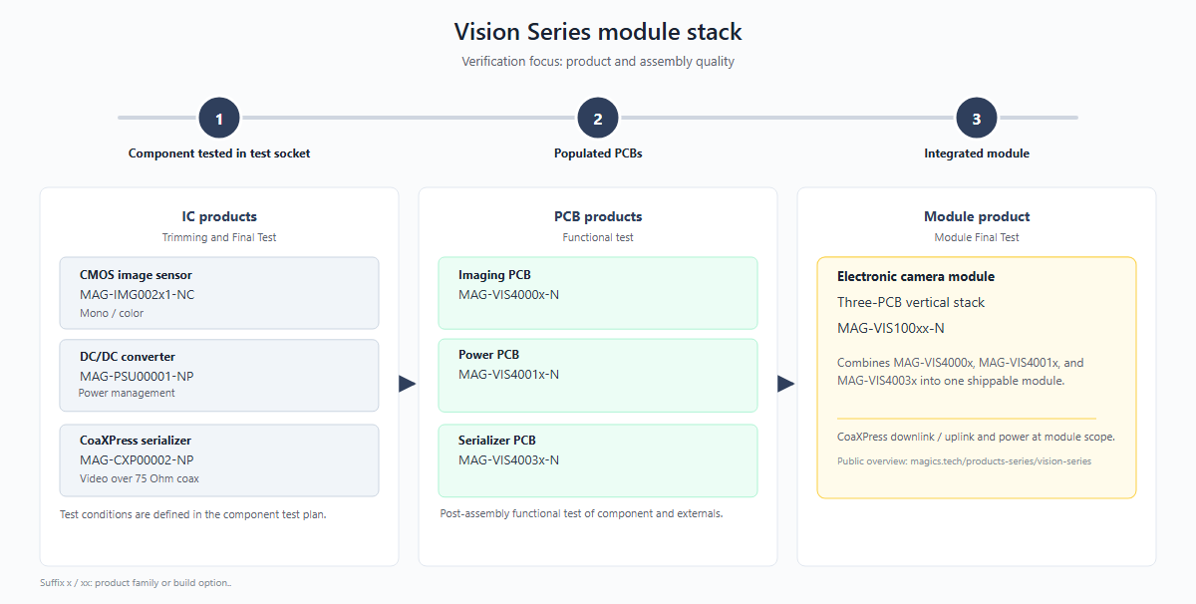 Figure 1: Vision Series: three-step verification rail

5.1 Stage 1: Component tested in test socket
- Focus: IC products
- Description: Trimming and Final Test of the individual integrated circuits. Tests include continuity, leakage, parametric trimming, and functional verification according to the qualification plan.

5.2 Stage 2: Populated PCBs
- Focus: PCB products
- Description: Functional test of post-assembly boards before stack integration. Verifies that the soldering and board-level interconnects are reliable and that the individual sub-systems function correctly.

5.3 Stage 3: Integrated module
- Focus: Module product
- Description: Module Final Test. Verifies the CoaXPress downlink/uplink and power delivery at the module scope. Ensures the complete electronic camera module meets the datasheet specifications.

6. Test specifications
This chapter outlines the test flows, test stages, and test procedures for each product in the Vision Series.

6.1 MAG-IMG002x1-NC (Image Sensor)

6.1.1 Test flow
The production and trimming test flows for the image sensor are depicted below:
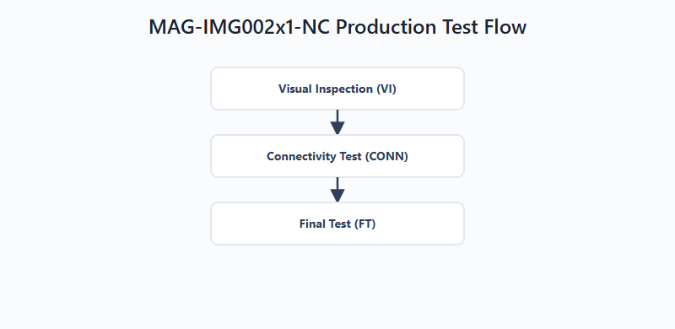 Figure 2: MAG-IMG002x1-NC Production Test Flow
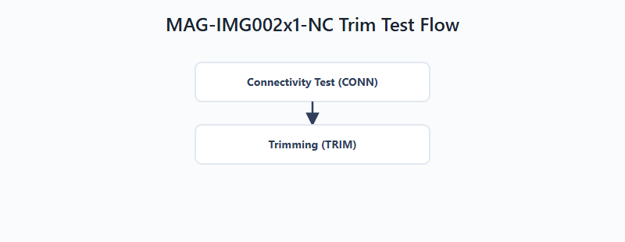 Figure 3: MAG-IMG002x1-NC Trim Test Flow

6.1.2 Test stages
- Visual Inspection (VI): Examination of external surfaces, glass lid, and wire bonding.
- Connectivity Test (CONN): Checks for shorts on the DUT interface to prevent damage.
- Trimming (TRIM): Tuning of internal references and blocks.
- Final Testing (FT): Confirms that the product is compliant against test limits.

6.1.3 Test procedures
- Continuity: Verifies that there are no open or short circuits on the pins.
- Power Short: Checks for shorts between power supplies and ground.
- Leakage: Measures the input leakage current on control pins.
- VIL/VIH: Measures the input low and high voltage thresholds.
- VOL/VOH: Measures the output low and high voltage levels.
- IOL/IOH: Measures the output drive strength.
- IDDD: Measures the digital and analog power consumption.
- Trim test: Trims internal references to target values.

6.2 MAG-CXP00002-NP (Serializer)

6.2.1 Test flow
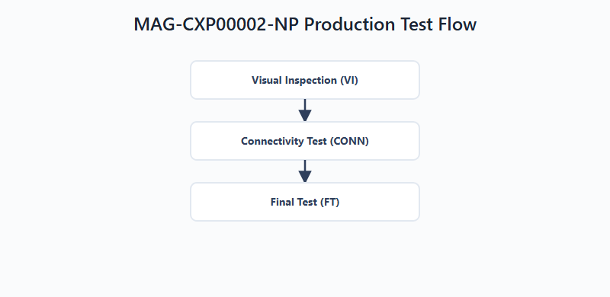 Figure 4: MAG-CXP00002-NP Production Test Flow

6.2.2 Test stages
- Visual Inspection (VI): Examination of external surfaces and packaging.
- Connectivity Test (CONN): Checks for shorts on the DUT interface.
- Final Testing (FT): Confirms functional and parametric compliance.

6.2.3 Test procedures
(Similar to MAG-IMG002x1-NC) - Continuity / Power Short: Verifies no open/short circuits on pins and supplies. - Leakage: Measures input leakage current. - Functional Test: Validates video transmission, SPI communication, and CXP link stability.

6.3 MAG-PSU00001-NP (DC/DC Converter)

6.3.1 Test flow
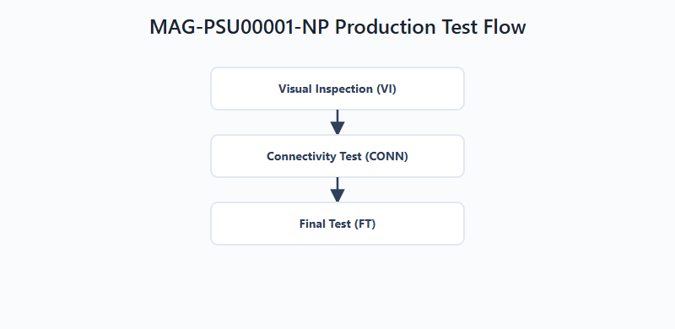 Figure 5: MAG-PSU00001-NP Production Test Flow

6.3.2 Test stages
- Visual Inspection (VI): Examination of external surfaces.
- Connectivity Test (CONN): Checks for shorts on the DUT interface.
- Final Testing (FT): Confirms functional and parametric compliance.

6.3.3 Test procedures
- Power Short: Verifies no shorts on input/output power pins.
- Load Short: Verifies the converter’s response to a shorted load.
- Leakage: Measures input leakage current on control pins.
- Threshold Voltage: Measures VIL/VIH and hysteresis.
- UVLO Test: Verifies Under-Voltage Lockout thresholds.
- Efficiency / Load Regulation: Measures converter efficiency under various loads.

6.4 MAG-VIS100xx-N (Vision Module)

6.4.1 Test flow
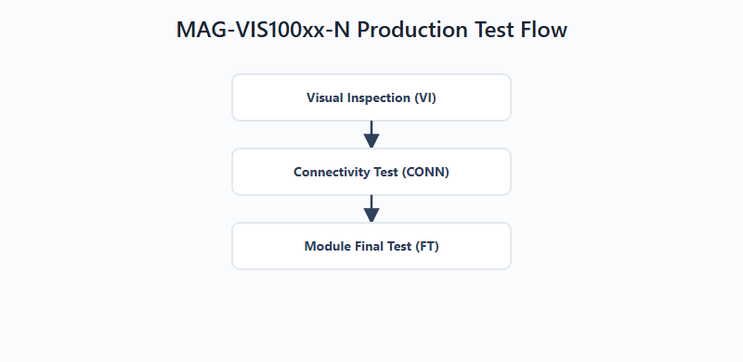 Figure 6: MAG-VIS100xx-N Production Test Flow

6.4.2 Test stages
- Visual Inspection (VI): Examination of the assembled PCB stack.
- Connectivity Test (CONN): Checks for shorts on the module interface.
- Module Final Test (FT): Confirms the integrated module meets specifications.

6.4.3 Test procedures
- CXP Core functionality: Validates the CoaXPress downlink and uplink communication.
- Video data check: Verifies the image sensor readout through the serializer.
- Power delivery check: Ensures the integrated DC/DC converters supply correct voltages.

7. Product Specifications & Acceptance Criteria
The key specifications for the Vision Series products are extracted from their respective datasheets. The acceptance criteria and test limits are defined in the production test plans.

7.1 MAG-IMG002X1-NC (Full HD CMOS Image Sensor)
Table 1: MAG-IMG002X1-NC Key Specifications
Parameter | Specification | Test Condition / Acceptance Criteria
Resolution | 1920 x 1080 (Full HD) | Validated via image capture test
Frame Rate | Up to 30 FPS | Validated via continuous mode test
Dynamic Range | > 60 dB | Characterized during optical test
Supply Voltage | 1.8V (Digital), 3.3V (Analog) | VDD pin voltage test
Power Consumption | < 1W (typical) | IDD current measurement
Radiation Hardness (TID) | > 1 MGy | Guaranteed by design and lot acceptance
Radiation Hardness (SEE) | > 62.5 MeV.cm²/mg | Guaranteed by design

7.2 MAG-CXP00002-NP (CoaXPress Serializer ASIC)
Table 2: MAG-CXP00002-NP Key Specifications
Parameter | Specification | Test Condition / Acceptance Criteria
Downlink Speed | 1.25 Gbps | Tested via functional interface test
Uplink Speed | 20 Mbps | Tested via functional interface test
Supply Voltage | 3.3V | VDD pin voltage test (LSL: 3.0V, USL: 3.6V)
Power Consumption | 272 mW (typical) | IDD current measurement
Clock Input | 10 - 40 MHz | Tested via PLL lock verification
Radiation Hardness (TID) | > 1 MGy (100 Mrad) | Guaranteed by design and lot acceptance
Radiation Hardness (SEE) | > 60 MeV.cm²/mg | Guaranteed by design

7.3 MAG-PSU00001-NP (10W Synchronous Step-Down DC/DC Converter)
Table 3: MAG-PSU00001-NP Key Specifications
Parameter | Specification | Test Condition / Acceptance Criteria
Input Voltage Range | 5V to 11V | UVLO High (LSL: 4.4V, USL: 4.8V)
Load Capability | 4A (active cooling) | IOL/IOH current tests
Switching Frequency | 1 - 3 MHz | Functional switching test
Input Leakage Current | - | LSL: -10mA, USL: 10mA
VIL (Input Low Voltage) | 0.73V (typical) | LSL: 0.67V, USL: 0.78V
VIH (Input High Voltage) | 0.815V (typical) | LSL: 0.77V, USL: 0.90V
Radiation Hardness (TID) | > 1 MGy | Guaranteed by design and lot acceptance
Radiation Hardness (SEE) | 64 MeV.cm²/mg | Tested free of destructive SEEs

7.4 MAG-VIS100xx-N (Electronic Vision Module)
Table 4: MAG-VIS100xx-N Key Specifications
Parameter | Specification
Components | MAG-IMG002X1, MAG-CXP0002, 2x MAG-PSU00001
Input Voltage | 9V (generates 3.3V and 1.8V internally)
Video Interface | CoaXPress 1.25 Gbps (75-Ohm coax)
Radiation Hardness | > 1 MGy TID (Si)
Operating Temp | 0 to 50 °C ambient

