

Project & (Type of document)
  - Subject: [Subject]

Author: Jonathan Vanden Berk (Magics Technologies)

version | Date | Reviewed by | Approved by
... | [Publish Date] | ... | ...

Revision history
Version | Date | Revisions
… | … | First version  Reviewed by:…  Approved by:…

Table of Contents
Revision history 2
Table of Contents 3
List of Figures 4
List of Tables 5
1 Heading 1 6
1.1 Heading 2 6
1.1.1 Heading 3 6
2 Figures 7
3 Tables 8
Bibliography 10
List of Acronyms 11
Appendix A Style – Appendix 1 12
A.1 Style appendix 2 12

List of Figures
Figure 1: Caption below the figure 2

List of Tables
Table 1: Table caption above table 7

Heading 1

Heading 2
Lorem ipsum dolor sit amet, consectetur adipiscing elit. Nunc eleifend maximus magna non mattis. In vehicula est eu enim porta, lacinia pretium elit vehicula. Quisque rutrum eget est vel tristique. Ut mattis, mi id iaculis mollis, leo sem bibendum massa, ut commodo eros metus non nisl. Nunc posuere ligula nisl, ut fringilla purus suscipit vitae.

Numbered list:
- Lorem ipsum dolor sit amet, consectetur adipiscing elit.
- Duis aliquet mi quis ipsum condimentum, at finibus erat pulvinar.
- Pellentesque vitae libero ac tortor tristique pellentesque mollis
- Pellentesque vitae libero ac tortor tristique pellentesque mollis

Multilevel list
- Lorem ipsum dolor sit amet, consectetur adipiscing elit.
  - Duis aliquet mi quis ipsum condimentum, at finibus erat pulvinar.
    - Pellentesque vitae libero ac tortor tristique pellentesque mollis
  - Etiam at ex quis dolor vulputate placerat.
- Suspendisse ac dui in lectus pellentesque faucibus.

Heading 3
Lorem ipsum dolor sit amet, consectetur adipiscing elit. Sed sed malesuada justo, quis elementum orci. Cras feugiat, nibh nec tincidunt luctus, massa lectus eleifend libero, quis venenatis turpis velit nec felis.
Lorem ipsum dolor sit amet, consectetur adipiscing elit. Sed sed malesuada justo, quis elementum orci. Cras feugiat, nibh nec tincidunt luctus, massa lectus eleifend libero, quis venenatis turpis velit nec felis.

Heading 4

Heading 5
Lorem ipsum dolor sit amet, consectetur adipiscing elit. Sed sed malesuada justo, quis elementum orci. Cras feugiat, nibh nec tincidunt luctus, massa lectus eleifend libero, quis venenatis turpis velit nec felis.

Figures
- Figure placed in document are put in paragraph style “Figure” .
- Figures have a Figure caption below the figure.


Figure 1: Caption below the figure

Tables
Tables have a Table caption above the table.

Table 1: Table caption above table
Column 1 | Column 2
Put the text in a table in “Table” style
Text
Text
Text

Default Table Design in this template = Grid Table 4- accent 3

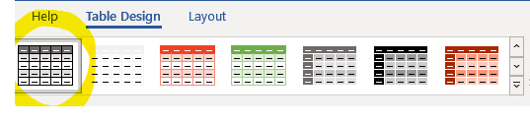
Figure 2: Default Table Design = Grid Table 4 – accent 3

In the Table Design tab you can choose some options like “Header Row”, “First Column”,… This tab is available as soon as your cursor is somewhere inside a table.

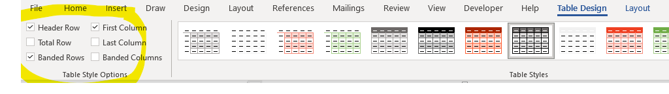

Select the whole table and put the text inside the Table in paragraph style “Table” to make the text/table more compact.

Table 2: Table with text in text-style “Table-small”
Column 1 | Column 2
Put the text in a table in “Table” style
Text
Text
Text

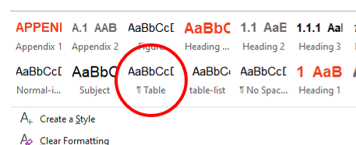
Figure 3: Paragraph style “Table” for text in Tables

The Layout tab gives you options on e.g. width of the table…
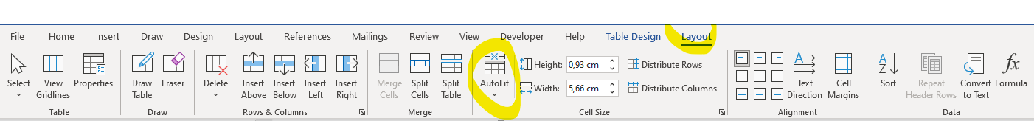

Bibliography

[1] | Magics, Design Document, Geel, 2021.

List of Acronyms
Acronym | Definition

- Style – Appendix 1
- Style appendix 2

