**Demo Graphic Data Files Relation**

**Introduction**

There is a UI app demo that we need to develop in Grafana. This demo can be browsed directly in the next URL address: [http://45.76.129.133:8081](http://45.76.129.133:8081/) .

In order to create this demo in Grafana, it is needed to know the relation between the embedded graphics and the input data files. This document explains this relation. On the other hand, we need to keep the current demo layout as much as possible.

**Home**

The home entrance (<http://45.76.129.133:8081/home>) is as follows:

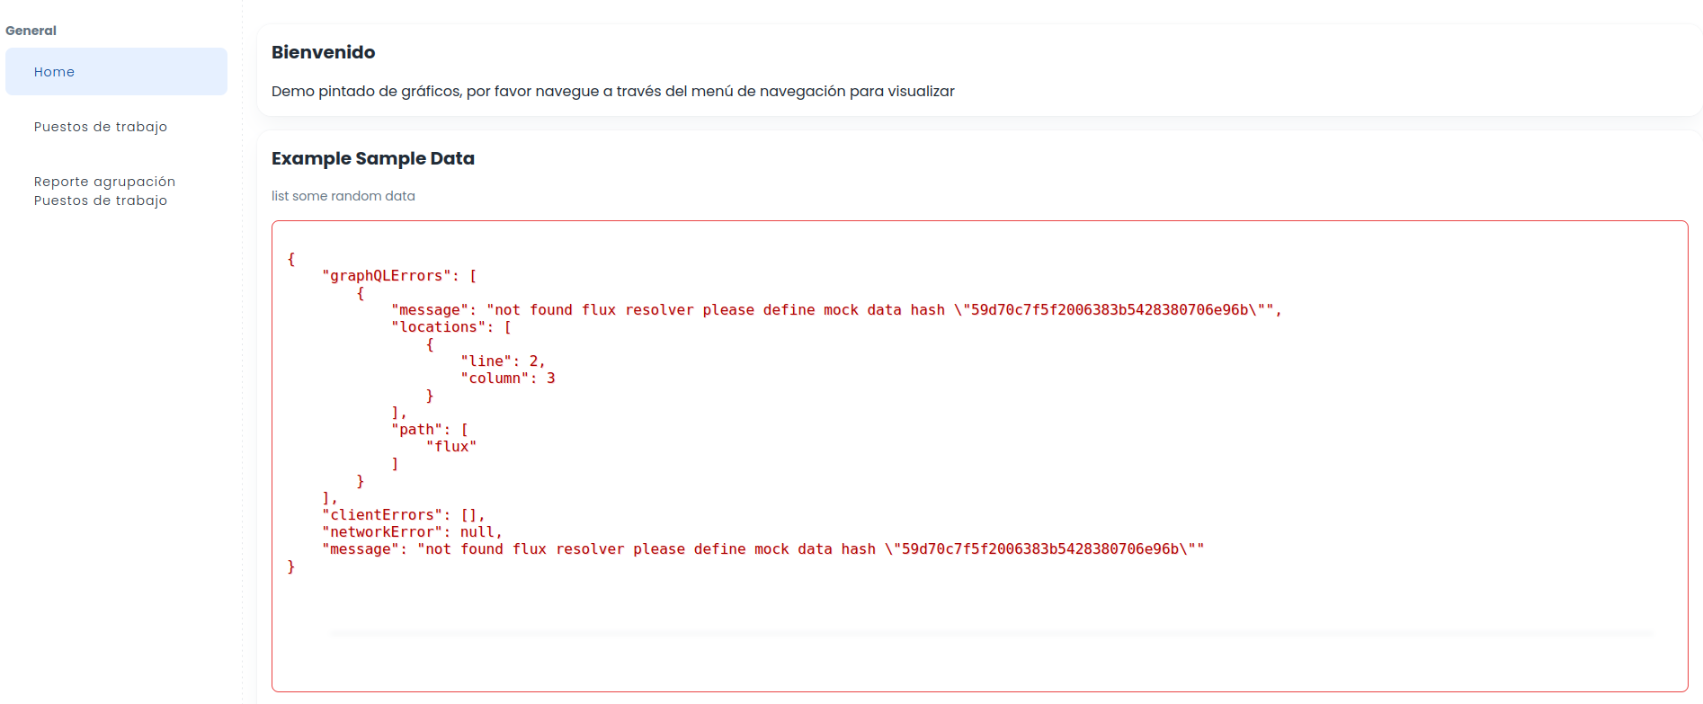

We don’t need to replicate this view, but we need to modify the left pane, in order to display all the workstations like the old ugly UI (below), with the new nice design (above):

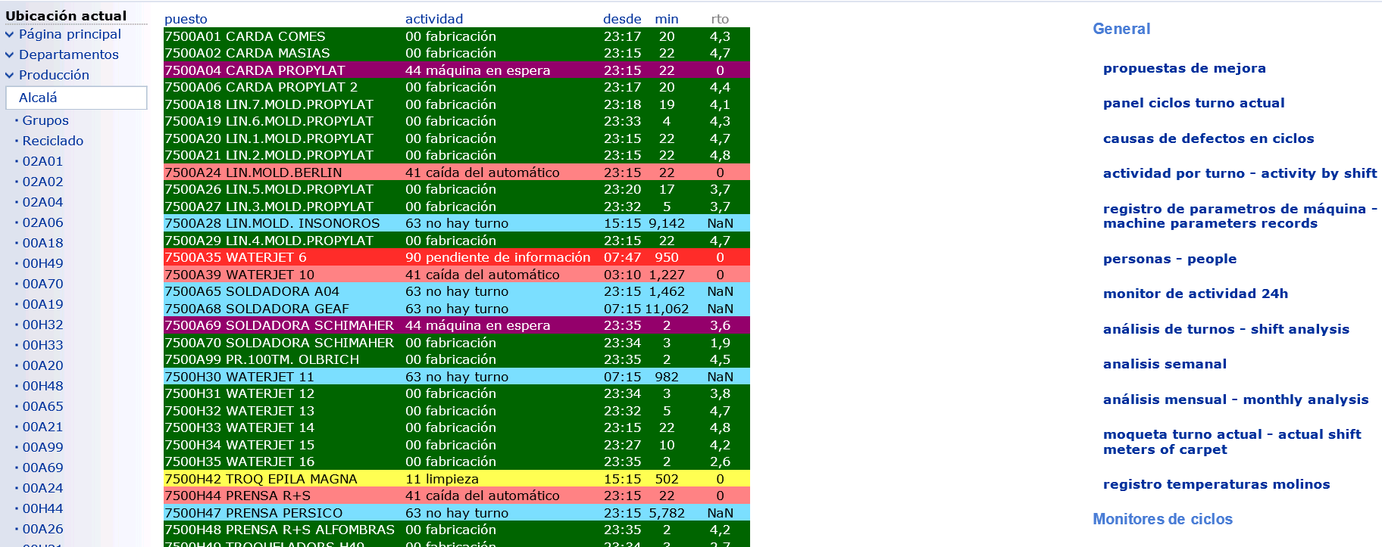

The workstation ids, to be displayed in the left pane, can be found in the **id** field of the **listadoDePuestos.json** file.

**Lists**

The main entrance has to contain the Workstation list followed by the Workers list, as it is layed out in <http://45.76.129.133:8081/workstations>:

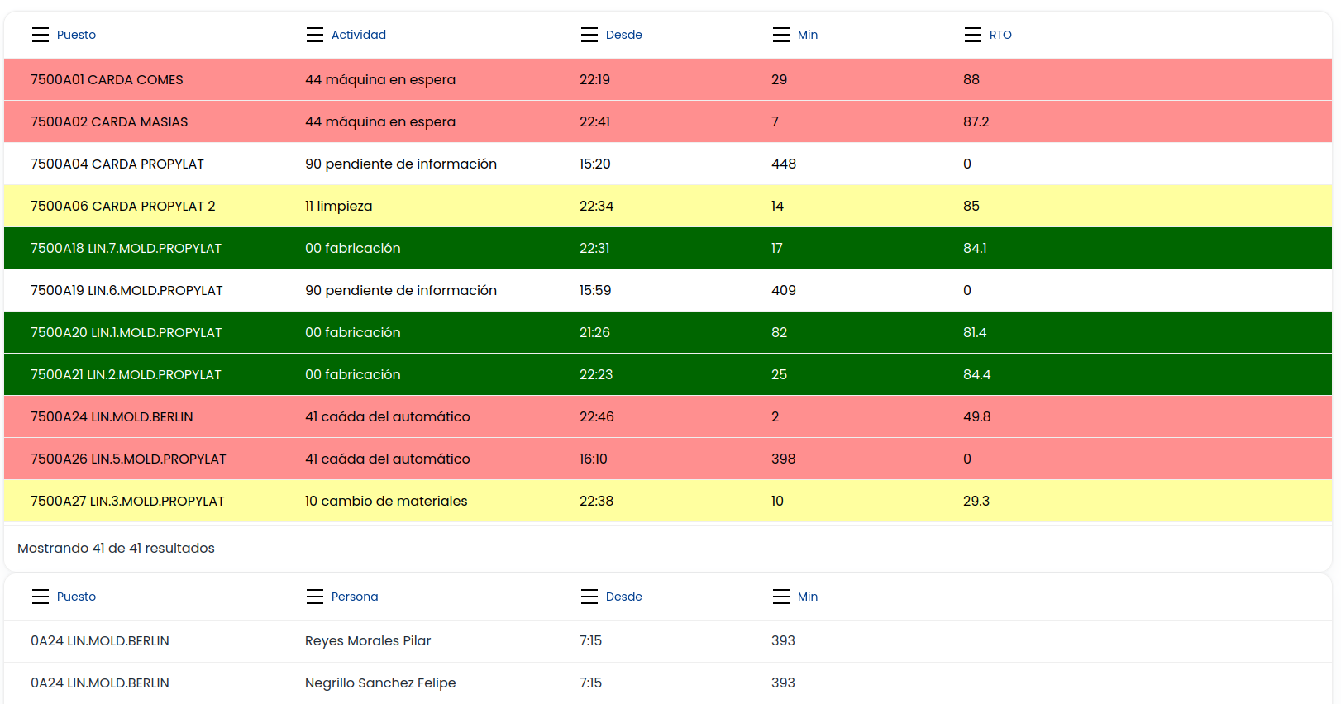

The workstation and worker lists have to be fully displayed, out of a frame, container, layer, … , I mean that the second list has to start when the first one ends, without internal scrolling, as it is in the old ugly UI:

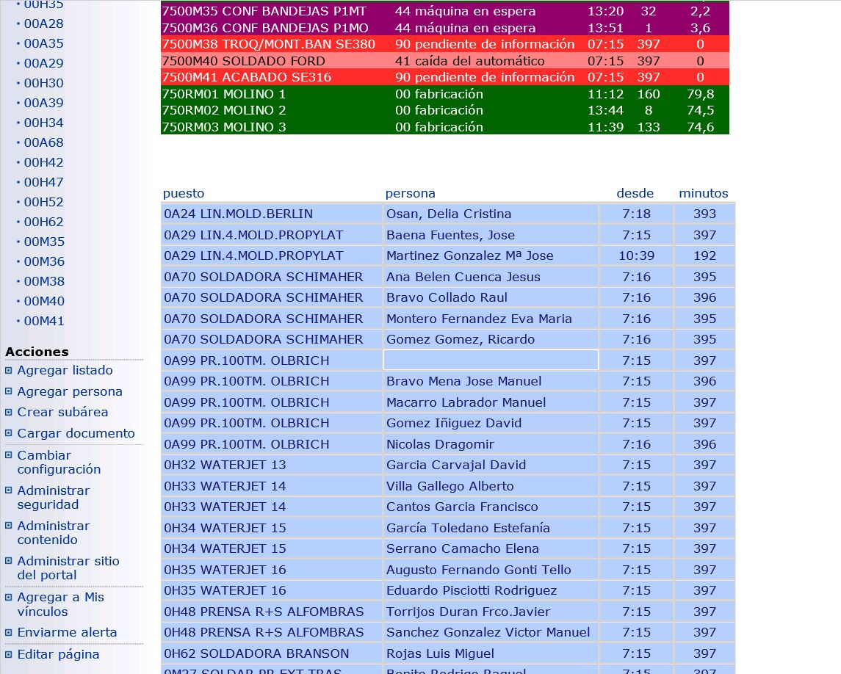

The workstation data can be found in the **listadoDePuestos.json** file and the workers data in the **personas.json** file.

**Workstation**

Once a workstation link is clicked in the previous list, the UI displays the next view:

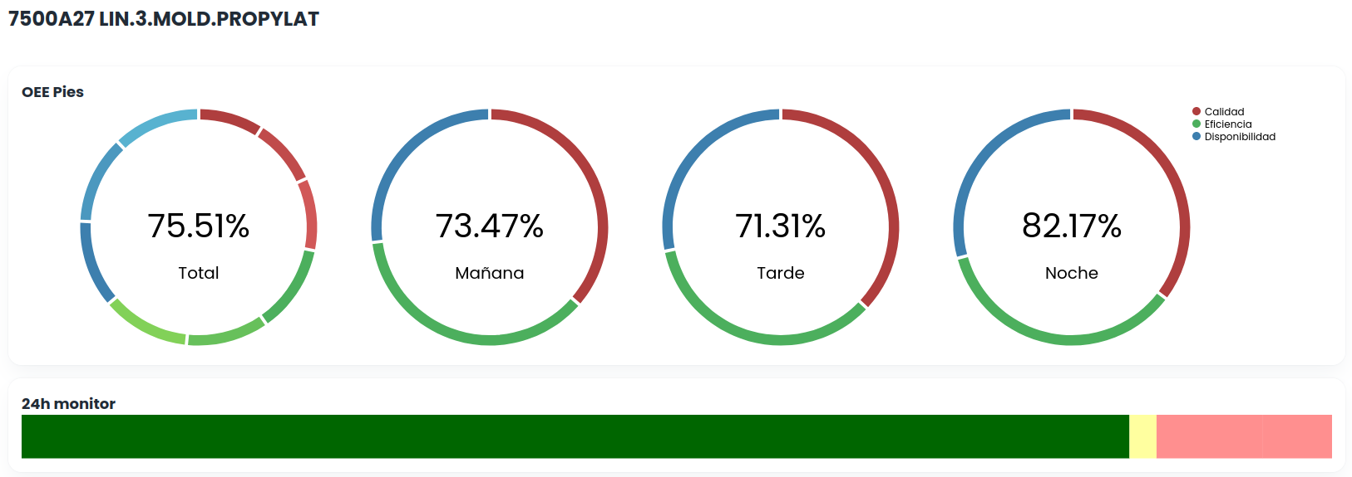

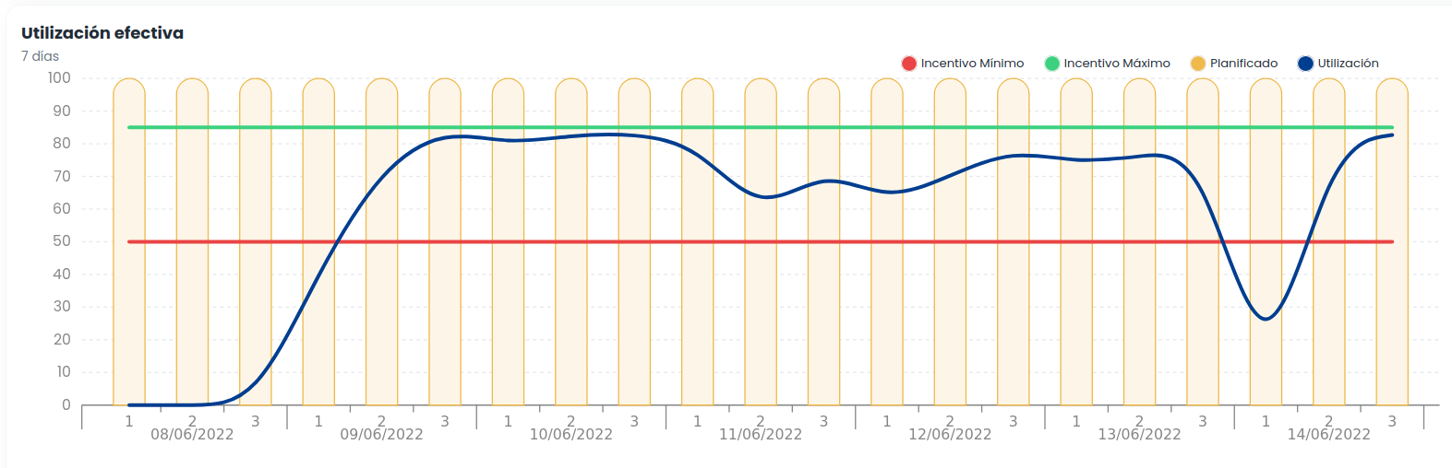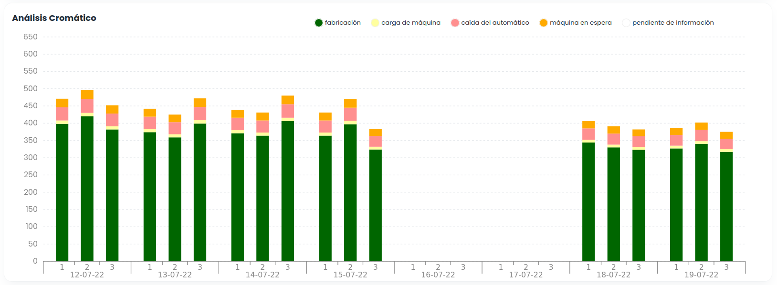

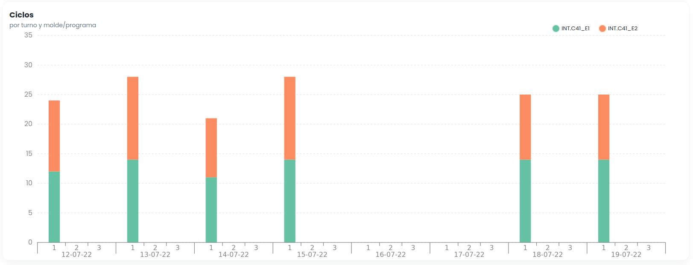

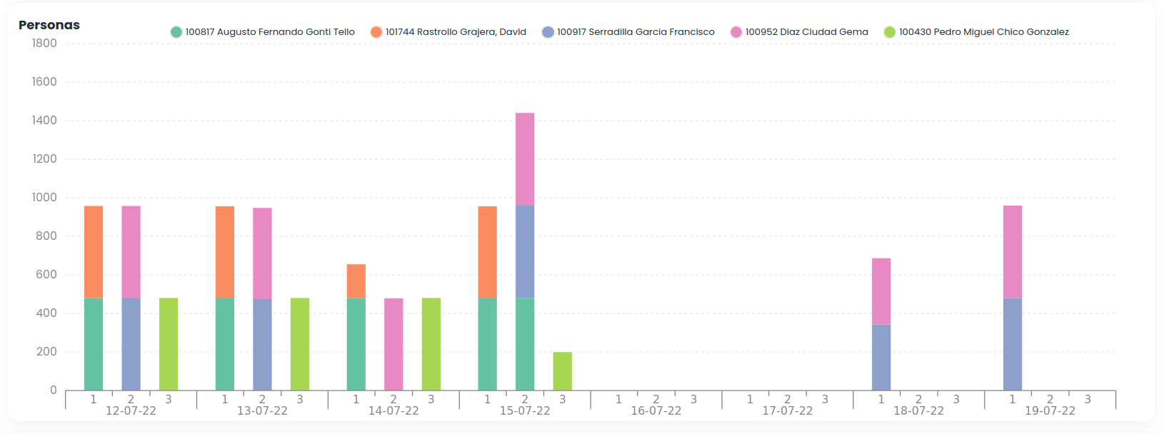

**Grouped Workstations**

JJ

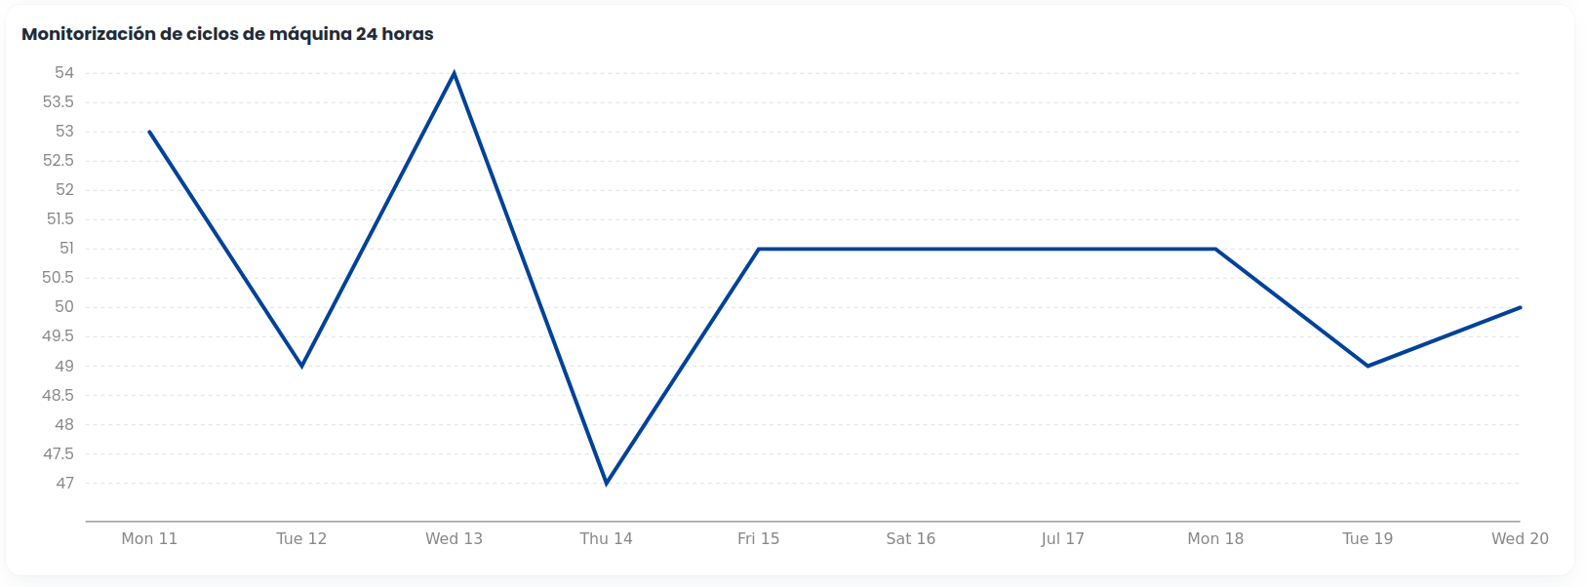

Let us review each Graphic:

***OEE Pies:***

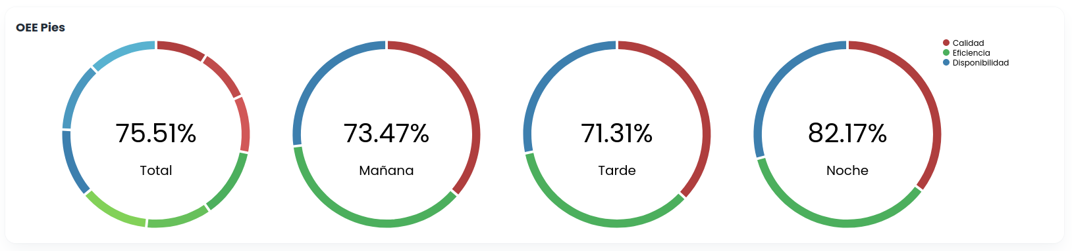

The total pie can be ignored.

All the **red colours** come from the **calidad.json** file:

* The **roll-over** is “Calidad” + the value. This value is **Calidad** field.
* The displayed data have only one date (fecha) and workstation (idpuesto).
* “Mañana” (morning), “Tarde” (afternoon), “Noche” (evening) are the turns and these values are stored in the **Turno** field, where M is Mañana, T is Tarde and N is Noche.

All the **blue colours** come from the **disponibilidad.json** file:

* The **roll-over** is “Disponibilidad” + the value. This value is **D****isponibilidad** field.
* The displayed data have only one date (fecha) and workstation (idpuesto).
* “Mañana” (morning), “Tarde” (afternoon), “Noche” (evening) are the turns and these values are stored in the **Turno** field, where M is Mañana, T is Tarde and N is Noche.

All the **green colours** come from the **eficiencia.json** file:

* The **roll-over** is “Eficiencia” + the value. This value is **Eficiencia** field.
* The displayed data have only one date (fecha) and workstation (idpuesto).
* “Mañana” (morning), “Tarde” (afternoon), “Noche” (evening) are the turns and these values are stored in the **Turno** field, where M is Mañana, T is Tarde and N is Noche.

Each pie Graph **inner value** is the **product** of the related calidad, eficiencia and disponibilidad values.

***Utilización Efectiva***:

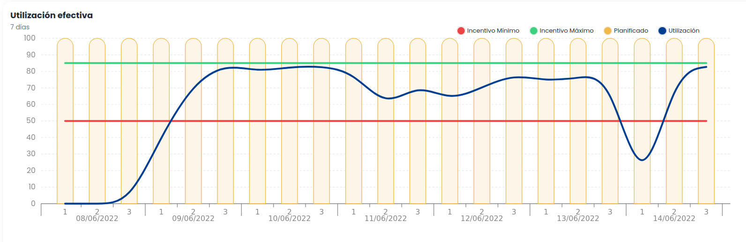

From the **grafico1Large.json** data file, the **green** line data is the **incentivomaximo** field, the **red** line data is the **incentivominimo** field, the **blue** line data is the **utilizacionp** field and the **bar** values should be equal to **100** always. The **roll-over** should display the **blue** line values (utilizacionp).

***Análisis Cromático:***

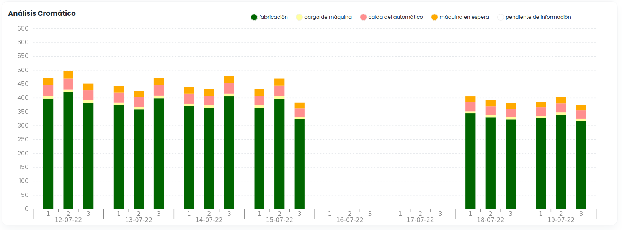

From the **grafico2Large.json** data file:

1. The **date** values at the bottom are selected from the **fecha** field.
2. The **1, 2, 3** values at the bottom correspond to the **turno** field, where it is required to filter by these 1, 2, 3 values to display the bars.
3. The **activity id** is stored in the **mensaje** field and the **activity description** in the **actividaddescripcion** field.
4. Every activity has its specific **colour**, following the criteria depicted in this document: **paradacolors.ts** that is attached.
5. The **activity value** is the **minutos** field.

***Ciclos:***

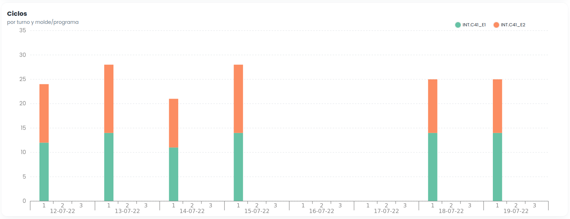

From the **grafico3Large.json** data file:

1. The **date** values at the bottom are selected from the **fecha** field.
2. The **1, 2, 3** values at the bottom correspond to the **turno** field, where it is required to filter by these 1, 2, 3 values to display the bars.
3. The **mold** valueis stored in the **molde** field.
4. The mold colour is the one than can be seen in the web.
5. *The* ***mold value*** *is the* ***ciclos*** *field.*

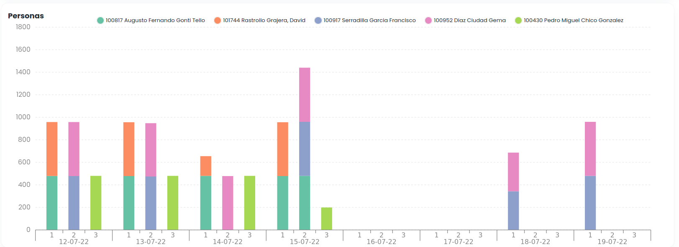***Personas:***

From the **grafico4Large.json** data file:

1. The **date** values at the bottom are selected from the **fecha** field.
2. The **1, 2, 3** values at the bottom correspond to the **turno** field, where it is required to filter by these 1, 2, 3 values to display the bars.
3. The **person name** is stored in the **persona** field.
4. Every person has a colour to be chosen randomly from the existing ones in the web (however you want to do it).
5. The **person value** is the **minutos** field.

***Monitorización de ciclos de máquina 24 horas:***

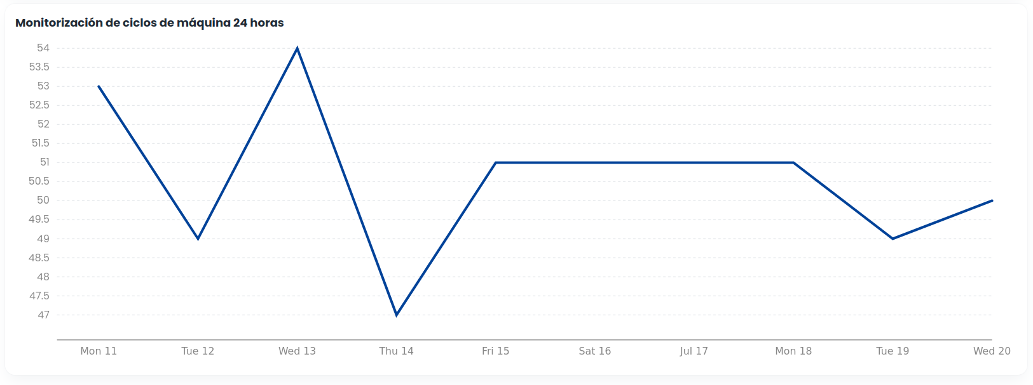

These data will be extracted from a new file that I will provide today.