item_categories.csv (84, 2)

**item_category_name, item_category_id**

**items.csv**(22170, 3)

**item_name, item_id, item_category_id**

**sales_train.csv.gz**(2935849, 6)

**date, date_block_num, shop_id, item_id, item_price, item_cnt_day**

**sample_submission.csv.gz**(214200, 2)

**ID, item_cnt_month**

**shops.csv** (60, 2)

**shop_name, shop_id**

**test.csv.gz** (214200, 3)

**ID, shop_id, item_id**

**Input : shop_id , item_id**

**목표 : 다음달 총 매출액**

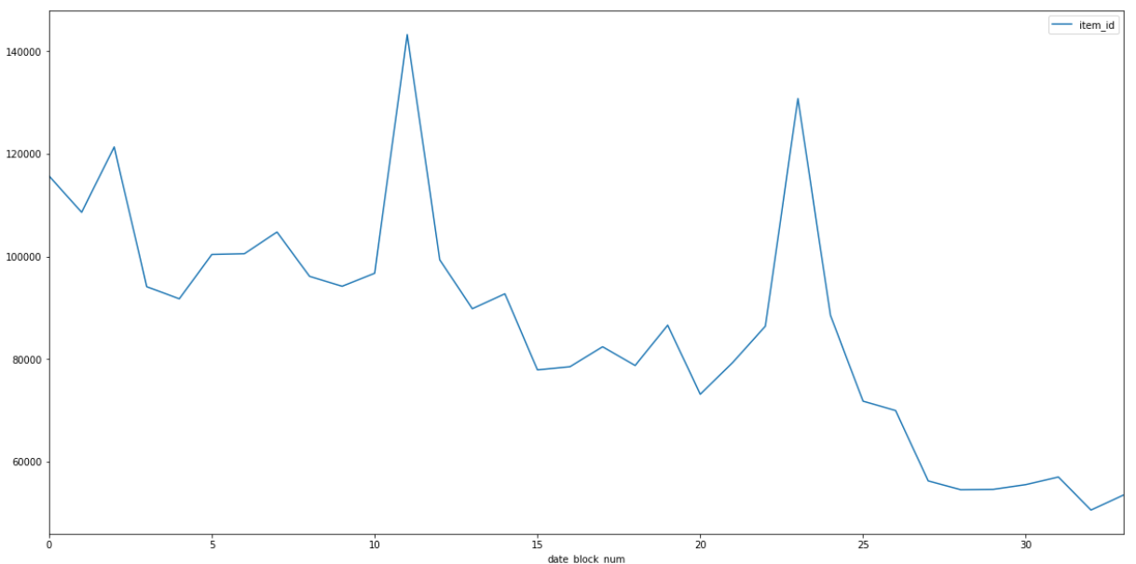

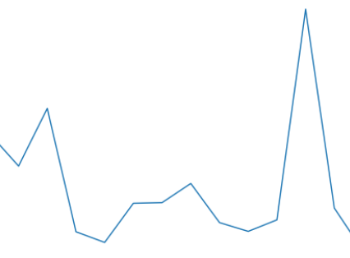

LSTM

**1267561**