1、人员
select DISTINCT USERCODE,USERNAME,DEPTCODE from V_NCJ_USERINFO where USERCODE not in (
select USER_NAME from RUOYI_SYS_USER
)

2、角色
select ROLENAME,NOTES from ROLEDEF where ROLENAME not in (
select ROLE_NAME from RUOYI_SYS_ROLE
)
and ROLENAME like '%_%';

3、用户角色信息插入
INSERT INTO RUOYI_SYS_USER_ROLE
SELECT
DISTINCT
RSU.USER_ID,
RSR.ROLE_ID
FROM EMPLOYEE E1
LEFT JOIN EMPLOYEEROLE ER ON ER.EMPLOYEEID = E1.EMPLOYEEID
LEFT JOIN ROLEDEF R ON R.ROLEID = ER.ROLEID
JOIN RUOYI_SYS_ROLE RSR ON RSR.ROLE_NAME = R.ROLENAME
JOIN RUOYI_SYS_USER RSU ON RSU.USER_NAME = E1.EMPLOYEENAME;

4、导出所有url方法
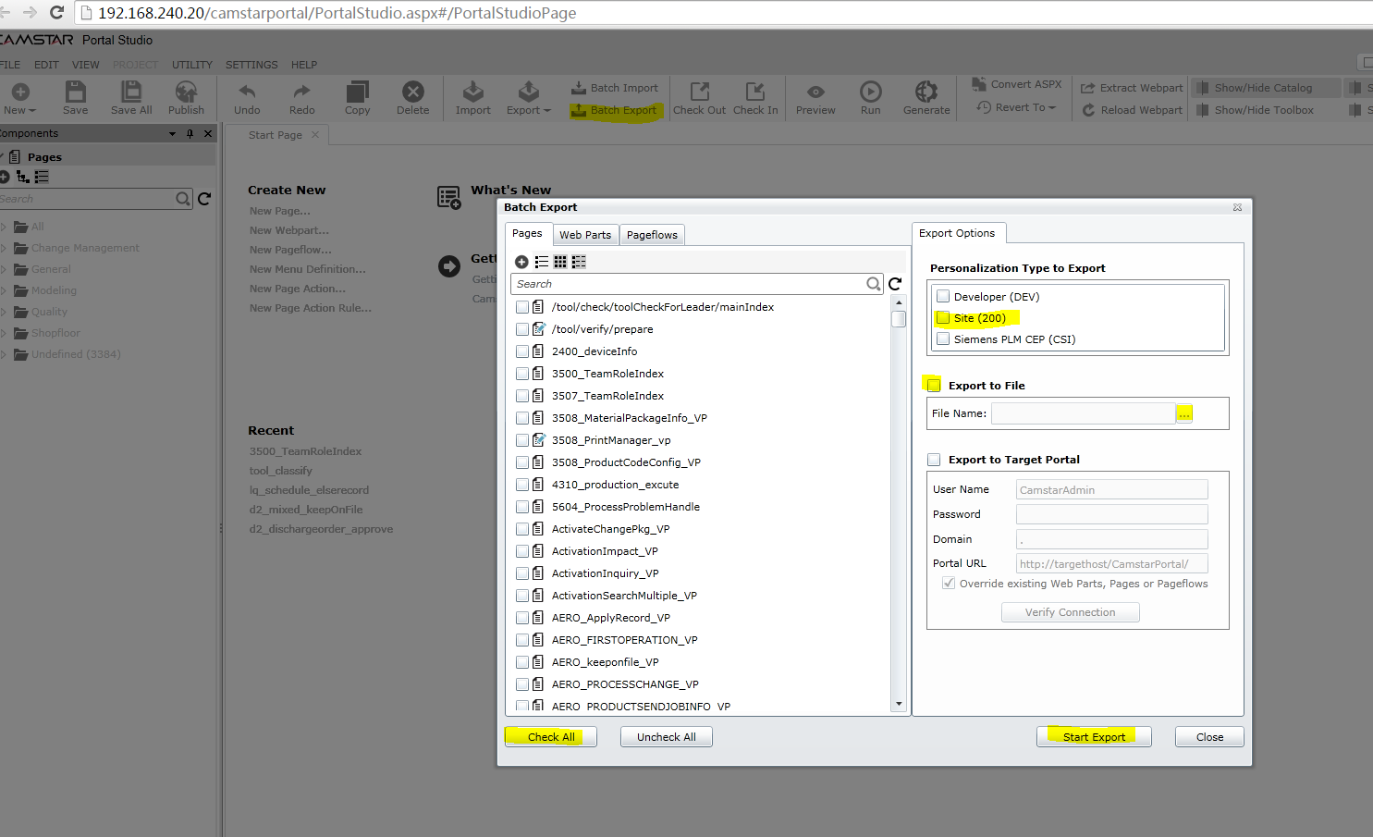

5、url方法导出后xml解析
复制到一个TestController2文件中，利用postman调用调试
package com.ruoyi.project.dashboard.controller;
import com.ruoyi.framework.aspectj.lang.annotation.Anonymous;
import org.apache.poi.ss.usermodel.Row;
import org.apache.poi.ss.usermodel.Sheet;
import org.apache.poi.ss.usermodel.Workbook;
import org.apache.poi.xssf.usermodel.XSSFWorkbook;
import org.dom4j.*;
import org.dom4j.io.SAXReader;
import org.springframework.web.bind.annotation.CrossOrigin;
import org.springframework.web.bind.annotation.PostMapping;
import org.springframework.web.bind.annotation.RequestMapping;
import org.springframework.web.bind.annotation.RestController;
import java.io.IOException;
import java.io.OutputStream;
import java.nio.file.Files;
import java.nio.file.Path;
import java.nio.file.Paths;
import java.util.*;
/**
* 解析 Camstar all.xml -> page_model.xlsx
* 默认只提取 URL 属性，如需更多请在 PROPS 里添加。
*/
@RestController
@RequestMapping("/tool2")
@CrossOrigin
@Anonymous
public class TestController2 {
private static final Path XML_FILE = Paths.get("E:\\all.xml");
private static final Path EXCEL_FILE = Paths.get("page_model.xlsx");
@PostMapping("/test")
public void test() throws Exception {
if (!Files.exists(XML_FILE)) {
System.err.println("请将 all.xml 放到当前目录");
return;
}
List<PageModelRow> data = parse();
writeExcel(data);
System.out.println("已生成 " + EXCEL_FILE.toAbsolutePath() + " 共 " + data.size() + " 条");
}
/* -------------------- 解析 -------------------- */
private static List<PageModelRow> parse() throws Exception {
List<PageModelRow> list = new ArrayList<>();
SAXReader reader = new SAXReader();
Document doc = reader.read(XML_FILE.toFile());
Element root = doc.getRootElement();
Element pages = root.elements("Pages").get(0);
List<Element> elements = pages.elements();
Map<String,String> uriMap = new HashMap<>();
uriMap.put("ns", root.getNamespaceURI());
XPath xPathDesc = DocumentHelper.createXPath("./ns:Personalizations/ns:WorkspaceContent/ns:DynamicWebParts/ns:WebPartDefinition/ns:Control");
xPathDesc.setNamespaceURIs(uriMap);
for (Element pm : elements){
String name = pm.attributeValue("Name");
if (pm.element("Personalizations") == null|| pm.element("Personalizations").element("WorkspaceContent") == null
||pm.element("Personalizations").element("WorkspaceContent").element("DynamicWebParts") == null
||pm.element("Personalizations").element("WorkspaceContent").element("DynamicWebParts").element("WebPartDefinition") == null
||pm.element("Personalizations").element("WorkspaceContent").element("DynamicWebParts").element("WebPartDefinition").element("Control") == null) {
list.add(new PageModelRow(name, "", ""));
continue;
}
Element element = pm.element("Personalizations").element("WorkspaceContent").element("DynamicWebParts").element("WebPartDefinition").element("Control");
String url = "";
List<Element> property = element.elements("Property");
if(property.size() >0){
List<Element> value = property.get(0).elements("Value");
if(value.size() > 0){
url = value.get(0).getText();
}
}
String description2 = "";
List<Element> description = element.elements("Description");
if(description.size() >0){
List<Element> value = description.get(0).elements("Value");
if(value.size() > 0){
description2 = value.get(0).getText();
}
}
list.add(new PageModelRow(name, url, description2));
}
return list;
}
/* -------------------- 写 Excel -------------------- */
private static void writeExcel(List<PageModelRow> data) throws IOException {
try (Workbook wb = new XSSFWorkbook()) {
Sheet sheet = wb.createSheet("PageModel");
Row header = sheet.createRow(0);
int c = 0;
header.createCell(c++).setCellValue("Name");
header.createCell(c++).setCellValue("Description");
header.createCell(c++).setCellValue("URL");
int r = 1;
for (PageModelRow row : data) {
Row xlsRow = sheet.createRow(r++);
c = 0;
xlsRow.createCell(c++).setCellValue(row.name);
xlsRow.createCell(c++).setCellValue(row.desc);
xlsRow.createCell(c++).setCellValue(row.url);
}
// 自适应列宽
for (c = 0; c < header.getLastCellNum(); c++) sheet.autoSizeColumn(c);
try (OutputStream out = Files.newOutputStream(EXCEL_FILE)) {
wb.write(out);
}
}
}
/* -------------------- 数据行 -------------------- */
private static class PageModelRow {
final String name;
final String desc;
final String url;
PageModelRow(String name, String desc, String url) {
this.name = name;
this.desc = desc;
this.url = url;
}
}
}

引入依赖：
<dependency>
<groupId>org.dom4j</groupId>
<artifactId>dom4j</artifactId>
<version>2.1.3</version>
</dependency>
<dependency>
<groupId>jaxen</groupId>
<artifactId>jaxen</artifactId>
<version>1.2.0</version>
</dependency>
<dependency>
<groupId>xml-apis</groupId>
<artifactId>xml-apis</artifactId>
<version>1.4.01</version>
</dependency>
截止12.25库内一共3683条，xml文件中共3680条，全部识别，插入到表VP_URL_DESC，无url和description的共357条。

6、未导出的数据查询--共3条
select * from UIVIRTUALPAGE ui where UIVIRTUALPAGENAME not in (
select name from VP_URL_DESC
)

7、查询一级菜单及VP信息如下
共4840条，因有一个vp挂在多个菜单下导致大于vp数量
select distinct pm.CAPTION,pm.PARENTID,pmf.PORTALMENUDEFINITIONNAME, UIVIRTUALPAGENAME from UIVIRTUALPAGE ui
join PORTALMENUITEM pm on pm.VIRTUALPAGEID = ui.UIVIRTUALPAGEID
join PORTALMENUDEFINITION pmf on pm.PARENTID = pmf.PORTALMENUDEFINITIONID

8、最终菜单选择
因存在大量孤魂野鬼的VP页面，因此关联了角色查询，语句如下，提取结果的2983条数据进行插入
select distinct ROLEPERMISSIONNAME from UIVIRTUALPAGE ui join ROLEPERMISSION rp on ui.UIVIRTUALPAGENAME = rp.ROLEPERMISSIONNAME
join ROLEDEF rd on rd.ROLEID = rp.ROLEID
join PORTALMENUITEM pm on pm.VIRTUALPAGEID = ui.UIVIRTUALPAGEID
join PORTALMENUDEFINITION pmf on pm.PARENTID = pmf.PORTALMENUDEFINITIONID

9、处理一级菜单并插入
原一级菜单370条
select distinct PORTALMENUDEFINITIONNAME from PORTALMENUDEFINITION where PORTALMENUDEFINITIONNAME not like '%全功能%';
配置到人员的有336条
select distinct pmf.PORTALMENUDEFINITIONNAME from UIVIRTUALPAGE ui
join ROLEPERMISSION rp on ui.UIVIRTUALPAGENAME = rp.ROLEPERMISSIONNAME
join ROLEDEF rd on rd.ROLEID = rp.ROLEID
join PORTALMENUITEM pm on pm.VIRTUALPAGEID = ui.UIVIRTUALPAGEID
join PORTALMENUDEFINITION pmf on pm.PARENTID = pmf.PORTALMENUDEFINITIONID;
去掉一些异常页面，还有322条数据。

10、处理二级菜单并插入
一级菜单从10001开始，因此查询的时候添加menu_id>10001条件
select distinct ROLEPERMISSIONNAME,pm.CAPTION,rsm.MENU_ID,substr(ROLENAME,1, instr(ROLENAME,'_')-1) as workshopcode,
case when vud.URL is not null then vud.URL else vud.DESCRIPTION end as url from UIVIRTUALPAGE ui
join ROLEPERMISSION rp on ui.UIVIRTUALPAGENAME = rp.ROLEPERMISSIONNAME
join ROLEDEF rd on rd.ROLEID = rp.ROLEID
join PORTALMENUITEM pm on pm.VIRTUALPAGEID = ui.UIVIRTUALPAGEID
join PORTALMENUDEFINITION pmf on pm.PARENTID = pmf.PORTALMENUDEFINITIONID
join RUOYI_SYS_MENU rsm on rsm.MENU_NAME = pmf.PORTALMENUDEFINITIONNAME and rsm.PARENT_ID = 0 and MENU_ID > 10000
join VP_URL_DESC vud on vud.NAME = ROLEPERMISSIONNAME
where ROLENAME not like 'Default%'
order by MENU_ID

分表方案
select * from RUOYI_SYS_ROLE;
select * from RUOYI_SYS_USER;
SELECT * FROM RUOYI_SYS_MENU;
SELECT * FROM RUOYI_SYS_USER_ROLE;
SELECT * FROM RUOYI_SYS_ROLE_MENU;
以上五张表新建，按部门

一级菜单
综合考量，建议menu表分表分库，因此建议一级菜单查询示例如下：
手动插入一级菜单
select CAPTION as menu_name,0 as parent_id,SEQUENCE as order_num, '1'as is_frame, SEQUENCE as order_num, SEQUENCE as path
from PORTALMENUITEM where PARENTID =(
select PORTALMENUDEFINITIONID from PORTALMENUDEFINITION where PORTALMENUDEFINITIONNAME = '全功能菜单(液冷)')
建议二级菜单查询示例如下：
select CAPTION,SEQUENCE from PORTALMENUITEM where PARENTID in (
select MENUDEFINITIONID from PORTALMENUITEM where PARENTID =(
select PORTALMENUDEFINITIONID from PORTALMENUDEFINITION where PORTALMENUDEFINITIONNAME = '全功能菜单(液冷)'))

二级菜单信息导出
select distinct pm.CAPTION as menu_name,rsm.MENU_ID as parent_id,SEQUENCE as order_num, '0'as is_frame,
'C' AS menu_type, ROLEPERMISSIONNAME AS REMARK , case when vud.URL is not null then vud.URL else vud.DESCRIPTION end as path
-- ,substr(ROLENAME,1, instr(ROLENAME,'_')-1) as workshop_code
from UIVIRTUALPAGE ui
join ROLEPERMISSION rp on ui.UIVIRTUALPAGENAME = rp.ROLEPERMISSIONNAME
join ROLEDEF rd on rd.ROLEID = rp.ROLEID and ROLENAME like '560%'
join PORTALMENUITEM pm on pm.VIRTUALPAGEID = ui.UIVIRTUALPAGEID
JOIN (select CAPTION,MENUDEFINITIONID from PORTALMENUITEM where PARENTID =(
select PORTALMENUDEFINITIONID from PORTALMENUDEFINITION where PORTALMENUDEFINITIONNAME = '全功能菜单(液冷)')) pmf
on pm.PARENTID = pmf.MENUDEFINITIONID
join LQ_SYS_MENU rsm on rsm.MENU_NAME = pmf.CAPTION and rsm.PARENT_ID = 0
join VP_URL_DESC vud on vud.NAME = rp.ROLEPERMISSIONNAME
where ROLENAME not like 'Default%'
order by MENU_ID;

人员信息
insert into LQ_SYS_ROLE
select * from RUOYI_SYS_ROLE where REMARK like '560%';
insert into LQ_SYS_USER
select * from RUOYI_SYS_USER where REMARK like '560%';
insert into LQ_SYS_ USER_ROLE
select * from RUOYI_SYS_USER_ROLE where USER_ID in (
select USER_ID from RUOYI_SYS_USER where REMARK like '560%'
);

一级菜单与角色关系
insert into LQ_SYS_ROLE_MENU
select distinct lsr.ROLE_ID, rsm.MENU_ID
-- ,substr(ROLENAME,1, instr(ROLENAME,'_')-1) as workshopcode
-- , case when vud.URL is not null then vud.URL else vud.DESCRIPTION end as url
from UIVIRTUALPAGE ui
join ROLEPERMISSION rp on ui.UIVIRTUALPAGENAME = rp.ROLEPERMISSIONNAME
join ROLEDEF rd on rd.ROLEID = rp.ROLEID and ROLENAME like '560%'
join PORTALMENUITEM pm on pm.VIRTUALPAGEID = ui.UIVIRTUALPAGEID
JOIN (select CAPTION,MENUDEFINITIONID from PORTALMENUITEM where PARENTID =(
select PORTALMENUDEFINITIONID from PORTALMENUDEFINITION where PORTALMENUDEFINITIONNAME = '全功能菜单(液冷)')) pmf
on pm.PARENTID = pmf.MENUDEFINITIONID
join LQ_SYS_MENU rsm on rsm.MENU_NAME = pmf.CAPTION and rsm.PARENT_ID = 0
join LQ_SYS_ROLE lsr on rd.ROLENAME = lsr.ROLE_NAME
join VP_URL_DESC vud on vud.NAME = rp.ROLEPERMISSIONNAME
where ROLENAME not like 'Default%'
order by MENU_ID

二级菜单与角色关系
insert into LQ_SYS_ROLE_MENU
select lsr.ROLE_ID,lsm.MENU_ID from ROLEPERMISSION rp
join LQ_SYS_MENU lsm on lsm.REMARK = rp.ROLEPERMISSIONNAME
join ROLEDEF rd on rd.ROLEID = rp.ROLEID and ROLENAME like '560%'
join LQ_SYS_ROLE lsr on lsr.ROLE_NAME = rd.ROLENAME

注意设置一级菜单的类型M,二级菜单类型C

全局搜索替换表名

将patch应用

记得解冲突

复制ruoyi原生表数据到新表

处理不是外链的路由

之前配置的页面记得删除
如果表中无法找到，可以查看前端代码中是否写的有

问题答惑
1、点击菜单页面加载出问题
不用隐身窗口登录才可以访问老平台页面
新页面需要cookie，请求的是服务器的cookie，因此不能本地访问
2、部分一级菜单无二级菜单
因menu_type设置为空
3、登录后一直在加载
可能存在菜单设置path为空值
4、展开一个一级菜单其他也被展开
一级菜单也要设置path，且path要设置不同的值
5、密码修改页面的路径暂无，暂不处理，直接删除
6、顺序需要修改
二级顺序修改
select sequence,MENU_ID from UIVIRTUALPAGE ui
join LQ_SYS_MENU lsm on ui.UIVIRTUALPAGENAME = lsm.REMARK
join (select * from PORTALMENUITEM where PARENTID in (
select MENUDEFINITIONID from PORTALMENUITEM where PARENTID =(
select PORTALMENUDEFINITIONID from PORTALMENUDEFINITION where PORTALMENUDEFINITIONNAME = '全功能菜单(液冷)'))
)
pm on pm.VIRTUALPAGEID = ui.UIVIRTUALPAGEID
order by MENU_ID;
7、记得把admin账户复制过去，只需要复制sys_user表

