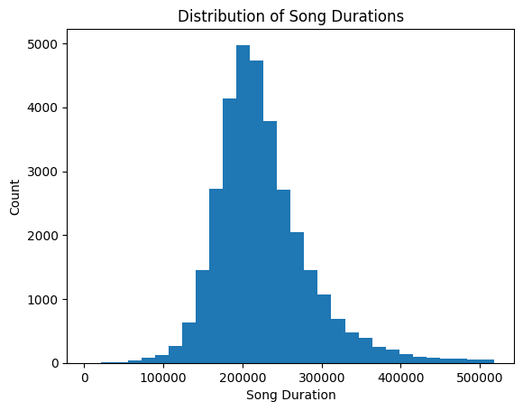 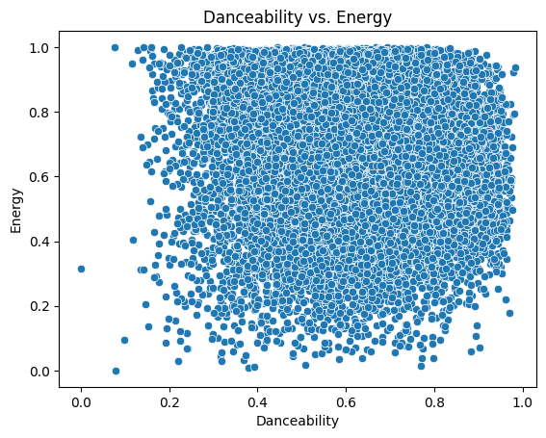

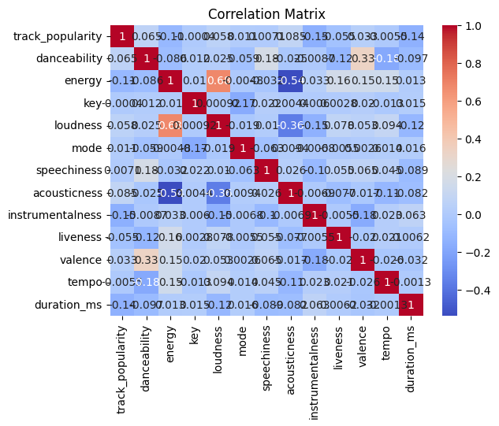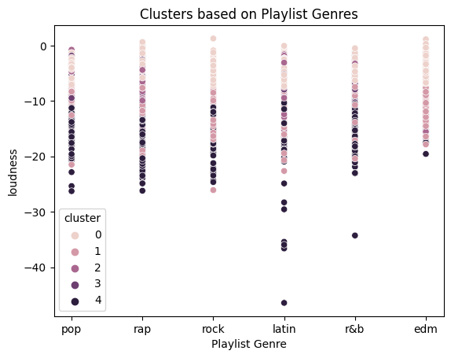

3668 80's Songs | Top 💯 80s Music Hits

3676 GTA V - Radio Mirror Park

3675 GTA V - Radio Mirror Park

3674 GTA V - Radio Mirror Park

3673 80's Songs | Top 💯 80s Music Hits

Name: playlist_name, dtype: object