### Performance Summary : 5 Algorithms ###

>>> [Train set] Performance Comparison
 | Algorithm | N | True Positive | True Negative | False Positive | False Negative | Precision | Recall | Specificity | F1-score | Accuracy | Balanced Accuracy | AUC
0 | Logistic Regression | 1510 | 539 | 355 | 400 | 216 | 0.5740 | 0.7139 | 0.4702 | 0.6364 | 0.5921 | 0.5921 | 0.6259
1 | Random Forest | 1510 | 519 | 643 | 112 | 236 | 0.8225 | 0.6874 | 0.8517 | 0.7489 | 0.7695 | 0.7695 | 0.8810
2 | XGBoost | 1510 | 755 | 24 | 731 | 0 | 0.5081 | 1.0000 | 0.0318 | 0.6738 | 0.5159 | 0.5159 | 0.8528
3 | LightGBM | 1510 | 504 | 450 | 305 | 251 | 0.6230 | 0.6675 | 0.5960 | 0.6445 | 0.6318 | 0.6318 | 0.6864
4 | CatBoost | 1510 | 566 | 457 | 298 | 189 | 0.6551 | 0.7497 | 0.6053 | 0.6992 | 0.6775 | 0.6775 | 0.7307

>>> [Validation(CV)] Performance Comparison
 | Algorithm | N | True Positive | True Negative | False Positive | False Negative | Precision | Recall | Specificity | F1-score | Accuracy | Balanced Accuracy | AUC
0 | Logistic Regression | 186 | 83 | 0 | 103 | 0 | 0.4462 | 1.0000 | 0.0000 | 0.6171 | 0.4462 | 0.5000 | 0.5205
1 | Random Forest | 186 | 68 | 15 | 88 | 15 | 0.4359 | 0.8193 | 0.1456 | 0.5690 | 0.4462 | 0.4825 | 0.5092
2 | XGBoost | 186 | 83 | 0 | 103 | 0 | 0.4462 | 1.0000 | 0.0000 | 0.6171 | 0.4462 | 0.5000 | 0.4755
3 | LightGBM | 186 | 72 | 14 | 89 | 11 | 0.4472 | 0.8675 | 0.1359 | 0.5902 | 0.4624 | 0.5017 | 0.5311
4 | CatBoost | 186 | 62 | 20 | 83 | 21 | 0.4474 | 0.8193 | 0.1845 | 0.5787 | 0.4677 | 0.5019 | 0.4706

>>> [Test set] Performance Comparison
 | Algorithm | N | True Positive | True Negative | False Positive | False Negative | Precision | Recall | Specificity | F1-score | Accuracy | Balanced Accuracy | AUC
0 | Logistic Regression | 56 | 18 | 9 | 19 | 10 | 0.4865 | 0.6429 | 0.3214 | 0.5538 | 0.4821 | 0.4821 | 0.4796
1 | Random Forest | 56 | 25 | 5 | 23 | 3 | 0.5208 | 0.8929 | 0.1786 | 0.6579 | 0.5357 | 0.5357 | 0.4235
2 | XGBoost | 56 | 28 | 0 | 28 | 0 | 0.5000 | 1.0000 | 0.0000 | 0.6667 | 0.5000 | 0.5000 | 0.4592
3 | LightGBM | 56 | 3 | 19 | 9 | 25 | 0.2500 | 0.1071 | 0.6786 | 0.1500 | 0.3929 | 0.3929 | 0.4158
4 | CatBoost | 56 | 7 | 16 | 12 | 21 | 0.3684 | 0.2500 | 0.5714 | 0.2979 | 0.4107 | 0.4107 | 0.4260

## Total Shap Explanation
Train Dataset: 2026-05-14 22:45:57.027994
Total Explanation (Beeswarm + Importance Bar)...
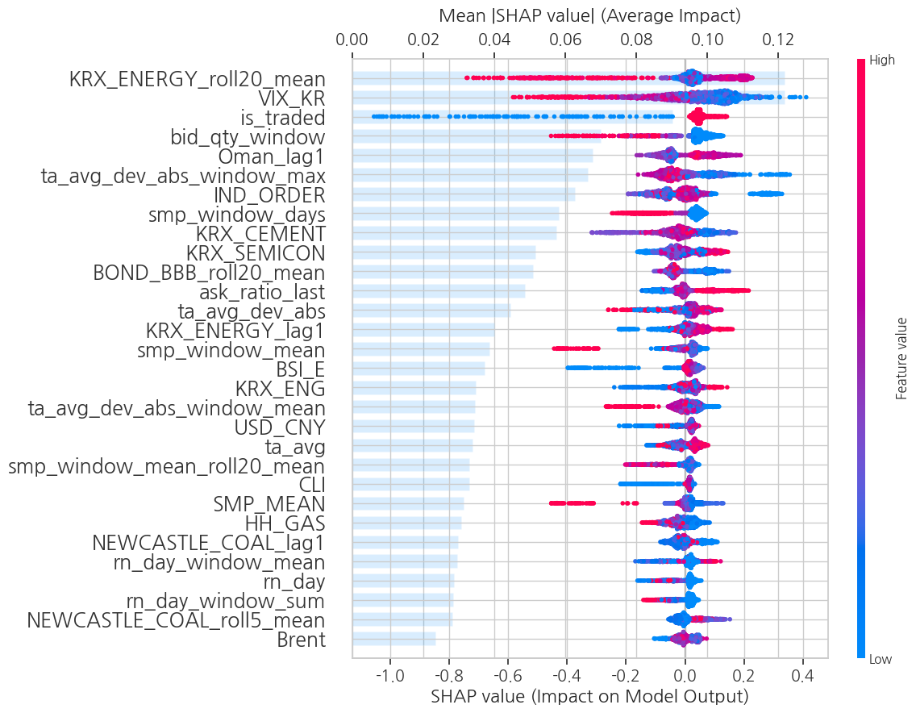
Test Dataset: 2026-05-14 22:45:57.627546
Total Explanation (Beeswarm + Importance Bar)...
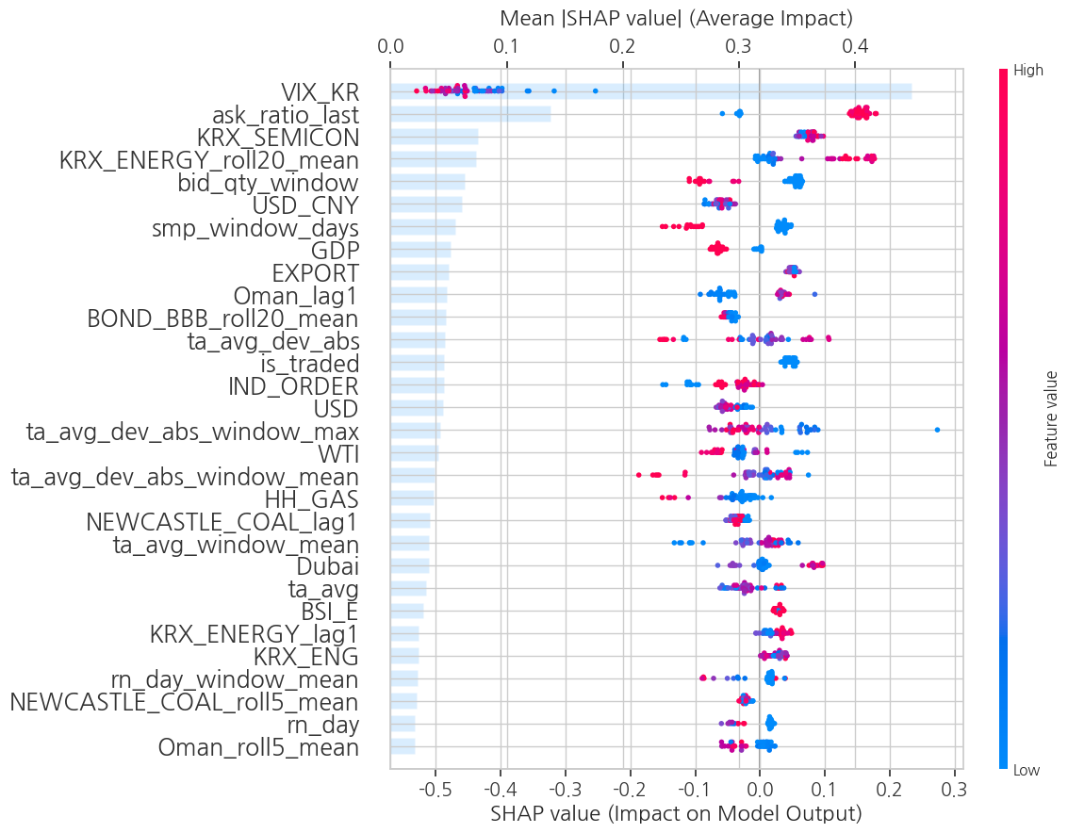

## 방향성 표

## Shap Interaction
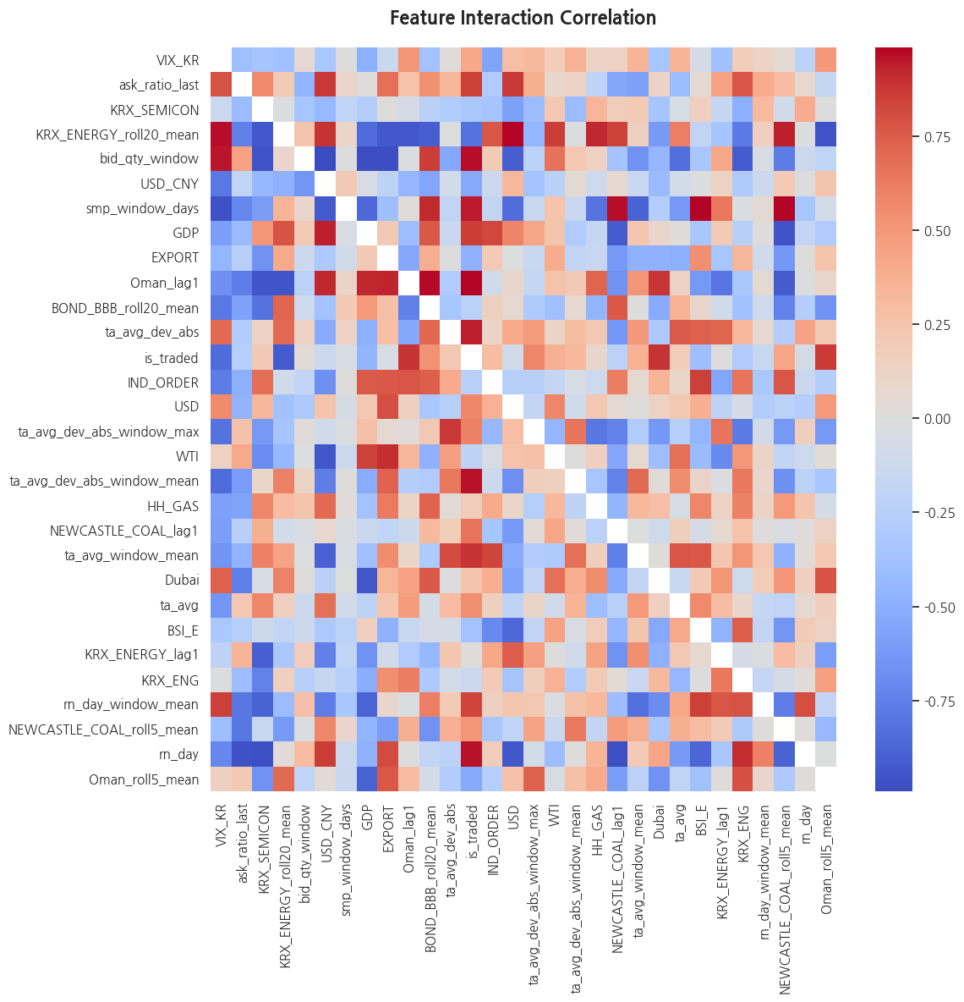

## 하위그룹별 SHAP 비교
(1) VIX_KR

(2) Phase

