

BUSINESS RULES FOR AN EMPLOYING COMPANY

COURSE PRESENTER

(DR. AISHA SIYAMI)

|  |  |
| --- | --- |
| STUDENT | ID |
| HANIN MESFER ALMALKI  (leader) | 444003284 |
| AREEJ TALEB ALSAIARI | 444002403 |
| JOOD MOHAMMED ALGARNI | 444005790 |
| NOURA NAWAR ALHUTHALI | 444001743 |

DEPARTMENT OF (DATA SCIENCE)

COLLEGE OF COMPUTERS

|  |  |  |  |  |
| --- | --- | --- | --- | --- |
| Tasks | Hanin | Areej | Jood | Noura |
| Concept&  Entities |  |  |  |  |
| Business  rules |  |  |  |  |
| Chen’s Notation |  |  |  |  |
| UML  notation |  |  |  |  |
| Mapping |  |  |  |  |
| Normalization |  |  |  |  |
| Create database and tables |  |  |  |  |
| Insert |  |  |  |  |
| Update and delete |  |  |  |  |
| Select 4 command |  |  |  |  |
| Select 6 command |  |  |  |  |

Talent Connect Company: It is an organization that specializes in connecting company with the right candidates for available positions, examining and evaluating the skills of applicants and providing effective recruitment solutions to meet the needs of customers.

* Each company has the company name, address, email.
* Each user can be associated with only one company, but a company can have multiple users.
* Each user has login information, username, password, user id, email, Resumes, Skills, Experience Levels.
* Each user can apply for one job, but each job can be applied to by multiple users.

* Each job has job title, job id, working hours, skills required, level of experience, salary, employment type (full-time, part-time, contract).
* Each job can have multiple interviews, but each interview is associated with only one job.

* Each employee has an employee id, full name, date of birth, email, job position.

* Each interview has an interviewer name, date, time, candidate name, interview Result (accepted, rejected, pending).
* Each employee Conducts multiple interviews, but each interview conducted by one employee.
* feedback is associated with the company, and Each feedback has date of the feedback, Commenter, feedback text (not exceeding 300 words).

Chen’s Notation

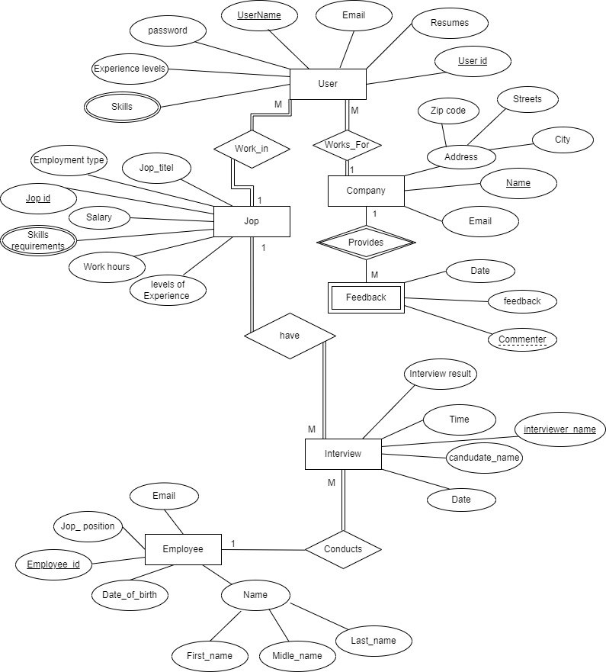

UML Notation

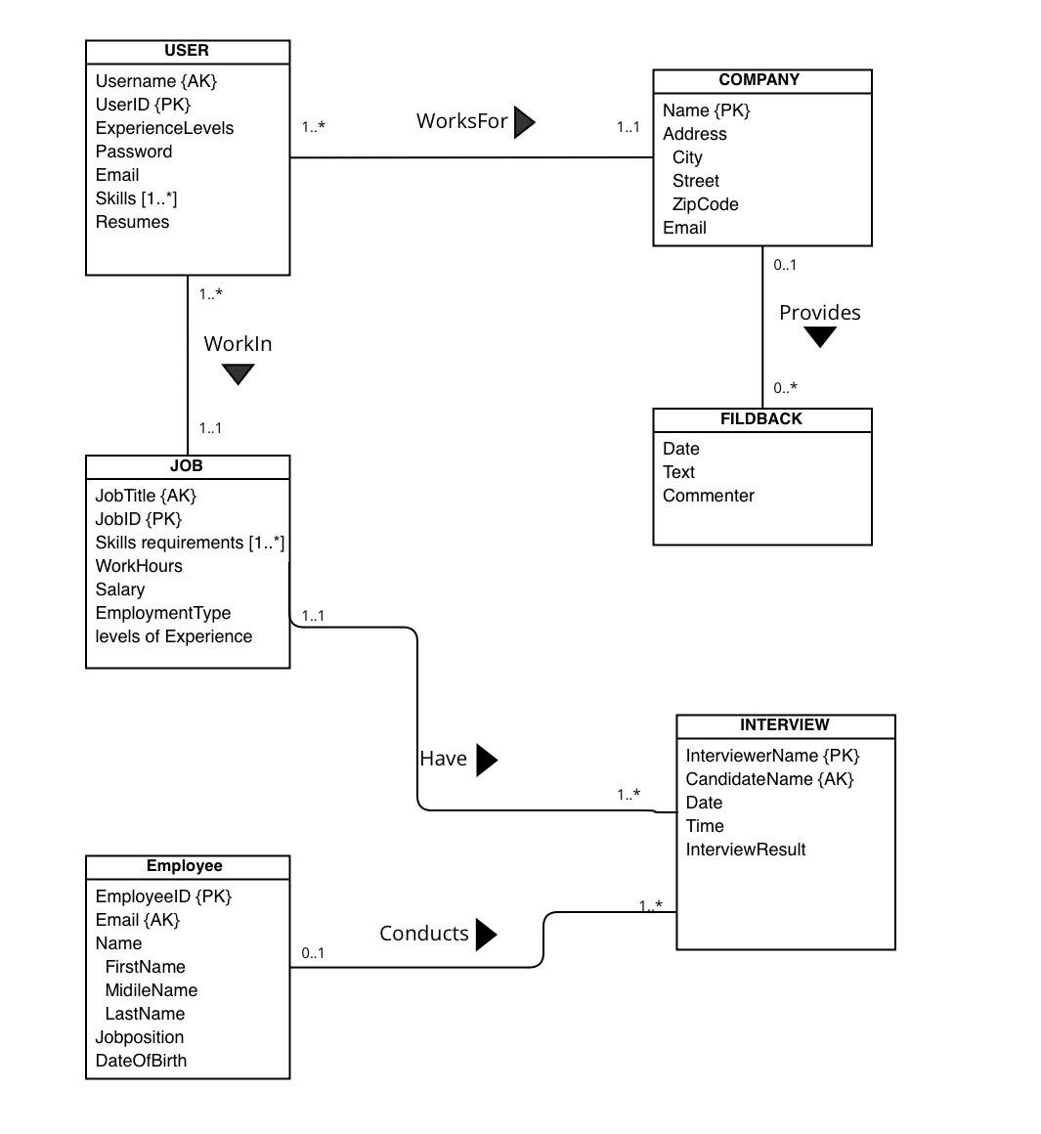

Mapping:

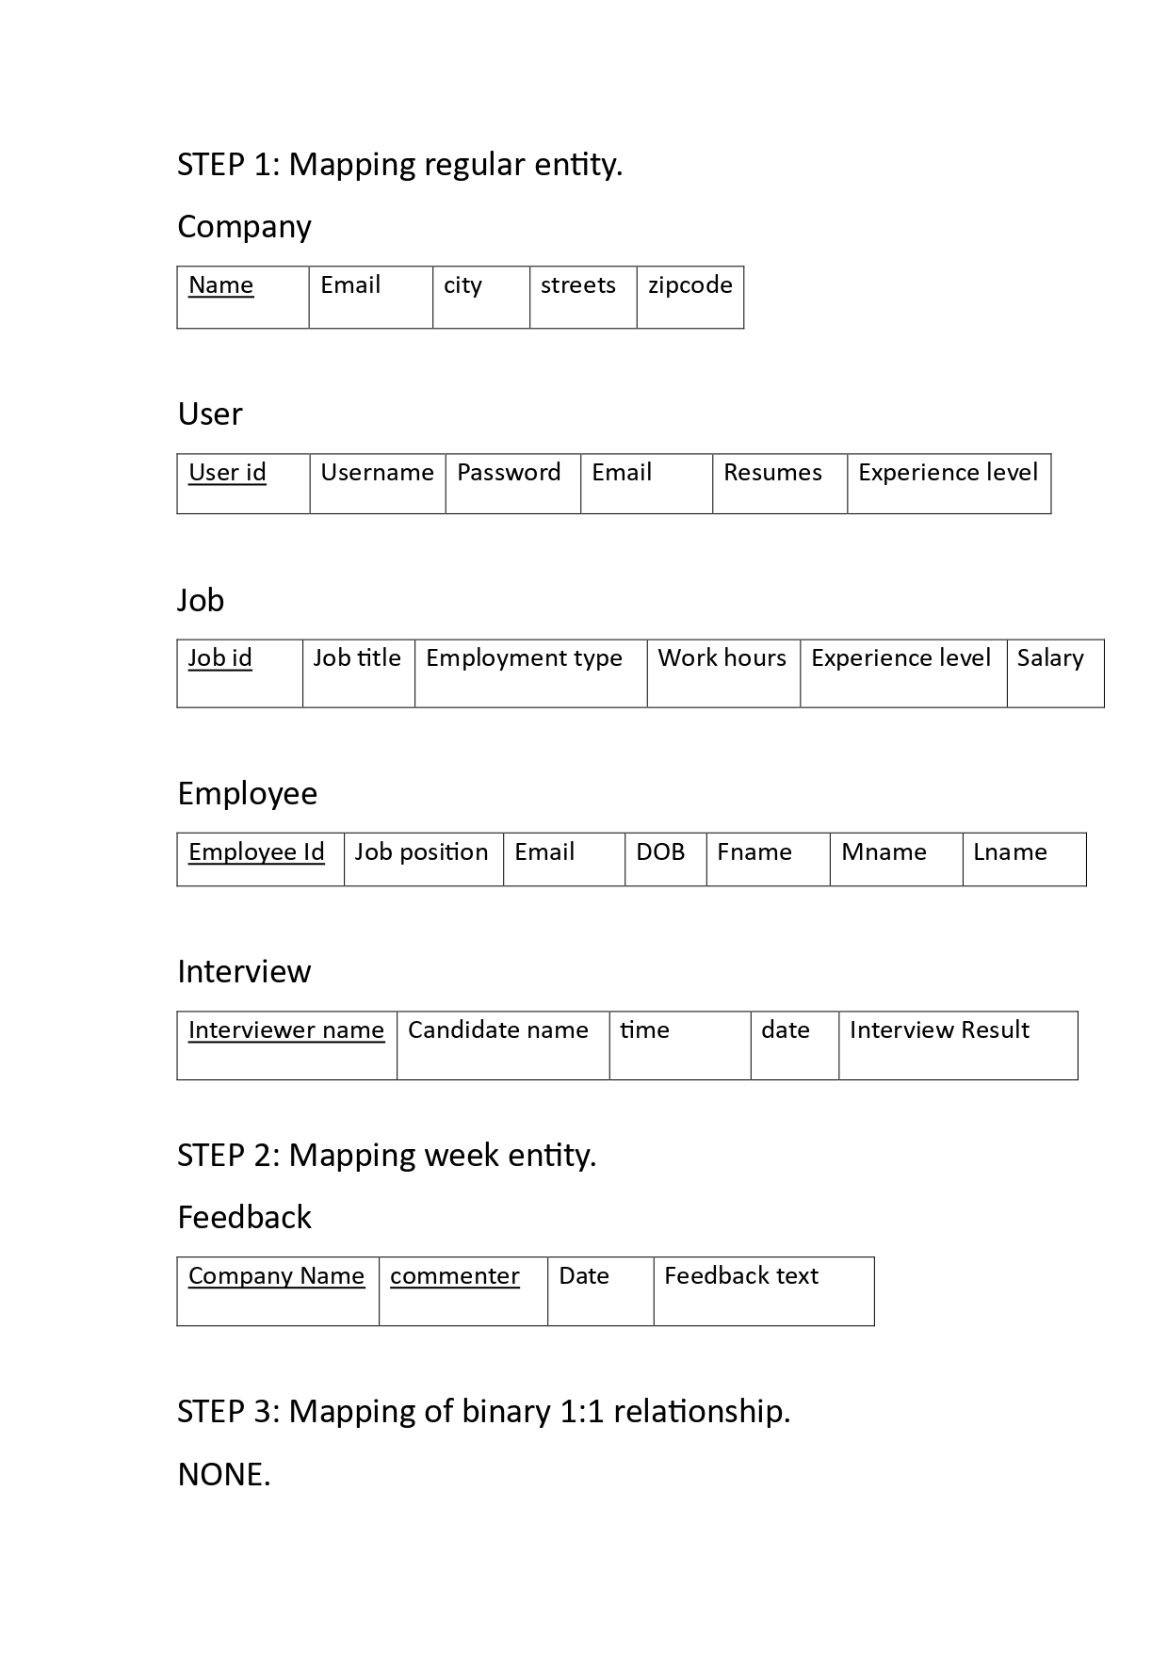

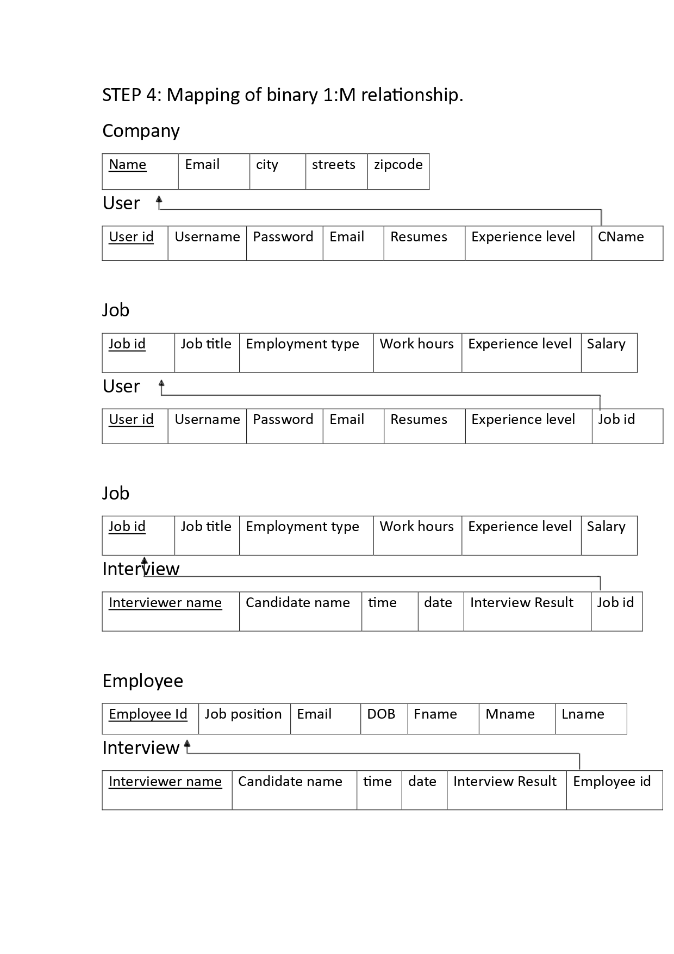

Final Mapping:

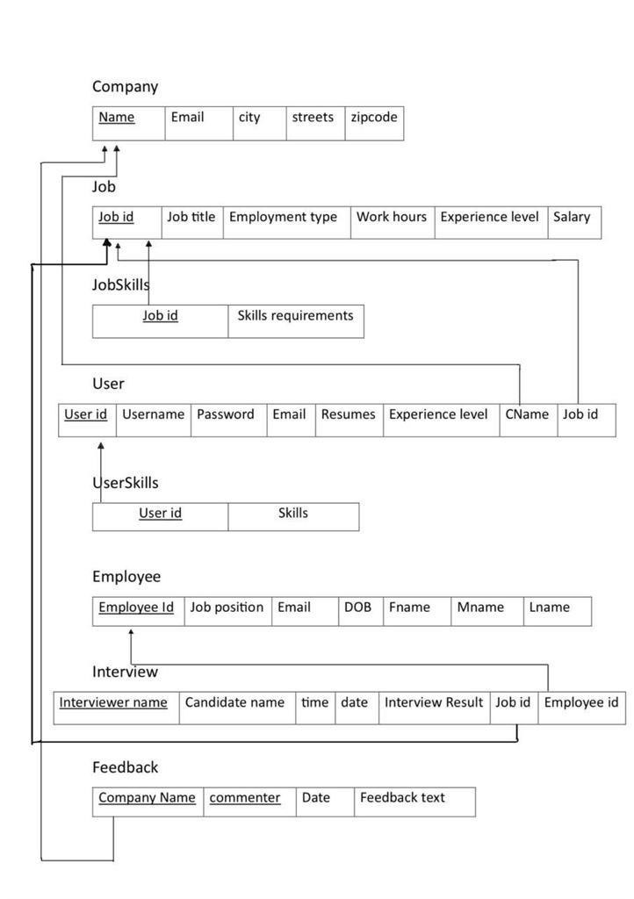

Normalization:

Company

|  |  |  |  |  |
| --- | --- | --- | --- | --- |
| Name | Email | city | street | zipcode |

1NF: The table in 1NF because there are no multi-valued attributes.

2NF: The table in 2NF because there are no partial dependencies.

3NF: The table in 3NF because there are no transitive dependencies.

User

|  |  |  |  |  |  |  |  |
| --- | --- | --- | --- | --- | --- | --- | --- |
| User id | Username | Password | Email | Resumes | Experience level | CName | Job id |

1NF: The table in 1NF because there are no multi-valued attributes.

2NF: The table in 2NF because there are no partial dependencies.

3NF: The table in 3NF because there are no transitive dependencies.

Employee

|  |  |  |  |  |  |  |
| --- | --- | --- | --- | --- | --- | --- |
| Employee Id | Job position | Email | DOB | Fname | Mname | Lname |

1NF: The table in 1NF because there are no multi-valued attributes.

2NF: The table in 2NF because there are no partial dependencies.

3NF: The table in 3NF because there are no transitive dependencies.

Job

|  |  |  |  |  |  |
| --- | --- | --- | --- | --- | --- |
| Job id | Job title | Employment type | Work hours | Experience level | Salary |

1NF: The table in 1NF because there are no multi-valued attributes.

2NF: The table in 2NF because there are no partial dependencies.

3NF: The table in 3NF because there are no transitive dependencies.

Interview

|  |  |  |  |  |  |  |
| --- | --- | --- | --- | --- | --- | --- |
| Interviewer name | Candidate name | time | date | Interview Result | Job id | Employee id |

1NF: The table in 1NF because there are no multi-valued attributes.

2NF: The table in 2NF because there are no partial dependencies.

3NF: The table in 3NF because there are no transitive dependencies.

Feedback

|  |  |  |  |
| --- | --- | --- | --- |
| Company Name | commenter | Date | Feedback text |

1NF: The table in 1NF because there are no multi-valued attributes.

2NF: The table in 2NF because there are no partial dependencies.

3NF: The table in 3NF because there are no transitive dependencies.

Implementation

1: Create and use schema

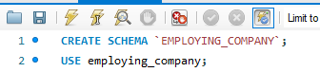

2: Create table

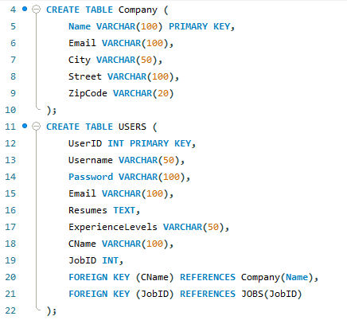

Result:

3: Insert Commands

Insert data into Company table.

Result:

Insert data into USER table for 5 people.

Result:

Insert data into JOBS table for 5 jobs.

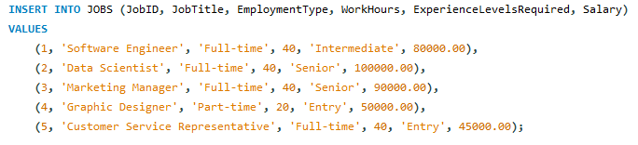

Result:

Insert data into Employees table.

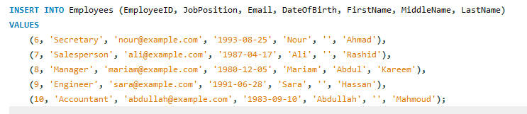

Result:

Insert data into Feedback table.

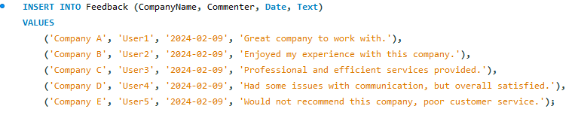

Result:

Insert data into Interview table.

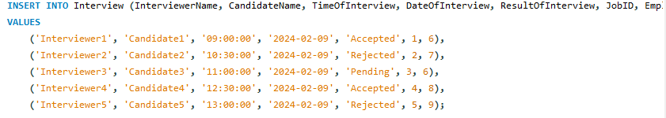

Result:

Insert skills for the user.

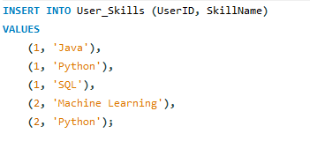

Result:

Insert skills for the job.

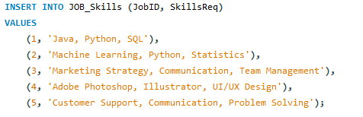

Result:

4: Update Commands

1

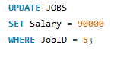

Result:

2

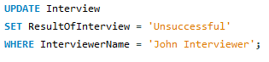

Result:

5: Delete Commands

1



Result:

2



Result:

6: Select Commands

1-Retrieve all feedback entries where the commenter is User1

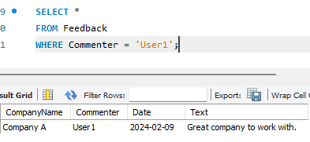

2-Retrieve the names of interviewers who have interviewed candidates with a Accepted result.

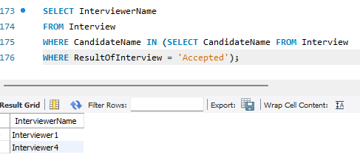

3-Count the number of feedback entries for each commenter.

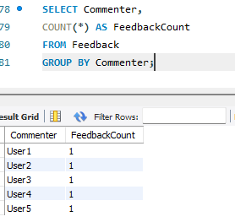

4-Retrieve companies with less or equal than 1 Users.

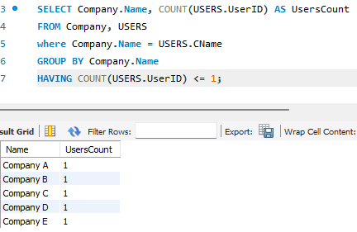

5-Retrieve feedback entries ordered by the date in descending order.

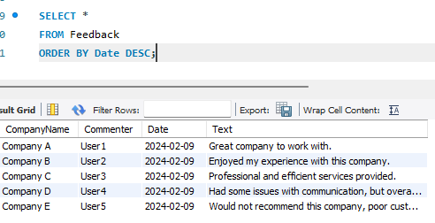

6-Retrieve the latest interview date for each candidate.

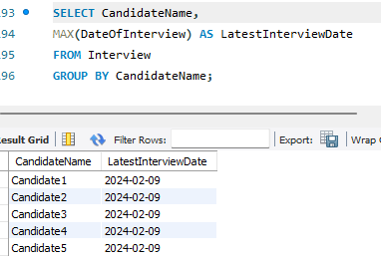

7-Retrieve the usernames and corresponding company names for users who have a specific experience level (e.g., 'Intermediate').

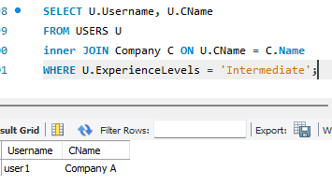

8-Find companies that have more than 1 users with 'Intermediate' experience levels.

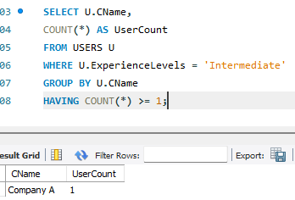

9-Retrieve employees without 1 employee.

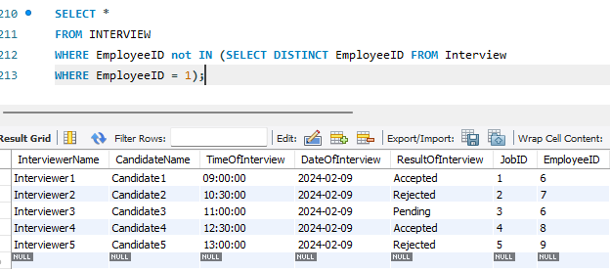

10-Retrieve Users information and the corresponding company name for Users who work for a company.

