Rosbot Active View Design
Body Orientation Conditioned Four to Two View Selection
This document specifies an offline training design for a mobile Rosbot using four low-height ETRI views. The robot records a stable first view A. A candidate generator builds four reachable target poses around the person; a masked DDQN selects one discrete index a ∈ {0,1,2,3}, which looks up the current candidate table and returns (x_a, y_a, yaw_a). VPOCLIP remains frozen and fuses the two views at class-score level.
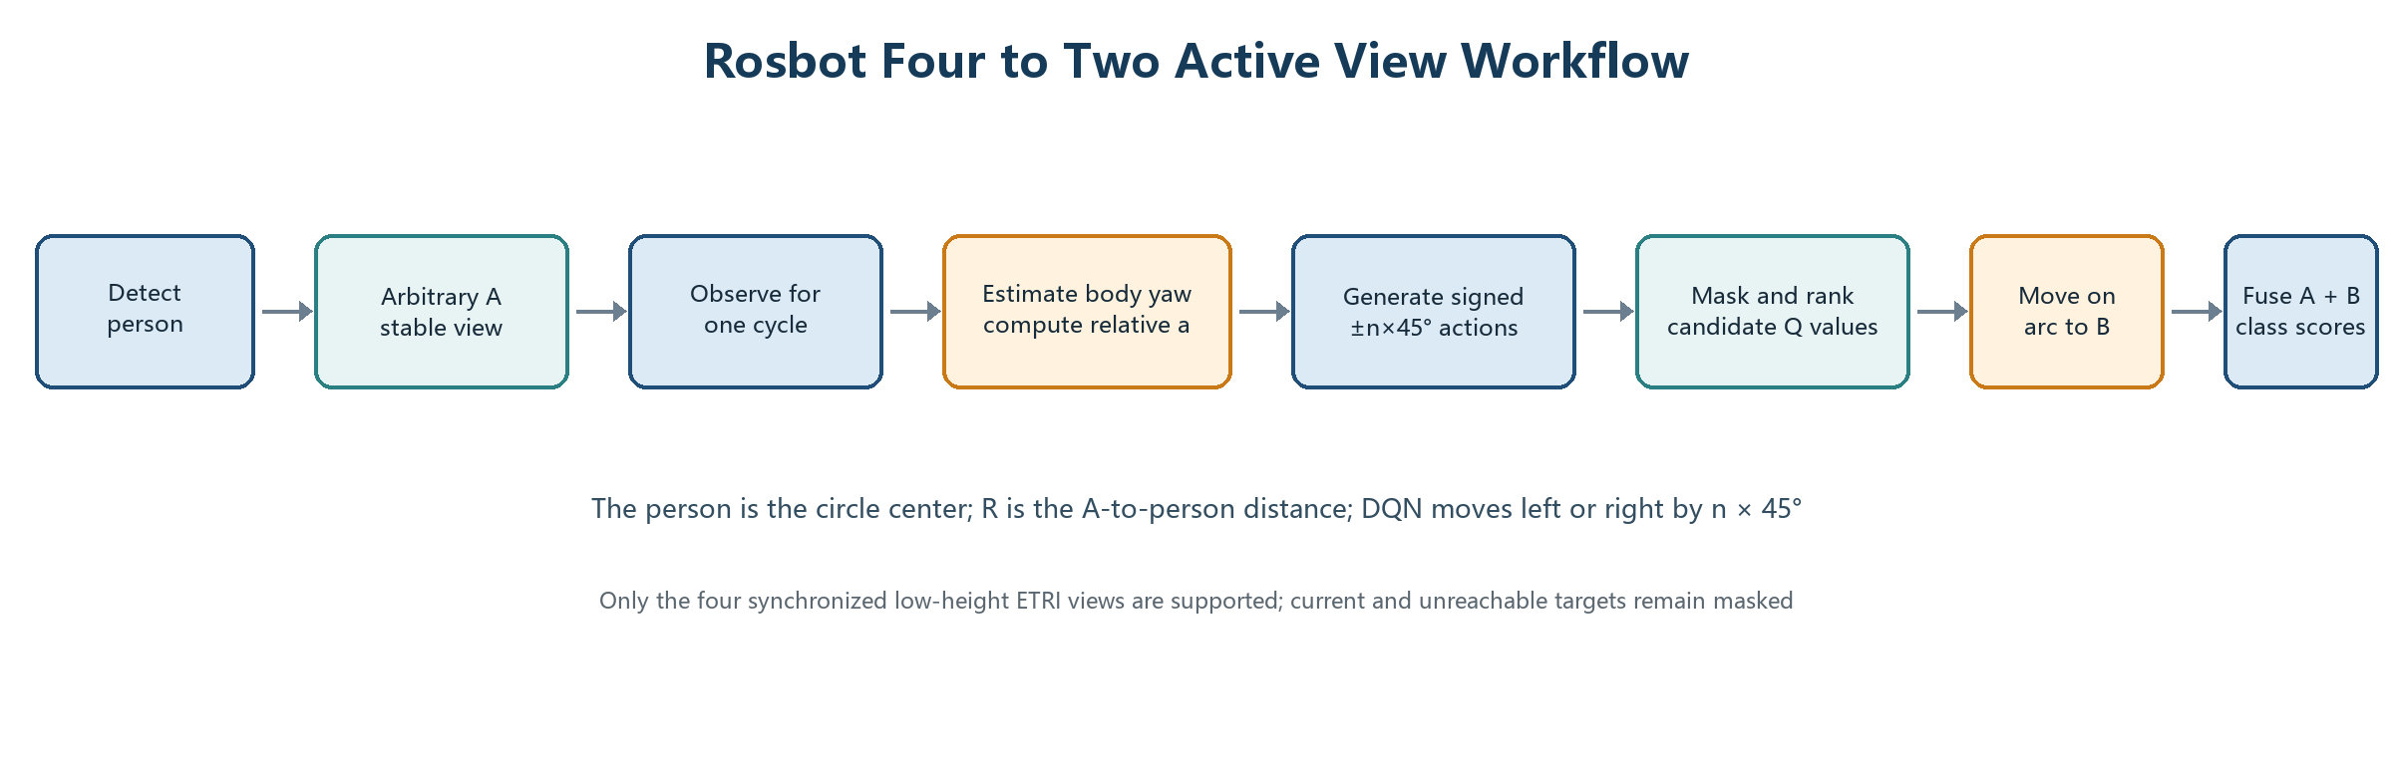

Design at a Glance
Item | Definition
First view A | The first stable recognition position after approach; record person distance R.
Relative frame | Person at the origin; body heading ψ defines the reference frame; R is the target distance.
DQN action | Discrete index a ∈ {0,1,2,3}; selects one row of the current candidate table.
Second view B | The candidate row selected by a; its target pose is resolved from the current person/map state.
Output | Fuse A and B scores and return the class with the largest fused score.

1 Geometry and View Mapping
Let the person position be p_h=(x_h,y_h), body heading be θ_h, and A the first stable view. Estimate θ_h from the skeleton. For candidate i, with distance r_i and body-relative angle α_i, generate the target position by x_i = x_h + r_i cos(θ_h + α_i), y_i = y_h + r_i sin(θ_h + α_i); set yaw_i to face the person.
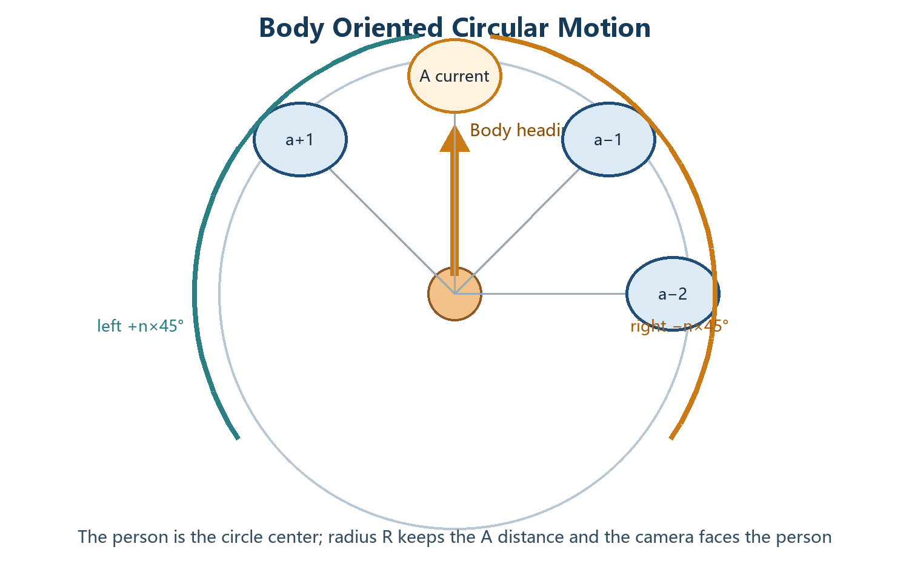
Variable | Meaning
p, ψ | Person position and body heading in the ground plane.
A, R | First stable view and distance from A to the person; R is the arc radius.
a | Current relative angle: robot bearing minus ψ, wrapped to [−π, π].
k | Candidate-table index; target pose is read as (x_a,y_a,yaw_a).
Vepisode | Four candidate view slots; their actual bearings may vary by sample or scene.

The four candidate rows are generated from the current person/map state. The slot rules may use nominal α_i values, but obstacle, collision and reachability checks can change the final pose. Invalid rows are masked before action selection.

2 State Action and Transition

2.1 State sA
State component | Variables and purpose
Visual and quality | zA, class scores, Top-K similarities, entropy HA and margin; evidence and uncertainty at A.
Skeleton and objects | joint coordinates/confidence/visibility; object class, confidence and relative position.
Body geometry | sinθ_h, cosθ_h, yaw confidence; candidate bearings, distances, reachability and movement cost.
Action constraints | candidate index a, target pose table, reachability, collision, movement cost, support and selected masks.

2.2 Action and Mask
The network outputs Q(s,a) for a ∈ {0,1,2,3}. Mask invalid or already selected rows, choose the highest-Q valid index, then read (x_a,y_a,yaw_a) from the current candidate table.

2.3 Transition Variables
Store τi = (sA(i), ai, rB(i), sAB(i), di): sA is the pre-action state, ai the selected candidate index, rB the post-B reward, sAB the fused A+B record, and di=1 the terminal flag, so yi=ri.

3 Reward Fusion and Training

SA and SB are cosine similarities or logits from independent frozen VPOCLIP passes. Use softmax only for probability, cross-entropy or entropy diagnostics; prediction remains argmax over the fused score.
clip,A: s_A → mask → epsilon-greedy k → observe B → fuse → r_B → store τ_i
batch: SmoothL1(Q_online(s_A,k), r_B); periodically copy Q_online to Q_target
Subjects: 45 VPOCLIP train | 25 DQN train | 10 validation | 20 final test. DQN uses four low-height views; high views support recognizer pretraining or robustness ablations.

