10. Address for “test_backtrace” = 0xf0100040
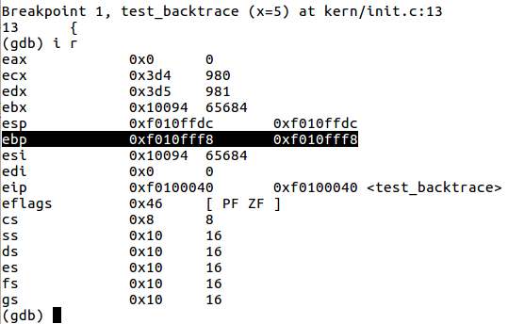

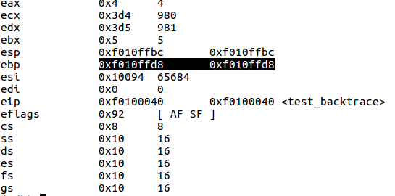
Stack grows by 0xf010fff8-0xf010ffd8 = 32 bytes

Words are:-
1. function parameter
2.return address
3.ebp
4.ebx
5.ebx
And there is a hole of 12bytes in between.(may be due to alignment or compiler optimization).

