

Draw It or Lose It
CS 230: Project Software Design Template
Jose De Jesus
Professor: Butu Emilia
Date: 10/18/2026

Table of Contents

CS 230 Project Software Design Template 1
Table of Contents 2
Document Revision History 2
Executive Summary 3
Requirements 3
Design Constraints 3
System Architecture View 3
Domain Model 3
Evaluation 4
Recommendations 5

Document Revision History

Version | Date | Author | Comments
1.0 | 09/20/26 | Jose DeJesus | Initial draft: Executive Summary, Requirements, Design Constraints, and Domain Model.
2.0 | 10/18/26 | Jose DeJesus | Added Recommendations section.

Instructions
Fill in all bracketed information on page one (the cover page), in the Document Revision History table, and below each header. Under each header, remove the bracketed prompt and write your own paragraph response covering the indicated information.
Executive Summary
The Gaming Room offers Draw It or Lose It, a team guessing game in which stock drawings are rendered on screen as clues, as an Android-only app. The company now wants a web-based version that serves multiple platforms without needing a separate native app for each one. In the game, teams play four one-minute rounds. Each drawing is rendered at a steady rate and is complete at the 30-second mark. If a team does not solve the puzzle before time runs out, each remaining team gets one 15-second guess.
Creative Technology Solutions (CTS) proposes a web-based, distributed application written in Java. A single server-side service will own all game data, and browsers on any platform will act as the clients. The first prototype, delivered with this document, builds the core of that service and meets the four software requirements. A game can have one or more teams, and each team has multiple players. Games, teams, and players all extend a common Entity base class that carries an id and a name. The GameService class uses the singleton pattern so that only one instance can exist in memory, and it hands out unique identifiers for every game, team, and player. The iterator pattern is used to search for a name before anything is added, so names stay unique and a user can check whether a name is in use before choosing it.
Before proceeding, The Gaming Room should know the following:
Scope of the prototype. It covers the domain model and the game service only. It has no user interface, network communication, round timers, or drawing library yet.

Storage. Game data is held in memory, so it is lost when the server restarts. A storage decision is needed before launch.
Scaling. The singleton guarantees one service per running server. Running several servers later will require shared storage for game state.
Hardware and hosting. These decisions follow from the software decisions above. CTS will bring an evaluation of operating platforms and a recommendation as the next step.
Client input needed. CTS needs The Gaming Room to supply the stock drawing library and puzzle list, and an estimate of how many teams and players will play at the same time.
Requirements
Business requirements. The Gaming Room wants to extend Draw It or Lose It from an Android-only app to a web-based game that serves multiple platforms. The game must keep its current play: teams guess a puzzle from stock drawings over four one-minute rounds, drawings finish rendering at 30 seconds, and each remaining team gets one 15-second guess if the puzzle is not solved. The Gaming Room staff do not know how to set up the environment, so CTS is also asked to streamline development.
Technical requirements. A game must be able to involve one or more teams, and each team must have multiple players. Game and team names must be unique so users can check whether a name is in use when choosing a team name. Only one instance of the game service can exist in memory at any time, which is achieved by giving every game, team, and player a unique identifier.
Design Constraints
Because Draw It or Lose It will run in a web-based distributed environment, the game logic and data live on a server while many players on different devices connect to it at the same
time. The constraints below come from that environment and from the client’s four software requirements. Each one shapes how the application must be built.
One shared instance. Only one instance of the game service may exist in memory, and every client request must go through it so that all players see the same games, teams, and players. The service is therefore built as a singleton. Once many requests arrive at the same time, access to the shared lists and counters must also be made thread-safe, for example with synchronized methods or concurrent collections. The prototype protects instance creation only, so broader thread safety is needed before launch.
Unique identifiers. Every game, team, and player needs an identifier that is never reused. The identifiers come from counters held by the service, and each increment must be atomic so that two simultaneous requests never receive the same value. If the server restarts, the counters must be restored from storage so old identifiers are not issued again.

Unique names. A name must be checked before a game, team, or player is added, and the check and the add must happen as one uninterrupted step. Otherwise two users could claim the same name at the same moment. The prototype uses an iterator to scan the list, which is simple and fast enough for small numbers but slows as the list grows. A production version would use an indexed lookup or a database uniqueness rule. The rules for names also need to be defined. The prototype compares names exactly (uppercase and lowercase count as different), rejects blank names, requires team names to be unique within a game, and requires player names to be unique within a team. A production version should decide whether names such as “Red Pencils” and “red pencils” count as the same.

Multiple platforms and browsers. Clients will be desktops, laptops, tablets, and phones running different operating systems and browsers. The client side should use web standards (HTML5, CSS, and JavaScript), adapt to different screen sizes, and be tested on a defined list of browsers and devices. Keeping the game rules on the server means they are written once rather than once per platform.
Real-time communication and timing. Drawings render at a steady rate, complete at 30 seconds, and rounds end at 60 seconds, followed by the 15-second guesses. The server must keep the official clock and push updates to every client at once, for example with WebSockets. If each device relied on its own clock, players would drift out of sync and the game would be unfair.
Network reliability and latency. Connections vary in speed and can drop. The application must tolerate late or lost messages, let a player rejoin a game in progress, and resend the current round and drawing progress on reconnection so that one dropped connection does not end the game for a team.
Data storage and content delivery. The stock drawing library is large, and game data is currently held only in memory. Drawings should be stored and delivered separately from game state, for example through caching or a content delivery network, so they load quickly. A persistent store is needed if games must survive a restart. The client must also confirm it holds the rights to use the drawings on the web.
Security and privacy. The application handles player names and identifiers, and some players may be children. All traffic should use HTTPS, and input such as names must be validated and cleaned to
block malicious content. Identifiers should not be guessable or trusted on their own for access, and the privacy rules that apply to players’ personal information must be reviewed.
Scalability and availability. A singleton is one instance per running program, so this design suits a single server. If demand requires more than one server, game state will have to move to a shared store or games will have to be assigned to particular servers, and the design will need to be revisited.
Maintainability and portability. The client’s staff need a design they can extend. Java runs on all major server operating systems, the shared Entity base class removes duplicated code, and the patterns used are standard, which makes the code easier to hand off, test, and extend.
Fgtyhjd

System Architecture View
Please note: There is nothing required here for these projects, but this section serves as a reminder that describing the system and subsystem architecture present in the application, including physical components or tiers, may be required for other projects. A logical topology of the communication and storage aspects is also necessary to understand the overall architecture and should be provided.
Domain Model
The diagram below shows the domain model in the com.gamingroom package. Entity is the base class. It holds an id and a name, and provides getId(), getName(), and toString(). It has a private no-argument constructor and a public constructor that takes an id and a name, so every entity must be created with both. Game, Team, and Player each inherit from Entity (the open-arrow lines) and add only what is specific to them: a Game holds a list of Teams, a Team holds a
list of Players, and a Player adds nothing beyond what Entity provides. GameService sits above them. It keeps a list of Games, counters for the next game, team, and player ids, and a static reference to its own single instance. ProgramDriver contains main() and uses SingletonTester, whose testSingleton() checks that the service behaves as a singleton.
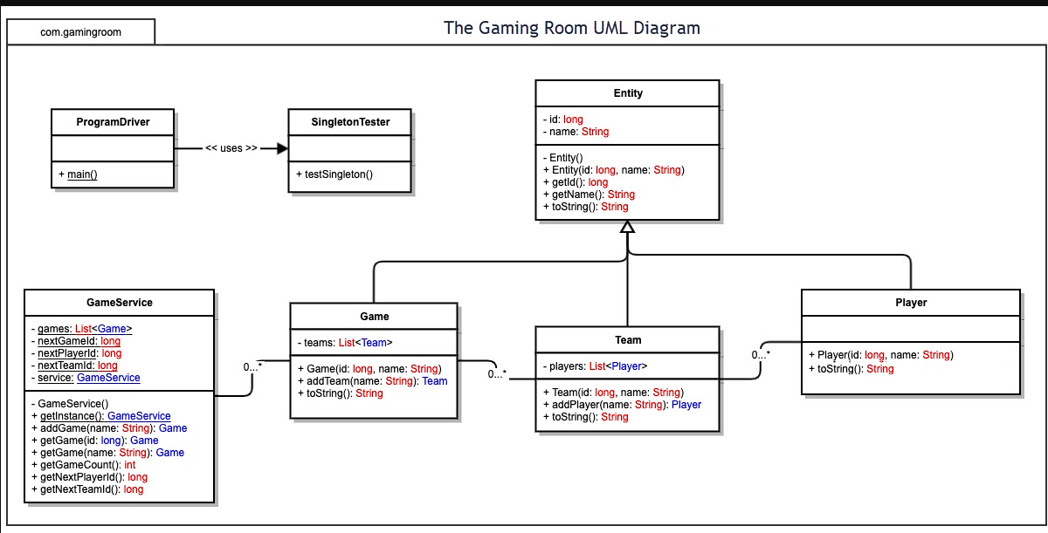
Figure 1. The Gaming Room UML class diagram.
The “0..*” labels show how the classes relate. GameService is associated with zero or more Games, a Game with zero or more Teams, and a Team with zero or more Players. This is a containment hierarchy: a player belongs to a team, a team belongs to a game, and the service holds the games. It supports the requirements that a game can involve one or more teams and that each team has multiple players. The diagram allows zero so that a game or team can be created first and filled in afterward.
The following object-oriented principles and design patterns appear in the diagram:

Inheritance. Game, Team, and Player extend Entity, so the id, the name, and their accessors are written once and reused. A new kind of entity can be added later without repeating that code.
Encapsulation. The id, name, and the lists of teams and players are private and are reached only through public methods. A team’s players can be changed only through addPlayer(), which enforces the unique-name rule. The private constructors in Entity and GameService prevent misuse.
Polymorphism. Each subclass overrides toString(), so a Game, Team, or Player can be treated as an Entity and still describes itself correctly.
Abstraction. Callers ask GameService to add or find a game without knowing how games are stored. The list can later be replaced by a database without changing the callers.
Singleton pattern. GameService has a private constructor, a private static service field, and a public static getInstance() method. This meets the requirement that only one instance exists in memory. The id counters live in this one instance, so identifiers are unique across the whole application.
Iterator pattern. addGame(), getGame(), addTeam(), and addPlayer() use an iterator to search for a name before adding anything. This meets the requirement that names are unique and lets a user check whether a name is already in use.
Together these choices keep the model small and easy to extend. The shared parent class removes duplication, encapsulation keeps each rule in one place, and the two patterns satisfy the hardest requirements, a single instance and unique names, with very little code.



Evaluation
Using your experience to evaluate the characteristics, advantages, and weaknesses of each operating platform (Linux, Mac, and Windows) as well as mobile devices, consider the requirements outlined below and articulate your findings for each. As you complete the table, keep in mind your client’s requirements and look at the situation holistically, as it all has to work together.
In each cell, remove the bracketed prompt and write your own paragraph response covering the indicated information.

Development Requirements | Mac | Linux | Windows | Mobile Devices
Server Side | <Evaluate Mac for its characteristics, advantages, and weaknesses for hosting a web-based software application.> | <Evaluate Linux for its characteristics, advantages, and weaknesses for hosting a web-based software application.> | <Evaluate Windows for its characteristics, advantages, and weaknesses for hosting a web-based software application.> | <Evaluate Mobile Devices for their characteristics, advantages, and weaknesses for hosting a web-based software application.>
Client Side | <Determine the software development considerations (cost, time, expertise) that are necessary for supporting multiple types of clients as they pertain to Mac.> | <Determine the software development considerations (cost, time, expertise) that are necessary for supporting multiple types of clients as they pertain to Linux.> | <Determine the software development considerations (cost, time, expertise) that are necessary for supporting multiple types of clients as they pertain to Windows.> | <Determine the software development considerations (cost, time, expertise) that are necessary for supporting multiple types of clients as they pertain to Mobile Devices.>
Development Tools | <Identify the relevant programming languages and tools (IDEs and other tools) that are used to build this type of software for deploying on Mac.> | <Identify the relevant programming languages and tools (IDEs and other tools) that are used to build this type of software for deploying on Linux.> | <Identify the relevant programming languages and tools (IDEs and other tools) that are used to build this type of software for deploying on Windows.> | <Identify the relevant programming languages and tools (IDEs and other tools) that are used to build this type of software for deploying on Mobile Devices.>
Recommendations
Analyze the characteristics of and techniques specific to various systems architectures and make a recommendation to The Gaming Room. Specifically, address the following:
- Operating Platform: We recommend that The Gaming Room host the Draw It or Lose It server on Linux in a cloud environment, and deliver the game to players through one responsive web client that runs in any modern browser. This matches the Project Two evaluation. Linux has little or no license cost, it runs the Java service described in this document without changes, and every major cloud provider rents it by the hour, so the company can start with a few servers and add more as the player base grows. Because the game rules live on the server, a single codebase serves Windows, Mac, Linux, iOS, and Android players, and the company does not need to build and maintain a separate native app for each one. Windows Server remains a reasonable second choice if the company's staff already know Windows administration well, and Mac hardware is best kept on developers' desks for Safari and iOS testing rather than used for hosting. Phones and tablets are clients only, so they are not a hosting option.
- Operating Systems Architectures: Linux uses a modular monolithic kernel. The core of the operating system (the process scheduler, memory manager, file systems, network stack, and device drivers) runs together in protected kernel space, while applications run in user space and reach the kernel only through system calls. Drivers and file systems can be loaded as kernel modules, so the server can be tuned without rebuilding the kernel. For Draw It or Lose It, the Java Virtual Machine, which runs the game service, is simply a user-space process. This separation means a crash in the game service cannot take down the operating system.
Linux runs many processes and threads at once and divides processor time among them with its scheduler. This suits the game, where one JVM must handle many simultaneous players, each
with an open connection and a stream of guesses and timer updates. A service manager such as systemd starts the game service at boot, restarts it if it fails, and records its logs. For isolation, Linux provides namespaces and control groups (cgroups), which are the building blocks of containers such as Docker. Packaging the game service as a container lets the same image run on a developer's laptop, a test server, and production, which directly helps with the client's request to streamline development. Kubernetes or a similar tool can then start and stop copies of the container as demand changes.
For comparison, the other platforms studied in Project Two are built differently. Windows uses a hybrid kernel with strong integration into Active Directory and .NET. macOS uses a hybrid kernel (XNU) built on a Unix foundation, but Apple no longer sells a server edition. iOS and Android are designed around one user, a battery, and a touchscreen, which is why they serve as clients rather than hosts. Linux is the one architecture designed from the start for unattended, multi-user, network-facing service. Table 1 summarizes the differences.
Table 1. Comparison of operating system architectures.
Platform | Kernel architecture | Typical role | Fit for Draw It or Lose It
Linux | Modular monolithic kernel. Scheduler, memory manager, file systems, and network stack run in kernel space; drivers load as modules; applications run in user space. | Servers, cloud, containers, embedded devices | Recommended host. Low cost, proven at scale, native container support, and runs the Java game service unchanged.
Windows | Hybrid (NT) kernel. Core services run in kernel space, with subsystems in user space; tightly integrated with Active Directory and .NET. | Desktops and enterprise servers | Capable host through Windows Server and IIS, but with per-server licensing and higher memory use. Best if staff are Microsoft-skilled. Also a major client platform.
macOS | Hybrid XNU kernel, combining the Mach microkernel with BSD components, running on Apple hardware. | Desktops and laptops; no current server edition | Not suited to hosting. Useful for developer machines and Safari testing, and a client platform.
Mobile (iOS and Android) | iOS uses an XNU-based kernel and Android uses the Linux kernel. Both sandbox every app and manage memory and battery aggressively. | Single-user phones and tablets | Clients only. The web client must handle small screens, touch input, apps suspended in the background, and unstable networks.

- Storage Management: We recommend a layered storage design in which each type of data goes to the kind of storage that suits it. The operating system and the game service live on the server's boot volume, formatted with the ext4 file system (XFS is an equally good alternative). Both are
- journaling file systems, which means that after a power loss or crash the system replays a log and returns to a consistent state without a long repair. Cloud block storage, such as Amazon EBS or an equivalent, backs the volumes, and Linux's Logical Volume Manager (LVM) allows a volume to be grown later without downtime.
Game data needs more than the in-memory lists used in the prototype, because those lists are lost whenever the server restarts. We recommend a relational database such as PostgreSQL, running on its own server or as a managed cloud service, to store games, teams, players, scores, and the identifier counters. Database transactions and uniqueness constraints also give the unique-name and unique-identifier rules a safe home when many requests arrive at once. The database should replicate to a standby copy in a second availability zone and take automatic daily backups, with point-in-time recovery so that a bad deployment or a mistaken delete can be undone. PostgreSQL is preferred over a NoSQL store because the data is structured and related (games contain teams, and teams contain players), and its transactions and uniqueness constraints enforce the unique-name and unique-identifier rules directly. Object storage is preferred over keeping drawings in the database or on server disks because it costs less per gigabyte, grows without limit, keeps the game servers free of large files, and connects directly to a CDN.
The stock drawing library is large and does not change during a game, so it should be kept in cloud object storage (for example Amazon S3) and delivered through a content delivery network. Players then load drawings from a location near them, and the game servers do not spend their memory or bandwidth serving image files. This separation of drawings, game state, and operating system files is also what lets the company add more game servers later, because none of them holds data that another server needs.
The storage needed can be estimated. The 200-image library at about 8 MB each is roughly 1.6 GB, and keeping smaller versions for different platforms would add about half again, for a total near 2.4 GB before the library grows. This is an estimate, and actual usage should be measured after launch rather than assumed. Player data (accounts, teams, scores, and game history) is small by comparison, but it cannot be recreated if it is lost, so it deserves the backups and replication described above even though it takes little space. Keeping the images on the server or in the cloud, instead of inside every client, keeps installs small and means a new picture only has to be added once.
A useful way to compare the two is that memory is the workbench and storage is the warehouse. Memory holds what the game is using right now, such as the current drawing, the timer, and each team's guesses. It is fast but small, and everything in it is lost if the process crashes (Silberschatz et al., 2018). Storage holds what the game must keep, such as the full library, accounts, and scores. It is large and permanent but slower to reach. The game constantly moves data from one to the other, which is why game state must be written to the database and not held only in memory. Storage management asks how much to keep, while memory management asks how little to hold at once.
- Memory Management: Linux manages memory with virtual memory. Every process, including the JVM that runs Draw It or Lose It, sees its own private address space, and the kernel maps those addresses to physical memory in fixed-size pages. Pages are loaded on demand, so only the parts of the program actually in use occupy RAM. If memory runs short, the kernel can write rarely used pages to swap space on disk, although a production game server should be sized so that it almost never swaps, since a swapped page is far slower than one in RAM. Linux also uses spare memory as a page cache for files that were recently read, which speeds up repeated reads
- of the same data. Because each process has its own address space, one program cannot read or overwrite another program's memory, which supports both stability and security.
For the game itself, the JVM adds its own layer on top of this. Objects such as Game, Team, Player, and the entries behind the singleton GameService are created on the Java heap, and the garbage collector reclaims objects that are no longer referenced, such as a finished game. These objects are small. The larger memory costs are the open connection and buffers kept for each connected player, each thread's stack, and any drawings cached in memory. We recommend setting a fixed maximum heap size, choosing a low-pause garbage collector so that collection does not interrupt a timed round, and keeping the drawing files in the CDN rather than in the heap.
Several specific memory management techniques work underneath all of this. Segmentation divides a program's address space into logical regions: its code, its data, the heap, and each thread's stack. Linux gives every process this layout, but it places those regions in physical memory by paging, not by allocating whole segments. Paging avoids external fragmentation of physical memory, because any free page frame can hold any page. It does cause some internal fragmentation, because a region that does not fill its last page wastes the remainder of that page. Fragmentation can also occur inside the JVM, where freed objects leave gaps in the heap, so the garbage collector periodically compacts live objects together so that large allocations still succeed. Copy-on-write lets processes share the same physical pages until one of them changes a page, at which point the kernel makes a private copy. This makes starting several containers from the same image cheap, because they share read-only pages such as system libraries and the JVM's own files, and each pays only for what it modifies. Finally, paging and swapping are related but different. Paging moves individual pages between RAM and disk as needed, while
classic swapping moves an entire process out of memory. Linux swaps at the page level, which is gentler, but it is still risky for a JVM, because garbage collection touches the whole heap, and a partly swapped heap can make a collection slow enough to freeze a timed round. We therefore recommend sizing RAM so the game heap stays fully in memory, setting the servers to avoid swapping (for example by lowering the swappiness setting), and relying on monitoring and automatic restarts, not swap, to handle overload (Silberschatz et al., 2018).
Linux control groups let each container have a hard memory limit, so a fault in one service cannot starve the others. If a process still exceeds its limit, the kernel's out-of-memory handler stops it, and the service manager restarts it. This is another reason the game state must be written to the database and not held only in memory. The team should monitor memory use, heap size, and garbage collection time, and run load tests with realistic numbers of teams and players before launch. The client has not yet supplied that estimate, so the memory sizing here is provisional.
The library figures make these choices concrete. Loading all 200 images up front (about 8 MB each, roughly 1.6 GB) is not workable, because a compressed file is only the starting size: once an image is decoded it takes memory for every pixel (Android Developers, n.d.), and a phone would run out of memory long before the library finished loading. Browsers generally decode images the same way, so the web client should request only the current round's image, scaled to the screen it is shown on, since extra resolution uses memory with no visible benefit. The client may preload one image ahead so the game does not stall between rounds. That means briefly holding two images, so the old one should be released as soon as a round ends. At the CDN and any server-side cache, games that use the same popular image should share one cached copy instead of each keeping its own. The maximum image size should also be set per device class,
because phones, consoles, and browsers cap memory differently. In short, memory management asks how little the game must hold at once.
- Distributed Systems and Networks: Draw It or Lose It is a client-server distributed system. Browsers on many platforms are the clients, and the Linux servers hold the game service and data. Because all clients speak standard web protocols, they can interoperate regardless of operating system. The browser loads the page and the drawings over HTTPS, makes ordinary requests (HTTPS with JSON) for actions such as creating a team or checking whether a name is in use, and keeps a WebSocket connection open during play so the server can push the round clock, drawing progress, and guesses to every team at once. The server holds the official clock, so a slow phone cannot gain or lose time.
The system is made of several components, and each depends on the others. A DNS service points players to the game. A load balancer receives their connections and spreads them over several game servers. The game servers depend on the database for saved state, on object storage and the CDN for drawings, and on the network for every message. Because the prototype's singleton holds game state in one server's memory, running several servers requires either assigning each game to one server (for example with a routing rule at the load balancer) or moving shared state to a common store such as the database or an in-memory cache like Redis. A shared message channel then lets servers pass events between each other. Figure 2 shows how these components connect.

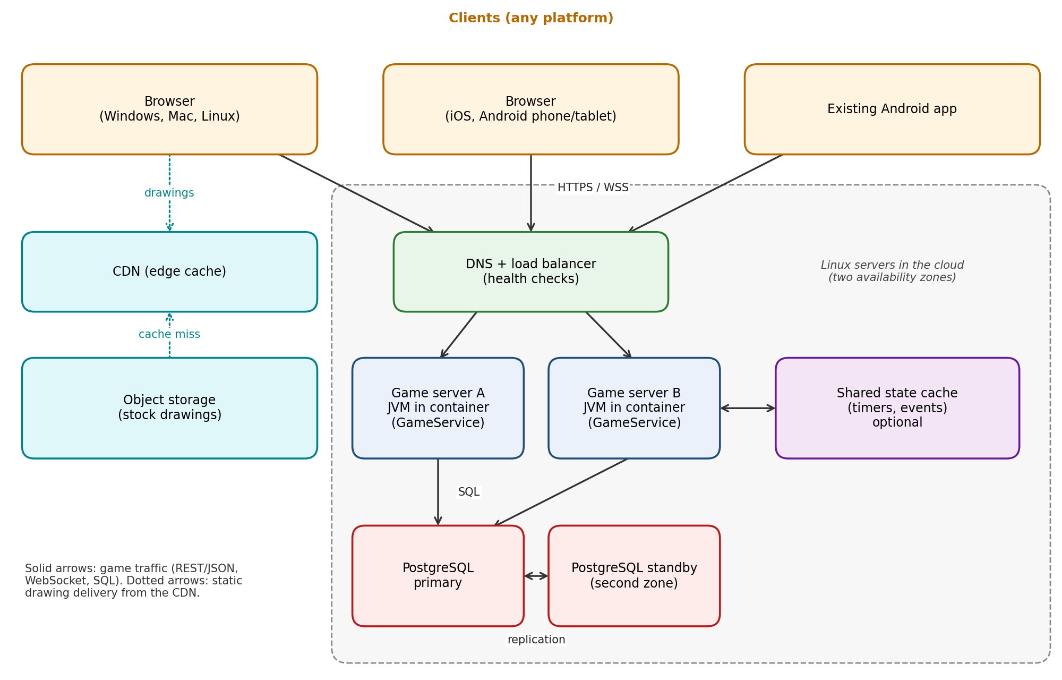
Figure 2. Logical topology of Draw It or Lose It.
Outages must be planned for rather than hoped away. If a player's connection drops, the client should reconnect automatically, and the server should resend the current round, remaining time, and drawing progress so the player can continue. Heartbeat messages let the server detect a dead connection and avoid waiting for a player who has gone. If one game server fails, the load balancer's health checks remove it from service, and its games can resume on another server using the state stored in the database. Placing servers and the database standby in two availability zones protects against the loss of a single data center. If the CDN or database is unavailable, the game should degrade as gracefully as possible, for example by pausing a round and showing a clear message rather than ending it unfairly. Finally, latency differs for each player, so the server's clock, not the arrival time of a message, should decide whether a guess counted.
The separation between clients and server also depends on a shared contract. The server owns the data and the rules around it (who the players are, what counts as a valid record, and who may change what), while each client owns only how that data looks and feels on its screen. If the contract is a REST API that returns JSON, either side can change without forcing a change in the other. For example, the server's storage can move from a hard-coded list to a real database without changing the API. The same server can then serve a browser, the existing Android app, and later a console client, which only needs to send an HTTP request and parse JSON. The expensive work of supporting a new platform stays inside that one client (for a console, the manufacturer's certification process and a controller-based interface), and the server and its security model do not change. Each client must still send credentials correctly, parse the JSON for its own platform, and react sensibly when it receives an error such as a 403 instead of data.
- Security: Security should be built into every layer. On the Linux server, the recommended platform provides several protections. Each process runs as a user with permissions, so the game service should run under its own low-privilege account and never as root. Mandatory access control (SELinux or AppArmor) limits what the service can touch even if it is compromised. A host firewall (nftables) and cloud security groups should allow only the ports the game needs, such as HTTPS, and administrators should log in with SSH keys and multi-factor authentication instead of passwords. Automatic security updates, a regular patching schedule, and the audit and system logs help the team prevent and investigate attacks. Linux's vendor-supported security updates and large community are an advantage here.
Between platforms, all traffic should use TLS: HTTPS for requests and secure WebSockets (wss) for live play. This protects data crossing the network whether the player uses a phone on public Wi-Fi or a desktop at home, and it works the same on every operating system. Certificates should
be renewed automatically. The server should treat every client as untrusted. It must validate and clean all input, such as team and player names, to block injection and cross-site scripting. It should check on every request that the player is allowed to act on that game or team, because an identifier alone must not grant access. Because game identifiers are sequential in the prototype, production identifiers shown to players should be random and hard to guess. The web client should use a Content Security Policy and secure cookies, and any account passwords should be stored only as salted hashes (for example bcrypt or Argon2).
To protect stored information, the database volume and backups should be encrypted at rest, using Linux disk encryption or the cloud provider's key management service, and secrets such as database passwords and keys should be kept in a secrets manager, not in the source code. The game should collect as little personal information as possible, ideally a display name and no more, because some players may be children. The client must review the privacy laws that apply to its players, such as COPPA in the United States and GDPR in Europe, and publish a clear privacy policy. Finally, the team should test for weaknesses before launch and on a regular schedule, monitor logs for unusual activity, and prepare a plan for responding if a breach occurs.
The GameAuth prototype built for The Gaming Room shows how to separate two questions. Authentication asks who is making the request. It is handled by checking credentials and building a user object that carries a set of roles. Authorization asks whether that person may do this specific thing. It is handled by comparing those roles with what each endpoint requires, for example open to everyone, user only, or admin only. A request from someone without the needed role is refused with a 403 status that every client already understands. Because this check runs on the server for every request, it protects players the same way on every platform. The prototype uses HTTP Basic Authentication with a hard-coded user list, which is acceptable for a
demonstration but not for production, because the password is re-sent with every request and new users can only be added by editing source code. Before launch, the user list should move into the database with a registration flow, and sessions should use short-lived signed tokens (such as JWT) over TLS so that a password is sent only at login.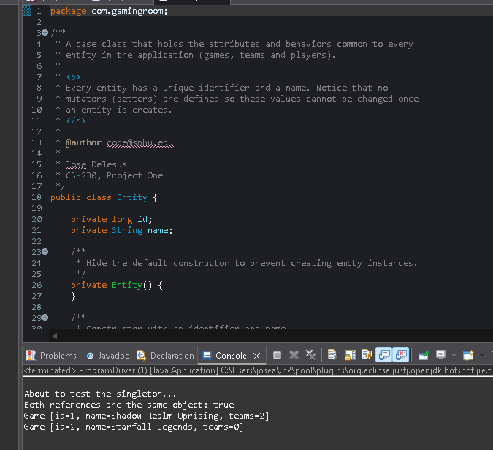
References
Android Developers. (n.d.). Loading large bitmaps efficiently. Google. https://developer.android.com/topic/performance/graphics/load-bitmap
Silberschatz, A., Galvin, P. B., & Gagne, G. (2018). Operating system concepts (10th ed.). Wiley.

